Program 4:More Queries on bank Database
i. Find all the customers who have an account at all the branches located in a specific city (Ex. Delhi).
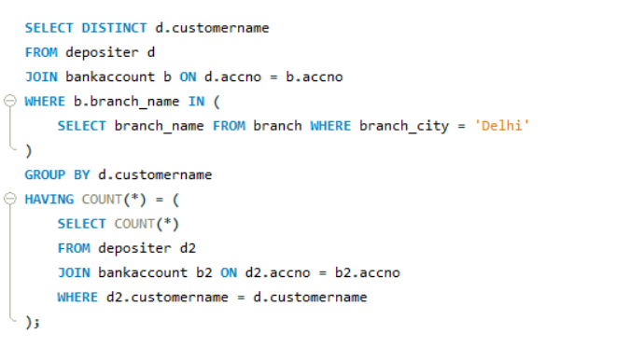
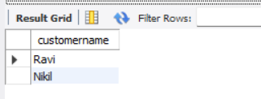
ii.Find all customers who have a loan at the bank but do not have an account.
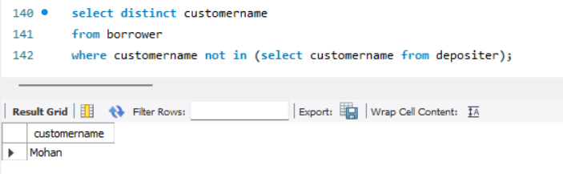

iii. Find all customers who have both an account and a loan at the Bangalore brach.
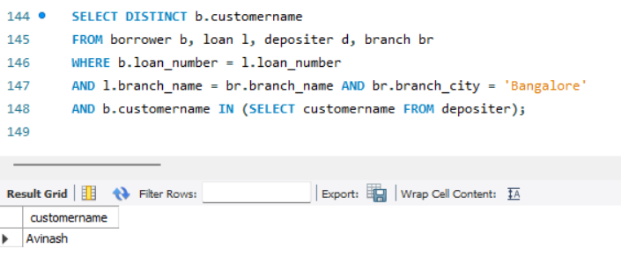
iv. Find the names of all branches that have greater assets than all branches located in Bangalore.
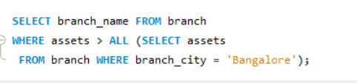
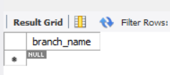
v. Demonstrate how you delete all account tuples at every branch located in a specific city (Ex. Bombay).
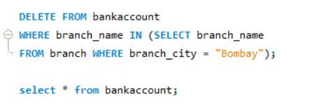
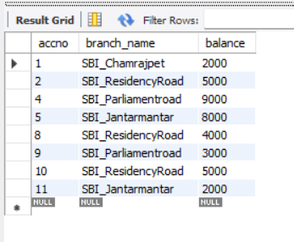
vi. Update the Balance of all accounts by 5%
