Program 6: More Queries on Employee Database
i. List the name of the managers with the maximum employees
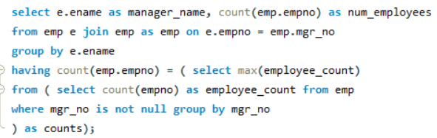

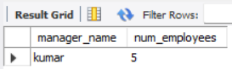

ii. Display those managers name whose salary is more than average salary of his employee.
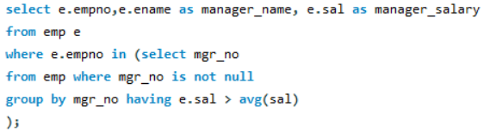
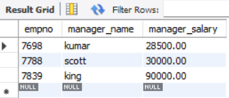
iii. Find the name of the second top level managers of each department.
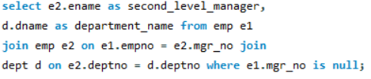
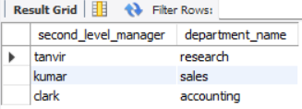

iv. Find the employee details who got second maximum incentive in January 2019.
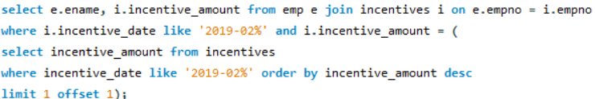
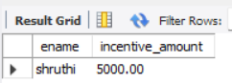
v. Display those employees who are working in the same department where his manager is working.
