Program Database :8
i. Find the pnames of parts for which there is some supplier.
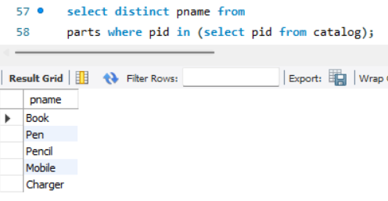
ii. Find the snames of suppliers who supply every part.
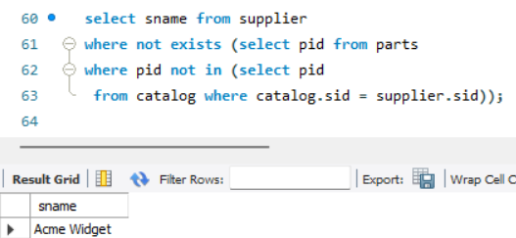

iii. Find the snames of suppliers who supply every red part. 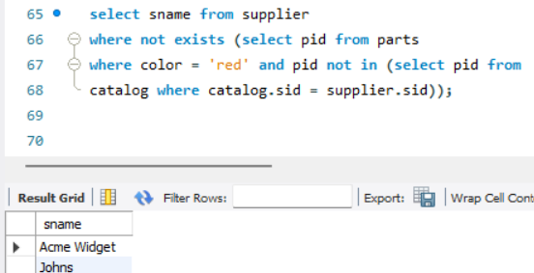

iv. Find the pnames of parts supplied by Acme Widget Suppliers and by no one else.
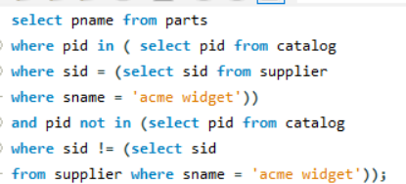
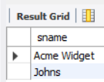
vi. Find the sids of suppliers who charge more for some part than
the average cost of that part (averaged over all the suppliers who supply that part).
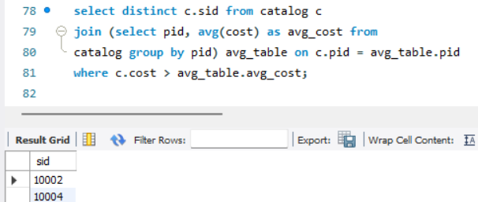
vii. For each part, find the sname of the supplier who charges the most for that part.

