31.Customer Segmentation using Clustering Program:-
import pandas as pd import numpy as np from sklearn.cluster import KMeans from sklearn.preprocessing import StandardScaler import matplotlib.pyplot as plt
# Sample customer data: CustomerID, Total_Spend, Frequency, Avg_Order_Value data = {
"customer_id": [1,2,3,4,5,6,7,8],
"total_spend": [5000, 800, 1500, 7000, 12000, 3000, 400, 6000],
"frequency": [50, 10, 20, 60, 90, 30, 5, 55],
"avg_order_value": [100, 80, 75, 120, 130, 100, 80, 110]} df = pd.DataFrame(data)
# Select features for clustering
X = df[["total_spend", "frequency", "avg_order_value"]]
# Scale the data scaler = StandardScaler()
X_scaled = scaler.fit_transform(X) # Apply K-Means clustering kmeans = KMeans(n_clusters=3, random_state=0) df["cluster"] = kmeans.fit_predict(X_scaled) print("Cluster Centers (scaled):") print(kmeans.cluster_centers_) print("\nCustomer Segments:") print(df[["customer_id", "total_spend", "frequency", "avg_order_value", "cluster"]])
# Simple 2D visualization: total_spend vs frequency plt.scatter(df["total_spend"], df["frequency"], c=df["cluster"]) plt.xlabel("Total Spend")
plt.ylabel("Frequency") plt.title("Customer Segmentation using K-Means") plt.show()

Output:-
Cluster Centers (scaled):
[[ 2.06353226 1.84900065 1.6306179 ]
[-0.8315727 -0.87827531 -0.83194791] [ 0.42091952 0.5547002 0.56572458]]
Customer Segments:
customer_id total_spend frequency avg_order_value cluster
- 1 5000 50 100 2
- 2 800 10 80 1
- 3 1500 20 75 1
- 4 7000 60 120 2
- 5 12000 90 130 0
- 6 3000 30 100 1
- 7 400 5 80 1
- 8 6000 55 110 2
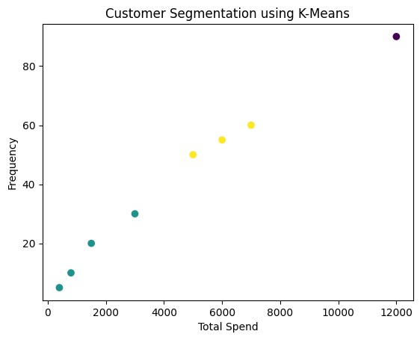

32.House Price Prediction using Linear Regression (Bivariate) Program:-
import pandas as pd import numpy as np import matplotlib.pyplot as plt from sklearn.linear_model import LinearRegression from sklearn.metrics import mean_squared_error, r2_score
# Sample data: size (sq.ft) and price data = {
"size": [800, 1000, 1200, 1500, 1800, 2000],
"price": [150000, 180000, 210000, 250000, 280000, 300000]
} df = pd.DataFrame(data)
# Bivariate analysis: scatter plot plt.scatter(df["size"], df["price"]) plt.xlabel("House Size (sq.ft)") plt.ylabel("Price") plt.title("House Size vs Price") plt.show()
# Prepare data
X = df[["size"]] # feature matrix y = df["price"] # target # Build model model = LinearRegression() model.fit(X, y) # Predictions y_pred = model.predict(X)
# Evaluation mse = mean_squared_error(y, y_pred) r2 = r2_score(y, y_pred) print("Coefficient (slope):", model.coef_[0]) print("Intercept:", model.intercept_) print("Mean Squared Error:", mse) print("R² Score:", r2)

Output:-
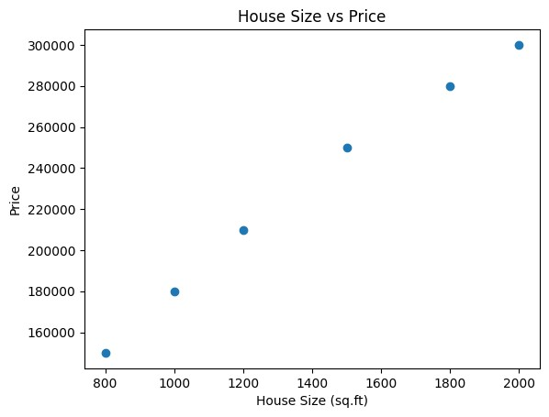
Coefficient (slope): 124.80857580398164
Intercept: 55681.47013782541
Mean Squared Error: 21694742.2154161
R² Score: 0.9923803832219026

33.Car Price Prediction using Multiple Linear Regression Program:-
import pandas as pd from sklearn.linear_model import LinearRegression from sklearn.metrics import mean_squared_error, r2_score
# Sample car data data = {
"engine_size": [1.2, 1.5, 2.0, 2.5, 3.0],
"horsepower": [80, 100, 130, 160, 200],
"fuel_eff": [18, 17, 15, 13, 11], # kmpl
"price": [600000, 750000, 900000, 1200000, 1500000]} df = pd.DataFrame(data)
# Features and target
X = df[["engine_size", "horsepower", "fuel_eff"]] y = df["price"] # Build model model = LinearRegression() model.fit(X, y) # Predictions y_pred = model.predict(X)
# Evaluation mse = mean_squared_error(y, y_pred) r2 = r2_score(y, y_pred) print("Coefficients:", model.coef_) print("Intercept:", model.intercept_) print("Mean Squared Error:", mse) print("R² Score:", r2)

Output:-
Coefficients: [-750000. 10000. -150000.]
Intercept: 3399999.9999999986
Mean Squared Error: 750000000.0
R² Score: 0.992816091954023

34.Treatment Outcome Classification using KNN Program:-
import pandas as pd from sklearn.model_selection import train_test_split from sklearn.neighbors import KNeighborsClassifier from sklearn.metrics import accuracy_score, precision_score, recall_score, f1_score
# Sample medical data data = {
"age": [30, 45, 50, 35, 60, 55, 40, 65],
"bp": [120,130,140,125,150,145,135,155], # blood pressure
"chol":[180,200,220,190,240,230,210,250], # cholesterol
"outcome": ["Good","Bad","Bad","Good","Bad","Bad","Good","Bad"]} df = pd.DataFrame(data) X = df[["age","bp","chol"]] y = df["outcome"]
# Train-test split
X_train, X_test, y_train, y_test = train_test_split(
X, y, test_size=0.25, random_state=0)
# KNN model knn = KNeighborsClassifier(n_neighbors=3) knn.fit(X_train, y_train)
# Predictions y_pred = knn.predict(X_test)
# Evaluation accuracy = accuracy_score(y_test, y_pred) precision = precision_score(y_test, y_pred, pos_label="Good") recall = recall_score(y_test, y_pred, pos_label="Good") f1 = f1_score(y_test, y_pred, pos_label="Good") print("Predictions:", y_pred) print("True labels:", list(y_test)) print("Accuracy:", accuracy) print("Precision:", precision) print("Recall:", recall) print("F1-Score:", f1)

Output:-
Predictions: ['Bad' 'Bad']
True labels: ['Good', 'Bad']
Accuracy: 0.5
Precision: 0.0 Recall: 0.0
F1-Score: 0.0

35.Customer Segmentation using K-Means (Retail Store Data) Program:-
import pandas as pd from sklearn.cluster import KMeans from sklearn.preprocessing import StandardScaler import matplotlib.pyplot as plt # Sample retail customer data data = {
"customer_id": [1,2,3,4,5,6,7,8,9,10],
"total_spent": [1000, 2000, 500, 7000, 8000, 1200, 300, 4500, 6000, 900],
"visit_frequency": [5, 10, 3, 25, 30, 7, 2, 18, 22, 4]} df = pd.DataFrame(data)
X = df[["total_spent", "visit_frequency"]]
# Scale features scaler = StandardScaler()
X_scaled = scaler.fit_transform(X)
# K-Means clustering kmeans = KMeans(n_clusters=3, random_state=0) df["cluster"] = kmeans.fit_predict(X_scaled) print("Customer segments:") print(df[["customer_id","total_spent","visit_frequency","cluster"]])
# Visualization plt.scatter(df["total_spent"], df["visit_frequency"], c=df["cluster"]) plt.xlabel("Total Spent") plt.ylabel("Visit Frequency") plt.title("Customer Segmentation using K-Means") plt.show()

Output:-
Customer segments:
customer_id total_spent visit_frequency cluster
- 1 1000 5 0
- 2 2000 10 0
- 3 500 3 0
- 4 7000 25 1
- 5 8000 30 1
- 6 1200 7 0
- 7 300 2 0
- 8 4500 18 2
- 9 6000 22 2
- 10 900 4 0
