36. Analysis of Stock Price Variability Program:-
import pandas as pd import csv
# Create a dummy stock_data.csv file for demonstration with open('stock_data.csv', 'w', newline='') as f:
writer = csv.writer(f) writer.writerow(['Date', 'Close']) writer.writerow(['2023-01-01', 100.0]) writer.writerow(['2023-01-02', 102.5]) writer.writerow(['2023-01-03', 101.8]) writer.writerow(['2023-01-04', 103.2]) writer.writerow(['2023-01-05', 104.0])
# Read stock data from CSV # CSV columns: Date, Close df = pd.read_csv("stock_data.csv") # Ensure Date is parsed as datetime (optional) df["Date"] = pd.to_datetime(df["Date"])
# Basic statistics mean_price = df["Close"].mean() std_price = df["Close"].std() min_price = df["Close"].min() max_price = df["Close"].max() price_range = max_price - min_price print("Average closing price:", mean_price) print("Standard deviation (variability):", std_price) print("Minimum closing price:", min_price) print("Maximum closing price:", max_price) print("Price range:", price_range)
Average closing price: 102.3
Standard deviation (variability): 1.5231546211727824
Minimum closing price: 100.0
Maximum closing price: 104.0
Price range: 4.0

37. Correlation Between Study Time and Exam Scores Program:-
import pandas as pd import matplotlib.pyplot as plt

# Sample data data = {
"study_time": [1, 2, 3, 4, 5, 6, 7, 8],
"score": [35, 45, 50, 60, 65, 75, 80, 90]
} df = pd.DataFrame(data)

# Correlation corr = df["study_time"].corr(df["score"]) print("Correlation between study time and score:", corr)
# Scatter plot plt.scatter(df["study_time"], df["score"]) plt.xlabel("Study Time (hours)") plt.ylabel("Exam Score") plt.title("Study Time vs Exam Score") plt.grid(True) plt.show()

Correlation between study time and score: 0.9975674982216793
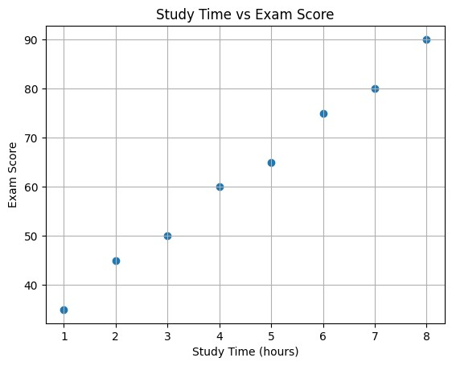

38. Temperature Variability Analysis for Different Cities Program:-
import pandas as pd
# Example: read from CSV (city, date, temperature)
# df = pd.read_csv("temperature_data.csv")
# Sample data for demo data = {
"City": ["CityA","CityA","CityA","CityB","CityB","CityB","CityC","CityC","CityC"],
"Temperature": [30, 32, 31, 25, 27, 29, 35, 36, 34]
} df = pd.DataFrame(data) # Group by city grouped = df.groupby("City")["Temperature"] mean_temp = grouped.mean() std_temp = grouped.std() max_temp = grouped.max() min_temp = grouped.min() temp_range = max_temp - min_temp print("Mean temperature:\n", mean_temp) print("\nStandard deviation:\n", std_temp) print("\nTemperature range:\n", temp_range) # City with highest temperature range city_highest_range = temp_range.idxmax() # City with most consistent temperature (lowest std) city_most_consistent = std_temp.idxmin() print("\nCity with highest temperature range:", city_highest_range) print("City with most consistent temperature:", city_most_consistent) Mean temperature:
City
CityA 31.0
CityB 27.0
CityC 35.0
Name: Temperature, dtype: float64
Standard deviation:
City
CityA 1.0
CityB 2.0
CityC 1.0
Name: Temperature, dtype: float64
Temperature range:
City
CityA 2
CityB 4
CityC 2
Name: Temperature, dtype: int64
City with highest temperature range: CityB
City with most consistent temperature: CityA

39. Customer Clustering using K-Means (Transaction Data) Program:-
import pandas as pd from sklearn.cluster import KMeans from sklearn.preprocessing import StandardScaler import matplotlib.pyplot as plt # Sample transaction data data = {
"customer_id": [1,2,3,4,5,6,7,8,9,10],
"total_amount_spent": [500, 2000, 150, 8000, 7000, 900, 300, 4500, 6000, 1000],
"num_items": [5, 20, 2, 50, 45, 8, 3, 30, 40, 10]
}

df = pd.DataFrame(data)
X = df[["total_amount_spent", "num_items"]]
# Scale the features scaler = StandardScaler()
X_scaled = scaler.fit_transform(X)
# K-Means clustering kmeans = KMeans(n_clusters=3, random_state=0) df["cluster"] = kmeans.fit_predict(X_scaled) print("Customer clusters:") print(df[["customer_id","total_amount_spent","num_items","cluster"]])
# Visualization plt.scatter(df["total_amount_spent"], df["num_items"], c=df["cluster"]) plt.xlabel("Total Amount Spent") plt.ylabel("Number of Items Purchased") plt.title("Customer Segmentation using K-Means") plt.show()
Customer clusters: customer_id total_amount_spent num_items cluster
- 1 500 5 0
- 2 2000 20 0
- 3 150 2 0
- 4 8000 50 1
- 5 7000 45 1
- 6 900 8 0
- 7 300 3 0
- 8 4500 30 2
- 9 6000 40 1
- 10 1000 10 0
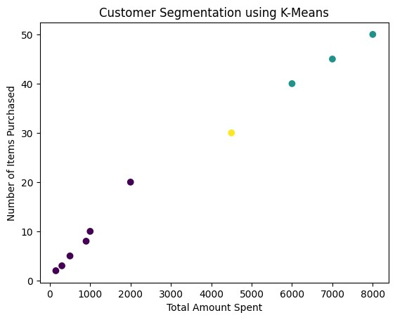

40. Soccer Players Data Analysis from CSV Program:-
import pandas as pd import matplotlib.pyplot as plt import csv
# Create a dummy players.csv file for demonstration with open('players.csv', 'w', newline='') as f:
writer = csv.writer(f) writer.writerow(['name', 'goals', 'salary', 'age', 'position']) writer.writerow(['Player A', 20, 1000000, 25, 'Forward']) writer.writerow(['Player B', 15, 800000, 28, 'Midfielder']) writer.writerow(['Player C', 22, 1200000, 24, 'Forward']) writer.writerow(['Player D', 10, 700000, 30, 'Defender']) writer.writerow(['Player E', 5, 500000, 32, 'Defender']) writer.writerow(['Player F', 18, 900000, 26, 'Midfielder']) writer.writerow(['Player G', 3, 400000, 35, 'Goalkeeper']) writer.writerow(['Player H', 25, 1500000, 23, 'Forward'])
# Read data from CSV file df = pd.read_csv("players.csv") # Top 5 players by goals top_goals = df.sort_values(by="goals", ascending=False).head(5) print("Top 5 players by goals:\n", top_goals)
# Top 5 players by salary top_salary = df.sort_values(by="salary", ascending=False).head(5) print("\nTop 5 players by salary:\n", top_salary)
# Average age avg_age = df["age"].mean() print("\nAverage age:", avg_age) Top 5 players by goals:
name goals salary age position
7 Player H 25 1500000 23 Forward
2 Player C 22 1200000 24 Forward
0 Player A 20 1000000 25 Forward
5 Player F 18 900000 26 Midfielder 1 Player B 15 800000 28 Midfielder Top 5 players by salary:
name goals salary age position
7 Player H 25 1500000 23 Forward
2 Player C 22 1200000 24 Forward
0 Player A 20 1000000 25 Forward
5 Player F 18 900000 26 Midfielder
1 Player B 15 800000 28 Midfielder
Average age: 27.875
Players above average age:
name goals salary age position
1 Player B 15 800000 28 Midfielder
- Player D 10 700000 30 Defender
- Player E 5 500000 32 Defender 6 Player G 3 400000 35 Goalkeeper
Distribution of players by position:
position
Forward 3
Midfielder 2
Defender 2
Goalkeeper 1
Name: count, dtype: int64

