Technical Story Card

Revision History

|  |  |  |  |
| --- | --- | --- | --- |
| Version No. | Date | Prepared by / Modified by | Significant Changes |
| 1 |  | Jeevan |  |
|  |  | Venkatash  Hema  Bala Krishna  Sai Pranay |  |

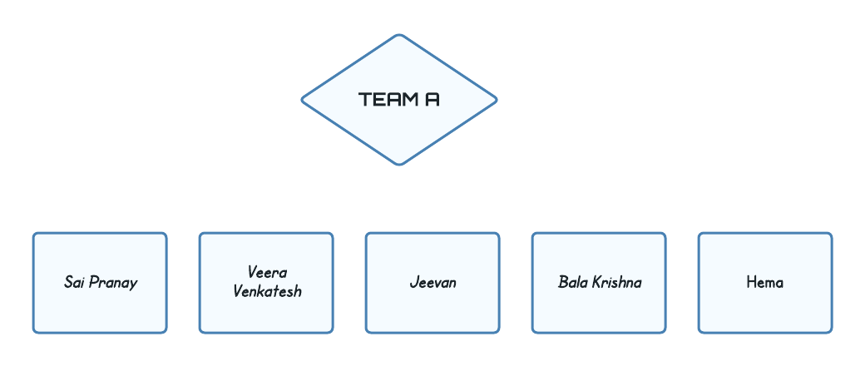

Table of Contents

1 Introduction 1

1.1 Project Overview

2 Scope of Change 2

3 List of modules 3

4 Design and Detailed technical updates 4

4.1 Process model 4

4.1.1 Use case Model 4

4.1.2 Sequence diagram 4

4.2 Proposed user Interface design 4

4.3 Database design changes 4

5 Other Technical changes 5

5.1 Non-functional related changes 5

6 References 6

# Introduction

The aim of this is online shopping application is to benefit the users to buy and manage their products securely with our website. This project is developed using HTML, JAVA script, CSS, Bootstrap, Node.js and mongodb. This application is very useful where the buyer can directly buy the products from home via internet on mobile or system. This application reduces lot of work load for customer as well as owner. The transaction of money is completed in real time system.

# 1.1 Project Overview

The central concept of the application is to allow the customer to shop virtually using the Internet and allow customers to buy the items and articles of their desire from the store. The information pertaining to the products are stores on an RDBMS at the server side (store).

The Server process the customers and the items are shipped to the address submitted by them. The application was designed into two modules first is for the customers who wish to buy the articles. Second is for the storekeepers who maintains and updates the information pertaining to the articles and those of the customers. The end user of this product is a departmental store where the application is hosted on the web and the administrator maintains the database. The application which is deployed at the customer database, the details of the items are brought forward from the database for the customer view based on the selection through the menu and the database of all the products are updated at the end of each transaction. Data entry into the application can be done through various screens designed for various levels of users. Once the authorized personnel feed the relevant data into the system, several reports could be generated as per the security

# Scope of Change

The system recommends a facility to accept the orders 24*7 and a home delivery system which can make customers happy. If shops are providing an online portal where their customers can enjoy easy shopping from anywhere, the shops won’t be losing any more customers to the trending online shops. Since the application is available in the Smartphone it is easily accessible and always available.

* Friendly User Interface
* Providing Security
* Low cost
* Configurable and extensible application UI design

By **analyzing**, the present scenario it is very certain and clear that Online Shopping has a great scope as in past few years, the rate of shopping and prompt delivery of goods over internet has rapidly increased. People now prefer to shop online due to its features and wide range of varieties.

# List of impacted modules

There are modules in this application

* Admin
* Customer Login
* Category
* Product
* Security and authentication

**Admin:**

* The website administrator has full control of the website.
* The admin module contains user’s details and category entry, sub-category entry and Product.

**Customer Login:**

The customer module contains information about the products and offers and the price of the products. Before that the customer has to register in this application for this registration form is developed the new users must register and can continue the shopping.

**Category:**

The Category module will store and maintains details of the categories by products which could be differentiated so that it is easier to see the product

**Product:**

This module will stores and maintains the details of the products along with their price, description and image

**Security and Authentication:**

The security and authentication module contains about access privileges to customers and employees for various operations. The security is very important for online transactions to done.

# Design and Detailed technical updates

## Process model

### Use case Model

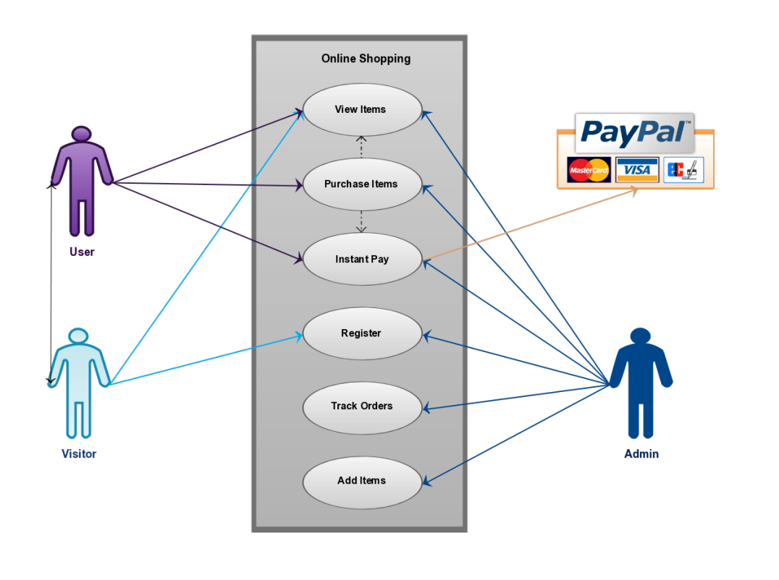

|  |  |
| --- | --- |
| Brief Description | Customer Registration (sign-up) |
| Basic Flow | This use case describes how a customer register in to the system   1. The customer has to register himself into the system. 2. After the successful registration, customer will get a success message. 3. The following information is required during registration.  * Name * Mobile Number * E mail * Password |
| Alternate Flow | 1. The system will validate the information provided. If any invalid data is found, the input form will be redirected with error message. |
| Validation | 1. Name is required and minimum 3 characters and max 30 characters. 2. The Email should be valid. 3. Password should be alphanumeric with valid specifications. |
| Pre-Conditions | User should have network access and Browser with latest updates. |
| Post-Conditions | Success message should be shown. |

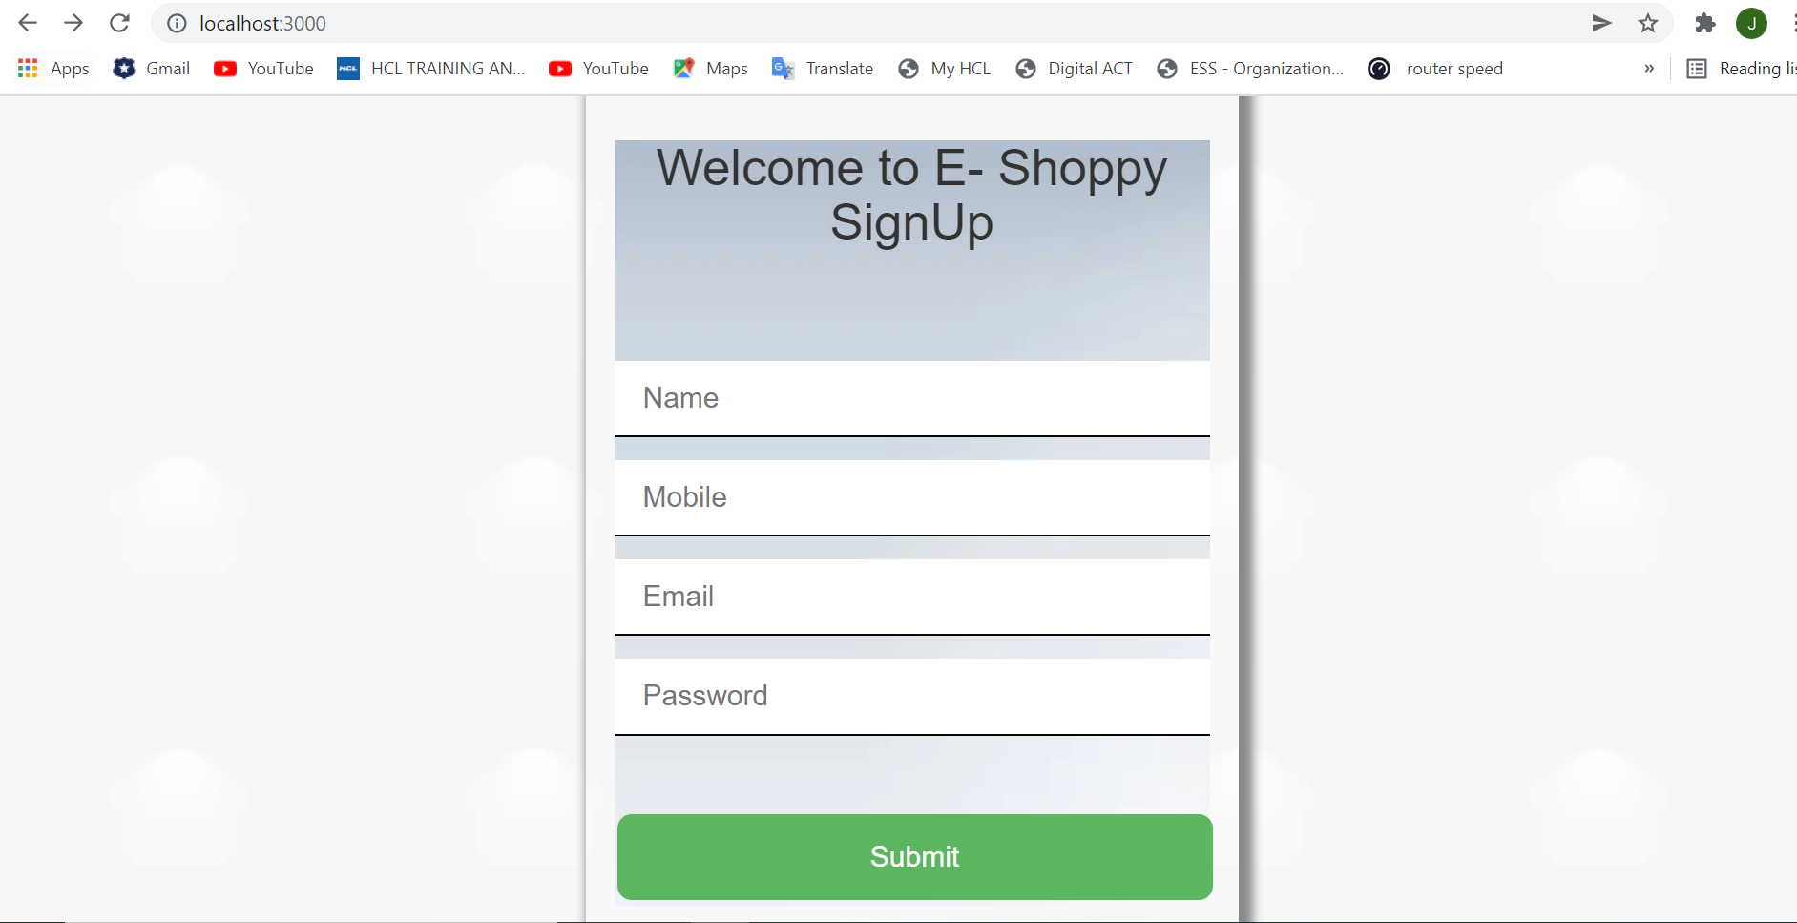

|  |  |
| --- | --- |
| Brief Description | Customer Log In |
| Basic Flow | This use case describes how a user log-in in to the system   1. The user has to register himself into the system. 2. After the successful login, user will be taken to the appropriate landing page. 3. The following information is required to login.  * Email * Password |
| Alternate Flow | 1. The system will validate the information provided. If any invalid data is found, the input form will be redirected with error message. |
| Validation | 1. Valid Email 2. Valid Password |
| Pre-Conditions | User should have network access and Browser with latest updates. |
| Post-Conditions | Success message should be shown. |

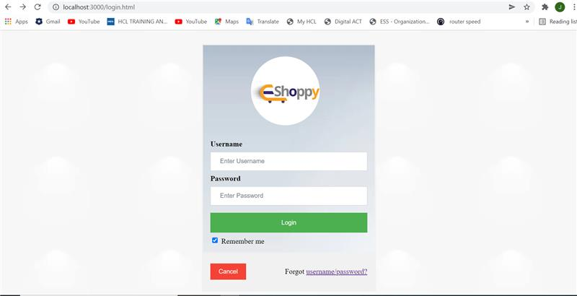

|  |  |
| --- | --- |
| Brief Description | Home Page |
| Basic Flow | This use case describes how the homepage looks like  1. The user can see our features.  2. He/she can click on the products which they want to order.  3. After the successful login, user will be taken to the appropriate landing page.  4. The following has to be done to move into the home page.   * Sign-Up * Log-In   5.User can able to see reviews, products and categories. |
| Pre-Conditions | User should have already logged into the system. |
| Post-Conditions | Success message should be shown. |

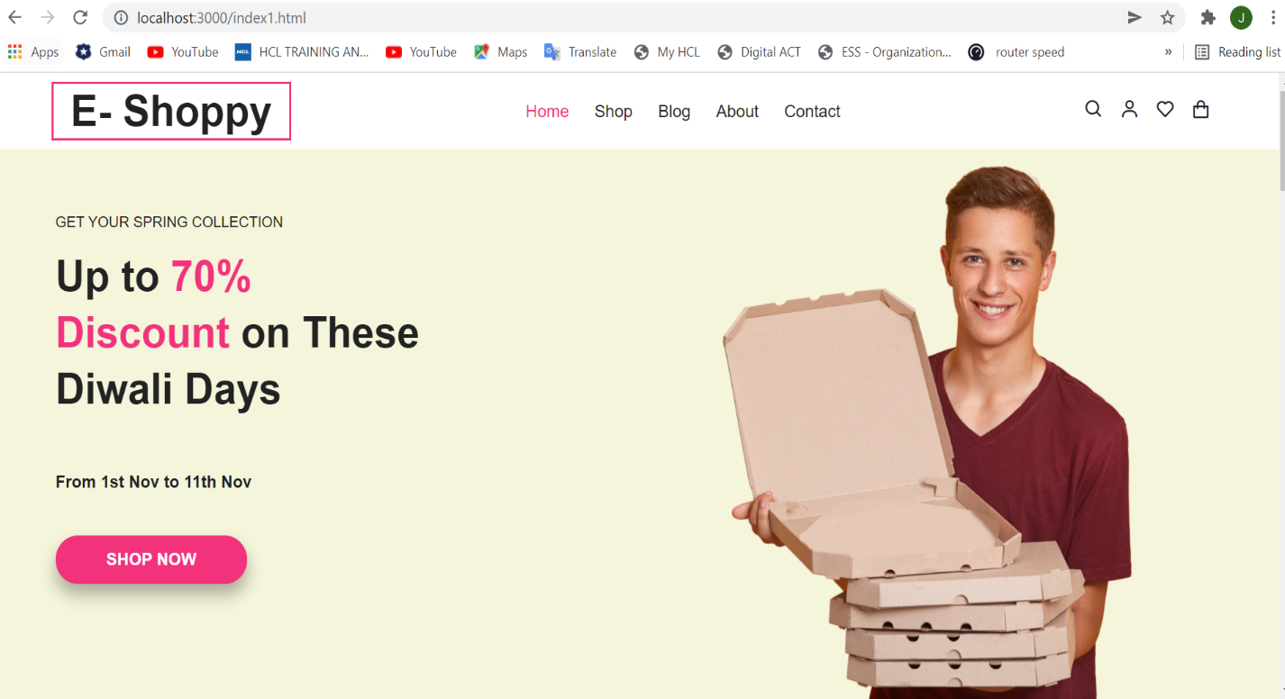

**Architecture Diagram**

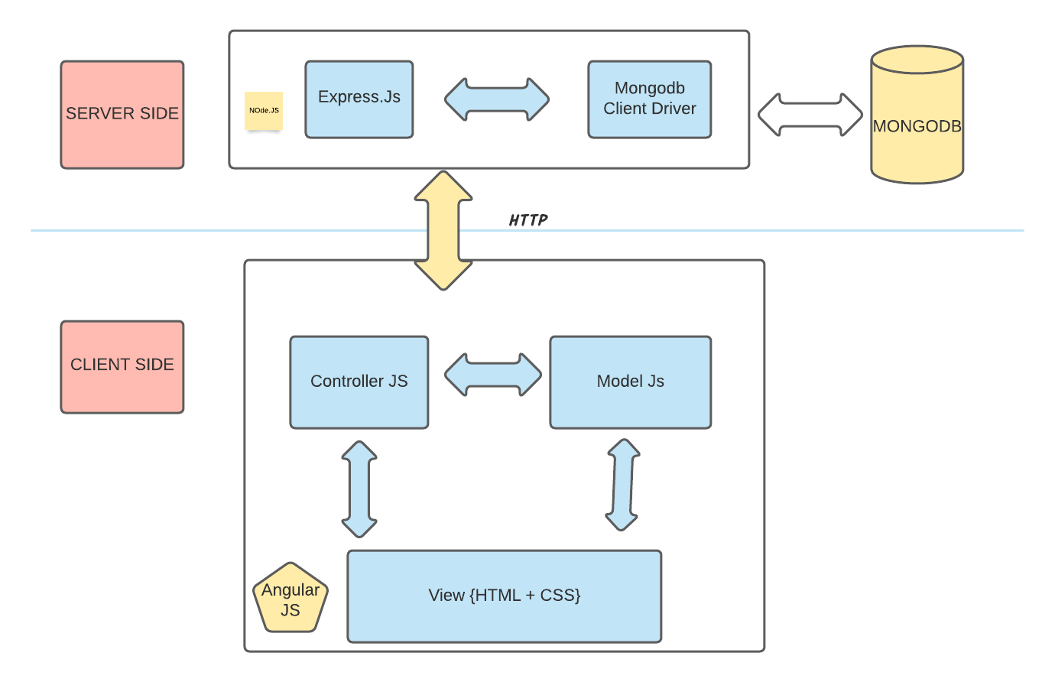

Proposed System:

In the proposed system customer need not go to the shop for buying the products. He can order the product he wish to buy through the application in his Smartphone. The shop owner will be admin of the system. Shop owner can appoint moderators who will help owner in managing the customers and product orders. The system also recommends a home delivery system for the purchased products.

* Secure registration and profile management facilities for Customers.
* Browsing through the E - Shoppy to see the items that are there in each category of products like Electronics, Men’s Fashion, Women’s Fashion, Home Appliances etc.
* Creating a Shopping cart so that customer can Shop no. of items and checkout finally with the entire shopping cart
* Customers should be able to mail the Shop about the items they would like to see in the Shop
* Secured mechanism for checking out from the Shop (Credit card verification mechanism)
* Updates to customers about the Recent Items in the Shop.
* Uploading ‘Most Purchased’ Items in each category of products in the Shop like Electronics, Men’s Fashion, Women’s Fashion, Home Appliances etc.

### Sequence diagram

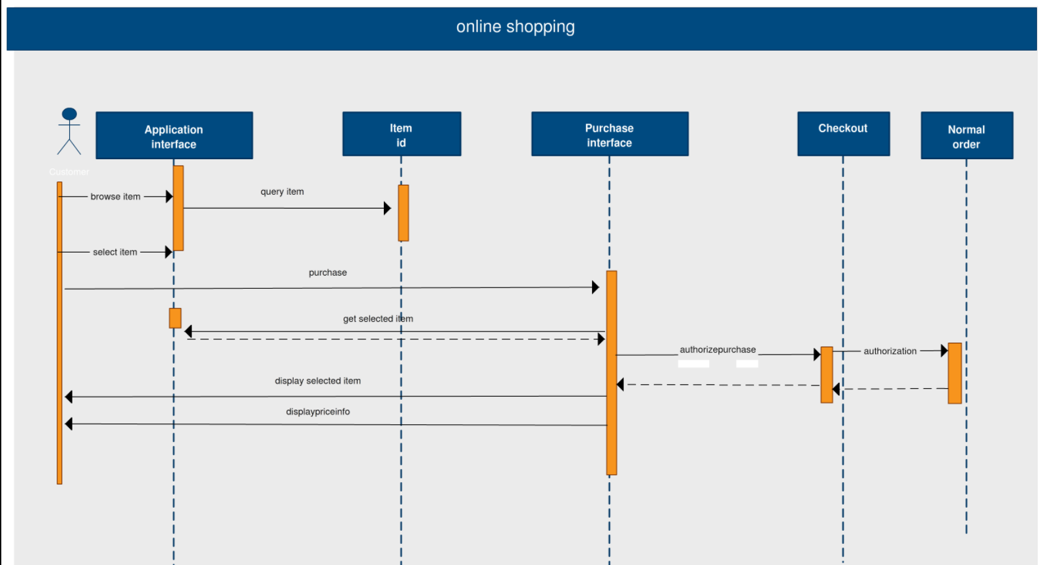

## User Interface design

## 

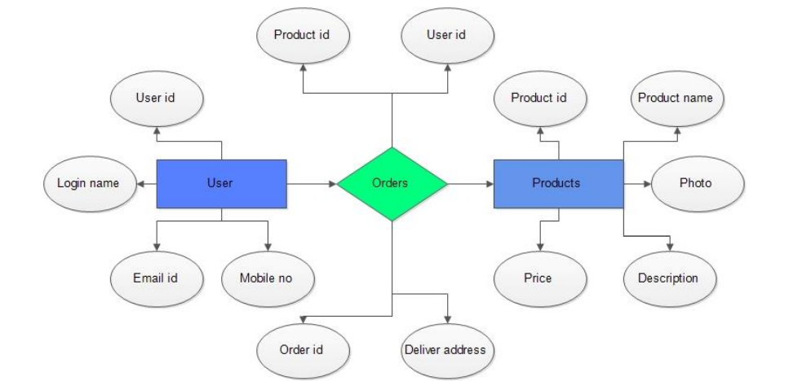

## Database Design

Databases are the storehouses of data used in the software systems. The data is stored in tables inside the database. Several tables are created for the manipulation of the data for the system. Two essential settings for a database are

* Primary Key - the field that is unique for all the record occurrences.
* Foreign Key - the field used to set relation between tables.

Normalization is a technique to avoid redundancy in the tables.

## System Tools

The various system tools that have been used in developing both the front end and the back end of the project are being discussed in this chapter.

4.4.1. **FRONT END**: HTML, CSS, JAVA SCRIPT, BOOTSRAP are utilized to implement the frontend.

4.4.2. **BACK END:** The back end is implemented using MONGODb which is used to design the databases.

E-R Diagram

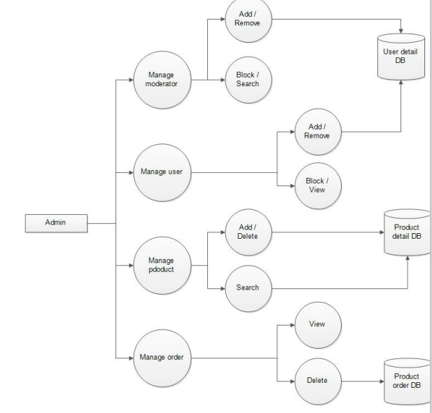

# Non-Functional/Operational Requirements

## Security

* Pages of the website must be access in the way they were intended to be accessed. Included files shall not be accessed outside of their parent file.
* Administrator can only perform administrative task on pages they are privileged to access. Customers will not be allowed to access the administrator pages.

## Efficiency and Maintainability

* Page loads should be returned and formatted in a timely fashion depending on the request being made.
* Administrators will have the ability to edit the aspects of the order forms, product descriptions, prices and website directly

# References

<http://www.w3schools.com/html/defualt.asp>

<http://www.w3schools.com/css/default.asp>

<http://www.w3schools.com/js/default.asp>

Architecture/ ER Diagram: Lucid visual collaboration suite