Introdution:

**Volleyball** is a [team sport](https://en.wikipedia.org/wiki/Team_sport) in which two teams of six players are separated by a net. Each team tries to score points by grounding a ball on the other team's court under organized rules. It has been a part of the official program of the [Summer Olympic Games](https://en.wikipedia.org/wiki/Summer_Olympic_Games) since [Tokyo 1964](https://en.wikipedia.org/wiki/1964_Summer_Olympics).

[Beach volleyball](https://en.wikipedia.org/wiki/Beach_volleyball) was introduced to the programme at the [Atlanta 1996](https://en.wikipedia.org/wiki/1996_Summer_Olympics). The adapted version of volleyball at the [Summer Paralympic Games](https://en.wikipedia.org/wiki/Summer_Paralympic_Games) is [sitting volleyball](https://en.wikipedia.org/wiki/Sitting_volleyball)

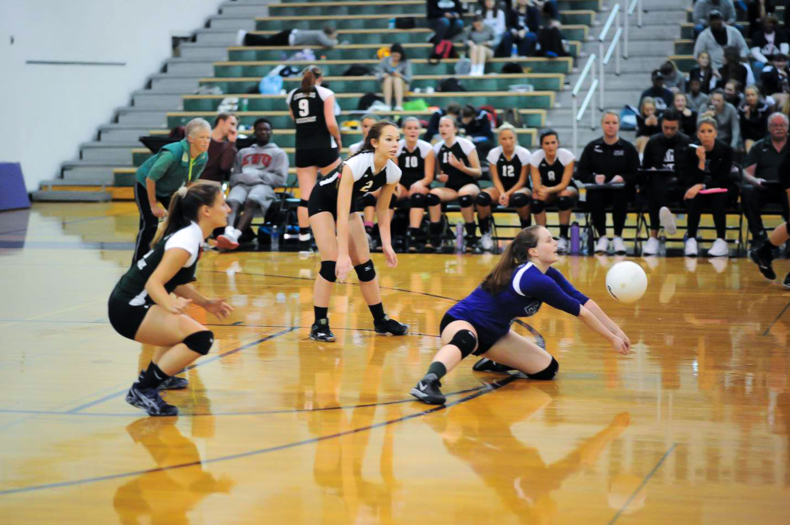

History:

In December 1895, in [Holyoke, Massachusetts](https://en.wikipedia.org/wiki/Holyoke,_Massachusetts) (United States), [William G. Morgan](https://en.wikipedia.org/wiki/William_G._Morgan), a [YMCA](https://en.wikipedia.org/wiki/YMCA) physical education director, created a new game called *Mintonette*, a name derived from the game of [badminton](https://en.wikipedia.org/wiki/Badminton), as a pastime to be played (preferably) indoors and by any number of players. The game took some of its characteristics from other sports such as baseball, [tennis](https://en.wikipedia.org/wiki/Tennis) and [handball](https://en.wikipedia.org/wiki/Team_handball). Another indoor sport, [basketball](https://en.wikipedia.org/wiki/Basketball), was catching on in the area, having been invented just ten miles (sixteen kilometres) away in the city of [Springfield, Massachusetts](https://en.wikipedia.org/wiki/Springfield,_Massachusetts), only four years before. Mintonette was designed to be an indoor sport, less rough than basketball, for older members of the YMCA, while still requiring a bit of athletic effort.

## Rules of the game:

## 

## The court dimensions:

## A volleyball court is 9 m × 18 m (29.5 ft × 59.1 ft), divided into equal square halves by a net with a width of one meter (39.4 in). The top of the net is 2.43 m (7 ft 11+11⁄16 in) above the center of the court for men's competition, and 2.24 m (7 ft 4+3⁄16 in) for women's competition, varied for veterans and junior competitions. The minimum height clearance for indoor volleyball courts is 7 m (23.0 ft), although a clearance of 8 m (26.2 ft) is recommended. A line 3 m (9.8 ft) from and parallel to the net is considered the "attack line". This "3 meter" (or "10-foot") line divides the court into "back row" and "front row" areas (also back court and front court). These are in turn divided into 3 areas each: these are numbered as follows, starting from area "1", which is the position of the serving player

## Volleyball - Wikipedia

### The ball:

[FIVB](https://en.wikipedia.org/wiki/FIVB" \o "FIVB) regulations state that the ball must be spherical, made of leather or synthetic leather, have a circumference of 65–67 cm (26–26 in), a weight of 260–280 g (9.2–9.9 oz) and an interior air pressure of 0.30–0.325 kg/cm2 (4.26 to 4.61 psi)(294.3 to 318.82 mbar or hPa). Other governing bodies have similar regulations.

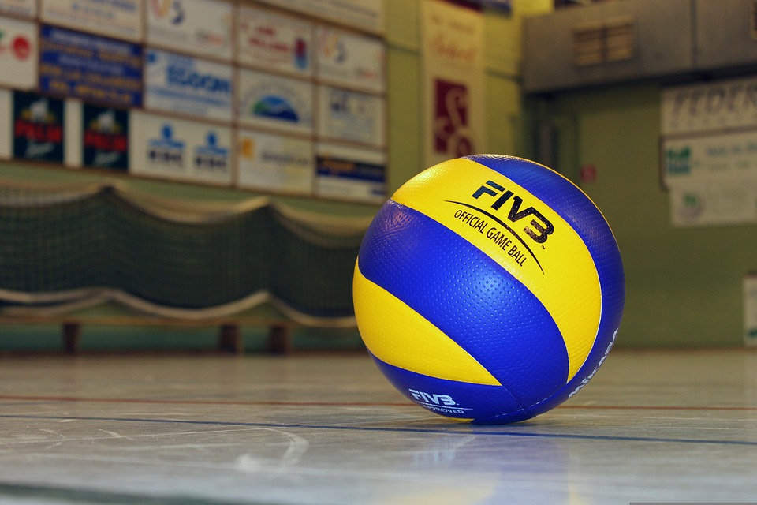



## 

### Gameplay:

Each team consists of six players. To get play started, a team is chosen to serve by [coin toss](https://en.wikipedia.org/wiki/Coin_toss). A player from the serving team throws the ball into the air and attempts to hit the ball so it passes over the net on a course such that it will land in the opposing team's court (the *serve*).

Each team consists of six players. To get play started, a team is chosen to serve by [coin toss](https://en.wikipedia.org/wiki/Coin_toss). A player from the serving team throws the ball into the air and attempts to hit the ball so it passes over the net on a course such that it will land in the opposing team's court (the *serve*).

The game continues in this manner, rallying back and forth until the ball touches the court within the boundaries or until an error is made. The most frequent errors that are made are either to fail to return the ball over the net within the allowed three touches, or to cause the ball to land outside the court.

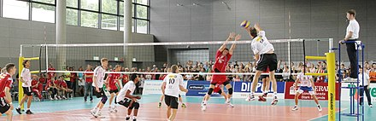

These contacts usually consist first of the *bump* or *pass* so that the ball's trajectory is aimed towards the player designated as the *setter*; second of the *set* (usually an over-hand pass using wrists to push finger-tips at the ball) by the setter so that the ball's trajectory is aimed towards a spot where one of the players designated as an *attacker* can hit it, and third by the *attacker* who *spikes* (jumping, raising one arm above the head and hitting the ball so it will move quickly down to the ground on the opponent's court) to return the ball over the net. The team with possession of the ball that is trying to attack the ball as described is said to be on *offence*.

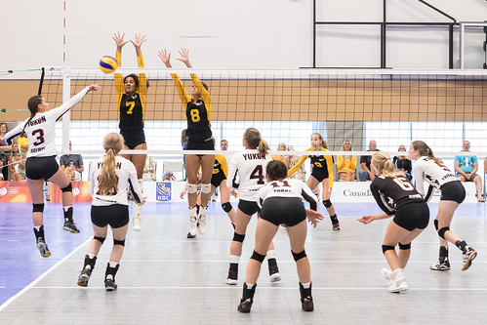

### Scoring:

The game continues, with the first team to score 25 points by a two-point margin awarded the set. Matches are best-of-five sets and the fifth set, if necessary, is usually played to 15 points. (Scoring differs between leagues, tournaments, and levels; high schools sometimes play best-of-three to 25; in the [NCAA](https://en.wikipedia.org/wiki/National_Collegiate_Athletic_Association) matches are played best-of-five to 25 as of the [2008](https://en.wikipedia.org/wiki/2008_NCAA_Division_I_Women%27s_Volleyball_Tournament) season.)

Before 1999, points could be scored only when a team had the serve (*side-out scoring*) and all sets went up to only 15 points. The FIVB changed the rules in 1999 (with the changes being compulsory in 2000) to use the current scoring system (formerly known as *rally point system*), primarily to make the length of the match more predictable and to make the game more spectator- and television-friendly.

The final year of side-out scoring at the [NCAA Division I Women's Volleyball Championship](https://en.wikipedia.org/wiki/NCAA_Division_I_Women%27s_Volleyball_Championship) was [2000](https://en.wikipedia.org/wiki/2000_NCAA_Division_I_Women%27s_Volleyball_Tournament). Rally point scoring debuted in [2001](https://en.wikipedia.org/wiki/2001_NCAA_Division_I_Women%27s_Volleyball_Tournament), and games were played to 30 points through [2007](https://en.wikipedia.org/wiki/2007_NCAA_Division_I_Women%27s_Volleyball_Tournament). For the [2008](https://en.wikipedia.org/wiki/2008_NCAA_Division_I_Women%27s_Volleyball_Tournament) season, games were renamed "sets" and reduced to 25 points to win. Most high schools in the U.S. changed to rally scoring in 2003, and several states implemented it the previous year on an experimental basis.

### Recent rule changes:

Other rule changes enacted in 2000 include allowing serves in which the ball touches the net, as long as it goes over the net into the opponents' court. Also, the service area was expanded to allow players to serve from anywhere behind the end line but still within the theoretical extension of the sidelines. Other changes were made to lighten up calls on faults for carries and double-touches, such as allowing multiple contacts by a single player ("double-hits") on a team's first contact provided that they are a part of a single play on the ball.

In 2008, the NCAA changed the minimum number of points needed to win any of the first four sets from 30 to 25 for women's volleyball (men's volleyball remained at 30 for another three years, switching to 25 in 2011). If a fifth (deciding) set is reached, the minimum required score remains at 15. In addition, the word "game" is now referred to as "set".

## Skills:

## Serve:

## A player stands behind the inline and serves the ball, in an attempt to drive it into the opponent's court. The main objective is to make it land inside the court; it is also desirable to set the ball's direction, speed and acceleration so that it becomes difficult for the receiver to handle it properly. A serve is called an "ace" when the ball lands directly onto the court or travels outside the court after being touched by an opponent; when the only player on the server's team to touch the ball is the server.

## In contemporary volleyball, many types of serves are employed:

## Underhand.

## Sky ball serve.

## Topspin.

## [Float](https://en.wikipedia.org/wiki/Volleyball_float_serve" \o "Volleyball float serve).

## Jump serve.

## Jump float

## Décomposition d’un service au volley-ball | Décomposition d’… | Flickr

## Pass:

## Also called reception, the pass is the attempt by a team to properly handle the opponent's serve or any form of attack. Proper handling includes not only preventing the ball from touching the court but also making it reach the position where the setter is standing quickly and precisely.

## The skill of passing involves fundamentally two specific techniques: underarm pass, or bump, where the ball touches the inside part of the joined forearms or platform, at waistline; and overhand pass, where it is handled with the fingertips, like a set, above the head. Either are acceptable in professional and [beach volleyball](https://en.wikipedia.org/wiki/Beach_volleyball); however, there are much tighter regulations on the overhand pass in beach volleyball. When a player passes a ball to their setter, it's ideal that the ball does not have a lot of spin to make it easier for the setter.

## Womens Volleyball vs Robert Morris-Springfield 10-26-10 | Flickr

### Set:

The set is usually the second contact that a team makes with the ball. The main goal of setting is to put the ball in the air in such a way that it can be driven by an attack into the opponent's court. The setter coordinates the offensive movements of a team, and is the player who ultimately decides which player will actually attack the ball.

As with passing, one may distinguish between an overhand and a bump set. Since the former allows for more control over the speed and direction of the ball, the bump is used only when the ball is so low it cannot be properly handled with fingertips, or in beach volleyball where rules regulating overhand setting are more stringent.

There is also a jump set that is used when the ball is too close to the net. In this case, the setter usually jumps off their right foot straight up to avoid going into the net. The setter usually stands about ⅔ of the way from the left to the right of the net and faces the left (the larger portion of net that he or she can see).

Sometimes a setter refrains from raising the ball for a teammate to perform an attack and tries to play it directly onto the opponent's court. This movement is called a "dump".The most common dumps are to 'throw' the ball behind the setter or in front of the setter to zones 2 and 4. More experienced setters toss the ball into the deep corners or spike the ball on the second hit.



## 

## Attack:

## The attack, also known as the *spike*, is usually the third contact a team makes with the ball. The object of attacking is to handle the ball so that it lands on the opponent's court and cannot be defended. A player makes a series of steps (the "approach"), jumps, and swings at the ball.

## Contemporary volleyball comprises a number of attacking techniques:

## Backcourt (or back row)

## Line and Cross-court Shot

## Dip/Dink/Tip/Cheat/Dump

## Tool/Wipe/Block-abuse

## Quick hit/"One

## Slide

## Double quick hit/"Stack"/"Tandem"

## Galerie media | Sitting Volleyball România

## Block:

## Blocking refers to the actions taken by players standing at the net to stop or alter an opponent's attack.

## A block that is aimed at completely stopping an attack, thus making the ball remain in the opponent's court, is called offensive. A well-executed offensive block is performed by jumping and reaching to penetrate with one's arms and hands over the net and into the opponent's area. It requires anticipating the direction the ball will go once the attack takes place. It may also require calculating the best footwork to executing the "perfect" block.

## Blocking is also classified according to the number of players involved. Thus, one may speak of single (or solo), double, or triple block.

## Successful blocking does not always result in a "roof" and many times does not even touch the ball. While it is obvious that a block was a success when the attacker is roofed, a block that consistently forces the attacker away from their 'power' or preferred attack into a more easily controlled shot by the defence is also a highly successful block.

## File:Volleyball block.jpg - Wikimedia Commons

## Dig:

## Digging is the ability to prevent the ball from touching one's court after a spike or attack, particularly a ball that is nearly touching the ground. In many aspects, this skill is similar to passing, or bumping: overhand dig and bump are also used to distinguish between defensive actions taken with fingertips or with joined arms. It varies from passing however in that is it a much more reflex based skill, especially at the higher levels. It is especially important while digging for players to stay on their toes; several players choose to employ a split step to make sure they're ready to move in any direction.

## Double Dig | traveljapanblog.com/ashland/tag/volleyball/ | Al Case | Flickr

## Formations:

## Volleyball – Klexikon - Das Freie Kinderlexikon

## The three standard volleyball formations are known as "4–2", "6–2" and "5–1", which refers to the number of hitters and setters respectively. 4–2 is a basic formation used only in beginners' play, while 5–1 is by far the most common formation in high-level play.

## 4–2:

## The 4–2 formation has four hitters and two setters. The setters usually set from the middle front or right front position. The team will, therefore, have two front-row attackers at all times. In the international 4–2, the setters set from the right front position. The international 4–2 translates more easily into other forms of offence.

## 6–2:

## In the 6–2 formation, a player always comes forward from the back row to set. The three front row players are all in attacking positions. Thus, all six players act as hitters at one time or another, while two can act as setters. So the 6–2 formation is actually a 4–2 system, but the back-row setter penetrates to set.

## 5–1:

## The 5–1 formation has only one player who assumes setting responsibilities regardless of their position in the rotation. The team will, therefore, have three front-row attackers when the setter is in the back row and only two when the setter is in the front row, for a total of five possible attackers.

## Strategy:

## Player specialization:

## Response Time, Visual Search Strategy, and Anticipatory Skills in ...

## There are five positions filled on every volleyball team at the elite level. Setter, Outside Hitter/Left Side Hitter, Middle Hitter, Opposite Hitter/Right Side Hitter and Libero/Defensive Specialist. Each of these positions plays a specific, key role in winning a volleyball match.

## Setters

## Liberos

## Outside hitters or Left side hitters

## Opposite hitters or Right-side hitters

## At some levels where substitutions are unlimited, teams will make use of a Defensive Specialist in place of or in addition to a Libero. This position does not have unique rules like the libero position, instead, these players are used to substitute out a poor back row defender using regular substitution rules.

## Controversies:

## In 2017, a new volleyball players' union was formed in response to dissatisfaction with the organization and structure of professional beach volleyball tournaments. The union is named the International Beach Volleyball Players Association, and it consists of almost 100 professional players. The IBVPA claims its goal is to help athletes and provide them with the means to enjoy playing volleyball by improving the way the sport is run.

## Variations and related games:

## Beachball volleyball

## [Biribol](https://en.wikipedia.org/wiki/Biribol)

## [Ecua-volley](https://en.wikipedia.org/wiki/Ecua-volley)

## [Footvolley](https://en.wikipedia.org/wiki/Footvolley)

## [Handball](https://en.wikipedia.org/wiki/Handball)

## [Hooverball](https://en.wikipedia.org/wiki/Hooverball)

## [Newcomb ball](https://en.wikipedia.org/wiki/Newcomb_ball) (sometimes spelled "Nuke 'Em")

## [Sepak Takraw](https://en.wikipedia.org/wiki/Sepak_Takraw)

## [Snow volleyball](https://en.wikipedia.org/wiki/Snow_volleyball)

## [Throwball](https://en.wikipedia.org/wiki/Throwball)

## [Towel volleyball](https://en.wikipedia.org/w/index.php?title=Towel_volleyball&action=edit&redlink=1)

## [Wallyball](https://en.wikipedia.org/wiki/Wallyball)

## [9-man](https://en.wikipedia.org/wiki/9-man)