**ON**

**LABORTARY MANAGEMENT SYSTEM**

**INDEX**

1. Introduction to Project
2. Abstract of the project
3. System Analysis
4. Hardware/ Software Requirements
5. Feasibility Study
6. Software Requirement Specifications
7. Project Planning
8. Project Scheduling (20 Days)
9. Flow Chart
10. Modules
11. Coding
12. Database Tables
13. Output Screens

**Introduction to Project**

**Project Overview:**

The purpose of this project is to provide the services in blood lab where our body tests has to be done in an effective and efficient manner

Laboratory management systems belong to the class of application software intended for storage and management of information obtained in the course of the work of the laboratory. The systems are used to control and manage samples, standards, test results, reports, laboratory staff, instruments, and work flow automation. Integration of laboratory information management systems with the enterprise’s information systems will make it possible to promptly transmit required data to the laboratory and the enterprise administration.

**Project Objectives:**

The basic objectives and tasks of industrial enterprises comprise the production of products of appropriate quality and achieving increased efficiency of the production process with least costs. Modern analytic laboratories that are part of enterprises (or are independent entities) constitute complex structures that perform their activities in accordance with standard documents from the quality control system, the principles of the appropriate laboratory (GLP, Good Laboratory Practice) and industrial practice and requirements imposed on testing laboratories. The efficient activity of a laboratory not only requires that the laboratory be equipped with modern physicochemical instruments, but also that it adopt automation principles to perform analytic studies. Analytic laboratories carry out a host of functions, including quality control of raw material, intermediate products, and finished products; metrological certification of measurement techniques; ecological management; routine inspection of measurement instruments; external and internal laboratory auditing; and many other functions. When considering the structure and functions of analytic laboratories, it becomes obvious that successful implementation of such multifaceted activity requires the use of information measurement and information management systems.

**Abstract of the project**

The Lab Management System (LMS) is designed for Any Lab to replace their existing manual, paper based system. The new system is to control the following information; patient information, room availability, staff and operating and patient invoices. These services are to be provided in an efficient, cost effective manner, with the goal of reducing the time and resources currently required for such tasks. A significant part of the operation of any Lab involves the acquisition, management and timely retrieval of great volumes of information. This information typically involves; patient personal information and medical history, staff information, , staff scheduling and various facilities waiting lists. All of this information must be managed in an efficient and cost wise fashion so that an institution's resources may be effectively utilized LMS will automate the management of the Lab making it more efficient and error free. It aims at standardizing data, consolidating data ensuring data integrity and reducing inconsistencies. The basic objectives and tasks of industrial enterprises comprise the production of products of appropriate quality and achieving increased efficiency of the production process with least costs. Modern analytic laboratories that are part of enterprises constitute complex structures that perform their activities in accordance with standard documents from the quality control system, the principles of the appropriate laboratory and industrial practice and requirements imposed on testing laboratories.

**System Analysis**

1. **Existing System :**

Labs currently use a manual system for the management and maintenance of critical information. The current system requires numerous paper forms, with data stores spread throughout the lab management infrastructure. Often information (on forms) is incomplete, or does not follow management standards. Forms are often lost in transit between departments requiring a comprehensive auditing process to ensure that no vital information is lost. Multiple copies of the same information exist in the Lab and may lead to inconsistencies in data in various data stores.

1. **Proposed System:**

The Lab Management System is designed for Any Lab to replace their existing manual, paper based system. The new system is to control the following information; patient information and patient invoices. These services are to be provided in an efficient, cost effective manner, with the goal of reducing the time and resources currently required for such tasks.

**Hardware/Software Requirements**

**System Specifications Minimum Hardware Requirements:-**

* Pentium-IV(Processor).
* 4 GB Ram
* Hard disk 500 GB
* Microsoft Compatible 101 or more Key Board Software Requirements: -

**Operating System** :

* Windows 7 , 10
* Programming language: .NET
* Web-Technology: ASP.NET 4.5
* Front-End: ASP.NET MVC
* Back-End: SQL SERVER
* Web Server: IIS

If system, which is going to be developed, is complex in nature the goals of the entire system could not be easily comprehended. Hence the need for a more rigorous system analysis phase arose.

**Feasibility Study**

Feasibility study is conducted once the problem is clearly understood. Feasibility study is a high level capsule version of the entire system analysis and design process. The objective is to determine quickly at a minimum expense how to solve a problem. The purpose of feasibility is not to solve the problem but to determine if the problem is worth solving. The system has been tested for feasibility in the following points.

1. Technical Feasibility

2. Economical Feasibility

3. Operational Feasibility.

1. **Technical Feasibility:** The project entitles "Laboratory Management System” is technically feasibility because of the below mentioned feature. The project was developed in Asp.net MVC which is depending upon Model View Controller. It provides the high level of reliability, availability and compatibility. All these make Asp.net MVC an appropriate language for this project. Thus the existing software Asp.net MVC is a powerful language.
2. **Economical Feasibility:** The computerized system will help in automate the selection leading the profits and details of the organization. With this software, the machine and manpower utilization are expected to go up by 80-90% approximately. The costs incurred of not creating the system are set to be great, because precious time can be wanted by manually.
3. **Operational Feasibility:** In this project, the management will know the details of each project where he may be presented and the data will be maintained as decentralized and if any inquires for that particular contract can be known as per their requirements and necessaries.

**Software Requirement Specifications**

The Software Requirements Specification is produced at the culmination of the analysis task. SRS is a document that completely describes what the proposed software should do without describing how the software will do it. The basic limitation for this is that the user need keeps changing as environment in which the system was to function changes with time. This leads to a request for requirement changes even after the requirement phase is done and the SRS is produced. The function and performance allocated to software as part of System Engineering are refined by:

Establishing a complete information description of the System.

A detailed functional description.

A representation of System behavior .

An indication of performance requirements and design constraints. Appropriate validation criteria, & Other information pertinent to requirements.

**1. INTRODUCTION**

**1.1 PURPOSE**

The Software is for the automation of Lab Management. It maintains two levels of users:-

1. Administrator Level
2. Manager Level

**The Software includes:-**

1. Maintaining Patient details
2. Providing and maintaining all kinds of tests for a patient.
3. Billing and Invoice

**User Classes and Characteristics:** This software is used two types of end user. First is Administrator who has right to control this software. Administrator view complaints and mark the complaint to the person complaint, can also forward the complaint to the concerned person. User classes of system are as follows:

**Administrator:-**

Administrator is responsible for following activities:-

1. Test Management.
2. Sub Test Management.
3. Main Test Management.
4. Test Value Management.
5. Technologies Management.
6. Patient Management
7. Test Order Management
8. Billing

**Manager:-**

1. Patient Management
2. Test Order Management
3. Billing

Manager can add the records of patients and he can create the order and take the bills in our software. Though Administrator have all the right of all modules.

**Project Planning**

Project life cycle has three stages: -

Project Initiation –

I prepare the project plans and finalize the outcome of each phase. In this stage I also prepare the comprehensive list of tasks involved in each phase, and the project.

Project Execution – In this stage, I develop the product. This Stage consists of following phase:

• Requirement Analysis

• High Level Design

• Low Level Design

• Construction

• Testing

• Acceptance

Project Completion – In this stage, I have to update the site regularly. Each new item has to add by the administrator as according to the needs and demands. This stage is very important the freshness of the site. When any updating or up gradation is required for the website, I make the website up to date. There are lots of requirements after the completion of the Project. As this website is dynamic website in which lots of changes are required.

**Project Scheduling (20 Days)**

|  |  |
| --- | --- |
| **2nd july to 8th july** | **Feasibility Study** |
| **9th julyto 11th july** | **Requirement Gathering** |
| **12th july to 14th july** | **Designing** |
| **15th july to 18th july** | **Coding** |
| **19th july to 22th july** | **Testing and Implementation** |

**Flow Chart**

**Start**

**End**

**Mgr Modules**

**Modules**

**Admin**

**Manger**

**Login**

**MODULES**

1. **Test Management**
2. **Sub Test Management**
3. **Main Test Management**
4. **Test Value Management**
5. **Technologies Management**
6. **Patient Management**
7. **Test Order Management**
8. **Billing**
9. **Role Management**
10. **Identity Use provided by asp**

**Coding Part**

**Controllers in my App:-**

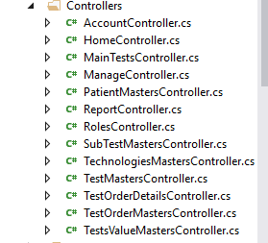

**Controller Coding**

1. **TestMasters Controller:-**

In this controller I have added the index, details, Create, Edit and Delete Methods for working on the Tests of humans.

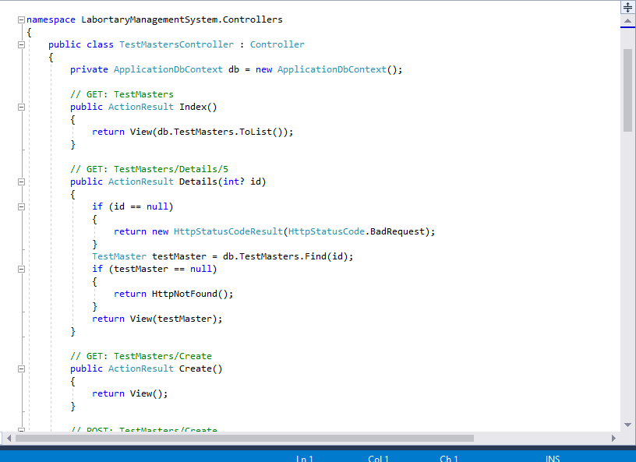

1. **Sub Test Masters Controller:-**

In this controller I have added Sub tests under the test controller and given the foreign key reference to test master id in this controller. And In this controller with the help of this controller’s code we can add sub tests and delete and update also.

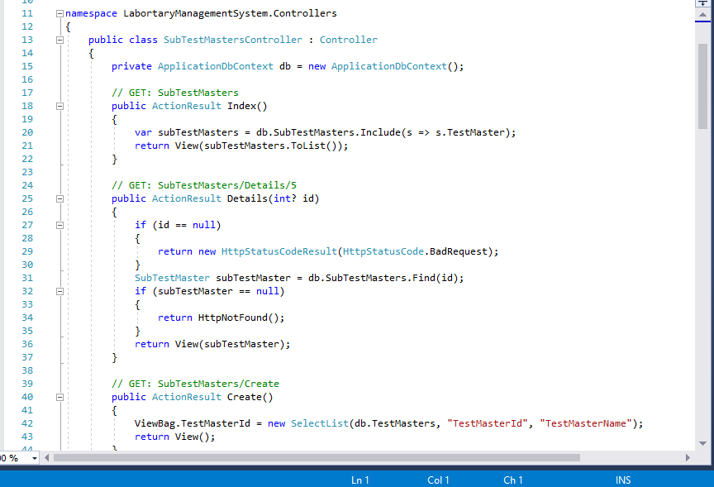

1. **Main test Controller:-**

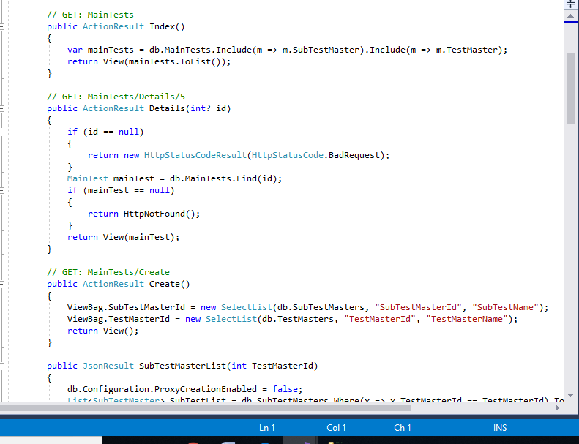In this controller there is code of main tests.

1. 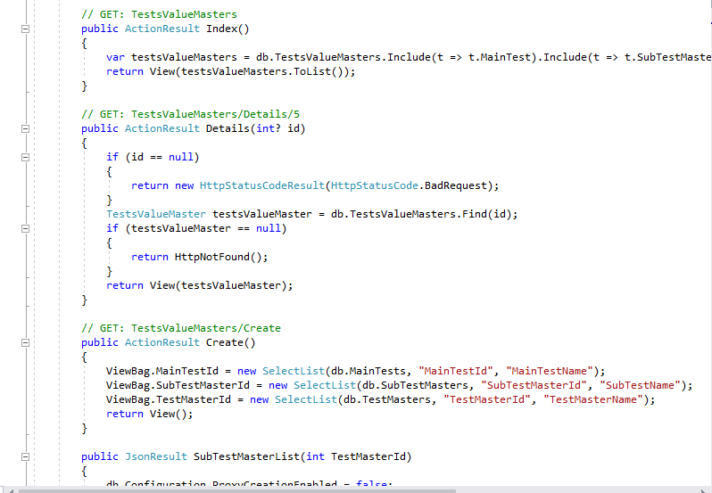**Test Values Controller:-**

1. **Technologies Master:**

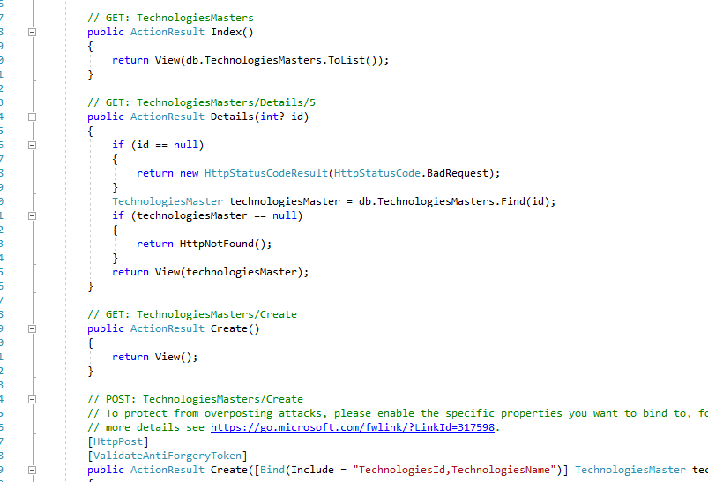

1. **Patient Master:-**

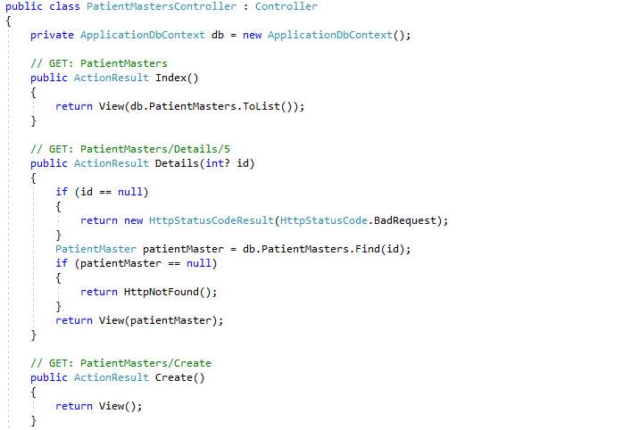

1. **Test Order Master:**

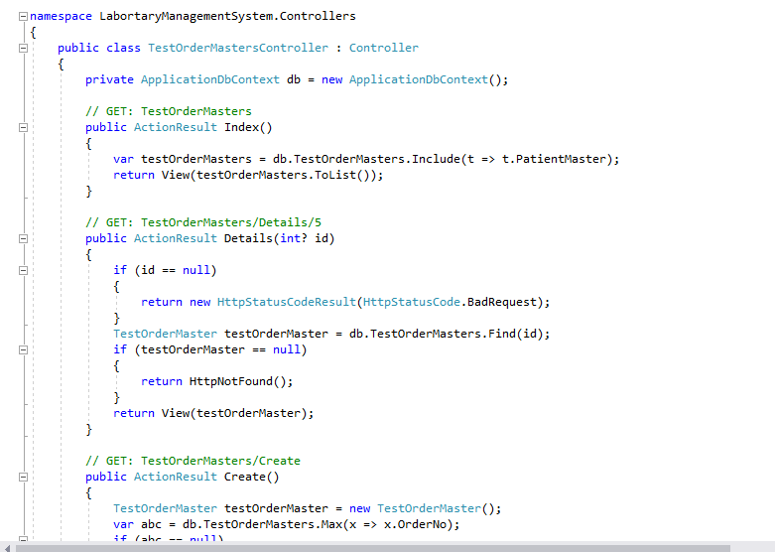

1. **Test Order Details:**

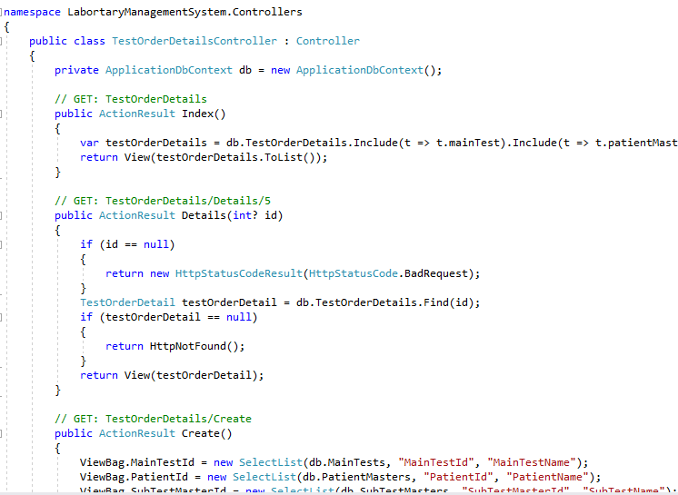

1. **Reports:**

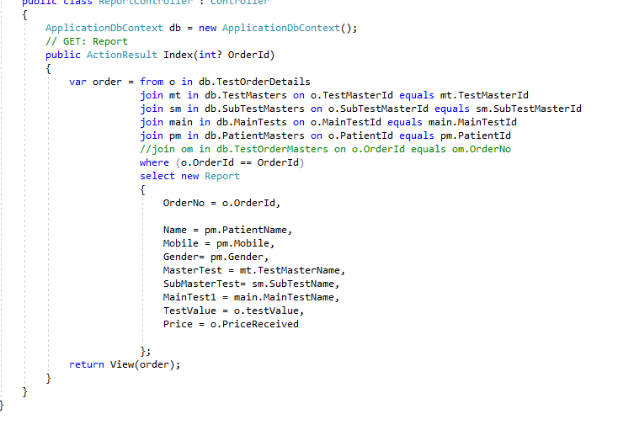

1. **Role Controller:**

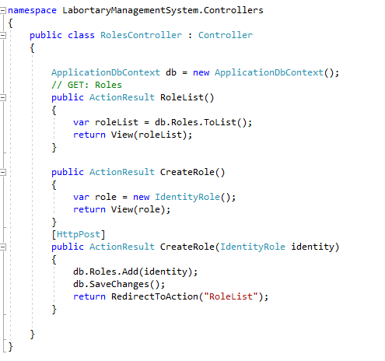

**Models**

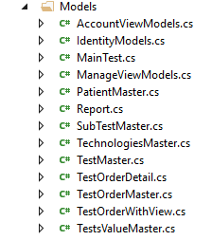

**Views**

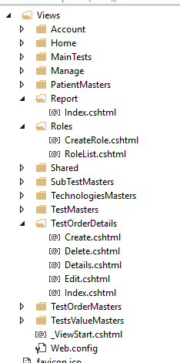

**Output Screens**

**Home Page:**

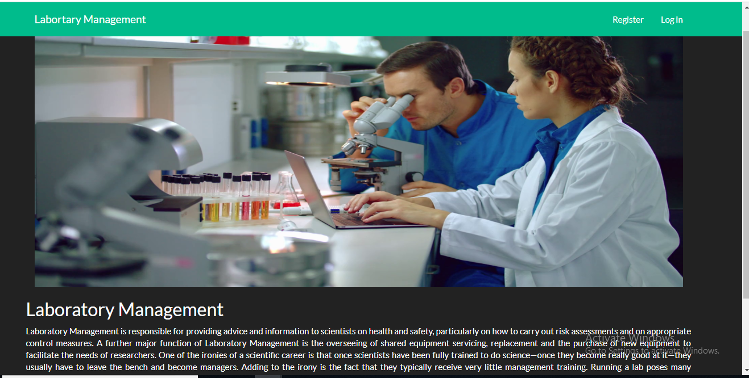

**Login:**

