**Project done by : Simranjeet Singh , Lovepreet Singh , Jeevan Singh , Gurpinder Singh , Ajaypal Singh**

**XAMARIN FRAMEWORK**

In this program, there is the use of the Xamarin framework that is one of the best frameworks that is applicable in the use of C#. Apart from this, in this it can be stated that this application is worthful for the visual studio only. The one of the best advantages for using this framework is that it is runnable in the visual studio only and there is less possibilities that any issue and the error can be occurred in this.

In the concern of this project, it can be determined that there is the use of the C# language and this application is developed on the basis of this uses. It run effectively and there is less possibility for occurring the error as well.

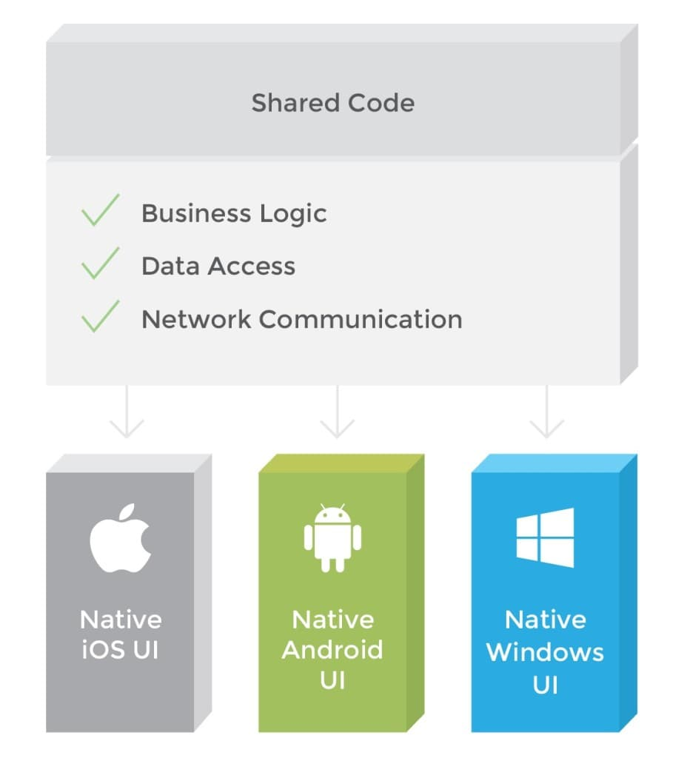

Platform of this application is android that is required and for this Xamarin framework the android platform is necessary. This application is applicable for the all android and the IOS users so, it presents that flexibility of the project as well. The extension ofXamarin framework is the .NET that is effective having the access on the multiple platforms. Apart from this, the one of the most beneficial advantage of using the Xamarin is that it helps to have the direct literary of the Objective-C, Java and C++ libraries.

Test Logs:

|  |  |  |  |  |  |
| --- | --- | --- | --- | --- | --- |
| Test Number | Actions taken | Input Data | Expected Outcome | Result Obtained | Test Pass/Fail |
| 1 | Click App icon | Icon click | Take to home | It took to home | Pass |
| 2. | Search Box put text | Text appears as typed in search box | Typed as entered | As expected | Pass |
| 3. | Click Search Button | Movie name in the search box | It shows the result based and api result | As expected | Pass |
| 4. | Click Back Button | Click action of button | It takes back to home page | As expected | Pass |
| 5. | Search for random name not a movie | Enter random value not a proper movie | Show the close match | As expected | Pass |
| 6. | Exit button | Click exit button | Exists the app | As expected | Pass |

Home page:

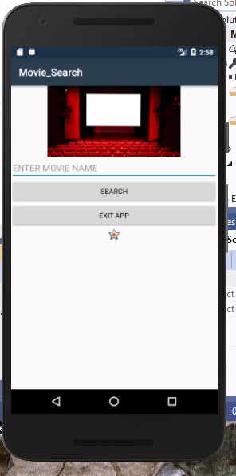

Result Page:

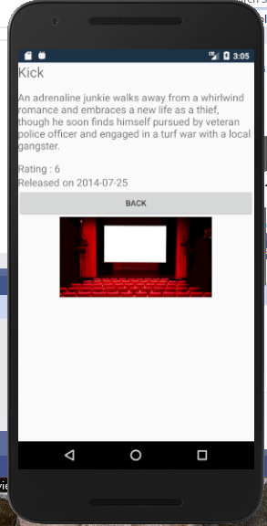

Search Button:

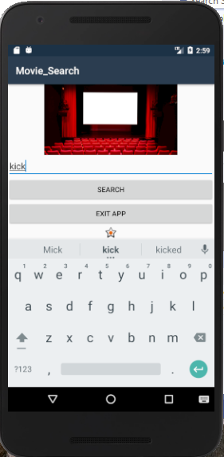

Back Button:



Exit button:

