CHAPTER 1
INTRODUCTION
1.1 Introduction to Computer Graphics
Computer Graphics is concerned with all aspects of producing pictures or images using a computer. The field began humbly almost 50 years ago, with the display of a few lines on a cathode-ray tube (CRT); now, we can create images by computer that are indistinguishable from photographs of real objects. We routinely train pilots with simulated airplanes, generating graphical displays of a virtual environment in real time. Feature-length movies made entirely by computer have been successful, both critically and financially. Massive multiplayer games can involve tens of thousands of concurrent participants.
Perhaps the dominant characteristic of this new millennium is how computer and communication technologies have become dominant forces in our lives. Activities as wide –ranging as filmmaking, publishing, banking and education continue to undergo revolutionary changes as these technologies alter the ways in which we conduct our daily activities. The combination of computers, networks, and the complex human visual system, through computer graphics, has led to new ways of displaying information, seeing virtual worlds, and communicating with people and machines.
The Computer Graphics is one of the most effective and commonly used methods to communicate the processed information to the user. It displays the information in the form of graphics objects such as pictures, charts, graphs and diagram instead of simple text. In computer graphics, pictures or graphics objects are presented as a collection of discrete picture elements called pixels. The pixel is the smallest addressable screen element.
Computer graphics today is largely interactive: The user controls the contents structure, and appearance of objects and their displayed images by using input devices, such as a keyboard, mouse, or touch-sensitive panel on the screen. Computer graphics concerns with the pictorial synthesis of real or imaginary objects from their computer-based models, where the related field of image processing treats the converse process, the analysis of scenes, or the reconstruction of models of 2D or 3D objects from their pictures. The image processing can be classified as
- Image enhancement.
- Pattern detection and recognition.
- Scene analysis and computer vision.
The image enhancement deals with the improvement in the image quality by eliminating noise or by increasing image contrast. Pattern detection and recognition deals with the detection and clarification of standard patterns. And finding deviations from these patterns. The optical character recognition (OCR) technology is a practical example for pattern detection & recognition. Scene analysis deals with the recognition and reconstruction of 3D model of scene from several 2D images.

  - Introduction to Blender
Blender is the free and open source 3D creation suite. It supports the entirety of the 3D pipeline—modeling, rigging, animation, simulation, rendering, compositing and motion tracking, even video editing and game creation. Blender's features include 3D modeling, UV unwrapping, texturing, raster graphics editing, rigging and skinning, fluid and smoke simulation, particle simulation, soft body simulation, sculpting, animating, match moving, rendering, motion graphics, video editing and compositing.
Though it is often distributed without extensive example scenes found in some
other programs, the software contains features that are characteristic of
high-end 3D software.
Among its capabilities are:
- Support for a variety of geometric primitives, including polygon meshes, fast subdivisionsurface modeling, Beziercurves, NURBSsurfaces, metaballs, icospheres, multi-res digital sculpting (including dynamic topology, maps baking, remeshing, re-symmetrize, decimation), outline font, and a new n-gon modeling system called B-mesh.
- Internal render engine with scanline rendering, indirect lighting, and ambient occlusion that can export in a wide variety of formats.
- A pathtracer render engine called Cycles, which can take advantage of the GPU for rendering. Cycles supports the Open Shading Language since Blender 2.65.
- Integration with a number of external render engines through plugins.
- Keyframed animation tools including inverse kinematics, armature (skeletal), hook, curve and lattice-based deformations, shape animations, non-linear animation, constraints, and vertex weighting.
- Simulation tools for soft body dynamics including mesh collision detection, LBM fluid dynamics, smoke simulation, Bullet rigid body dynamics, ocean generator with waves.
- A particle system that includes support for particle-based hair.
- Modifiers to apply non-destructive effects.
- Python scripting for tool creation and prototyping, game logic, importing/exporting from other formats, task automation and custom tools. Basic non-linear video/audio editing.
- A fully integrated node-based compositor within the rendering pipeline accelerated with OpenGL. Procedural and node-based textures, as well as texture painting, projective painting, vertex painting, weight painting and dynamic painting.
- Real-time control during physics simulation and rendering. Camera and object tracking.
- Grease Pencil tools for 2D animation within a full 3D pipeline.

1.2.1 Problem Statement
Simulation of a human practicing yoga. This project depicts creation of a human model and applying animations to it. The human is modeled by the help of a background sketch. The animation is shown by applying appropriate relationship between the bones.

1.2.2 Scope
The concepts used in this project such as texture mapping, rotation and some animations. It is depicted as a man is practicing yoga when applied some animations. All of these are used for realistic effect.

CHAPTER 2
LITERATURE SURVEY

Existing method:
The simple scene along with the background containing some of the 2D objects with interaction was existing earlier. Basic OpenGL primitives like GL_POLYGON, GL_LINES, GL_LINE_LOOP, GL_POINTS etc, are used where we can visualize only one view of the 2D scene that is front view, which is not that useful in the current technology which is being upgraded every now and then. And the 3D transformations are also used to make them rotate.
Proposed technique:
Using blender, we can model the objects with minimal effort and can maximize the quality, the textures, the various transformations used for viewing the
Human which appears so real. The same Human which when modeled by OpenGL lacks quality.
CHAPTER 3

REQUIREMENT SPECIFICATION

3.1 Project Requirements
The tool is designed such that users with a computer having minimum configuration can also use it. It does not require complex graphics packages or complex setup procedures.
The tool requires simple installation by downloading it from any website.
3.2 Hardware Requirements
The hardware requirements are very minimal and the software can run on most of the machines.
- Processor – core i5 processor or above.
- Processor Speed - 500 MHz or above
- RAM - 64MB or above Storage Space - 2 MB or above, hard disk -10MB.
- Monitor resolution - A color monitor with a minimum resolution of 1965*800
- Supports both single & double buffering

3.3 Software Requirements
A Linux or windows-based operating system is required to develop the 2D and 3D graphics applications.
The blender tool is required to be installed.

CHAPTER 4
DESIGN

4.1 Flowchart
start
Human model is created

Scale the cube according to reference image

Texture is added and animation is added

Rendering is done on the obtained human model

The required human model with animation is obtained.

4.2 Flow of the Project
- Scene1
Add mirror property to the cube.
- Scene2
Include reference image in the blender window
- Scene3
Scale the cube according to reference image.
- Scene4
The human is given the animation.
- Scene5
Rendering of the model is done.
- Scene6
The obtained human is rendered using animation and the final 3-D model of a human.

CHAPTER 5
IMPLEMENTATION

5.1 FUNCTIONS USED
- Scaling
This function is used to scale the object i.e. to provide it with the perfect size.
- Material Function
This function is used to display the types of active data and display them. Using this function, we can even edit the data.
- Lighting Function
This function is used to provide the object with proper lighting so that the view of the object is realistic.
- Rotation
This function is used to provide rotation for the object i.e. rotate in any axis (x,y,z)
- Animation
A simulation of movement created by displaying a series of pictures, or frames.
- Rendering
This function is used for rendering i.e. give a realistic view to the object.

CHAPTER 6
RESULTS
6.1 SCREENSHOTS
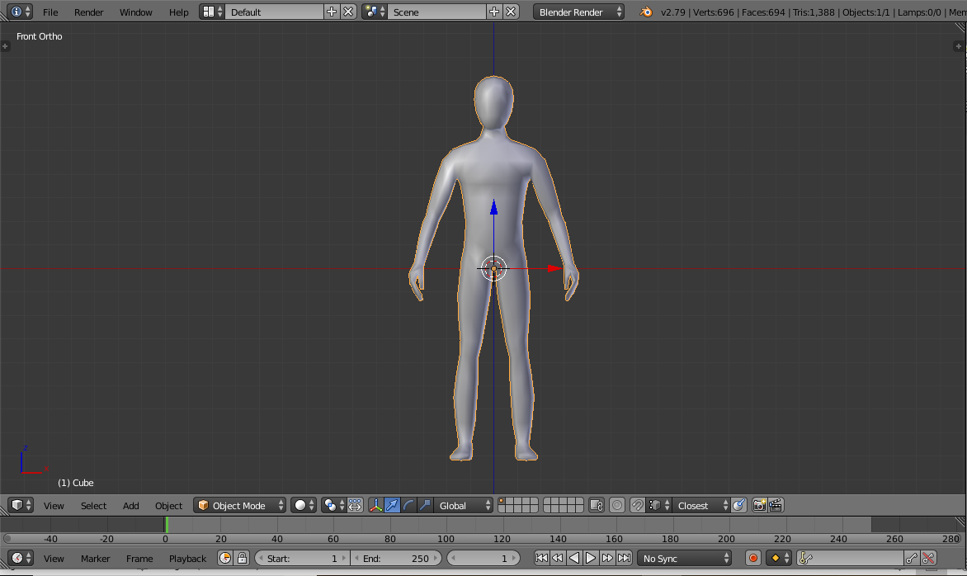
Figure 6.1.1 Human model

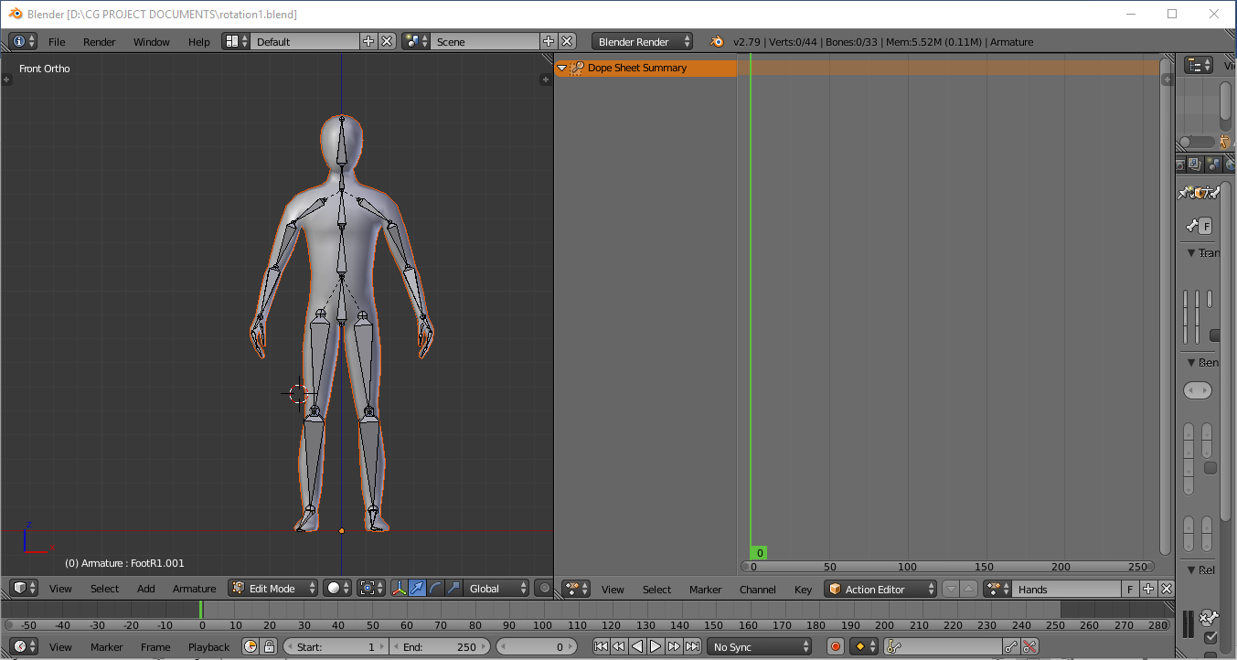
Figure 6.1.2 Model added with bone armature

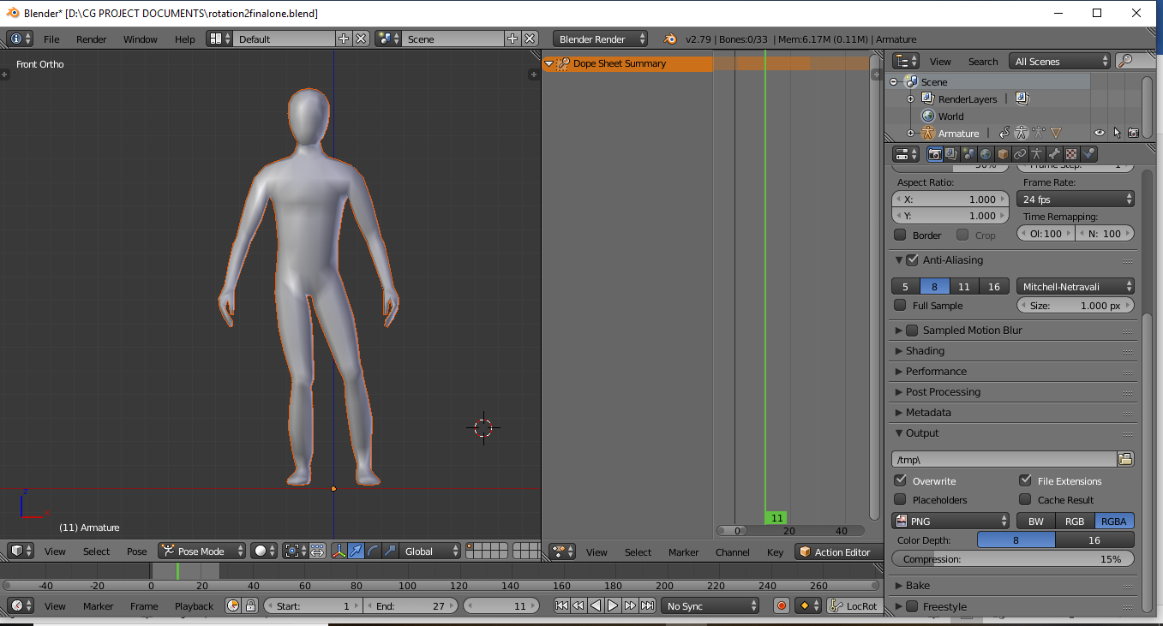
Figure 6.1.3 Rendered Human model

CHAPTER 7
CONCLUSION & FUTURE SCOPE

In this project we demonstrated how to model a human using blender. Using blender for graphics is an advancement as it really produces a more realistic image. The Human here looks more realistic as we have applied some animations to the model. In future weighted painting can be applied so that the model would look even more realistic. Various viewer positions can be used for viewing the Human in any direction.

REFERENCES

Referred Books

1. Interactive Computer Graphics A Top-Down Approach with OpenGL -Edward Angel, 5th Edition, Addison-Wesley, 2008.

2. James D Foley, Andries Van Dam, Steven K Feiner, John F Hughes, Computer Graphics, Pearson Education 1997.

Links Referred

1. https://youtu.be/aAO4C_8y0w8

2. https://youtu.be/jp_SqjB0468

