SIMATS ENGINEERING (SAVEETHA SCHOOL OF ENGINEERING)
Department of Artificial Intelligence and Data Science
ASSESSMENT TOOL 1 – ANALYTICAL PROBLEM SOLVING

Course Code: | CSA17 | Course Title: | Artificial Intelligence
CO Assessed: | CO1 – Apply (BL3) | Assessment: | Assessment Tool 1 – Analytical Problem Solving
Weightage: | 35% of CIA | Duration / Marks: | 60 mins
CO1 Statement: | Apply AI basics such as intelligent agents and uninformed search methods to solve problems effectively. (BL3)
Student Name: | Jeevana Reddy | Reg. No.: | 192411259
Section / Batch: | BE-CSE | Date: | 5/10/26

Code of Conduct
I Jeevana Reddy, 192411259 (Name / Reg No) certify that this submission is my original work and that I have adhered to the guidelines specified for this assessment. I understand that any violation of academic integrity rules will result in disciplinary action.
Signature of the Student: D. JEEVANA REDDY

Instructions
- Read each question carefully before answering.
- Answer all four questions. Show every step: state your assumptions, the method you choose and why, your calculations, and finally interpret the result for the agent or AI system in the problem.
- Questions are drawn from Foundations and History of AI, Intelligent Agents (Agents and Environments) and the Concept of Rationality.
- Prepare digital Write up units and clear final answers (marks, minutes, percentage points, expected utility); present tables and working neatly.
- Marks will be awarded using the Analytical Problem Solving rubric: problem understanding, method selection, solution process, accuracy of calculation and interpretation of results.
- Upload in Github and GCR (Question paper with regNo, Name, Answers and rubrics and evalution page at last).
- Duration: 1 hour (15 minutes per question).

Section / Topic | Focus | Question Nos.
1. Foundations and History of AI | Definitions of AI (four approaches), Turing Test, eras and milestones in the history of AI | Q3
2. Intelligent Agents: Agents and Environments | Agent function and program, PEAS description, task environment properties, agent architectures | Q1, Q2
3. Concept of Rationality | Performance measure, percept sequence, expected utility, rational versus omniscient agent | Q1, Q4

Annexure A – Analytical Problem Solving

Question 1: Two-Room Vacuum World
Topic: Agents and environments, concept of rationality | 15 minutes
A vacuum-cleaner agent lives in a world with two squares, A and B. At each time step it perceives its own location and whether that square is Dirty or Clean. Its actions are Suck, Right, Left and NoOp. The agent starts in square A, and both squares are initially Dirty. Once a square is cleaned, dirt never reappears.
Performance measure over a lifetime of T = 6 time steps: +1 for every clean square at the end of each time step, and a penalty of p for every Left or Right move (take p = 1 unless told otherwise).
- Agent X (simple reflex): if the current square is Dirty, Suck; otherwise move to the other square.
- Agent Y (reflex with internal state): if the current square is Dirty, Suck; otherwise, if it remembers that both squares have been cleaned, NoOp; otherwise move to the other square.

- Write the PEAS description (Performance measure, Environment, Actuators, Sensors) of this agent from the data given
Assumptions: score at each step = (number of clean squares after the action) − p × (1 if the action is Left/Right, else 0); moves between A and B always succeed; actions are deterministic; the percept is [location, status].

PEAS element | Description
Performance measure | +1 for every clean square at the end of each time step, and −p for every Left or Right move, summed over the lifetime of T = 6 steps (maximum possible clean-square points = 2 × 6 = 12).
Environment | Two squares A and B in a row (discrete, one-dimensional). Both squares start Dirty, the agent starts in A, and dirt never reappears. Properties: partially observable (the agent senses only its own square), deterministic, static, single-agent, sequential.
Actuators | Suck (vacuum), Left and Right (wheels), NoOp (do nothing).
Sensors | Location sensor (A or B) and dirt sensor for the current square (Dirty / Clean) – together giving the percept [location, status].

(b) Trace Agent X for all 6 time steps in a table (action, clean squares at end of step, move penalty, step score) and find its total score for p = 1.
Method: a step-by-step simulation. Rule of X: if the current square is Dirty → Suck, otherwise move to the other square. Step score = clean squares at end of step − move penalty.
Step | Location | Percept | Action | Clean squares at end of step | Move penalty | Step score | Cumulative
1 | A | [A, Dirty] | Suck | 1 (A) | 0 | 1 | 1
2 | A | [A, Clean] | Right | 1 (A) | 1 | 1 − 1 = 0 | 1
3 | B | [B, Dirty] | Suck | 2 (A, B) | 0 | 2 | 3
4 | B | [B, Clean] | Left | 2 | 1 | 2 − 1 = 1 | 4
5 | A | [A, Clean] | Right | 2 | 1 | 2 − 1 = 1 | 5
6 | B | [B, Clean] | Left | 2 | 1 | 2 − 1 = 1 | 6
Total |  |  |  | 10 | 4 |  | 6

Total clean-square points = 1 + 1 + 2 + 2 + 2 + 2 = 10; moves made = 4 (steps 2, 4, 5, 6). Score of Agent X = 10 − 4(1) = 6.
(c) Trace Agent Y in the same way and find its total score for p = 1
Method: same simulation. Y keeps a memory of the squares it has cleaned; once it remembers that both A and B are clean it chooses NoOp.
Step | Location | Percept | Action (reason) | Clean squares at end of step | Move penalty | Step score | Cumulative
1 | A | [A, Dirty] | Suck | 1 (A) | 0 | 1 | 1
2 | A | [A, Clean] | Right (B not yet known clean) | 1 (A) | 1 | 1 − 1 = 0 | 1
3 | B | [B, Dirty] | Suck | 2 (A, B) | 0 | 2 | 3
4 | B | [B, Clean] | NoOp (memory: A and B clean) | 2 | 0 | 2 | 5
5 | B | [B, Clean] | NoOp | 2 | 0 | 2 | 7
6 | B | [B, Clean] | NoOp | 2 | 0 | 2 | 9
Total |  |  |  | 10 | 1 |  | 9

Total clean-square points = 10; moves made = 1 (step 2 only). Score of Agent Y = 10 − 1(1) = 9.
(d) Derive the total score of X and of Y as functions of p. For which values of p is Y strictly better than X?
Both agents collect the same 10 clean-square points (the squares are cleaned at the same steps); they differ only in the number of moves: X makes 4, Y makes 1.
Score_X(p) = 10 − 4p Score_Y(p) = 10 − p
Difference: Score_Y − Score_X = (10 − p) − (10 − 4p) = 3p.
Y is strictly better than X when 3p > 0, i.e. for all p > 0. For p = 0 both score 10 (tie). For p < 0 (moves are rewarded) X would be better. At p = 1: Y − X = 9 − 6 = 3, which agrees with parts (b) and (c).
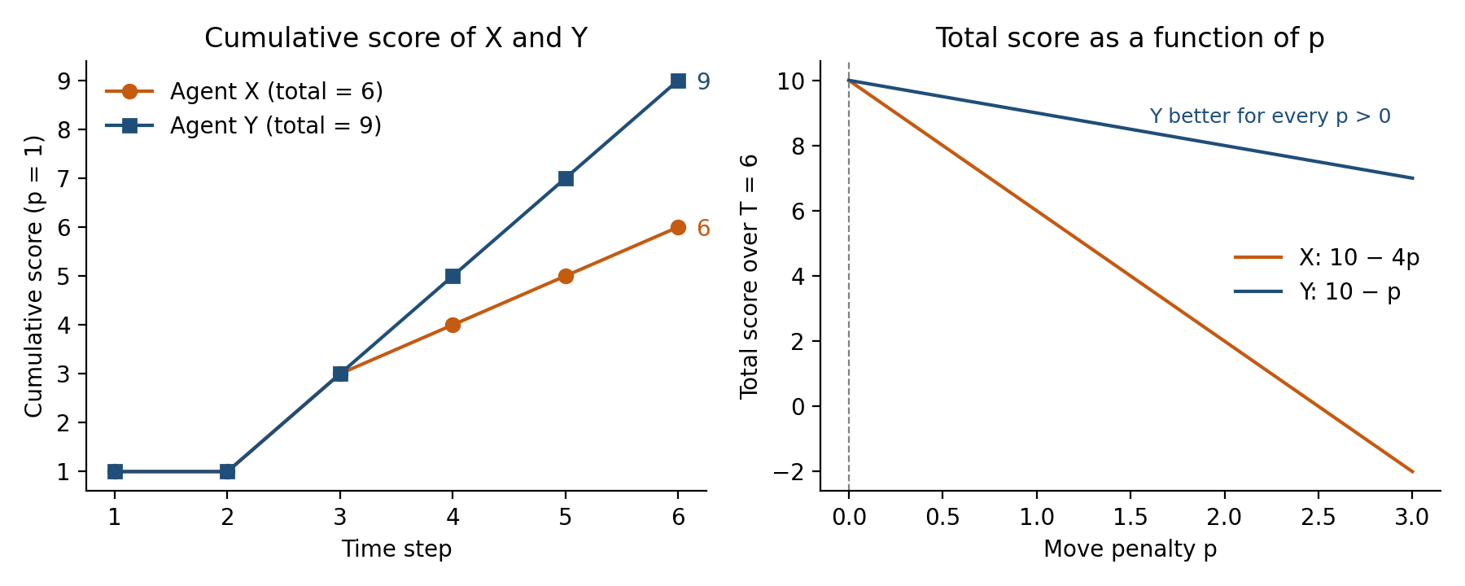
Figure 1 – Q1: cumulative score (p = 1) and total score as a function of the move penalty p
(e) Which agent is rational? Interpret your result: explain how the performance measure and the percept history decide rationality, and why X cannot match Y even though both see the same percepts at each step.
Conclusion: Agent Y is rational (for p ≥ 0, and clearly for p > 0); Agent X is not rational when p > 0.
• Why Y is optimal: A can be cleaned at step 1, but B cannot be cleaned before step 3 (a move is needed at step 2, then Suck). So clean-square points ≤ 1 + 1 + 2 + 2 + 2 + 2 = 10, and at least one move is unavoidable, so no agent can score more than 10 − p. Y scores exactly 10 − p, hence it maximises the performance measure.
• Role of the performance measure: rationality is defined relative to the measure. Because every Left/Right move costs p, wandering after the job is finished is a pure loss. If p were 0, X would be equally good; the penalty is what makes X irrational.
• Role of the percept history: a rational agent chooses the action expected to maximise performance given the percept sequence so far plus built-in knowledge. Y uses the whole history (A was cleaned at step 1, B at step 3) and so concludes that nothing is left to do.
• Why X cannot match Y: X’s agent function depends only on the current percept. At steps 4–6 it sees [B, Clean] or [A, Clean] – exactly what Y sees – but it cannot tell “the other square is clean” from “the other square is still dirty”, so it keeps shuttling and loses p on every move. Y has the same current percepts but a memory (internal state), so it can distinguish the two situations. The difference is therefore the use of history, not better sensors.

Question 2: Task Environment Analysis and Agent Selection
Topic: Agents and environments (PEAS, environment properties, agent types) | 15 minutes
Three AI agents are to be deployed in the following task environments:
- E1: An autonomous taxi driving through city traffic.
- E2: A part-picking robot that uses a camera to pick defective parts off a moving conveyor belt and place them in bins.
- E3: A chess-playing agent in a tournament game played with a clock.
Difficulty score convention: for each of the six properties below, the harder value scores 1 point and the easier value scores 0. A semi-dynamic environment scores 0.5 on the Static/Dynamic property.
Property | Easier value (0) | Harder value (1)
Observability | Fully observable | Partially observable
Number of agents | Single agent | Multi-agent
Determinism | Deterministic | Stochastic
Episodic / Sequential | Episodic | Sequential
Static / Dynamic | Static | Dynamic (semi-dynamic = 0.5)
Discrete / Continuous | Discrete | Continuous

- Classify each environment on all six properties with a one-phrase justification for each.

Property | E1: Autonomous taxi | E2: Part-picking robot | E3: Chess with a clock
Observability | Partially observable – sensors see only nearby surroundings; other drivers’ intentions and hidden hazards are unseen | Partially observable – camera sees only the part in view; defects may be occluded or noisy | Fully observable – the whole board is visible to both players
Number of agents | Multi-agent – other vehicles, pedestrians, cyclists | Single agent – the robot works alone on the belt | Multi-agent – an opponent (competitive)
Determinism | Stochastic – traffic, signals and accidents are unpredictable | Stochastic – sensor noise, gripper slip, varying part positions | Deterministic – a move has exactly one outcome; no chance element
Episodic / Sequential | Sequential – each driving decision affects later situations and safety | Episodic – each part is classified and picked independently of earlier ones | Sequential – every move affects the rest of the game
Static / Dynamic | Dynamic – the world keeps changing while the taxi deliberates | Dynamic – the belt keeps moving while the robot decides | Semi-dynamic – board is unchanged while thinking, but the clock keeps running
Discrete / Continuous | Continuous – speed, position and steering angle vary continuously | Continuous – part position, belt speed and arm motion are continuous | Discrete – finite board positions and legal moves

(b) Compute the difficulty score of E1, E2 and E3 and rank them from hardest to easiest.
Method: apply the given convention (harder value = 1, easier = 0, semi-dynamic = 0.5) to the classification in (a) and add the six scores.
Property | E1: Taxi | E2: Robot | E3: Chess
Observability | 1 | 1 | 0
Number of agents | 1 | 0 | 1
Determinism | 1 | 1 | 0
Episodic / Sequential | 1 | 0 | 1
Static / Dynamic | 1 | 1 | 0.5
Discrete / Continuous | 1 | 1 | 0
Difficulty score | 6 | 4 | 2.5

Ranking (hardest → easiest): E1 (6) > E2 (4) > E3 (2.5). The taxi is hardest because all six properties take their harder value; chess is easiest because it is fully observable, deterministic and discrete.
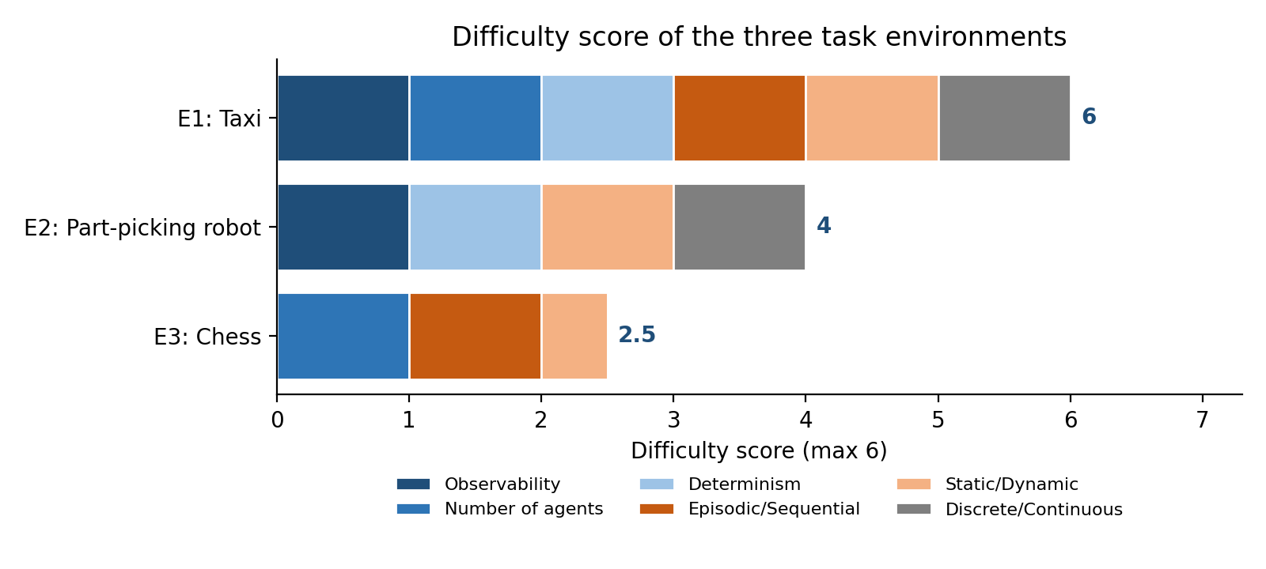
Figure 2 – Q2: difficulty score of E1, E2 and E3 broken down by property
(c) For the hardest and the easiest environment, choose the most suitable agent architecture (simple reflex, model-based reflex, goal-based, utility-based, learning) and justify the choice using your classification.
Hardest environment – E1 (autonomous taxi): utility-based agent (with a learning component).
• Partially observable → it must maintain an internal model/belief of hidden vehicles and road state (a simple reflex agent is not enough).
• Stochastic, dynamic, multi-agent → outcomes are uncertain, so actions must be compared by expected utility, not by a single yes/no goal.
• Many conflicting objectives (safety, speed, fuel, comfort, legality): “reach the destination” does not separate safe from unsafe or fast from slow routes; a utility function gives the trade-off. Learning lets it improve from experience in the continuous, ever-changing traffic.
Easiest environment – E3 (chess): goal-based agent using adversarial look-ahead search (minimax with alpha-beta pruning).
• Fully observable, deterministic and discrete → the exact game model is known, so the agent can simulate future moves and pick those leading to its goal (checkmate / win); no belief state or probability model is needed.
• Sequential → a reflex agent would fail because a move must be judged by where it leads; with the clock (semi-dynamic) an evaluation function cuts the search depth.

(d) Interpret: explain how the properties of an environment, not just its domain, decide how complex the agent program must be.
The agent program must match the properties of the task environment, not the name of the domain. Chess and driving both look “intelligent”, yet chess is fully observable, deterministic and discrete, so a clean search procedure solves it, whereas driving has every difficulty. Each hard property adds a specific requirement:
• Partial observability → internal state / memory / belief tracking.
• Stochastic → reasoning with probabilities and expected utility.
• Sequential → look-ahead and planning instead of one-step reflexes (episodic tasks like E2 need only per-item decisions).
• Dynamic → real-time decisions; the world does not wait.
• Multi-agent → modelling and anticipating other agents (game theory / cooperation).
• Continuous → handling infinite state and action spaces by control methods rather than enumeration.
Hence a higher difficulty score means a more complex agent program: E1 (6) needs the richest architecture, E2 (4) can use a model-based/learning perception module, and E3 (2.5) is handled by a goal-based search agent.

Question 3: Turing Test Data Across the History of AI
Topic: Foundations and history of AI (Turing Test, acting humanly, eras of AI) | 15 minutes
In a Turing-test style study, judges held five-minute text conversations with an unknown party and then said whether it was a human or a machine. Each system below faced 50 independent interrogations in which it was the machine. The table shows how many times the judge correctly identified it as a machine.
System | Era / technique | Interrogations | Correctly identified
ELIZA | 1960s, keyword pattern matching | 50 | 47
Chatbot B | 2010s, scripted rules plus statistical NLP | 50 | 36
System C | 2020s, large neural language model | 50 | 29

Reference: Turing (1950) predicted that an average interrogator would have no more than a 70% chance of making the right identification after five minutes. A judge who is purely guessing is right 50% of the time.
(a) Compute the correct-identification rate and the fooling rate (percentage of interrogations in which the machine was taken for a human) for each system
Formulae: correct-identification rate = (correct / 50) × 100; fooling rate = 100 − correct-identification rate = ((50 − correct) / 50) × 100.
System | Correctly identified (of 50) | Correct-identification rate | Taken for human (50 − correct) | Fooling rate
ELIZA | 47 | 47/50 = 94% | 3 | 3/50 = 6%
Chatbot B | 36 | 36/50 = 72% | 14 | 14/50 = 28%
System C | 29 | 29/50 = 58% | 21 | 21/50 = 42%

(b) Decide which systems satisfy Turing's 70% criterion. State the method you use and how far each system is from the 50% chance level.
Method: a system satisfies the criterion if the judges’ correct-identification rate is ≤ 70%. The distance from the 50% chance level shows how close the judges are to pure guessing. As a supporting check I compare the gap with the sampling error for n = 50.
System | Correct rate | vs 70% limit | Satisfies criterion? | Distance from 50% chance
ELIZA | 94% | 24 points above | No | +44 points
Chatbot B | 72% | 2 points above | No (narrowly) | +22 points
System C | 58% | 12 points below | Yes | +8 points

Sampling check: with n = 50 the standard error around 50% is √(0.5 × 0.5 / 50) = 7.1 points. System C’s +8 points is only about 1.1 standard errors (z ≈ 1.13, p ≈ 0.26), so its judges are statistically indistinguishable from guessing. Chatbot B’s +22 points is about 3.1 standard errors, so judges clearly beat chance against it; its 2-point miss of the 70% line is within sampling error (z ≈ 0.31), so it is borderline. ELIZA (z ≈ 3.7 above 70%) clearly fails.
- Compute the improvement in fooling rate from ELIZA to System C in percentage points and as a ratio. Also compute the improvement from Chatbot B to System C in percentage points
Comparison | Fooling rates | Improvement (percentage points) | Improvement (ratio)
ELIZA → System C | 6% → 42% | 42 − 6 = 36 points | 42 / 6 = 7×
Chatbot B → System C | 28% → 42% | 42 − 28 = 14 points | 42 / 28 = 1.5×

System C fools judges seven times as often as ELIZA (a rise of 36 points) and 14 points more often than the 2010s Chatbot B.
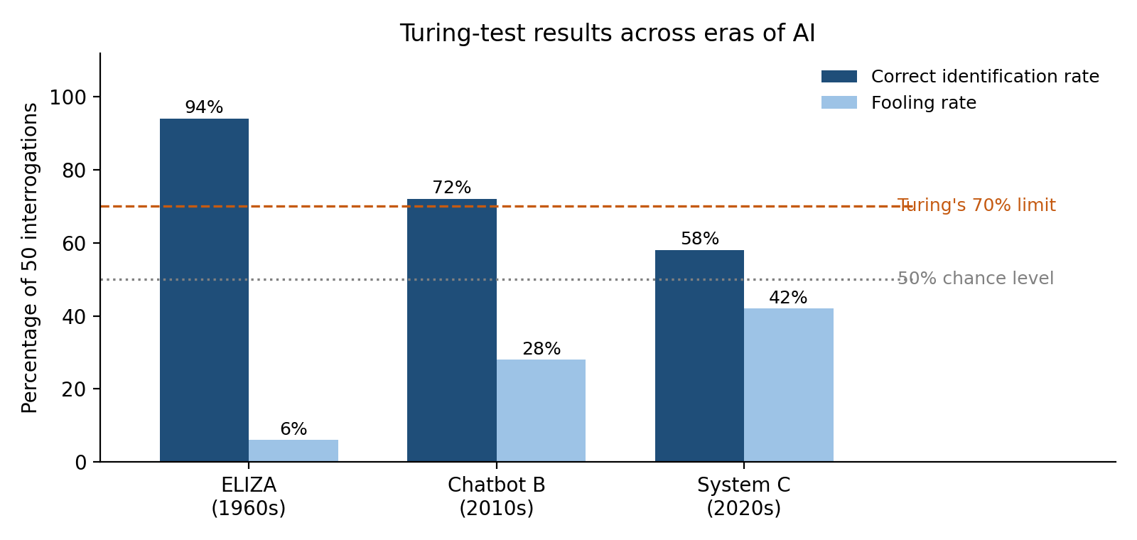
Figure 3 – Q3: correct-identification and fooling rates against the 70% and 50% reference lines
(d) Interpret: the Turing Test measures "acting humanly". Explain why a high fooling rate does not prove that System C is thinking or acting rationally, using one idea from the foundations of AI (for example the four approaches to defining AI, or the Chinese Room argument).
The foundations of AI define the field by four approaches: thinking humanly, thinking rationally, acting humanly and acting rationally. The Turing Test measures only acting humanly – whether the outward behaviour in a five-minute text chat is indistinguishable from a person’s. A 42% fooling rate therefore shows that System C’s language output looks human to judges; it says nothing about whether it reasons correctly (thinking rationally), models human cognition (thinking humanly) or chooses actions that maximise expected performance (acting rationally).
Chinese Room argument (Searle): a person who follows a rule-book to manipulate Chinese symbols can give replies that fool Chinese speakers without understanding a word. In the same way, a neural language model can produce fluent answers by statistical pattern-matching without understanding, so passing (or nearly passing) the test is not evidence of thinking.
Further points: even ELIZA’s simple keyword matching fooled 6% of judges, so “fooling” can come from judge gullibility or a short test; humans may also be imitated by copying their mistakes, which a rational agent need not make; and System C’s 42% is still below the 50% chance level. A high fooling rate is thus necessary evidence of human-like behaviour, not proof of thought or rationality.

Question 4: Rational Route Choice under Uncertainty
Topic: Concept of rationality (expected performance, rational versus omniscient agent) | 15 minutes
A rational taxi agent must reach the airport. The deadline is 55 minutes. Its performance measure (utility) for a trip is:
U = 100 − T − 20·L
where T is the travel time in minutes and L = 1 if the taxi arrives after the 55-minute deadline, otherwise L = 0.
Route | Normal time (min) | Probability of disruption | Time if disrupted (min)
R1: Highway | 30 | 0.30 (accident) | 70
R2: City road | 45 | 0.10 (signal failure) | 60
R3: Ring road | 50 | 0 (never disrupted) | 50

(a) Compute the utility of each route in each outcome (normal and disrupted), clearly marking the late trips.
Method: U = 100 − T − 20·L, with L = 1 only if T > 55 (deadline missed).

Route | Outcome | Probability | Time T (min) | Late? (T > 55) | Utility U = 100 − T − 20L
R1 Highway | Normal | 0.70 | 30 | No (L = 0) | 100 − 30 − 0 = 70
R1 Highway | Disrupted (accident) | 0.30 | 70 | LATE (L = 1) | 100 − 70 − 20 = 10
R2 City road | Normal | 0.90 | 45 | No (L = 0) | 100 − 45 − 0 = 55
R2 City road | Disrupted (signal failure) | 0.10 | 60 | LATE (L = 1) | 100 − 60 − 20 = 20
R3 Ring road | Always (never disrupted) | 1.00 | 50 | No (L = 0) | 100 − 50 − 0 = 50

- Compute the expected utility of R1, R2 and R3 and state which route the rational agent should choose.
Method: EU(route) = Σ probability × utility.
EU(R1) = 0.70 × 70 + 0.30 × 10 = 49 + 3 = 52
EU(R2) = 0.90 × 55 + 0.10 × 20 = 49.5 + 2 = 51.5
EU(R3) = 1.00 × 50 = 50
Decision: the rational agent chooses R1 (Highway), which has the highest expected utility (52), narrowly ahead of R2 (51.5) and R3 (50), even though R1 carries a 30% risk of being late.
(c) A new percept arrives: a radio alert reports a major accident on the highway, raising the probability of disruption on R1 to 0.80. Recompute the expected utility of R1 and re-decide the route.
EU(R1) = 0.20 × 70 + 0.80 × 10 = 14 + 8 = 22
R2 (51.5) and R3 (50) are unchanged because the alert concerns only the highway. The ranking is now R2 (51.5) > R3 (50) > R1 (22). The agent should switch to R2 (City road).
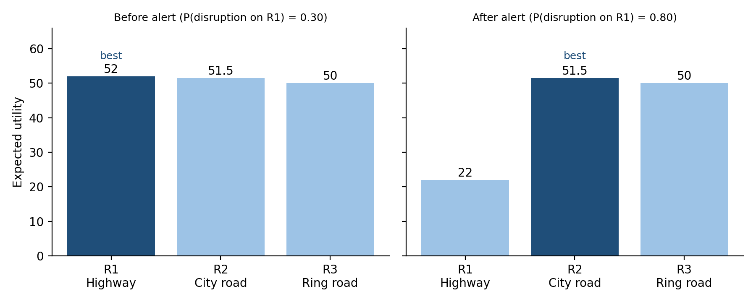
Figure 4 – Q4: expected utility of each route before and after the radio alert
(d) Suppose the agent chose the route in part (b) and the disruption did occur. Compute the utility actually obtained and state whether the agent was irrational. Distinguish between a rational agent and an omniscient agent.
- The agent chose R1 and the accident occurred: T = 70 > 55, so the trip is late and U = 100 − 70 − 20 = 10 (not the expected 52).
- The agent was not irrational. When it decided, R1 had the highest expected utility given its percepts and knowledge; the 10 was the 30%-probability bad outcome. Rationality is judged by the expected performance of the decision at the time, not by the result of one trial.
- Rational vs omniscient: a rational agent maximises expected performance given the percept sequence and built-in knowledge. An omniscient agent knows the actual outcome of every action in advance and so maximises actual performance – impossible in a real, uncertain world. Being unable to foresee the accident does not make the agent irrational.

(e) Interpret: explain why rationality depends on the percept sequence and the performance measure, and why part (c) changes the decision although the roads themselves did not change.
A rational action is the one that maximises the expected value of the performance measure, given the percept sequence so far. The performance measure fixes what counts as good (here: short time with a 20-point penalty for lateness – a different measure, such as reliability only, would favour R3). The percept sequence fixes what the agent believes about the world (here, the probabilities).
In part (c) the roads, travel times and utility formula did not change, but the radio alert changed the agent’s percept sequence and hence its beliefs: the disruption probability on R1 rose from 0.30 to 0.80, which cut EU(R1) from 52 to 22. The best action therefore changed from R1 to R2. R1 stays best only while p(disruption) is below about 0.31 (solve 70 − 60q = 51.5), so the original choice was close to a tipping point.
Hence rationality is relative to the agent’s information, not just to the physical world: the same agent with a different percept sequence can rationally choose a different action – and using new information to update the decision is itself part of acting rationally.

Rubrics for Calculation
Criteria | Weightage | Level 4 – Exemplary (100% of marks) | Level 3 – Proficient (75%) | Level 2 – Developing (50%) | Level 1 – Beginning (25%)
Problem Understanding | 20% | Clearly interprets problem, identifies all parameters and requirements accurately | Understands problem with minor gaps | Partial understanding; misses key elements | Misinterprets or unable to understand problem
Method Selection | 20% | Selects most appropriate method/formula with strong justification | Selects correct method with minor errors | Inappropriate or partially correct method | Unable to select method
Solution Process | 25% | Logical, systematic steps with correct approach throughout | Mostly correct steps with minor mistakes | Disorganized steps; multiple errors | No clear process
Accuracy of Calculation | 20% | All calculations accurate; correct final answer | Minor calculation errors | Frequent errors; incorrect final answer | No valid calculations
Interpretation of Results | 15% | Clearly interprets results with units and engineering relevance | Basic interpretation with minor omissions | Limited or unclear interpretation | No interpretation

Q. No. / Criteria | Problem Understanding (4) | Method Selection (4) | Solution Process (5) | Accuracy of Calculation (4) | Interpretation of Results (3) | Sub. Total (20) | Total %
1
2
3
4
Total

Faculty In-charge | Course Coordinator | Program Director
Jai Sharma
Signature: _______________ | Signature: _______________ | Signature: _______________
Date: ___________________ | Date: ___________________ | Date: ___________________

