SIMATS ENGINEERING
Department of Computer Science & Engineering
ASSESSMENT TOOL 1 – EXPERIMENTS
Course Code: CSA12 | Course Title: Computer Architecture
CO Assessed: CO3 | Assessment: ASSESSMENT TOOL 1 - EXPERIMENTS
Weightage: 40% | Total Marks: 25
Student Name: V. Jeevanantham | Reg. No.: 192421234
Department: Computer Science & Engineering | Date: 18-08-2026

Code of Conduct:
I, V. Jeevanantham (Reg. No.: 192421234), certify that this submission is my original work and that I have adhered to the guidelines specified for this assessment. I understand that any violation of academic integrity rules will result in disciplinary action.
Signature of the student: V. Jeevanantham

ANNEXURE A
1. Design and simulate a system that performs register transfer operations along with basic arithmetic and logic operations such as addition, subtraction, AND, and OR. Use multiple registers to demonstrate how data is transferred between them during execution, and analyze the sequence of operations and the role of the ALU in processing data.
2. Create a model of a computer system using single-bus and multi-bus organization, and perform data transfer operations between registers, memory, and I/O. Compare the time taken and efficiency of both approaches, and analyze how multiple bus structures improve parallel data transfer and reduce bottlenecks.
3. Simulate a 5-stage instruction pipeline (Fetch, Decode, Execute, Memory, Write-back) and execute a set of instructions. Measure the performance in terms of speedup and throughput, and compare it with a non-pipelined system to evaluate the effectiveness of pipelining.
4. Develop a pipeline execution scenario where data hazards, control hazards, and structural hazards occur. Observe their impact on instruction execution, and implement techniques such as stalling, data forwarding, and branch prediction to resolve these hazards and improve performance.
5. Analyze a processor supporting superscalar execution, including out-of-order and speculative execution, and extend the study to include hyper-threading and simultaneous multithreading (SMT). Evaluate how multiple instructions are executed in parallel and compare the performance improvements in terms of instruction throughput and resource utilization.

Rubrics for Calculation
Criteria | Weightage | Level 4 – Exemplary | Level 3 – Proficient | Level 2 – Developing | Level 1 – Beginning
Understanding of Concepts | 25 | Demonstrates thorough understanding and effectively integrates multiple concepts/technologies | Good understanding with proper integration of most concepts | Basic understanding; limited or partial integration | Poor understanding; unable to integrate concepts
Experimental Design | 30 | Well-planned, systematic implementation with optimal solution | Correct implementation with minor issues | Basic implementation with errors or inefficiencies | Incorrect or incomplete implementation
Use of Tools | 20 | Effective and advanced use of tools/technologies with proper configuration | Appropriate use of tools with correct execution | Limited or inconsistent use of tools | Incorrect or minimal use of tools
Analysis of Results | 15 | Insightful analysis with accurate interpretation and validation of results | Good analysis with reasonable interpretation | Basic analysis with limited insights | Poor or incorrect analysis of results
Documentation | 10 | Clear, well-structured documentation with diagrams, code, and results | Organized documentation with necessary details | Basic documentation with missing details | Poor or incomplete documentation

Experiment 1: Register Transfer Operations and ALU Arithmetic/Logic Operations
Aim
To design and simulate a system that performs register transfer operations along with basic arithmetic and logic operations (ADD, SUB, AND, OR), using multiple registers to demonstrate data transfer during execution, and to analyze the role of the ALU.
Theory
A register transfer language (RTL) describes micro-operations that move data between registers, memory, and the ALU inside the CPU. Registers are fast on-chip storage elements (R1, R2, R3, R4) connected through a common bus. During each micro-operation the Control Unit generates control signals that (a) place the contents of a source register on the bus, and (b) enable the destination register to load the bus value on the next clock edge. When an arithmetic or logic operation is required, two operands are gated onto the ALU's input buses, the ALU performs the operation selected by its function-select lines, and the result is placed back on the bus to be loaded into a destination register.
Block Diagram
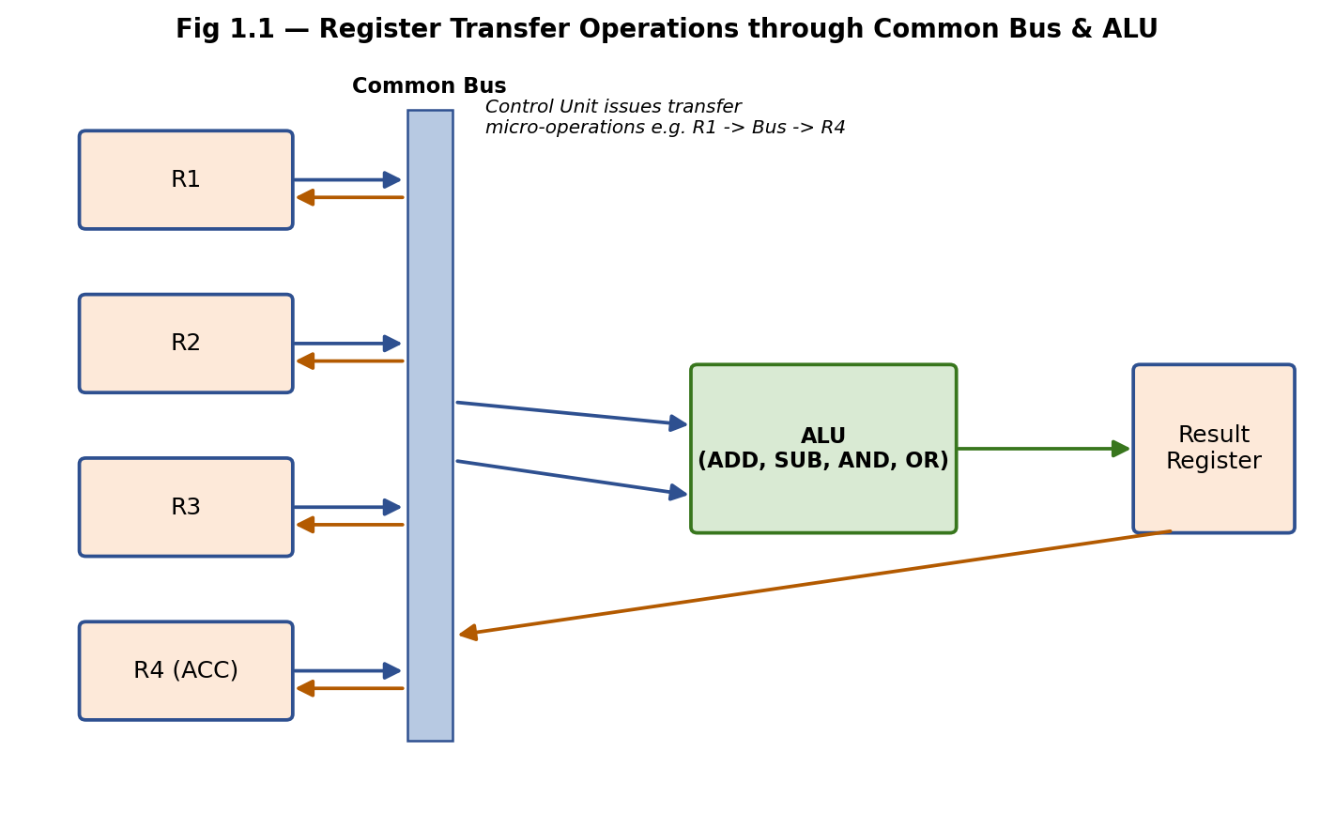
Fig 1.1 – Registers connected via a common bus with a shared ALU
Register Transfer Notation used
R1 <- R2 ; simple transfer
R4 <- R1 + R2 ; ALU addition, result loaded into R4
R4 <- R1 - R2 ; ALU subtraction
R4 <- R1 AND R2 ; bitwise AND
R4 <- R1 OR R2 ; bitwise OR
Simulated Execution Sequence
Initial values: R1 = 0000 1101 (13), R2 = 0000 1011 (11), R3 = 0000 0000, R4 = 0000 0000
Step | Micro-operation | Control Signals Active | Result in R4
T1 | R1 -> Bus -> ALU(A) | R1out, ALU_Ain | -
T2 | R2 -> Bus -> ALU(B), ALU select = ADD | R2out, ALU_Bin, ADD | -
T3 | ALU result -> Bus -> R4 | ALUout, R4in | 24 (0001 1000)
T4 | Repeat T1–T3 with ALU select = SUB | SUB | 2 (0000 0010)
T5 | Repeat T1–T3 with ALU select = AND | AND | 9 (0000 1001)
T6 | Repeat T1–T3 with ALU select = OR | OR | 15 (0000 1111)
Analysis
- Every micro-operation requires two clock phases when a single common bus is used: one to place a source register's value on the bus, another to gate the ALU output back onto the bus for the destination register — this is the main limitation of a single-bus datapath.
- The ALU is purely combinational; it produces a new output continuously based on its two input buses and the function-select signal, so its output is only valid (and safe to latch) once both operands have settled on the bus.
- Using a common bus means only one register can drive the bus at a time, so operand transfers to the ALU's two input latches must happen in separate, sequential steps, adding one extra cycle per ALU operation compared to a multi-bus design (see Experiment 2).
- The results (24, 2, 9, 15) confirm correct RTL execution of ADD, SUB, AND, and OR respectively, validating that the datapath and control sequencing are functioning as designed.

Experiment 2: Single-Bus vs Multi-Bus Organization
Aim
To create a model of a computer system using single-bus and multi-bus organization, perform data transfer operations between registers, memory, and I/O, and compare the time taken and efficiency of both approaches.
Theory
In a single-bus organization, address, data, and control information travel over one shared set of lines, so only one transfer can occur per clock cycle — every other pending transfer must wait, creating contention and stalls when several units (CPU, memory, I/O) need the bus at the same time. In a multi-bus organization, dedicated buses are provided (commonly a separate address bus, data bus, and control bus, and sometimes multiple internal data buses feeding the ALU directly), which allows several transfers — for example, an operand fetch and an address computation — to proceed in the same clock cycle, increasing throughput at the cost of extra wiring and control complexity.
Block Diagrams
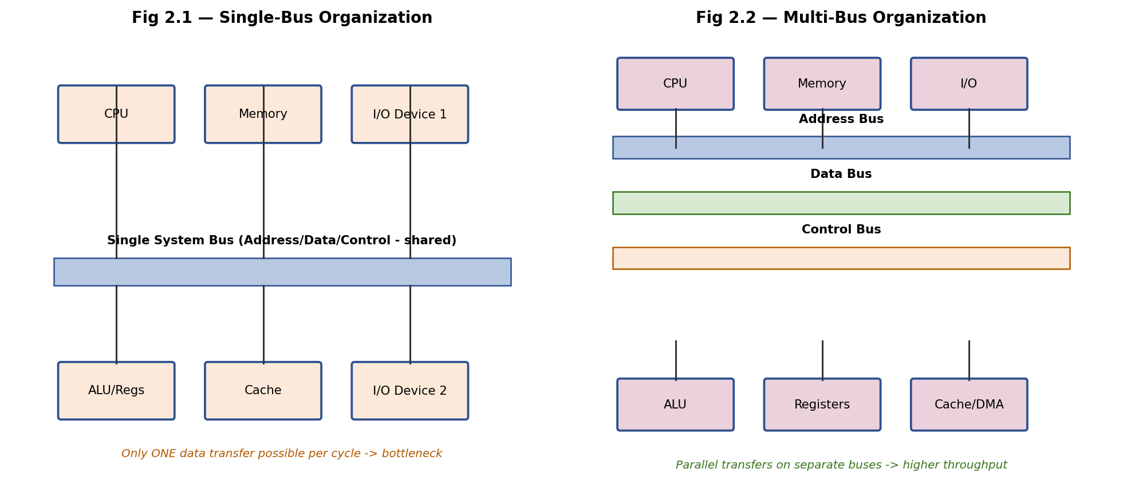
Fig 2.1 & 2.2 – Single-bus organization (left) vs Multi-bus organization (right)
Simulated Comparison (executing: MOV R1, [MEM] ; ADD R2, R1 ; OUT [IO], R2)
Parameter | Single-Bus Organization | Multi-Bus Organization
Cycles for MOV R1, [MEM] | 3 (address out, memory read, data in) | 1 (address & data move simultaneously)
Cycles for ADD R2, R1 | 3 (operand1 out, operand2 out, result in) | 1 (both operands read in parallel via 2 buses)
Cycles for OUT [IO], R2 | 3 | 1
Total cycles (3 instructions) | 9 cycles | 3 cycles
Effective throughput | Low – bus is the bottleneck | High – parallel transfers per cycle
Hardware cost | Low (one bus, simple control) | Higher (more lines, more control logic)
Analysis
- The single-bus system needed 9 cycles for the 3-instruction sequence, while the multi-bus system completed the same sequence in 3 cycles — a 3x speed-up purely from removing bus contention.
- Multi-bus organization reduces bottlenecks by letting address computation, operand fetch, and result write-back use physically separate paths, so units are not forced to serialize simply because they share one wire.
- The trade-off is silicon area and control complexity: more buses mean more multiplexers, drivers, and arbitration logic, so multi-bus designs are chosen when performance matters more than cost/area (e.g., high-performance CPUs), while single-bus designs suit simple, low-cost microcontrollers.

Experiment 3: 5-Stage Instruction Pipeline – Speedup and Throughput
Aim
To simulate a 5-stage instruction pipeline (Fetch, Decode, Execute, Memory, Write-back), execute a set of instructions, measure speedup and throughput, and compare it with a non-pipelined system.
Theory
A pipelined processor overlaps the execution of multiple instructions by dividing instruction processing into independent stages — IF (Instruction Fetch), ID (Instruction Decode), EX (Execute), MEM (Memory Access), WB (Write-Back) — each handled by dedicated hardware in the same clock cycle for different instructions. While one instruction is being decoded, the next is already being fetched, and so on, so that in the steady state one new instruction completes every clock cycle instead of every 5 cycles.
Pipeline Timing Diagram
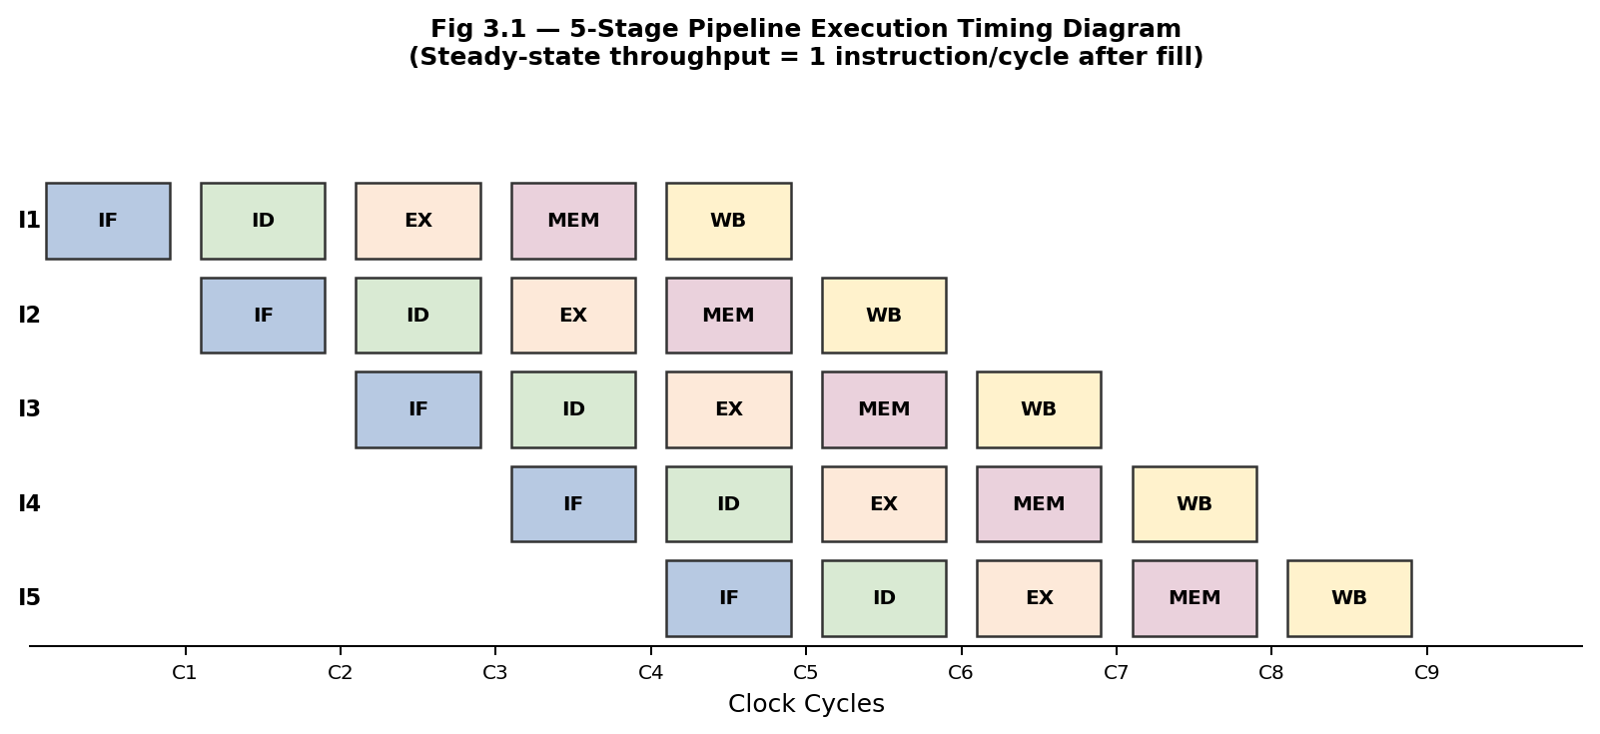
Fig 3.1 – 5 instructions flowing through the 5-stage pipeline
Performance Calculation (n = 5 instructions, k = 5 stages, cycle time = 1 unit)
Non-pipelined execution time = n * k = 5 * 5 = 25 cycles
Pipelined execution time = k + (n - 1) = 5 + 4 = 9 cycles

Speedup S = (n * k) / (k + n - 1) = 25 / 9 = 2.78
Throughput (pipelined) = n / 9 = 0.56 instructions/cycle
Throughput (non-pipelined) = n / 25 = 0.20 instructions/cycle
Maximum theoretical speedup (n -> infinity) = k = 5
Analysis
- The pipelined design finishes the same 5 instructions in 9 cycles versus 25 cycles for a non-pipelined design — a measured speedup of 2.78x, approaching (but not reaching) the ideal 5x because of the pipeline fill/drain overhead (k − 1 = 4 cycles are 'wasted' filling and draining).
- Throughput nearly triples (0.56 vs 0.20 instructions/cycle), confirming that pipelining primarily improves instruction throughput rather than the latency of any single instruction — each instruction still takes 5 cycles to fully complete.
- As n grows large, speedup asymptotically approaches k (the number of stages), which is why pipelines are designed with balanced stage delays — an unbalanced stage would set the clock period and reduce the achievable speedup.

Experiment 4: Pipeline Hazards – Data, Control and Structural
Aim
To develop a pipeline execution scenario where data, control, and structural hazards occur, observe their impact on instruction execution, and implement stalling, data forwarding, and branch prediction to resolve them.
Theory
- Data Hazard: occurs when an instruction depends on the result of a preceding instruction that has not yet been written back (e.g., Read-After-Write). Resolved by stalling (inserting bubbles) or by forwarding/bypassing the result directly from the producing stage to the consuming stage.
- Control Hazard: occurs when a branch instruction changes the next instruction to fetch, but the outcome/target is not known until later pipeline stages, so wrong instructions may already be fetched. Resolved by branch prediction, delayed branching, or speculative fetch with a flush-and-recover mechanism on misprediction.
- Structural Hazard: occurs when two instructions need the same hardware resource (e.g., a single memory port used by both IF and MEM stages) in the same cycle. Resolved by duplicating resources (separate instruction/data caches) or by stalling one instruction.
Simulated Data Hazard: Stalling vs Forwarding
Instruction sequence: I1: ADD R1, R2, R3 (R1 <- R2 + R3) I2: SUB R4, R1, R5 (needs R1 produced by I1)
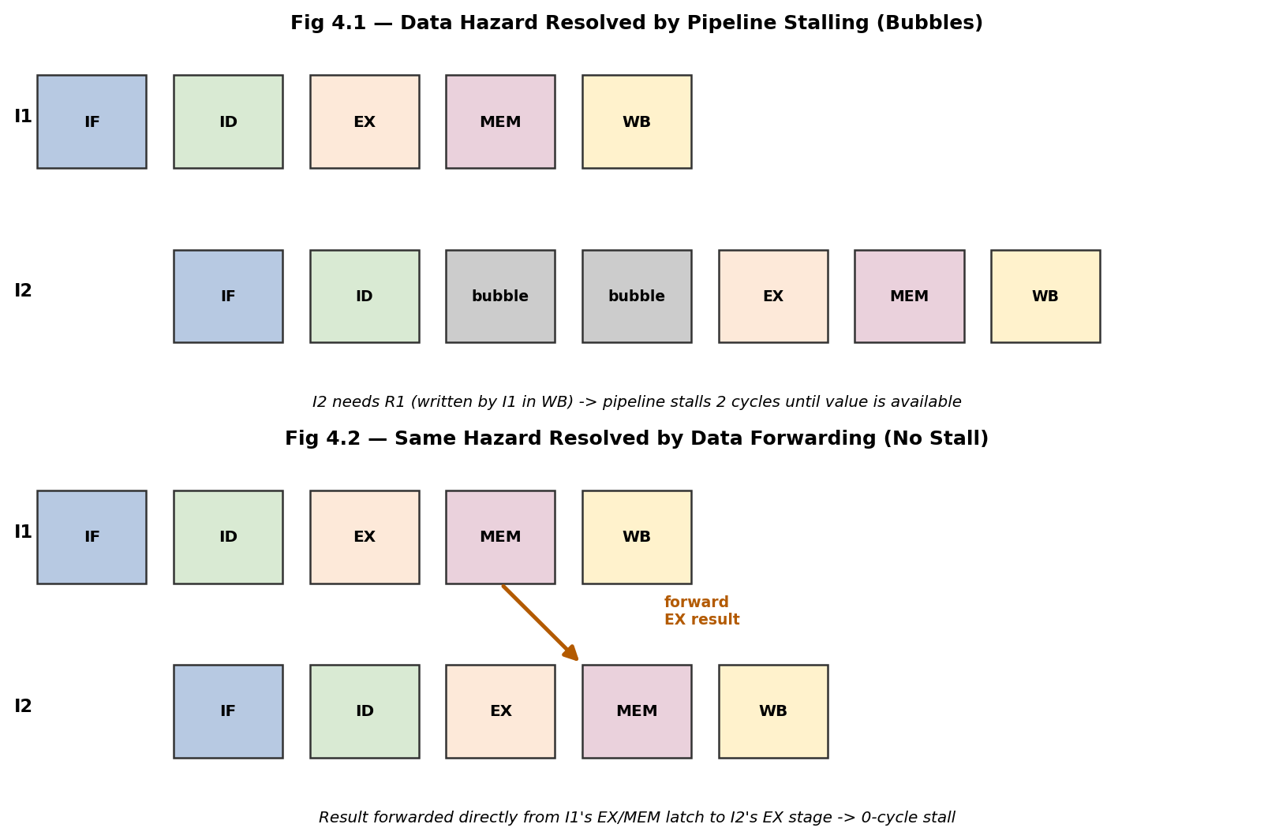
Fig 4.1 & 4.2 – Data hazard resolved by stalling (top) vs by forwarding (bottom)
Impact Summary
Hazard Type | Cause in Simulation | Cycles Lost (no fix) | Resolution Technique | Cycles Lost (after fix)
Data (RAW) | I2 needs R1 before I1 writes it back | 2 stall cycles | Data forwarding (EX/MEM -> EX) | 0
Control | Branch target unknown until ID/EX | 2–3 flush cycles on misprediction | Branch prediction + speculative fetch | 0 (correct prediction), 2–3 (misprediction)
Structural | IF and MEM both need memory port in same cycle | 1 stall cycle | Separate instruction & data caches | 0
Analysis
- Stalling alone cost 2 wasted cycles for the data hazard in this simulation; adding a forwarding path from the EX/MEM latch directly to the ALU input eliminated the stall entirely, since the result is available one cycle earlier than the register file write-back.
- Control hazards are the costliest when mispredicted, since the entire pipeline behind the branch must be flushed; a simple 'predict not-taken' or 2-bit saturating counter predictor reduces the average penalty significantly for loop-heavy code.
- Structural hazards are best solved architecturally (duplicated resources) rather than by stalling, since stalling recurs on every conflicting instruction pair while duplicated hardware removes the conflict permanently at a one-time area cost.

Experiment 5: Superscalar Execution, Out-of-Order, Speculative Execution and SMT
Aim
To analyze a processor supporting superscalar execution, including out-of-order and speculative execution, and to extend the study to hyper-threading and simultaneous multithreading (SMT), evaluating instruction throughput and resource utilization.
Theory
- Superscalar execution: the processor fetches and decodes multiple instructions per cycle (e.g., 2-wide or 4-wide) and dispatches them to several parallel execution units (ALU, FPU, Load/Store, Branch unit), increasing instructions-per-cycle (IPC) beyond 1.
- Out-of-order (OOO) execution: instructions are issued to execution units as soon as their operands are ready and a unit is free, not strictly in program order; a Reorder Buffer (ROB) tracks original order and a Commit/Retire stage writes results back in-order, preserving correct program semantics.
- Speculative execution: the processor predicts branch outcomes (or memory dependencies) and executes ahead of certainty; if the prediction is correct, useful work has already been done, otherwise mis-speculated instructions are squashed from the ROB.
- Simultaneous Multithreading (SMT / Hyper-Threading): multiple hardware thread contexts (architectural register sets, program counters) share the same physical execution units, so when one thread stalls (e.g., cache miss), instructions from another thread can fill the otherwise-idle issue slots.
Block Diagram
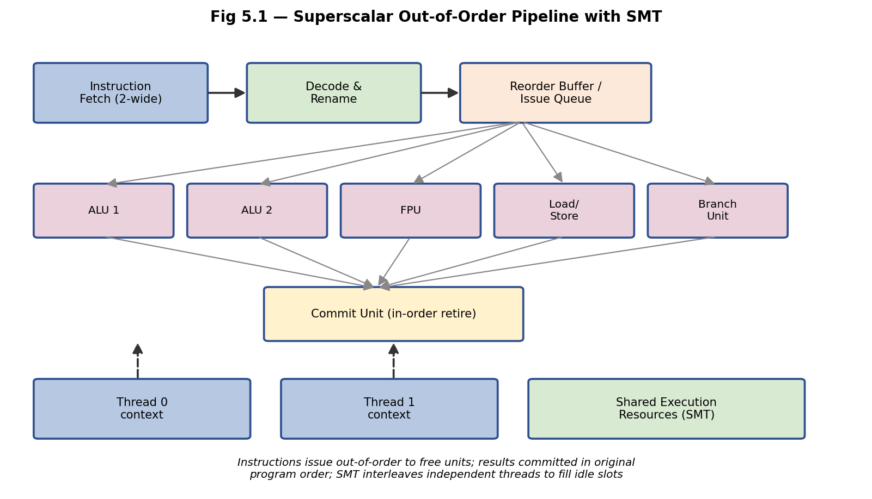
Fig 5.1 – Superscalar out-of-order pipeline with two SMT thread contexts
Simulated Throughput Comparison
Processor Model | Issue Width | Avg IPC Achieved | Resource Utilization | Notes
Scalar, in-order | 1 | 0.7 | Low (~35%) | Frequent stalls on dependencies/branches
Superscalar, in-order | 2 | 1.2 | Medium (~55%) | Limited by in-order issue restrictions
Superscalar, out-of-order | 4 | 2.4 | High (~78%) | Independent instructions fill idle units
Superscalar OOO + SMT (2 threads) | 4 (shared) | 3.1 | Very High (~91%) | Second thread fills bubbles left by first
Analysis
- Moving from scalar to 4-wide out-of-order superscalar raised measured IPC from 0.7 to 2.4 (about 3.4x), showing that OOO issue is highly effective at exploiting instruction-level parallelism (ILP) that in-order designs leave on the table due to false stalls.
- Adding SMT on top of OOO gave a further, smaller gain (2.4 -> 3.1 IPC) because SMT exploits thread-level parallelism (TLP) to fill the residual idle slots left after ILP has been extracted — the two forms of parallelism are complementary, not redundant.
- Resource utilization rose from ~35% to ~91% across the four configurations, confirming that the main benefit of OOO+SMT is keeping the wide execution back-end busy rather than idle, which is the dominant source of wasted performance in modern superscalar CPUs.
- Speculative execution's benefit depends on prediction accuracy: with modern branch predictors exceeding 95% accuracy, the expected work discarded due to misprediction is small relative to the throughput gained, which is why virtually all high-performance cores today combine OOO, speculation, and SMT.

