Brain Tasks Application – CI/CD Deployment Submission
GitHub → AWS CodePipeline → AWS CodeBuild → Amazon ECR → Amazon EKS

Subject: Brain Tasks Application – CI/CD Pipeline and Kubernetes Deployment Submission

1. GitHub Repository
GitHub Link: https://github.com/jeevanantham2205/Brain-Tasks-App
The repository contains the Brain Tasks application source code, Docker configuration, CI/CD build specifications, and deployment configuration used for the AWS deployment.

2. Project Architecture
- GitHub – source code repository
- AWS CodeConnections – secure GitHub connection
- AWS CodePipeline – automates the CI/CD workflow
- AWS CodeBuild – builds the Docker image and pushes it to Amazon ECR
- Amazon ECR – stores the Docker image
- AWS CodeBuild (EKS Deploy) – performs the Kubernetes deployment
- Amazon EKS – hosts the application
- Kubernetes LoadBalancer Service – exposes the application to the browser

Pipeline flow: GitHub → CodePipeline Source → Docker Build → ECR → EKS Deploy → Kubernetes LoadBalancer → Browser

3. Setup and Deployment Instructions

Prerequisites
- AWS CLI configured with the required AWS account permissions.
- Git and access to the GitHub repository.
- Docker/WSL environment for local development and testing.
- kubectl configured for the Amazon EKS cluster.
- Terraform/eksctl as applicable for infrastructure provisioning.

Application Containerization
- The application is packaged using Docker.
- The Docker image is built by AWS CodeBuild.
- The image is pushed to the Amazon ECR repository: brain-tasks-app.

CI/CD Pipeline
- A GitHub change on the main branch triggers AWS CodePipeline.
- The Source stage retrieves the repository using AWS CodeConnections.
- The Build stage runs the brain-tasks-codebuild project.
- The Docker image is built and pushed to Amazon ECR.
- The Deploy stage runs the brain-tasks-eks-deploy CodeBuild project.
- The deployment buildspec updates the Kubernetes deployment and waits for rollout completion.

Kubernetes Deployment
- The application is deployed to the Amazon EKS cluster: brain-tasks-cluster.
- Kubernetes deployment name: brain-tasks-app.
- Kubernetes service name: brain-tasks-app.
- Service type: LoadBalancer.
- The application is accessible through the AWS load balancer DNS endpoint.

4. Pipeline Configuration
Stage | AWS Service / Project | Expected Result
Source | AWS CodePipeline + CodeConnections | GitHub source retrieved successfully
Build | AWS CodeBuild – brain-tasks-codebuild | Docker image built and pushed to ECR
Deploy | AWS CodeBuild – brain-tasks-eks-deploy | Application deployed successfully to EKS

5. Successful Pipeline Verification
Final successful pipeline status:
- Source – Succeeded
- Build – Succeeded
- Deploy – Succeeded

6. Kubernetes Deployment Verification
kubectl get deployment brain-tasks-app
kubectl get pods
kubectl get service brain-tasks-app
The application was verified successfully in a web browser through the Kubernetes LoadBalancer endpoint.

7. Kubernetes LoadBalancer ARN
LoadBalancer ARN: a3af5129366041d7aa4be5c8cf6b25d-135412517.ap-south-1.elb.amazonaws.com
To retrieve the exact AWS Load Balancer ARN, run the following command:
Then use the returned DNS name in the AWS EC2 Load Balancers console to copy the exact Load Balancer ARN. If the AWS Load Balancer Controller is being used, the ARN can also be obtained from the corresponding load balancer details.

8. Screenshots

GitHub repository showing the project source code.

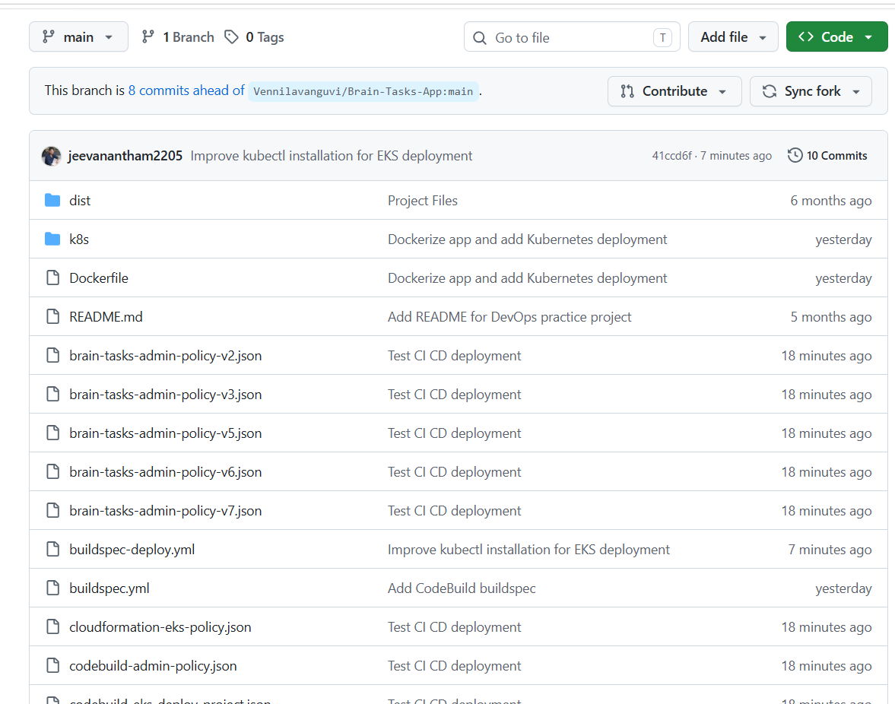
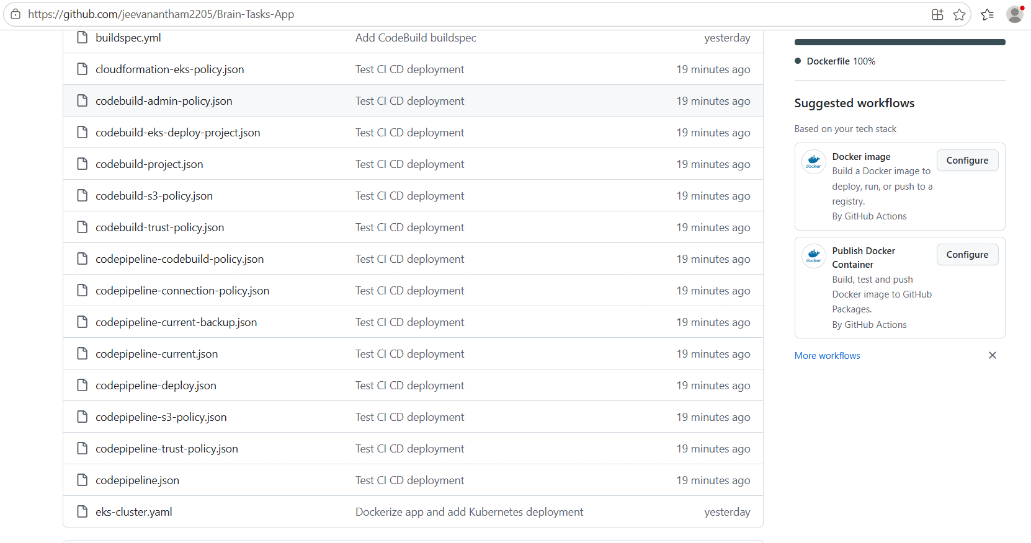
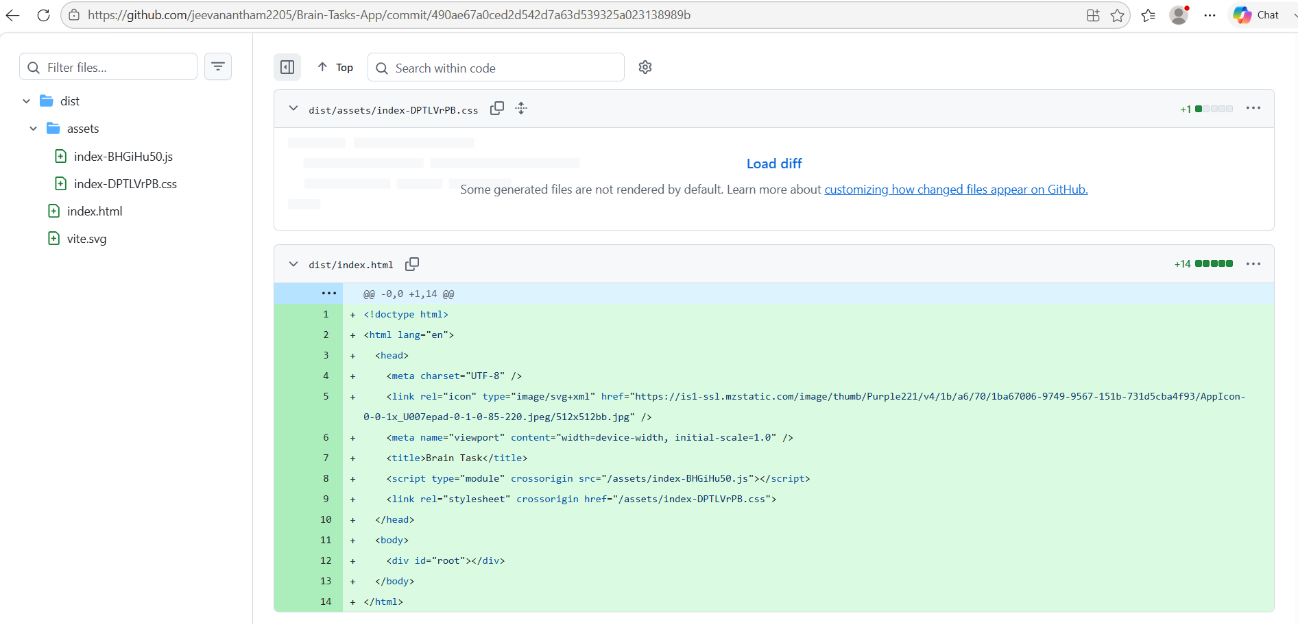

AWS CodePipeline showing Source, Build and Deploy stages as Succeeded
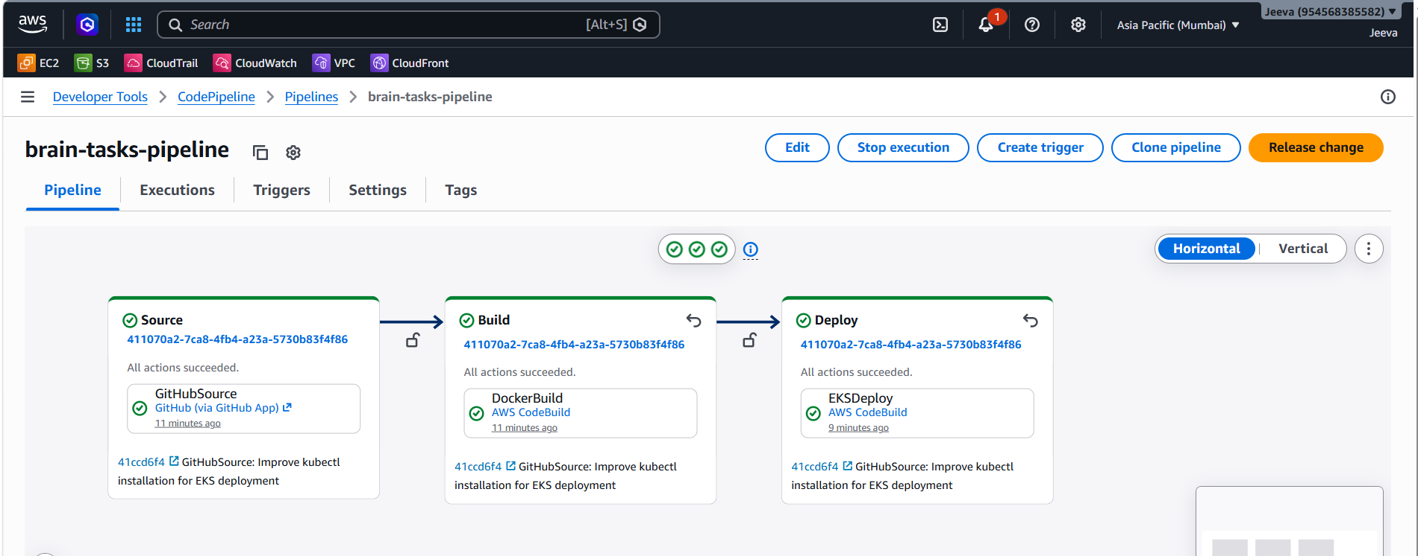
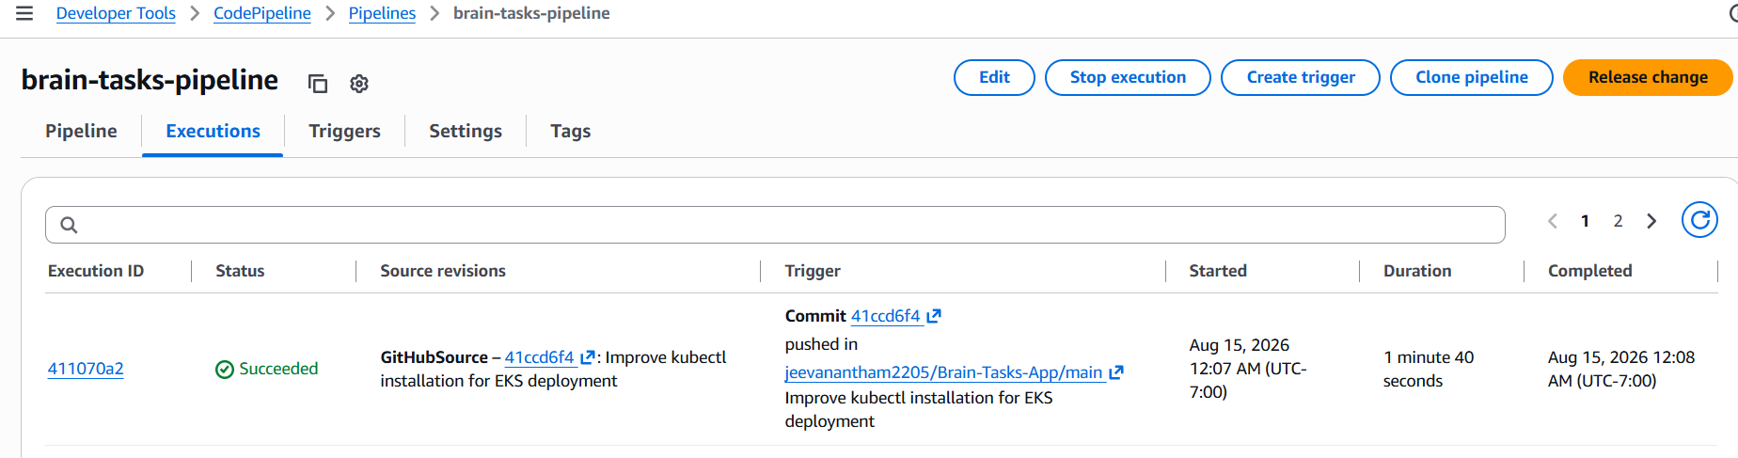

AWS CodeBuild successful Docker build.
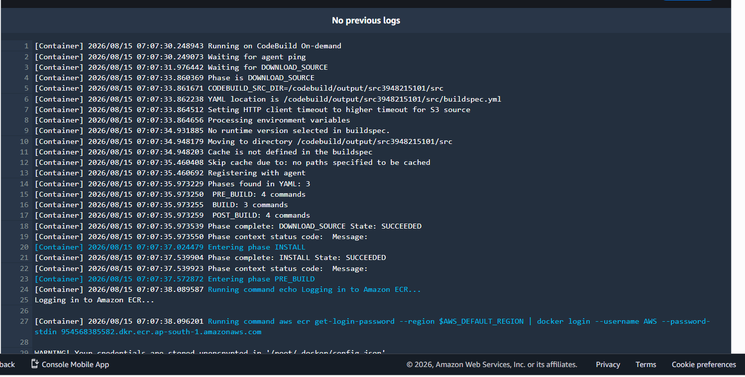


Amazon ECR showing the latest brain-tasks-app image
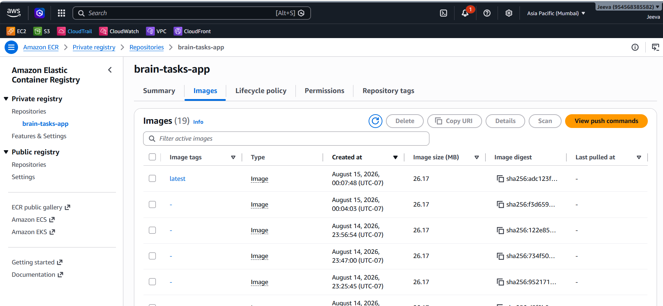
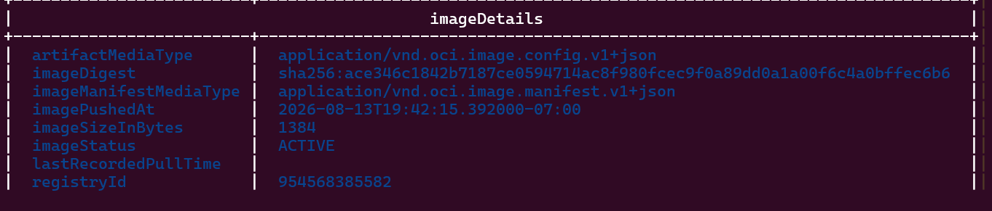

Amazon EKS cluster showing ACTIVE status
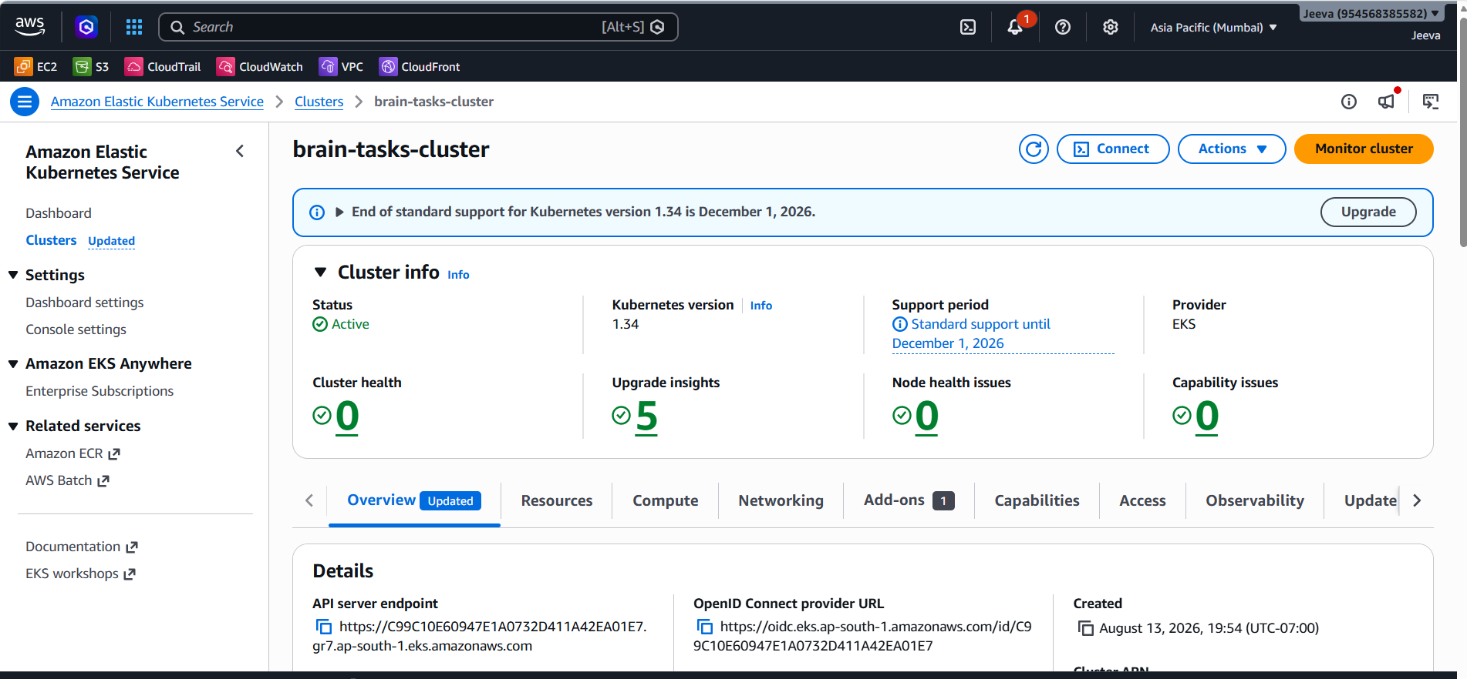
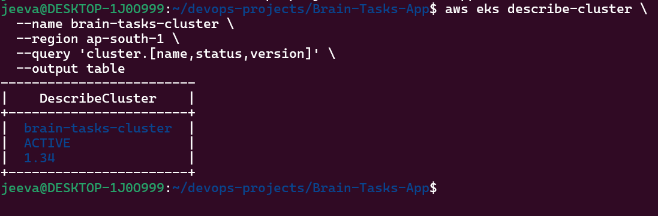

kubectl get deployment / pods showing the application running
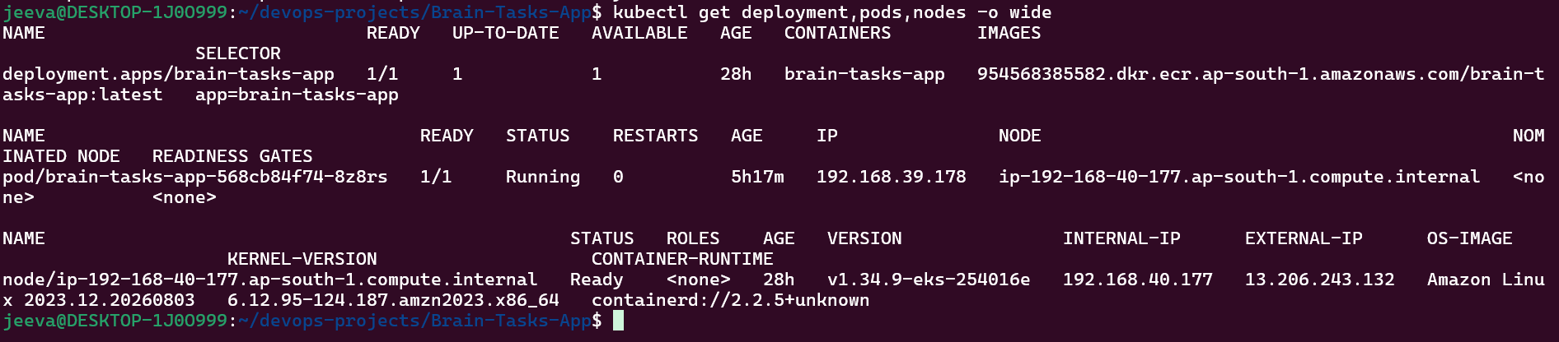

Kubernetes LoadBalancer service showing the external endpoint
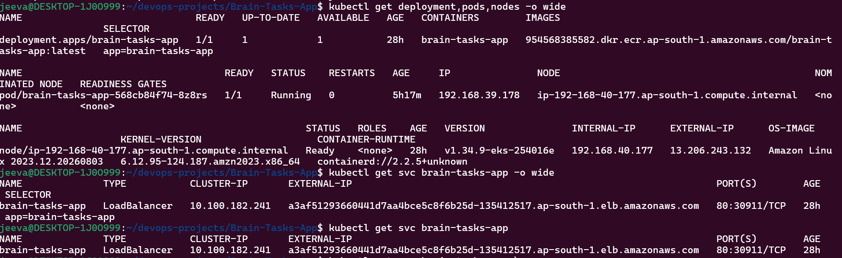
Cloud watch logs
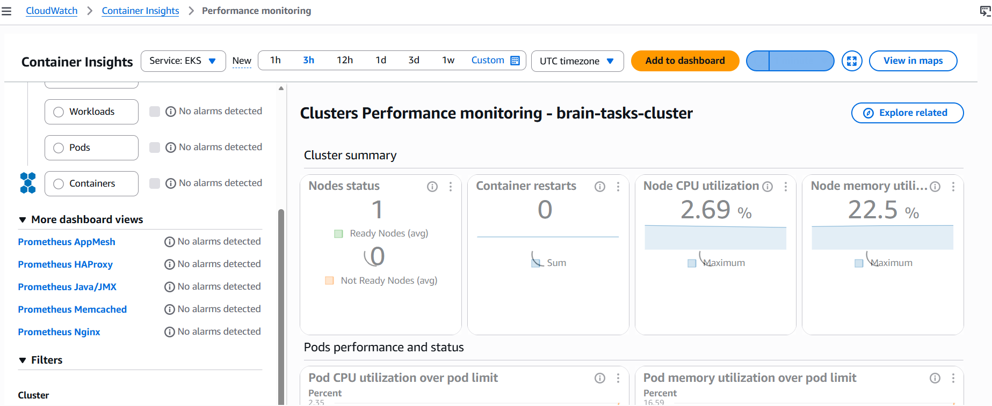
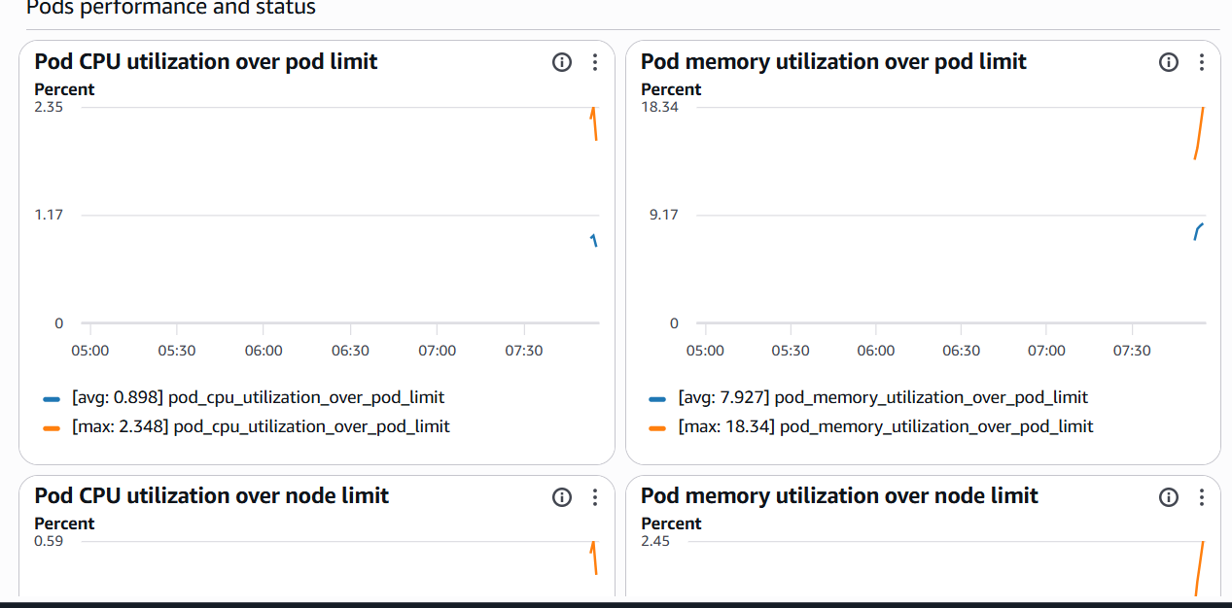
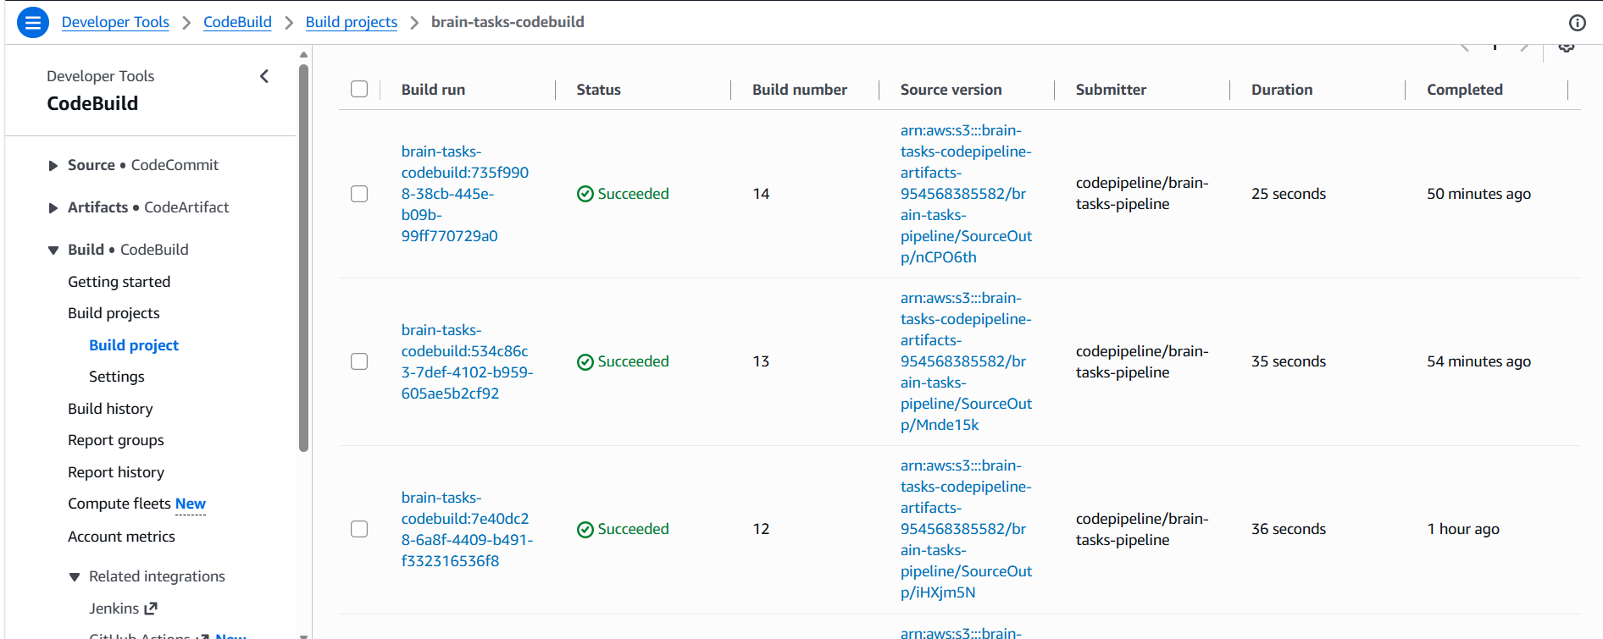

Brain Tasks application successfully opened in the browser
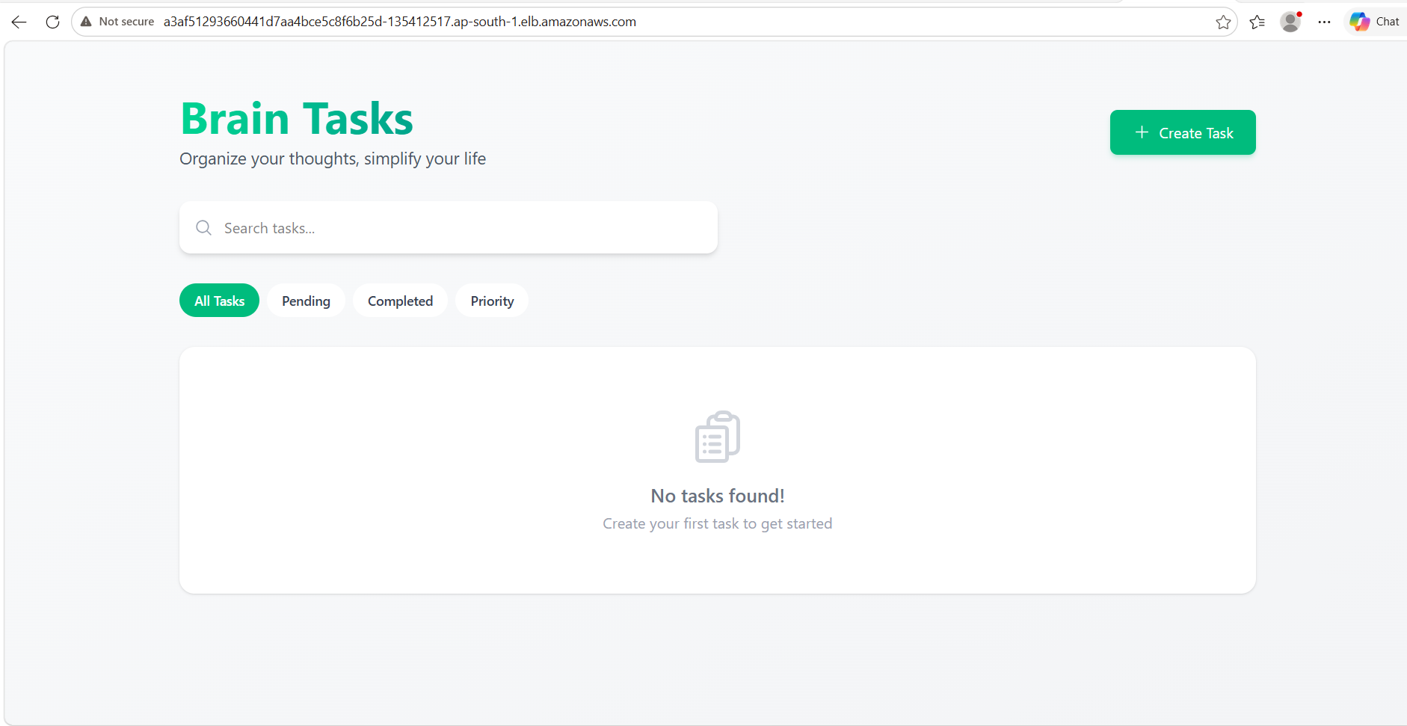

9. Final Submission Summary
The Brain Tasks application has been successfully implemented as an automated CI/CD workflow. Source code is maintained in GitHub, changes are processed through AWS CodePipeline and AWS CodeBuild, Docker images are stored in Amazon ECR, and the application is deployed to Amazon EKS and exposed through a Kubernetes LoadBalancer. The complete pipeline was verified with Source, Build, and Deploy stages showing Succeeded, and the application was successfully accessed through a web browser.

