Trend Application

1. Submission overview
Submitted the complete GitHub repository, a README explaining installation and the CI/CD workflow, screenshots demonstrating successful execution, and Kubernetes LoadBalancer deployment.

2. Repository and code
Repository: https://github.com/jeevanantham2205/Trend
Include the application distribution files, Dockerfile, nginx.conf, Jenkinsfile, infrastructure configuration, Kubernetes manifests (when implemented), and monitoring configuration if intended as part of the deliverable. Do not commit passwords, SSH private keys, tokens, or cloud credentials.

3. Project overview
1. Project Overview
Trendify is a static frontend web application containerized using Docker and served through Nginx on port 3000.
The project demonstrates a DevOps workflow using GitHub, Jenkins, Docker, AWS EC2, Amazon EKS, Kubernetes, Prometheus, and Grafana.
Technology Stack
Technology | Purpose
Git & GitHub | Source code and version control
Docker | Application containerization
Nginx | Static frontend web server
Jenkins | CI/CD pipeline automation
Docker Hub | Container image registry
AWS EC2 | Jenkins server and standalone Docker deployment
AWS EKS | Managed Kubernetes cluster
Kubernetes | Container orchestration
AWS Network Load Balancer | Public access to the Kubernetes application
Prometheus | Metrics collection
Node Exporter | Host-level metrics
cAdvisor | Container metrics
Grafana | Monitoring dashboards
Project Architecture
Developer
|
v
GitHub Repository
|
v
Jenkins CI/CD Pipeline
|
+-- Checkout
+-- Docker Build
+-- Docker Push
+-- Docker Deploy (EC2)
|
v
Docker Hub
|
+--------------------------+
| |
v v
AWS EC2 Amazon EKS
Docker Container Kubernetes Deployment
Port 3000 2 Application Pods
|
v
Kubernetes Service
Port 80 -> 3000
|
v
AWS Network Load Balancer
|
v
Public Application URL
Local Setup
Step 1 — Clone the Repository
git clone https://github.com/jeevanantham2205/Trend.git
cd Trend
Step 2 — Build the Docker Image
docker build -t trend-app:latest .
The Docker image packages the frontend application and its Nginx configuration.
Nginx is configured to serve the application on port 3000.
Step 3 — Run the Container
docker run -d \
--name trend-app \
-p 3000:3000 \
trend-app:latest
Step 4 — Verify the Application
docker ps
Expected: The container is running, with port 3000 published.
Test HTTP connectivity:
curl -I http://localhost:3000
Expected response:
HTTP/1.1 200 OK
Server: nginx
Open the application in a browser:
http://localhost:3000
Useful Docker Commands
docker logs trend-app
docker stop trend-app
docker start trend-app
docker inspect trend-app

Jenkins successful pipeline

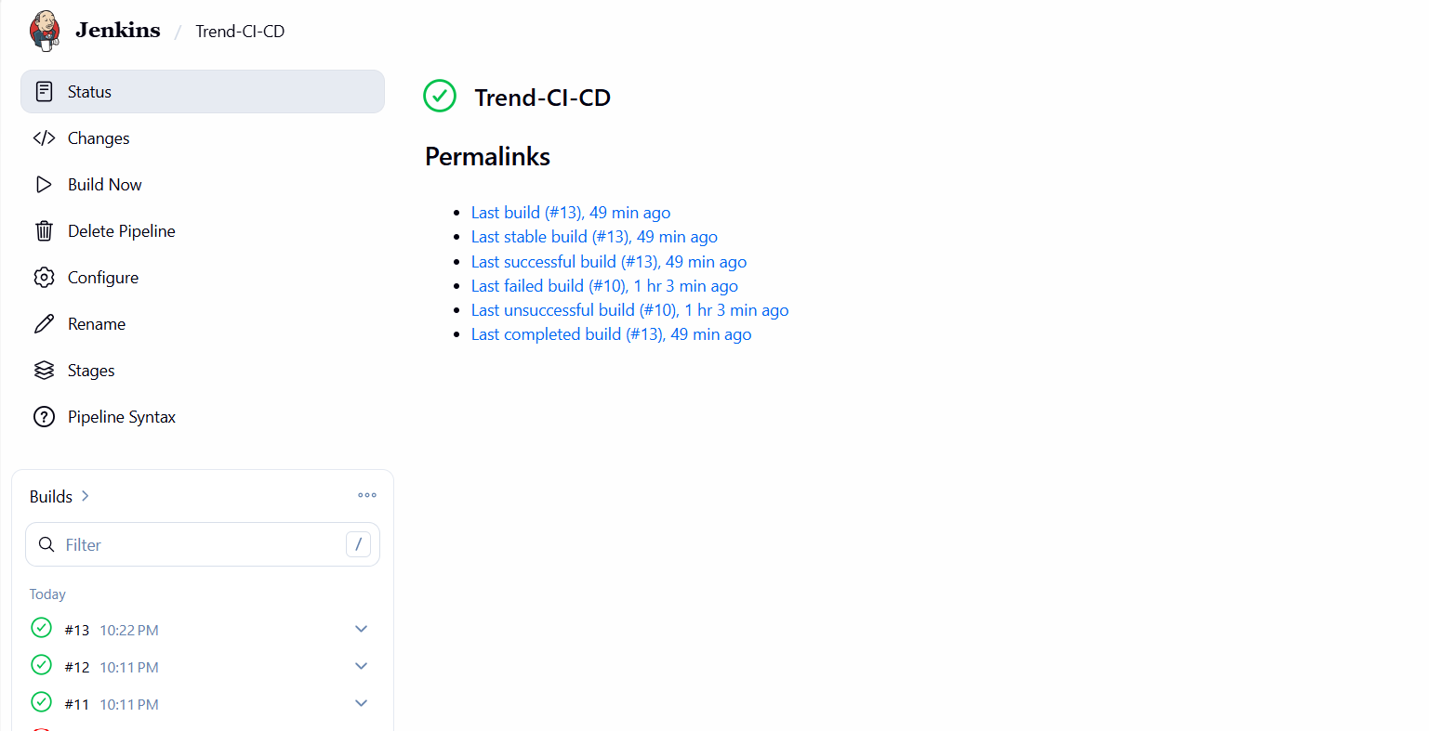
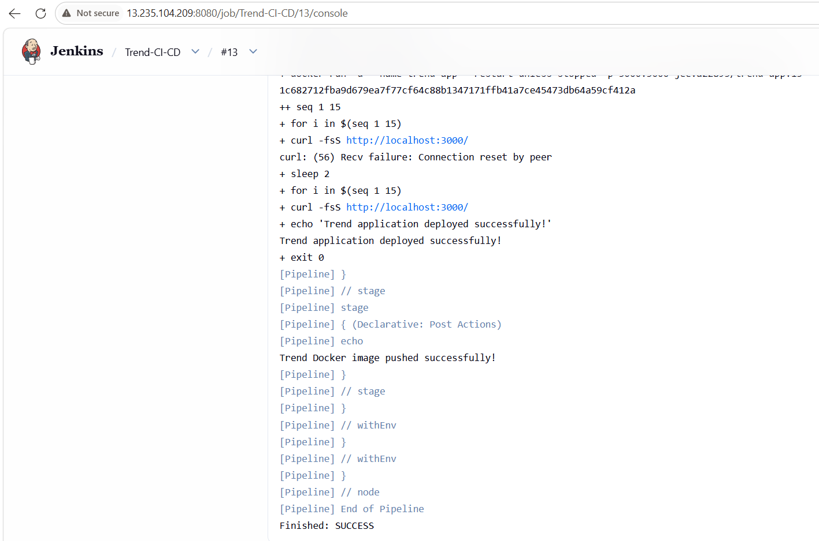

Docker Hub image

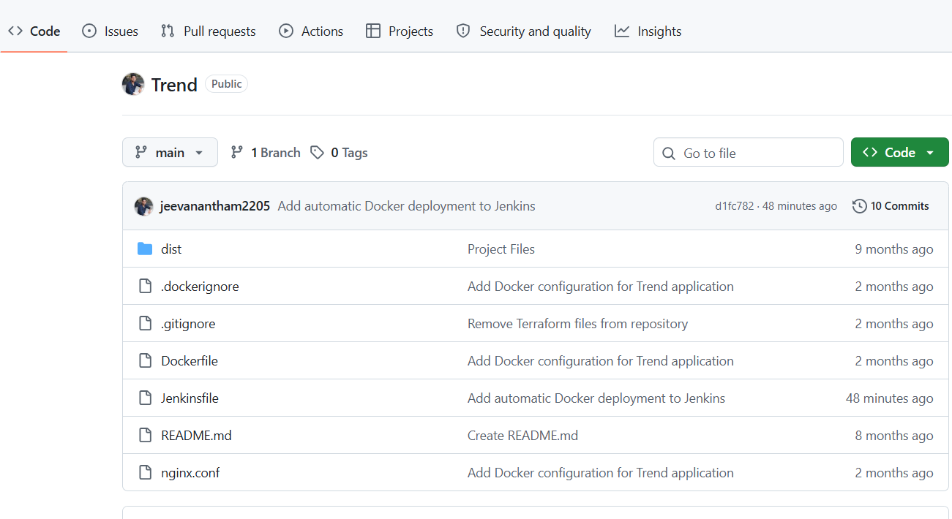
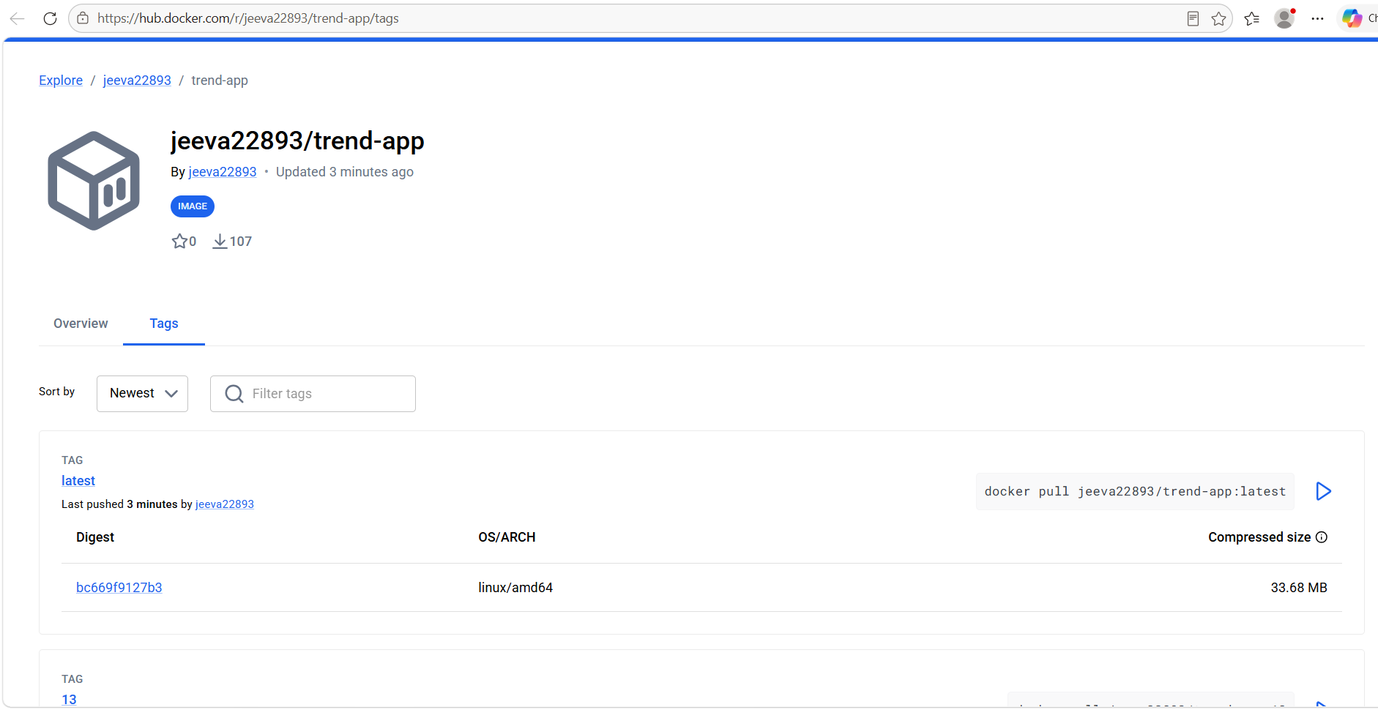

Monitoring dashboard

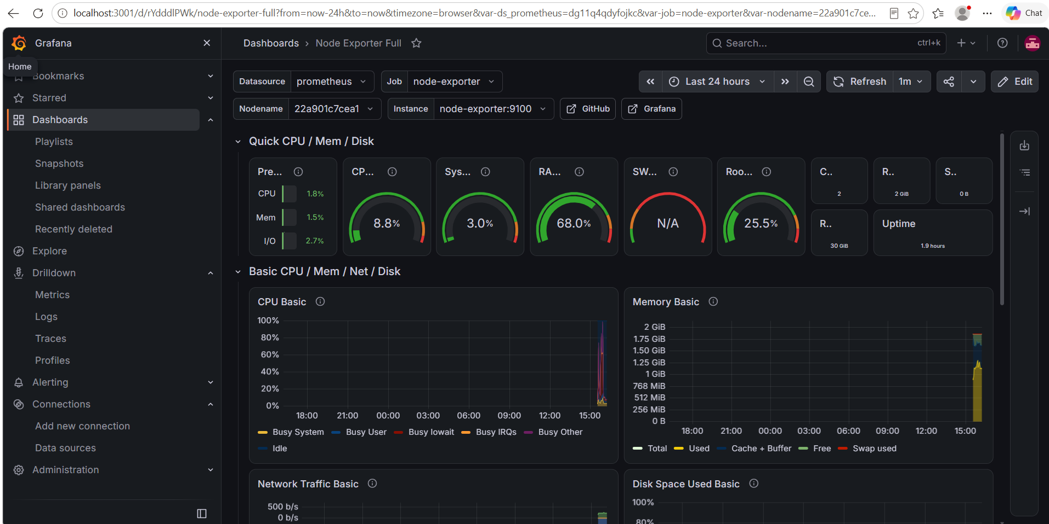

Kubernetes LoadBalancer and ARN

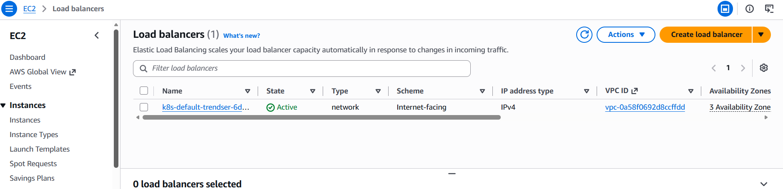
ARN: arn:aws:elasticloadbalancing:ap-south-1:954568385582:loadbalancer/net/k8s-default-trendser-6dd58fc27d/8de4695ca6e8755e

6. Kubernetes LoadBalancer details.

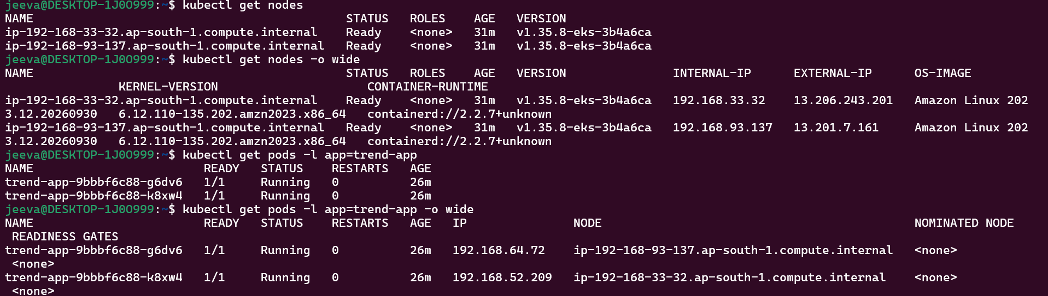
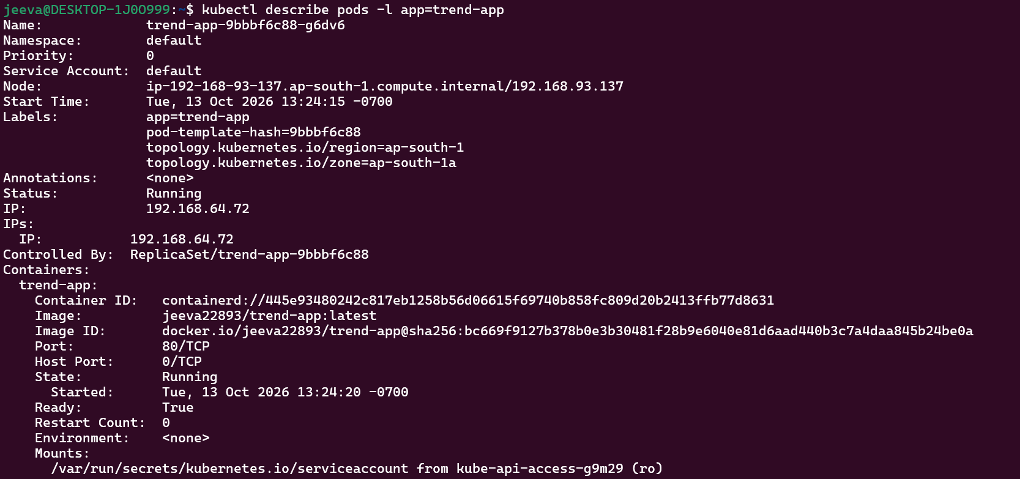
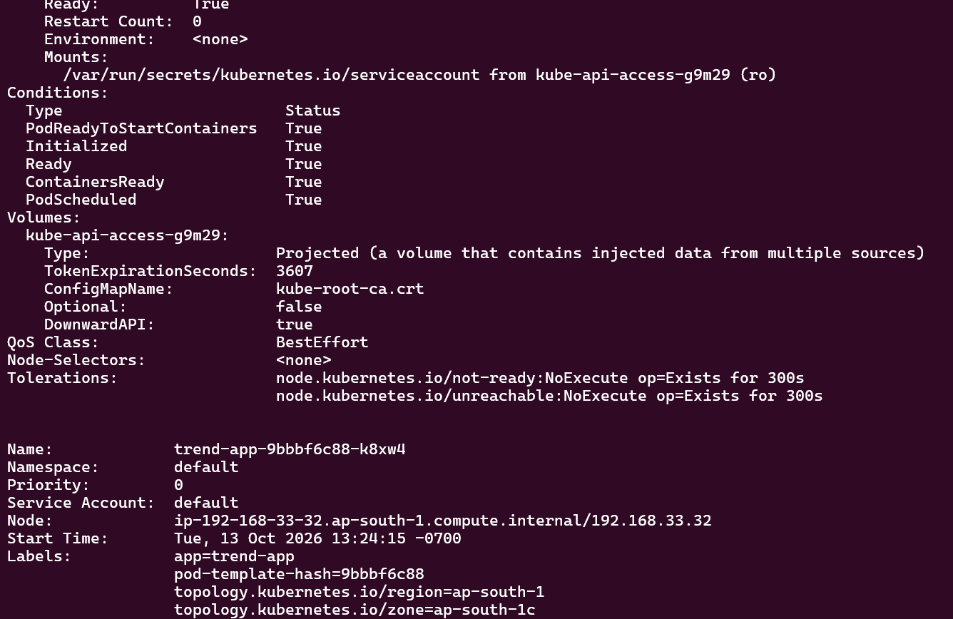
Public application URL: http://k8s-default-trendser-6dd58fc27d-8de4695ca6e8755e.elb.ap-south-1.amazonaws.com/

