TREND STORE
  - DevOps Deployment & Monitoring
AWS • Terraform • Docker • Jenkins • Amazon EKS • Kubernetes • Prometheus • Grafana
Project repository: https://github.com/jeevanantham2205/trend-store-devops-store-devops
Source application: https://github.com/Vennilavanguvi/Trend
Docker Hub image: jeeva22893/trend-store

Executive summary
The Trend Store static React/Vite distribution was containerized with Nginx, published to Docker Hub, and deployed to Amazon EKS. Terraform provisioned AWS networking, IAM, Jenkins EC2 infrastructure, and EKS resources. A Jenkins Pipeline builds and pushes versioned images and rolls out updates using kubectl. Prometheus and Grafana were installed on EKS to monitor Kubernetes and node metrics. The final source and infrastructure configuration were pushed to GitHub.

Verified outcome
Area | Observed result
Kubernetes application | trend-store deployment: 2/2 available
Monitoring | Grafana 3/3; Prometheus 2/2; all monitoring pods Running with zero restarts
Prometheus | Targets page accessible; user confirmed targets UP
Grafana | confirmed CPU and memory dashboards work
Helm | monitoring release: deployed, revision 1
GitHub | main synchronized at commit af91936; clean working tree

1. Architecture and deployment flow
Developer → GitHub (main) → Jenkins on EC2 → Docker build → Docker Hub
↓
kubectl deploy to EKS
↓
Trend Store pods (2 replicas)
↓
AWS Load Balancer → Web browser
Terraform → VPC / subnets / IAM / Jenkins EC2 / EKS / node group
Prometheus ← node-exporter + kube-state-metrics + Kubernetes targets
Grafana ← Prometheus data source

1.1 Technology stack
Layer | Technology | Purpose
Application | Prebuilt React/Vite dist | Static web frontend
Web server | Nginx 1.27 Alpine | Serves frontend on container port 3000
Container registry | Docker Hub | Versioned container images
Infrastructure as code | Terraform AWS provider / modules | VPC, IAM, EC2, EKS
CI/CD | Jenkins Pipeline | Build, push, deploy
Orchestration | Amazon EKS / Kubernetes 1.34 | Two application replicas
Monitoring | kube-prometheus-stack 92.9.0 | Prometheus, Grafana, exporters
Version control | GitHub | Code and infrastructure source

1.2 AWS deployment identifiers
Resource | Value
AWS Region | ap-south-1 (Mumbai)
EKS cluster | trend-store-eks
Jenkins EC2 | i-0de86ba1460feae93 (t3.medium)
Worker nodes | 2 × t3.medium; Ready at verification
VPC | vpc-095643c478719ec99
Jenkins address at verification | 13.234.18.166:8080 (may change)
Load Balancer URL | http://a07979ca135034c66bf5f137c47c59c7-1790172459.ap-south-1.elb.amazonaws.com

The AWS identifiers and public endpoints above are historical evidence and may change after resource updates or teardown.

2. Prerequisites and local environment
- Ubuntu under WSL on Windows; VS Code; Git; Docker; Terraform; AWS CLI v2; kubectl; Helm 3.
- AWS IAM principal with permissions for EC2, VPC, IAM, EKS, CloudWatch Logs, and supporting AWS services.
- Docker Hub account and a Jenkins credential for registry authentication.
- An EC2 SSH key pair, with private key stored locally and excluded from Git.
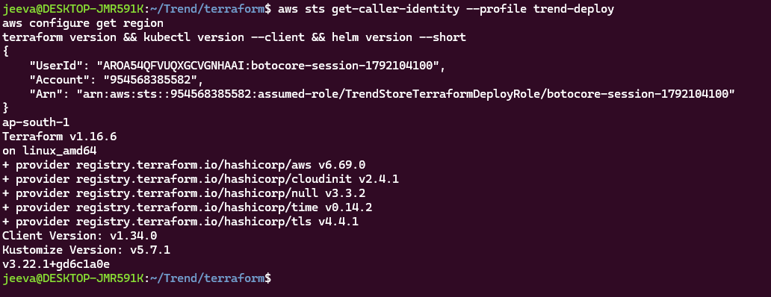

3. Repository and application containerization
The upstream Trend repository supplied a prebuilt Vite React dist/ directory rather than the full source tree and package.json. Accordingly, this pipeline packages the existing compiled assets; it does not run npm build.

3.1 Relevant repository structure
Trend/
├── dist/ # prebuilt frontend assets
├── Dockerfile
├── nginx.conf
├── Jenkinsfile
├── k8s/
│ ├── deployment.yaml
│ └── service.yaml
├── terraform/ # AWS infrastructure
├── monitoring/values.yaml
├── .gitignore
└── .dockerignore

3.2 Dockerfile
FROM nginx:1.27-alpine
COPY nginx.conf /etc/nginx/conf.d/default.conf
COPY dist/ /usr/share/nginx/html/
EXPOSE 3000
CMD ["nginx", "-g", "daemon off;"]
nginx.conf configures Nginx to listen on port 3000 and fall back to index.html for React single-page-app routes. The container image copies the prebuilt dist/ output.

3.3 Build, test, and publish
docker build -t jeeva22893/trend-store:latest .
docker run --rm -d --name trend-store-local -p 3001:3000 jeeva22893/trend-store:latest
curl -I http://localhost:3001
docker stop trend-store-local
# Registry push is performed by Jenkins after authenticating with Docker Hub.
The successful Jenkins pipeline published both the numbered build image and latest. The observed running EKS image was jeeva22893/trend-store:3 after Jenkins build #3.

4. Terraform infrastructure provisioning
Terraform source is in terraform/. The implementation used the AWS provider v6 series, terraform-aws-modules/vpc/aws v6.7.3 and terraform-aws-modules/eks/aws v21 series. The .terraform.lock.hcl file pins resolved provider versions.

4.1 Provisioned components
- VPC with public and private subnet routing and NAT for worker connectivity.
- IAM roles and permissions for Jenkins and EKS.
- Ubuntu Jenkins EC2 host, security group and startup script.
- EKS control plane and managed worker node group (two t3.medium nodes).
- EKS addons including VPC CNI, CoreDNS and kube-proxy.
- Security-group rule allowing Jenkins EC2 to reach the EKS API on TCP 443.

4.2 Typical execution commands
cd ~/Trend/terraform
terraform fmt -recursive
terraform init
terraform validate
AWS_PROFILE=trend-deploy terraform plan -input=false
AWS_PROFILE=trend-deploy terraform apply
Set the required values (region, project name, key pair, admin CIDR and Kubernetes version), review the plan and costs, and ensure permissions are sufficient. Use terraform.tfvars locally; do not commit it.

4.3 Observed Terraform validation
Terraform initialization and validation succeeded. Following the Jenkins-to-EKS security-group rule import and synchronization, the final plan returned “No changes. Your infrastructure matches the configuration.” This indicates the tracked infrastructure matched Terraform state at that point.

5. Jenkins server and CI/CD

5.1 Jenkins installation and connectivity
Jenkins runs on an EC2 t3.medium instance in the same VPC as EKS. The bootstrap script installs Java 21, Docker, Jenkins, AWS CLI and kubectl. The Jenkins service was running and its Docker access was verified. Jenkins uses its EC2 IAM role to access AWS rather than storing long-lived AWS access keys.
ssh -i ~/.ssh/grafana.pem ubuntu@13.234.18.166
sudo systemctl status jenkins
docker --version
aws --version
kubectl version --client
Security: the SSH key is private and must not be uploaded. Jenkins port 8080 and SSH port 22 were restricted to an administrator public IP; do not open them to 0.0.0.0/0 for convenience.

5.2 Jenkins job setup
- Create a Pipeline job named trend-store-cicd.
- Choose Pipeline script from SCM; Git repository https://github.com/jeevanantham2205/trend-store-devops-store-devops.git; branch */main; script path Jenkinsfile.
- Install required Jenkins Git, Pipeline and Docker-related plugins; configure Docker Hub username/token as Jenkins credential dockerhub-creds.
- Ensure Jenkins IAM access to EKS and network access to the Kubernetes API.

5.3 Pipeline stages and results
Stage | Action / evidence
Checkout | Fetch main branch from GitHub
Build | Docker build using Nginx and dist/
Registry push | Push jeeva22893/trend-store:<build-number> and latest
Configure cluster | aws eks update-kubeconfig for trend-store-eks
Deploy | kubectl apply -f k8s/
Rollout | kubectl set image ...:<build-number> and rollout status
Verify | kubectl get deployment/pods/services

Jenkins build #3 succeeded after Docker Hub credentials were corrected. The deployed application image tag was :3. Capture the build #3 console output showing the build, push and rollout stages.

6. Kubernetes deployment
The Deployment runs two replicas of trend-store with port 3000, readiness probing at /, and configured CPU/memory requests and limits. The Service is type LoadBalancer, forwarding external port 80 to container port 3000.
aws eks update-kubeconfig --region ap-south-1 --name trend-store-eks --profile trend-deploy
kubectl get nodes
kubectl apply -f ~/Trend/k8s/
kubectl get deployment trend-store
kubectl get pods -o wide
kubectl get svc trend-store-service
kubectl rollout status deployment/trend-store
Verified deployment output: trend-store READY 2/2, UP-TO-DATE 2, AVAILABLE 2. The AWS Load Balancer DNS address was provisioned and the application was accessible.

7. Prometheus and Grafana monitoring

7.1 Installation
Monitoring was installed into namespace monitoring with Helm chart kube-prometheus-stack 92.9.0. The custom monitoring/values.yaml reduces resource requests and retention, disables Alertmanager, and keeps Grafana internal using ClusterIP.
kubectl create namespace monitoring # only if absent
mkdir -p monitoring/charts
helm pull oci://ghcr.io/prometheus-community/charts/kube-prometheus-stack \
--version 92.9.0 --destination monitoring/charts
helm upgrade --install monitoring \
monitoring/charts/kube-prometheus-stack-92.9.0.tgz \
--namespace monitoring -f monitoring/values.yaml \
--wait --timeout 10m
The ordinary Helm repository chart download timed out at GitHub release-assets. Pulling the same chart through ghcr.io OCI succeeded. The final release status was deployed, revision 1.

7.2 Verified monitoring pods
Pod / component | Observed state
monitoring-grafana | 3/3 Running, 0 restarts
monitoring-kube-prometheus-operator | 1/1 Running, 0 restarts
monitoring-kube-state-metrics | 1/1 Running, 0 restarts
monitoring-prometheus-node-exporter (2 pods) | 1/1 Running each, 0 restarts
prometheus-monitoring-kube-prometheus-prometheus-0 | 2/2 Running, 0 restarts

7.3 Local dashboard access
# Grafana, from one WSL terminal
kubectl port-forward -n monitoring svc/monitoring-grafana 3002:80
# Browser: http://localhost:3002
# Prometheus, from a different terminal
kubectl port-forward -n monitoring svc/monitoring-kube-prometheus-prometheus 9091:9090
# Browser: http://localhost:9091/targets
Grafana username: admin. Retrieve the password locally from Kubernetes secret monitoring- and Grafana CPU/memory dashboards and Prometheus UP targets. Existing local services occupied ports 3000 and 9090, so 3002 and 9091 were used for port forwarding.

7.4 Monitoring interpretation
Prometheus collects Kubernetes and node/exporter metrics. The application is a static Nginx site and no application-specific /metrics endpoint was configured, so do not claim custom business metrics or HTTP request metrics are being scraped. Kubernetes workload health can be observed via kube-state-metrics and dashboards.

8. Troubleshooting record
Issue | Cause and resolution
Terraform AccessDenied | Initial IAM user lacked EC2 describe/create, IAM role creation, SSM, and Logs permissions. Deployment role profile trend-deploy was used.
Jenkins cloud-init failed | Leading blank line before #!/bin/bash caused Exec format error. Removed blank line and validated shell syntax. Existing instance retained; first-boot rerun not verified.
Jenkins to EKS API | Added TCP 443 SG rule referencing Jenkins SG, imported rule into Terraform and reconciled state.
Docker Hub login failure | Updated Jenkins dockerhub-creds; build #3 succeeded.
Helm chart download timeout | GitHub release-assets timed out; ghcr.io OCI pull succeeded.
Port 9090 in use | Forwarded local 9091 to Prometheus port 9090.
Metrics API not available | kubectl top requires Kubernetes Metrics Server; Prometheus/Grafana operate separately.

9. GitHub publication
cd ~/Trend
git status --short
git log -1 --oneline
Final verified commit: af91936 — “Add Terraform AWS infrastructure and EKS monitoring”. HEAD, origin/main and origin/HEAD pointed to this commit, and git status --short was empty. Repository: https://github.com/jeevanantham2205/trend-store-devops-store-devops

10. Submission evidence checklist
Insert actual screenshots in the spaces indicated below. Suggested naming convention: 01-application.png, 02-terraform-plan.png, etc. Do not include AWS secrets or Jenkins credentials in screenshots.

01 — Trend Store application
Browser showing the deployed storefront through the AWS Load Balancer URL.
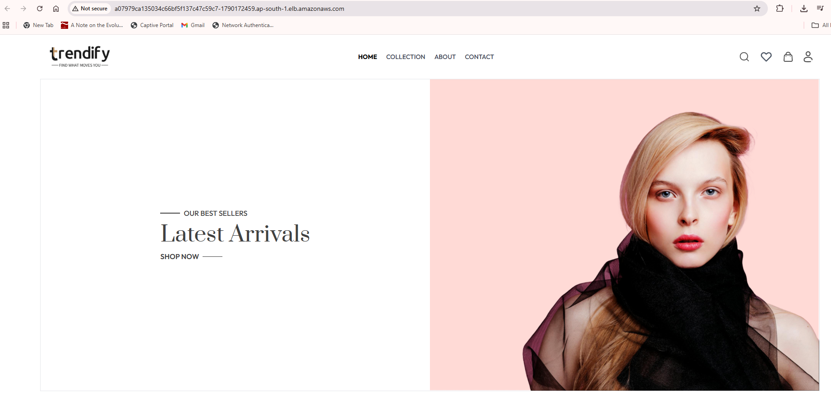
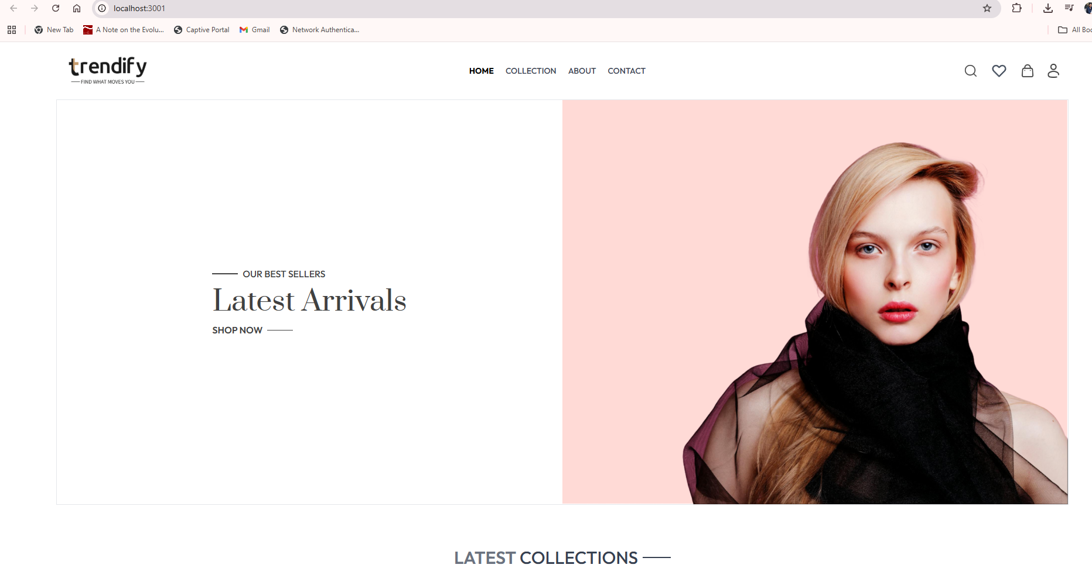

02 — Terraform validation and plan
Terraform Configuration Files
Terraform was used to define and provision the AWS infrastructure required for the Trend Store DevOps deployment. The infrastructure is managed as code, allowing consistent provisioning and validation.
1. main.tf — AWS Provider and Networking
The main.tf file configures the AWS infrastructure and Virtual Private Cloud (VPC) networking. The VPC provides the network environment for the Jenkins EC2 instance and Amazon EKS cluster.
2. eks.tf — Amazon EKS Cluster
The eks.tf file defines the trend-store-eks Kubernetes cluster in AWS Mumbai (ap-south-1). The configuration includes a managed node group with two worker nodes, providing the compute resources needed to run the Trend Store application.
3. jenkins.tf — Jenkins EC2 Infrastructure
The jenkins.tf file defines the AWS EC2 instance used to host Jenkins. It includes networking, security group configuration, IAM integration, and a reference to the Jenkins bootstrap script.
4. jenkins-userdata.sh — Jenkins Installation
The jenkins-userdata.sh script defines installation steps for Jenkins and supporting tools, including Java, Docker, AWS CLI and kubectl. The script is referenced by the Terraform EC2 configuration. During the project, an initial bootstrap formatting issue was corrected, and the existing Jenkins instance was configured successfully.
5. variables.tf and outputs.tf
The variables.tf file defines configurable Terraform inputs, while outputs.tf provides information about the deployed infrastructure.
6. jenkins-eks-access.tf — Jenkins to EKS Connectivity
This file manages the security group rule allowing the Jenkins EC2 instance to communicate with the EKS Kubernetes API over HTTPS.
Validation and Verification
Terraform configuration validation was performed using:
terraform validate
Result: Success! The configuration is valid.
A Terraform plan was also used to compare the deployed infrastructure against the configuration and verify the expected infrastructure state.
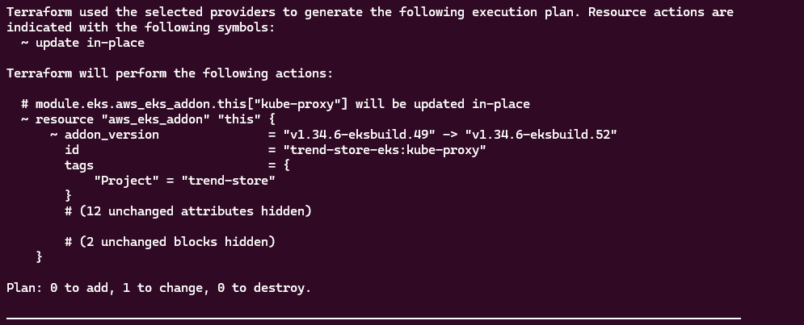
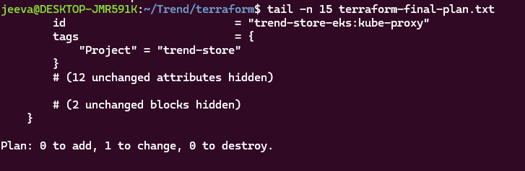
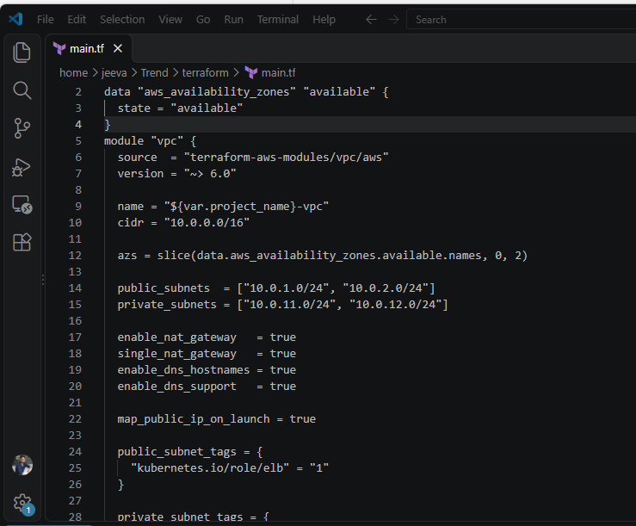
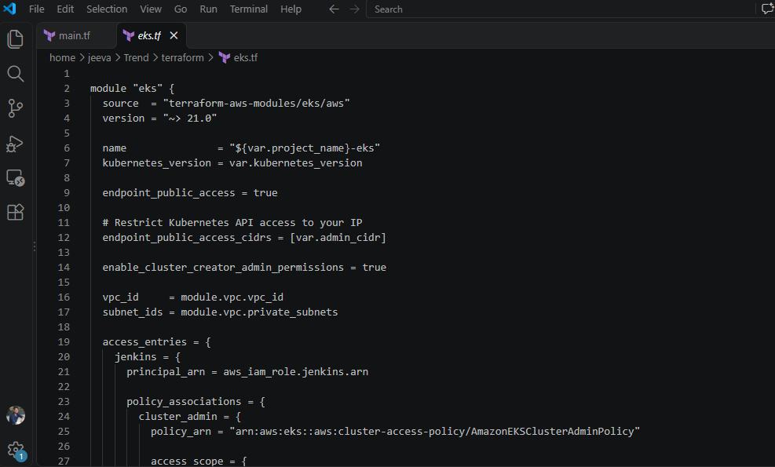
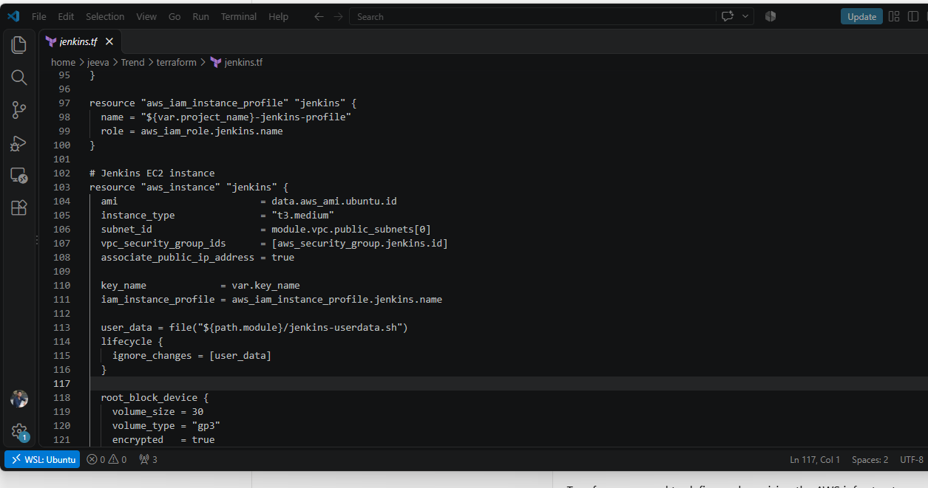

03 — AWS infrastructure
EKS cluster and two Ready worker nodes; EC2 Jenkins instance.
Jenkins EC2 Provisioning and Installation Using Terraform
Terraform was used to provision the AWS EC2 infrastructure required to host the Jenkins CI/CD server for the Trend Store application.
The jenkins.tf configuration defines the EC2 instance, networking, security group and IAM integration. It references the jenkins-userdata.sh bootstrap script through Terraform's user_data argument.
The bootstrap script defines the installation of Java, Docker, Jenkins, AWS CLI and kubectl. These tools support the CI/CD pipeline, which builds the Trend Store Docker image, pushes it to DockerHub and deploys the application to Amazon EKS.
During initial provisioning, the user-data script encountered an execution error caused by an incorrectly positioned shebang. This was identified through cloud-init logs. The source script was corrected, and the required tools were installed and verified on the existing Jenkins EC2 instance.
Terraform state verification confirmed that the Jenkins EC2 resource was managed by Terraform. The Jenkins and Docker services were subsequently verified as running.
Evidence: Terraform EC2 configuration, Jenkins user-data script, AWS EC2 instance details, Terraform state verification and Jenkins service status.

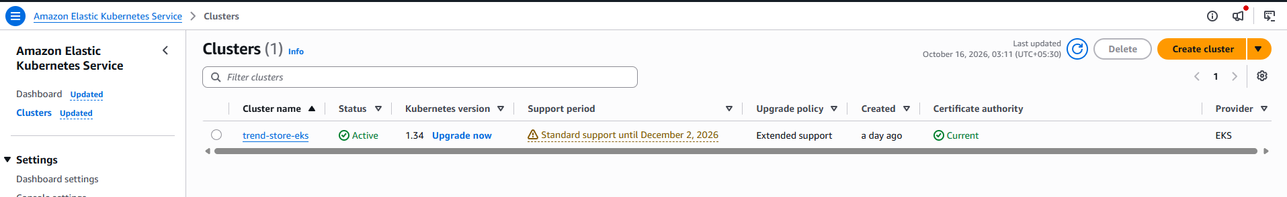
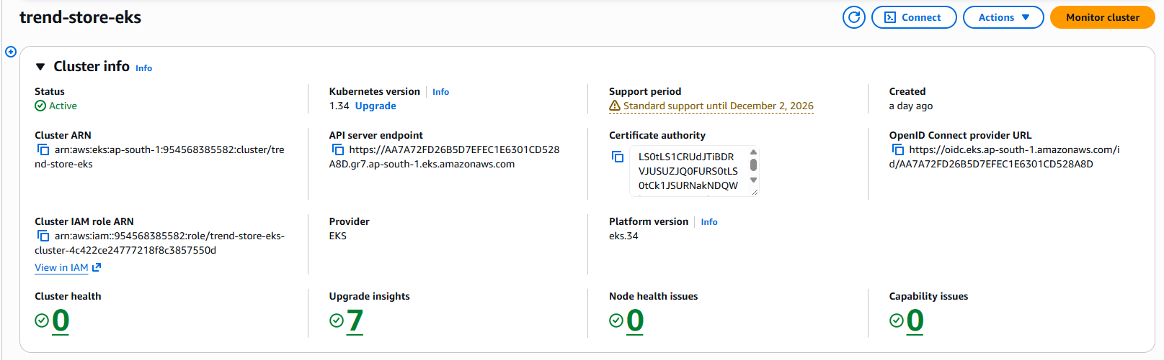
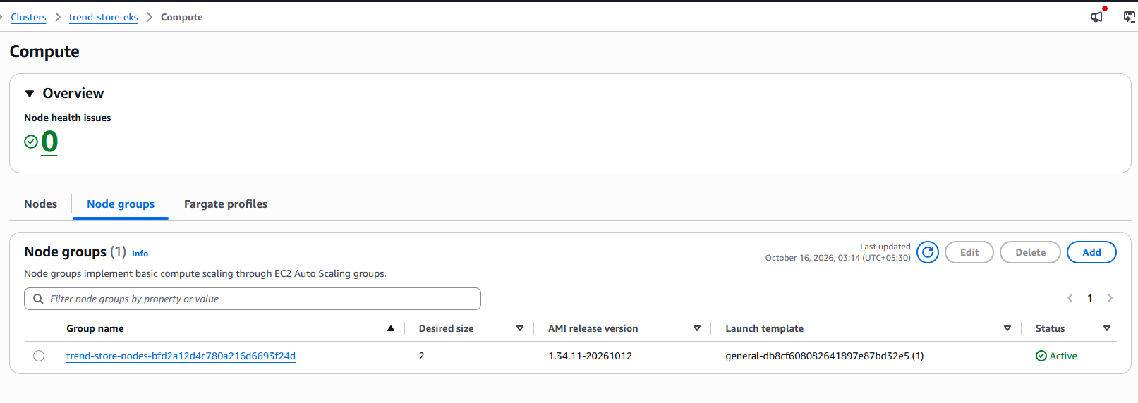

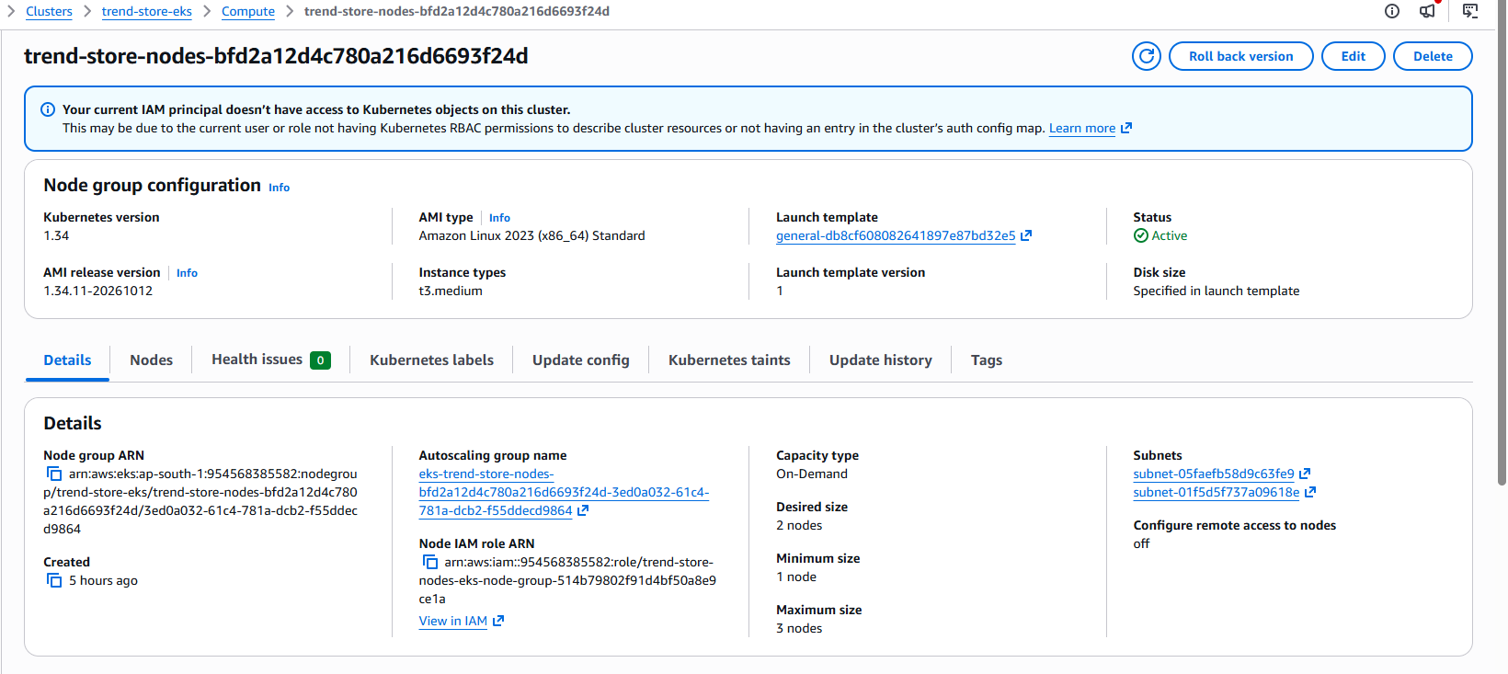
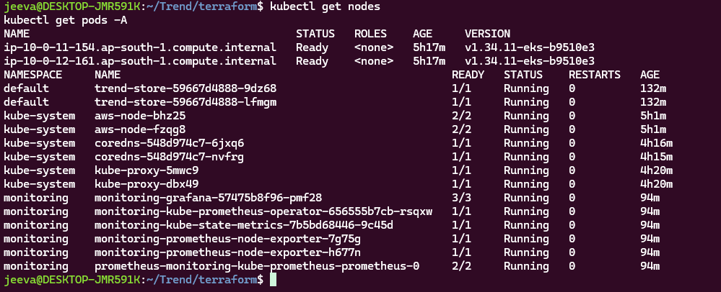
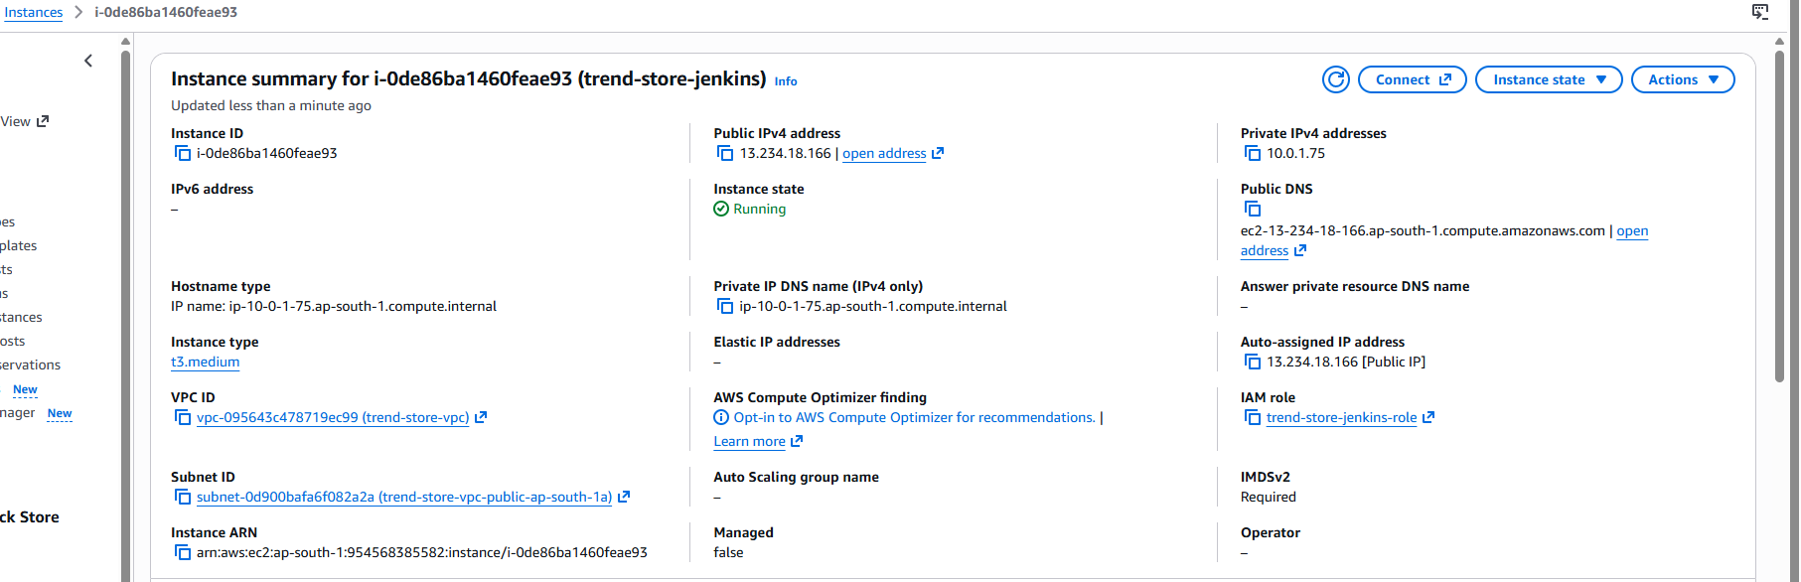
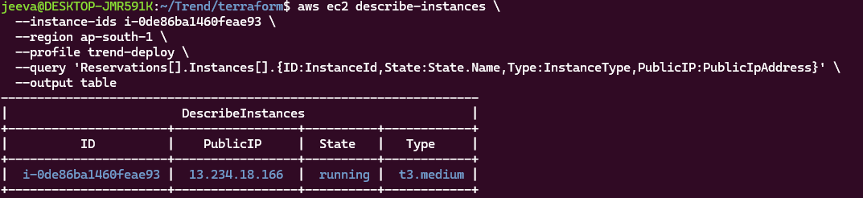
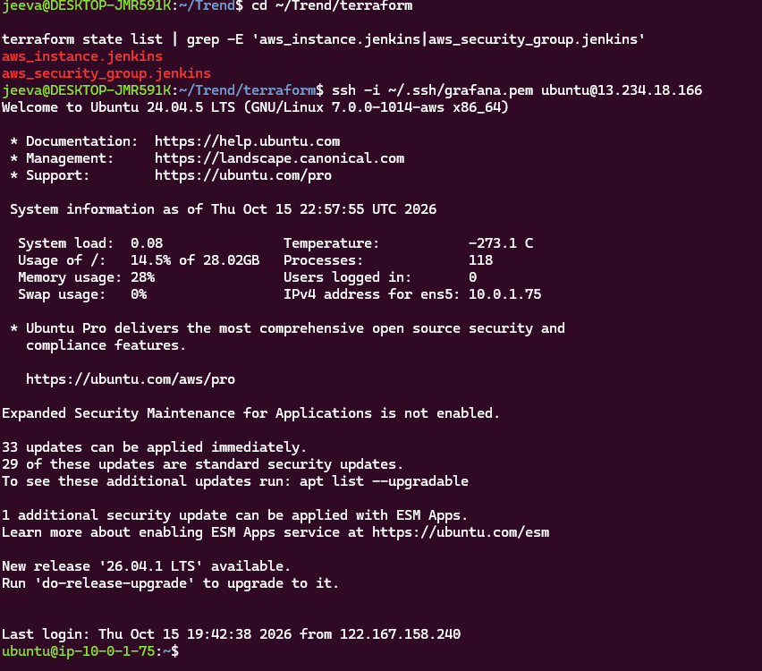
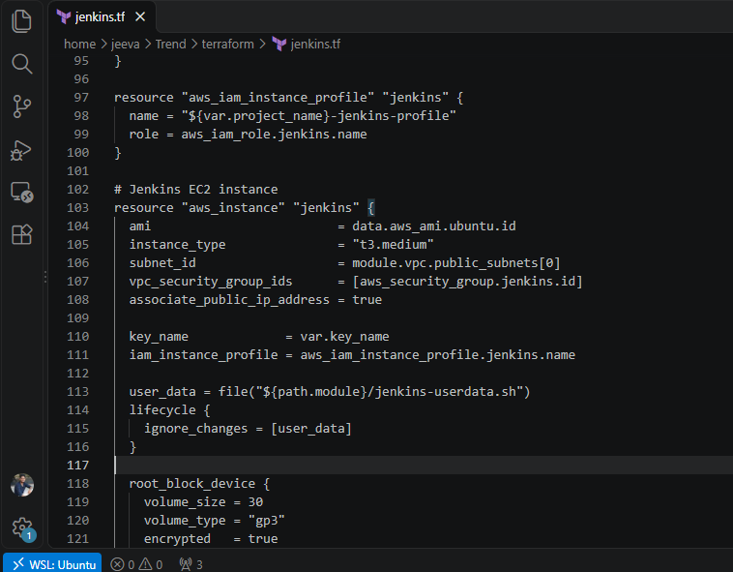
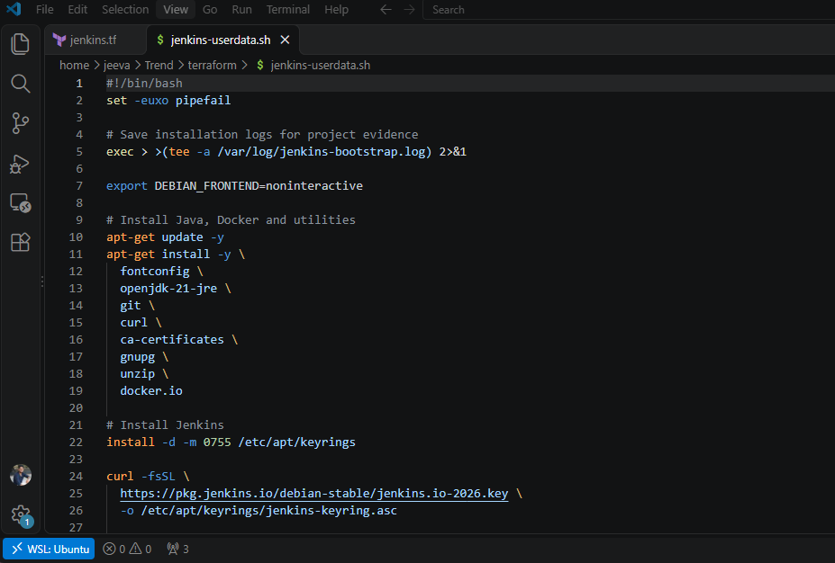

04 — Jenkins CI/CD
GitHub Repository and Jenkins Integration
The Trend Store DevOps project is maintained in a GitHub repository to provide source control and support continuous integration and deployment.
GitHub Repository: https://github.com/jeevanantham2205/trend-store-devops-store-devops
Branch: main
Repository Structure
The repository contains the Dockerfile for application containerization, Jenkinsfile for CI/CD automation, Kubernetes Deployment and Service YAML manifests, Terraform infrastructure configuration, and Prometheus/Grafana monitoring configuration.
The main directories and files are:
- k8s/ — Kubernetes Deployment and LoadBalancer Service manifests.
- terraform/ — AWS VPC, EKS, Jenkins EC2 and IAM infrastructure configuration.
- monitoring/ — Prometheus and Grafana Helm configuration.
- Dockerfile — Builds the Trend Store application container.
- Jenkinsfile — Defines the Docker build, DockerHub push and Amazon EKS deployment pipeline.
- nginx.conf — Configures Nginx to serve the application on port 3000.
- .gitignore and .dockerignore — Exclude unnecessary and sensitive files.
GitHub Integration with Jenkins
Jenkins was configured using the Pipeline from SCM option with Git as the source code management system.
The Jenkins job retrieves the project from the GitHub repository and executes the Jenkinsfile to:
- Check out the project code.
- Build the Trend Store Docker image.
- Push the image to DockerHub.
- Connect to the Amazon EKS cluster.
- Apply the Kubernetes manifests and update the deployed application image.
- Verify the Kubernetes deployment rollout.
Result
The GitHub repository provides version control for the DevOps project and is integrated with Jenkins to execute the CI/CD deployment pipeline.
Evidence: GitHub repository overview, complete tracked repository file tree, Git remote configuration and Jenkins Pipeline from SCM configuration.

Config:
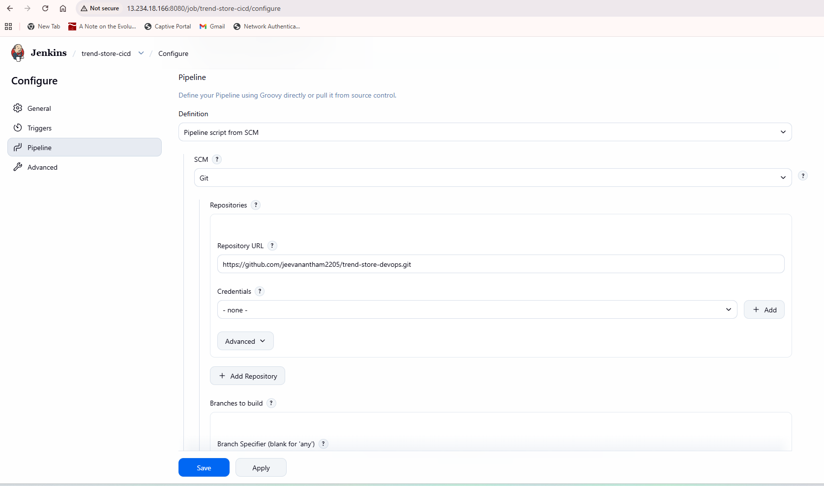
Build Output:
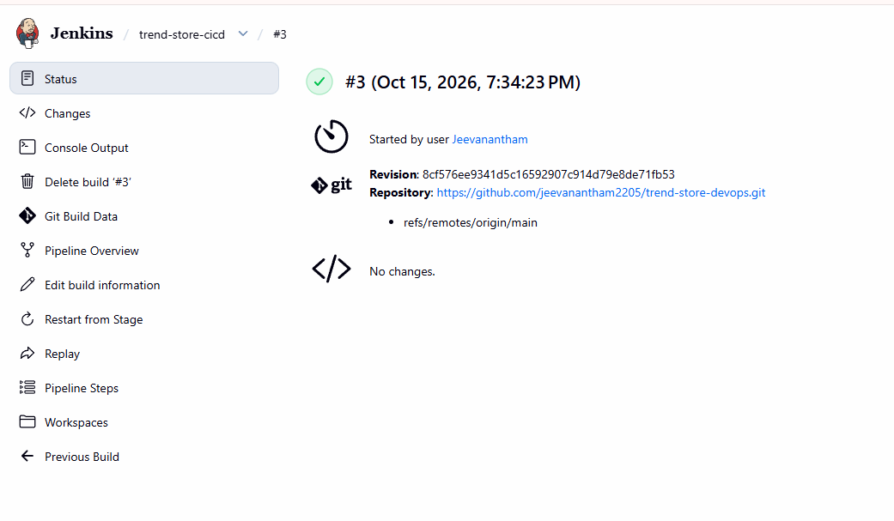
Console Output:
Started by user Jeevanantham
Obtained Jenkinsfile from git https://github.com/jeevanantham2205/trend-store-devops-store-devops.git
[Pipeline] Start of Pipeline
[Pipeline] node
Running on Jenkins in /var/lib/jenkins/workspace/trend-store-cicd
[Pipeline] {
[Pipeline] stage
[Pipeline] { (Declarative: Checkout SCM)
[Pipeline] checkout
The recommended git tool is: git
No credentials specified
> git rev-parse --resolve-git-dir /var/lib/jenkins/workspace/trend-store-cicd/.git # timeout=10
Fetching changes from the remote Git repository
> git config remote.origin.url https://github.com/jeevanantham2205/trend-store-devops-store-devops.git # timeout=10
Fetching upstream changes from https://github.com/jeevanantham2205/trend-store-devops-store-devops.git
> git --version # timeout=10
> git --version # 'git version 2.43.0'
> git fetch --tags --force --progress -- https://github.com/jeevanantham2205/trend-store-devops-store-devops.git +refs/heads/*:refs/remotes/origin/* # timeout=10
> git rev-parse refs/remotes/origin/main^{commit} # timeout=10
Checking out Revision 8cf576ee9341d5c16592907c914d79e8de71fb53 (refs/remotes/origin/main)
> git config core.sparsecheckout # timeout=10
> git checkout -f 8cf576ee9341d5c16592907c914d79e8de71fb53 # timeout=10
Commit message: "Add Docker Kubernetes and Jenkins CI/CD configuration"
> git rev-list --no-walk 8cf576ee9341d5c16592907c914d79e8de71fb53 # timeout=10
[Pipeline] }
[Pipeline] // stage
[Pipeline] withEnv
[Pipeline] {
[Pipeline] withEnv
[Pipeline] {
[Pipeline] stage
[Pipeline] { (Checkout)
[Pipeline] checkout
The recommended git tool is: git
No credentials specified
> git rev-parse --resolve-git-dir /var/lib/jenkins/workspace/trend-store-cicd/.git # timeout=10
Fetching changes from the remote Git repository
> git config remote.origin.url https://github.com/jeevanantham2205/trend-store-devops-store-devops.git # timeout=10
Fetching upstream changes from https://github.com/jeevanantham2205/trend-store-devops-store-devops.git
> git --version # timeout=10
> git --version # 'git version 2.43.0'
> git fetch --tags --force --progress -- https://github.com/jeevanantham2205/trend-store-devops-store-devops.git +refs/heads/*:refs/remotes/origin/* # timeout=10
> git rev-parse refs/remotes/origin/main^{commit} # timeout=10
Checking out Revision 8cf576ee9341d5c16592907c914d79e8de71fb53 (refs/remotes/origin/main)
> git config core.sparsecheckout # timeout=10
> git checkout -f 8cf576ee9341d5c16592907c914d79e8de71fb53 # timeout=10
Commit message: "Add Docker Kubernetes and Jenkins CI/CD configuration"
[Pipeline] }
[Pipeline] // stage
[Pipeline] stage
[Pipeline] { (Build Docker Image)
[Pipeline] sh
+ docker build -t jeeva22893/trend-store:3 -t jeeva22893/trend-store:latest .
DEPRECATED: The legacy builder is deprecated and will be removed in a future release.
Install the buildx component to build images with BuildKit:
https://docs.docker.com/go/buildx/

Sending build context to Docker daemon 9.29MB

Step 1/5 : FROM nginx:1.27-alpine
---> 65645c7bb6a0
Step 2/5 : COPY nginx.conf /etc/nginx/conf.d/default.conf
---> Using cache
---> 7b941429c45b
Step 3/5 : COPY dist/ /usr/share/nginx/html/
---> Using cache
---> 989b87082f63
Step 4/5 : EXPOSE 3000
---> Using cache
---> b6a0fefe865b
Step 5/5 : CMD ["nginx", "-g", "daemon off;"]
---> Using cache
---> e040dc259dd6
Successfully built e040dc259dd6
Successfully tagged jeeva22893/trend-store:3
Successfully tagged jeeva22893/trend-store:latest
[Pipeline] }
[Pipeline] // stage
[Pipeline] stage
[Pipeline] { (Push to DockerHub)
[Pipeline] withCredentials
Masking supported pattern matches of $DOCKER_TOKEN
[Pipeline] {
[Pipeline] sh
+ set +x

WARNING! Your credentials are stored unencrypted in '/var/lib/jenkins/.docker/config.json'.
Configure a credential helper to remove this warning. See
https://docs.docker.com/go/credential-store/

Login Succeeded
The push refers to repository [docker.io/jeeva22893/trend-store]
d7e507024086: Waiting
81bd8ed7ec67: Waiting
197eb75867ef: Waiting
34a64644b756: Waiting
37d82393e96a: Waiting
b464cfdf2a63: Waiting
39c2ddfd6010: Waiting
f18232174bc9: Waiting
61ca4f733c80: Waiting
ca1d3f2f8957: Waiting
ca1d3f2f8957: Waiting
d7e507024086: Waiting
81bd8ed7ec67: Waiting
197eb75867ef: Waiting
34a64644b756: Waiting
37d82393e96a: Waiting
b464cfdf2a63: Waiting
39c2ddfd6010: Waiting
f18232174bc9: Waiting
61ca4f733c80: Waiting
ca1d3f2f8957: Waiting
d7e507024086: Waiting
81bd8ed7ec67: Waiting
197eb75867ef: Waiting
34a64644b756: Waiting
37d82393e96a: Waiting
b464cfdf2a63: Waiting
39c2ddfd6010: Waiting
f18232174bc9: Waiting
61ca4f733c80: Waiting
ca1d3f2f8957: Waiting
d7e507024086: Waiting
81bd8ed7ec67: Waiting
197eb75867ef: Waiting
34a64644b756: Waiting
37d82393e96a: Waiting
b464cfdf2a63: Waiting
39c2ddfd6010: Waiting
f18232174bc9: Waiting
61ca4f733c80: Waiting
ca1d3f2f8957: Waiting
d7e507024086: Waiting
81bd8ed7ec67: Waiting
197eb75867ef: Waiting
34a64644b756: Waiting
37d82393e96a: Waiting
b464cfdf2a63: Waiting
39c2ddfd6010: Waiting
f18232174bc9: Waiting
61ca4f733c80: Waiting
ca1d3f2f8957: Waiting
d7e507024086: Waiting
81bd8ed7ec67: Waiting
197eb75867ef: Waiting
34a64644b756: Waiting
37d82393e96a: Waiting
b464cfdf2a63: Waiting
39c2ddfd6010: Waiting
f18232174bc9: Waiting
61ca4f733c80: Waiting
ca1d3f2f8957: Waiting
d7e507024086: Waiting
81bd8ed7ec67: Waiting
197eb75867ef: Waiting
34a64644b756: Waiting
37d82393e96a: Waiting
b464cfdf2a63: Waiting
39c2ddfd6010: Waiting
f18232174bc9: Waiting
61ca4f733c80: Waiting
197eb75867ef: Waiting
34a64644b756: Waiting
37d82393e96a: Waiting
b464cfdf2a63: Waiting
39c2ddfd6010: Waiting
f18232174bc9: Waiting
61ca4f733c80: Waiting
ca1d3f2f8957: Waiting
d7e507024086: Waiting
81bd8ed7ec67: Waiting
ca1d3f2f8957: Waiting
d7e507024086: Waiting
81bd8ed7ec67: Waiting
197eb75867ef: Waiting
34a64644b756: Waiting
37d82393e96a: Waiting
b464cfdf2a63: Waiting
39c2ddfd6010: Waiting
f18232174bc9: Waiting
61ca4f733c80: Waiting
39c2ddfd6010: Waiting
f18232174bc9: Waiting
61ca4f733c80: Waiting
ca1d3f2f8957: Waiting
d7e507024086: Waiting
81bd8ed7ec67: Waiting
197eb75867ef: Waiting
34a64644b756: Waiting
37d82393e96a: Waiting
b464cfdf2a63: Waiting
39c2ddfd6010: Waiting
f18232174bc9: Waiting
61ca4f733c80: Waiting
ca1d3f2f8957: Layer already exists
d7e507024086: Waiting
81bd8ed7ec67: Waiting
197eb75867ef: Waiting
34a64644b756: Waiting
37d82393e96a: Waiting
b464cfdf2a63: Waiting
34a64644b756: Layer already exists
37d82393e96a: Waiting
b464cfdf2a63: Layer already exists
39c2ddfd6010: Waiting
f18232174bc9: Waiting
61ca4f733c80: Waiting
d7e507024086: Waiting
81bd8ed7ec67: Waiting
197eb75867ef: Waiting
f18232174bc9: Waiting
61ca4f733c80: Waiting
d7e507024086: Waiting
81bd8ed7ec67: Waiting
197eb75867ef: Waiting
37d82393e96a: Waiting
39c2ddfd6010: Waiting
81bd8ed7ec67: Waiting
197eb75867ef: Layer already exists
37d82393e96a: Layer already exists
39c2ddfd6010: Layer already exists
f18232174bc9: Layer already exists
61ca4f733c80: Waiting
d7e507024086: Layer already exists
81bd8ed7ec67: Layer already exists
61ca4f733c80: Layer already exists
3: digest: sha256:e040dc259dd6969f552d9b6b8a6f7785bb5e8b93665b6599bad4ad77b1009d7c size: 2485
The push refers to repository [docker.io/jeeva22893/trend-store]
81bd8ed7ec67: Waiting
197eb75867ef: Waiting
37d82393e96a: Waiting
f18232174bc9: Waiting
61ca4f733c80: Waiting
b464cfdf2a63: Waiting
34a64644b756: Waiting
39c2ddfd6010: Waiting
ca1d3f2f8957: Waiting
d7e507024086: Waiting
ca1d3f2f8957: Waiting
d7e507024086: Waiting
81bd8ed7ec67: Waiting
197eb75867ef: Waiting
37d82393e96a: Waiting
f18232174bc9: Waiting
61ca4f733c80: Waiting
b464cfdf2a63: Waiting
34a64644b756: Waiting
39c2ddfd6010: Waiting
ca1d3f2f8957: Waiting
d7e507024086: Waiting
81bd8ed7ec67: Waiting
197eb75867ef: Waiting
37d82393e96a: Waiting
f18232174bc9: Waiting
61ca4f733c80: Waiting
b464cfdf2a63: Waiting
34a64644b756: Waiting
39c2ddfd6010: Waiting
d7e507024086: Waiting
81bd8ed7ec67: Waiting
197eb75867ef: Waiting
37d82393e96a: Waiting
f18232174bc9: Waiting
61ca4f733c80: Waiting
b464cfdf2a63: Waiting
34a64644b756: Waiting
39c2ddfd6010: Waiting
ca1d3f2f8957: Waiting
d7e507024086: Waiting
81bd8ed7ec67: Waiting
197eb75867ef: Waiting
37d82393e96a: Waiting
f18232174bc9: Waiting
61ca4f733c80: Waiting
b464cfdf2a63: Waiting
34a64644b756: Waiting
39c2ddfd6010: Waiting
ca1d3f2f8957: Waiting
f18232174bc9: Waiting
61ca4f733c80: Waiting
b464cfdf2a63: Waiting
34a64644b756: Waiting
39c2ddfd6010: Waiting
ca1d3f2f8957: Waiting
d7e507024086: Waiting
81bd8ed7ec67: Waiting
197eb75867ef: Waiting
37d82393e96a: Waiting
f18232174bc9: Waiting
61ca4f733c80: Waiting
b464cfdf2a63: Waiting
34a64644b756: Waiting
39c2ddfd6010: Waiting
ca1d3f2f8957: Waiting
d7e507024086: Waiting
81bd8ed7ec67: Waiting
197eb75867ef: Waiting
37d82393e96a: Waiting
37d82393e96a: Waiting
f18232174bc9: Waiting
61ca4f733c80: Waiting
b464cfdf2a63: Waiting
34a64644b756: Waiting
39c2ddfd6010: Waiting
ca1d3f2f8957: Waiting
d7e507024086: Waiting
81bd8ed7ec67: Waiting
197eb75867ef: Waiting
f18232174bc9: Waiting
61ca4f733c80: Waiting
b464cfdf2a63: Waiting
34a64644b756: Waiting
39c2ddfd6010: Waiting
ca1d3f2f8957: Waiting
d7e507024086: Waiting
81bd8ed7ec67: Waiting
197eb75867ef: Waiting
37d82393e96a: Waiting
39c2ddfd6010: Waiting
ca1d3f2f8957: Waiting
d7e507024086: Waiting
81bd8ed7ec67: Waiting
197eb75867ef: Waiting
37d82393e96a: Waiting
f18232174bc9: Waiting
61ca4f733c80: Waiting
b464cfdf2a63: Waiting
34a64644b756: Waiting
34a64644b756: Waiting
39c2ddfd6010: Layer already exists
ca1d3f2f8957: Waiting
d7e507024086: Waiting
81bd8ed7ec67: Waiting
197eb75867ef: Waiting
37d82393e96a: Layer already exists
f18232174bc9: Waiting
61ca4f733c80: Waiting
b464cfdf2a63: Waiting
ca1d3f2f8957: Waiting
d7e507024086: Waiting
81bd8ed7ec67: Layer already exists
197eb75867ef: Waiting
f18232174bc9: Layer already exists
61ca4f733c80: Waiting
b464cfdf2a63: Waiting
34a64644b756: Waiting
197eb75867ef: Waiting
61ca4f733c80: Waiting
b464cfdf2a63: Waiting
34a64644b756: Waiting
ca1d3f2f8957: Waiting
d7e507024086: Waiting
d7e507024086: Waiting
197eb75867ef: Layer already exists
61ca4f733c80: Layer already exists
b464cfdf2a63: Layer already exists
34a64644b756: Layer already exists
ca1d3f2f8957: Layer already exists
d7e507024086: Layer already exists
latest: digest: sha256:e040dc259dd6969f552d9b6b8a6f7785bb5e8b93665b6599bad4ad77b1009d7c size: 2485
Removing login credentials for https://index.docker.io/v1/
[Pipeline] }
[Pipeline] // withCredentials
[Pipeline] }
[Pipeline] // stage
[Pipeline] stage
[Pipeline] { (Deploy to EKS)
[Pipeline] sh
+ aws eks update-kubeconfig --region ap-south-1 --name trend-store-eks
Updated context arn:aws:eks:ap-south-1:954568385582:cluster/trend-store-eks in /var/lib/jenkins/.kube/config
+ kubectl apply -f k8s/
deployment.apps/trend-store configured
service/trend-store-service unchanged
+ kubectl set image deployment/trend-store trend-store=jeeva22893/trend-store:3
deployment.apps/trend-store image updated
+ kubectl rollout status deployment/trend-store --timeout=300s
Waiting for deployment "trend-store" rollout to finish: 1 out of 2 new replicas have been updated...
Waiting for deployment "trend-store" rollout to finish: 1 out of 2 new replicas have been updated...
Waiting for deployment "trend-store" rollout to finish: 1 out of 2 new replicas have been updated...
Waiting for deployment "trend-store" rollout to finish: 1 old replicas are pending termination...
Waiting for deployment "trend-store" rollout to finish: 1 old replicas are pending termination...
deployment "trend-store" successfully rolled out
[Pipeline] }
[Pipeline] // stage
[Pipeline] stage
[Pipeline] { (Verify Deployment)
[Pipeline] sh
+ kubectl get deployments
NAME READY UP-TO-DATE AVAILABLE AGE
trend-store 2/2 2 2 69m
+ kubectl get pods -o wide
NAME READY STATUS RESTARTS AGE IP NODE NOMINATED NODE READINESS GATES
trend-store-59667d4888-9dz68 1/1 Running 0 30s 10.0.11.160 ip-10-0-11-154.ap-south-1.compute.internal <none> <none>
trend-store-59667d4888-lfmgm 1/1 Running 0 16s 10.0.12.74 ip-10-0-12-161.ap-south-1.compute.internal <none> <none>
+ kubectl get svc trend-store-service
NAME TYPE CLUSTER-IP EXTERNAL-IP PORT(S) AGE
trend-store-service LoadBalancer 172.20.42.96 a07979ca135034c66bf5f137c47c59c7-1790172459.ap-south-1.elb.amazonaws.com 80:30226/TCP 69m
[Pipeline] }
[Pipeline] // stage
[Pipeline] stage
[Pipeline] { (Declarative: Post Actions)
[Pipeline] echo
Trend Store deployed successfully to AWS EKS!
[Pipeline] }
[Pipeline] // stage
[Pipeline] }
[Pipeline] // withEnv
[Pipeline] }
[Pipeline] // withEnv
[Pipeline] }
[Pipeline] // node
[Pipeline] End of Pipeline
Finished: SUCCESS

05 — Docker Hub
Repository jeeva22893/trend-store with image tags.
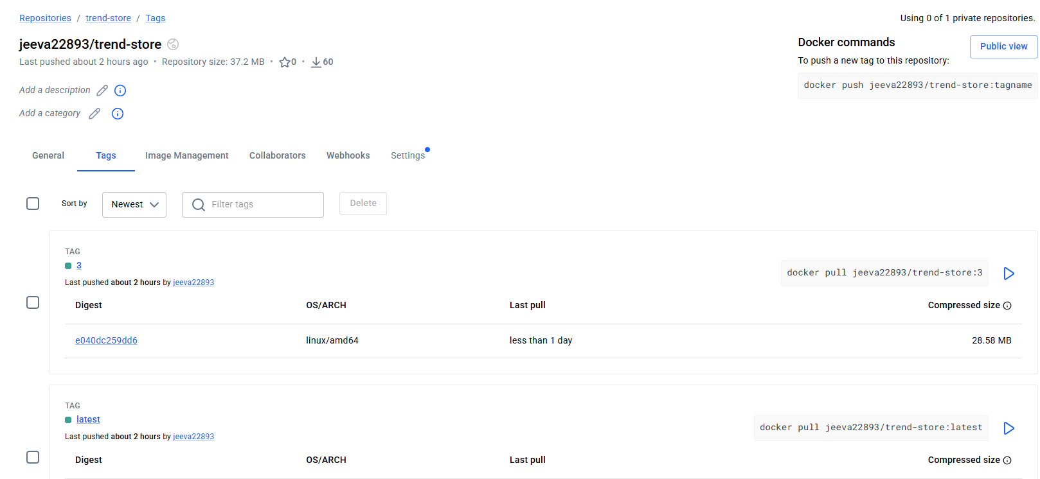

06 — Kubernetes application
Kubernetes Deployment and Service Configuration
The Trend Store application was deployed to Amazon EKS using Kubernetes Deployment and Service YAML manifests stored in the k8s/ directory of the GitHub repository.
1. Kubernetes Deployment — k8s/deployment.yaml
The Deployment manifest defines the Trend Store application workload. It specifies two replicas to provide application availability, the DockerHub container image, container port 3000, readiness checks, and resource requests and limits.
The Jenkins CI/CD pipeline applies the manifest and updates the deployed container image to the image tag associated with the Jenkins build.
[Insert the complete contents and screenshot of k8s/deployment.yaml here.]
2. Kubernetes Service — k8s/service.yaml
The Service manifest defines a Kubernetes Service named trend-store-service with type LoadBalancer.
It exposes port 80 externally and forwards traffic to port 3000 on the Trend Store application containers. AWS provisions a load balancer to make the application accessible.
[Insert the complete contents and screenshot of k8s/service.yaml here.]
3. Deployment Verification
The following commands were used to verify the deployment:
kubectl get deployment,pods,svc
kubectl rollout status deployment/trend-store
The deployment was verified with two available replicas, two Running application pods, and an AWS LoadBalancer service.
[Insert the Kubernetes deployment verification screenshot here.]
Result: The Trend Store application was successfully deployed to Amazon EKS and exposed through a Kubernetes LoadBalancer Service.

kubectl get deployment,pods,svc showing 2/2 available and LoadBalancer.
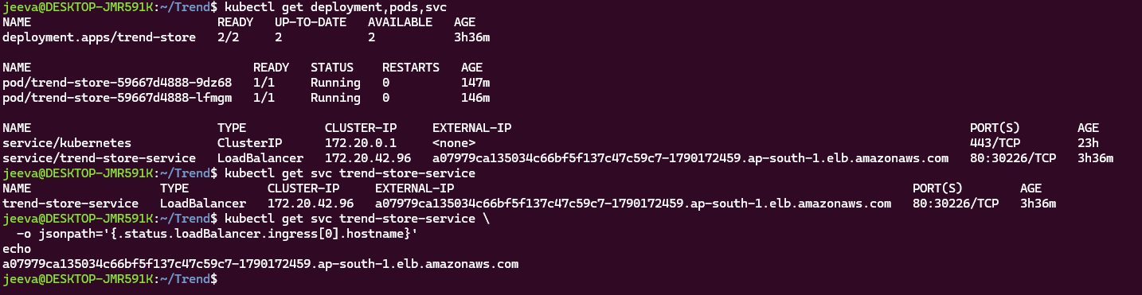
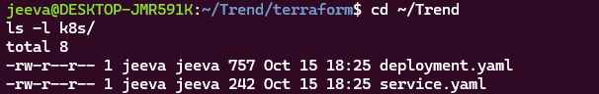
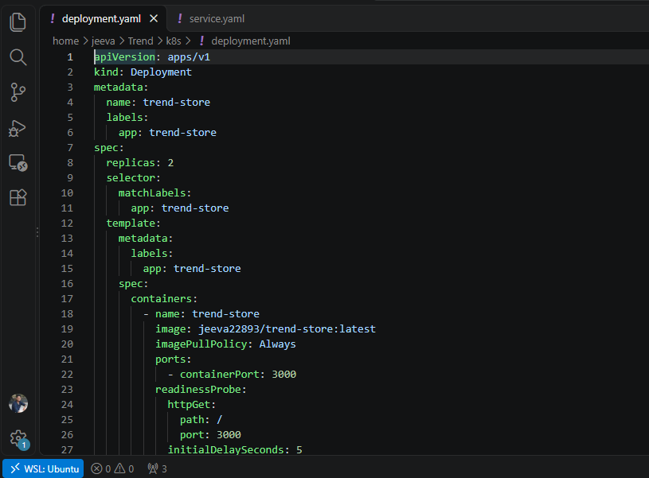
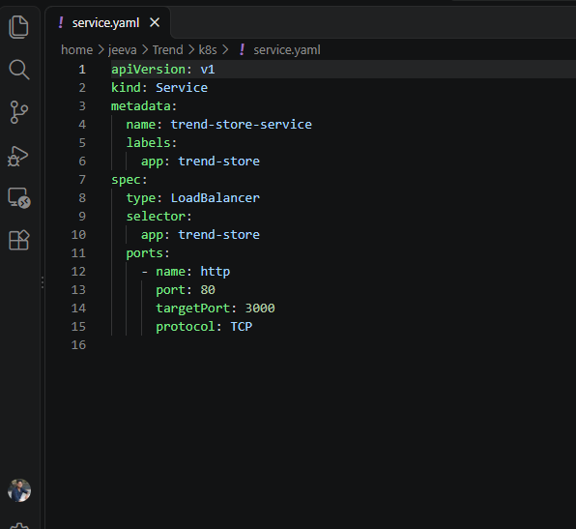
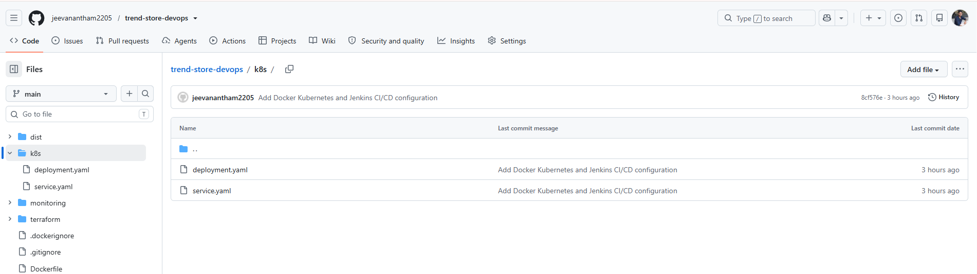

07 — Prometheus
Targets page showing UP states at localhost:9091/targets.
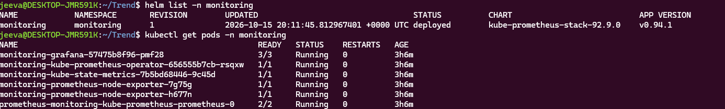
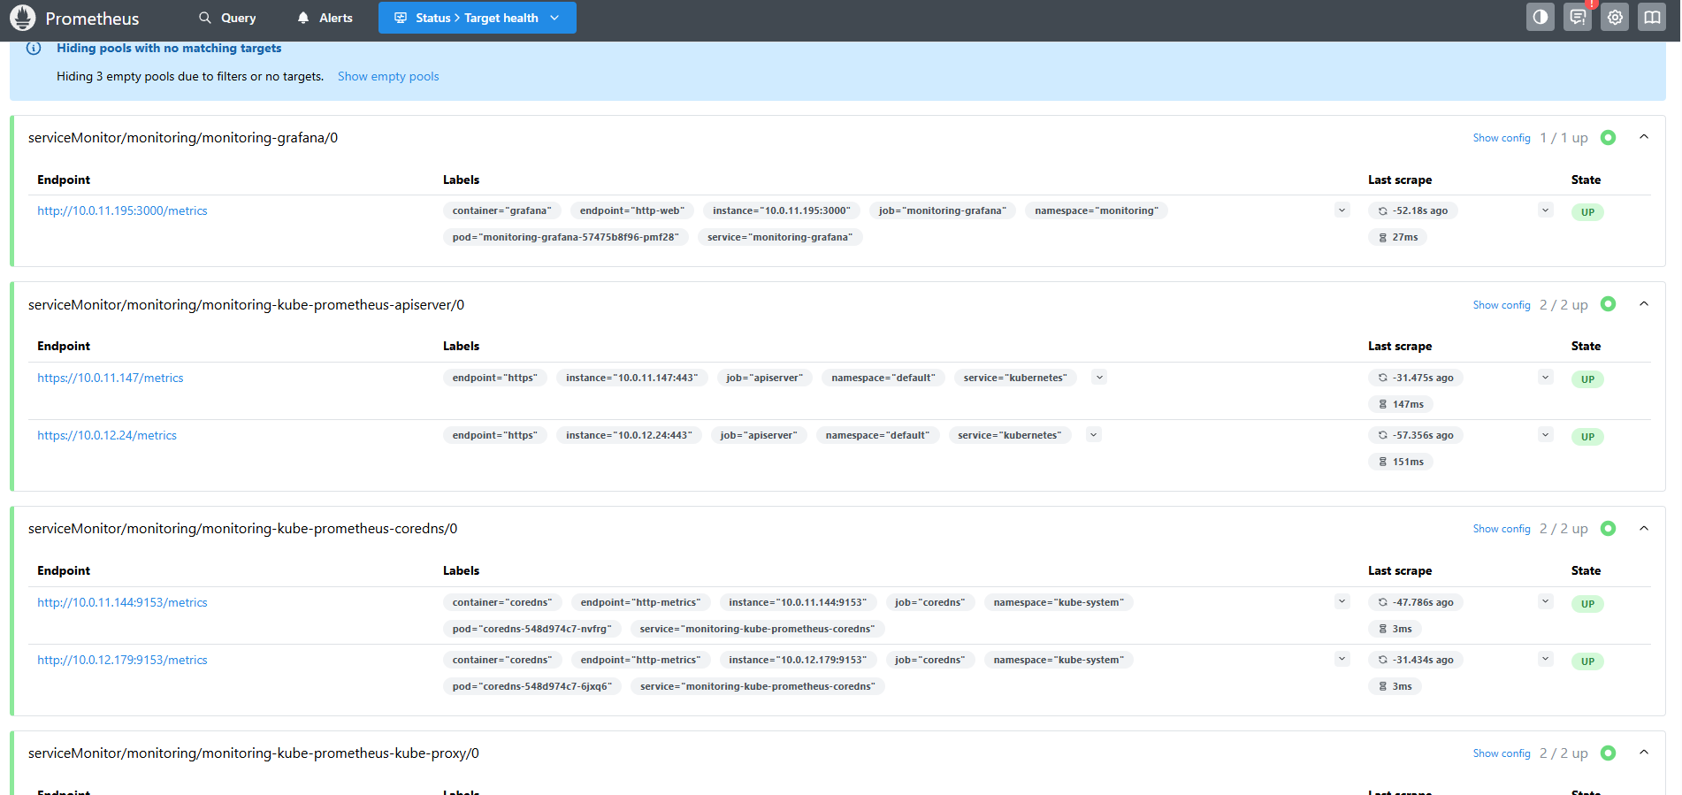
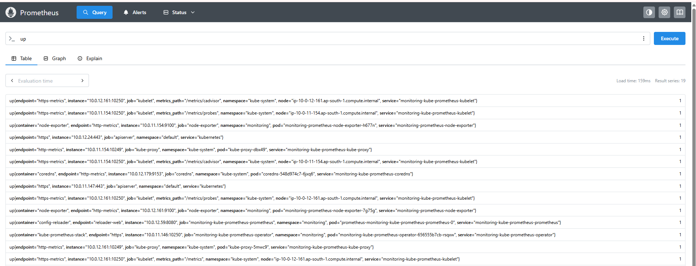

08 — Grafana
Kubernetes cluster dashboard with CPU and memory graphs.
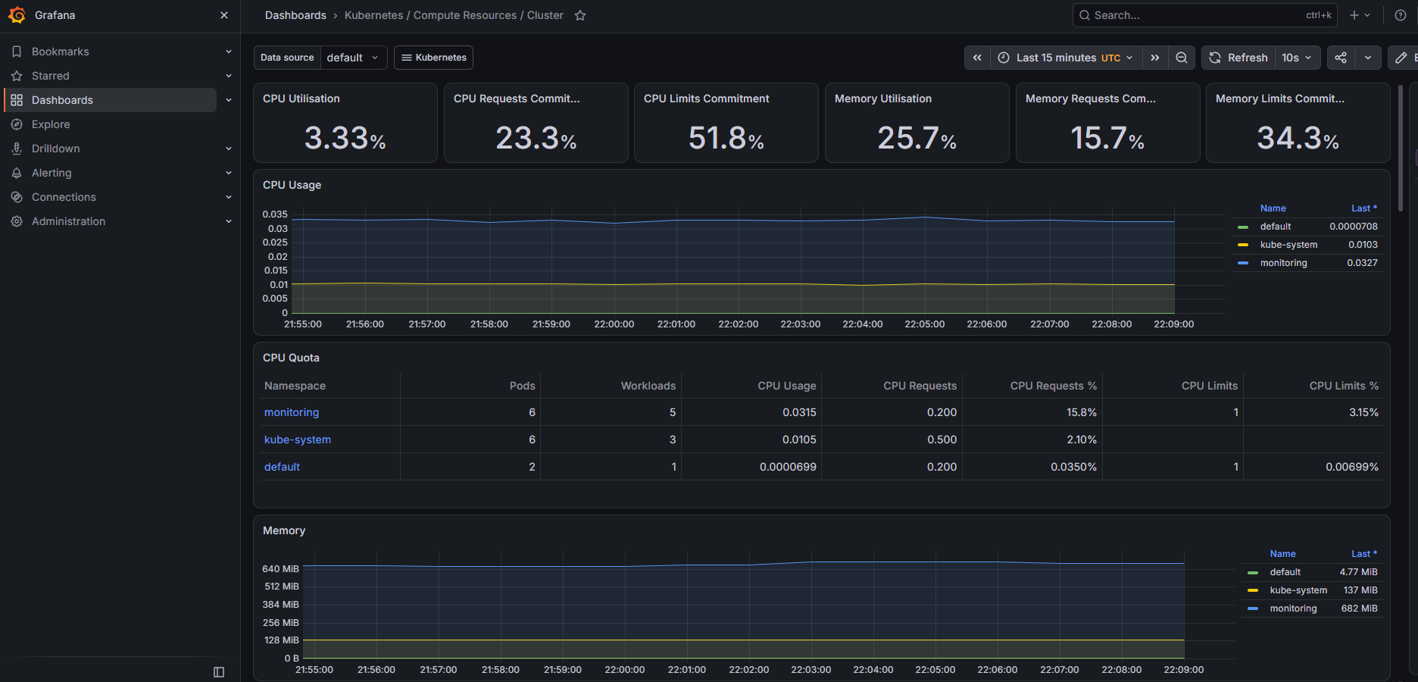

09 — GitHub
Repository tree with terraform/, monitoring/, k8s/, Dockerfile and Jenkinsfile.
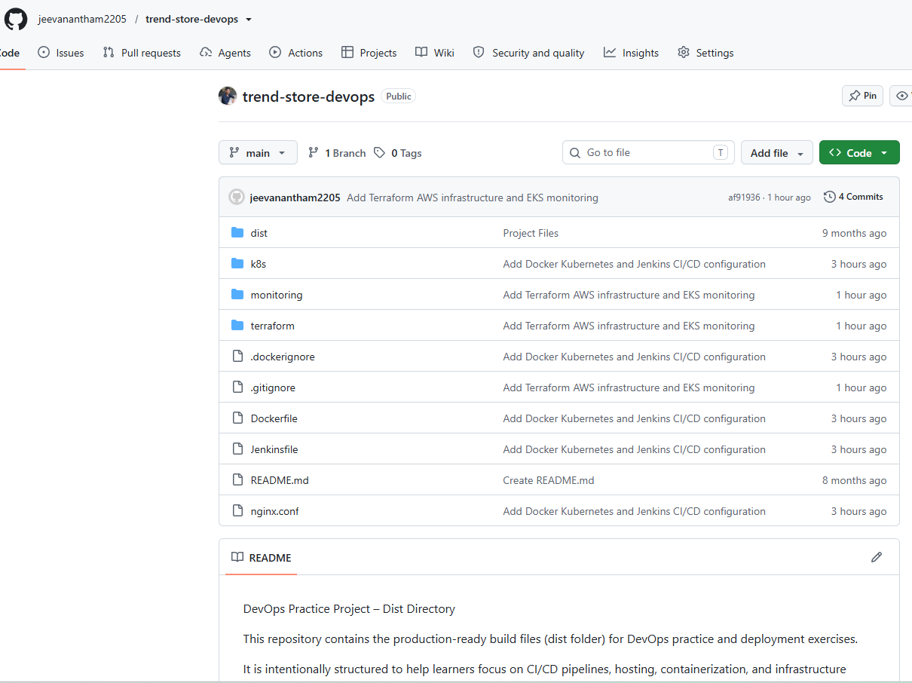
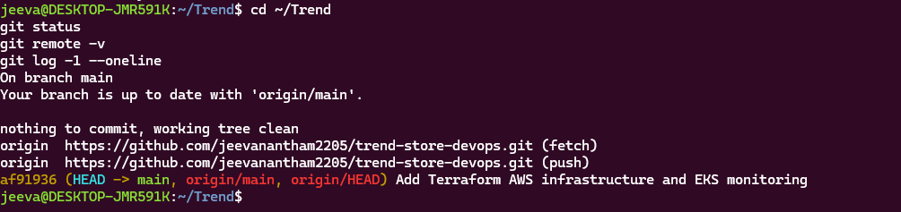

12. Final validation result
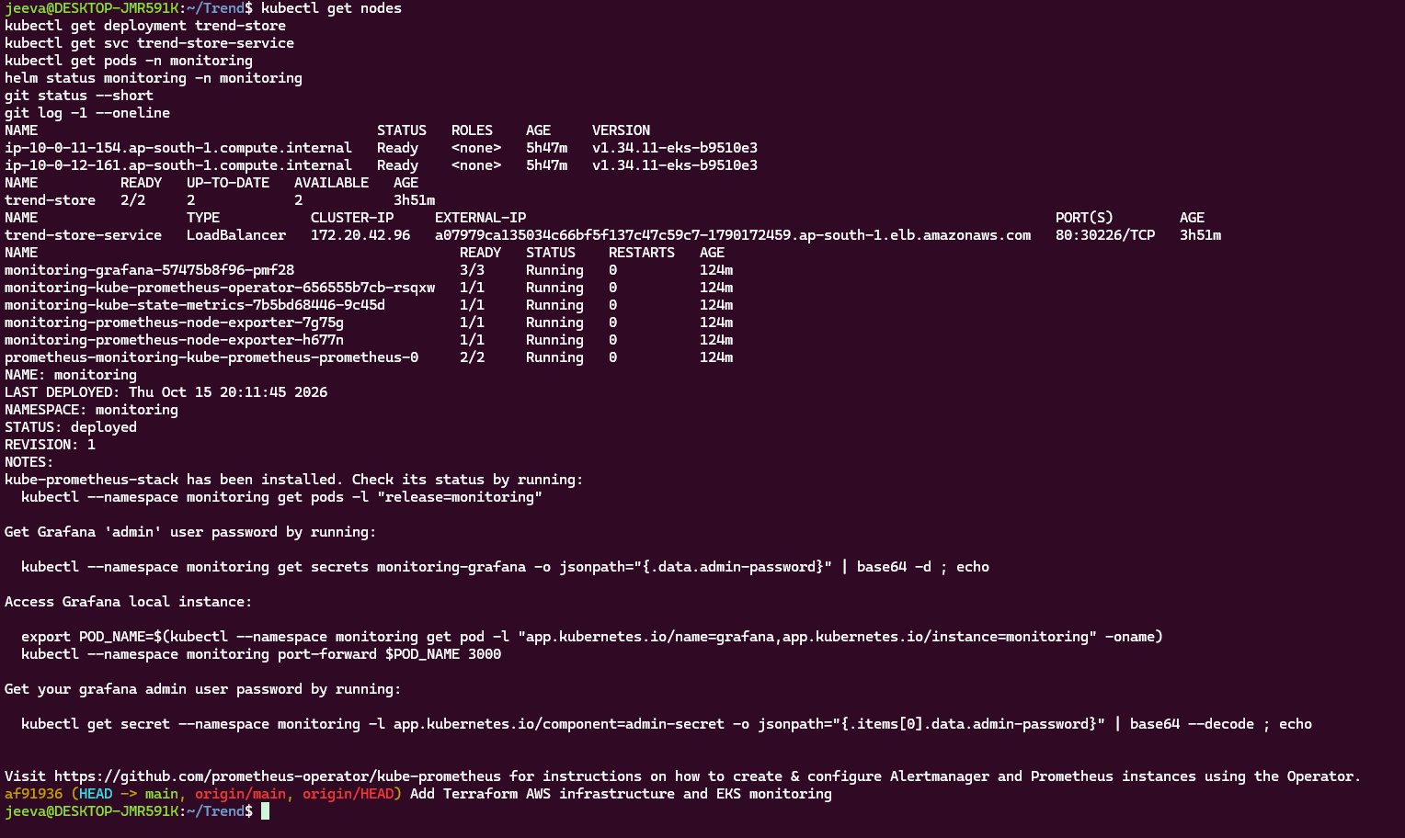

Conclusion
Trend Store was successfully containerized, built and published through Jenkins, deployed with two replicas on Amazon EKS, monitored with Prometheus and Grafana, and versioned in GitHub. The deployment and monitoring checks were observed to succeed.

