 Project Report Template

**Vehicle Management System**

**INTRODUCTION**

**Overview**

Vehicle Management is an application where a customer Details are stored inorder to choose cars, bikes and commercial vehicles for travel with in the city. The data which is stored here is further used to remind them if any offers are provided during the seasons and any updates regarding vehicles are sent to them in the form of messages and mails.

**Purpose**

1. Real Time Salesforce Project
2. Object & Relationship in Salesforce

**Problem Definition & Design Thinking**

**Empathy Map**

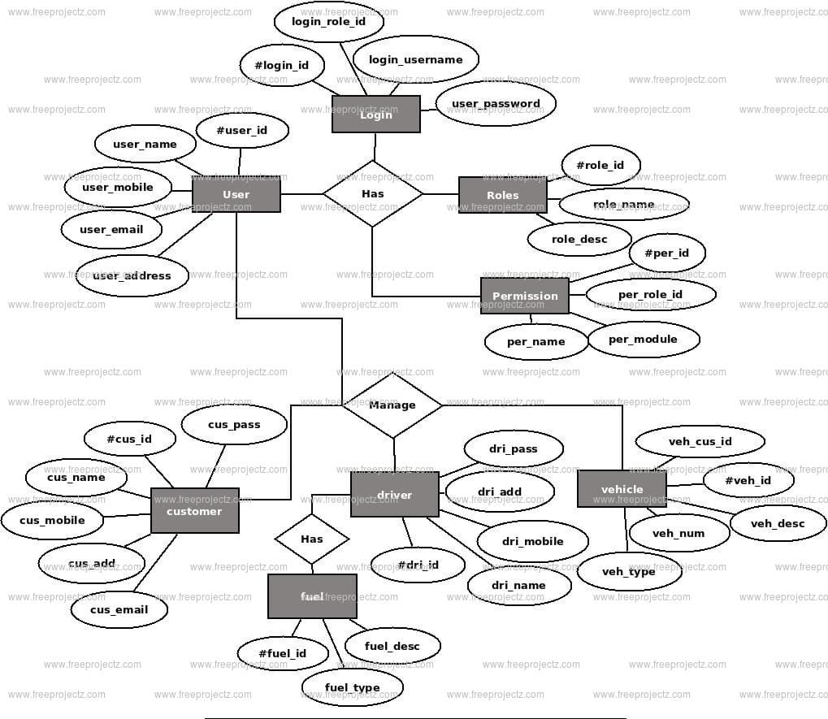

**Ideation & Brainstorming Map**

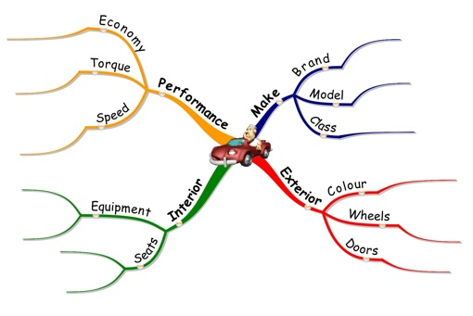

**RESULT**

**Data Model:**

|  |  |
| --- | --- |
| **Object name** | **Fields in the Object** |
| Vehicles | |  |  | | --- | --- | | Field label | Data type | | Customer Name | Text | | Custome r Mobile No | Number | | Vehicle Type | Picklist | | 2WHEELERS | Picklist | | 4WHEELERS | Picklist | | Vehicle Name | Text | | Vehicle No | Text | | Chassic No | Text | | Colour | Text | | Body Type | Text | | Vehicle Includes | Multi Picklist | | Condition | Picklist | | Mileage | Text | | Seats | Number | | Start Date | Date/Time | | End Date | Date/Time | | Opporetunity | Lookup(opportunities) | |
| Driver | |  |  | | --- | --- | | Field label | Data type | | Driver | Text | | Licence No | Text | | Mobile No | Number | | Fair Per HOUR | Text | | Vehicle | Lookup(Vehicle) | |

**Activity & Screenshot**

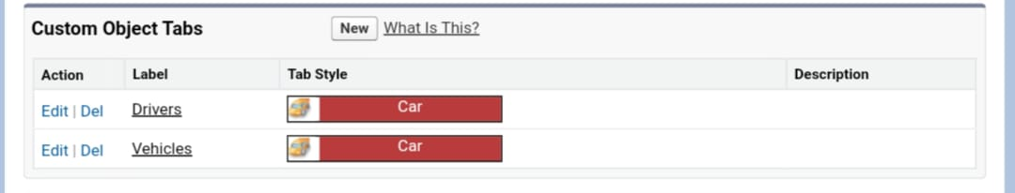

Create our customize object tabs

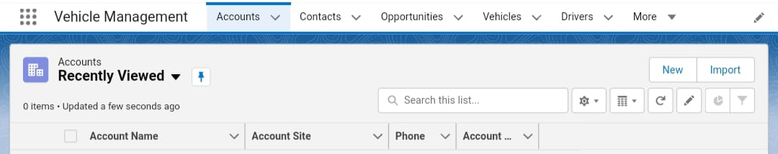

Creating Vehicle Management in Lightning App

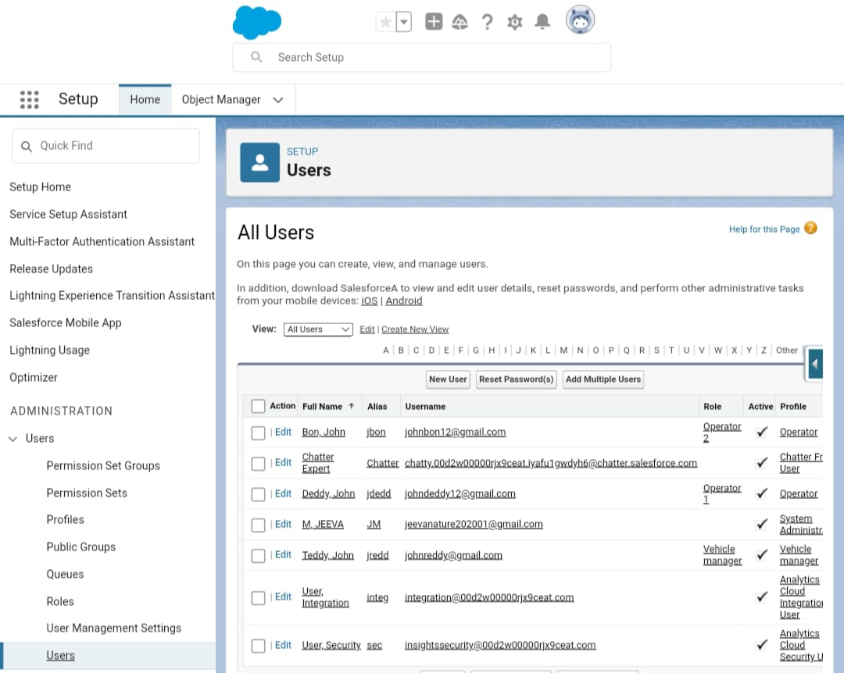

Customize our user interface.

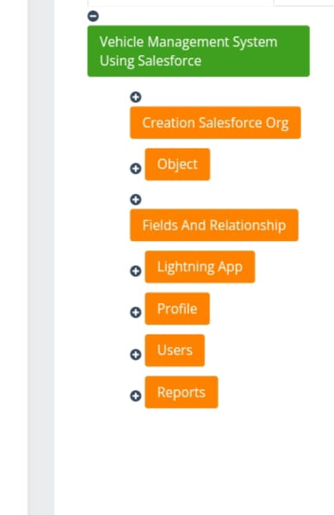

Do this steps one by one to complete the project.

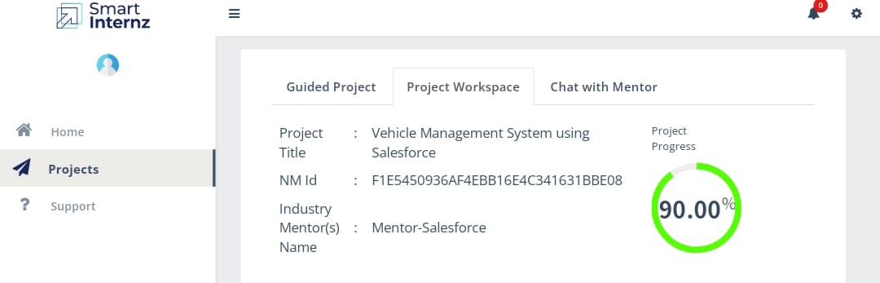

After, Completing guidelines in the pdf. We get this progress in our screen.

**Trailhead Profile Public URL**

**Team Lead** - https://trailblazer.me/id/jeevam20

**Team Member 1 – https://trailblazer.me/id/kris00**

**Team Member 2 -https://trailblazer.me/id/mathv8**

**Team Member3 - https://trailblazer.me/id/perib3**

 Project Report Template

**ADVANTAGES**

* Real – time Tracking
* Automated Operations
* Data Analytics

**DISADVANTAGES**

* Learnng Curve

**APPLICATIONS**

* Salesforce
* Trailblazer
* Git Repo
* Git Hub

**CONCLUSION**

The vehicle Management System Proposed to make easy process of Managing Vehicle with the objective to rep;ace the current approach.

**FUTURE SCOPE**

Summarize the accidental records and responds for the frther improvements.