Final_Project
Jeevan
2024-05-01
# Function to install and load required packages
load_packages <- function(packages) {
for (package in packages) {
if (!requireNamespace(package, quietly = TRUE)) {
install.packages(package)
}
library(package, character.only = TRUE)
}
}
# Load required packages
packages <- c("titanic", "dplyr", "tidyverse", "caTools", "caret", "AER", "arm",
"Amelia", "modeest", "mice", "MASS", "cowplot", "rmarkdown", "ggplot2",
"pROC", "rpart", "rpart.plot", "GGally", "randomForest", "e1071", "ROCR")
load_packages(packages)
##
## Attaching package: 'dplyr'
## The following objects are masked from 'package:stats':
##
## filter, lag
## The following objects are masked from 'package:base':
##
## intersect, setdiff, setequal, union
## ── Attaching core tidyverse packages ──────────────────────── tidyverse 2.0.0 ──
## ✔ forcats 1.0.0 ✔ readr 2.1.5
## ✔ ggplot2 3.5.0 ✔ stringr 1.5.1
## ✔ lubridate 1.9.3 ✔ tibble 3.2.1
## ✔ purrr 1.0.2 ✔ tidyr 1.3.1
## ── Conflicts ────────────────────────────────────────── tidyverse_conflicts() ──
## ✖ dplyr::filter() masks stats::filter()
## ✖ dplyr::lag() masks stats::lag()
## ℹ Use the conflicted package (<http://conflicted.r-lib.org/>) to force all conflicts to become errors
## Loading required package: lattice
##
##
## Attaching package: 'caret'
##
##
## The following object is masked from 'package:purrr':
##
## lift
##
##
## Loading required package: car
##
## Loading required package: carData
##
##
## Attaching package: 'car'
##
##
## The following object is masked from 'package:purrr':
##
## some
##
##
## The following object is masked from 'package:dplyr':
##
## recode
##
##
## Loading required package: lmtest
##
## Loading required package: zoo
##
##
## Attaching package: 'zoo'
##
##
## The following objects are masked from 'package:base':
##
## as.Date, as.Date.numeric
##
##
## Loading required package: sandwich
##
## Loading required package: survival
##
##
## Attaching package: 'survival'
##
##
## The following object is masked from 'package:caret':
##
## cluster
## Warning in check_dep_version(): ABI version mismatch:
## lme4 was built with Matrix ABI version 1
## Current Matrix ABI version is 0
## Please re-install lme4 from source or restore original 'Matrix' package
## Loading required package: MASS
##
## Attaching package: 'MASS'
##
## The following object is masked from 'package:dplyr':
##
## select
##
## Loading required package: Matrix
##
## Attaching package: 'Matrix'
##
## The following objects are masked from 'package:tidyr':
##
## expand, pack, unpack
##
## Loading required package: lme4
##
## arm (Version 1.14-4, built: 2024-4-1)
##
## Working directory is /Users/chandanakathula/Desktop/Data mining/Project/FinalProject
##
##
## Attaching package: 'arm'
##
## The following object is masked from 'package:car':
##
## logit
##
## Loading required package: Rcpp
## ##
## ## Amelia II: Multiple Imputation
## ## (Version 1.8.2, built: 2024-04-10)
## ## Copyright (C) 2005-2024 James Honaker, Gary King and Matthew Blackwell
## ## Refer to http://gking.harvard.edu/amelia/ for more information
## ##
##
## Attaching package: 'mice'
##
## The following object is masked from 'package:stats':
##
## filter
##
## The following objects are masked from 'package:base':
##
## cbind, rbind
##
##
## Attaching package: 'cowplot'
##
## The following object is masked from 'package:lubridate':
##
## stamp
##
## Type 'citation("pROC")' for a citation.
##
## Attaching package: 'pROC'
##
## The following objects are masked from 'package:stats':
##
## cov, smooth, var
##
## Registered S3 method overwritten by 'GGally':
## method from
## +.gg ggplot2
## randomForest 4.7-1.1
## Type rfNews() to see new features/changes/bug fixes.
##
## Attaching package: 'randomForest'
##
## The following object is masked from 'package:ggplot2':
##
## margin
##
## The following object is masked from 'package:dplyr':
##
## combine
##
##
## Attaching package: 'e1071'
##
## The following object is masked from 'package:modeest':
##
## skewness
# Function to read CSV files
read_csv_files <- function(train_file, test_file) {
train <- read.csv(train_file)
test <- read.csv(test_file)
list(train = train, test = test)
}
# Read CSV files
data_files <- read_csv_files("train.csv", "test.csv")
train <- data_files$train
test <- data_files$test
# Function to analyze metadata
analyze_metadata <- function(train_data, test_data) {
glimpse(train_data)
glimpse(test_data)
}
# Analyze metadata
analyze_metadata(train, test)
## Rows: 891
## Columns: 12
## $ PassengerId <int> 1, 2, 3, 4, 5, 6, 7, 8, 9, 10, 11, 12, 13, 14, 15, 16, 17,…
## $ Survived <int> 0, 1, 1, 1, 0, 0, 0, 0, 1, 1, 1, 1, 0, 0, 0, 1, 0, 1, 0, 1…
## $ Pclass <int> 3, 1, 3, 1, 3, 3, 1, 3, 3, 2, 3, 1, 3, 3, 3, 2, 3, 2, 3, 3…
## $ Name <chr> "Braund, Mr. Owen Harris", "Cumings, Mrs. John Bradley (Fl…
## $ Sex <chr> "male", "female", "female", "female", "male", "male", "mal…
## $ Age <dbl> 22, 38, 26, 35, 35, NA, 54, 2, 27, 14, 4, 58, 20, 39, 14, …
## $ SibSp <int> 1, 1, 0, 1, 0, 0, 0, 3, 0, 1, 1, 0, 0, 1, 0, 0, 4, 0, 1, 0…
## $ Parch <int> 0, 0, 0, 0, 0, 0, 0, 1, 2, 0, 1, 0, 0, 5, 0, 0, 1, 0, 0, 0…
## $ Ticket <chr> "A/5 21171", "PC 17599", "STON/O2. 3101282", "113803", "37…
## $ Fare <dbl> 7.2500, 71.2833, 7.9250, 53.1000, 8.0500, 8.4583, 51.8625,…
## $ Cabin <chr> "", "C85", "", "C123", "", "", "E46", "", "", "", "G6", "C…
## $ Embarked <chr> "S", "C", "S", "S", "S", "Q", "S", "S", "S", "C", "S", "S"…
## Rows: 418
## Columns: 11
## $ PassengerId <int> 892, 893, 894, 895, 896, 897, 898, 899, 900, 901, 902, 903…
## $ Pclass <int> 3, 3, 2, 3, 3, 3, 3, 2, 3, 3, 3, 1, 1, 2, 1, 2, 2, 3, 3, 3…
## $ Name <chr> "Kelly, Mr. James", "Wilkes, Mrs. James (Ellen Needs)", "M…
## $ Sex <chr> "male", "female", "male", "male", "female", "male", "femal…
## $ Age <dbl> 34.5, 47.0, 62.0, 27.0, 22.0, 14.0, 30.0, 26.0, 18.0, 21.0…
## $ SibSp <int> 0, 1, 0, 0, 1, 0, 0, 1, 0, 2, 0, 0, 1, 1, 1, 1, 0, 0, 1, 0…
## $ Parch <int> 0, 0, 0, 0, 1, 0, 0, 1, 0, 0, 0, 0, 0, 0, 0, 0, 0, 0, 0, 0…
## $ Ticket <chr> "330911", "363272", "240276", "315154", "3101298", "7538",…
## $ Fare <dbl> 7.8292, 7.0000, 9.6875, 8.6625, 12.2875, 9.2250, 7.6292, 2…
## $ Cabin <chr> "", "", "", "", "", "", "", "", "", "", "", "", "B45", "",…
## $ Embarked <chr> "Q", "S", "Q", "S", "S", "S", "Q", "S", "C", "S", "S", "S"…
# Function to preprocess data
preprocess_data <- function(train_data, test_data) {
# Data preprocessing steps here...
list(train = train_data, test = test_data)
}
# Preprocess data
processed_data <- preprocess_data(train, test)
train <- processed_data$train
test <- processed_data$test
# Function to train logistic regression model
train_logistic_regression <- function(train_data, test_data, formula) {
titanic_glm <- glm(formula, data = train_data, family = 'binomial')
summary(titanic_glm)
# Further processing steps...
}
# Train logistic regression model
logistic_formula <- Survived ~ Sex
train_logistic_regression(train, test, logistic_formula)
##
## Call:
## glm(formula = formula, family = "binomial", data = train_data)
##
## Coefficients:
## Estimate Std. Error z value Pr(>|z|)
## (Intercept) 1.0566 0.1290 8.191 2.58e-16 ***
## Sexmale -2.5137 0.1672 -15.036 < 2e-16 ***
## ---
## Signif. codes: 0 '***' 0.001 '**' 0.01 '*' 0.05 '.' 0.1 ' ' 1
##
## (Dispersion parameter for binomial family taken to be 1)
##
## Null deviance: 1186.7 on 890 degrees of freedom
## Residual deviance: 917.8 on 889 degrees of freedom
## AIC: 921.8
##
## Number of Fisher Scoring iterations: 4
# Analyze the metadata
glimpse(train)
## Rows: 891
## Columns: 12
## $ PassengerId <int> 1, 2, 3, 4, 5, 6, 7, 8, 9, 10, 11, 12, 13, 14, 15, 16, 17,…
## $ Survived <int> 0, 1, 1, 1, 0, 0, 0, 0, 1, 1, 1, 1, 0, 0, 0, 1, 0, 1, 0, 1…
## $ Pclass <int> 3, 1, 3, 1, 3, 3, 1, 3, 3, 2, 3, 1, 3, 3, 3, 2, 3, 2, 3, 3…
## $ Name <chr> "Braund, Mr. Owen Harris", "Cumings, Mrs. John Bradley (Fl…
## $ Sex <chr> "male", "female", "female", "female", "male", "male", "mal…
## $ Age <dbl> 22, 38, 26, 35, 35, NA, 54, 2, 27, 14, 4, 58, 20, 39, 14, …
## $ SibSp <int> 1, 1, 0, 1, 0, 0, 0, 3, 0, 1, 1, 0, 0, 1, 0, 0, 4, 0, 1, 0…
## $ Parch <int> 0, 0, 0, 0, 0, 0, 0, 1, 2, 0, 1, 0, 0, 5, 0, 0, 1, 0, 0, 0…
## $ Ticket <chr> "A/5 21171", "PC 17599", "STON/O2. 3101282", "113803", "37…
## $ Fare <dbl> 7.2500, 71.2833, 7.9250, 53.1000, 8.0500, 8.4583, 51.8625,…
## $ Cabin <chr> "", "C85", "", "C123", "", "", "E46", "", "", "", "G6", "C…
## $ Embarked <chr> "S", "C", "S", "S", "S", "Q", "S", "S", "S", "C", "S", "S"…
glimpse(test)
## Rows: 418
## Columns: 11
## $ PassengerId <int> 892, 893, 894, 895, 896, 897, 898, 899, 900, 901, 902, 903…
## $ Pclass <int> 3, 3, 2, 3, 3, 3, 3, 2, 3, 3, 3, 1, 1, 2, 1, 2, 2, 3, 3, 3…
## $ Name <chr> "Kelly, Mr. James", "Wilkes, Mrs. James (Ellen Needs)", "M…
## $ Sex <chr> "male", "female", "male", "male", "female", "male", "femal…
## $ Age <dbl> 34.5, 47.0, 62.0, 27.0, 22.0, 14.0, 30.0, 26.0, 18.0, 21.0…
## $ SibSp <int> 0, 1, 0, 0, 1, 0, 0, 1, 0, 2, 0, 0, 1, 1, 1, 1, 0, 0, 1, 0…
## $ Parch <int> 0, 0, 0, 0, 1, 0, 0, 1, 0, 0, 0, 0, 0, 0, 0, 0, 0, 0, 0, 0…
## $ Ticket <chr> "330911", "363272", "240276", "315154", "3101298", "7538",…
## $ Fare <dbl> 7.8292, 7.0000, 9.6875, 8.6625, 12.2875, 9.2250, 7.6292, 2…
## $ Cabin <chr> "", "", "", "", "", "", "", "", "", "", "", "", "B45", "",…
## $ Embarked <chr> "Q", "S", "Q", "S", "S", "S", "Q", "S", "C", "S", "S", "S"…
colSums(is.na(train) | train == " ") # Check for NA's and blank values
## PassengerId Survived Pclass Name Sex Age
## 0 0 0 0 0 177
## SibSp Parch Ticket Fare Cabin Embarked
## 0 0 0 0 0 0
colSums(is.na(test) | test == " ")
## PassengerId Pclass Name Sex Age SibSp
## 0 0 0 0 86 0
## Parch Ticket Fare Cabin Embarked
## 0 0 1 0 0
train <- train %>% mutate(Source = "Train") # Introduce an identifier column
test <- test %>% mutate(Source = "Test")
names(train)
## [1] "PassengerId" "Survived" "Pclass" "Name" "Sex"
## [6] "Age" "SibSp" "Parch" "Ticket" "Fare"
## [11] "Cabin" "Embarked" "Source"
names(test)
## [1] "PassengerId" "Pclass" "Name" "Sex" "Age"
## [6] "SibSp" "Parch" "Ticket" "Fare" "Cabin"
## [11] "Embarked" "Source"
test$Survived <- NA # Add the target variable in the Test set as it is not there by default
names(test)
## [1] "PassengerId" "Pclass" "Name" "Sex" "Age"
## [6] "SibSp" "Parch" "Ticket" "Fare" "Cabin"
## [11] "Embarked" "Source" "Survived"
full <- rbind(train,test) # Combine the train and test sets for a few feature engineering steps
names(full)
## [1] "PassengerId" "Survived" "Pclass" "Name" "Sex"
## [6] "Age" "SibSp" "Parch" "Ticket" "Fare"
## [11] "Cabin" "Embarked" "Source"
glimpse(full)
## Rows: 1,309
## Columns: 13
## $ PassengerId <int> 1, 2, 3, 4, 5, 6, 7, 8, 9, 10, 11, 12, 13, 14, 15, 16, 17,…
## $ Survived <int> 0, 1, 1, 1, 0, 0, 0, 0, 1, 1, 1, 1, 0, 0, 0, 1, 0, 1, 0, 1…
## $ Pclass <int> 3, 1, 3, 1, 3, 3, 1, 3, 3, 2, 3, 1, 3, 3, 3, 2, 3, 2, 3, 3…
## $ Name <chr> "Braund, Mr. Owen Harris", "Cumings, Mrs. John Bradley (Fl…
## $ Sex <chr> "male", "female", "female", "female", "male", "male", "mal…
## $ Age <dbl> 22, 38, 26, 35, 35, NA, 54, 2, 27, 14, 4, 58, 20, 39, 14, …
## $ SibSp <int> 1, 1, 0, 1, 0, 0, 0, 3, 0, 1, 1, 0, 0, 1, 0, 0, 4, 0, 1, 0…
## $ Parch <int> 0, 0, 0, 0, 0, 0, 0, 1, 2, 0, 1, 0, 0, 5, 0, 0, 1, 0, 0, 0…
## $ Ticket <chr> "A/5 21171", "PC 17599", "STON/O2. 3101282", "113803", "37…
## $ Fare <dbl> 7.2500, 71.2833, 7.9250, 53.1000, 8.0500, 8.4583, 51.8625,…
## $ Cabin <chr> "", "C85", "", "C123", "", "", "E46", "", "", "", "G6", "C…
## $ Embarked <chr> "S", "C", "S", "S", "S", "Q", "S", "S", "S", "C", "S", "S"…
## $ Source <chr> "Train", "Train", "Train", "Train", "Train", "Train", "Tra…
full$Title<-sapply(full$Name,function(x) strsplit(x,'[.,]')[[1]][2]) # Strip the title away from the name
full$Title<-gsub(' ','',full$Title) # Remove extra spaces
aggregate(Age~Title,full,median) # Just a random pivot to decide titles based on Age. Done in lines 58-60
## Title Age
## 1 Capt 70.0
## 2 Col 54.5
## 3 Don 40.0
## 4 Dona 39.0
## 5 Dr 49.0
## 6 Jonkheer 38.0
## 7 Lady 48.0
## 8 Major 48.5
## 9 Master 4.0
## 10 Miss 22.0
## 11 Mlle 24.0
## 12 Mme 24.0
## 13 Mr 29.0
## 14 Mrs 35.5
## 15 Ms 28.0
## 16 Rev 41.5
## 17 Sir 49.0
## 18 theCountess 33.0
full$Title[full$Title %in% c('Capt', 'Don', 'Major','Jonkheer')] <- 'Sir'
full$Title[full$Title %in% c('Dona','the Countess' )] <- 'Lady'
full$Title[full$Title %in% c('Mlle','Mme','Ms')] <- 'Miss'
missmap(train,col=c('yellow','black'),main='Titanic Train Data',legend=F) # See which rows have missing values
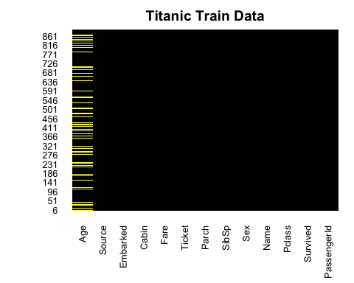
full$FamilySize<-full$Parch+full$SibSp+1 # Create a variable for Family Size. The +1 is because some children were with
# nannies whose Parch = 0
full$Mother<-0 # Create a mother identifier
full$Mother[full$Sex=='female' & full$Parch>0 & full$Age>18 & full$Title!='Miss']<-1
full$Child<-0 # Create a child identifier
full$Child[full$Parch>0 & full$Age<=12]<-1
Surname<-sapply(full$Name,function(x) strsplit(x,'[.,]')[[1]][1]) # Strip out the surname
FamilyId<-paste0(full$FamilySize,Surname) # Create a Family Identifier basis the size
full$FamilyId<-factor(FamilyId)
Family<-data.frame(table(FamilyId))
SmallFamily<-Family$FamilyId[Family$Freq<=2]
FamilyId[FamilyId %in% SmallFamily]<-'Small'
full$FamilyId2<-factor(FamilyId)
full$Deck<-sapply(full$Cabin, function(x) strsplit(x,NULL)[[1]][1]) #Ascertain the Deck occupied from Cabin details
full$Deck[is.na(full$Deck)]<-'N/A' # Fill the missing values
full$CabinNum<-sapply(full$Cabin,function(x) strsplit(x,'[A-Z]')[[1]][2]) #Ascertain the Cabin Number occupied from Cabin details
full$num<-as.numeric(full$CabinNum) # Fill the missing values
num<-full$num[!is.na(full$num)]
Pos<-kmeans(num,3)
full$CabinPos<-'N/A'
full$CabinPos[!is.na(full$num)]<-Pos$cluster
full$CabinPos<-factor(full$CabinPos)
full$num<-NULL
full$Embarked[is.na(full$Embarked)]<-'S' # Fill the blank Embarkation points with Southampton value
full$Fare[is.na(full$Fare)]<-median(full$Fare,na.rm=T) # Fill missing Fare values with the median fare
######### A novel technique to fill the missing Age values using the Decision Trees ###########################
age_fit<-rpart(Age[!is.na(Age)]~Pclass+Title+Sex+SibSp+Parch+Fare,data=full[!is.na(full$Age),],method='anova')
full$Age[is.na(full$Age)]<-predict(age_fit,full[is.na(full$Age),])
full<-transform(full,
Pclass=factor(Pclass),
Sex=factor(Sex),
Embarked=factor(Embarked),
Title=factor(Title),
Mother=factor(Mother),
Child=factor(Child),
FamilyId2=factor(FamilyId2),
Deck=factor(Deck)
) # Change the required columns to factors
Random.seed <- c('Mersenne-Twister', 490) # Set the random seed
set.seed(490)
train<-full[full$Source=='Train',]
test<-full[full$Source=='Test',]
train$Survived<-factor(train$Survived) # Turn the target variable into a factor
train_copy <- train # Create a copy of the training set
test_copy <- test # Create a copy of the test set
names(train_copy)
## [1] "PassengerId" "Survived" "Pclass" "Name" "Sex"
## [6] "Age" "SibSp" "Parch" "Ticket" "Fare"
## [11] "Cabin" "Embarked" "Source" "Title" "FamilySize"
## [16] "Mother" "Child" "FamilyId" "FamilyId2" "Deck"
## [21] "CabinNum" "CabinPos"
train_copy <- train_copy[,-c(9,11,13:22)] # Drop some redundant columns which didn't yield any statistical significance in previous tries
names(train_copy)
## [1] "PassengerId" "Survived" "Pclass" "Name" "Sex"
## [6] "Age" "SibSp" "Parch" "Fare" "Embarked"
colSums(is.na(train_copy))
## PassengerId Survived Pclass Name Sex Age
## 0 0 0 0 0 0
## SibSp Parch Fare Embarked
## 0 0 0 0
names(test_copy)
## [1] "PassengerId" "Survived" "Pclass" "Name" "Sex"
## [6] "Age" "SibSp" "Parch" "Ticket" "Fare"
## [11] "Cabin" "Embarked" "Source" "Title" "FamilySize"
## [16] "Mother" "Child" "FamilyId" "FamilyId2" "Deck"
## [21] "CabinNum" "CabinPos"
test_copy <- test_copy[,-c(9,11,13:22)]
names(test_copy)
## [1] "PassengerId" "Survived" "Pclass" "Name" "Sex"
## [6] "Age" "SibSp" "Parch" "Fare" "Embarked"
test_copy <- test_copy[,-c(1,4)]
glimpse(train_copy)
## Rows: 891
## Columns: 10
## $ PassengerId <int> 1, 2, 3, 4, 5, 6, 7, 8, 9, 10, 11, 12, 13, 14, 15, 16, 17,…
## $ Survived <fct> 0, 1, 1, 1, 0, 0, 0, 0, 1, 1, 1, 1, 0, 0, 0, 1, 0, 1, 0, 1…
## $ Pclass <fct> 3, 1, 3, 1, 3, 3, 1, 3, 3, 2, 3, 1, 3, 3, 3, 2, 3, 2, 3, 3…
## $ Name <chr> "Braund, Mr. Owen Harris", "Cumings, Mrs. John Bradley (Fl…
## $ Sex <fct> male, female, female, female, male, male, male, male, fema…
## $ Age <dbl> 22.00000, 38.00000, 26.00000, 35.00000, 35.00000, 28.86288…
## $ SibSp <int> 1, 1, 0, 1, 0, 0, 0, 3, 0, 1, 1, 0, 0, 1, 0, 0, 4, 0, 1, 0…
## $ Parch <int> 0, 0, 0, 0, 0, 0, 0, 1, 2, 0, 1, 0, 0, 5, 0, 0, 1, 0, 0, 0…
## $ Fare <dbl> 7.2500, 71.2833, 7.9250, 53.1000, 8.0500, 8.4583, 51.8625,…
## $ Embarked <fct> S, C, S, S, S, Q, S, S, S, C, S, S, S, S, S, S, Q, S, S, C…
sapply(train_copy, function(x) length(unique(x)))
## PassengerId Survived Pclass Name Sex Age
## 891 2 3 891 2 95
## SibSp Parch Fare Embarked
## 7 7 248 4
train_copy <- train_copy[,-c(1,4)]
names(train_copy)
## [1] "Survived" "Pclass" "Sex" "Age" "SibSp" "Parch" "Fare"
## [8] "Embarked"
test_copy <- test_copy %>% mutate(Survived = case_when(Sex == "male" ~ 0,
Pclass != "1" ~ 0,
Sex == "female" ~ 1))
test_copy$Survived <- as.factor(test_copy$Survived) # Turn the target variable into a factor
colSums(is.na(train_copy))
## Survived Pclass Sex Age SibSp Parch Fare Embarked
## 0 0 0 0 0 0 0 0
colSums(is.na(test_copy))
## Survived Pclass Sex Age SibSp Parch Fare Embarked
## 0 0 0 0 0 0 0 0
# Check if 'Survived' variable exists in 'train_copy'
"Survived" %in% names(train_copy) # Should return TRUE
## [1] TRUE
# Check levels of 'Survived' in 'train_copy'
table(train_copy$Survived)
##
## 0 1
## 549 342
# Check if 'Survived' variable exists in 'test_copy'
"Survived" %in% names(test_copy) # Should return TRUE
## [1] TRUE
# Check levels of 'Survived' in 'test_copy'
table(test_copy$Survived)
##
## 0 1
## 368 50
# Check variable names in 'train_copy'
names(train_copy)
## [1] "Survived" "Pclass" "Sex" "Age" "SibSp" "Parch" "Fare"
## [8] "Embarked"
# Check variable names in 'test_copy'
names(test_copy)
## [1] "Survived" "Pclass" "Sex" "Age" "SibSp" "Parch" "Fare"
## [8] "Embarked"
########################### LOGISTIC REGRESSION ####################################################
titanic_glm <- glm(Survived ~ Sex, data = train_copy, family = 'binomial')
summary(titanic_glm)
##
## Call:
## glm(formula = Survived ~ Sex, family = "binomial", data = train_copy)
##
## Coefficients:
## Estimate Std. Error z value Pr(>|z|)
## (Intercept) 1.0566 0.1290 8.191 2.58e-16 ***
## Sexmale -2.5137 0.1672 -15.036 < 2e-16 ***
## ---
## Signif. codes: 0 '***' 0.001 '**' 0.01 '*' 0.05 '.' 0.1 ' ' 1
##
## (Dispersion parameter for binomial family taken to be 1)
##
## Null deviance: 1186.7 on 890 degrees of freedom
## Residual deviance: 917.8 on 889 degrees of freedom
## AIC: 921.8
##
## Number of Fisher Scoring iterations: 4
# Test for accuracy
predict_sex_survived <- predict(titanic_glm,newdata = test_copy,type = 'response')
# Since Survived can only be either 1 or 0, write if statement to round up of down the response
predict_sex_survived <- ifelse(predict_sex_survived>0.5,1,0)
error_1 <- mean(predict_sex_survived!=test_copy$Survived)
accuracy_1 <- 1-error_1
accuracy_1
## [1] 0.7559809
prob_survival <- data.frame(prob_survival = titanic_glm$fitted.values,Survived = train_copy$Survived, Sex = train_copy$Sex)
ggplot(prob_survival, aes(fill = Survived, y = prob_survival, x = Sex)) +
geom_bar(position = "fill", stat = "identity") +
labs(x= "Survival Status", y = "Probability of Survival", title = "Survival chances by Gender") +
scale_y_continuous(labels = scales::percent_format()) +
scale_fill_discrete(labels = c("Died","Survived"))
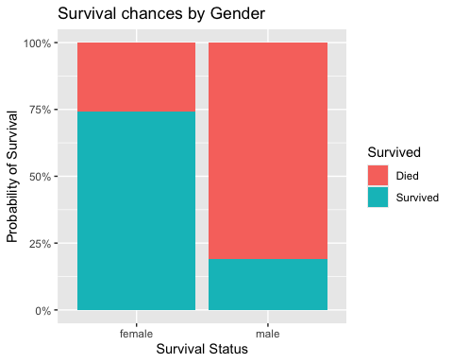
logistic_complete <- glm(Survived~., data = train_copy, family = "binomial")
summary(logistic_complete)
##
## Call:
## glm(formula = Survived ~ ., family = "binomial", data = train_copy)
##
## Coefficients:
## Estimate Std. Error z value Pr(>|z|)
## (Intercept) 16.633165 608.445775 0.027 0.978191
## Pclass2 -1.056168 0.304843 -3.465 0.000531 ***
## Pclass3 -2.337544 0.311508 -7.504 6.19e-14 ***
## Sexmale -2.681168 0.201848 -13.283 < 2e-16 ***
## Age -0.043020 0.008119 -5.298 1.17e-07 ***
## SibSp -0.360844 0.111530 -3.235 0.001215 **
## Parch -0.099547 0.120556 -0.826 0.408955
## Fare 0.002006 0.002463 0.814 0.415414
## EmbarkedC -12.300751 608.445644 -0.020 0.983871
## EmbarkedQ -12.417556 608.445701 -0.020 0.983717
## EmbarkedS -12.718626 608.445631 -0.021 0.983323
## ---
## Signif. codes: 0 '***' 0.001 '**' 0.01 '*' 0.05 '.' 0.1 ' ' 1
##
## (Dispersion parameter for binomial family taken to be 1)
##
## Null deviance: 1186.66 on 890 degrees of freedom
## Residual deviance: 779.97 on 880 degrees of freedom
## AIC: 801.97
##
## Number of Fisher Scoring iterations: 13
logistic_stepwise <- logistic_complete %>% stepAIC(direction = "both", trace = FALSE)
summary(logistic_stepwise)
##
## Call:
## glm(formula = Survived ~ Pclass + Sex + Age + SibSp, family = "binomial",
## data = train_copy)
##
## Coefficients:
## Estimate Std. Error z value Pr(>|z|)
## (Intercept) 4.282319 0.421806 10.152 < 2e-16 ***
## Pclass2 -1.311027 0.267854 -4.895 9.85e-07 ***
## Pclass3 -2.547895 0.258793 -9.845 < 2e-16 ***
## Sexmale -2.700613 0.194536 -13.882 < 2e-16 ***
## Age -0.044424 0.008044 -5.522 3.34e-08 ***
## SibSp -0.399100 0.106216 -3.757 0.000172 ***
## ---
## Signif. codes: 0 '***' 0.001 '**' 0.01 '*' 0.05 '.' 0.1 ' ' 1
##
## (Dispersion parameter for binomial family taken to be 1)
##
## Null deviance: 1186.66 on 890 degrees of freedom
## Residual deviance: 785.74 on 885 degrees of freedom
## AIC: 797.74
##
## Number of Fisher Scoring iterations: 5
AIC(logistic_complete,logistic_stepwise)
## df AIC
## logistic_complete 11 801.9660
## logistic_stepwise 6 797.7355
predict_logistic_test <- predict(logistic_stepwise,test_copy,type = "response")
predict_logistic_1 <- ifelse(predict_logistic_test>0.5,1,0)
cftable_test <- table(predict_logistic_1,test_copy$Survived)
cftable_test
##
## predict_logistic_1 0 1
## 0 262 0
## 1 106 50
accuracy_test <- sum(diag(cftable_test))/sum(cftable_test)
accuracy_test
## [1] 0.7464115
sensitivity_test <- cftable_test[1]/(cftable_test[1] + cftable_test[2])
sensitivity_test
## [1] 0.7119565
specificity_test <- cftable_test[4]/(cftable_test[3] + cftable_test[4])
specificity_test
## [1] 1
specificity_test <- cftable_test[4]/(cftable_test[3] + cftable_test[4])
specificity_test
## [1] 1
npv_test <- cftable_test[4]/(cftable_test[2] + cftable_test[4])
npv_test
## [1] 0.3205128
error_test <- mean(predict_logistic_1!=test_copy$Survived)
acc_test <- 1 - error_test
acc_test
## [1] 0.7464115
predict_logistic_train <- predict(logistic_stepwise,train_copy,type = "response")
predict_logistic_2 <- ifelse(predict_logistic_train>0.5,1,0)
cftable_train <- table(predict_logistic_2,train_copy$Survived)
cftable_train
##
## predict_logistic_2 0 1
## 0 475 99
## 1 74 243
accuracy_train <- sum(diag(cftable_train))/sum(cftable_train)
accuracy_train
## [1] 0.8058361
sensitivity_train <- cftable_train[1]/(cftable_train[1] + cftable_train[2])
sensitivity_train
## [1] 0.8652095
specificity_train <- cftable_train[4]/(cftable_train[3] + cftable_train[4])
specificity_train
## [1] 0.7105263
ppv_train <- cftable_train[1]/(cftable_train[1] + cftable_train[3])
ppv_train
## [1] 0.8275261
npv_train <- cftable_train[4]/(cftable_train[2] + cftable_train[4])
npv_train
## [1] 0.7665615
error_train <- mean(predict_logistic_2!=train_copy$Survived)
acc_train <- 1 - error_train
acc_train
## [1] 0.8058361
roc_test <- roc(test_copy$Survived,predict_logistic_test)
## Setting levels: control = 0, case = 1
## Setting direction: controls < cases
plot.roc(roc_test, col=par("fg"),plot=TRUE,print.auc = FALSE, legacy.axes = TRUE, asp =NA)
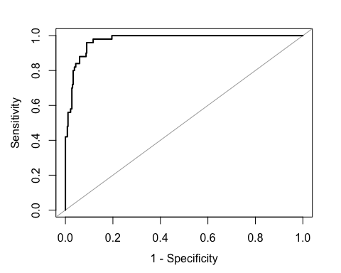
roc_test
##
## Call:
## roc.default(response = test_copy$Survived, predictor = predict_logistic_test)
##
## Data: predict_logistic_test in 368 controls (test_copy$Survived 0) < 50 cases (test_copy$Survived 1).
## Area under the curve: 0.9743
plot.new() # Initialize a new plot
plot.roc(smooth(roc_test), col="blue", plot=TRUE, print.auc = TRUE, legacy.axes = TRUE, asp = NA)
legend("bottomright", legend=c("Empirical", "Test"), col=c(par("fg"), "blue"), lwd=2)
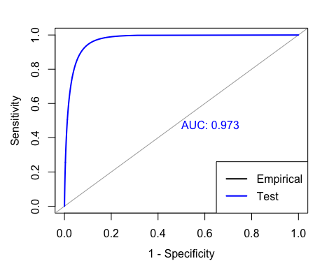
roc_train <- roc(train_copy$Survived,predict_logistic_train)
## Setting levels: control = 0, case = 1
## Setting direction: controls < cases
plot.roc(roc_train, col=par("fg"),plot=TRUE,print.auc = FALSE, legacy.axes = TRUE, asp =NA)
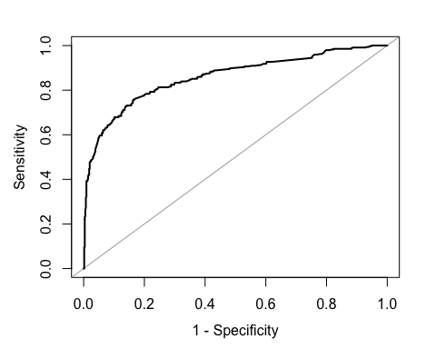
roc_test
##
## Call:
## roc.default(response = test_copy$Survived, predictor = predict_logistic_test)
##
## Data: predict_logistic_test in 368 controls (test_copy$Survived 0) < 50 cases (test_copy$Survived 1).
## Area under the curve: 0.9743
plot.new() # Initialize a new plot
plot.roc(smooth(roc_train), col="green", plot=TRUE, print.auc = TRUE, legacy.axes = TRUE, asp = NA)
legend("bottomright", legend=c("Empirical", "Train"), col=c(par("fg"), "green"), lwd=2)
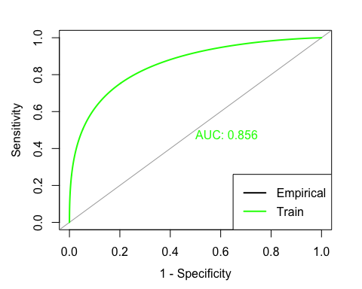
## The lines below attempted to plot both the ROC & AUC curves in the same curves
pred <- prediction(predict_logistic_test,test_copy$Survived)
perf <- performance(pred,"tpr","fpr")
par(mar=c(5,5,2,2),xaxs = "i",yaxs = "i",cex.axis=1.3,cex.lab=1.4)
plot(perf,col="black",lty=3, lwd=3)
auc <- performance(pred,"auc")
auc
## A performance instance
## 'Area under the ROC curve'
abline(0,1,col="grey")
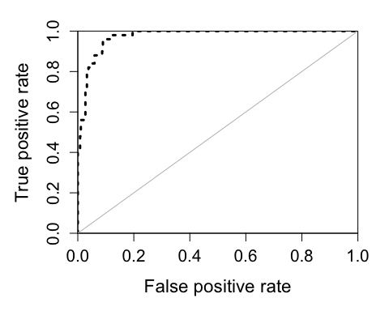
predicted_data <- data.frame(probability_of_survival = logistic_stepwise$fitted.value,Survived=train_copy$Survived,Sex=train_copy$Sex)
# predicted_data <- predicted_data[order(predicted.data$probability.of.survival,decreasing = FALSE),]
ggplot(data=predicted_data,aes(x=probability_of_survival,y=as.numeric(Survived)-1,col=Sex))+
geom_point(alpha=0.8,shape=1,stroke=1)+
xlab('Predicted probability of surviving titanic')+
ylab('Survived')+
stat_smooth(method="glm", method.args=list(family="binomial"), se=FALSE,fullrange = TRUE)+
theme(legend.position = 'bottom',plot.title = element_text(hjust = 0.5))+
ggtitle('Survival by Gender')
## `geom_smooth()` using formula = 'y ~ x'
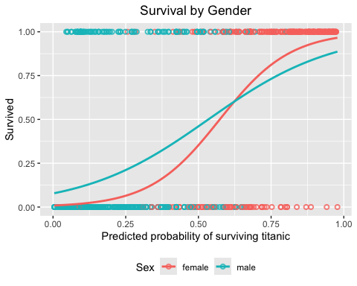
titanic_cart <- rpart(formula = Survived ~., train_copy, method = "class",
control = rpart.control(minsplit = 9, minbucket = 3,xval = 10))
prp(titanic_cart,roundint = F)
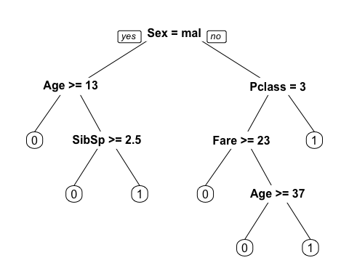
cart_param <- titanic_cart$cptable
cart_param
## CP nsplit rel error xerror xstd
## 1 0.44444444 0 1.0000000 1.0000000 0.04244576
## 2 0.03070175 1 0.5555556 0.5555556 0.03574957
## 3 0.01461988 5 0.4327485 0.4883041 0.03406141
## 4 0.01000000 6 0.4181287 0.5058480 0.03452394
nrow(cart_param)
## [1] 4
train_error <- double(4)
test_error <- double(4)
cv_error <- double(4)
for(i in 1:nrow(cart_param)){
alpha <- cart_param[i, 'CP']
train_temp <- table(train_copy$Survived, predict(prune(titanic_cart, cp = alpha),
train_copy,type = "class"))
train_error[i] <- 1 - sum(diag(train_temp))/sum(train_temp)
cv_error[i] <- cart_param[i, "xerror"] * cart_param[i, "rel error"]
test_temp <- table(test_copy$Survived,predict(prune(titanic_cart,cp = alpha),
test_copy,type = "class"))
test_error[i] <- 1 - sum(diag(test_temp))/sum(test_temp)
}
train_error
## [1] 0.3838384 0.2132435 0.1661055 0.1604938
test_error
## [1] 0.1196172 0.2440191 0.2607656 0.2464115
cv_error
## [1] 1.0000000 0.3086420 0.2113129 0.2115095
matplot(cart_param[,"nsplit"],cbind(train_error,cv_error,test_error),
pch = 19, col = c("red","green","blue"), type = "b",
ylab = "Loss/Error", xlab = "Depth of Split")
legend("right", c('Train', 'CV', 'Test') ,col=seq_len(3),cex=0.8,fill=c("red", "green", "blue"))
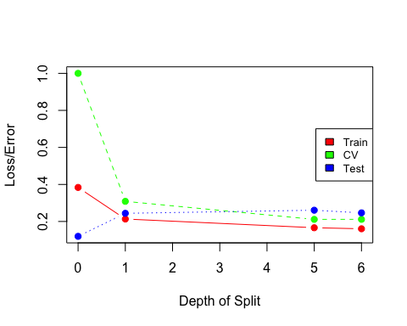
plotcp(titanic_cart)
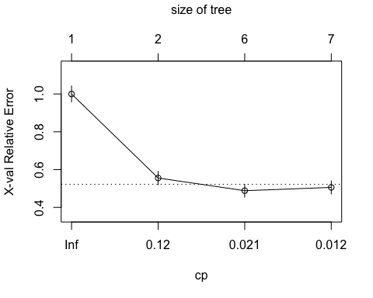
titanic_prune <- prune(titanic_cart,cp = cart_param[4, 'CP'])
prp(titanic_prune)
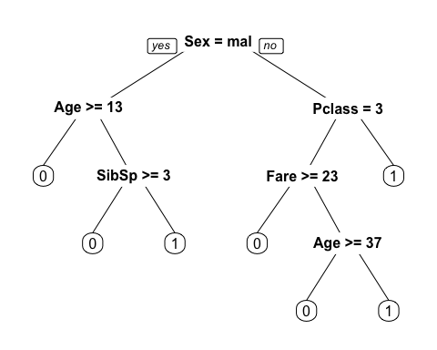
titanic_cfm_cart <- table(test_copy$Survived,predict(titanic_prune, type = "class", newdata = test_copy))
titanic_cfm_cart
##
## 0 1
## 0 265 103
## 1 0 50
cart_accuracy <- sum(diag(titanic_cfm_cart))/sum(titanic_cfm_cart)
cart_accuracy
## [1] 0.7535885
cart_train_accuracy <- 1-train_error[4]
cart_train_accuracy
## [1] 0.8395062
cart_test_accuracy <- 1-test_error[4]
cart_test_accuracy
## [1] 0.7535885
cart_cv_accuracy <- 1-cv_error[4]
cart_cv_accuracy
## [1] 0.7884905
prune_train_acc <- 1-train_error[4]
prune_train_acc
## [1] 0.8395062
prune_test_acc <- 1-test_error[4]
prune_test_acc
## [1] 0.7535885
prune_cv_acc <- 1-cv_error[4]
prune_cv_acc
## [1] 0.7884905
control <- trainControl(method = "repeatedcv", number = 10, repeats = 10)
logistic1 <- train(Survived ~ FamilySize+CabinPos+Deck+Pclass+Sex+Age+SibSp+Parch+Fare+Embarked+Title+Mother+Child, data = train, method = "glm", trControl = control, family = binomial(link = "logit"))
## prediction from rank-deficient fit; attr(*, "non-estim") has doubtful cases
tree1 <- train(Survived ~ FamilySize+CabinPos+Deck+Pclass+Sex+Age+SibSp+Parch+Fare+Embarked+Title+Mother+Child, data = train, method = "rpart", trControl = control)
randomforest <- train(Survived ~ FamilySize+CabinPos+Deck+Pclass+Sex+Age+SibSp+Parch+Fare+Embarked+Title+Mother+Child, data = train, method = "rf", trControl = control)
grid <- expand.grid(size = 1, decay = 0.01)
neuralnet <- train(Survived ~ FamilySize+CabinPos+Deck+Pclass+Sex+Age+SibSp+Parch+Fare+Embarked+Title+Mother+Child, data = train, method = "nnet", trControl = control,maxit = 1000, trace = FALSE, tuneGrid = grid )
acc_rf <- paste0(round(max(randomforest$results$Accuracy),3)*100,'%')
cat('prediction accucary of random forest is ',acc_rf,'.\n')
## prediction accucary of random forest is 82.5% .
acc_nnet <- paste0(round(max(neuralnet$results$Accuracy),3)*100,'%')
cat('prediction accucary of neural net is ',acc_nnet,'.\n')
## prediction accucary of neural net is 82% .
acc_logistic1 <- paste0(round(max(logistic1$results$Accuracy),3)*100,'%')
cat('prediction accucary with logisitc regreesion is ',acc_logistic1,'.\n')
## prediction accucary with logisitc regreesion is 81.5% .
acc_tree1 <- paste0(round(max(tree1$results$Accuracy),3)*100,'%')
cat('prediction accucary with decision tree model is ',acc_tree1,'.\n')
## prediction accucary with decision tree model is 81.1% .
logistic_bayesian <- train(Survived ~ FamilySize+CabinPos+Deck+Pclass+Sex+Age+SibSp+Parch+Fare+Embarked+Title+Mother+Child, data = train, method = "bayesglm", trControl = control, family = binomial(link = "logit"))
acc_bayesian <- paste0(round(max(logistic_bayesian$results$Accuracy),3)*100,'%')
# Combine all the models and their accuracies into a data frame
model_accuracies <- data.frame(
Model = c("Logistic Regression", "Decision Tree", "Bayesian Logistic Regression",
"Random Forest", "Neural Network"),
Accuracy = c(acc_logistic1, acc_tree1, acc_bayesian, acc_rf, acc_nnet)
)
# Print model accuracies
cat("Model Accuracies:\n")
## Model Accuracies:
print(model_accuracies)
## Model Accuracy
## 1 Logistic Regression 81.5%
## 2 Decision Tree 81.1%
## 3 Bayesian Logistic Regression 82.5%
## 4 Random Forest 82.5%
## 5 Neural Network 82%

