1. What is supervised learning in general and prediction in particular?
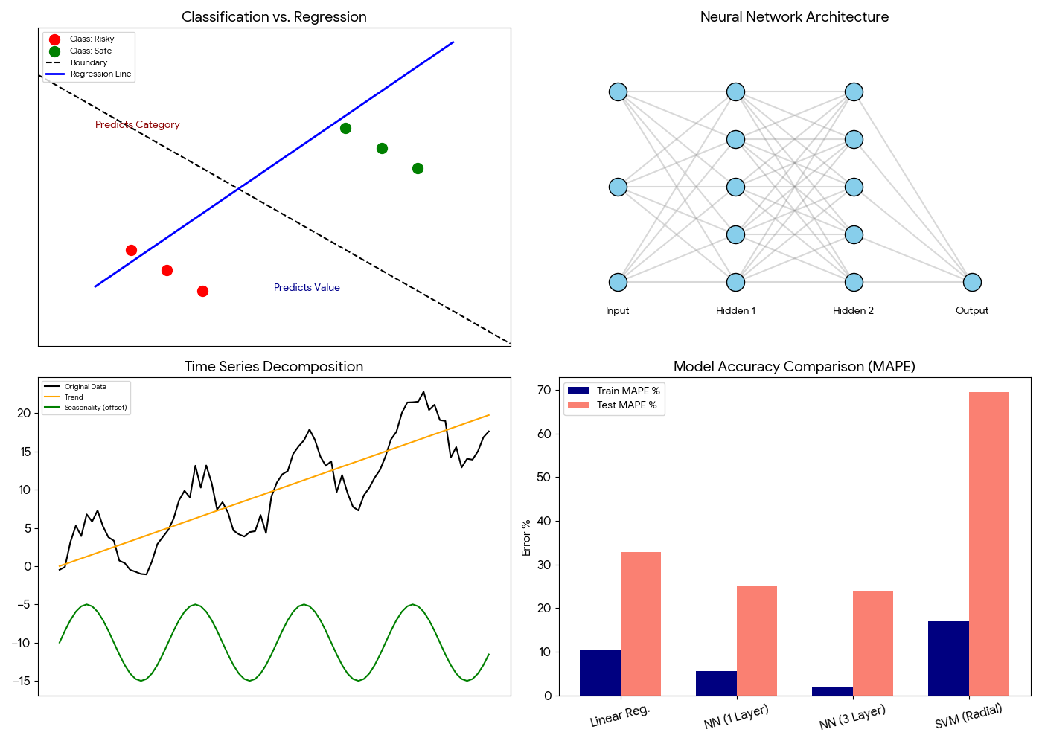
Supervised learning is a core form of data analysis used to extract models that describe important data classes or forecast future trends. This method relies on a labeled dataset where the algorithm is taught to recognize patterns based on known pairs of inputs and outputs. Within this broad field, there is a critical distinction between classification and prediction:

- Classification: This process is used to predict categorical class labels. For instance, a bank loan officer might analyze historical data to determine if a new customer is "risky" or "safe". The goal here is to place the data point into a specific group.
- Prediction (Regression): Prediction specifically refers to forecasting continuous-valued functions or numeric values. An example provided in the materials is a marketing manager who needs to predict the exact amount of money a given customer will spend during an upcoming sale.
- Business Context: A marketing manager might use prediction to calculate the exact numeric value a customer will spend during a sale.
- Goal: The ultimate objective of prediction is to use historical experience to make a statement about how a numeric variable will behave in the future.
2. Examples of regression used in business applications such as product demand.
Regression analysis is widely used in the business world to identify the relationship between two or more continuous variables, enabling data-driven forecasting. The most common application is determining how a change in one factor, like price or marketing, will influence an outcome like sales or product demand.
- Italian Clothing Company Example: In the provided case study, a clothing brand used linear regression to analyze the relationship between advertising spend and yearly sales . By designating sales as the response variable and advertising as the predictor, they estimated a precise relationship: Sales = 168 + 23 * (Advertising) .
- Forecasting Demand: Businesses use these models to anticipate product demand, which allows them to optimize inventory and supply chains. By analyzing historical demand levels against variables like pricing or economic indicators, companies can avoid both overstocking and missed sales opportunities.
- Strategic Planning: Regression models can also predict customer lifetime value or the likely impact of a price hike on total revenue, helping managers make informed strategic decisions rather than relying on intuition.
3. What are some of the popular prediction techniques?
The field of machine learning offers various techniques for prediction, ranging from simple statistical models to complex multi-layer architecture. Each method has different ways of handling data and minimizing errors:
- Linear Regression: Useful for finding a direct relationship between a predictor (independent variable) and a response (dependent variable) . The model chooses values that minimize the error in the equation Y(pred) = b0 + b1*x.
- Neural Networks: These are multi-layer networks that simulate learning through hidden layers. They use Forward Propagation to calculate activations and Backward Propagation to tweak weights and biases based on errors.
- Support Vector Machine (SVM): A linear model that creates a hyperplane to separate data for both classification and regression tasks.
- Regression Trees and Random Forests: These techniques use a tree-like structure for decision-making. A Random Forest generalizes this by combining multiple trees, and performance can be refined by adjusting parameters like nodesize (e.g., changing it from 10,000 to 1,000 to improve MAPE).
4. What is time-series analysis?
Time-series analysis is a mathematical procedure used to study data points taken at specified times, usually at equal intervals. Unlike standard regression, which looks at the relationship between different variables, time-series analysis focuses on predicting future values based solely on previously observed values of the same variable. A core part of this analysis is Time Series Decomposition, which splits the original data into three components:
- Seasonal Component: This captures patterns that repeat within a fixed period . For example, a website might consistently see a spike in traffic during weekends.
- Trend Component: This reflects the underlying long-term direction of the metrics . An example is a website that is gradually increasing in popularity over several years.
- Random/Noise: These are the residuals left in the data after the trend and seasonal effects are removed . This analysis is essential for understanding whether a recent change is a temporary fluctuation or part of a larger trend.

5. What are some of the popular time-series prediction techniques?
There are several specialized techniques for forecasting time-series data, specifically designed to handle the unique challenges of trend and seasonality:
- Holt-Winters: This extension of exponential smoothing is designed to handle time series that contain both systematic trends and seasonal variations. It uses weighted sums of past observations, where recent observations are typically given more importance than those from the distant past.
- ARIMA(p, d, q): Short for Auto Regressive Integrated Moving Average, this model is classified by three order parameters . p is the number of autoregressive terms, d is the number of non-seasonal differences needed, and q is the number of lagged forecast errors.
- Applied Examples:
  - Beer Dataset: The materials demonstrate performing Holt-Winters and ARIMA (4,0,0) on Australian beer consumption data to forecast the next 12 periods .
  - Electricity Demand: An autoregression model can be built using variables such as the demand from the same hour last week, the same hour yesterday, and the previous four consecutive hours to predict the next hour’s consumption .
6. How do you measure the quality of prediction?
To determine which model is the most effective, several metrics are used to evaluate the error between predicted and actual values. The primary metric highlighted in the presentations is the Mean Absolute Percentage Error (MAPE):
- Definition: MAPE is the average of the absolute percentage errors of the forecasts. The error is calculated as the actual value minus the forecasted value.
- Why use absolute values? Absolute values are used so that positive and negative errors do not cancel each other out, providing a true reflection of the model's accuracy.
- Benefits: This measure is highly preferred in business contexts because it is easy to understand and provides the error in terms of a simple percentage.
- Model Comparison Example: In the synthetic dataset experiments, different models showed varying degrees of accuracy. For example, a three-layer Neural Network achieved a significantly better test error (MAPE of 23.92%) compared to a Support Vector Machine, which had a MAPE of 69.42% . Ultimately, the smaller the MAPE, the better the forecast.

7. Use the presentation to write a report on the beer dataset.
The beer dataset tracks monthly beer consumption in Australia from January 1956 to August 1995. Based on the time-series analysis provided in the lecture materials, this dataset serves as a perfect example of how complex data can be broken down into predictable patterns for business planning.
- Time Series Decomposition: The primary step in analyzing this data is decomposition. This process separates the raw consumption figures into three distinct layers: the Trend (a steady long-term increase in consumption over decades), the Seasonal component (repeating annual cycles where consumption peaks during specific months), and Random Noise (unpredictable residuals).
- Modeling Techniques:
  - Holt-Winters: This method was used to handle the systematic trend and seasonal variations. The presentation shows that this model achieved a MAPE of 5.44%, making it a very reliable tool for forecasting.
  - ARIMA (4, 0, 0): This autoregressive model was also applied to predict the next 12 periods. It uses four lags (past data points) to estimate future values.
- Key Learnings: The analysis proves that beer consumption is not random but follows a highly seasonal cycle. For a brewery, this means they can accurately plan production and inventory levels 12 months in advance with a high degree of confidence.

