CHERAN KRISHNAMOORTHY
---------------------------------------------------------------------------------------------------------------------------------
23 1/1 2nd chappal lane,
colombo 06.
Telephone: 0777 47 81 47 (Mobile) 0114 374324
Email: cherankrish@gmail.com
Skype : cherankrish
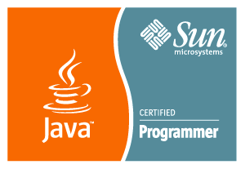

Professional Profile
I am an enthusiastic and professional Web Developer And Software Developer, who enjoys being part of, as well as leading, a successful and productive team.
High capable in writing Webbased and Desktop programs using PHP.
Bullets of my PHP knowledge
1. Redhat, FreeBSD(linux) with PHP (Load balance configuration)
2. SuPHP +server configuration
3. Security in PHP .Development and Development environment, servers etc.
4. Object oriented PHP + Design patterns + xml
5. Pear and GD Package
6. GTK PHP/Desktop applications
7. Curl/ftp/simple xml libraries
8. SMS applications in PHP
9. SMS gateways
10. Wurfl and Tera-Wurfl & Understanding of mobile OSes
11.Amazon S3 + Godaddy cloud
12. Apache web server load balancing and redundancy
13. Perl and Linux shell scripts

PHP Frameworks I use and recommend
- Zend framework( Using that from mid beta).
Notable work : Please visit www.nexva.com. A major app store which sells all platform mobile apps. This major application took two years of development, built on zend framework, hosted on Amazon elastic servers.

2. Cake PHP
Notable work: Please visit www.mihinlanka.com. I’m the designer, analyst, quality assurer and coder of this web application running on cake php.
4. jQuery with PHP
Using and very much enjoying JQuery javascript framework.helps to avoid a lot of cross browser issues.
5. MySql / Postgresql / Oracle 10g / Sqllite / MsSql with php
I worked on more than eighty web based projects in my career. E commerce / Mobile apps / Web portals / Forums / SMS/Teleco / banking
I am..
One of the member of Suntel product development team which directly leads my Suntel IT director Dr.Tarik mariker ( Kindly refer my linkedin profile to see his recommendation)
Team leader of Suntel SMS Solutions (Delivering SMS broadcast using web).
Head architect and project manager of Suntel web phone and SIP server implementation.( Enabling telephone calls over the internet using voice over IP)
Head architect and Team leader of Suntel real time billing and online user billing platform.
(users can see their call records , payments , past invoices , paybills)
Member of Suntel IDC team(Internet data center).Trained by Suntel to find security threats in web servers and applications. Have been responsible as well as adviser of all application level security issues of the customers.
Profile
Professionally trained in PHP object oriented Design style, including High tech design pattern implementation, PDO, PEAR, MYSQLI, XML integration , And SQLITE with AJAX. I’ve attended more than three seminars about PHP cyber security in Malaysia and India. And I speak about php and opensource developments in conferences.
Objective
I am now looking to build on my extensive range of technical skills within a suitably challenging role on PHP or JAVA Environment. I am keen to achieve further professional development.
IDEs I use
E-Clips , Netbeans & Dreamweaver

2004 – 2006 Software Engineer EcWays Pvt Ltd.
2005 – 2007 Singtel Singapore
2007 – 2009 Suntel Srilanka
2010 – 2011 Nexva Inc. France , Srilanka
2011 – Present Loops solutions Srilanka.
Some Selected Portfolio
webphone.suntel.lk , www.nexva.com , www.wow.lk , www.suntel.lk , www.techstore.co.uk , www.yaaldevi.com , www.wowshop.lk , www.mihinlanka.com ,
EDUCATIONAL QUALIFICATIONs
Sun certified Developer (Java 1.4) for Java Technology
Diploma in Linux Environment
BCS
Oracle 10g Administration
PMB trained project management professional
G.C.E(O\L)Examination

Subject Grade
- English C
- Science B
- Mathematics C
- Social studies B
- History C
- Art B
- Tamil B
- Tamil lit A
- Agriculture B
- Hinduism B

G.C.E (A\L) Examination-2004

- Political science B
- Tamil C
- Economics C

Open source Contributions
Drupal
User Account http://drupal.org/user/766800

PHP DOC
Dirty MVC , PHP frame work http://sourceforge.net/projects/dirtymvc/

AWARDS I WON
- E-swabimani 2010 by ICTA , President secretariat .Srilanka.(Please see ICTA,E-swabimani website)
- Manthan 2010. New Delhi. India.(Please see Manthan awards website)
E-Swabimani 2010   | Manthan 2010  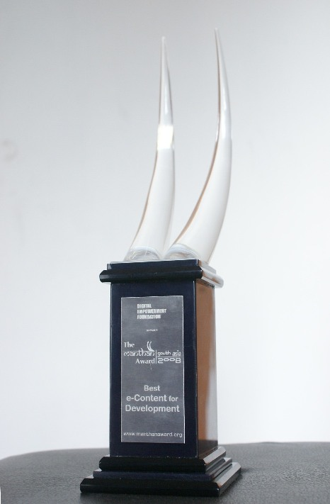
Personal Details
Date of Birth: 27-09-1985 Languages: TAMIL, ENGLISH, Sinhala
Nationality: SRILANKAN Health: Excellent; Smoker Occasionally
Interests & Activities
I have interest in electronics , computing,business and investing .Also I enjoy reading books specially autobiographies.
Referees
U. Chekkilan
Director - Product Support
Professional Systems Integrators (Pvt) Ltd
#20 Sir Chittampalam A. Gardiner Mw,
Colombo 02, Sri Lanka
u.chekkilan@eteck.co.uk
chekkilan@yahoo.com

Jude James Ananthan
Marketing administrator
Ec Ways Pvt ltd.
95, Parakumba place
Colombo-06
T.P:0773405341

