Installating Eclipse Kepler in Ubuntu

Step 1: First make sure that you have Java installed in your computer.
For this, just open the terminal and type
java -version

If you do not have Java installed, in Ubuntu, you have the Ubuntu software center from where you can install OpenJDK
(Install the lastest version – jdk1.8)

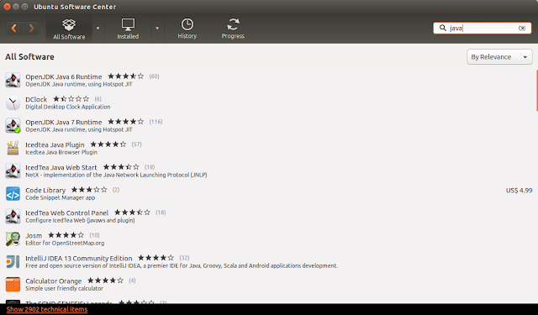
Step 2: Now download the Eclipse Kepler SR2 Package required.

Click on this link https://eclipse.org/downloads/packages/release/Kepler/SR2. This will take you to the Eclipse website which contains the Eclipse Kepler packages for downloading. Select the Eclipse Standard 4.3.2 option. Select 32-bit or the 64-bit option in front of Linux, depending on your computer. Now the eclipse package will get downloaded.

Step 3: Now you can install eclipse in your computer.
First you need to extract the downloaded package of Eclipse to /opt directory so that you can access eclipse from anywhere using the following command.

cd /opt/ && sudo tar -zxvf ~/Downloads/eclipse-*.tar.gz
Step 4: It will be easier for you if a launcher shortcut is created.

Now type this command in the terminal.
sudo gedit /usr/share/applications/eclipse.desktop

This will launch the text editor. Now you can copy and paste what is given below into it.
[Desktop Entry]
Name=Eclipse 4
Type=Application
Exec=/opt/eclipse/eclipse
Terminal=false
Icon=/opt/eclipse/icon.xpm
Comment=Integrated Development Environment
NoDisplay=false
Categories=Development;IDE;
Name[en]=Eclipse

You don't have to change anything in it. Now save the document

Step 5: Launch eclipse

