1.) Copy file abc.txt from local directory to the user’s directory (testroot1) in HDFS.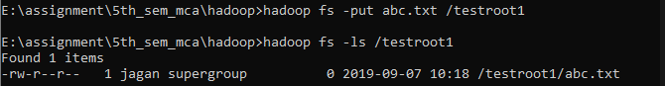

2.) Get a directory listing of the user’s directory in human readable format.

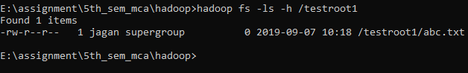

3.) Create a three-level hierarchical directory structure of tr1, tr2, tr3 in root directory.

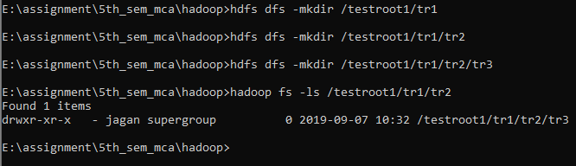

4.) Copy a file called sample.txt from local directory into tr3 and tr2.

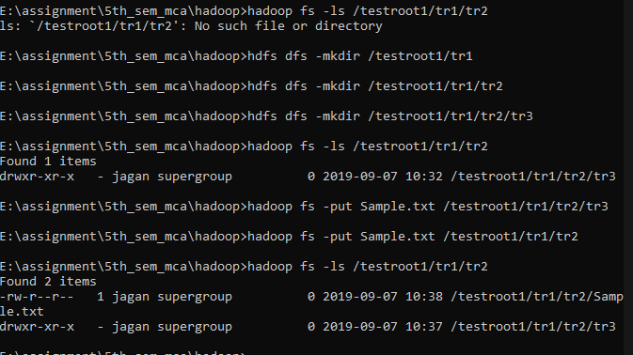

5.) Append new content into the Sample.txt of tr3 from stdin

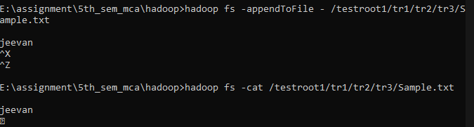

6.) Move that file to tr1.

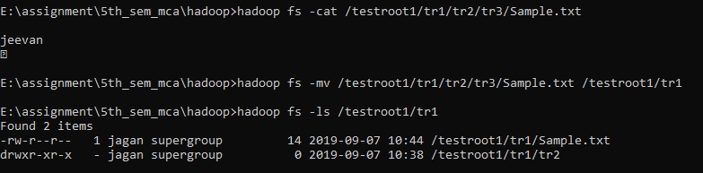

7.) Move the file from tr2 to local directory.



8.) Give the listing of test root recursively based on size

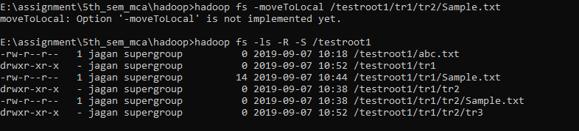

9.) Create another root directory called newtest.

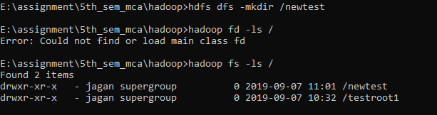

10.) Create a zero-length file called newsample.txt in tr2

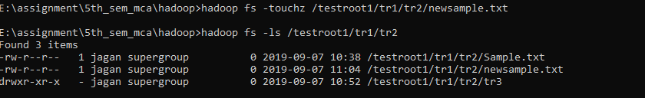

11.) Copy a file bcd.txt from root directory to tr2

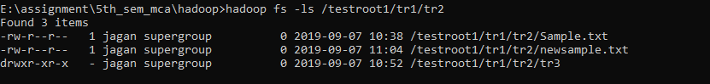

12.) Copy the contents of tr2 to the directory ‘newtest’

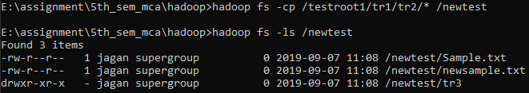

13.) Give the listing of newtest based on date.



14.) Delete the directory tr2

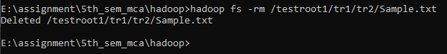

15.) Get the syntax of setfacl.



16.) Reduce the size of sample.txt to 5

17.) Show the last content of abc.txt.



18.) Show the amount of space used by abc.txt in human readable format.

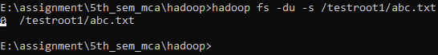

19.) Show the capacity of newtest.

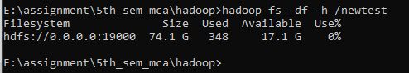

20.) Count the number of directories files in testroot

