In the notes below, the following standard notation is used:
Hits (): Event predicted and occurred.
False Alarms (): Event predicted but did not occur.
Misses (): Event occurred but was not predicted.
Correct Negatives (): Event not predicted and did not occur.
Occurred Didn’t Occur
Predicted [a, b]
Didn’t Predict [c, d]

Probability of Detection (POD)
Also known as the "Hit Rate" or "Recall," the Probability of Detection measures the fraction of observed "yes" events that were correctly forecasted.
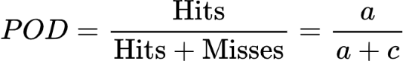

False Alarm Ratio (FAR)
The False Alarm Ratio measures the fraction of predicted "yes" events that turned out to be "no" events.
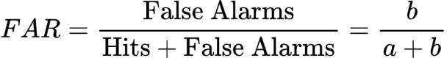

Frequency Bias (Bias)
Frequency Bias compares the total number of times an event was forecasted to the total number of times the event was actually observed.
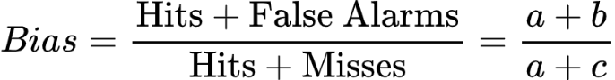

Critical Success Index (CSI)
Also known as the "Threat Score," the Critical Success Index measures the fraction of observed and/or forecast events that were correctly predicted.

