SKILLORA

AI-Powered Resume Builder and Job Recommendation Bot

CVR College of Engineering, Hyderabad

Jeevan K M – 24B81A0523
M Sai Pujitha – 24B81A0539
P Vivek – 24B81A0564

ABSTRACT
The rapid digitization of recruitment processes has increased the demand for intelligent systems that can assist job seekers in creating professional resumes and identifying relevant job opportunities. This paper presents SKILLORA, an AI-powered Resume Builder and Job Recommendation Bot designed to provide end-to-end career assistance through conversational platforms such as WhatsApp and Telegram. The system enables users to upload resumes or provide personal and professional details through a chatbot interface. Natural Language Processing (NLP) techniques are employed to extract structured information such as skills, education, experience, and projects from unstructured resume data. The extracted information is used to generate ATS-friendly resumes using predefined templates enhanced by Large Language Models (LLMs). Job and internship opportunities are fetched from multiple online sources and matched with user profiles using similarity-based analysis and ranking mechanisms. The backend is implemented using Python and FastAPI with a modular, service-oriented architecture. User profiles, preferences, and notification subscriptions are stored in a relational database to enable personalization. When suitable opportunities are not immediately available, the system provides automated notifications through email and WhatsApp. The proposed system improves accessibility, personalization, and efficiency in resume creation and job discovery, making it suitable for academic evaluation and real-world deployment.
Keywords:
Artificial Intelligence, Natural Language Processing, Resume Parsing, Resume Builder, Job Recommendation System, Conversational Chatbot, WhatsApp Bot, Telegram Bot, Skill Extraction, Similarity Matching, ATS-Friendly Resume, Large Language Models, FastAPI, Modular Architecture, Job Ranking, Database Management, Notification System.

INTRODUCTION
With the exponential growth of online recruitment platforms, job searching has become a predominantly digital process. While numerous portals provide job listings, many users face challenges in preparing professional resumes and identifying opportunities that closely match their skills and career goals. Manual resume creation and repetitive job searching are time-consuming and often inefficient.
Conversational Artificial Intelligence systems offer a practical solution by enabling users to interact with intelligent services through natural language. Messaging platforms such as WhatsApp and Telegram are widely adopted and provide a convenient medium for deploying intelligent career assistance systems. By integrating chatbot interfaces with Artificial Intelligence, Natural Language Processing, and backend automation, personalized resume-building and job recommendation services can be delivered effectively.
This paper proposes SKILLORA, a chatbot-based system that assists users throughout the resume creation and job discovery lifecycle. The system emphasizes modular architecture, AI-driven text processing, similarity-based job matching, and automated notifications. The objective is to simplify career assistance while maintaining scalability and maintainability.
SYSTEM ARCHITECTURE
The proposed system follows a modular, service-based architecture to ensure scalability, fault isolation, and ease of maintenance. Each module is responsible for a specific task and communicates with other modules through well-defined APIs. This architectural approach allows independent development, testing, and future enhancement of individual components.
Architecture Overview
The system is divided into the following major layers:
• User Interaction Layer
• Bot Layer
• API and Application Layer
• Resume Processing Module
• AI and NLP Layer
• Job Matching Module
• Database Layer
• Notification Service
• Utilities and Data Storage
This layered architecture ensures a clean separation of concerns and smooth data flow across the system.

USER INTERACTION AND BOT LAYER
Users interact with the system through WhatsApp and Telegram bots, which serve as the primary entry point. The interaction is fully conversational and designed to guide users through available services.
Responsibilities:
• Greeting users and presenting available options
• Accepting resume uploads in PDF or DOCX format
• Collecting personal and professional details interactively
• Displaying generated resumes and job recommendations
• Informing users about notification subscriptions
The bot layer does not perform any business logic or AI processing. It simply forwards user inputs and files to the backend and delivers structured responses returned by backend services.

API AND APPLICATION LAYER
The backend application is implemented using Python and the FastAPI framework. This layer acts as the central coordinator of the entire system.
Key Functions:
• Receiving and validating requests from bots
• Managing user sessions and workflows
• Routing requests to appropriate internal modules
• Coordinating resume parsing, AI analysis, and job matching
• Aggregating responses and sending structured outputs back to bots
FastAPI is selected for its high performance, scalability, and support for asynchronous operations, which is essential for handling multiple concurrent users and background tasks.

RESUME PROCESSING MODULE
The Resume Processing Module handles all operations related to resume handling and generation.
Resume Parsing:
Uploaded resumes are processed using PDF and DOCX extraction libraries such as PyPDF2 and python-docx. The extracted text is analyzed to identify key sections including skills, education, work experience, and projects. The parsed information is converted into a structured format for further processing.
Resume Generation:
If a user does not provide an existing resume, the system collects details interactively and generates a professional resume using predefined, ATS-friendly templates. These templates follow standard industry formatting guidelines.
Content Enhancement:
Language enhancement techniques supported by Large Language Models are applied to improve clarity, grammar, and professional tone, ensuring high-quality resume output.

AI AND NLP MODULE
The AI and NLP module provides intelligence and personalization to the system.
Skill Extraction:
Natural Language Processing techniques are employed to identify relevant technical and soft skills from resume text and user inputs. The system uses spaCy along with custom skill keyword datasets to improve extraction accuracy.
Similarity-Based Matching:
Extracted skills and job requirements are converted into numerical embeddings. Cosine similarity is used to measure how closely a user profile matches available job listings. This similarity score forms the basis for job recommendations.
LLM-Based Resume Enhancement:
Large Language Models are used to tailor resume content to specific job roles, improving impact and relevance.

JOB MATCHING AND RANKING MODULE
The Job Matching Module is responsible for retrieving, matching, and ranking job and internship opportunities.
Job Fetching:
Job listings are fetched from multiple sources using APIs and controlled web scraping mechanisms. Retrieved listings are cached to reduce repeated external requests.
Job Matching:
User skills are compared with job requirements using AI-driven similarity analysis.
Job Ranking:
Matched jobs are ranked based on relevance scores that consider skill overlap, experience level, and location preferences. The top-ranked jobs are presented to the user.

DATABASE AND DATA MANAGEMENT
A relational database is used to store persistent system data.
Stored Data Includes:
• User profiles
• Resume metadata
• Extracted skills
• Job preferences
• Notification subscriptions
SQLite is used for mini-scale deployment, while PostgreSQL can be adopted for scalable implementations. This layer enables personalization and session continuity.
NOTIFICATION SERVICE
The notification service ensures that users do not miss relevant opportunities.
If suitable jobs are not immediately available, the system activates a background workflow that periodically checks for new listings. When matching opportunities are identified, users are notified automatically.
Notification Channels:
- Email notifications using SMTP or third-party services
- WhatsApp notifications using messaging APIs
- This feature improves user engagement and long-term usefulness of the system.

IMPLEMENTATION DETAILS
Backend Framework: Python, FastAPI AI and NLP Tools: spaCy, similarity models, Large Language Models Database: SQLite / PostgreSQL Bots: WhatsApp Cloud API, Telegram Bot API Notification Services: SMTP, WhatsApp API
The system is implemented as a mini-scale project with real-world applicability.
WORKFLOW
The block diagram illustrates the complete data flow and interaction between different modules of the SKILLORA system. The process begins at the User Interaction Layer, where users communicate through WhatsApp or Telegram bots. These bots forward user messages and uploaded resumes to the API and Application LayerThe API layer acts as the central controller and routes requests to the Resume Processing Module for parsing uploaded resumes or generating new resumes using predefined templates. Parsed resume data is stored in the Data Storage layer and passed to the AI and NLP module.
Within the AI and NLP module, the Skill Extractor identifies relevant skills from resume content using NLP techniques and predefined skill datasets. The LLM Helper enhances resume content to improve clarity, grammar, and job relevance. The Similarity Modelconverts both user skills and job descriptions into vector embeddings and computes similarity scores.

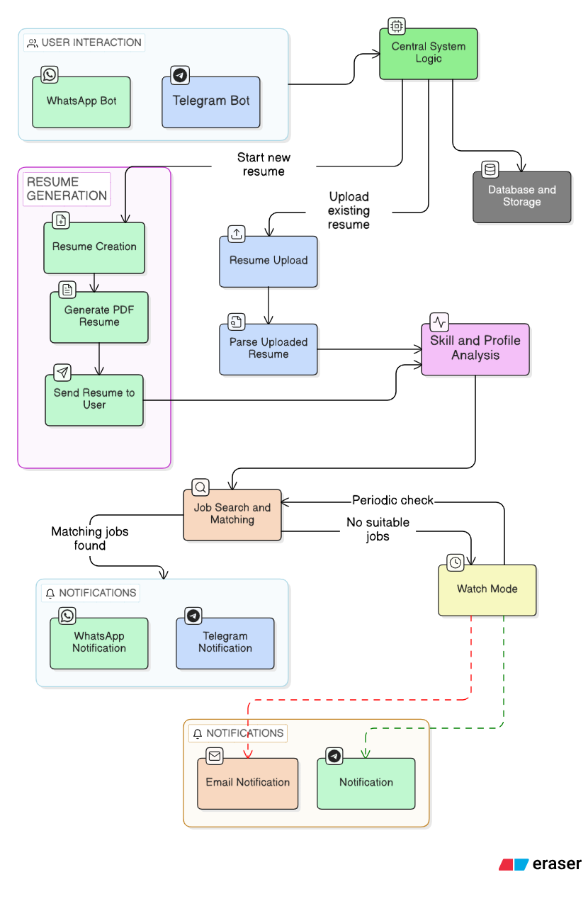

The Job Matching module retrieves job listings using the Job Fetcher, compares them with user profiles through the Job Matcher, and ranks suitable jobs using the Job Ranker based on relevance scores. Cached job data and skill datasets are accessed from the storage layer to improve performance.If suitable jobs are identified, results are returned to the API layer and displayed to users through the bot interface. If no immediate matches are found, the Notification Service is triggered. The Notification Scheduler periodically checks for new jobs, matches them against stored user preferences, and sends alerts via email or WhatsApp. The Database layer stores user profiles, session data, extracted skills, and notification preferences, ensuring continuity and personalization across interactions.This structured flow ensures efficient coordination between conversational interfaces, AI-driven processing, and backend services.
FUTURE SCOPE
Although SKILLORA effectively addresses resume building and job recommendation requirements, several enhancements can be incorporated in future versions:
• Integration with additional job platforms and government job portals for wider coverage.
• Incorporation of advanced deep learning models for more accurate skill extraction and job matching.
• Support for multilingual resume processing and chatbot interaction.
• Real-time interview preparation assistance, including mock interviews and question generation.
• Resume analytics dashboard providing detailed feedback and improvement suggestions.
• Mobile application integration for enhanced accessibility.
• Use of reinforcement learning to continuously improve job recommendation accuracy based on user feedback.
These enhancements would further strengthen the system’s applicability in real-world recruitment and career guidance scenarios.
CONCLUSION
This paper presented SKILLORA, an AI-powered Resume Builder and Job Recommendation Bot deployed on conversational platforms such as WhatsApp and Telegram. By integrating chatbot interfaces with AI-driven resume processing, skill extraction, and similarity-based job matching, the system provides an accessible and personalized career assistance solution. The modular, service-oriented architecture ensures scalability, maintainability, and clarity, making the system suitable for academic evaluation as well as real-world deployment. Automated notification services further enhance user engagement by ensuring timely delivery of relevant job opportunities.

REFERENCES
[1] D. Jurafsky and J. H. Martin, Speech and Language Processing, 3rd ed., Pearson, 2023.
[2] C. D. Manning, P. Raghavan, and H. Schütze, Introduction to Information Retrieval, Cambridge University Press, 2008.
[3] G. Salton and M. J. McGill, Introduction to Modern Information Retrieval, McGraw-Hill, 1983.
[4] spaCy Documentation. [Online]. Available: https://spacy.io
[5] FastAPI Documentation. [Online]. Available: https://fastapi.tiangolo.com
[6] Telegram Bot API Documentation. [Online]. Available: https://core.telegram.org/bots/api
[7] WhatsApp Cloud API Documentation, Meta Developers. [Online].
[8] T. Mikolov et al., “Efficient Estimation of Word Representations in Vector Space,” in Proc. ICLR, 2013.
[9] J. Devlin et al., “BERT: Pre-training of Deep Bidirectional Transformers for Language Understanding,” in Proc. NAACL-HLT, 2019.
[10] I. Goodfellow, Y. Bengio, and A. Courville, Deep Learning, MIT Press, 2016.
[11] S. Bird, E. Klein, and E. Loper, Natural Language Processing with Python, O’Reilly Media, 2009.
[12] R. S. Sutton and A. G. Barto, Reinforcement Learning: An Introduction, MIT Press, 2018.
[13] A. Vaswani et al., “Attention Is All You Need,” in Proc. NeurIPS, 2017.
[14] P. Lewis et al., “Retrieval-Augmented Generation for Knowledge-Intensive NLP Tasks,” in Proc. NeurIPS, 2020.
[15] SendGrid Documentation. [Online]. Available: https://docs.sendgrid.com

