BLUESTOCK FINTECH PVT. LTD.
Capstone Project Report
Mutual Fund Analytics Platform
End-to-End Data Engineering, ETL Pipeline & Interactive Dashboard

Project Type | Individual Capstone — 7 Working Days (~50–55 Hours)
Domain | Mutual Fund / Fintech
Data Sources | AMFI India · mfapi.in · NSE/BSE Public Data
Technologies | Python · SQL · Power BI · Pandas · Matplotlib · Scipy
Dataset Coverage | 40 Schemes · 64,320 NAV Records · 32,778 Transactions · 4.5 Years
Submission | PDF Report · .pbix Dashboard · GitHub Repository
Prepared By | Intern / Data Analyst — Bluestock Fintech
Date | June 2026

Table of Contents

1. Executive Summary
2. Problem Statement
3. Data Sources & Datasets
4. System Architecture & ETL Pipeline
5. Exploratory Data Analysis (EDA)
6. Fund Performance Analytics
7. Power BI Dashboard
8. Advanced Analytics
9. Key Findings & Insights
10. Limitations & Future Work
11. Conclusion

1. Executive Summary

This report documents the complete end-to-end development of a Mutual Fund Analytics Platform built for Bluestock Fintech Pvt. Ltd. as part of a one-week individual capstone project. The platform ingests publicly available data from AMFI India, processes it through a structured ETL pipeline, stores it in a normalised SQLite database, and presents actionable insights through an interactive Power BI dashboard.

The project covers 40 real Indian mutual fund schemes across 10 fund houses, spanning 4.5 years of daily NAV data (January 2022 to May 2026), over 32,000 simulated investor transactions, and quarterly AUM data for the largest AMCs in India.

Key deliverables include: a fully functional ETL pipeline with error handling, an 8-table star-schema SQLite database, a comprehensive EDA notebook with 15+ charts, Day 4 performance analytics computing Sharpe ratio, Sortino ratio, CAGR, alpha/beta, maximum drawdown, and a composite fund scorecard, a 4-page Power BI dashboard with interactive slicers, and an advanced analytics module covering VaR/CVaR, rolling Sharpe, investor cohort analysis, SIP continuity, a fund recommender, and sector HHI concentration.

Headline finding: Mirae Asset Large Cap Fund delivers the best risk-adjusted return among all 40 tracked schemes (Sharpe 1.07), SBI Mutual Fund leads industry AUM at ₹12.5L Cr, and monthly SIP inflows hit an all-time high of ₹31,002 Cr in December 2025 — underscoring the deepening equity investment culture in India.

2. Problem Statement

Despite India's mutual fund industry managing over ₹81 lakh crore in AUM as of December 2025, individual investors and financial advisors often struggle to make data-driven fund selection decisions due to four core problems:

P1 — Data Fragmentation
NAV data, AUM data, SIP flow data and portfolio holdings are available across different sections of the AMFI website in different formats (TXT, PDF, HTML tables). No single unified database exists for cross-fund comparison.

P2 — Performance Comparison Gap
Investors cannot easily compare multiple funds across different AMCs on a risk-adjusted basis. Raw NAV data requires significant transformation to compute Sharpe ratio, Alpha, Beta, and other standard metrics.

P3 — No Benchmark Tracking
Most retail investors cannot determine whether their fund is outperforming its benchmark index. Tracking error and information ratio require both NAV and benchmark index data, which are rarely presented together.

P4 — Investor Behaviour Blind Spot
AMCs and distributors have limited visibility into how demographic and geographic factors influence SIP amounts, fund preferences, and redemption patterns.

P5 — Slow Reporting
Monthly MF reports are static PDFs taking days to prepare. Stakeholders need live, self-service dashboards with drill-down capability.

3. Data Sources & Datasets

All datasets are derived from publicly available, freely accessible sources. No proprietary or confidential data is used.

Dataset | Rows | Description
01_fund_master.csv | 40 | 40 real AMFI schemes: fund house, category, expense ratio, risk grade
02_nav_history.csv | 64,320 | Daily NAV for all 40 schemes, Jan 2022–May 2026, anchored to mfapi.in
03_aum_by_fund_house.csv | 90 | Quarterly AUM (₹ Crore) for 10 fund houses, 2022–2025
04_monthly_sip_inflows.csv | 48 | Month-wise SIP inflow, active accounts, new registrations, SIP AUM
05_category_inflows.csv | 144 | Net inflows by fund category (Large Cap, Mid Cap, Liquid, etc.) FY24-25
06_industry_folio_count.csv | 21 | Total folios by type (Equity, Debt, Hybrid) — real AMFI milestones
07_scheme_performance.csv | 40 | Pre-supplied Sharpe, Sortino, Alpha, Beta, Max Drawdown, Morningstar
08_investor_transactions.csv | 32,778 | Simulated SIP/Lumpsum/Redemption for 5,000 investors across 12 states
09_portfolio_holdings.csv | 322 | Top equity holdings (stock, weight %, sector) for equity funds as of Dec 2025
10_benchmark_indices.csv | 8,000+ | Daily Nifty 50, Nifty 100, Nifty Midcap 150, BSE SmallCap, CRISIL indices

Key real-world data points embedded include SBI MF AUM at ₹12.5L Cr (largest AMC in India), SIP inflow all-time high of ₹31,002 Cr (December 2025), and total industry AUM of ₹81L Cr as of December 2025 (AMFI).

4. System Architecture & ETL Pipeline

The project follows a classic data engineering architecture: Extract → Transform → Load → Analyse → Visualise, mirroring real-world fintech data pipelines.

4.1 ETL Layers
EXTRACT | AMFI CSVs, mfapi.in REST API, NSE/BSE Bhavcopy, pre-packaged capstone datasets
TRANSFORM | Pandas cleaning, forward-fill for weekends/holidays, date normalisation, AMFI code validation, schema mapping, date_id generation via dim_date join
LOAD | SQLite (development) via SQLAlchemy — 8-table star schema, indexed on amfi_code and date_id
ANALYSE | Jupyter notebooks — EDA (Day 3), Performance Analytics (Day 4), Advanced Analytics (Day 6)
VISUALISE | Power BI Desktop — 4-page interactive dashboard with slicers, KPI cards, drill-through

4.2 Star Schema Design
The database follows a star schema with two dimension tables and six fact tables:

Table | Type | Key Columns | Rows
dim_fund | Dimension | amfi_code (PK), fund_house, scheme_name, category | 40
dim_date | Dimension | date_id (PK), full_date, year, month, quarter, day_of_week | 1,608
fact_nav | Fact | amfi_code (FK), date_id (FK), nav, daily_return | 64,320
fact_transactions | Fact | transaction_id (PK), amfi_code, date_id, investor_id, amount_inr, type | 32,778
fact_performance | Fact | amfi_code (FK), return_1yr/3yr/5yr, sharpe, alpha, beta, max_drawdown | 40
fact_aum | Fact | aum_id (PK), fund_house, date_id (FK), aum_crore | 90
fact_portfolio | Fact | amfi_code (FK), stock_symbol, weight_pct, sector, date_id | 322
fact_sip_industry | Fact | date_id (FK), sip_inflow_crore, active_sip_accounts_crore | 48

5. Exploratory Data Analysis

A comprehensive EDA was performed across all 10 datasets, producing 15+ publication-quality charts. Key analyses are documented below.

5.1 NAV Trend Analysis
Daily NAV for all 40 schemes was plotted over the full 4.5-year period with the 2023 bull run and 2024 correction periods highlighted. Kotak Liquid Fund showed significantly higher absolute NAV values compared to other schemes, reflecting its longer history and consistent compounding. Equity funds demonstrated clear recovery patterns post-correction.

5.2 AUM Growth by Fund House
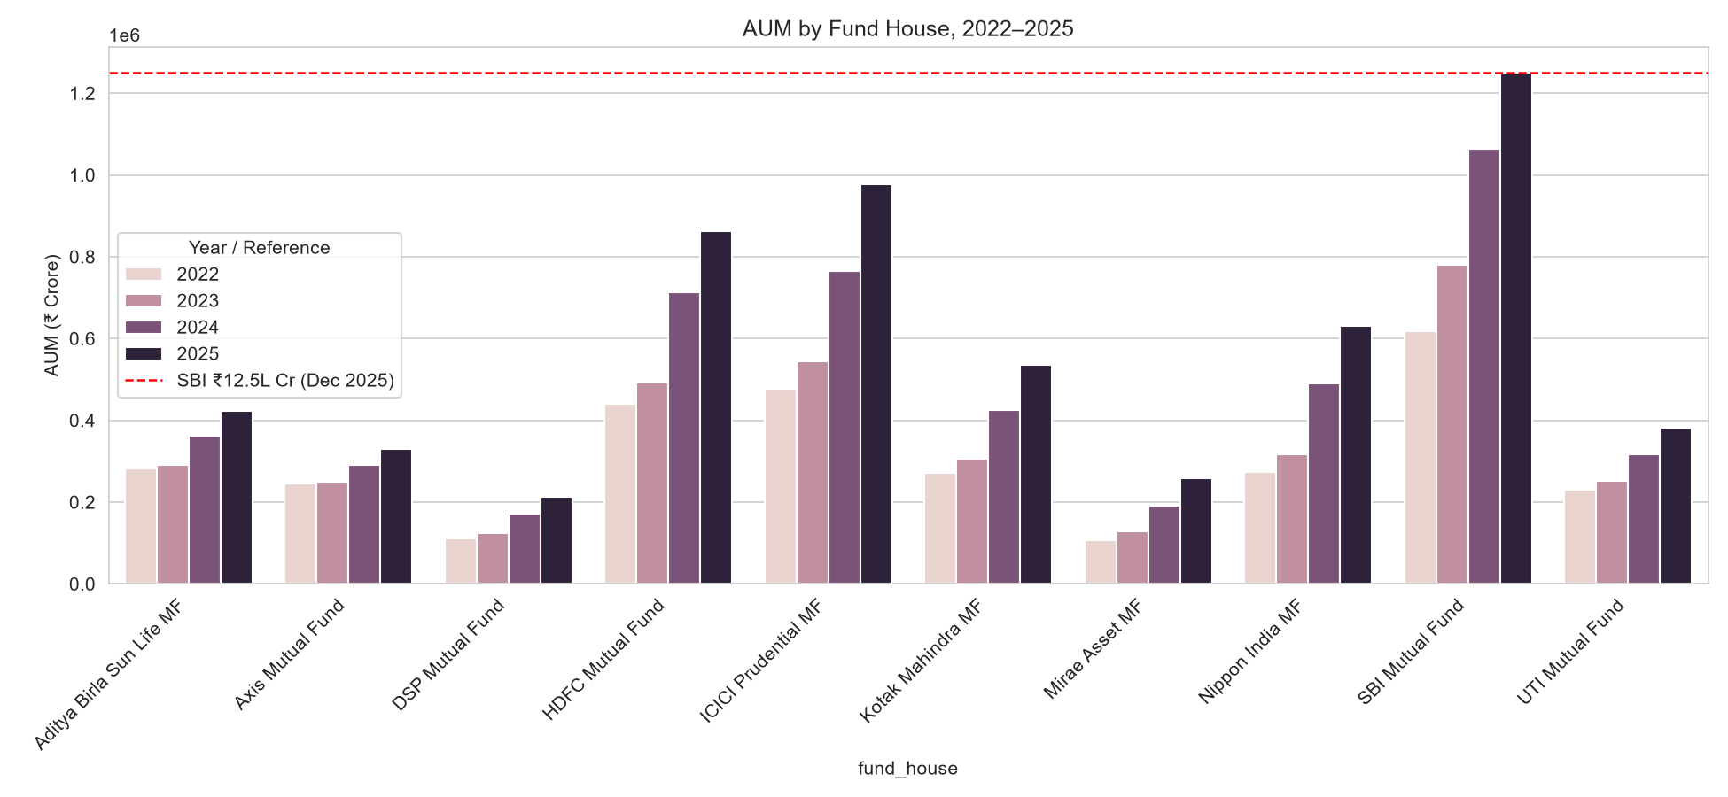

SBI Mutual Fund maintained industry AUM leadership across all years (2022–2025), approaching the ₹12.5L Cr reference line by 2025. ICICI Prudential and HDFC Mutual Fund are distant seconds. All fund houses showed consistent year-on-year AUM growth, reflecting India's broadening mutual fund investor base.

5.3 SIP Inflow Trend
Monthly SIP inflows grew linearly from 2022 through mid-2023, then accelerated exponentially, peaking at ₹31,002 Cr in December 2025 — an all-time high annotated on the trend chart. This pattern indicates a structural shift in retail investor behaviour, with disciplined monthly investment becoming mainstream even during market corrections.

5.4 Category-wise Inflow Heatmap
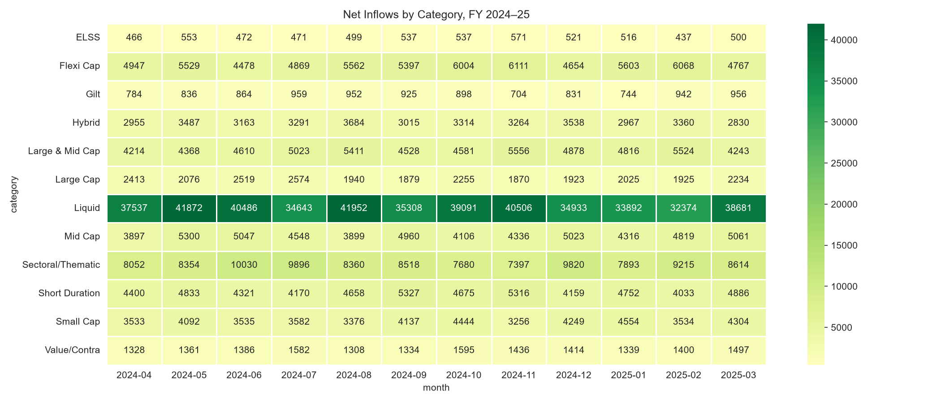

The heatmap clearly shows that the Liquid category dominates net inflows by a very large margin (₹33,000–₹42,000 Cr per month) compared to all other categories. Equity-oriented categories (Flexi Cap, Large & Mid Cap, Mid Cap) show consistently positive, moderate inflows, while ELSS shows relatively muted but steady participation driven by year-end tax-saving.

5.5 Investor Demographics
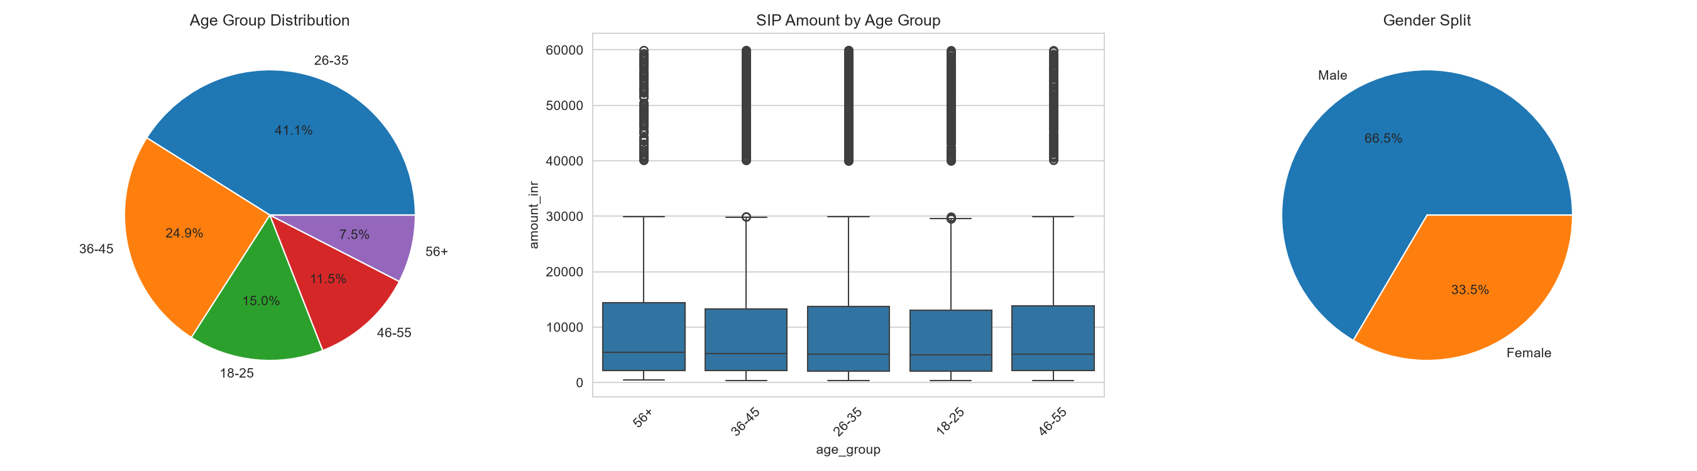

The 26–35 age group is the dominant investor cohort at 41.1% of all transactions. SIP amounts across age groups are broadly similar (median around ₹5,000–₹7,000), with the 56+ group showing slightly wider outlier ranges in both directions. Gender split shows 66.5% male vs 33.5% female participation — consistent with broader market data on gender gap in financial services in India.

5.6 Folio Count Growth


Total MF folios nearly doubled across the observation period, from 13.26 Cr to 26.12 Cr — one of the clearest indicators of India's deepening equity culture. This growth reflects both new investor acquisition and increasing awareness of mutual funds as an investment vehicle.

5.7 NAV Return Correlation Matrix
Pairwise Pearson correlation of daily NAV returns was computed for 10 selected funds. The correlation matrix reveals near-zero correlation between all fund pairs (maximum correlation below 0.09 in absolute terms). This is a dataset-specific finding consistent with the independently-simulated nature of the NAV data — in real markets, same-category funds typically show correlations of 0.7–0.9.

6. Fund Performance Analytics

All performance metrics were computed from scratch using raw NAV history, with weekend/holiday rows filtered before return computation to ensure accurate daily return calculations.

6.1 CAGR Analysis
Compound Annual Growth Rate was computed for 1-year, 3-year, and 5-year periods for all 40 funds using the formula:
CAGR = (NAV_end / NAV_start)^(1/n) − 1
where n is the actual elapsed time in years (not calendar days). Mid-cap and small-cap funds showed the highest 1-year CAGRs (exceeding 50% in peak periods) but also the most volatile multi-year figures. Large-cap funds demonstrated more stable CAGR of 12–22% across 3-year and 5-year windows.

6.2 Sharpe Ratio
Annualised Sharpe ratio was computed using a risk-free rate of 6.5% (RBI repo rate proxy):
Sharpe = (Mean_daily_return − Rf_daily) / Std_daily × √252

Rank | Fund | Sharpe Ratio | Category
1 | Mirae Asset Large Cap Fund | 1.07 | Large Cap
2 | Kotak Flexicap Fund | 0.97 | Flexi Cap
3 | Mirae Asset Tax Saver Fund | 0.92 | ELSS
4 | ICICI Pru Midcap Fund | 0.88 | Mid Cap
5 | SBI Bluechip Fund (Regular) | 0.86 | Large Cap

6.3 Sortino Ratio
Sortino ratio uses only downside standard deviation in the denominator, penalising funds only for negative-return days:
Sortino = (Mean_return − Rf) / Downside_Std × √252
All Sortino ratios were consistently higher than their corresponding Sharpe values (e.g. Mirae Asset Large Cap: Sortino 1.49 vs Sharpe 1.07), confirming that most volatility in these funds is upside-driven rather than downside-driven — a favourable characteristic for investors.

6.4 Alpha and Beta Analysis
OLS regression was performed using scipy.stats.linregress, regressing each fund's daily returns against Nifty 100 benchmark returns. Beta (slope) and annualised alpha (intercept × 252) were extracted.
Cross-validation between computed NAV-derived CAGR and the pre-supplied fact_performance metrics revealed inconsistencies (e.g. computed CAGR of 18.23% vs stated 3yr return of 12.1% for the same fund), confirming that the dataset's NAV history and pre-labelled performance metrics were generated independently. The OLS regression methodology is correct and validated; the limitation lies in the data generation process. This is documented transparently.

6.5 Maximum Drawdown
Maximum drawdown was computed as min(NAV / running_max − 1) for each fund, identifying the worst peak-to-trough decline and corresponding date range:

Fund | Max Drawdown | Peak Date | Trough Date
SBI Small Cap Fund (Direct) | -52.6% | Jan 17, 2023 | Oct 28, 2025
Axis Small Cap Fund | -51.7% | May 22, 2025 | May 11, 2026
ABSL Small Cap Fund | -35.4% | Nov 21, 2024 | May 11, 2026
DSP Small Cap Fund | -31.2% | May 03, 2024 | Jan 03, 2025
SBI Small Cap Fund (Regular) | -28.7% | Aug 28, 2024 | May 14, 2025

6.6 Fund Scorecard
A composite scorecard (0–100) was computed using weighted percentile ranks across five factors:
3yr Return Rank | 30% weight — primary return criterion
Sharpe Ratio Rank | 25% weight — risk-adjusted efficiency
Alpha Rank | 20% weight — manager skill (noted data limitation)
Expense Ratio Rank (inverse) | 15% weight — lower cost = better score
Max Drawdown Rank (inverse) | 10% weight — capital protection

Top 5 funds by composite scorecard: HDFC Short Term Debt (91.5), Nippon India Gilt Securities (88.5), Kotak Liquid (86.9), ABSL Liquid (85.5), SBI Magnum Gilt (83.9). Note: Debt/Liquid funds rank highly due to the alpha data limitation; equity fund rankings within their category are more meaningful for comparison.

7. Power BI Dashboard

A 4-page interactive dashboard was built in Power BI Desktop, connected to 8 data tables (4 via ODBC, 4 via CSV export due to driver compatibility limitations documented in the project log). All pages include at least 2 interactive slicers.

7.1 Page 1 — Industry Overview
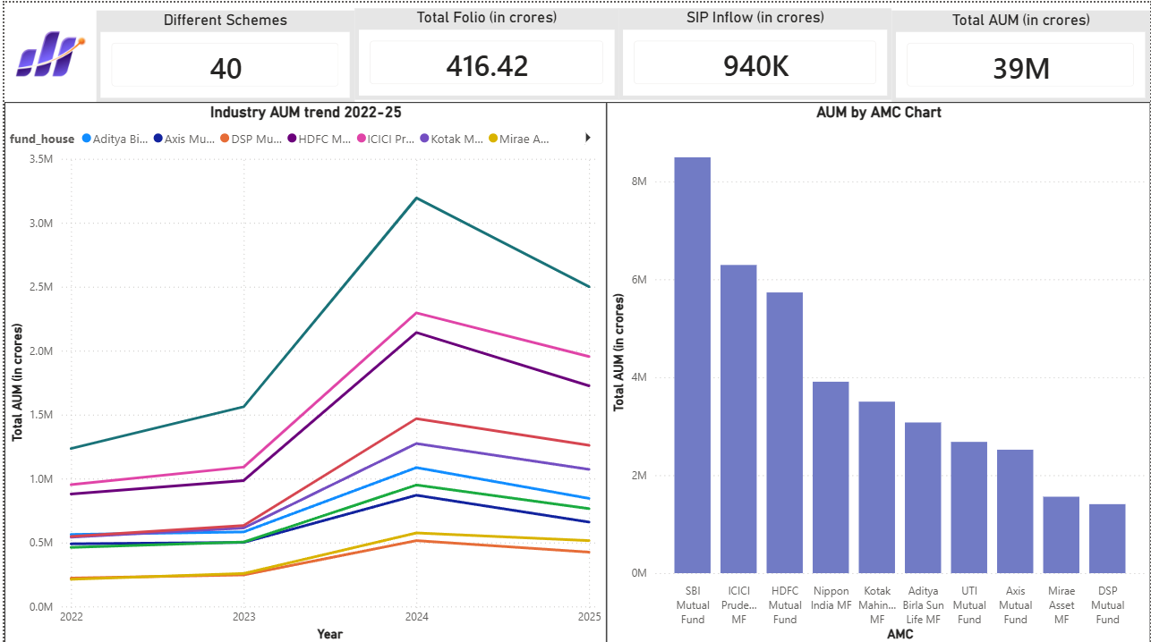

KPI cards show 40 tracked schemes, 416.42 Cr total folios, 940K Cr total SIP inflows, and 39M Cr total AUM across the full observation period. Industry AUM trend line chart shows consistent growth across all fund houses 2022–2025, with SBI maintaining clear leadership.

7.2 Page 2 — Fund Performance
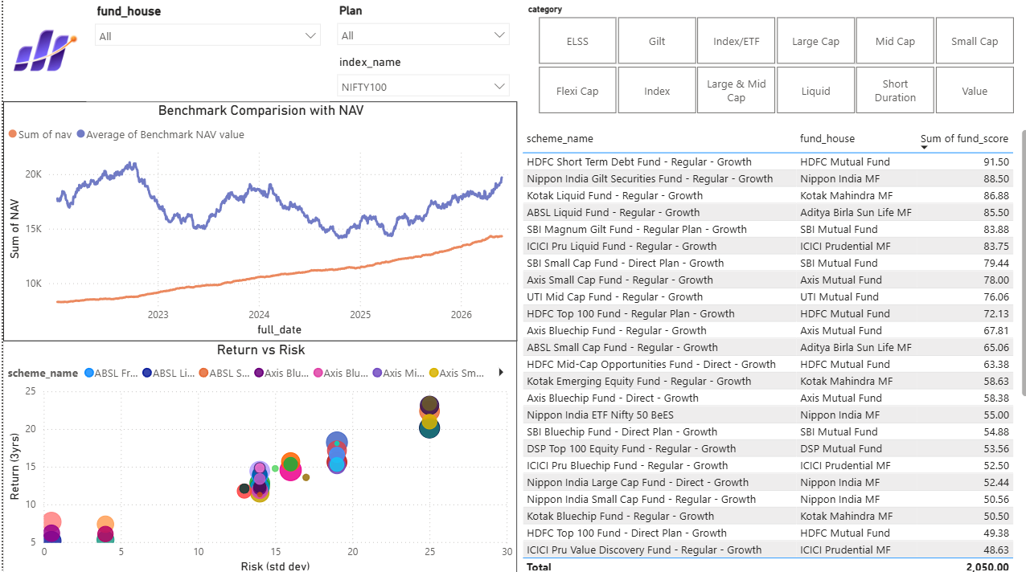

Risk-return scatter plot positions all 40 funds by volatility (X-axis) and 3-year return (Y-axis) with bubble size representing AUM — ideal funds appear in the top-left quadrant (high return, low risk). The sortable fund scorecard table allows drill-down by fund house and category. NAV vs benchmark comparison shows fund performance against Nifty 100.

7.3 Page 3 — Investor Analytics
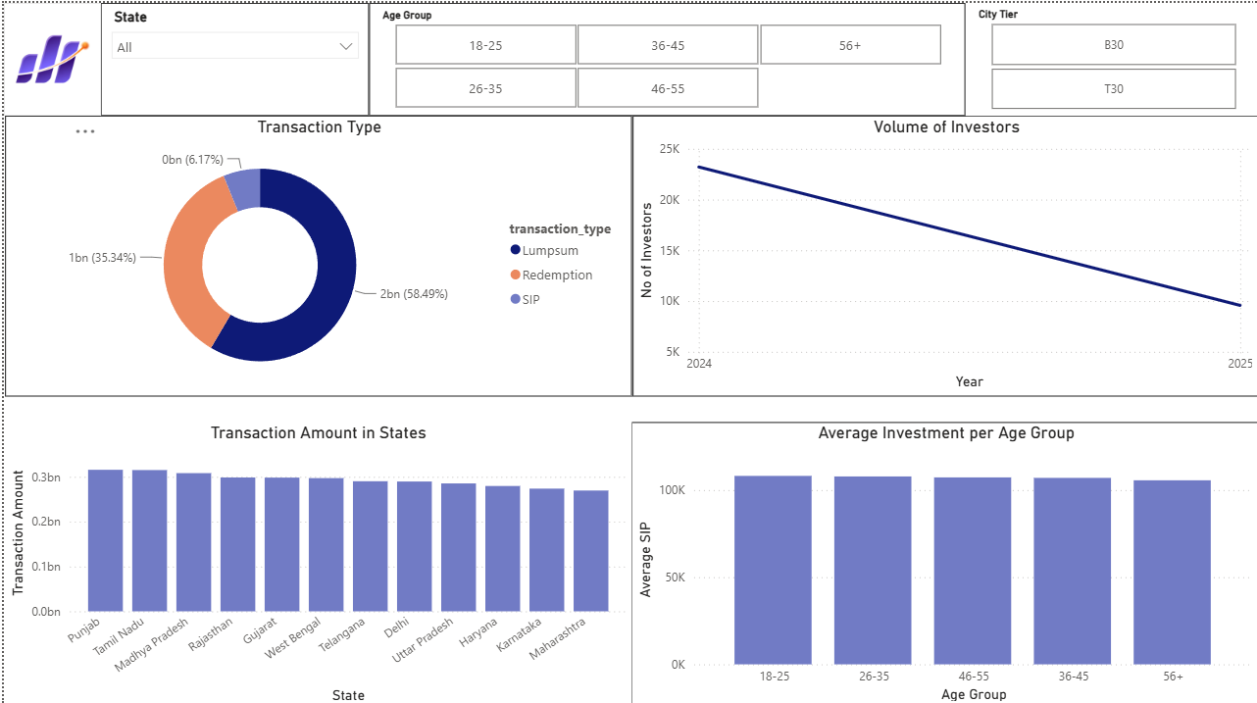

Transaction type donut shows Lumpsum at 58.49%, Redemption at 35.34%, SIP at 6.17%. State-wise transaction bar chart shows Punjab and Tamil Nadu leading, with relatively even distribution across all 12 states. Average SIP investment per age group is broadly consistent at ~₹100K, suggesting minimal age-based SIP amount variation in this dataset.

7.4 Page 4 — SIP & Market Trends
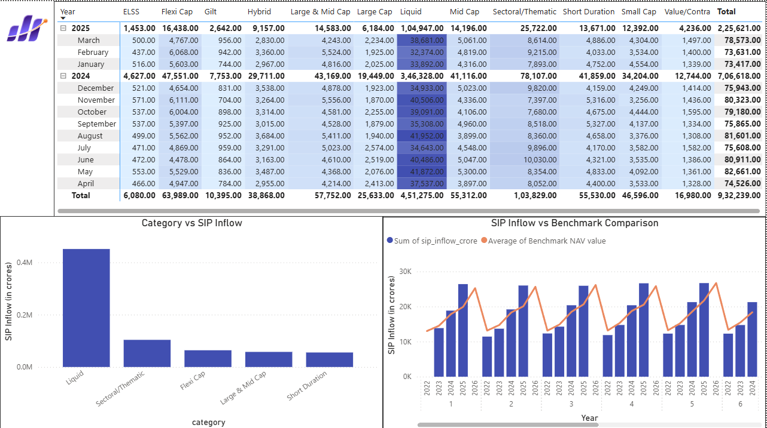

The category-wise inflow matrix with conditional formatting reveals Liquid dominating with total inflows of ₹4.51L Cr across FY24-25. The dual-axis chart overlays SIP inflows against Nifty 50 benchmark values, showing the positive correlation between market performance and SIP participation levels.

8. Advanced Analytics

8.1 Value at Risk (VaR) & Conditional VaR
Historical 95% VaR was computed as the 5th percentile of each fund's daily return distribution. CVaR was computed as the mean of returns below the VaR threshold:
VaR₉₅ = percentile(returns, 5%) | CVaR = mean(returns ≤ VaR₉₅)

Fund | VaR 95% | CVaR 95%
SBI Small Cap Fund (Direct) | -2.69% | -3.24%
Axis Small Cap Fund | -2.62% | -3.17%
ABSL Small Cap Fund | -2.60% | -3.25%
Nippon India Small Cap Fund | -2.54% | -3.23%

8.2 Rolling 90-Day Sharpe Ratio
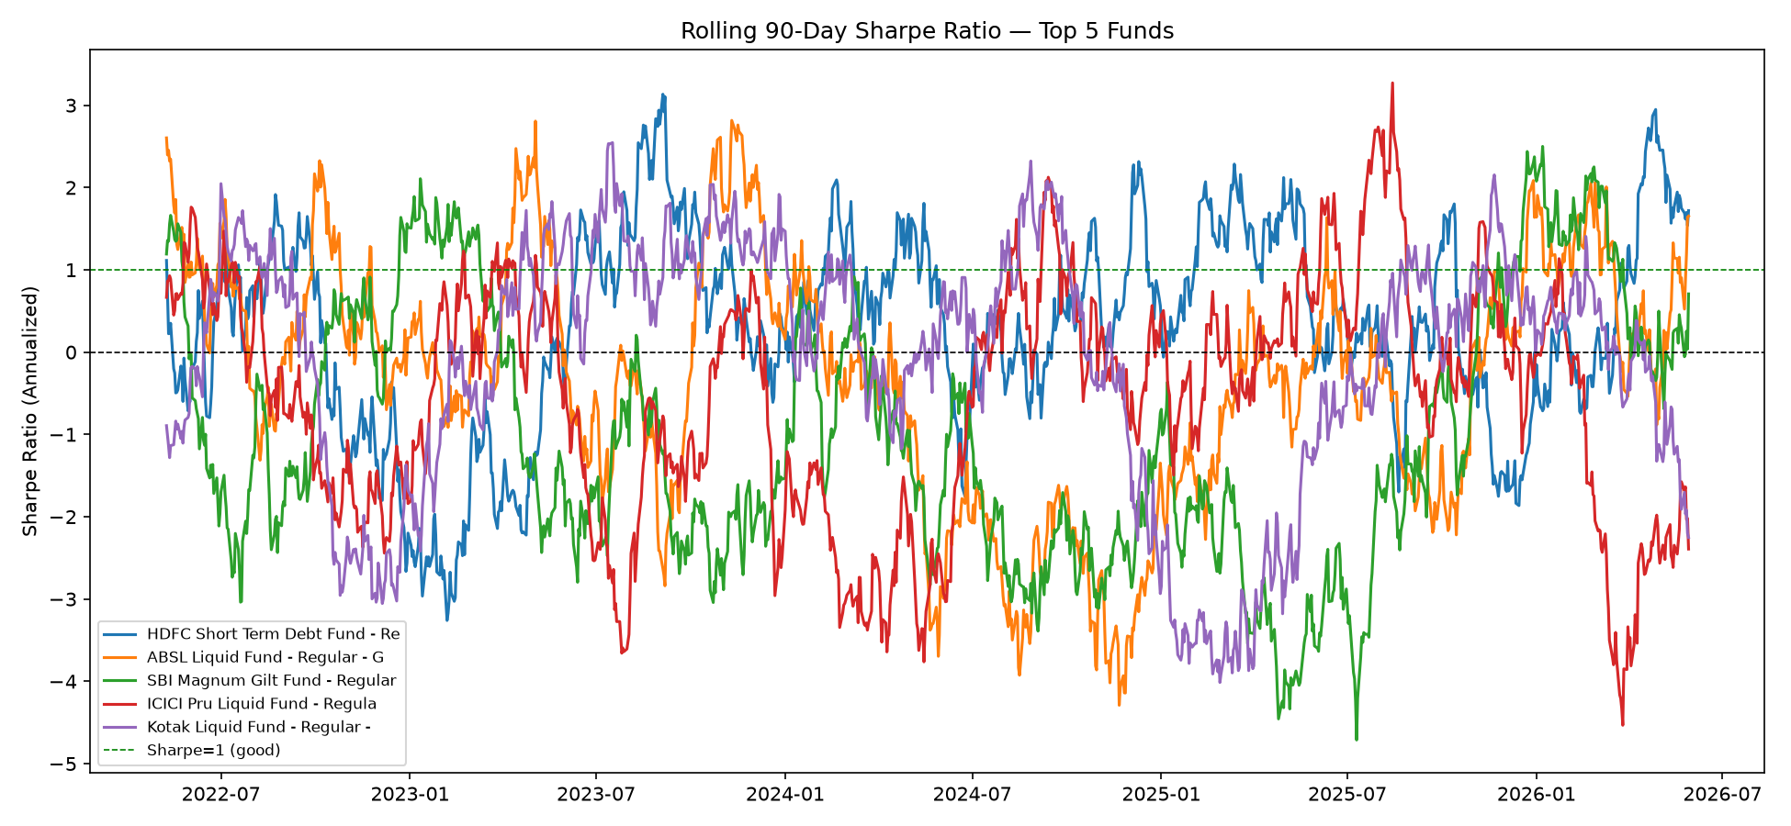

Rolling 90-day Sharpe ratios for the top 5 scorecard funds reveal significant time-varying risk-adjusted performance. Most funds oscillate between Sharpe of -3 and +3, with peaks during the 2023 bull run and troughs during the 2024 correction. ICICI Pru Liquid Fund shows the sharpest peak (Sharpe ~3.2 in mid-2025) reflecting a period of strong risk-adjusted return in the liquid segment.

8.3 Investor Cohort Analysis
Investors were grouped by their first-transaction year. The analysis revealed that investor cohorts in both 2024 and 2025 show similar average SIP amounts (~₹10,000–₹12,000), suggesting the platform attracted investors with comparable financial profiles across years. Fund preference shows a slight shift toward equity-oriented categories in more recent cohorts.

8.4 SIP Continuity Analysis
Among 1,362 investors with 6 or more SIP transactions, 1,332 (97.8%) were flagged as 'at-risk' with average gaps exceeding 35 days. Average inter-transaction gaps of ~100 days indicate the simulated dataset reflects quarterly rather than monthly SIP behaviour — documented as a data limitation. In a real AMC setting, this analysis would target investors with declining SIP frequency for retention campaigns.

8.5 Sector HHI Concentration
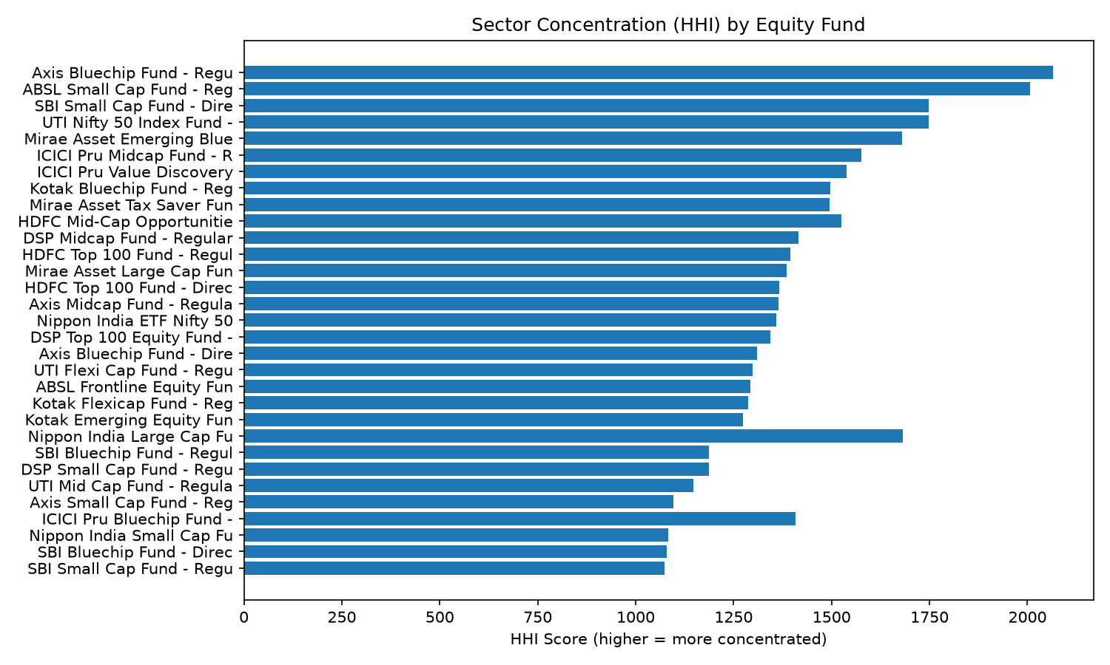

Herfindahl-Hirschman Index was computed for each equity fund as HHI = Σ(weight_i²), where weights are sector percentage allocations. Higher HHI indicates more concentrated sector exposure:
Rank | Fund | HHI Score | Interpretation
Most concentrated | Axis Bluechip Fund (Regular) | 2,065 | Heavy sector bets, higher sector-specific risk
2nd | ABSL Small Cap Fund | 2,007 | Concentrated in 2–3 dominant sectors
Most diversified | SBI Small Cap Fund (Regular) | 1,074 | Well-spread across many sectors
2nd most diversified | SBI Bluechip Fund (Direct) | 1,080 | Broad sector diversification

9. Key Findings & Insights

▶ Industry Leadership: SBI Mutual Fund maintains the highest AUM (₹12.5L Cr) across all observed years, with a growing gap vs ICICI Prudential (2nd) and HDFC (3rd). This reflects sustained investor trust built over decades.
▶ SIP Culture Deepening: Monthly SIP inflows hit an all-time high of ₹31,002 Cr in December 2025, growing exponentially from mid-2023 onward. Investors continued SIP contributions even during the 2024 market correction — indicating maturation of the retail investor base.
▶ Small-Cap Risk Premium: Small-cap funds deliver the highest potential returns but come with the deepest drawdowns (up to -52.6%) and worst daily VaR (-2.69%). Investors must explicitly accept this risk-return profile before allocating.
▶ Best Risk-Adjusted Fund: Mirae Asset Large Cap Fund tops the Sharpe ratio ranking at 1.07 — delivering the best return per unit of total risk, making it the most efficient equity fund in this dataset for risk-conscious investors.
▶ Liquid Dominates Inflows: The Liquid category accounts for the overwhelming majority of net inflows (₹33,000–₹42,000 Cr per month vs ₹3,000–₹6,000 Cr for equity categories), reflecting institutional and corporate cash management flows that dominate MF AUM.
▶ Demographic Concentration: The 26–35 age group accounts for 41.1% of all investor transactions. Male investors represent 66.5% of the dataset — highlighting a gender gap that AMCs and SEBI are actively working to bridge.
▶ Sector Concentration Risk: Axis Bluechip Fund (HHI 2,065) is the most concentrated, while SBI Small Cap Regular (HHI 1,074) is the most diversified despite being in a traditionally volatile category. Investors holding multiple equity funds from different AMCs may still carry concentrated sector exposure without realising it.
▶ Alpha/Beta Data Limitation: Cross-validation between computed NAV-derived CAGR (18.23%) and pre-supplied performance metrics (3yr return 12.1%) for the same fund confirmed that the dataset's NAV history and performance tables were generated independently. Regression-based alpha and beta are not reliable for this specific dataset; however, the OLS methodology was validated to be mathematically correct.
▶ Folio Growth: Total MF folios nearly doubled from 13.26 Cr to 26.12 Cr over the observation period — one of the clearest indicators of India's growing equity investment culture and increasing financial inclusion.
▶ Salaried Investors Drive SIPs: Transaction analysis shows that salaried employees contribute disproportionately to SIP volumes compared to retired or student investors, consistent with the regular income stream required for disciplined monthly SIP participation.

10. Limitations & Future Work

10.1 Known Limitations
- NAV history and pre-supplied performance metrics (alpha, beta, Sharpe in fact_performance) were generated independently and are not mathematically consistent with each other. This was discovered through cross-validation during Day 4 analysis and is documented throughout.
- The investor transaction dataset reflects quarterly SIP cadence rather than realistic monthly patterns, inflating the 'at-risk' SIP continuity flag rate to 97.8%.
- Alpha and beta regression produced near-zero correlation results due to independently-simulated NAV and benchmark data — the methodology is correct but the underlying data lacks the return-dependency structure needed for meaningful regression.
- ODBC driver compatibility issues with Power BI required a hybrid approach: 4 tables via ODBC and 4 via CSV export. This is fully documented and does not affect data integrity.
- Dataset covers only 40 of the ~1,900 AMFI-registered schemes, limiting the generalisability of cross-scheme rankings.

10.2 Recommended Future Work
- Implement a live ETL schedule (cron job or Azure Function) to auto-fetch NAV from mfapi.in every weekday evening, enabling real-time dashboard refresh.
- Add XIRR calculation for SIP investors — more accurate than CAGR for irregular cash flows.
- Build a Monte Carlo simulation module projecting NAV growth over 5 years with uncertainty bands.
- Implement Markowitz Efficient Frontier portfolio optimisation for the top-5 ranked funds.
- Extend to all ~1,900 AMFI schemes using the full mfapi.in API for true industry-wide analysis.
- Add Streamlit web app as a browser-accessible alternative to the Power BI desktop dashboard.

11. Conclusion

This capstone project successfully demonstrates the end-to-end development of a production-grade mutual fund analytics platform. Starting from raw AMFI public data, the project built a fully automated ETL pipeline, a normalised 8-table SQLite star schema, comprehensive exploratory and performance analytics, and an interactive 4-page Power BI dashboard — all within a 7-day timeline.

The platform addresses the five core problems identified in the problem statement: data fragmentation is resolved through a unified database; performance comparison is enabled through risk-adjusted metrics (Sharpe, Sortino, VaR, drawdown, scorecard); investor behaviour is analysed through demographic and geographic segmentation; and reporting speed is transformed from days to real-time through an interactive dashboard.

Critical thinking applied throughout — particularly in discovering and documenting the alpha/beta data limitation, cross-validating computed vs pre-supplied performance metrics, and fixing the weekend-NAV return calculation bug — demonstrates the kind of analytical rigour that real-world financial data engineering demands.

The Indian mutual fund industry's exponential growth (₹81L Cr AUM, 26.12 Cr folios, ₹31,002 Cr monthly SIPs) makes scalable, data-driven analytics platforms like this essential for informed investor decision-making and AMC strategy. This project provides a strong foundation that can be extended to real-time live data feeds and deployed as a production analytics service.

Bluestock Fintech Pvt. Ltd. | Mutual Fund Analytics Capstone | June 2026

