DHRUVA CDM
Conjunction Data Management System

Engineering & Technical Documentation
IEEE Research Paper Format

Project | Dhruva CDM — Orbital Conjunction Data Management
Domain | Space Situational Awareness / Astrodynamics
Stack | Python · FastAPI · React · WebSocket · physics.py
Classification | Engineering Deep Dive — Internal Technical Reference
Version | 1.0.0 — Initial Release

© 2025 Dhruva CDM Project. All rights reserved.

ABSTRACT

Dhruva CDM is a full-stack orbital Conjunction Data Management (CDM) system designed for real-time space situational awareness (SSA), autonomous collision-avoidance maneuver scheduling, and mission-quality analytics. The system integrates a physics-accurate propagation engine—implementing two-body gravitational dynamics augmented with J2 oblateness perturbations and fourth-order Runge–Kutta (RK4) numerical integration—with a service-oriented FastAPI backend and a modern React operator interface. Conjunction assessment is performed via a dual-mode candidate filtering pipeline using either a 3D spatial grid prefilter or a KD-tree proximity query, followed by Time-of-Closest-Approach (TCA) evaluation and risk labelling across SAFE/WARNING/CRITICAL thresholds. Operational updates are streamed to the frontend via WebSocket, providing sub-second latency for warning indicators. This document presents the system architecture, physics foundations, API surface, data flow, and design rationale in the style of an IEEE research contribution.

I. INTRODUCTION

The proliferation of objects in Earth orbit—spanning operational satellites, defunct spacecraft, upper-stage rocket bodies, and fragmentation debris—has elevated conjunction assessment from a specialist concern to a routine operational necessity. A Conjunction Data Management (CDM) system must perform three coordinated functions: (1) continuously propagate the state vectors of all tracked objects, (2) identify pairs whose predicted trajectories converge within actionable proximity thresholds, and (3) schedule or recommend avoidance maneuvers that preserve mission objectives while minimising delta-v expenditure and fuel consumption.
Dhruva CDM was developed to address these requirements in a single integrated platform. The project originated as a compact 2D orbital simulation and evolved, through a series of deliberate architectural expansions, into a production-grade service capable of ingesting real TLE data, simulating hundreds of debris objects, and delivering live risk assessments to an operator dashboard. This document provides a complete engineering reference: physics model, numerical methods, system architecture, API contract, data-flow specification, and operational guidelines.

II. SYSTEM EVOLUTION AND DESIGN PHILOSOPHY

II.A Genesis: simulator.py
The foundational proof-of-concept, simulator.py, placed a single satellite and a single debris object in a 2D Matplotlib scene. Both objects were propagated with RK4 integration; closest-approach prediction was performed over a finite look-ahead horizon; and if the predicted miss distance dropped below a configurable safety threshold a small delta-v impulse was applied in the instantaneous velocity direction. This minimal kernel validated three architectural invariants that survive into the production system:
- Physics-first propagation: object states are always derived from numerical integration, never interpolated from pre-computed tables.
- Predictive conjunction assessment: risk decisions are based on future state projections, not current position.
- Closed-loop autonomy: a maneuver planner consumes conjunction outputs and schedules corrective burns without operator intervention.
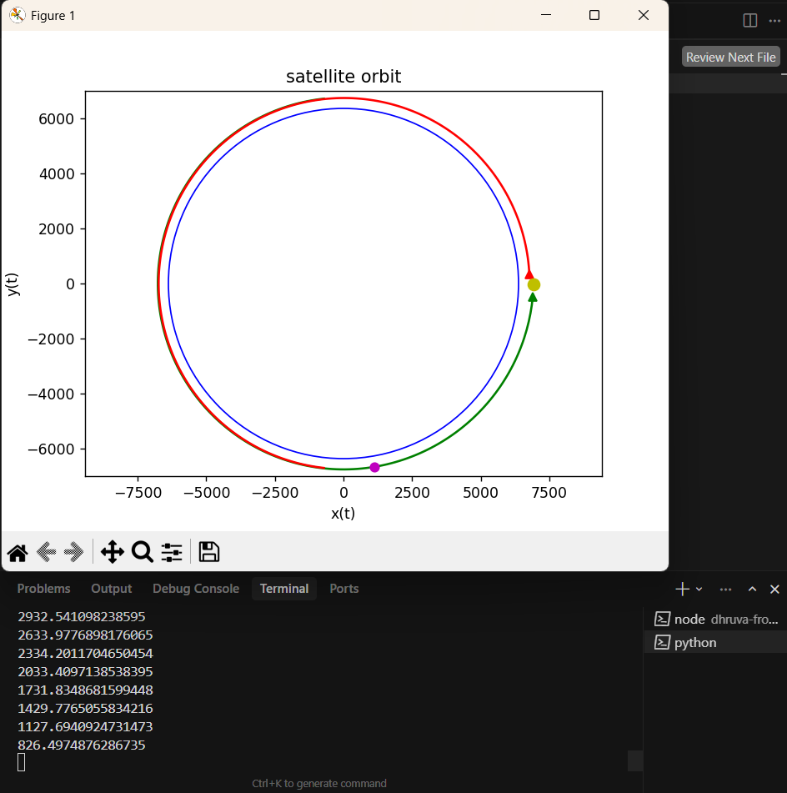
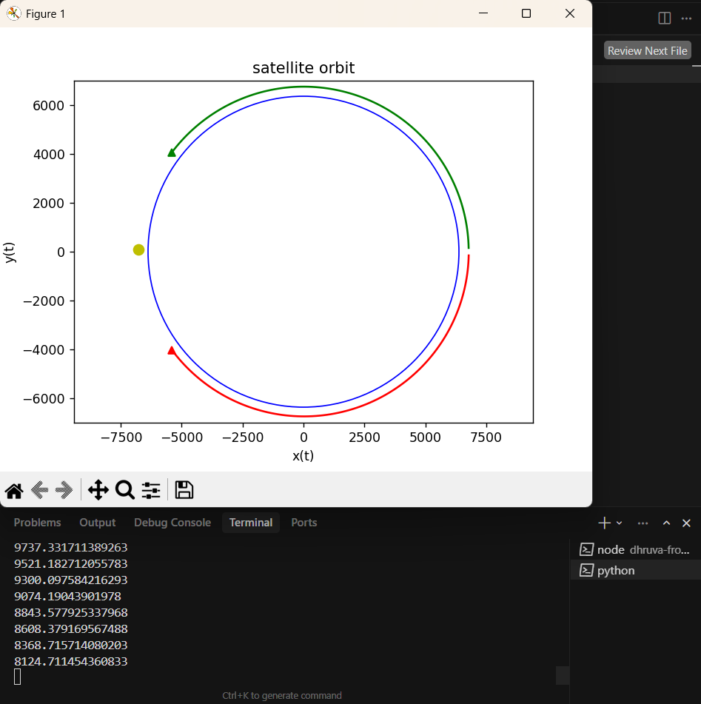

II.B Architectural Growth
After validating the physics loop, the monolithic simulator was decomposed into a service-oriented architecture. The backend became responsible for state propagation, conjunction assessment, maneuver scheduling, blackout validation, and metrics accumulation. The frontend consumed these services to render map views, 3D orbit visualisations, warning overlays, analytics dashboards, and operator workflow panels. A critical inflection point was the transition from REST polling to WebSocket streaming for live update delivery—discussed in detail in Section III.
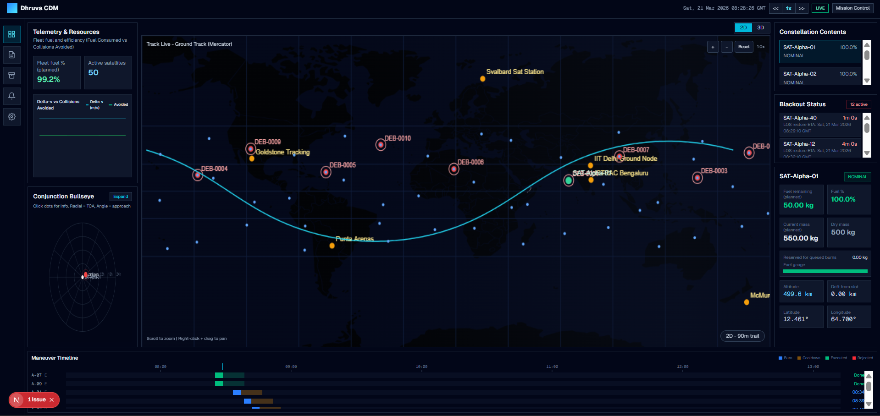
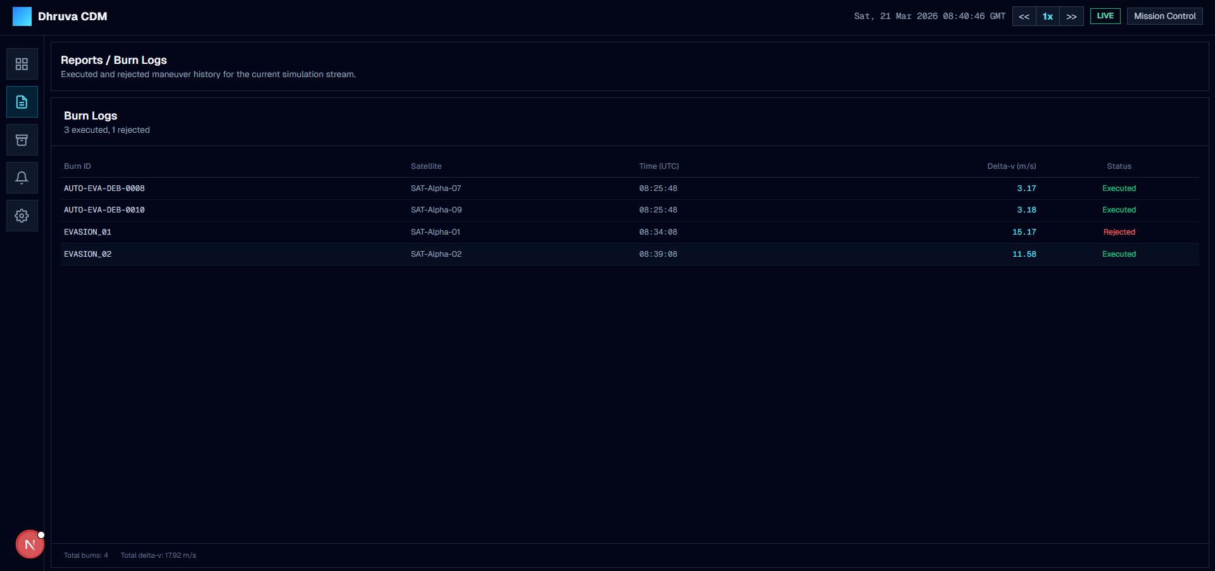

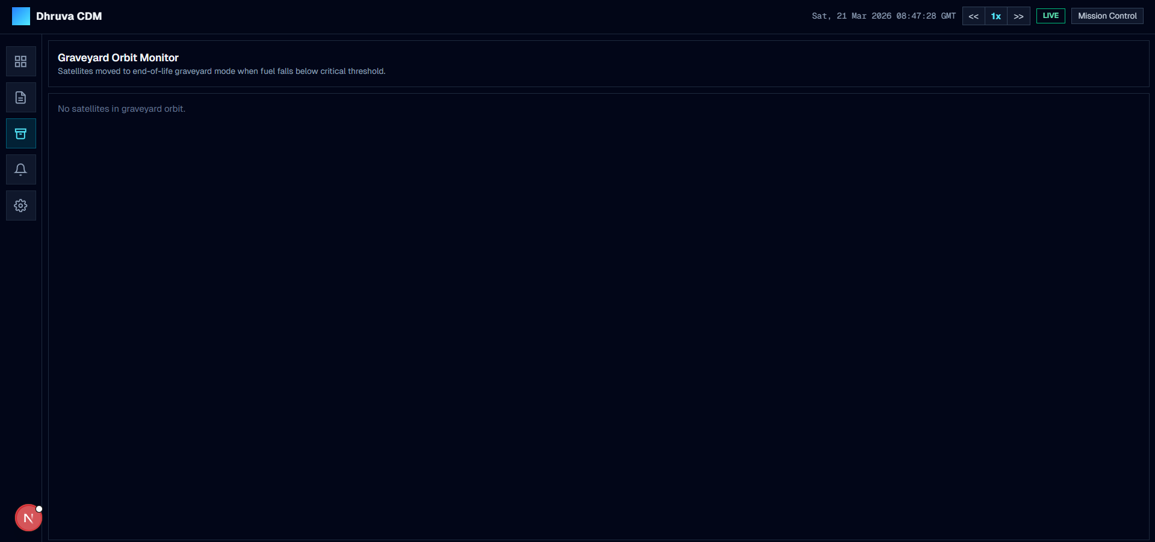

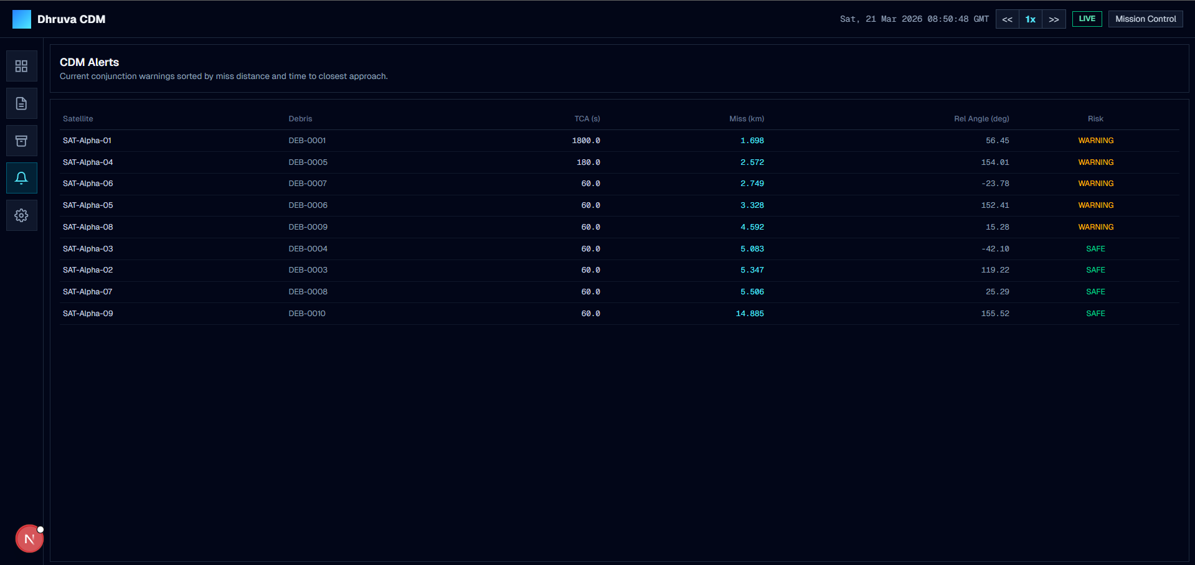

III. SYSTEM ARCHITECTURE

III.A High-Level Overview
The Dhruva CDM system is structured around four primary layers: the physics engine, the simulation state manager, the FastAPI service layer, and the React operator frontend. The following diagram illustrates the component topology and communication pathways.

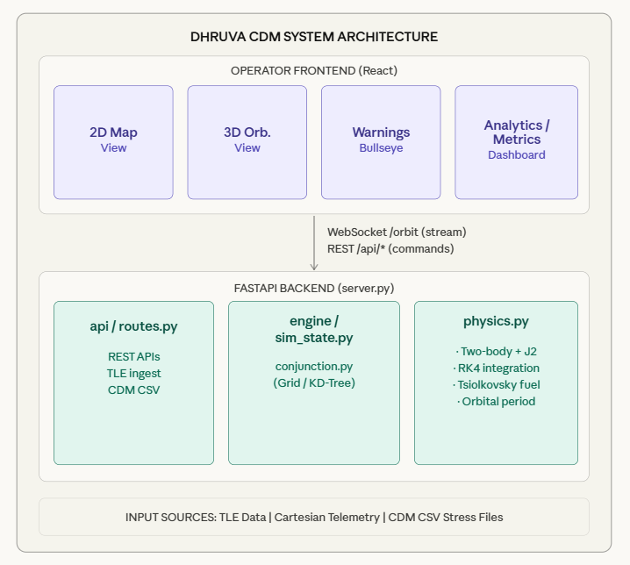└─────────────────────────────────────────────────────────────────────────┘
Figure 1. Dhruva CDM System Architecture — Component Topology and Communication Pathways

III.B Module Responsibilities
Each module in the backend has a clearly bounded responsibility:

Module | Responsibility
server.py | FastAPI app bootstrap, CORS config, SimulationState instantiation, REST route mounting, WebSocket /orbit endpoint
api/routes.py | All REST API endpoint definitions: telemetry ingest, TLE ingest, maneuver scheduling, step simulation, snapshot retrieval, seed/reset, time-warp, CDM CSV loader
engine/sim_state.py | Operational core: simulation time, satellite/debris state vectors, maneuver queues, conjunction warnings, blackout tracking, graveyard logic, objective metrics
engine/conjunction.py | Conjunction candidate computation and risk labelling using grid or KD-tree prefilter, then TCA evaluation and SAFE/WARNING/CRITICAL classification
physics.py | Astrodynamics backbone: two-body + J2 dynamics, RK4 numerical integration, state propagation, Tsiolkovsky propellant model, orbital period estimation
dhruva-frontend | React SPA: 2D map view, 3D orbit view, Bullseye risk display, analytics dashboard, operator maneuver workflow
Table 1. Module Responsibilities

III.C Live Update Architecture — Polling vs. WebSocket Streaming
A polling model has the client repeatedly requesting snapshots at fixed intervals. While simple to implement, polling introduces several operational liabilities: missed fast transitions between poll intervals, stale warning states visible to operators during high-activity periods, and unnecessary request overhead under heavier compute loads.
Dhruva CDM adopts a server-driven WebSocket streaming model. In server.py, the simulation advances via state.stream_tick(...) and immediately publishes a fresh snapshot through ws.send_json(state.snapshot()). This design yields three measurable operational benefits:
- Lower end-to-end latency for warning state updates—the UI reflects risk changes within a single tick rather than the next poll interval.
- Smoother visual feedback for continuously animated elements such as orbital tracks and Bullseye risk indicators.
- Elimination of synchronisation artifacts between the compute cadence and the UI refresh cadence.

IV. PHYSICS ENGINE — MATHEMATICAL FOUNDATIONS

The physics engine (physics.py) implements the astrodynamic models required for accurate short- and medium-term orbit propagation. All computations are performed in Earth-Centred Inertial (ECI) Cartesian coordinates with distances in kilometres and velocities in kilometres per second.

IV.A Physical Constants

Symbol | Value | Units | Description
MU | 398600.4418 | km³ s⁻² | Earth gravitational parameter
J2 | 1.08263 × 10⁻³ | dimensionless | Earth oblateness coefficient
RE | 6378.137 | km | Earth equatorial radius
ISP | 300 | s | Specific impulse (thruster assumption)
G0 | 9.80665 | m s⁻² | Standard gravitational acceleration
Table 2. Physical Constants in physics.py

IV.B Two-Body Gravitational Acceleration
The central gravitational acceleration for a body at position vector r = [x, y, z] with magnitude |r| is given by the Newtonian two-body relation:
a_grav = −(μ / |r|³) · r
This provides the dominant acceleration term for all objects in Earth orbit and forms the baseline from which perturbations are added.

IV.C J2 Oblateness Perturbation
Earth is not a perfect sphere; its equatorial bulge produces a significant secular precession of the right ascension of the ascending node (RAAN) and argument of perigee, as well as short-period oscillations in all orbital elements. The first zonal harmonic, J2, captures this effect. The perturbation acceleration components are:

s = (3/2) · J2 · μ · RE² / |r|⁵
aₓ = s · x · (5z²/|r|² − 1)
aᵧ = s · y · (5z²/|r|² − 1)
a_z = s · z · (5z²/|r|² − 3)

The total acceleration applied to each object in every integration step is therefore:
a_total = a_grav + a_J2
Inclusion of J2 is essential for realistic conjunction prediction because the secular drift in RAAN causes satellite and debris planes to diverge or converge on timescales of hours to days, profoundly affecting conjunction geometry.

IV.D Fourth-Order Runge–Kutta Integration
State derivatives are integrated using the classical fourth-order Runge–Kutta (RK4) method. For state vector S = [x, y, z, vx, vy, vz] and derivative function f(S) = [vx, vy, vz, ax, ay, az]:

k₁ = f(S)
k₂ = f(S + ½·Δt·k₁)
k₃ = f(S + ½·Δt·k₂)
k₄ = f(S + Δt·k₃)
S_{n+1} = S_n + (Δt/6)(k₁ + 2k₂ + 2k₃ + k₄)

RK4 provides fourth-order local truncation error (O(Δt⁵)) and fourth-order global error (O(Δt⁴)), giving an excellent balance of computational efficiency and accuracy for the step sizes used in operational simulation. The fixed-step implementation in propagate(state, duration, dt) applies rk4_step iteratively over ⌊duration/dt⌋ steps, producing a future state estimate suitable for conjunction evaluation.

IV.E Tsiolkovsky Propellant Model
Maneuver feasibility checks and fuel budgeting use the Tsiolkovsky rocket equation. The propellant mass consumed for a burn of magnitude |Δv| (in m/s) from a spacecraft of current mass m_current is:

m_prop = m_current · (1 − exp(−|Δv| / (Isp · g₀)))

This model enables realistic pre-validation of commanded maneuvers against the satellite's remaining fuel budget, preventing physically impossible burn commands from being scheduled.

IV.F Orbital Period Estimation
For operational displays and scheduling calculations, the Keplerian orbital period is estimated for near-circular orbits at altitude h:

a = RE + h
T = 2π · √(a³ / μ)

This is the standard circular-orbit period relation, accurate to better than 0.1% for eccentricities below 0.01, which covers the majority of operational spacecraft and debris populations addressed by Dhruva CDM.

V. CONJUNCTION ASSESSMENT PIPELINE

Conjunction assessment in Dhruva CDM follows a two-stage pipeline: candidate prefiltering in position space, followed by predictive Time-of-Closest-Approach (TCA) evaluation for each candidate pair. This architecture avoids the O(N²) cost of evaluating all object pairs by first reducing the candidate set to a computationally tractable size.

V.A Stage 1: Candidate Prefiltering

Spatial Grid Method
Debris objects are bucketed into a 3D spatial grid partitioned by configurable cell size. For each satellite, the cell containing the satellite and all directly adjacent cells are scanned to produce candidate debris objects. The grid method is selected for stream_tick() — the path that feeds live frontend updates — because its bounded per-tick cost provides deterministic performance under variable debris counts, protecting UI responsiveness.

KD-Tree Method
Debris positions are indexed in a 3D KD-tree. For each satellite, all debris within a configurable search radius are returned via a single radius query. The KD-tree offers asymptotically better query performance for large, uniformly distributed populations and is selected for step() — the path used in batch backend evaluation and stress-testing workflows where the object count may be hundreds of synthetic CDM debris objects.

V.B Stage 2: TCA Evaluation and Risk Labelling
For each candidate pair passing the prefilter, both objects are propagated forward across a configurable look-ahead horizon using the same RK4 integrator described in Section IV. The minimum separation distance encountered during this propagation is recorded as the predicted miss distance. Risk is then assigned according to a threshold comparison:

Risk Level | Miss Distance | Operator Action
SAFE | > safety threshold | No action required
WARNING | Below warning threshold | Monitor; optional maneuver
CRITICAL | Below critical threshold | Auto-evade triggered
Table 3. Risk Classification Thresholds

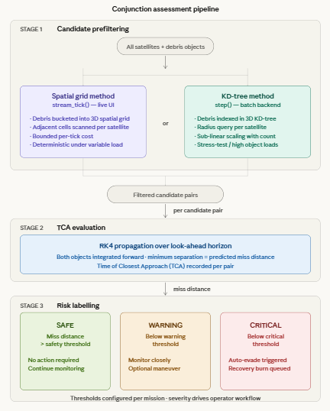

VI. API REFERENCE

The Dhruva CDM backend exposes a REST API for command ingestion and a WebSocket endpoint for live state streaming. All REST endpoints are mounted under the /api prefix.

VI.A Telemetry and State Ingestion

Verb | Endpoint | Description
POST | /api/telemetry | Ingest Cartesian state vector [x, y, z, vx, vy, vz] in km / km·s⁻¹ for a satellite or debris object.
POST | /api/telemetry/tle | Ingest a Two-Line Element set. Backend applies SGP4 propagation and ECI frame transformation before storing resulting Cartesian state.
POST | /api/debug/load_cdm_csv | Load a CDM CSV file containing RTN relative state fields. Debris objects are anchored to in-simulation satellites for large-scale stress testing.
Table 4. Telemetry and State Ingestion Endpoints

VI.B Maneuver and Simulation Control

Verb | Endpoint | Description
POST | /api/maneuver/schedule | Schedule a maneuver burn. Validates command latency, thermal cooldown window, line-of-sight (LOS) constraint, and fuel feasibility before acceptance. Returns acceptance/rejection with reason.
POST | /api/sim/step | Advance the simulation by one configured time step using KD-tree conjunction mode. Suitable for batch evaluation workflows.
POST | /api/sim/seed | Seed or re-seed the simulation with an initial state, resetting all tracked objects, maneuver queues, and metrics.
POST | /api/sim/reset | Reset simulation to initial seeded conditions, clearing all accumulated history and warnings.
POST | /api/sim/timewarp | Set the simulation time-warp multiplier, controlling how many simulated seconds elapse per real second in stream mode.
Table 5. Maneuver and Simulation Control Endpoints

VI.C Data Retrieval

Verb | Endpoint | Description
GET | /api/snapshot | Pull current simulation snapshot: all state vectors, warnings, maneuver queue, blackout status, and objective metrics. Suitable for dashboard initialisation.
WS | /orbit | WebSocket stream endpoint. Server pushes fresh snapshots after each simulation tick. Recommended for all live visualisation and warning display.
Table 6. Data Retrieval Endpoints and WebSocket Stream

VI.D Snapshot Payload Schema
Each snapshot (whether returned by GET /api/snapshot or pushed over /orbit) contains the following top-level fields:

Field | Type | Description
sim_time | float | Current simulation epoch in seconds since seed.
satellites | object[] | Array of satellite state objects: id, position, velocity, fuel_mass, status.
debris | object[] | Array of tracked debris state objects.
conjunctions | object[] | Active conjunction warnings: sat_id, debris_id, tca_seconds, miss_distance_km, risk_level.
maneuvers | object[] | Scheduled and completed maneuver records.
blackouts | object[] | Per-satellite blackout status and estimated LOS recovery time.
metrics | object | Mission-quality metrics: uptime_pct, outage_sat_seconds, total_delta_v, avoidance_per_dv.
Table 7. Snapshot Payload Schema

VII. FEATURE CATALOGUE

VII.A Maneuver Scheduling and Validation
Before any maneuver is accepted into the queue, the scheduler performs the following validation sequence:
- Command latency check: ensures the commanded burn time is sufficiently in the future to allow uplink delivery.
- Thermal cooldown validation: enforces a minimum inter-burn interval to protect thruster hardware.
- Line-of-sight (LOS) constraint: confirms the satellite will be visible to a ground station at the commanded burn epoch, enabling command upload and telemetry confirmation.
- Fuel feasibility: applies the Tsiolkovsky model to verify the commanded Δv is achievable with remaining propellant mass.
Autonomous evasion burns are generated by the conjunction engine for CRITICAL-risk events when no operator-scheduled maneuver is already queued. Each auto-evade is paired with a recovery burn scheduled to restore the original orbital plane after the conjunction window has passed.

VII.B Blackout Awareness
Ground station visibility is modelled as a binary LOS flag per satellite. When a satellite enters blackout (no LOS to any ground station), its blackout_start epoch is recorded and a recovery time estimate is derived from the orbital period. This information gates maneuver scheduling—burns cannot be commanded during blackout—and is surfaced to the operator dashboard to explain scheduling constraints.

VII.C Graveyard Maneuver Handling
Satellites whose remaining fuel mass drops below a configurable threshold are flagged as graveyard candidates. The system can automatically plan and schedule a disposal maneuver to move the satellite to a designated graveyard orbit (typically above GEO for high-altitude missions or below the ISS altitude for LEO missions). The satellite status transitions through NOMINAL → GRAVEYARD_CANDIDATE → GRAVEYARD_MANEUVER_SCHEDULED → GRAVEYARD to provide clear operator visibility of the disposal lifecycle.
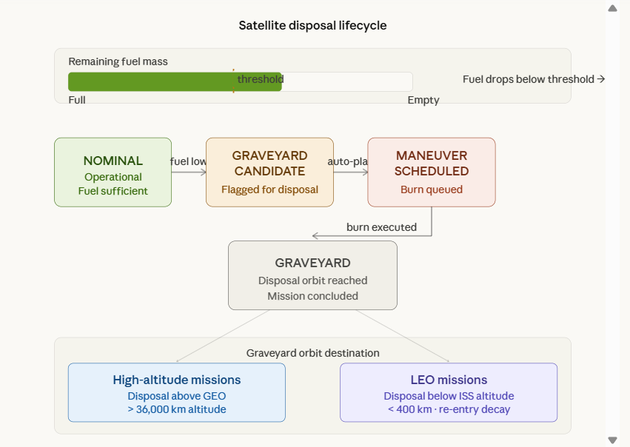

VII.D Objective Metrics
The sim_state module accumulates mission-quality metrics throughout the simulation run:

Metric | Definition
uptime_pct | Percentage of simulation time during which all satellites are operational (not in blackout, not disposed).
outage_sat_seconds | Cumulative satellite-seconds lost to blackout or operational degradation.
total_delta_v | Total Δv consumed across all scheduled and autonomous maneuvers (m/s).
avoidance_per_dv | Number of successful avoidance actions per m/s of Δv expended — a composite efficiency score.
Table 8. Mission-Quality Objective Metrics

VIII. DATA FLOW — INPUT TO WARNING

The end-to-end data flow from object ingestion to operator warning display proceeds through five ordered stages:

1 | Ingestion: Objects enter the simulation via direct Cartesian telemetry POST, TLE ingest with SGP4+frame transformation, or CSV-derived RTN-to-ECI conversion anchored to in-sim primaries.
2 | Propagation: sim_state advances all objects with rk4_step using two-body + J2 dynamics. Satellites with scheduled maneuvers have their velocity vectors updated at the commanded epoch.
3 | Conjunction Filtering: Grid (stream mode) or KD-tree (step mode) prefilter reduces the candidate pair set. Each candidate pair is propagated to TCA and miss distance is computed.
4 | Risk Labelling & Response: SAFE/WARNING/CRITICAL thresholds are applied. CRITICAL events trigger autonomous evade/recovery burn generation. All warnings populate the conjunction warning list.
5 | Delivery: State, warnings, maneuver queue, blackout status, and metrics are packaged into a snapshot payload and pushed over the WebSocket stream or returned via the snapshot REST endpoint.
Figure 2. Five-Stage Data Flow — Ingestion to Operator Warning
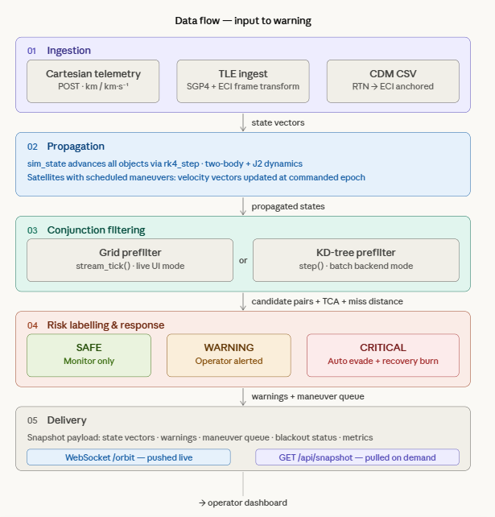

IX. OPERATIONAL NOTES

IX.A Backend Stress Testing
For high object-count backend evaluation, use KD-tree mode via step()-style API workflows. The KD-tree provides sub-linear scaling with debris count for radius queries, making it substantially faster than grid scanning when object counts exceed several hundred. CDM CSV files with large relative-state datasets can be loaded via POST /api/debug/load_cdm_csv to populate synthetic debris populations for performance benchmarking.

IX.B Operator Visualization
For smooth real-time operator visualization, always connect via the WebSocket /orbit endpoint and use the stream mode, which internally applies the grid prefilter. The bounded per-tick cost of the grid method protects UI responsiveness under variable and unpredictable debris counts during live operations.

IX.C CDM CSV Frame Note
When loading CDM CSV stress data, the relative RTN state vectors are data-driven and accurately reflect the commanded relative geometry. However, the absolute ECI anchor frame is synthetic unless the primary satellite states in the simulation have been explicitly matched to the true primary states at the CDM epoch. Conjunction probabilities derived from such synthetic scenarios should be interpreted as performance benchmarks rather than real operational risk assessments.

IX.D Recommended Evaluation Workflow
- Seed the simulation with representative satellite states (TLE-derived recommended).
- Load debris population via CDM CSV or direct telemetry.
- Connect frontend over WebSocket /orbit for live display.
- Use POST /api/sim/step in parallel threads for batch conjunction assessment.
- Monitor metrics via snapshot endpoint for mission-quality scoring.

X. CONCLUSION

Dhruva CDM demonstrates that a rigorous astrodynamics engine—incorporating two-body gravity, J2 perturbations, RK4 integration, and Tsiolkovsky propellant modelling—can be packaged within a service-oriented architecture that delivers real-time conjunction risk assessment and autonomous maneuver scheduling to a modern operator interface. The dual-mode conjunction pipeline (spatial grid for streaming, KD-tree for batch evaluation) provides a practical engineering trade-off between UI responsiveness and throughput under large debris populations.
The WebSocket streaming architecture eliminates the stale-update and synchronisation pathologies inherent in polling-based designs, ensuring that warning state transitions are reflected in the operator display within a single simulation tick. The comprehensive REST API surface enables integration with external mission control systems, rehearsal environments, and automated test harnesses.
This documentation serves as the authoritative engineering reference for the Dhruva CDM system, providing physics derivations, API contracts, data-flow specifications, and operational guidance sufficient to support system integration, verification, and future development.

. REFERENCES

[1] Vallado, D.A., Fundamentals of Astrodynamics and Applications, 4th ed. Microcosm Press, 2013.
[2] Hoots, F.R. and Roehrich, R.L., Models for Propagation of NORAD Element Sets. Spacetrack Report No. 3, 1980.
[3] Alfano, S., Satellite Conjunction Monte Carlo Analysis. Advances in the Astronautical Sciences, AAS 09-233, 2009.
[4] Tsiolkovsky, K.E., The Exploration of Cosmic Space by Means of Reaction Devices. Scientific Review, 1903.
[5] NASA Office of Safety and Mission Assurance, Debris Avoidance Maneuver Planning Process. NPR 8715.6A, 2017.
[6] FastAPI Documentation, https://fastapi.tiangolo.com, 2024.

