WEEKLY TRAINING REPORT
Week 4 — Advanced Features & Cloud Deployment
Task Management System | Hashclick Solutions LLC
Trainee Name | Jeevan Kumar Gujja
Organization | Hashclick Solutions LLC
Program | Java Developer
Week | Week 4 (Final Week)
Report Date | June 2026
Project | Task Management System
Live URL | https://week3-taskmanagement.onrender.com
Swagger Docs | https://week3-taskmanagement.onrender.com/swagger-ui.html

1. Week 4 Overview
Week 4 extended the Week 3 Task Management System with enterprise-grade features. The focus was on Role-Based Access Control (RBAC), an Admin Panel, overdue task detection, asynchronous email notifications, Swagger API documentation, and deploying the application live to the cloud via Docker on Render.

Features Completed This Week

# | Feature | Description
1 | RBAC | @PreAuthorize on all endpoints. ADMIN sees everything; USER sees own tasks only.
2 | Admin Panel | Admin-only UI to list users, promote/demote roles, and delete users.
3 | Overdue Detection | Overdue flag on tasks, red badge in UI, daily 8AM alert scheduler.
4 | Notifications | Async email on task assignment via @Async + NotificationService.
5 | Input Validation | @Valid + @NotBlank/@Email/@Size enforced with structured error responses.
6 | Swagger / OpenAPI | Live interactive API docs with JWT auth support at /swagger-ui.html.
7 | Docker | Two-stage Dockerfile: Maven build stage + JRE alpine runtime.
8 | Cloud Deployment | Deployed to Render (free tier). Auto-deploys on GitHub push.

2. Application Screenshots

2.1 Login Page
Login page at localhost:8080 — users log in or register and receive a JWT token.
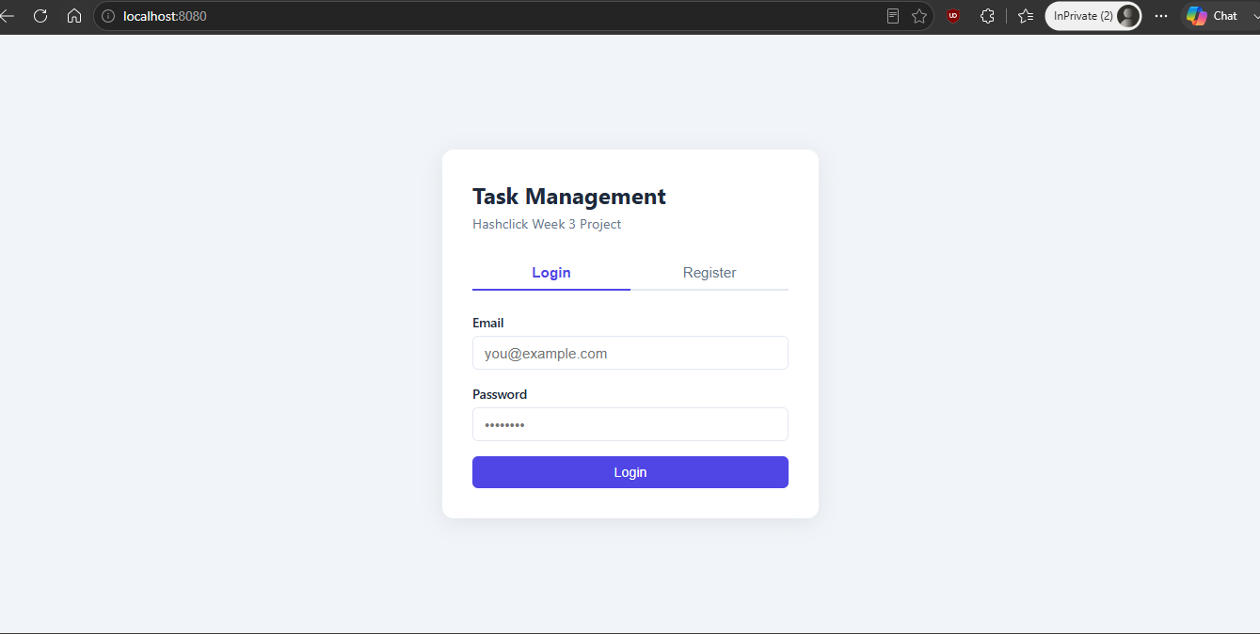
Figure 1 — Login Page

2.2 Task Dashboard — USER Role
Logged in as a USER — stats bar plus a grid of the user's own tasks.
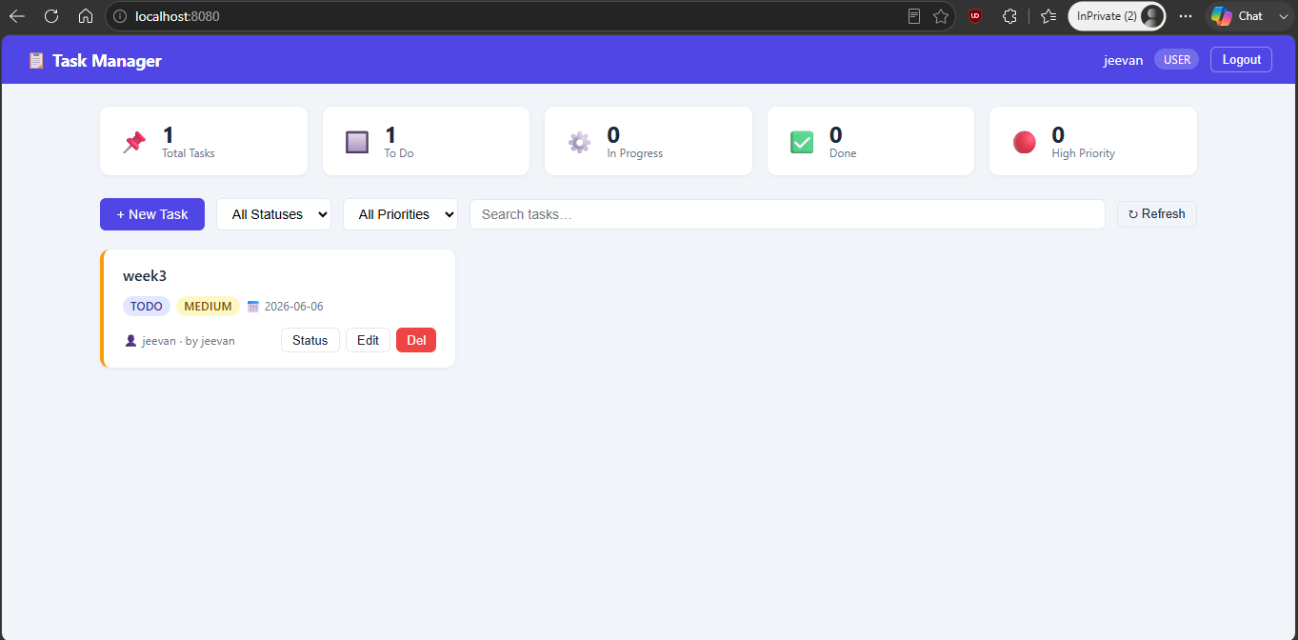
Figure 2 — Task Dashboard (USER role)

2.3 JWT Authentication — Login API
POST /api/auth/login returns a JWT token, name, email, and role for use in the Authorization header.
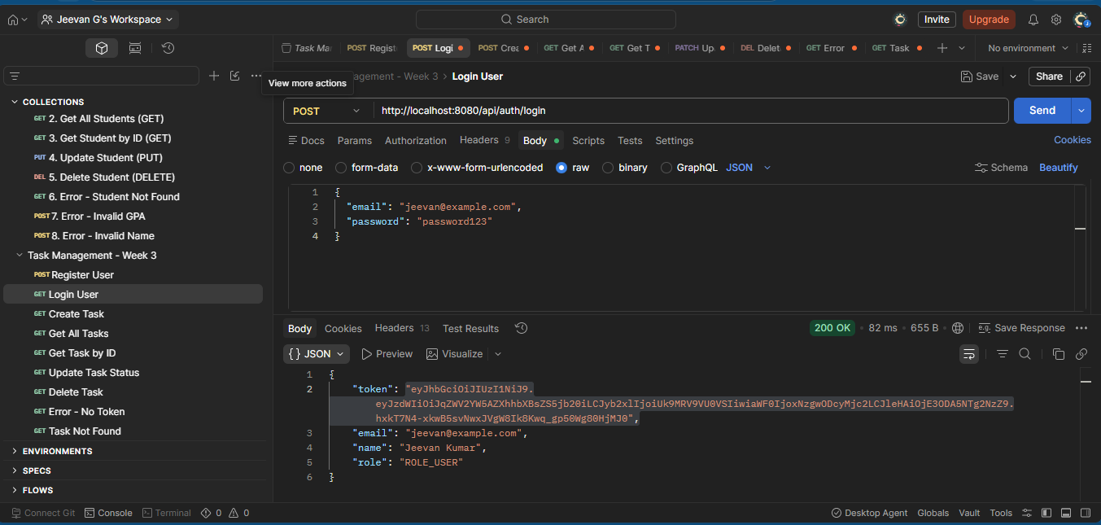
Figure 3 — Login API returning JWT token (Postman)

2.4 Create Task API
POST /api/tasks creates a task. Requires the JWT token and validates all input fields.
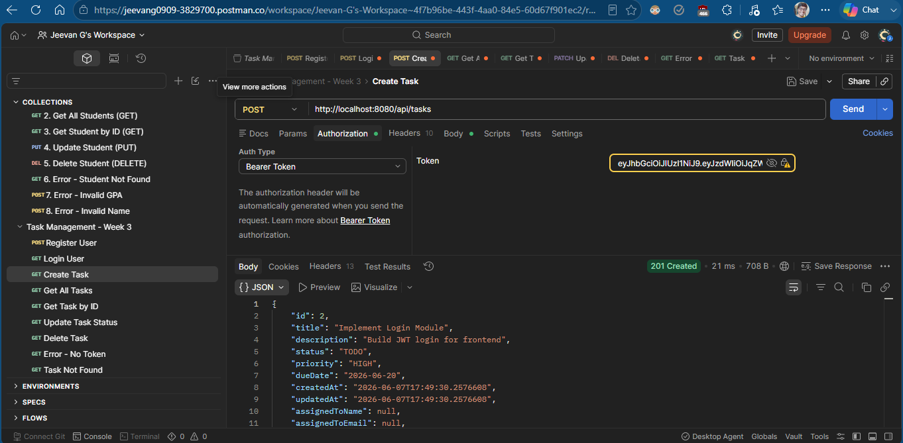
Figure 4 — Create Task API with JWT auth (Postman)

2.5 Render — Cloud Deployment
Deployed on Render via Docker. Auto-deploys on every GitHub push.
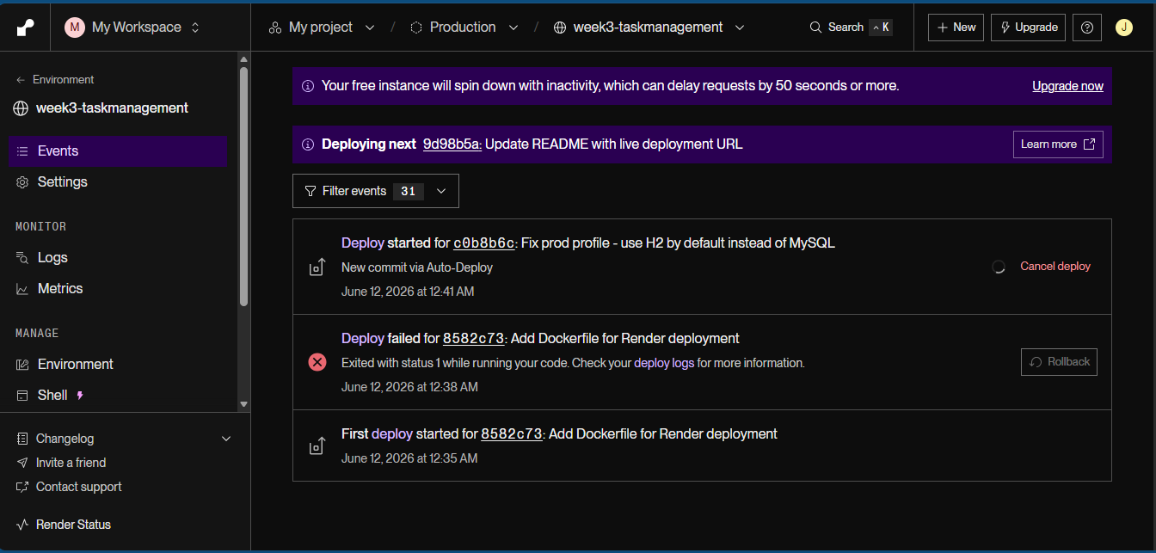
Figure 5 — Render deployment dashboard

3. Role-Based Access Control (RBAC)
RBAC is enforced using Spring Security's @PreAuthorize annotation at the method level. Every API endpoint checks the user's role from the JWT token before executing.

Action | ROLE_USER | ROLE_ADMIN
Register / Login | Yes | Yes
Create task | Yes | Yes
View own tasks | Yes | Yes
View ALL tasks | No | Yes
Update / Delete own task | Yes | Yes
Assign task to user | No | Yes
View overdue tasks | Own | All
Manage users (promote/delete) | No | Yes
View dashboard stats | No | Yes

4. New Files Created (Week 4)
- AdminController.java — Admin-only REST endpoints (users, stats, role change, delete)
- AdminService.java — Business logic for all admin operations
- NotificationService.java — @Async email notifications for task assignment and overdue
- OverdueAlertScheduler.java — @Scheduled daily 8AM overdue alert job
- UserResponse.java — DTO with id, name, email, role, taskCount
- DashboardStats.java — DTO for admin stats endpoint
- OpenApiConfig.java — Swagger bearer auth scheme and API metadata
- application-prod.properties — Production config (env vars, H2 default, MySQL opt-in)
- Dockerfile — Two-stage build: Maven + JRE alpine
- railway.json / Procfile / .env.example — Cloud deployment config files

5. Key Files Modified (Week 4)
- @PreAuthorize on all endpoints; overdue endpoint added: TaskController.java
- RBAC-aware queries; getAllTasksForUser(); notifications called: TaskService.java
- findOverdueTasks(), countOverdue(), countByStatus() added: TaskRepository.java
- overdue boolean flag and assignedToId field added: TaskResponse.java
- Swagger routes permitAll; /api/admin/** rule: SecurityConfig.java
- @EnableScheduling + @EnableAsync added: TaskManagementApplication.java
- Admin panel section; overdue badge + filter + stat counter: index.html
- springdoc-openapi 2.5.0 + spring-boot-starter-mail added: pom.xml

6. Challenges & Solutions
Challenge | Solution
Render has no Java runtime — only Docker | Created two-stage Dockerfile; Stage 1 builds JAR with Maven, Stage 2 runs with JRE alpine
Deployment failed — MySQL connection error | Fixed application-prod.properties to default to H2; MySQL is now opt-in via DATABASE_URL env var
Maven not in system PATH | Downloaded Apache Maven 3.9.6 locally and used full path to mvn.cmd
User delete failed with 500 error | Foreign key constraint — deleted user's tasks first via H2 Console, then deleted user
Port 8080 already in use on restart | Found PID with netstat, killed process, then restarted Spring Boot

7. Deliverables — Status
Deliverable | Status
RBAC with @PreAuthorize on all endpoints | Completed
Admin Controller — 5 admin endpoints | Completed
Admin Panel in frontend (promote/demote/delete users) | Completed
Overdue task detection, badge, filter, scheduler | Completed
Async email notifications (@Async) | Completed
Input validation (@Valid) with error responses | Completed
Swagger / OpenAPI docs at /swagger-ui.html | Completed
Two-stage Dockerfile | Completed
Deployed live on Render — https://week3-taskmanagement.onrender.com | Completed
README updated with Week 3 + Week 4 documentation | Completed
Presentation slides (11 slides) | Completed
Demo script | Completed
Weekly Report | Completed

8. Trainee Declaration
I confirm that all tasks assigned for Week 4 have been completed, tested, and deployed as described in this report.

Student Signature
______________________________
Date
______________________________

