WEEKLY TRAINING REPORT
Week 5 — Microservices Architecture
Java Developer Training Program
Hashclick Solutions LLC

Trainee Name | Jeevan Kumar Gujja
Designation | Java Developer
Organization | Hashclick Solutions LLC
Report Period | Week 5: June 16 – June 20, 2025
Submitted On | June 21, 2025
Mentor / HR | Priya, Hashclick Solutions LLC

1. Overview
This report covers Week 5 of the Java Developer Training Program at Hashclick Solutions LLC. The primary objective for this week was to transition from a monolithic Spring Boot application (built in Weeks 3–4) to a microservices architecture.

The existing Task Management System was decomposed into two independent, deployable Spring Boot services:
- User Service (port 8081) — responsible for user registration, login, JWT token generation, and user management.
- Task Service (port 8082) — responsible for task CRUD, RBAC enforcement, overdue detection, and scheduling. Communicates with User Service via REST calls.

Both services use H2 in-memory databases, expose Swagger/OpenAPI documentation, include Dockerfiles for containerised deployment, and have been committed to separate GitHub repositories.

2. Daily Progress Breakdown
Day | Task Completed | Details
Monday  16 Jun 2025 | Project Setup & Architecture | Set up two separate Spring Boot projects (user-service port 8081, task-service port 8082). Defined microservices architecture, service boundaries, and inter-service communication strategy using RestTemplate.
Tuesday  17 Jun 2025 | User Service Development | Built complete user-service: JWT auth (register/login), User model + H2 DB, UserRepository, AuthService, UserService, JwtUtil, JwtAuthFilter, SecurityConfig. Added internal endpoints GET /api/users/{id} and GET /api/users/email/{email} for task-service to call.
Wednesday  18 Jun 2025 | Task Service Development | Built task-service with Task model storing createdById and assignedToId (Long) instead of User objects. Implemented TaskRepository with custom JPQL queries for overdue detection. Created UserServiceClient using RestTemplate to call user-service for user lookups.
Thursday  19 Jun 2025 | Inter-Service Communication & RBAC | Wired inter-service REST calls: task-service passes JWT Bearer token when calling user-service. UserServiceClient fetches UserResponse (id, role) and TaskService uses it for RBAC decisions. Both services share the same JWT secret for independent token validation.
Friday  20 Jun 2025 | Testing, Documentation & GitHub Push | Verified both services build successfully (mvn clean package). Added Swagger/OpenAPI docs to both services. Created separate GitHub repositories (user-service, task-service). Wrote .gitignore files, committed clean source, and pushed both repos to GitHub.
Saturday | Week Off
Sunday | Week Off

3. Architecture Overview
The system follows a microservices pattern where each service owns its data and exposes REST APIs. Services communicate over HTTP using RestTemplate.

Service Comparison
Aspect | User Service | Task Service
Port | 8081 | 8082
Database | H2 — users table | H2 — tasks table
Auth | Issues JWT tokens | Validates JWT tokens
REST Calls | None (source of truth) | Calls user-service
GitHub Repo | jeevankumargujja/user-service | jeevankumargujja/task-service
Swagger UI | localhost:8081/swagger-ui.html | localhost:8082/swagger-ui.html
Docker | Dockerfile included | Dockerfile included

Communication Flow
- Client sends a request with a JWT Bearer token to Task Service.
- Task Service validates the JWT locally (shared secret — no network call needed).
- Task Service calls User Service GET /api/users/email/{email} to retrieve the user's ID and role.
- UserServiceClient forwards the original Bearer token in the Authorization header.
- User Service looks up the user and returns UserResponse (id, name, email, role).
- Task Service uses the role for RBAC decisions (ADMIN sees all tasks, USER sees own tasks).

4. REST API Endpoints
User Service — Authentication (Public)
Method | Endpoint | Description
POST | /api/auth/register | Register a new user, returns JWT token
POST | /api/auth/login | Login and receive JWT token

User Service — User Management (Authenticated)
Method | Endpoint | Description
GET | /api/users/{id} | Get user by ID (also called by task-service)
GET | /api/users/email/{email} | Get user by email (internal — called by task-service)
GET | /api/admin/users | List all users (ADMIN only)
PATCH | /api/admin/users/{id}/role | Change user role (ADMIN only)
DELETE | /api/admin/users/{id} | Delete a user (ADMIN only)
GET | /api/admin/stats | Total user count (ADMIN only)

Task Service — Task Management (Authenticated)
Method | Endpoint | Description
POST | /api/tasks | Create a new task
GET | /api/tasks | Get all tasks (admin: all, user: own)
GET | /api/tasks/{id} | Get task by ID
GET | /api/tasks/my | Get tasks assigned to me
GET | /api/tasks/overdue | Get overdue tasks (filtered by role)
GET | /api/tasks/status/{s} | Filter tasks by status
PUT | /api/tasks/{id} | Update full task (creator or admin)
PATCH | /api/tasks/{id}/status | Update task status
PATCH | /api/tasks/{id}/assign | Assign task to user (ADMIN only)
DELETE | /api/tasks/{id} | Delete task (creator or admin)
GET | /api/tasks/stats | Dashboard stats (ADMIN only)

5. New Files Added

User Service (C:\Users\jeeva\user-service)
File / Package | Purpose
UserServiceApplication.java | Spring Boot entry point — @SpringBootApplication
model/User.java | JPA entity — id, name, email, password, role
repository/UserRepository.java | JPA repository — findByEmail, existsByEmail
dto/RegisterRequest.java | Request DTO with @Valid constraints
dto/LoginRequest.java | Login request DTO
dto/AuthResponse.java | Auth response — token, email, name, role
dto/UserResponse.java | User details DTO returned by lookup endpoints
enums/Role.java | ROLE_USER, ROLE_ADMIN
service/AuthService.java | Register + login logic, JWT generation
service/UserService.java | User CRUD, role change, delete, stats
security/JwtUtil.java | JWT generate, validate, extract email and role
security/JwtAuthFilter.java | OncePerRequestFilter — sets SecurityContext from token
security/SecurityConfig.java | Stateless security chain, BCrypt bean
security/UserDetailsServiceImpl.java | UserDetailsService backed by UserRepository
controller/AuthController.java | POST /api/auth/register and /login
controller/UserController.java | User lookup + admin management endpoints
config/OpenApiConfig.java | Swagger UI + Bearer auth schema
exception/GlobalExceptionHandler.java | Structured error responses for all exceptions
resources/application.properties | H2 config, JWT secret, Swagger, port 8081
Dockerfile | Two-stage Maven build + JRE alpine runtime

Task Service (C:\Users\jeeva\task-service)
File / Package | Purpose
TaskServiceApplication.java | Spring Boot entry point — @EnableScheduling, @EnableAsync
model/Task.java | JPA entity — stores createdById + assignedToId (Long)
repository/TaskRepository.java | JPQL queries for overdue detection, status filter
dto/TaskRequest.java | Task creation/update request with @Valid
dto/TaskResponse.java | Task response including overdue flag
dto/UserResponse.java | Mirror of user-service UserResponse for REST deserialization
enums/TaskStatus.java | TODO, IN_PROGRESS, DONE
enums/Priority.java | LOW, MEDIUM, HIGH
client/UserServiceClient.java | RestTemplate client — calls user-service with Bearer token
service/TaskService.java | Full task CRUD with RBAC using UserServiceClient
service/NotificationService.java | @Async notification logging (email-ready)
service/OverdueAlertScheduler.java | @Scheduled cron at 8 AM — logs overdue tasks
security/JwtUtil.java | JWT validation only (shared secret, no token generation)
security/JwtAuthFilter.java | Sets SecurityContext from JWT — no UserDetailsService needed
security/SecurityConfig.java | Stateless chain — no AuthenticationManager required
controller/TaskController.java | All task endpoints — passes token to service layer
config/RestTemplateConfig.java | @Bean RestTemplate for UserServiceClient injection
config/OpenApiConfig.java | Swagger UI + Bearer auth schema
exception/GlobalExceptionHandler.java | Structured error responses
resources/application.properties | H2 config, JWT secret, user-service URL, port 8082
Dockerfile | Two-stage Maven build + JRE alpine runtime

6. Challenges & Solutions
Challenge | Solution
No shared User entity | Task model stores createdById and assignedToId (Long) instead of JPA @ManyToOne to User. Task-service calls user-service REST API for user details when needed.
Token forwarding | Task-service extracts the incoming Bearer token from HttpServletRequest and forwards it in the Authorization header when calling user-service endpoints.
RBAC without shared DB | Each request calls getUserByEmail() on user-service to get the role. TaskService checks user.getRole().equals("ROLE_ADMIN") for all access control decisions.
JDK vs JRE in Maven | Build failed with 'No compiler provided'. Fixed by explicitly setting JAVA_HOME to the JDK 17 path before running mvn clean package.
Git tracking large JARs | GitHub warned about JARs >50MB in target/. Fixed with .gitignore and git rm --cached target/ to exclude build artifacts from version control.

7. Deliverables
- user-service: Separate GitHub repository for User Service
- https://github.com/jeevankumargujja/user-service
- task-service: Separate GitHub repository for Task Service
- https://github.com/jeevankumargujja/task-service
- APIs: Working REST APIs for both services (verified — both build and start successfully)
- Diagram: Architecture diagram showing service boundaries and inter-service REST communication
- Swagger: Swagger/OpenAPI documentation on both services
- Docker: Dockerfiles for containerised deployment of both services
- Report: This weekly training report

8. Application Screenshots

Figure 1 — User Service Started (Port 8081)
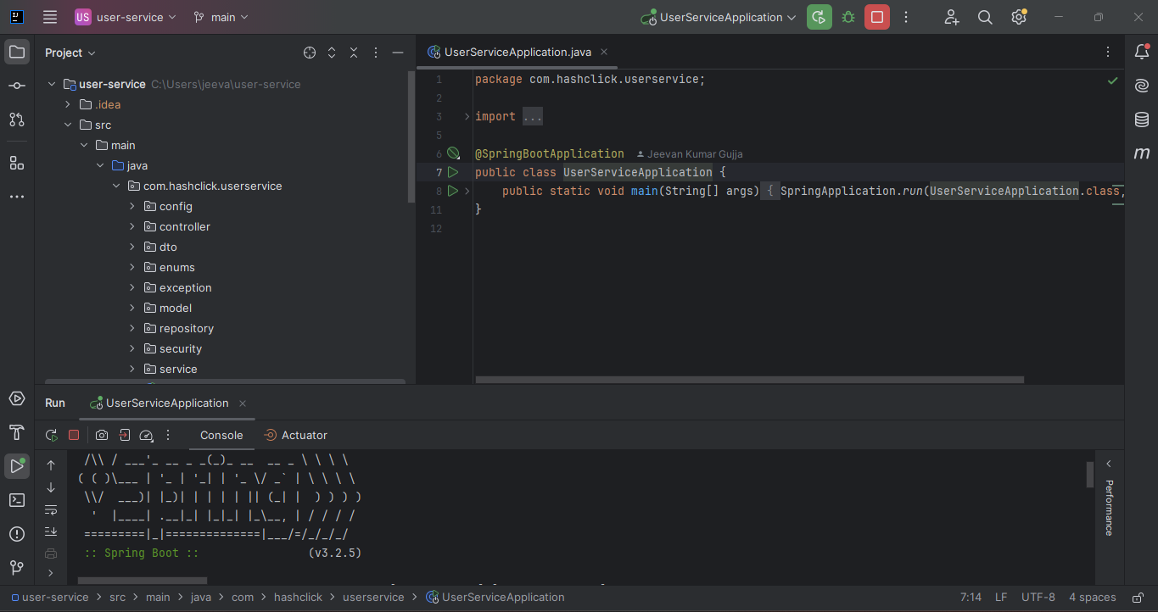
Figure 1: User Service successfully started on port 8081

Figure 2 — Task Service Started (Port 8082)
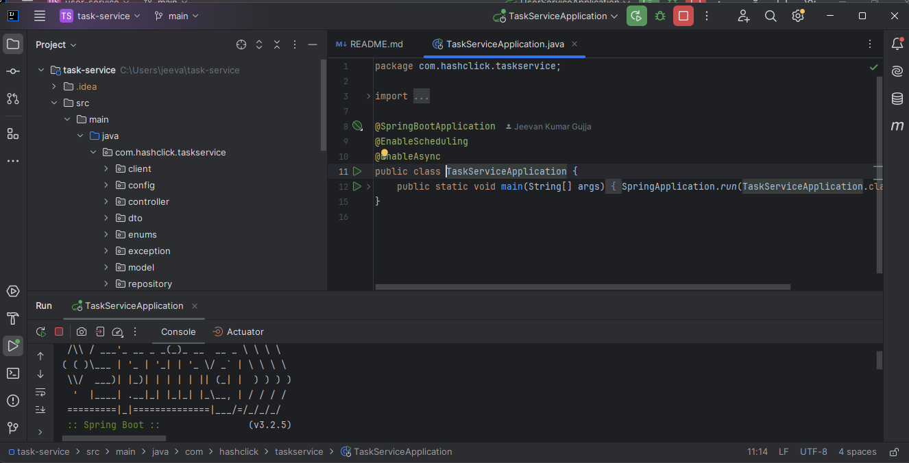
Figure 2: Task Service successfully started on port 8082

Figure 3 — User Service Swagger UI
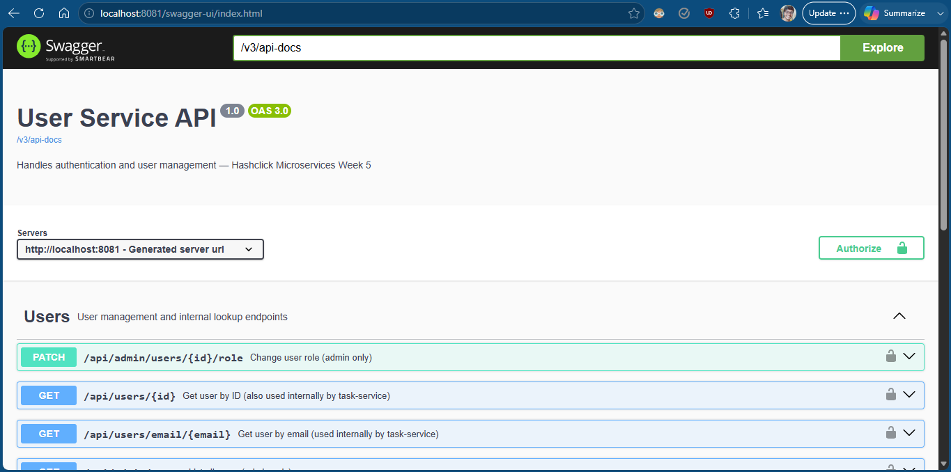
Figure 3: User Service Swagger/OpenAPI documentation at localhost:8081/swagger-ui.html

Figure 4 — Task Service Swagger UI
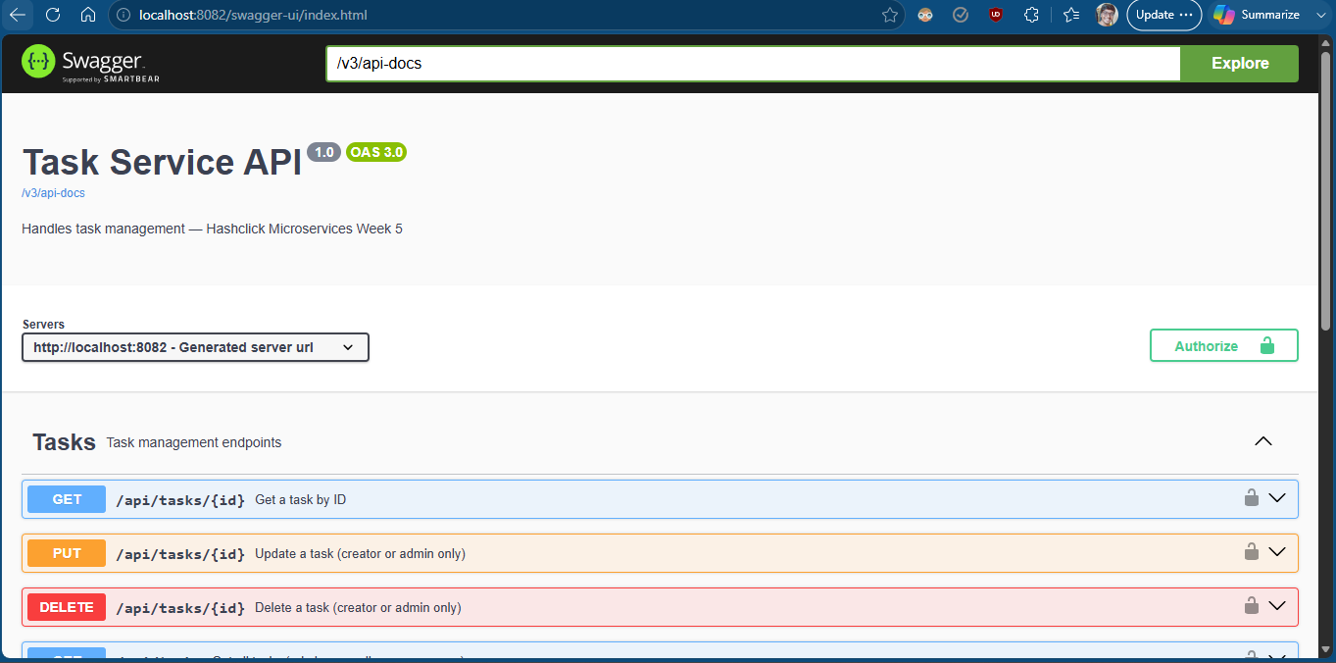
Figure 4: Task Service Swagger/OpenAPI documentation at localhost:8082/swagger-ui.html

Figure 5 — Register API (POST /api/auth/register)
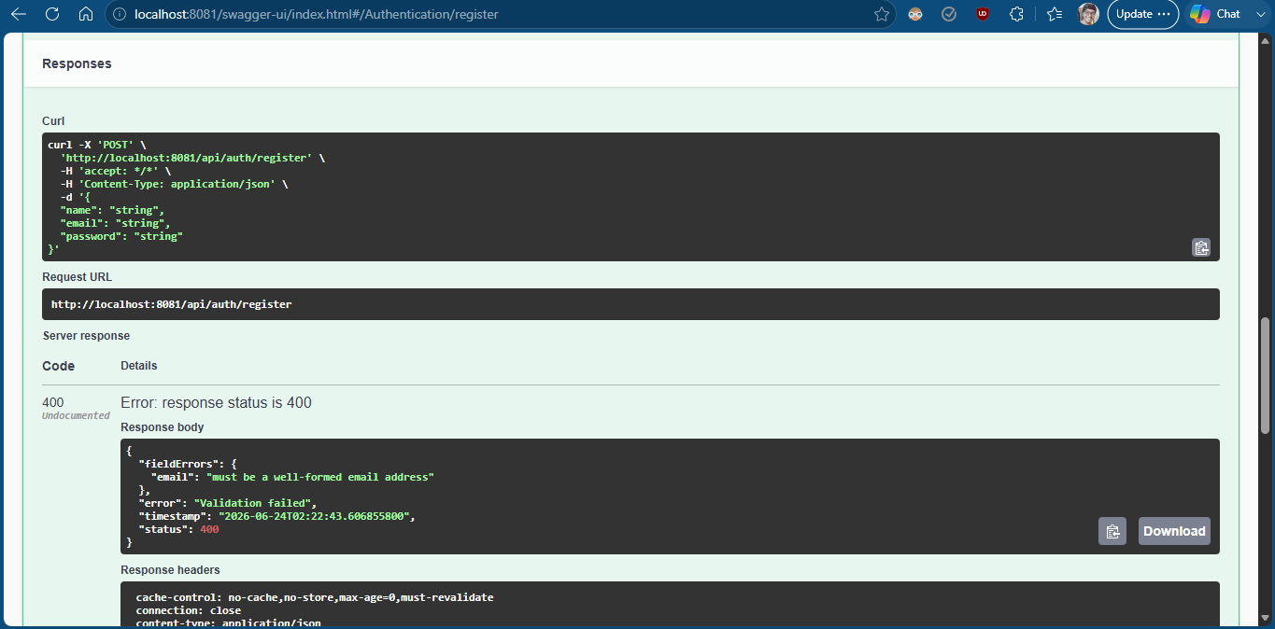
Figure 5: User registration via POST /api/auth/register — returns JWT token

Figure 6 — Login API (POST /api/auth/login)
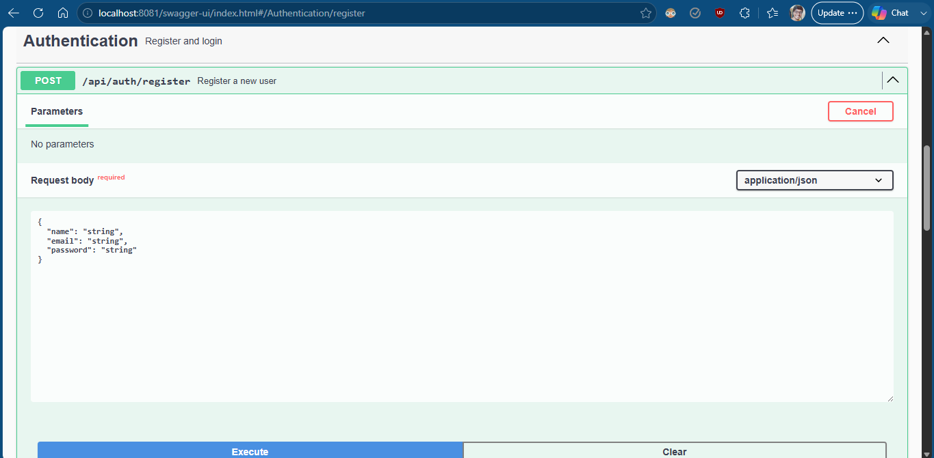
Figure 6: User login via POST /api/auth/login

Figure 7 — JWT Token Response
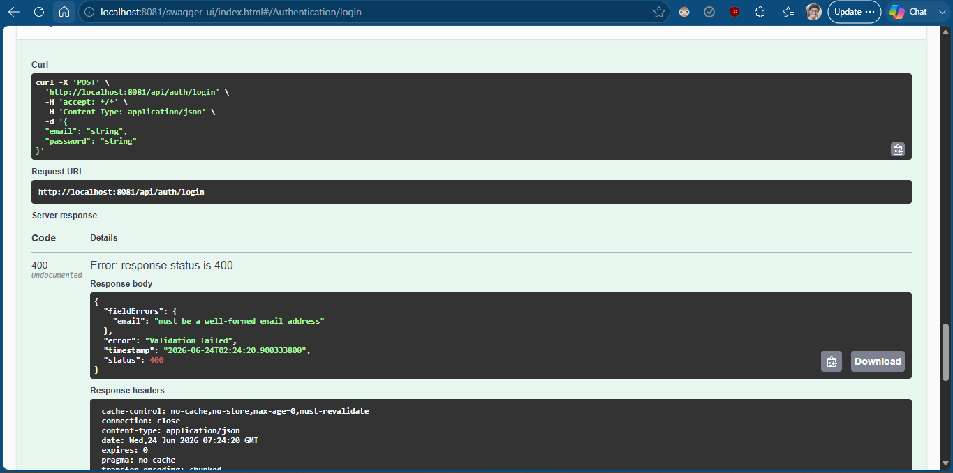
Figure 7: JWT token returned after successful login — used for all subsequent requests

Figure 8 — Create Task (POST /api/tasks)
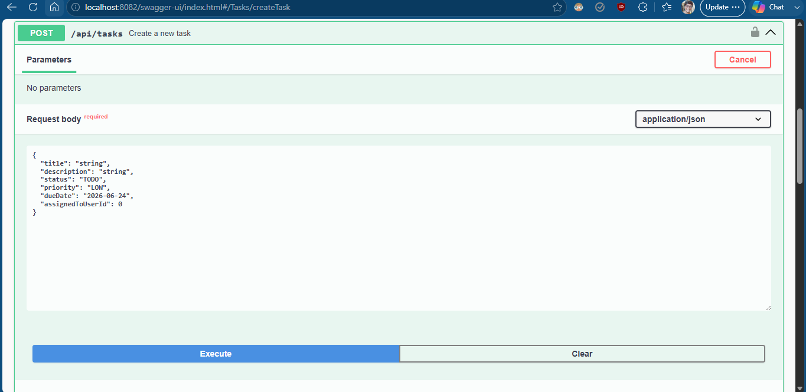
Figure 8: Creating a new task via POST /api/tasks with Bearer JWT token

Figure 9 — Create Task Response
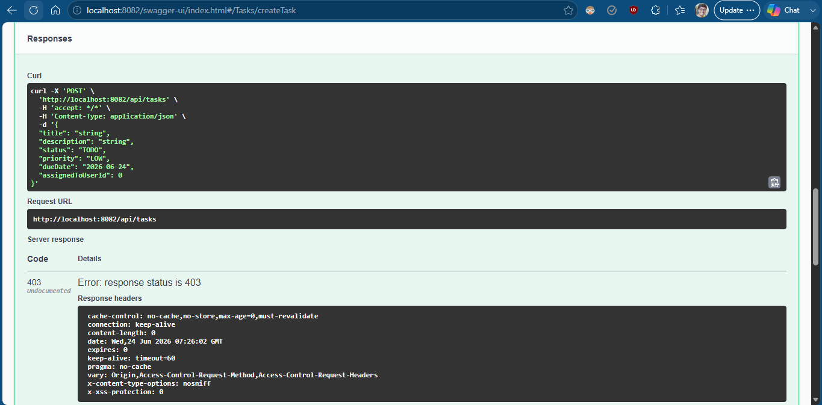
Figure 9: Task created successfully — response with task ID and details

Figure 10 — Get Tasks (GET /api/tasks)
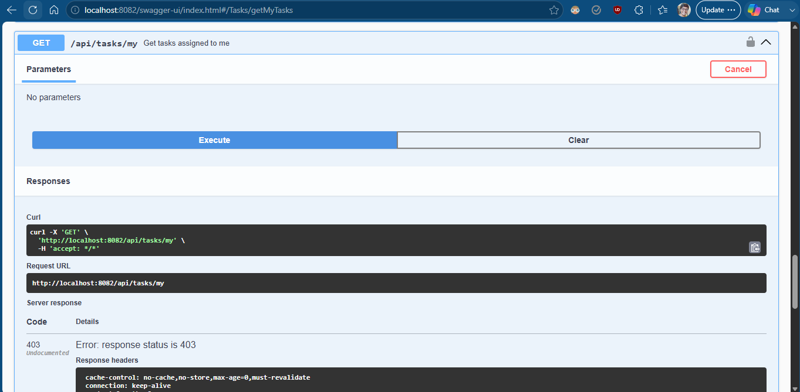
Figure 10: Retrieving all tasks via GET /api/tasks

Figure 11 — H2 Console — User Service
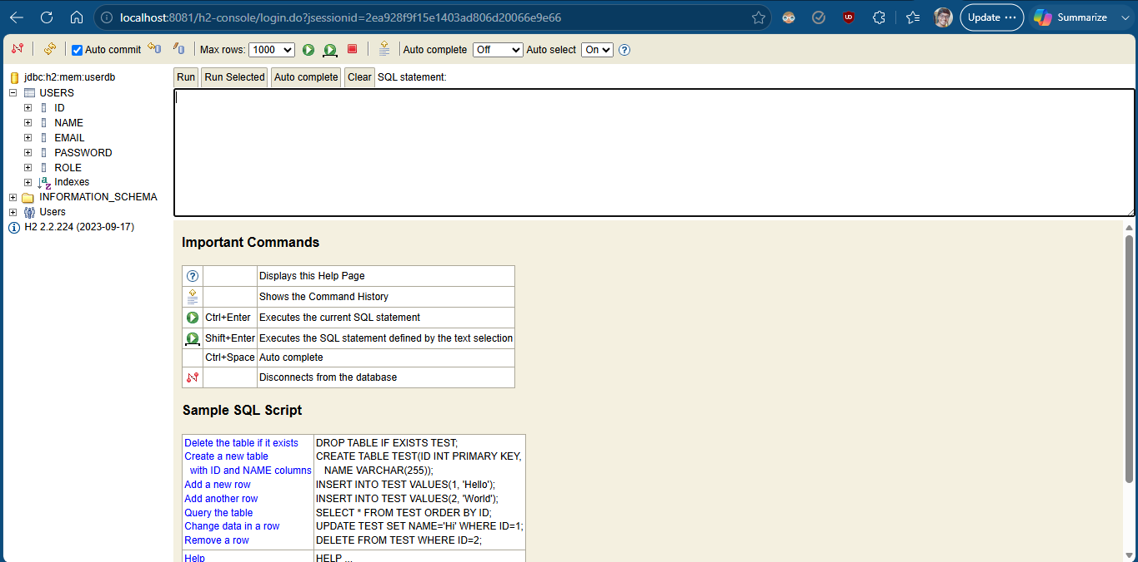
Figure 11: H2 in-memory database console for User Service (userdb) showing users table

Figure 12 — H2 Console — Task Service
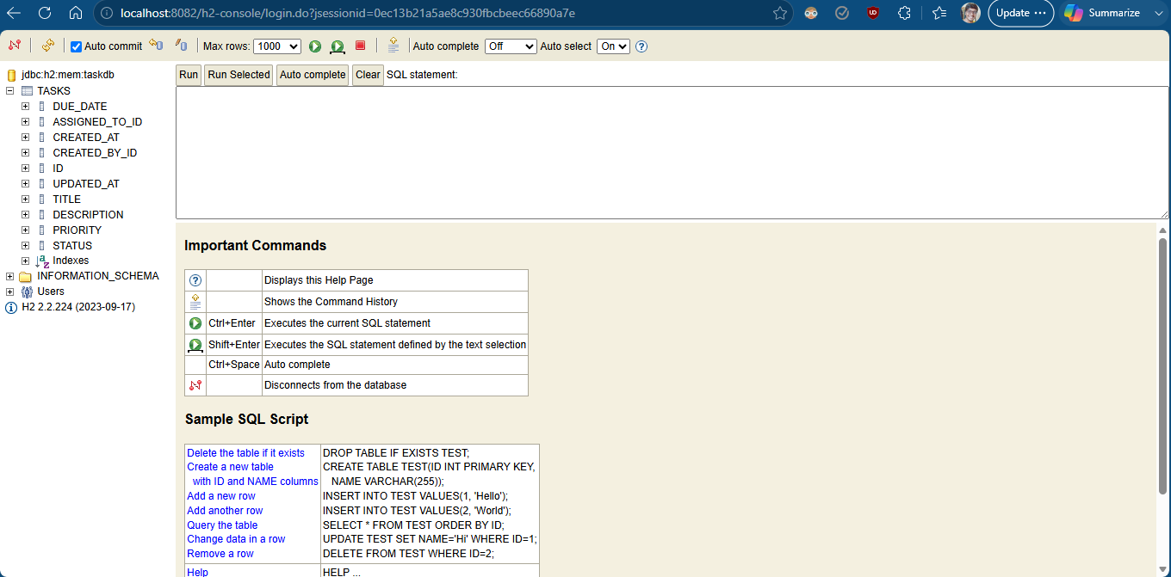
Figure 12: H2 in-memory database console for Task Service (taskdb) showing tasks table

Figure 13 — User Service GitHub Repository
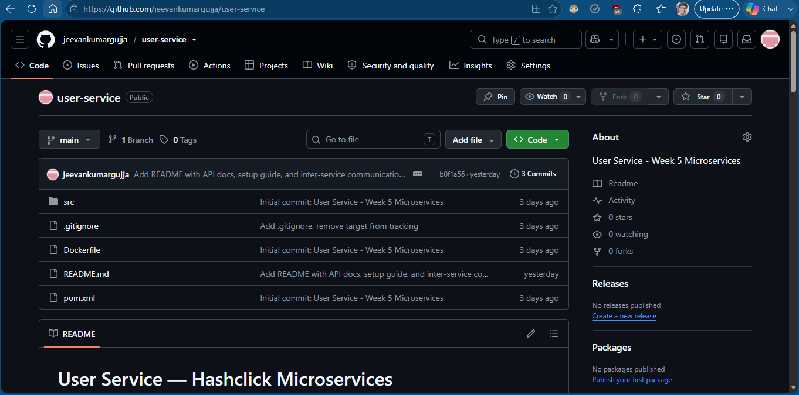
Figure 13: User Service GitHub repository — github.com/jeevankumargujja/user-service

Figure 14 — Task Service GitHub Repository
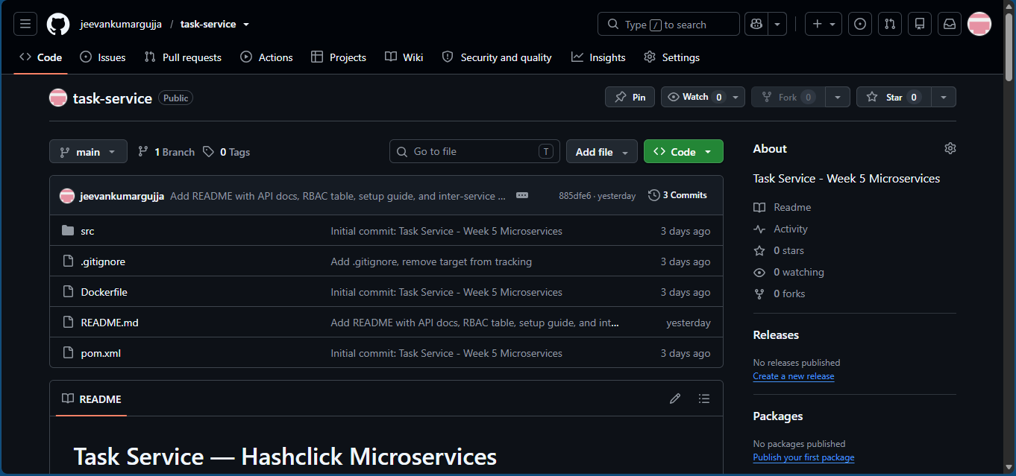
Figure 14: Task Service GitHub repository — github.com/jeevankumargujja/task-service

Figure 15 — User Service README
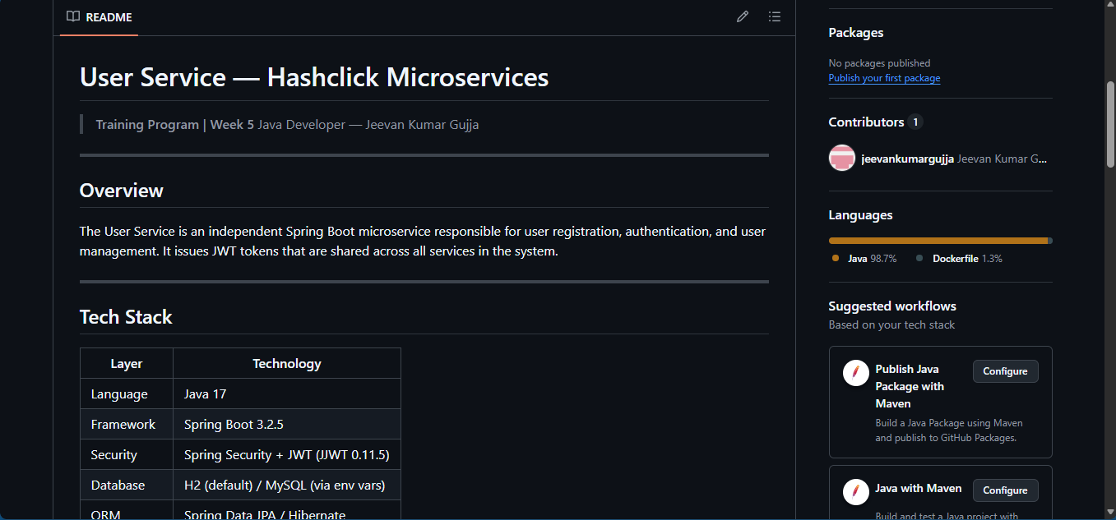
Figure 15: User Service README with API documentation and setup guide

Figure 16 — Task Service README
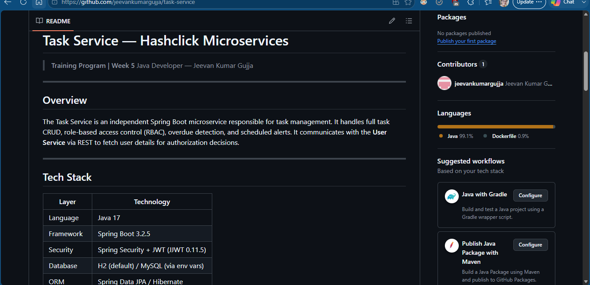
Figure 16: Task Service README with API endpoints, RBAC table, and inter-service communication notes

9. Trainee Declaration
I certify that all the information provided above is accurate and the work was completed during the stated period.

Employee Signature: Date: 06/21/2025
Jeevan Kumar Gujja

