On Job Training (OJT) Report on
Fitness-Hub at
Shivapuri Secondary School, Maharajgunj, Kathmandu

A Report Submitted
In the Partial Fulfillment of the Requirement for the Degree
Computer Engineering under Technical and Vocational Stream
Secondary Level Education (Grade - 10)

Submitted by:
Jeevan Neupane

Submitted To:
Department of Technical and Vocational Stream
National Examination Board
Sanothimi, Bhaktapur

Asar, 2083

CERTIFICATE OF APPROVAL
This On-Job-Training (OJT) project report entitled Fitness-Hub Submitted by Jeevan Neupane under the supervision of Mr. Sagun BabuAdhikari, IT Instructor, Shivapuri Secondary School, Maharajgunj, Kathmandu, is hereby submitted for the partial fulfillment of the requirement for the degree of Computer Engineering underTechnical and Vocational Stream in Secondary Level Education (Grade-10) during the academicyear of 2082/2083 B.S. is accepted.

Supervisor
Name: Er. Sagun Babu Adhikari
Designation: IT Instructor
School: Shivapuri Secondary School
Address: Maharajgunj, Kathmandu
Signature: ___________________
Date: ___________________

CERTIFICATE OF ON THE JOB TRAINING
This is to certify that the On-Job-Training (OJT) project entitled "Fitnes-Hub" has been carried out by Jeevan Neupane for the partial fulfillment of Computer Engineering under Technical and Vocational Stream in Secondary Level Education (Grade-10) during the academic year of 2082/2083 B.S. under the supervision of Mr. Sagun Babu Adhikari. During the project period, they have completed their work satisfactorily.

Supervisor
Name: Er. Sagun Babu Adhikari
Designation: IT Instructor
School: Shivapuri Secondary School
Address: Maharajgunj, Kathmandu
Signature: ___________________
Date: ___________________

DECLARATION

I, Jeevan Neupane, a student of Grade 10, hereby declare that the OJT report entitled 'Fitness-Hub' submitted to the Department of Computer Engineering, Shivapuri Secondary School, is my original work. The project was developed independently during my practice sessions at school, applying the principles of programming I have learned in class.
I have followed all the institutional guidelines provided by the school and the National Education Board (NEB) during the preparation of this report. All information used from external sources has been duly acknowledged.
.........................
Mr. Jeevan Neupane
Shivapuri Secondary School
Maharajgunj-10, Kathmandu

PREFACE
The present report is the outcome of the On-the-Job Training (OJT) project titled “Fitness-Hub”. It is prepared to fulfill the requirement of the Computer Engineering program under the Technical Stream at the Grade 12 level.
This report reflects the practical engineering exposure gained during our industry training. The core focus of this workspace session was to configure and build a functional web environment using the Django framework while maintaining rigorous project versioning via Git and GitHub distributed tools.
By relying explicitly on backend project architectures driven by Python, Git tracking workflows, and Django subsystems, our team mastered software repository orchestration, decentralized branch collaboration, and framework configuration patterns. This documentation outlines how specialized developer workspaces handle application parameters and route web assets effectively.
We are confident that the workspace management skills built around initializing frameworks, pushing repository commits, defining structural tables, and managing template nodes will form a strong pillar for our upcoming academic and engineering careers.

ACKNOWLEDGEMENT
Every great work is the result of combined efforts, guidance, and support. This project is no exception, and we are deeply grateful to everyone who played a role in making it a success.
First and foremost, we extend our sincere gratitude to the National Examination Board for designing a curriculum that bridges theoretical knowledge with real-world experience through the OJT program. This opportunity has truly shaped our understanding of Computer Engineering at the school level.
We are deeply thankful to our school, Shivapuri Secondary School, Maharajgunj, Kathmandu, for welcoming us and providing a nurturing environment to grow, learn, and apply our skills.
Our heartfelt appreciation goes to our respected Principal, Mrs. Sindhu Tuladhar, for her visionary leadership and constant encouragement, and to our coordinator and supervisor, Mr. Sagun Babu Adhikari, IT Instructor, whose unwavering guidance, patience, and expertise were the backbone of this entire project. His dedication to our learning went far beyond the classroom.
We also thank every member of the school staff who supported us with a smile and open arms throughout our training period.
To our friends , thank you for the laughter, the late nights, and the motivation when we needed it most. And to our parents , thank you for believing in us, supporting us endlessly, and giving us the wings to chase every opportunity that comes our way.

TABLE OF CONTENTS
Topic Page No.
CERTIFICATE OF APPROVAL ii
CERTIFICATE OF ON THE JOB TRAINING iii
DECLARATION iv
PREFACE v
ACKNOWLEDGEMENT vi
ABBREVIATIONS vii
CHAPTER 1: INTRODUCTION 1
1.1 Background 1
1.2 Objectives of OJT 2
1.3 Scope of the Project 2
1.4 Significance of the Project 3
CHAPTER 2: INTRODUCTION TO OJT WORKPLACE 4
2.1 About Shivapuri Secondary School 4
2.2 Organizational Structure 4
2.3 Facilities and Environment 5
CHAPTER 3: TECHNOLOGY USED 6
3.1 Programming Languages & Frameworks 6
3.2 Database 7
3.3 AI Integration 8

3.4 Hardware & Software Requirements 8
CHAPTER 4: PROJECT DESCRIPTION 10
4.1 Overview of Fitness-Hub 10
4.2 About 10
4.3 Login & Signup 11
4.4 AI 13
4.5 Shopping , Profile Setting , Workouts & Goals 14
Goals Page 14
Settings Page 14
Shopping Cart Page 15
Workout Library 16
CHAPTER 5: OBSERVATIONS & LEARNING EXPERIENCES 17
5.1 Introduction 17
5.2 Skills Gained 17
5.3 Practical Knowledge Acquired 18
5.4 Challenges Faced 19
5.5 Problem Solving 19
CHAPTER 6: CONCLUSION & RECOMMENDATIONS 20
6.1 Conclusion 20
6.2 Recommendations to School 20
6.3 References 21

ABBREVIATIONS

OJT | On-the-Job Training
MTV | Model-Template-View
ORM | Object-Relational Mapping
URL | Uniform Resource Locator
WSGI | Web Server Gateway Interface
ASGI | Asynchronous Server Gateway Interface
DTL | Django Template Language
VENV | Virtual Environment
Git | Global Information Tracker

CHAPTER 1: INTRODUCTION

1.1 Background
Practical experience plays a crucial role in technical education, serving as the bridge between classroom theory and real-world application. At Shivapuri Secondary School, the On-Job Training (OJT) program was designed to immerse students in hands-on exposure to modern technologies and collaborative teamwork within a professional environment. During this program, our team developed a Fitness-Hub Web Application using Django and Git/GitHub frameworks. The project emphasized creating a collaborative, version-controlled workspace where students could learn languages interactively while gaining skills in backend development, database management, and repository synchronization.
The Fitness Hub project transformed self-improvement into an engaging challenge by turning personal growth into something interactive and motivating. It provided structured routines that guided users through workouts and healthy habits, while progress tracking, milestones, and rewards kept them accountable and inspired. Accessible dashboards and tools made it easy to monitor progress consistently, and the collaborative workflows built with GitHub encouraged teamwork and exposure to industry-standard development practices. In essence, Fitness Hub reimagined the journey of self-improvement as a fun, community-driven experience that combined discipline with real-world learning.
Ultimately, the initiative served a dual purpose: providing a practical platform for fitness tracking while strengthening technical expertise, problem-solving abilities, and teamwork skills—essential foundations for future careers in computer engineering.

1.2 Objectives of OJT
The main objectives of this On-Job Training are:
• To apply theoretical knowledge of Computer Engineering in a real-world project environment
• To develop a fully functional full-stack web application from scratch
• To gain hands-on experience with modern web technologies including Django and AI integration
• To build a platform that genuinely motivates users to improve their daily habits through gamification
• To enhance teamwork, problem-solving, and project management skills
• To understand the complete software development lifecycle

1.3 Scope of the Project
- Develop a Fitness-Hub Web Application using Django framework and Git/GitHub for version control.
- Provide an interactive platform where students can practice and improve body through structured lessons and exercises.
- Implement user authentication, dashboards, and lesson tracking to personalize the learning experience.
- Apply Git/GitHub workflows for collaborative coding, branch management, and repository synchronization.
- Design a modular workspace with Django Models, Views, Templates, and SQLite database integration.
- Strengthen teamwork, problem-solving, and project management skills through real-world development
- Demonstrate how technical knowledge from the classroom can be applied to build scalable, practical
- Fitness Hub gamified self-improvement.

1.4 Significance of the Project
· The project demonstrates how classroom knowledge in Computer Engineering can be applied to solve real-world problems through practical implementation.
· By using Django and Git/GitHub, students gained exposure to industry-standard tools, preparing them for future professional environments.
· The application provides a structured and interactive platform for fitness tracking, making education more engaging and accessible.
· Similar to the Fitness Hub project, which gamified self-improvement, this project shows how technology can transform learning into a motivating and enjoyable experience.
· It strengthens essential skills such as teamwork, problem-solving, and project management, which are critical for academic and career growth.

CHAPTER 2: INTRODUCTION TO OJT WORKPLACE

2.1 About Shivapuri Secondary School
Shivapuri Secondary School is a well-established educational institution located in Maharajgunj, Kathmandu, Nepal. The school offers both general and technical education streams, including the Technical and Vocational Stream under the National Examination Board (NEB). It has been playing a significant role in shaping technically skilled students at the secondary level by providing quality education combined with practical training opportunities.
The school served as our OJT workplace where we received guidance, resources, and supervision necessary to develop the Fitness-Hub platform. It provided us with a conducive learning environment that encouraged innovation, teamwork, and the practical application of computer engineering concepts.

2.2 Organizational Structure
The organizational structure of Shivapuri Secondary School is as follows:
• Principal: Mrs. Sindhu Tuladhar
• IT Instructor / OJT Supervisor: Mr. Sagun Babu Adhikari
• Teaching Staff: Subject teachers across all streams
• Technical & Vocational Department: Responsible for overseeing OJT programs and technical education
• Students: Grade 9 and Grade 10 students enrolled in the Technical and Vocational Stream

2.3 Facilities and Environment
Shivapuri Secondary School provided the following facilities during our OJT period:
• A dedicated computer lab equipped with personal computers and internet access
• Guidance and mentorship from our IT Instructor, Mr. Sagun Babu Adhikari
The overall environment at Shivapuri Secondary School was highly encouraging and played a major role in the successful development of the Fitness-Hub platform.

CHAPTER 3: TECHNOLOGY USED

3.1 Programming Languages & Frameworks
The development of Fitness-Hub involved the use of several modern programming languages and frameworks:
Python
Python is a high-level, versatile, and beginner-friendly programming language. It served as the core backend language for Fitness-Hub Python's simplicity and powerful libraries made it the ideal choice for handling server-side logic, AI integration, and database operations.
Django
Django is a high-level Python web framework that encourages rapid development and clean, pragmatic design. It was used as the primary backend framework for Fitness-Hub, handling URL routing, database management, user authentication, REST API development, and server-side rendering of templates.
Django Channels
Django Channels extends Django to handle WebSocket connections. It was used to power the real-time multiplayer arena of Fitness-Hub, enabling live communication between players during multiplayer matches.
Javascript
JavaScript was used extensively on the frontend to handle user interactions, activity logic, real-time updates.
HTML & CSS
HTML (HyperText Markup Language) and CSS (Cascading Style Sheets) are the two core technologies used to build and design webpages. HTML provides the structure of the page, defining elements like headings, paragraphs, images, and links—it’s essentially the skeleton that organizes content. CSS, on the other hand, is responsible for the presentation and style, controlling aspects such as colors, fonts, spacing, and layout—it’s like the clothing and decoration that make the skeleton visually appealing. Together, they allow developers to create webpages that are both functional and attractive: HTML builds the foundation, while CSS enhances the look and feel.
HTML and CSS formed the structural and visual foundation of all templates in Fitness-Hub. They were used to design every page of the platform including the dashboard, activities, shop, social feed, and chat.

3.2 Database
SQLite
SQLite was used as the database for Fitness-Hub during development. It is a lightweight, file-based relational database that requires no separate server setup. The Fitness-Hub database contains models storing everything from user profiles , products data , user data AI message history.

3.3 AI Integration

One of the most powerful aspects of Fitness-Hub is its AI integration. The platform uses OpenRouter as its AI provider for generating daily challenges, verifying submissions, powering the AI companion, and creating quiz questions.
To ensure reliability, hardcoded fallback data is used whenever AI services are unavailable, allowing the platform to continue functioning without interruption.

3.4 Hardware & Software Requirements

Hardware Requirements
Component | Requirement
Processor | Intel Core i3 or higher
RAM | Minimum 4GB
Storage | Minimum 10GB free space
Internet | Stable broadband connection
Display | 1280x720 resolution or higher

Software Requirements

Software | Purpose
Python 3.14 | Backend programming language
Django 6.0.5 | Web framework
SQLite | Database
Visual Studio Code | Code editor
Git | Version control
Web Browser (Chrome/Firefox/Opera) | Frontend testing

CHAPTER 4: PROJECT DESCRIPTION

4.1 Overview of Fitness-Hub
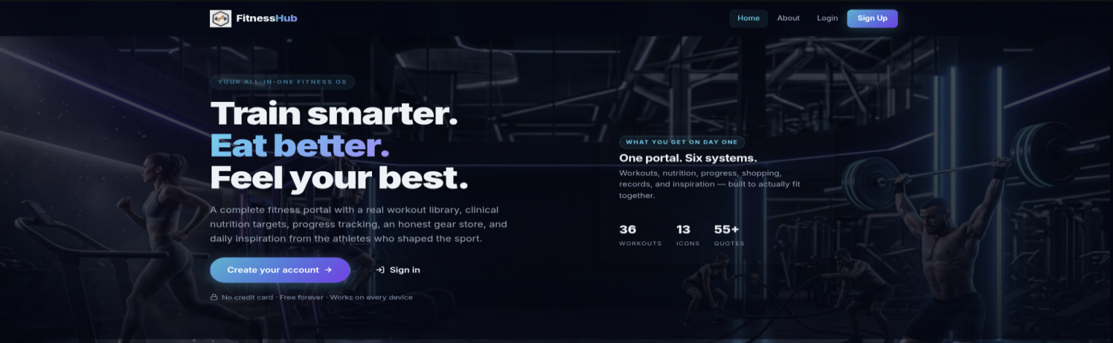

Fitness Hub is an interactive , full-stack web platform designed to make health and self-improvement engaging and accessible.

4.2 About

Fitness Hub is a complete portal for individuals who want a real training workflow — not just another fitness feed.

4.3 Login & Signup
The login page welcomes users back with the message “Sign in and pick up where you left off.” It highlights saved goals, records, meals, and daily quotes. Users enter their username and password to continue, or they can choose to create a new account. Motivational quotes and workout stats add an inspiring touch to the interface.
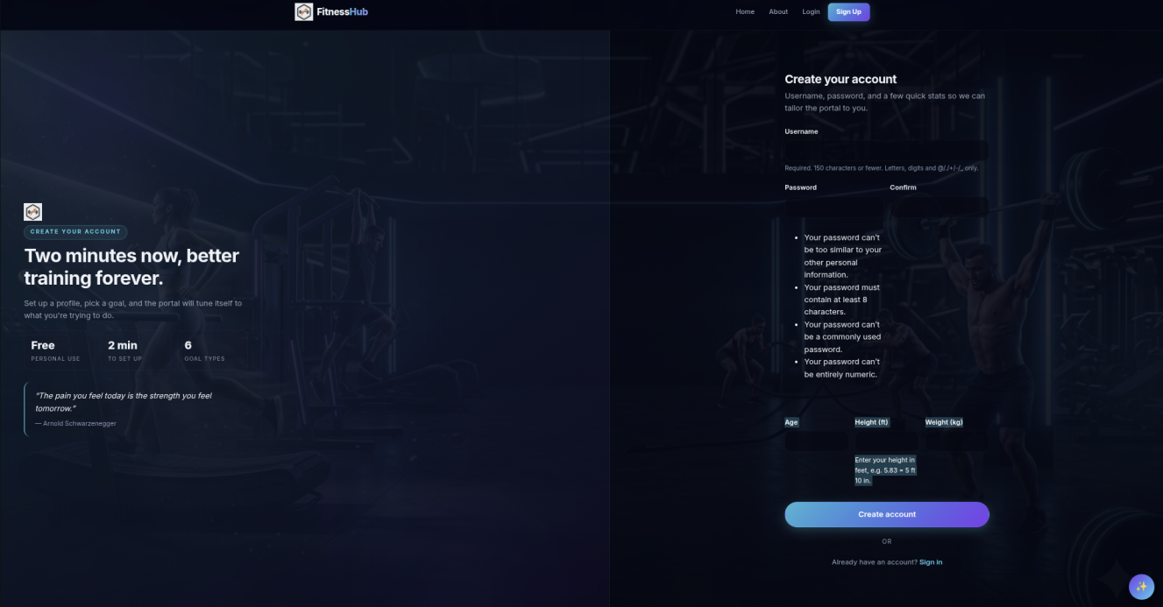

The sign-up page encourages new users with “Two minutes now, better training forever.” It allows quick account creation by entering a username, pas…
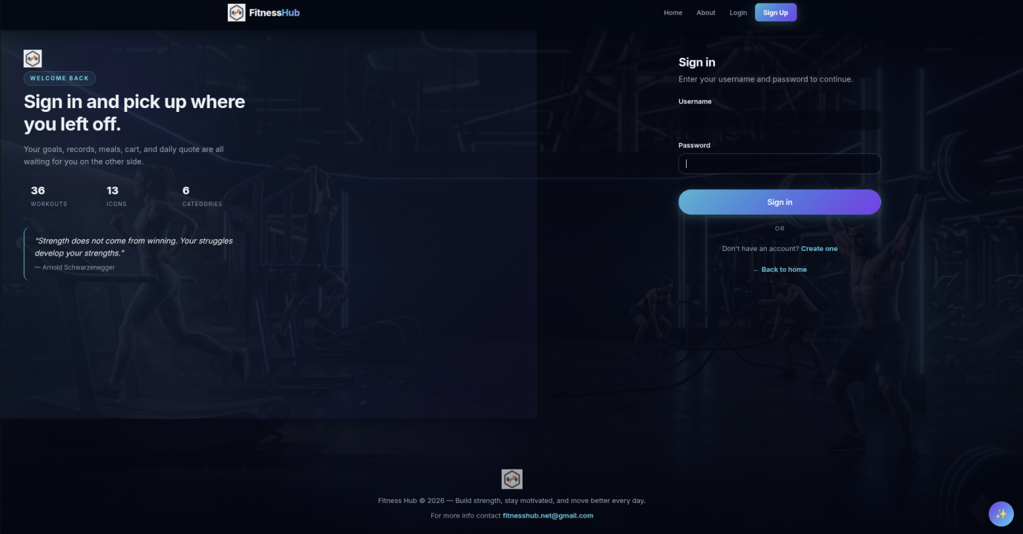

4.4 AI
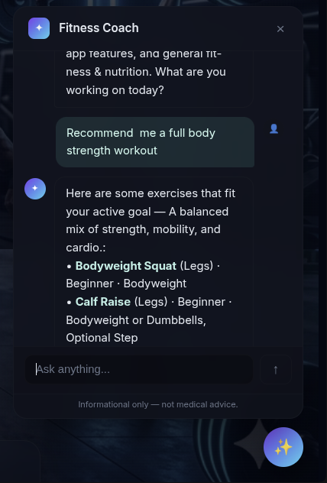

The AI Fitness Coach is an interactive assistant built into Fitness Hub to guide users through their fitness journey.

4.5 Shopping , Profile Setting , Workouts & Goals

Goals Page
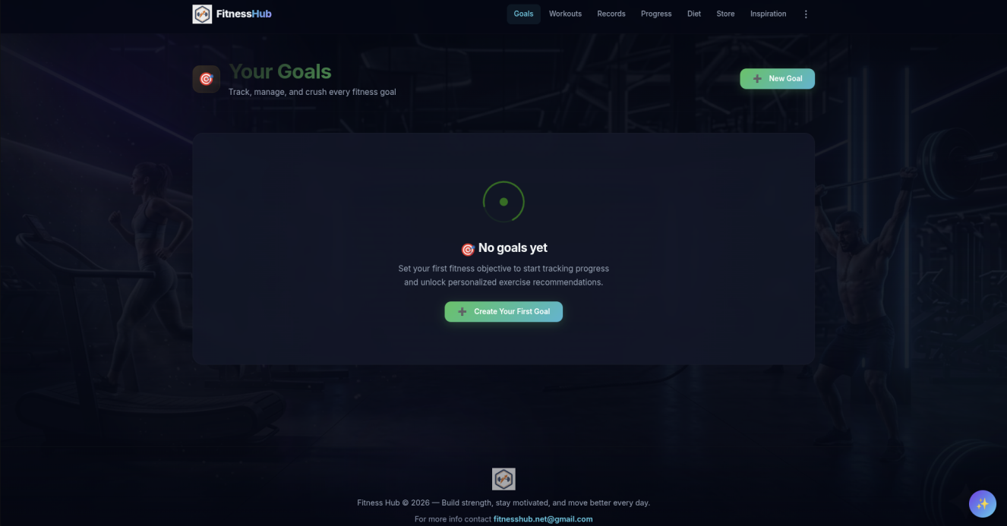
The Goals page lets users set, track, and manage their fitness objectives.

Settings Page
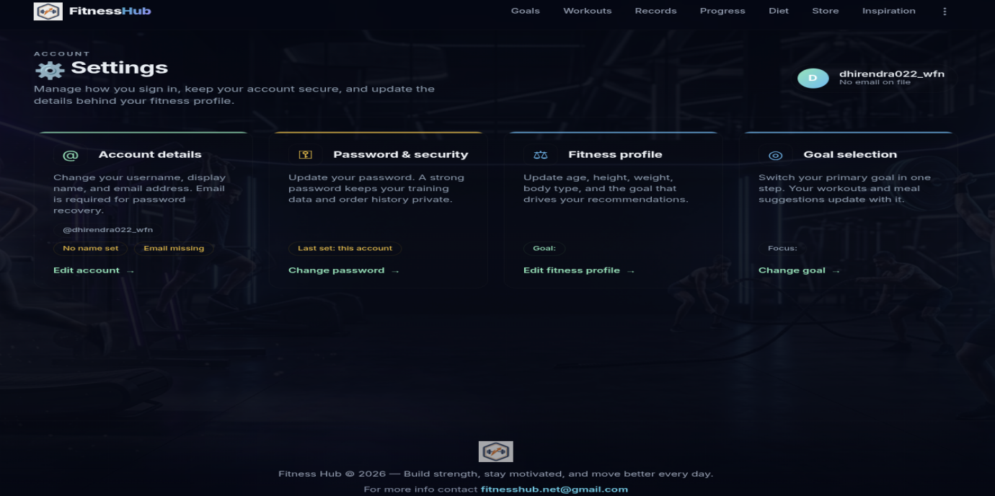

The Settings page helps users manage account details, passwords, fitness profiles, and goal preferences.

Shopping Cart Page
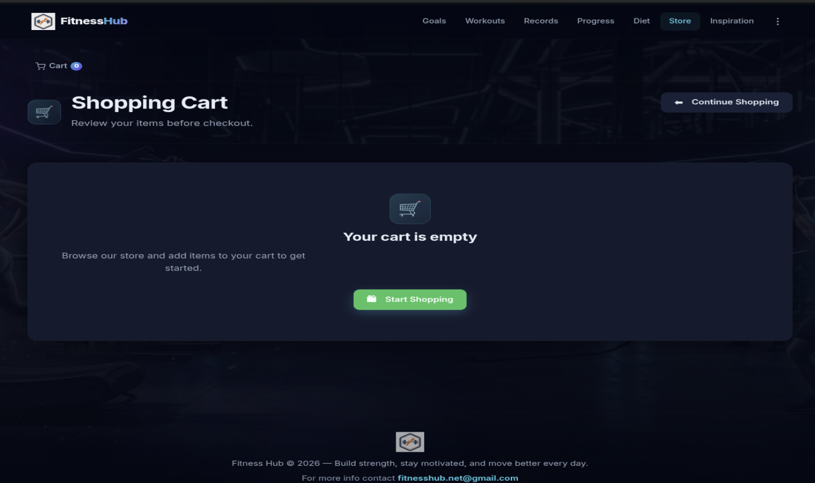

The Shopping Cart page provides a smooth shopping experience for fitness gear and supplements.

Workout Library
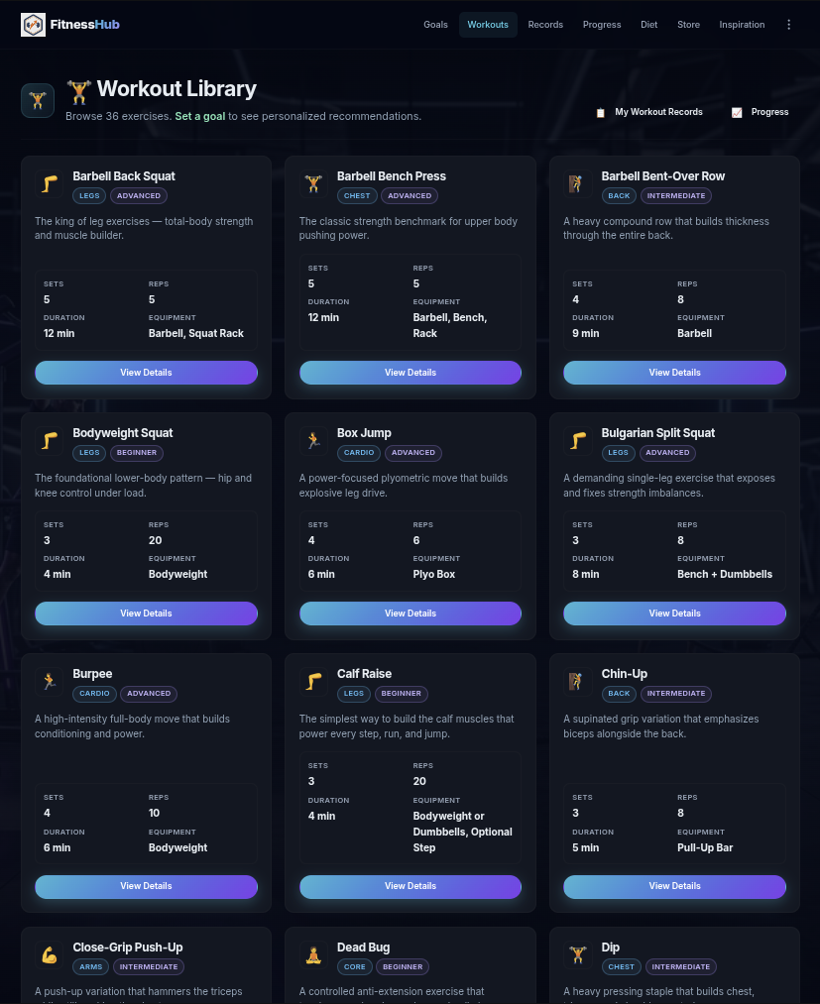
The Workout Library offers a collection of 36 exercises categorized by muscle group and difficulty level.

CHAPTER 5: OBSERVATIONS & LEARNING EXPERIENCES

5.1 Introduction
The On-Job Training period at Shivapuri Secondary School, Maharajgunj, Kathmandu was an incredibly enriching experience. Working on Fitness-Hub gave us the opportunity to step beyond the boundaries of textbooks and apply our knowledge in a real-world development environment. This chapter summarizes the key observations, skills gained, challenges faced, and practical knowledge acquired throughout the OJT period.

5.2 Skills Gained
Full-Stack Web Development
Through the development of Fitness-Hub, we gained hands-on experience in building a complete full-stack web application from scratch. We learned how to connect a Python Django backend with a dynamic HTML/CSS/JavaScript frontend and manage the entire data flow between them.
AI Integration
One of the most exciting skills we developed was integrating multiple AI providers into a real application. We learned how to make API calls to OpenCode and OpenRouter, handle responses, build fallback chains, and use AI to generate personalized content dynamically for each user.
Database Design
Designing 21 database models for Fitness-Hub gave us deep insight into relational database design. We learned how to structure models efficiently, define relationships between them, and manage migrations using Django's built-in tools.

5.3 Practical Knowledge Acquired
• Understood the complete software development lifecycle from planning and design to development,testing, and deployment
• Learned how to work collaboratively as a team, divide tasks efficiently, and integrate each other's work without conflicts
• Gained practical knowledge of version control concepts and project file management
• Understood the importance of writing clean, readable, and maintainable code
• Learned how to debug complex issues across both frontend and backend simultaneously
• Gained insight into how AI can be used not just as a tool but as a core feature of a product
• Understood how real-time systems behave differently from traditional request-response web applications
• Learned how to design an economy system with coins, rarity tiers, and rewards that genuinely motivates users

5.4 Challenges Faced
Managing a Large Codebase, With over 11,600 lines of Python and 13,000 lines of HTML/JavaScript, managing the codebase as a team required careful organization and clear communication to avoid conflicts and maintain code quality.

5.5 Problem Solving
Every challenge we faced during the OJT period taught us something valuable. We learned that problems in software development are inevitable — what matters is how systematically and creatively you approach them. From debugging WebSocket race conditions to fine-tuning AI prompts, each problem pushed us to think deeper, research more, and collaborate better. This problem-solving mindset is perhaps the most important skill we take away from this OJT experience

CHAPTER 6: CONCLUSION & RECOMMENDATIONS

6.1 Conclusion
The Fitness Hub platform successfully integrates technology and wellness, offering users a complete environment to manage workouts, goals, nutrition, and progress. Through its intuitive design and interactive features — including goal tracking, personalized workouts, secure settings, and an AI fitness coach — it transforms fitness management into a motivating, data-driven experience.
By combining functionality with user engagement, Fitness Hub demonstrates how modern web applications can promote consistency, self-improvement, and healthy living in a digital age.

6.2 Recommendations to School
Based on our OJT experience, we would like to humbly offer the following recommendations to Shivapuri Secondary School and the National Examination Board:
• Increase Practical Hours — More time should be dedicated to hands-on project work rather than purely theoretical lessons. Real-world development skills are best learned by doing.
• Introduce Modern Technologies Earlier — Students should be introduced to modern tools such as Django, React, Git, and cloud platforms earlier in the curriculum so they have more time to practice before OJT.
• Improve Computer Lab Infrastructure — Upgrading computers and providing faster and more stable internet access in the computer lab would significantly improve the quality of student projects.
• Encourage Team Projects — Team-based projects like ours teach collaboration, communication, and division of responsibilities — skills that are just as important as technical knowledge in the real world.
• Invite Industry Professionals — Regular workshops and guest sessions by working software developers and IT professionals would greatly inspire and motivate students.

6.3 References
· GitHub official documentation: https://docs.github.com
· Git official documentation: https://git-scm.com/docs
· Django official documentation: https://docs.djangoproject.com
· OpenRouter (AI model routing platform): https://openrouter.ai

