**EXNO : 6 CREATE AN  ATTRACTIVE WEB PAGE WITH TEMPLATES USING**

**DATE :11/01/25 WORDPRESS TOOL**

**AIM:**

To create an attractive web page with templates using Wordpress tool.

**PROCEDURE:**

**STEP 1:** Login to wordpress.

**STEP 2:** Design a web page with the desired content.

**STEP 3:** Select themes.

**STEP 4:** Include title, text, paragraph, etc.

**STEP 5:** Include image, audio and video.

**STEP 6:** Publish the pages.

**STEP 7:** Click View Page to view the designed webpage.

**Adding a new page:**

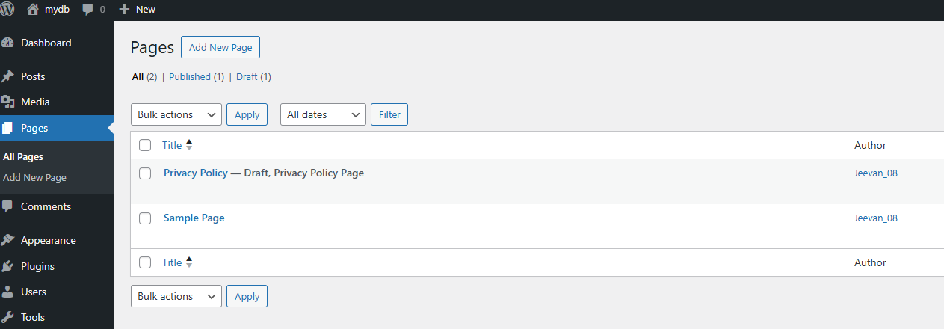

**Select the template**

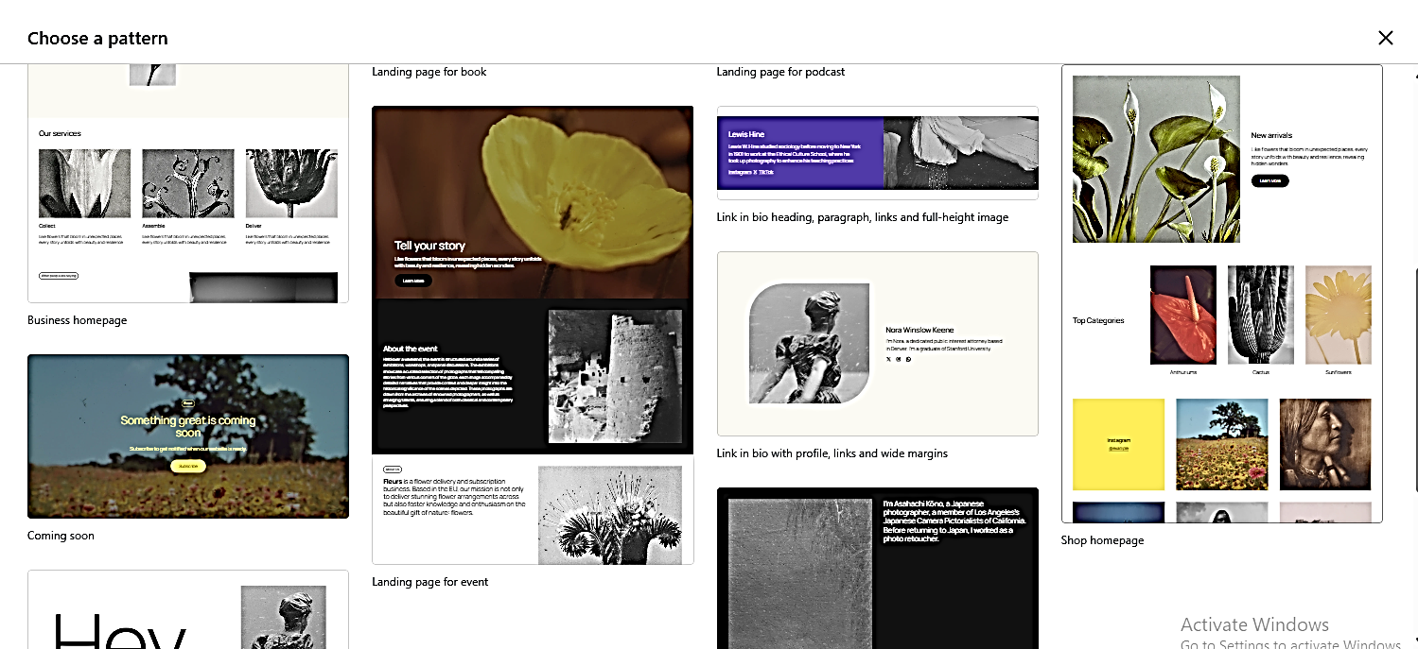

**Add text and images**



**After Creating and Publishing the pages**

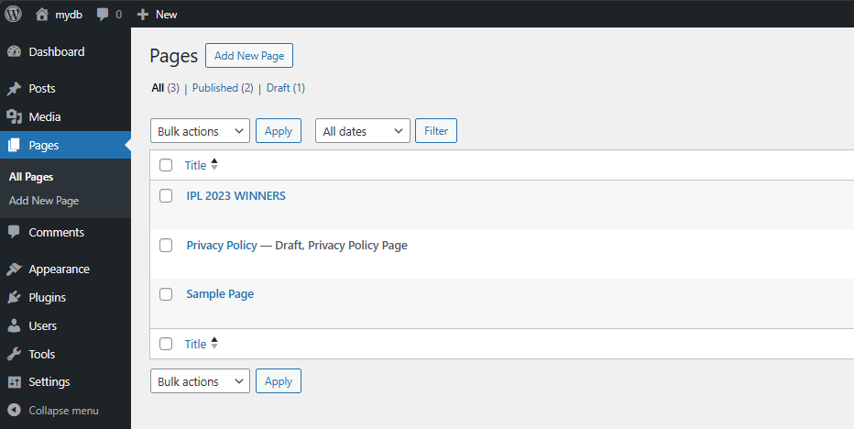

**OUTPUT**

**MOBILE LAYOUT**



**DESKTOP LAYOUT**



**RESULT**

Thus a webpage with templates is created successfully with Wordpress tool.