**EXNO : 8 INSTALL AND CONFIGURE DRUPAL TOOL**

**DATE : 29.1.25**

**AIM:**

To install and configure drupal tool

**PROCEDURE:**

**STEP 1:** Download Drupal 10.2.2 from drupal.org.

**STEP 2:** Extract it to C:\xampp\htdocs\drupal.

**STEP 3:** Start XAMPP and run Apache & MySQL.

**STEP 4:** Create a database "mydb" in phpMyAdmin.

**STEP 5:** Open http://localhost/drupal and follow the installation.

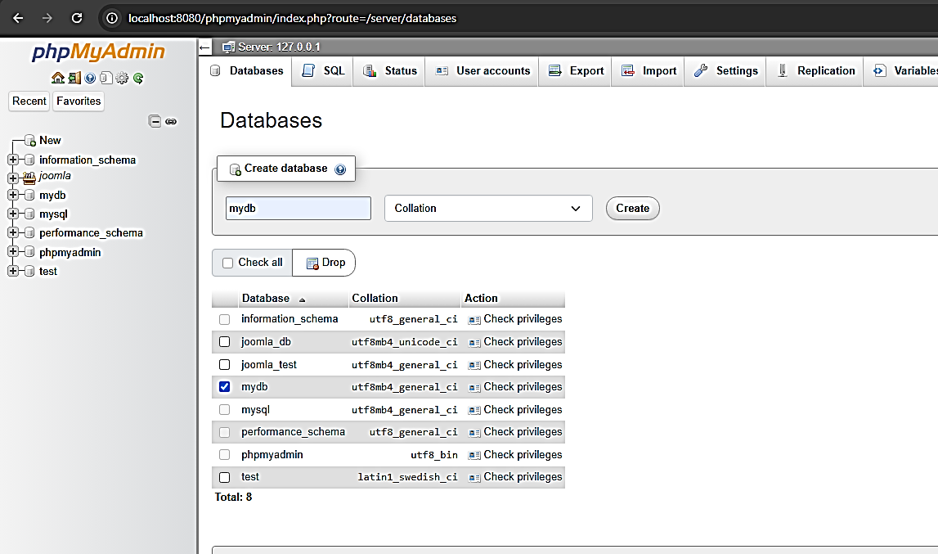

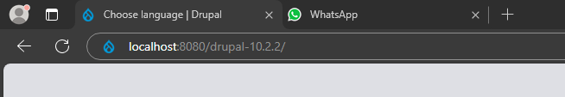

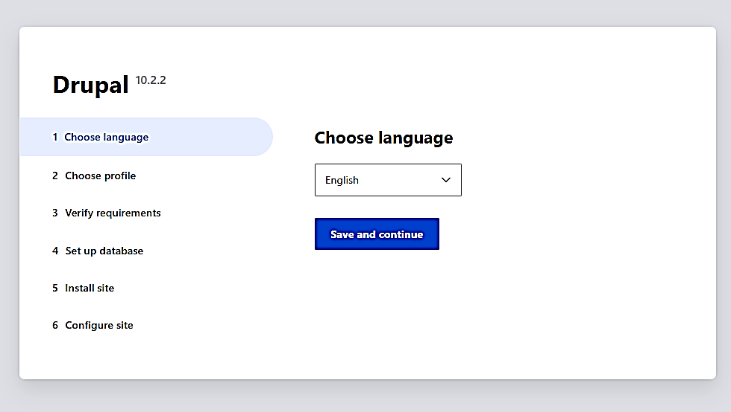

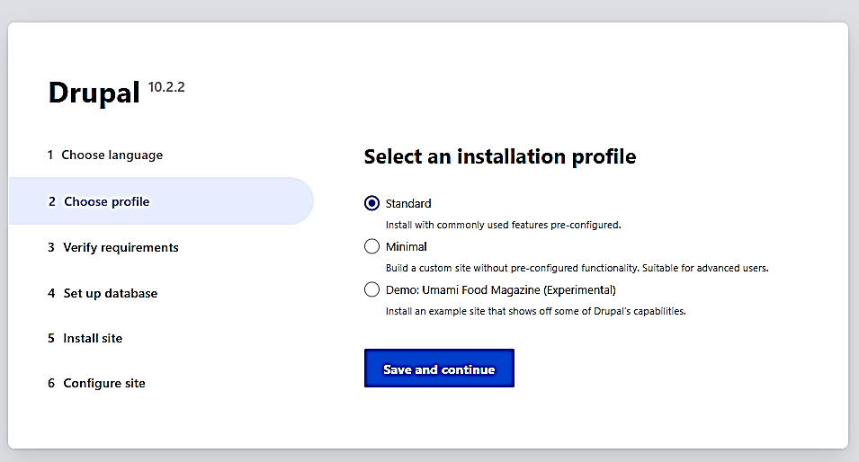

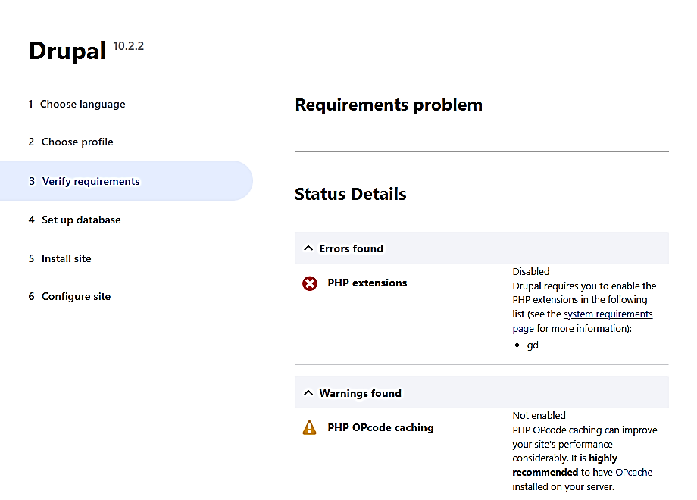

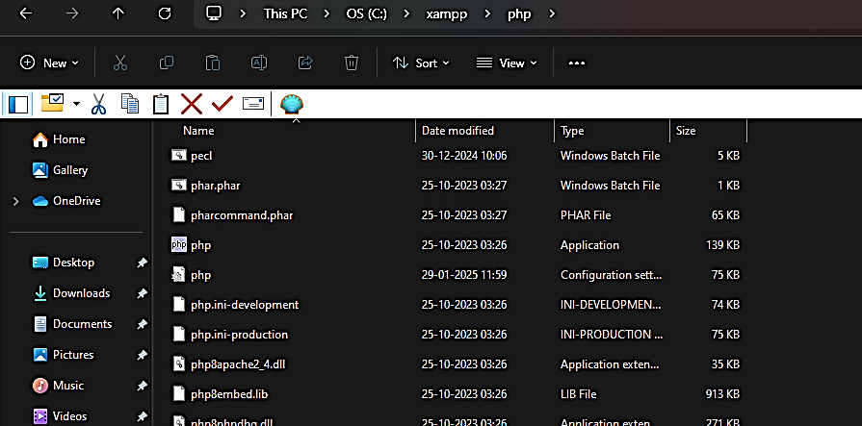

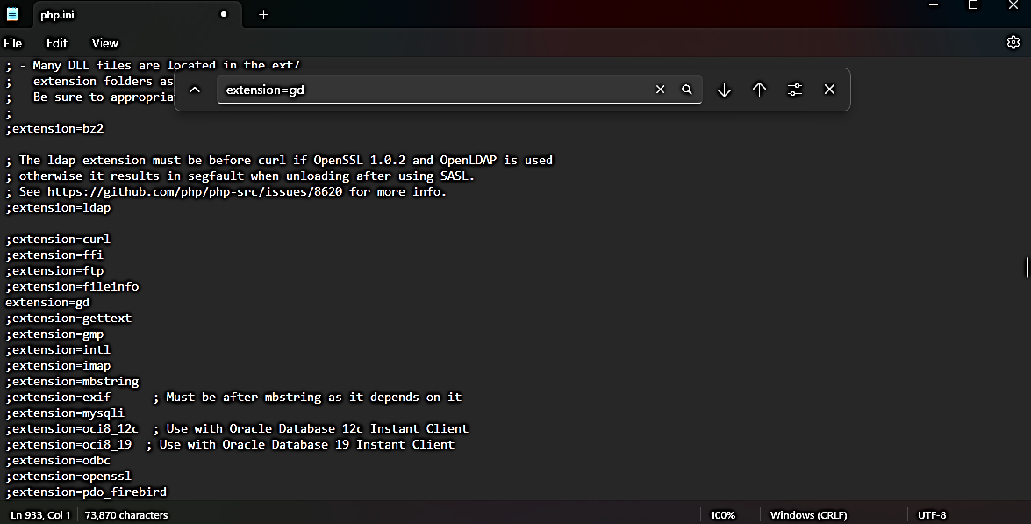

Change from ;extension=gd to extension=gd save it and restart xampp

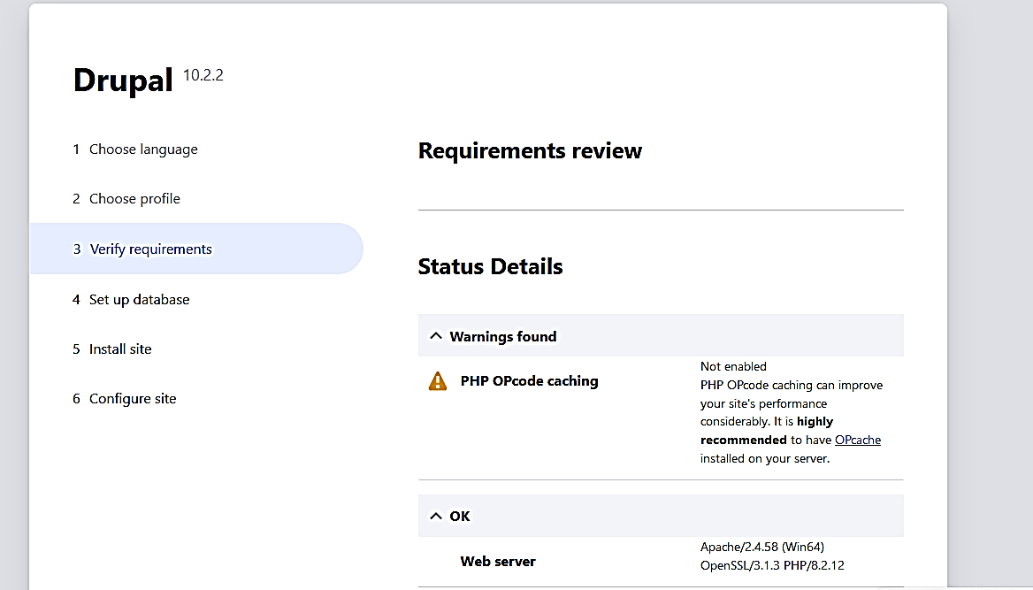

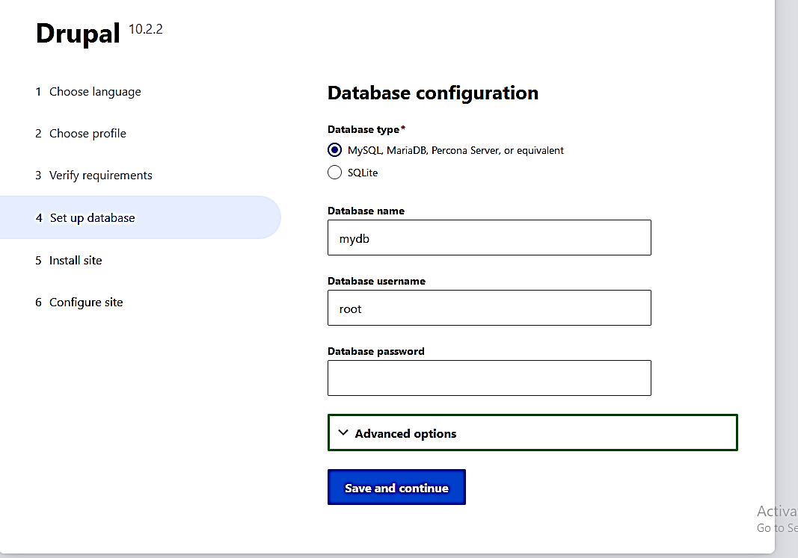

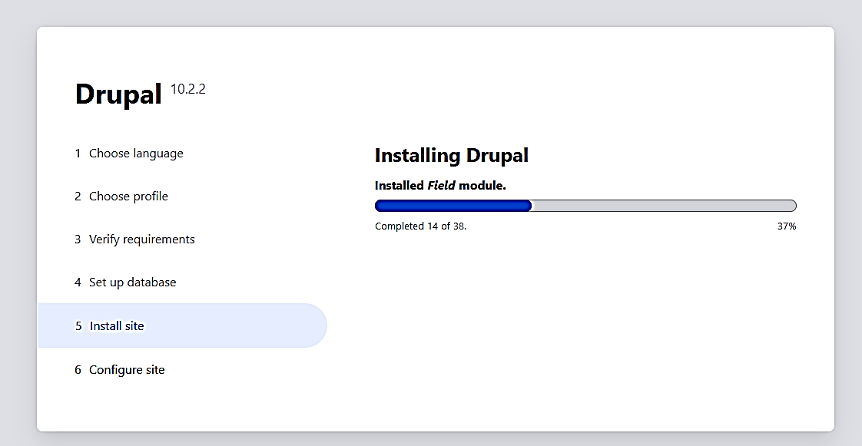

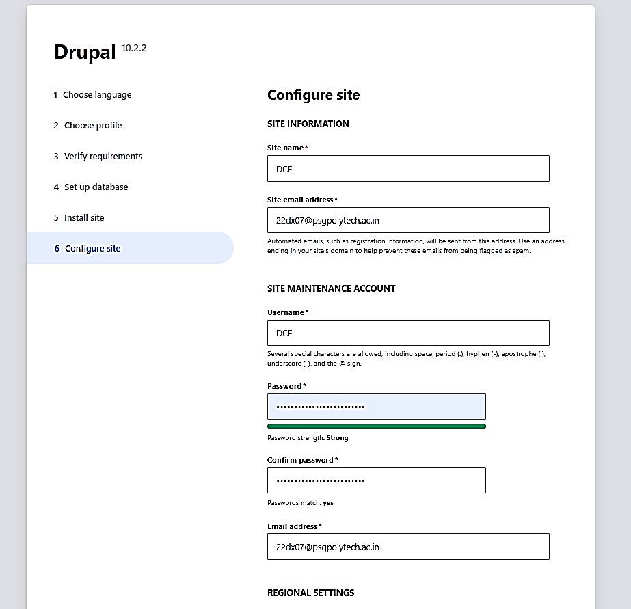

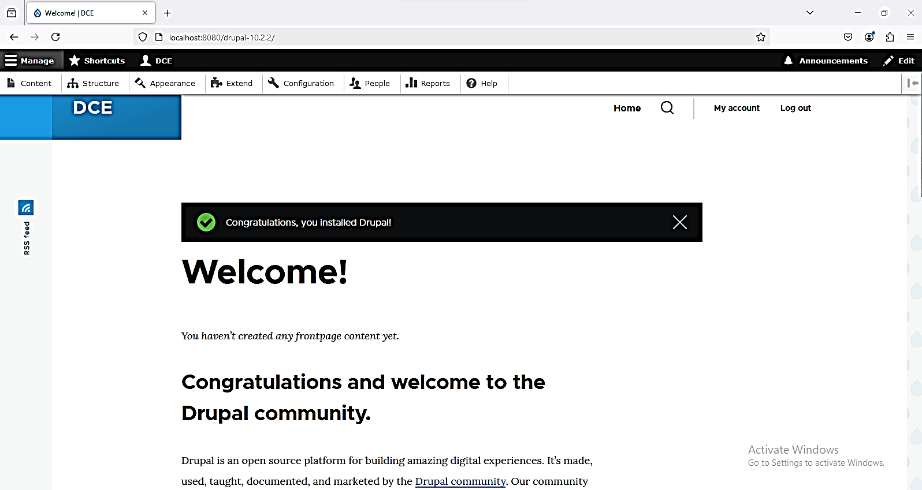

**RESULT:**

Thus the Drupal tool was installed and configured successfully.