**EX.NO:1 INSTALL AND CONFIGURE JOOMLA TOOL**

**DATE: 04/12/24**

**AIM**

To install and configure Joomla Tool

**PROCEDURE**

1. Download XAMPP control panel and install it.

2. Now enable the Apache, MySQL services.

3. Download JOOMLA and extract it inside the htdocs folder.

4. Now goto localhost/phpMyAdmin on your browser.

5. Create a database in MySQL.

6. No goto localhost/Joomla on your browser.

7. Now fill in the main configuration and database configuration details and click “Install Joomla”.

8. Now JOOMLA gets installed.

9. Create a new website by entering your own website name in the JOOMLA webpage.

**INSTALLATION**

**Step 1: Install and Activate XAMPP**

Firstly, you are required to download XAMPP from the link given below: [**https://www.apachefriends.org/index.html**](https://www.apachefriends.org/index.html)

Just download the valid Windows installer of XAMPP and install it by running the installer package. It can be installed easily, just like the other windows software. It is suggested to use the default location for installation.

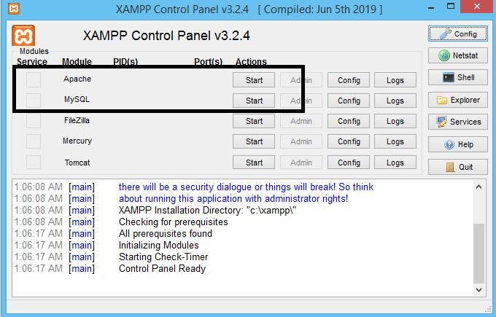When the installation is done, launch the XAMPP software. It should look like this:

Now, you have to activate the XAMPP software by turning on the options, shown in the above screenshot.

**Step 2: Joomla Download and Upload**

## If you install in your localhost, then you need to

Download the **.zip** or **.tar.gz** file of Joomla from the official website. [**https://downloads.joomla.org/**](https://downloads.joomla.org/)

Extract the downloaded file and copy all the files into the 'htdocs' folder, which is available in the XAMPP installation directory. You can also create the subdirectory and copy all the files into that subdirectory. Here, we are using a subdirectory 'Joomla'.

This PC > Local Disk (C:) > xampp > htdocs > Joomla

## If you install from your hosting then

You need to upload the compressed file to your domains' root and extract it. You can perform it using a file manager or using an FTP client. Most of the hosts provide web-based file managers for day to day tasks. By default, these files should be appeared in the **public_html** directory (usually a root folder).

**Step 3: Create a Database**

Before installing the Joomla, you will need to create a database that you can use to connect. To do this, open a browser and navigate to **localhost/phpmyadmin**. Click on the tab named '**Databases**' which is available at the top of the page. Put a name that you want to use as a name for the database and click on the '**create**' button.

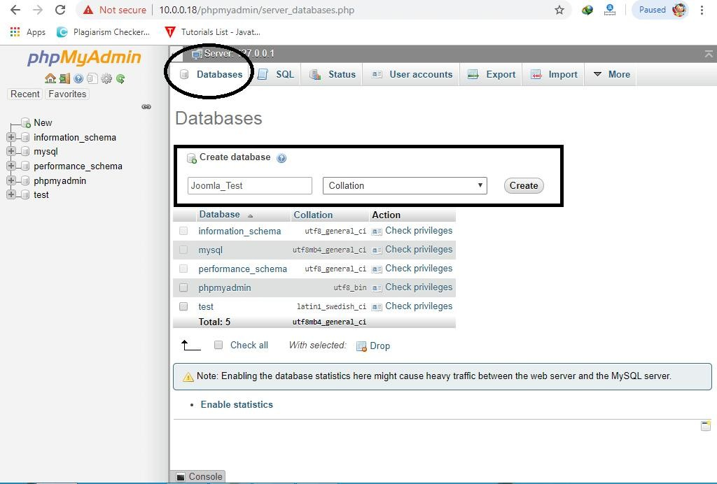

To create on a live server, navigate through your control panel, and open **Databases > MySQL Databases** section. Create your database name, user id, and password. Keep remembering the name of the database that you created because it will be required during theJoomla installation.

**Step 4: Install Joomla**

Open a browser, and search [*http://localhost*](http://localhost/) or [*http://localhost/xxxx*](http://localhost/xxxx) (where xxxx is the name of asubdirectory inside 'htdocs' directory.

If you are using a live server, then you must use

[*http://yourdomain.com*](http://yourdomain.com/) or [*http://yourdomain.com/joomla*,](http://yourdomain.com/joomla) depending on where you have uploaded theJoomla installation package.

Now, you are required to complete three basic steps to install Joomla onto your computer:

* Main Configuration
* Database Configuration
* Finalize Joomla Installation

# **Main Configuration**

Once you navigate to an appropriate link, you will be taken to the main page of Joomla web installer.Here, you are required to add the necessary information about the site and administrator, such as:

* **Select Language:** Select your own language from the drop-down menu.
* **Site Name:** Create the name of your site.
* **Description:** Type the description of your site in short.
* **Site Offline:** Make your site online or keep offline. Choose 'Yes' for 'offline' and 'No' for'online'.
* **Admin Email:** Type a valid email address that you want to use for your site.
* **Admin Username:** Type 'admin' as default username or make a custom username.
* **Admin Password:** Type your own password for your site.
* **Confirm Admin Password:** Re-type the same password that you used above.
* 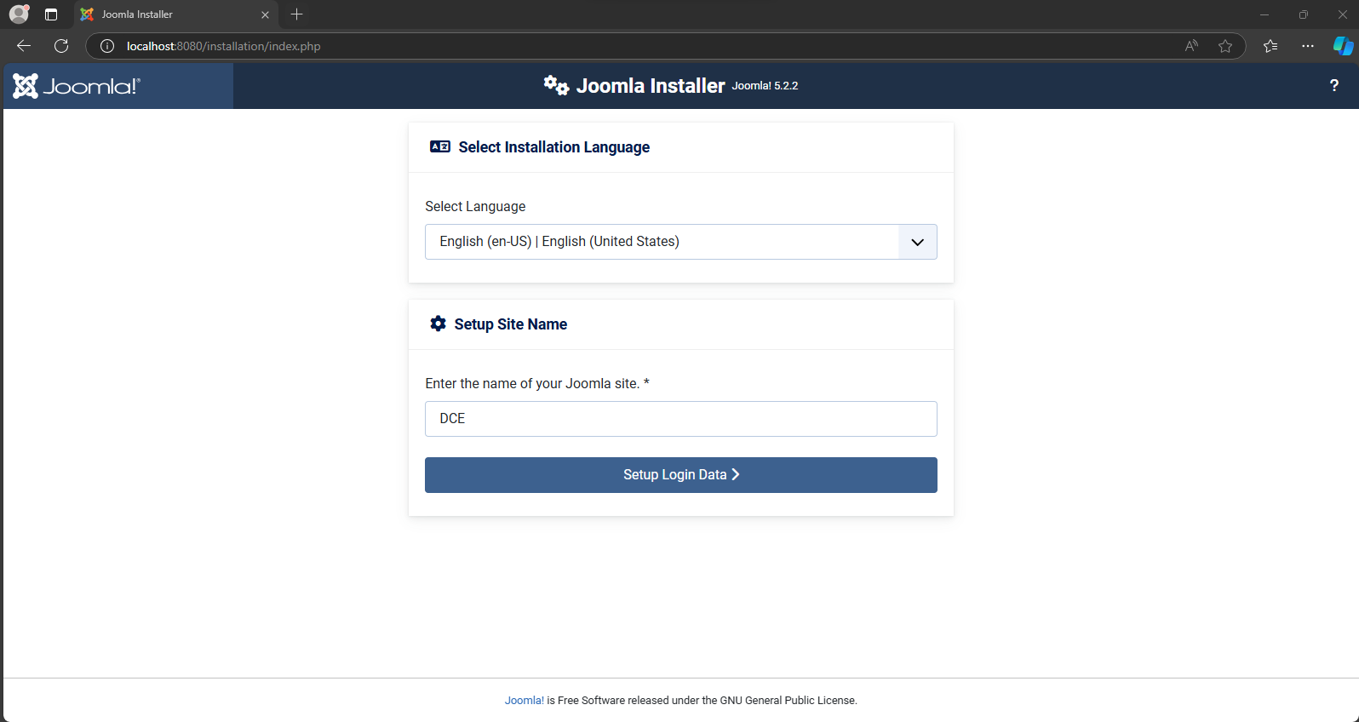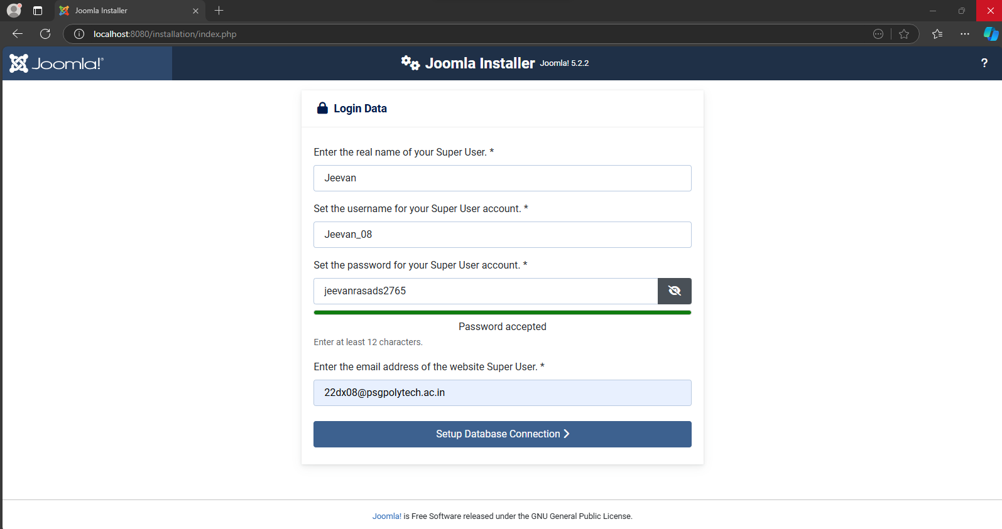Click on the 'Next' button to continue into '**Database Configuration**'.

# **Database Configuration**

This page contains the following data:

* **Database Type:** Select MySQLi
* **Host Name:** Type 'localhost'.
* **Username:** 'root'.
* **Password:** Keep it blank
* **Database Name:** Type the name of the database that you have created in the above stepusing phpMyAdmin. (For example, "joomla_test" in our case as shown below)
* **Table Prefix:** It will be generated automatically.
* **Old Database Process:** Click on the 'Backup' button to backup tables from the former Joomlainstallation or Click on the 'Remove' button to delete those tables.
* Click the 'Next' button to continue into the final page

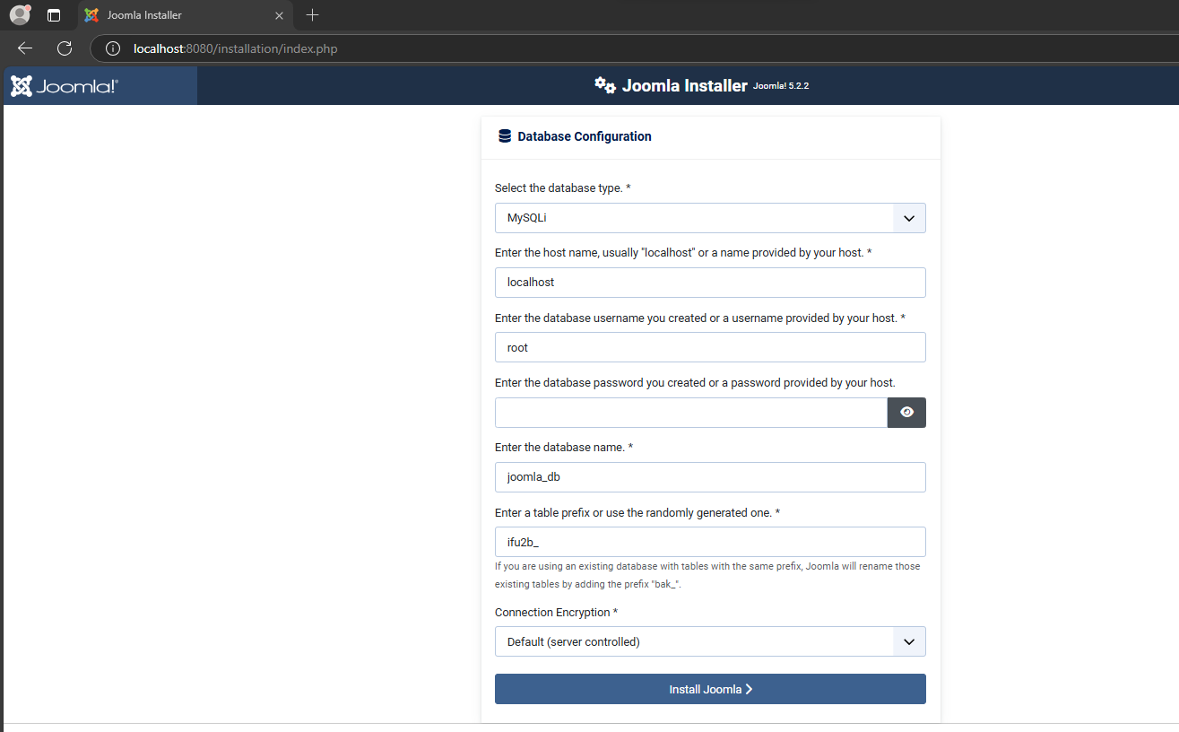

**Overview**

* **Finalization:** You can install sample data by clicking on the appropriate selection.
* **Overview:** This section shows all the information that you configured in previous steps. Justreview all the information and click on the '**Install**' button.

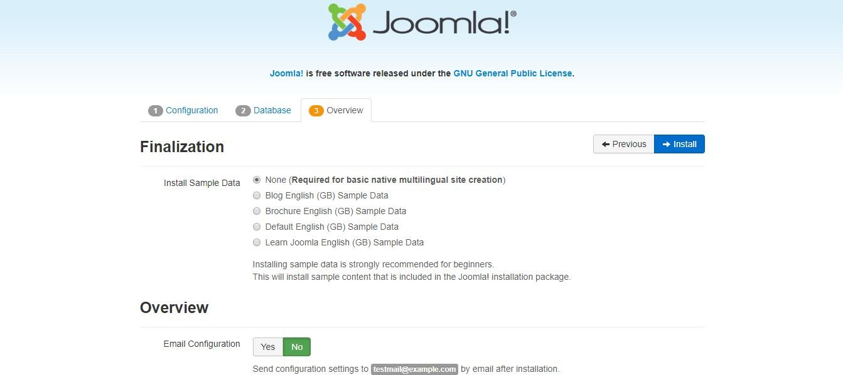

As soon as the installation finishes, you just need to click on the button"Remove installation folder" to complete the installation process. You can either click on 'Site' to check your site or 'Administrator' to access the administration area.

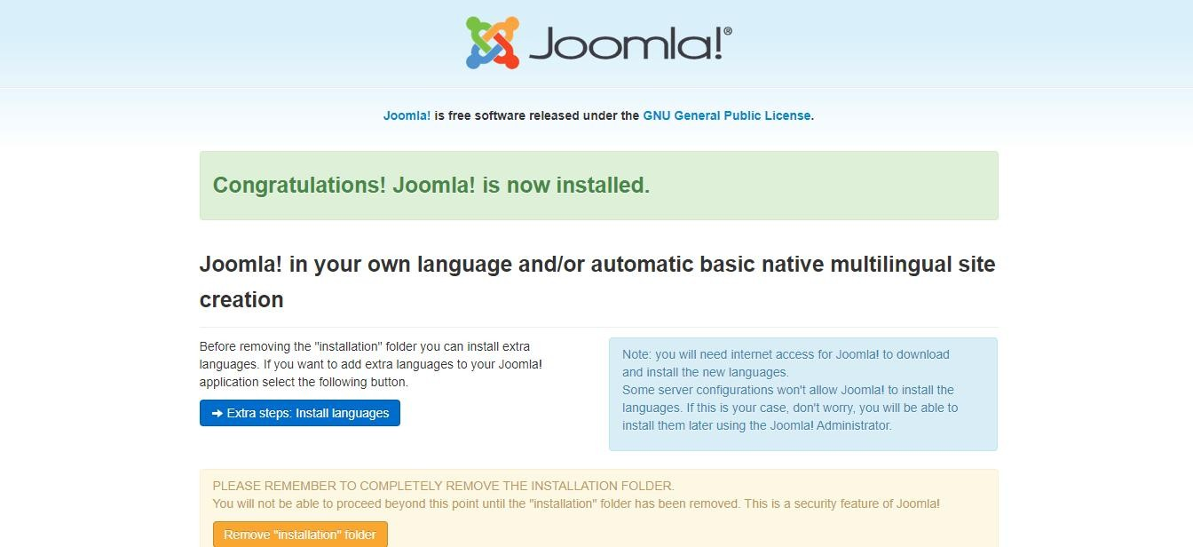

Now, Joomla is successfully installed on the localhost.

**Step 5: Test Joomla**

When you have completed the installation, you are ready to open the front- end and back-end of your website. Either click on 'Open Site' or type your domain in the browser's address bar to open the front-end of your site. If you have logged in into your account, then you can directly edit the options from the front-end view.

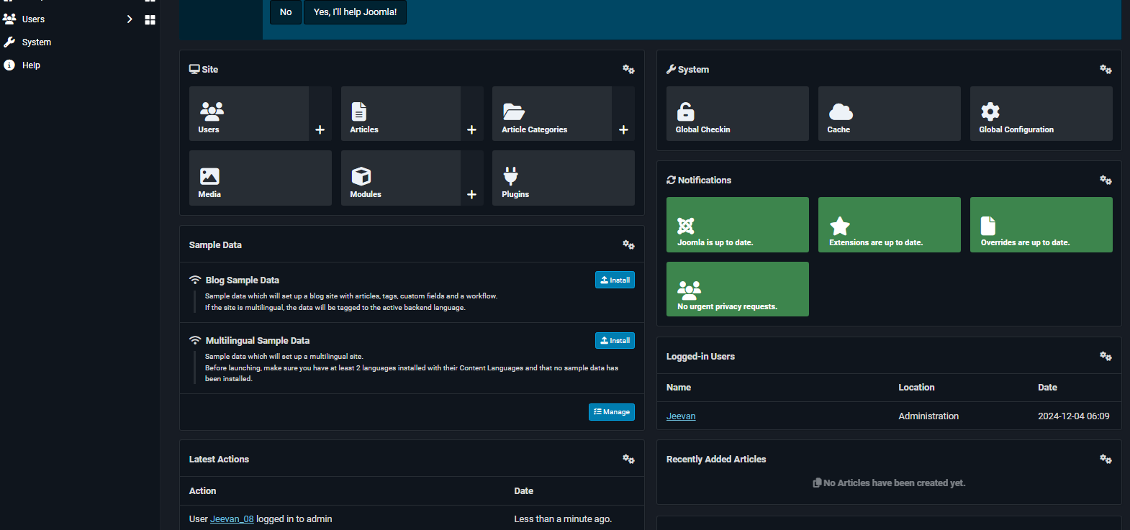

**Result**

Thus, Installing and configuring Joomla Tool was executed successfully.