# Ex. No: 2 Create a CMS admin and organize a site using Joomla Site Management

# Date:11/12/24

**Aim:**

To create a CMS admin and organize a site using Joomla Site Management

# Joomla Basics

Like any other CMS, websites created with Joomla are controlled through a backend interface. In Joomla’s case, it’s called a Control Panel, and you can find it on https://yourdomain.com/administrator by default. The first things you’ll see once logged are new message notifications, a log of the recent user actions, as well as left-side menus with shortcuts to essential areas in the backend.

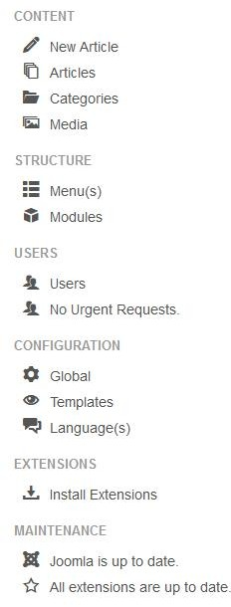

From here, you can write and publish articles, create menus, install modules, manage users, and many more. These tools, along with the rest of the utilities, are categorized and accessible from the ribbon at the top of the screen, as well.

It includes:

* Selecting template
* Customizing template
* Installing template
* Installing extensions
* Creating& positioning modules
* Creating articles
* Adding articles to navigation menus

# Procedure:

* Log into your Joomla Backend.
* The default URL is *<yourwebsite>/administrator*.
* Go to **Users** → **Manage**.
* Click on *New* in the top left corner.
* Enter a Name.
* Enter a Login Name.
* Enter an Email address. This address should be set to receive System Emails.
* Enter and then confirm the password.
* Select Administrator or Super User depending on the access level you wish to grant.
* Save & Close.

1. **Creating Users**

**Step 1:** Start apache and mysql in Xampp control panel.

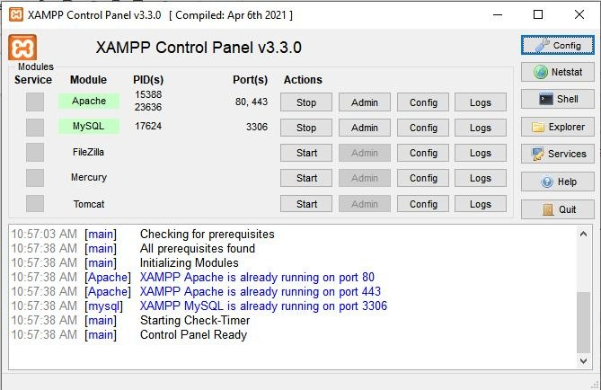

**Step 2:** Navigate to localhost/Joomla5/administrator to open administrator panel.

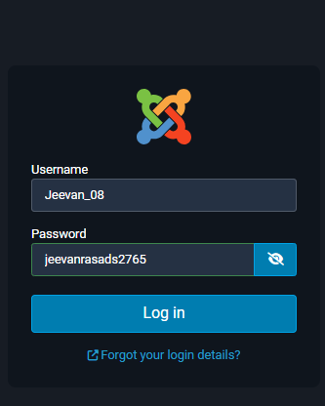

**Step 3:** Under Site -> Users -> click on he plus symbol to create a new user.

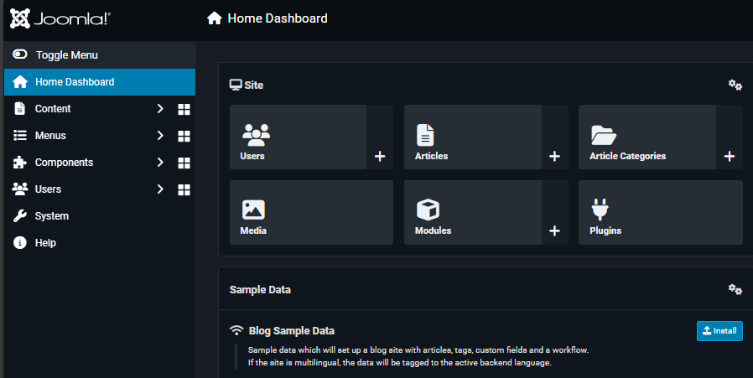

**Step 4:** Enter the Username, Password & Mail id and click Save & Close. Similarly create one more user.

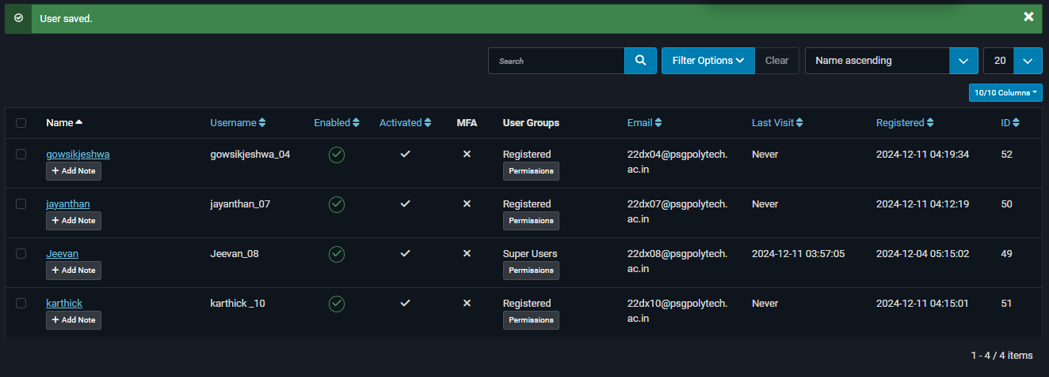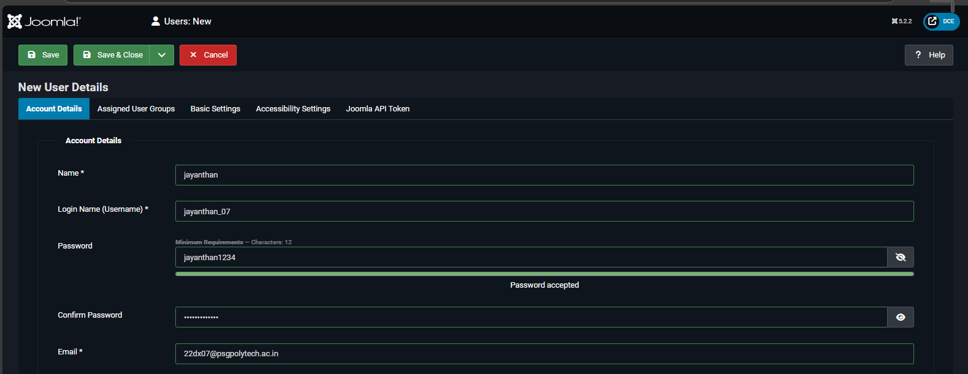

# Modify the site template

**Step 5:** In the left panel click System and go to Site Template Styles as:

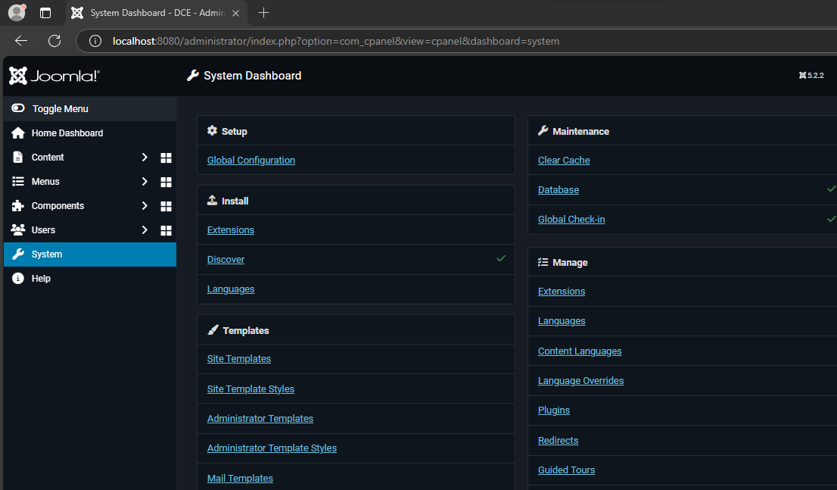

**Step 6:** Now click the default template:

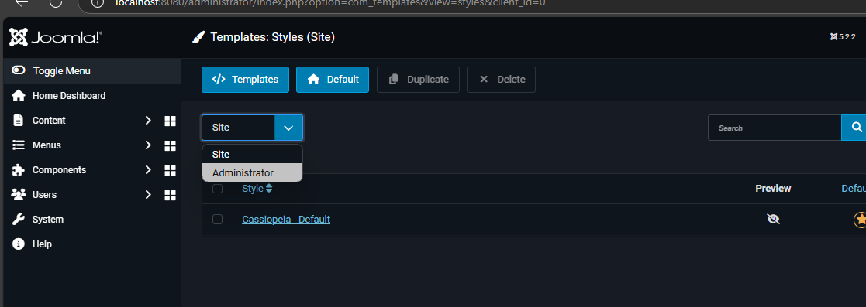

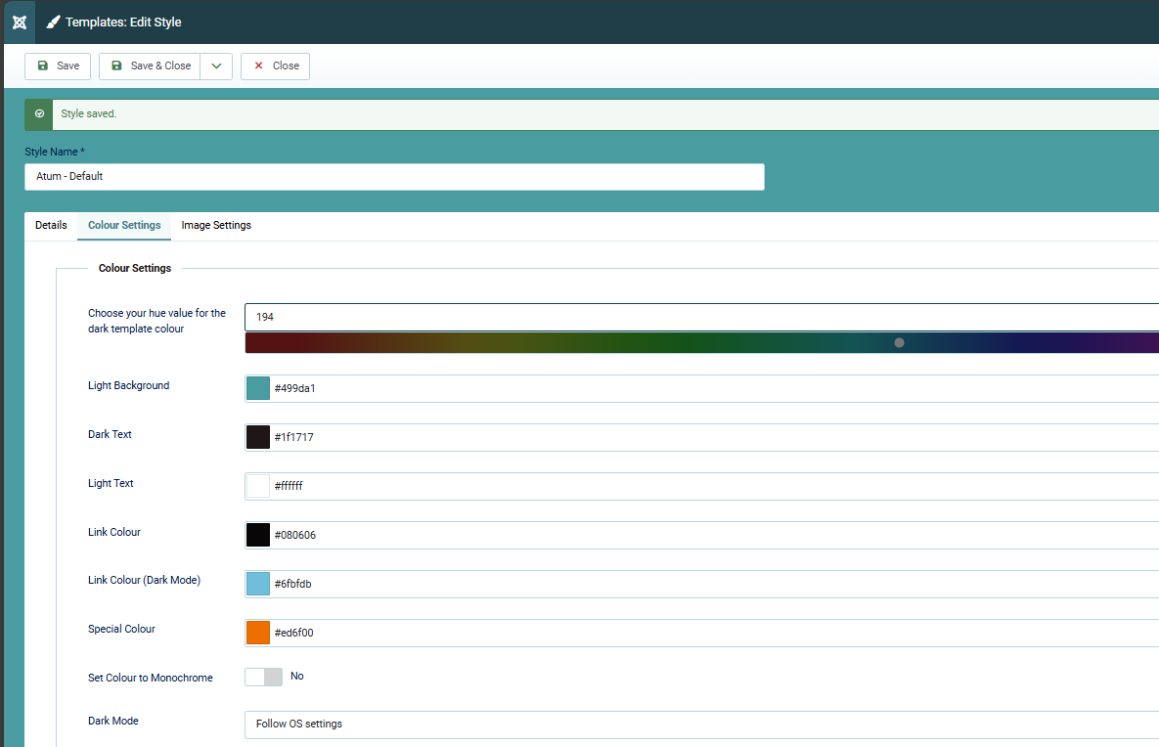

Now click Advanced & Add Logo and click Save & Close.

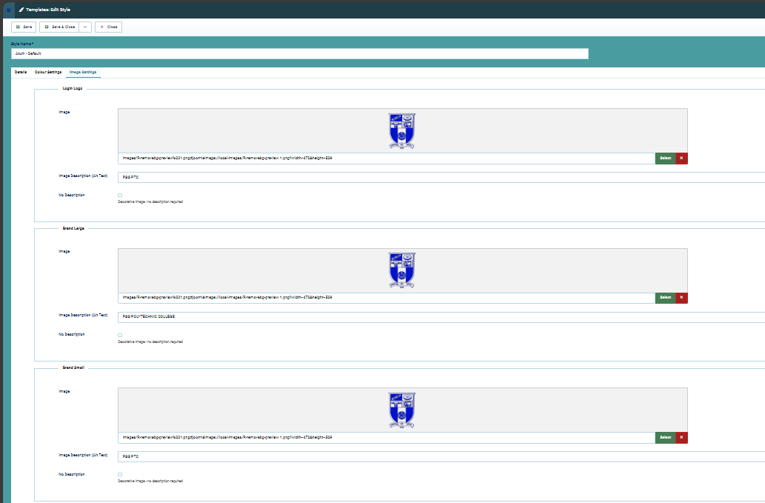

Now open a new tab & open localhost/Joomla5/ to view the new site template as:

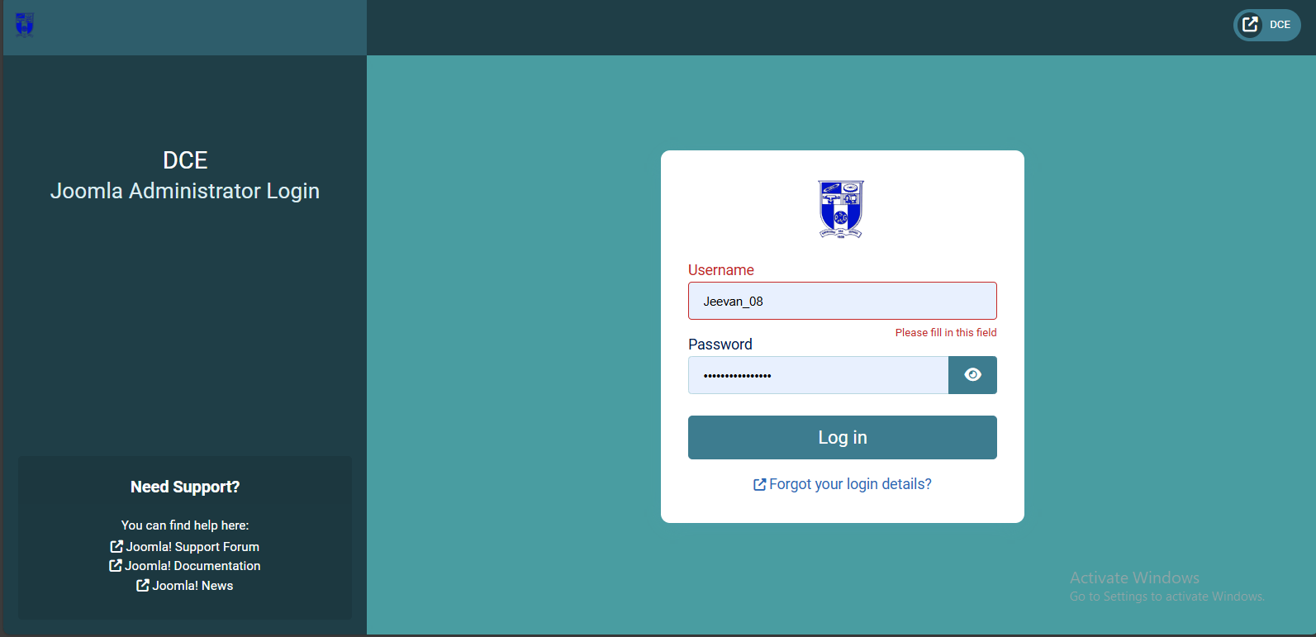

# 3. Create a Poll

**Step 7:** Now download the Joomla Extension “sexy polling reloaded” from github.

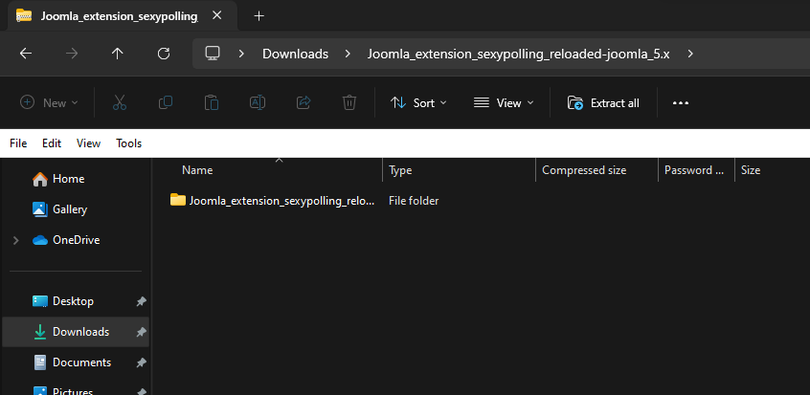

**Step 8:** Click on System -> Install Extensions as:

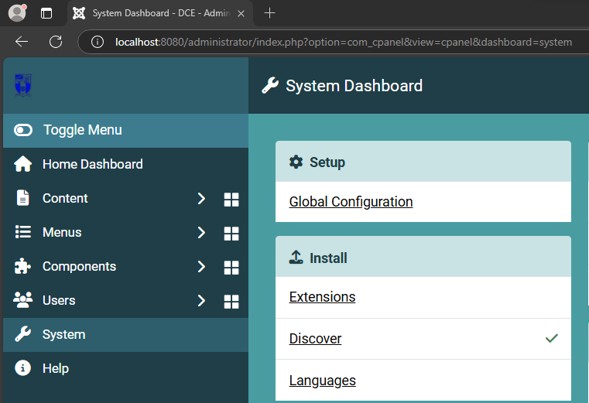

Drag & drop the downloaded zip file to install as:

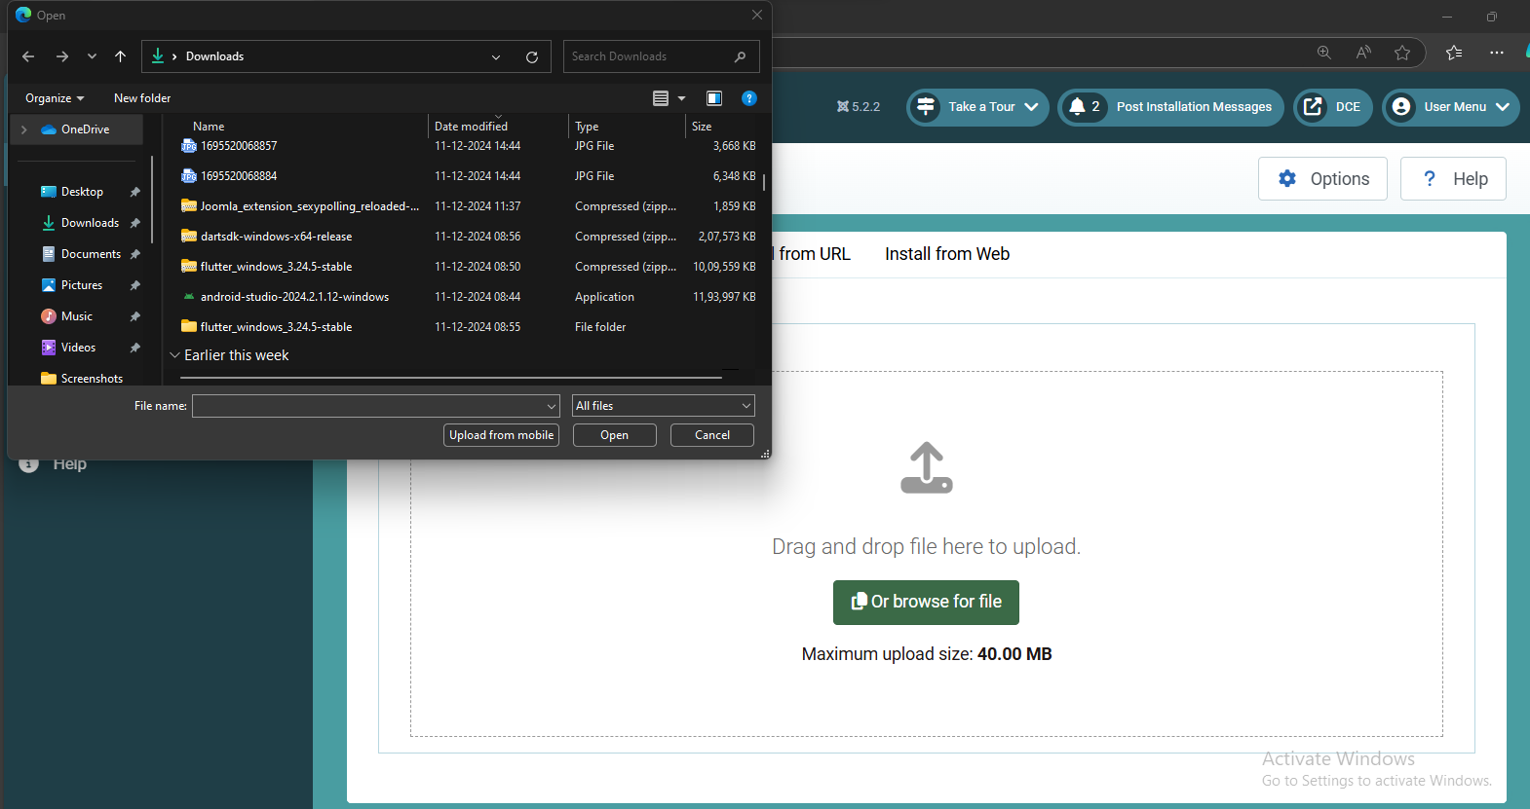

Drag & drop the downloaded zip file to install as:

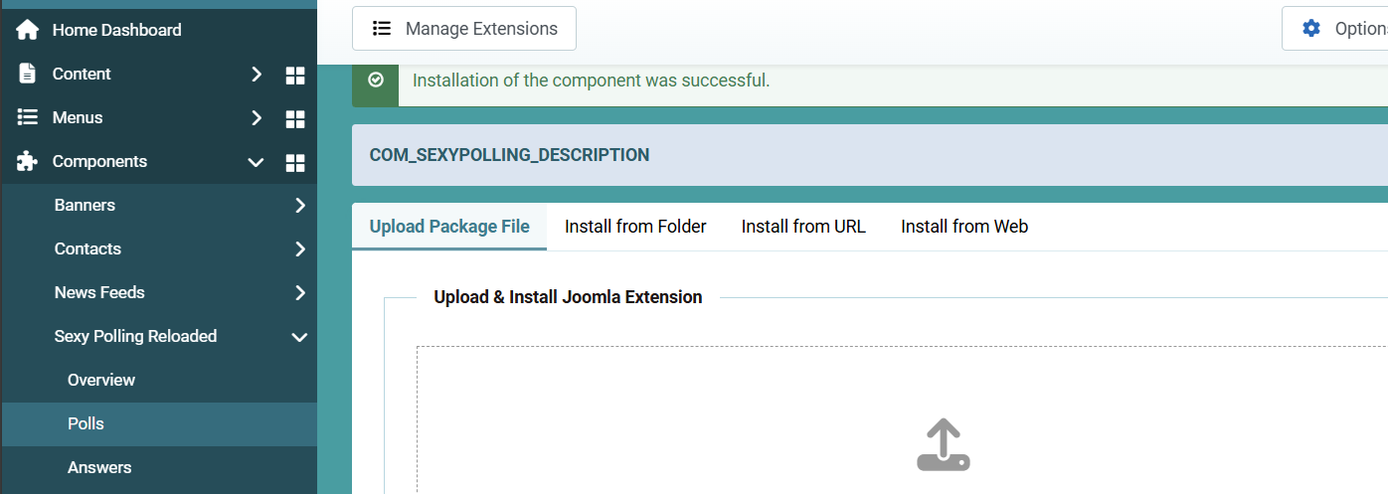

**Step 9:** Now click on Sexy Polling Reloaded & Click on Polls and Click on New to create a new poll.

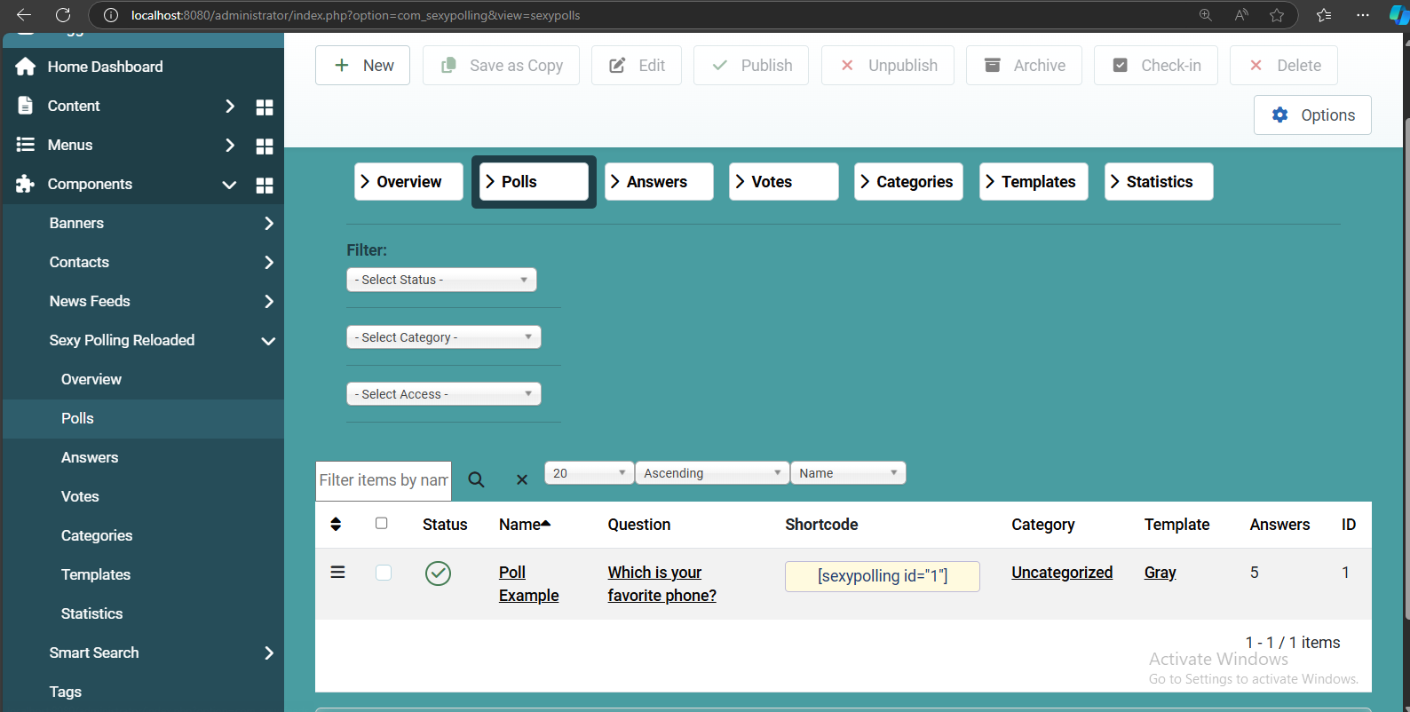

Type the Name & Question and click Save & Close.

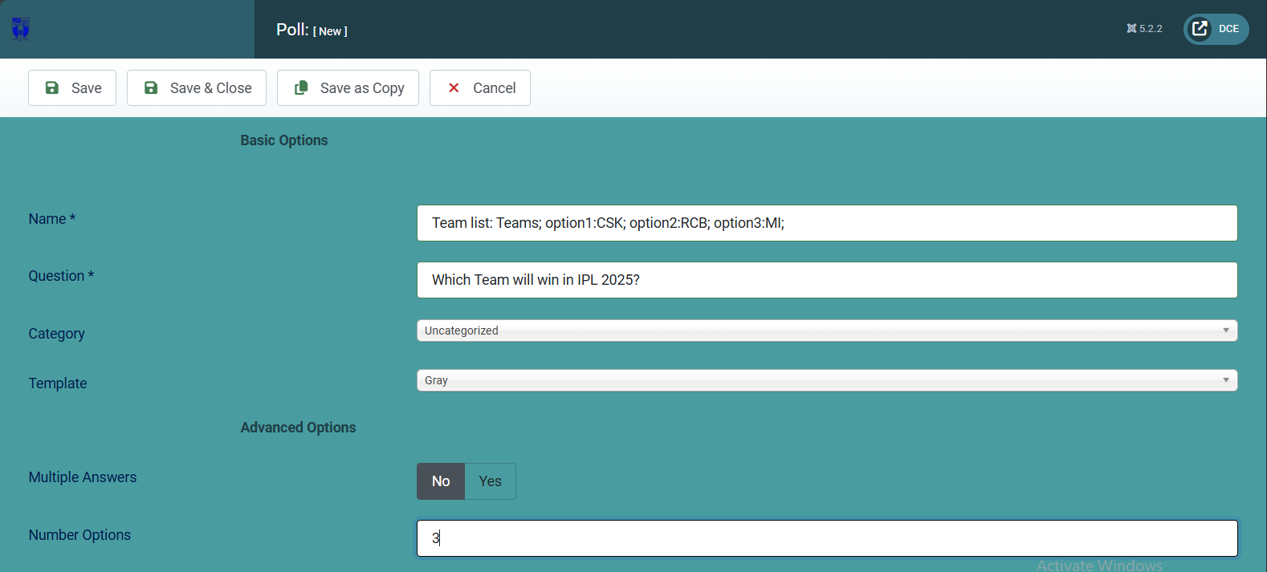

**Step 11:** Now enter the questions on the poll and click save and close

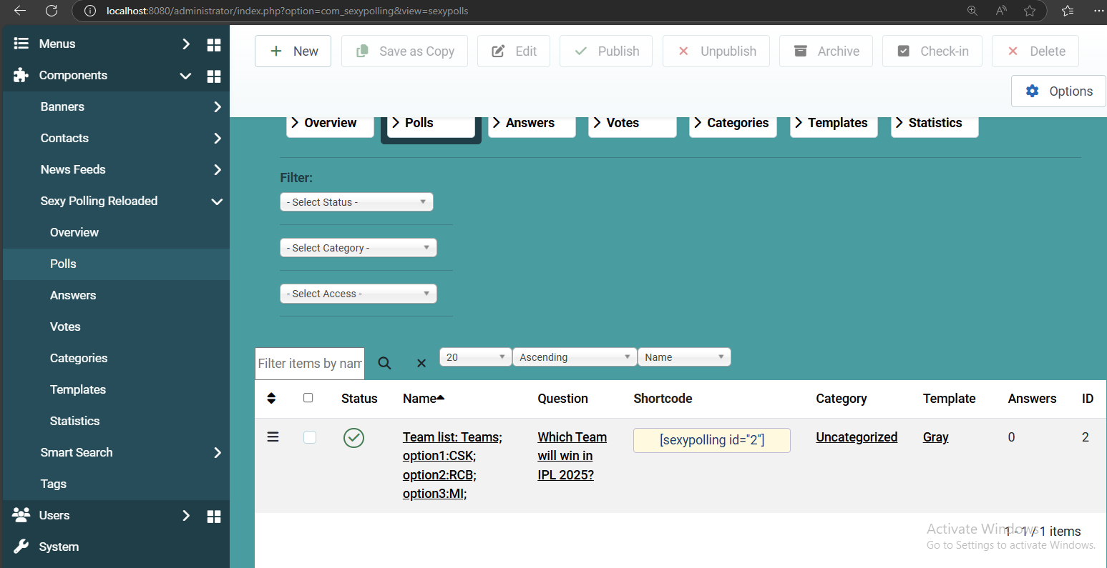

# Result:

# Thus, Creating a CMS admin and organize a site using Joomla Site Management was executed Sucessfully.