**EX.NO: 3 CREATE & EDIT ARTICLES, MENUS & MODULES USING JOOMLA**

**DATE:28/12/24**

**Aim:**

To create and edit articles, menus and modules using Joomla.

[Joomla Article](https://www.joomlart.com/documentation/joomla-tutorials/joomla-article-tutorials) is a piece of content consisting of text, links to other resources, image, media, etc. Articles are the basic units of information in the content system and the bottom level in the content hierarchy.

Joomla Menu is a set of menu items used for website navigation. Each menu item defines an URL to a page on your site, and holds settings that control the contents (articles, category lists, tagged items, etc), view and style of that page. Menu is the most popular and standard way to publish content to front-page.

A module is an add-on to the site that extends the functionality. A module usually occupies a secondary portion of the web page and is not considered the primary focus of a page. It can be displayed on different positions and you can choose on which active menu items it should be displayed. Modules are lightweight and flexible extensions. They are used for small bits of the page that are generally less complex and are able to be seen across different components.

Module types:

## Breadcrumbs Module

## Feed Display Module

## Custom Module

## Footer Module

## Latest News Module

## Search Module

## Random Image Module

## Who’s Online Module

**Procedure:**

**Step 1:** Start apache and mysql in Xampp control panel

**Step 2:** Navigate to localhost:8080/administrator to open administrator panel

**Step 3:** In the left panel, choose article and click new

**Step 4:** In the article page, Enter the article title

**Step 5:** Fill in the article content and choose the article position to main

**Step 6:** Click save and close to exit the article page

**Step 7:** Navigate to All menu items, under the menu drop-down in the left panel

**Step 8:** Click new to create a menu and select the menu type as Single article and

select your article.

**Step 9:** Enter the menu Title and select the menu’s parent as Main

**Step 10:** Create a new menu with the parent as the previous menu to create a sub menu.

**Step 11:** Preview the web page.

## Creating a new article

Click **Content → Article** --> "New" button to create new article.

Adding new article page: add article title, article content and assign it to a category:

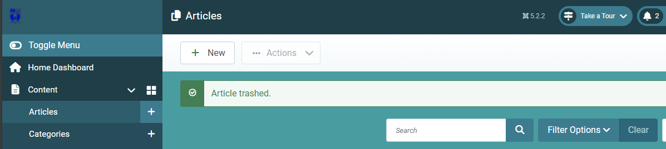

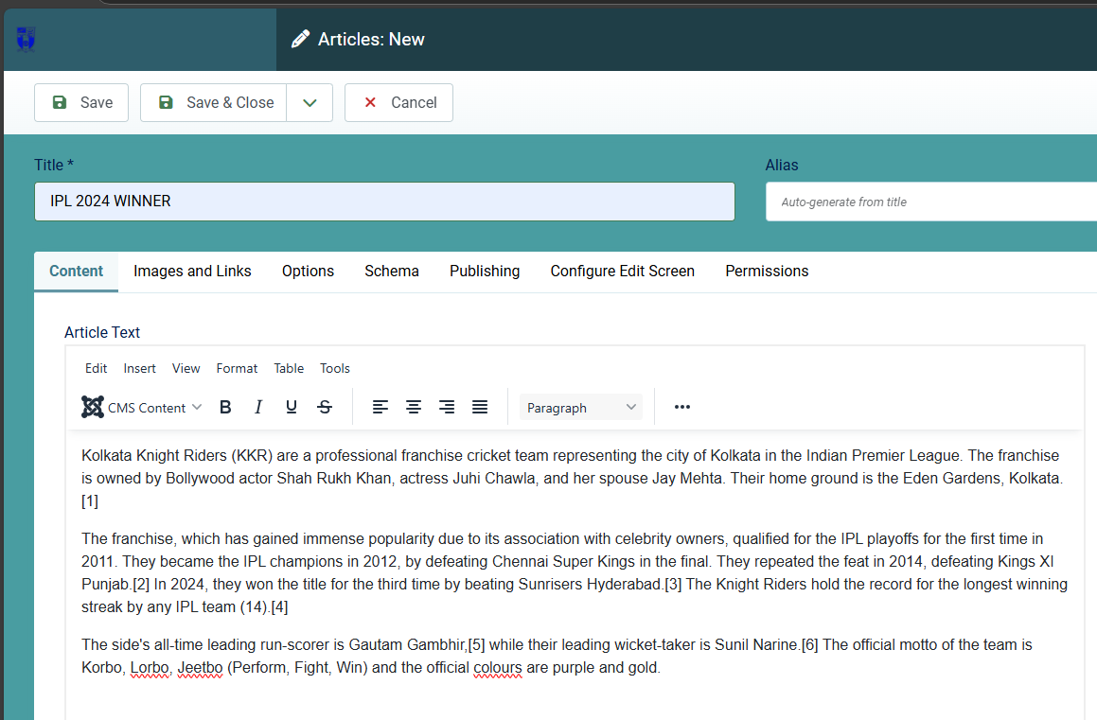

To add intro images and full article image for the article, open the tab **Images and Links** then browse image for intro image and full article image. The image size depends on the site layout.

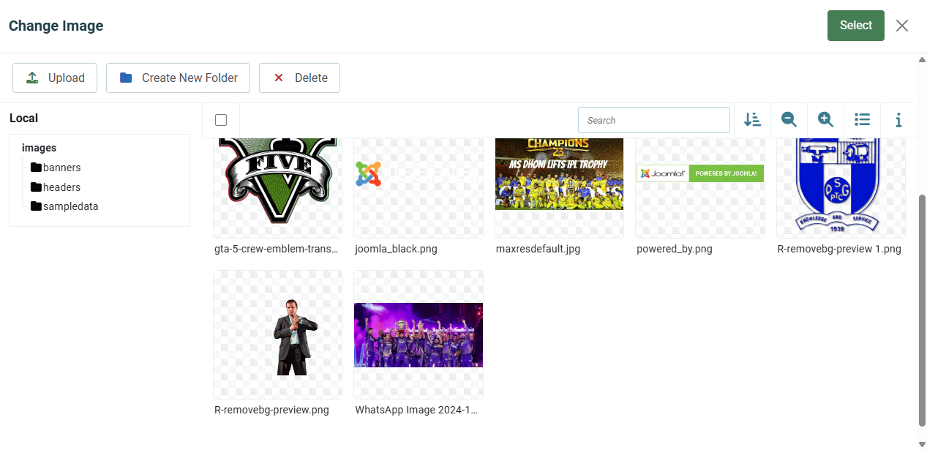

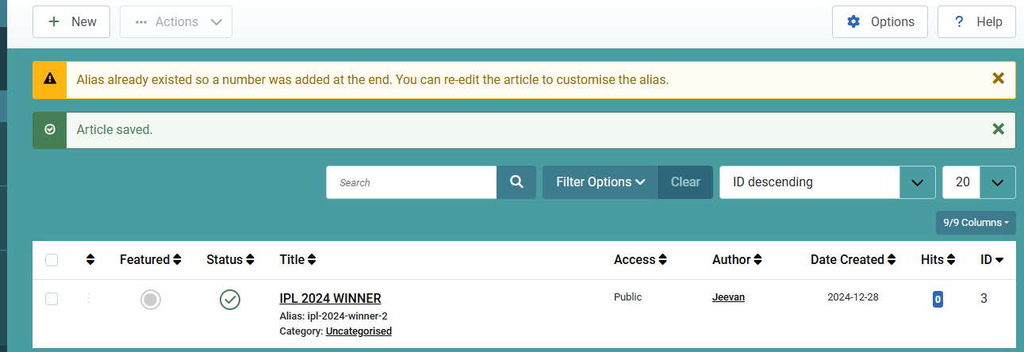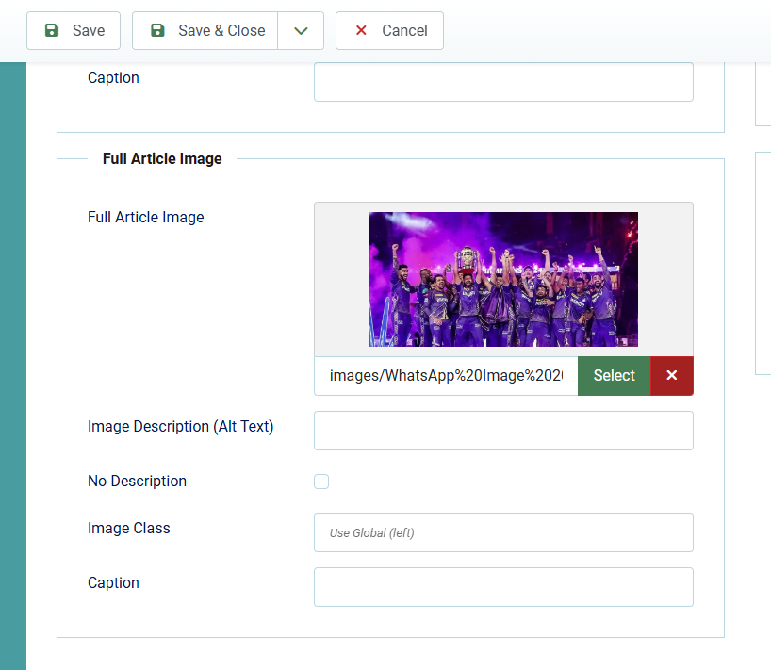

# **Display Articles in Front-end**

# To display an article in front-page of your Joomla site, the standard way is link it in the menu of your website. To do this, we will create new menu item. Go to **Menus → All Menu Items --> click the Home**.

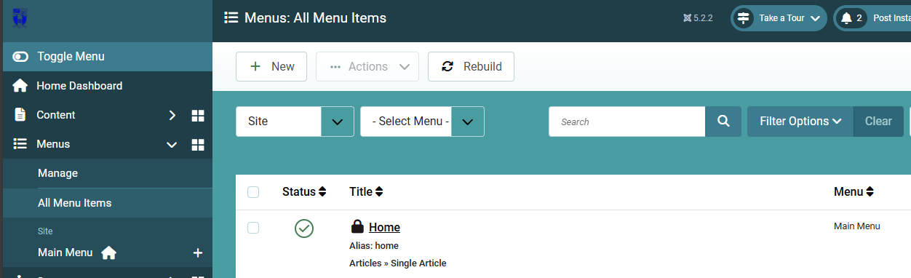

In the adding new menu item, add title for the menu and select menu type, there are lots of menu type, to show article in front-page, select **Menu Item Type: Single Article**

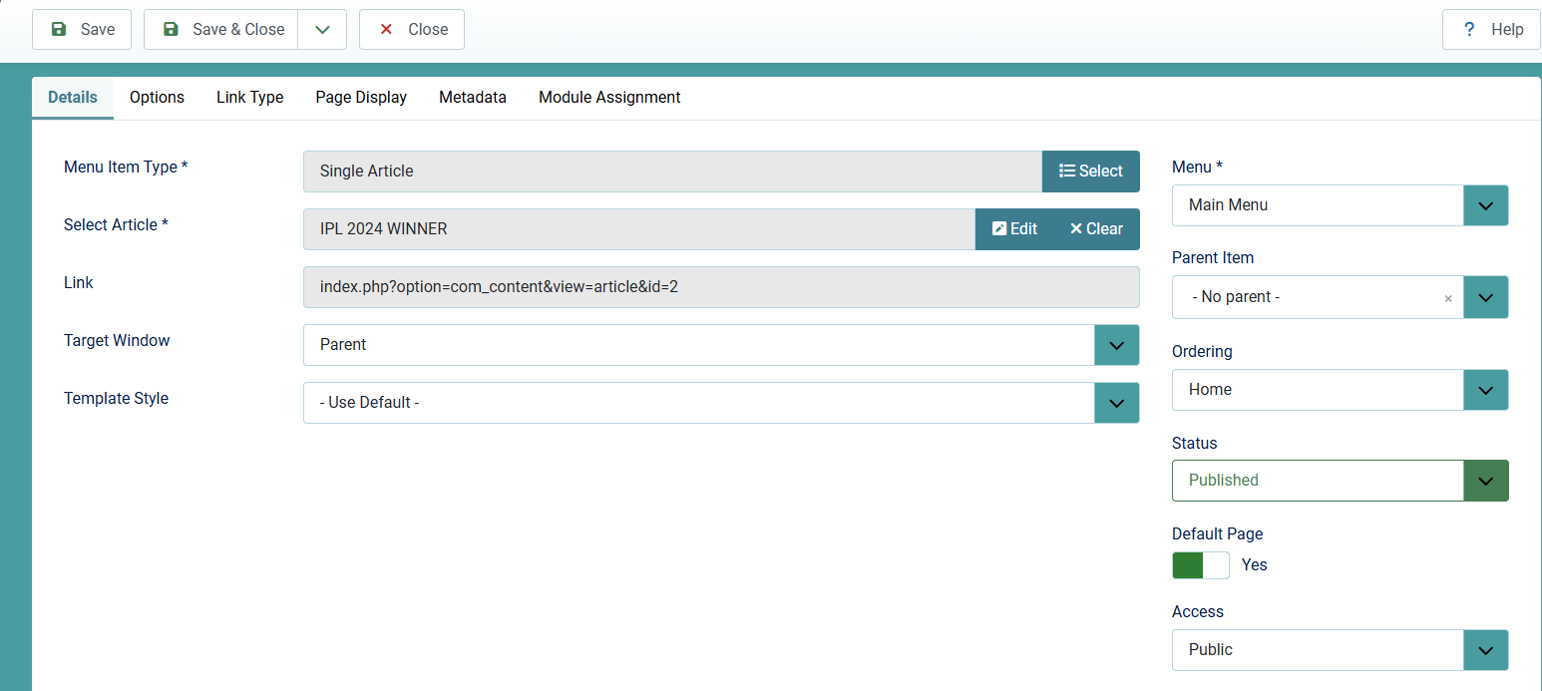

**Select Article: Joomla** as:

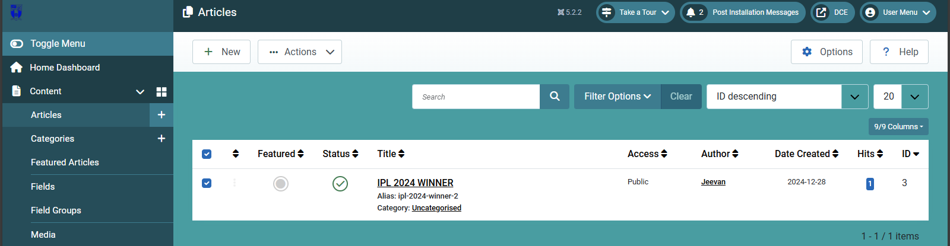

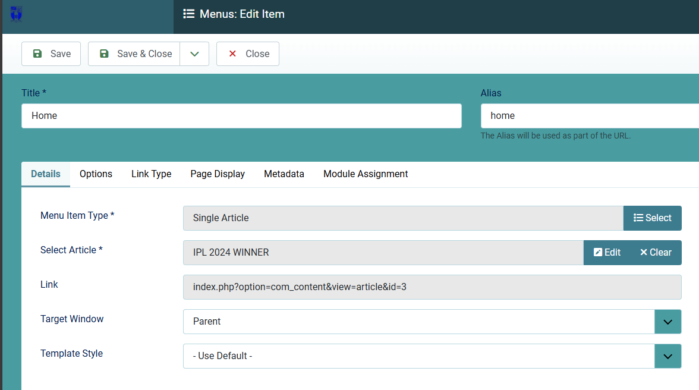

**Select Menu: Main Menu** and Click **Save & Close.**

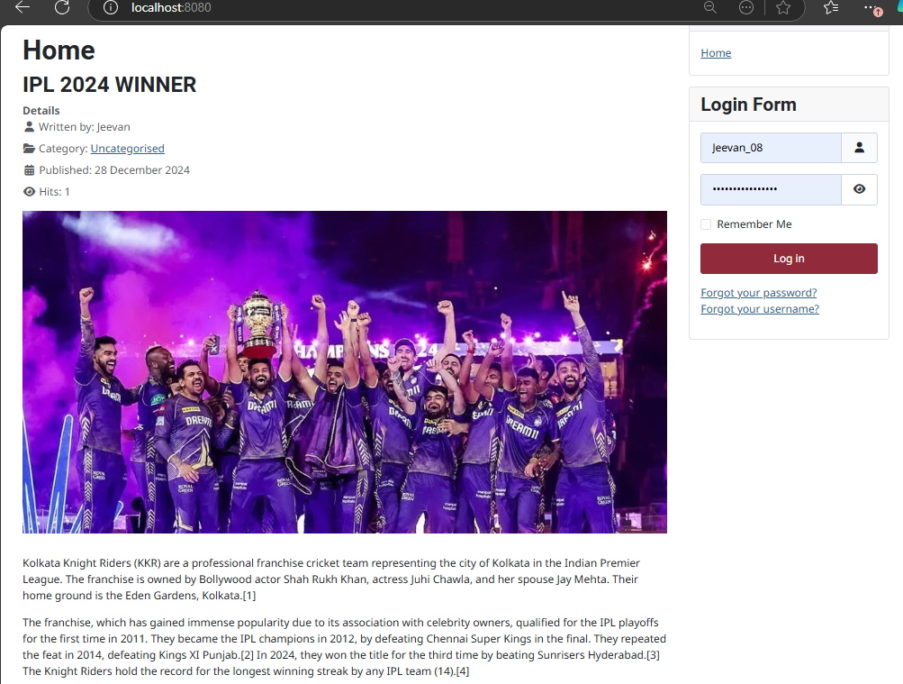Now, open the site front-end to see how the article is displayed.

1. **Creating a Menu**

Click **Menu --> Main Menu -> +**

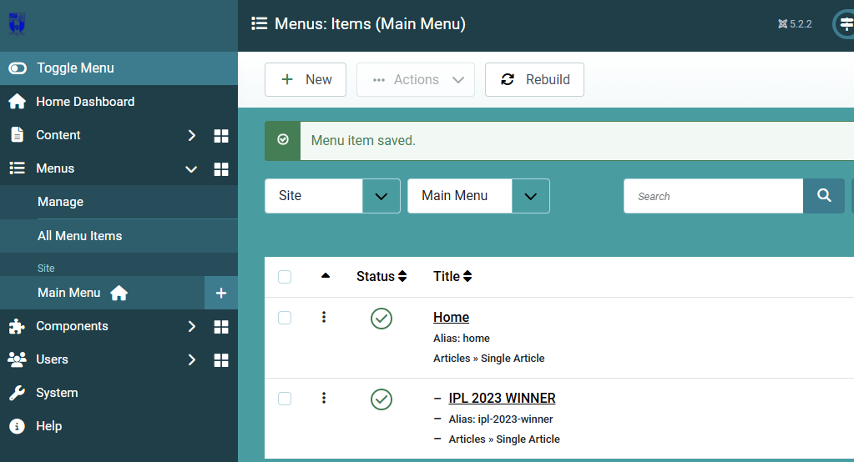

**Menu Item Type -> Article -> Single Article**

**Select Article: IPL 2023 WINNERS**

**Menu: Main Menu**

**Parent Item: Home**

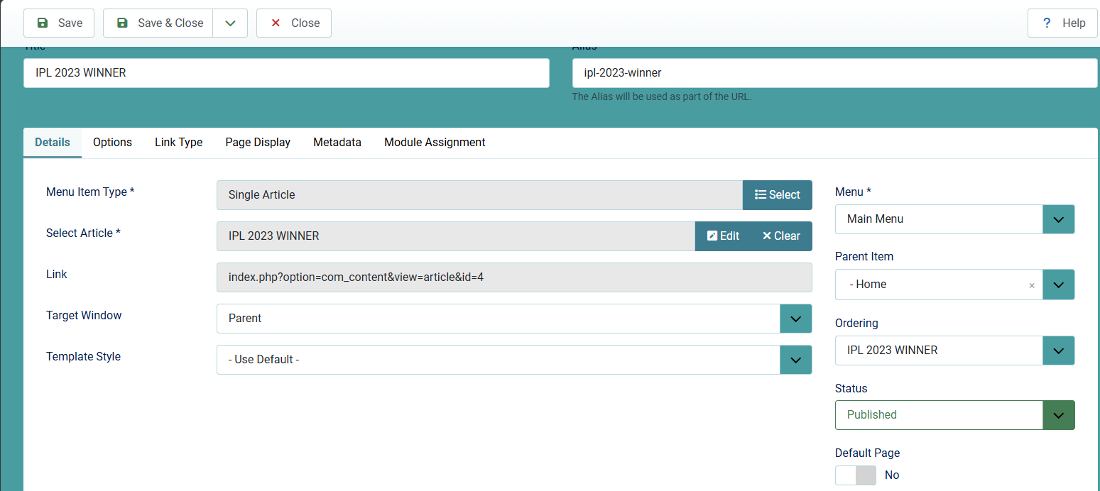

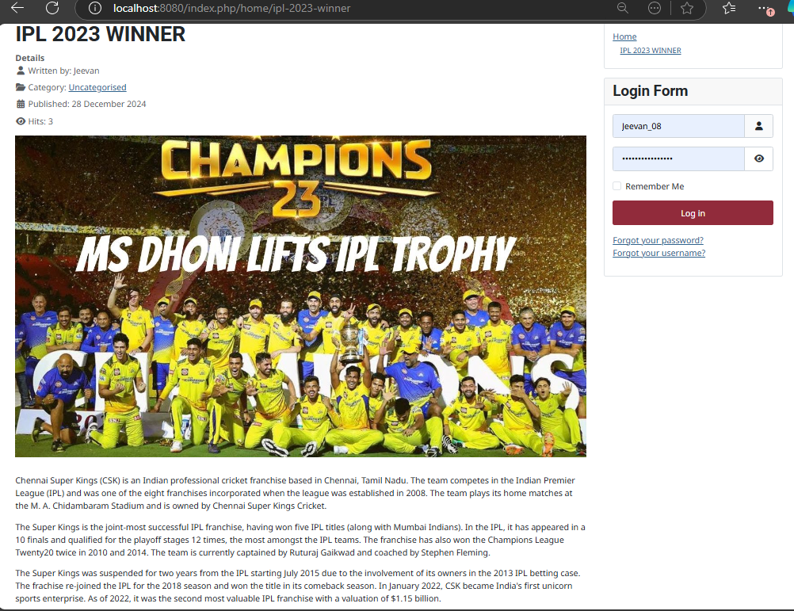

1. **Creating a Module**

**Content --> Site Modules --> New**

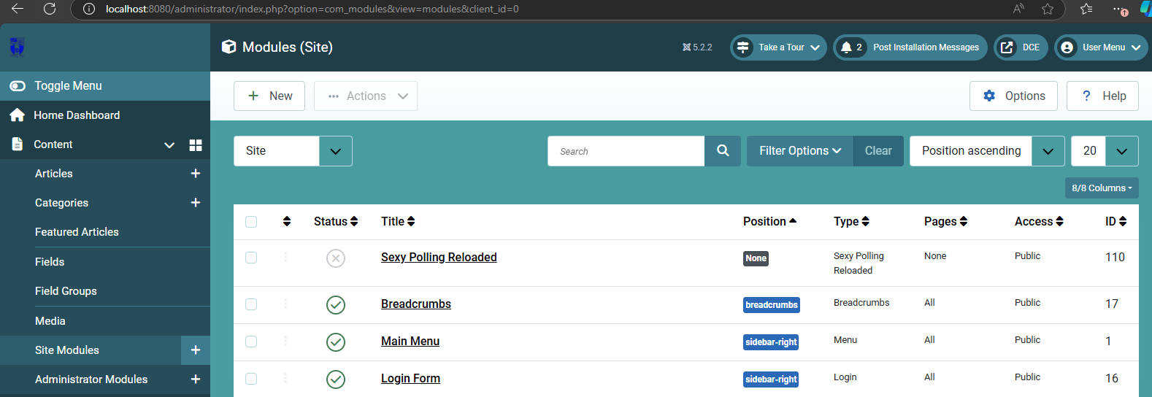

**Select a module type --> Custom**

**Title: HISTORY OF IPL**

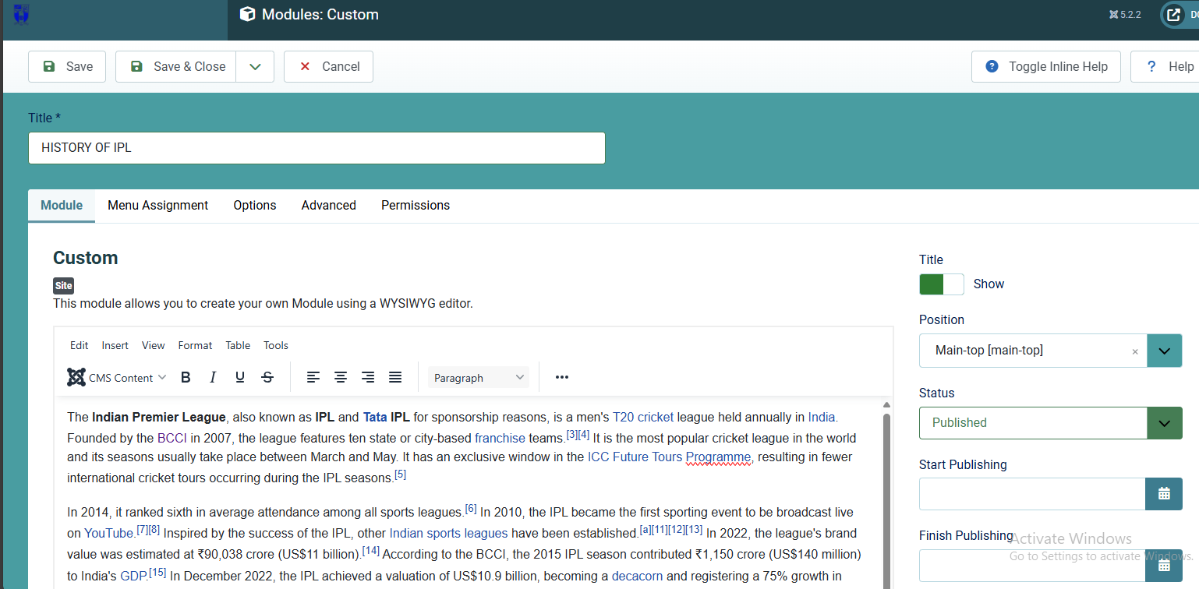

**Menu Assignment --> On all pages**

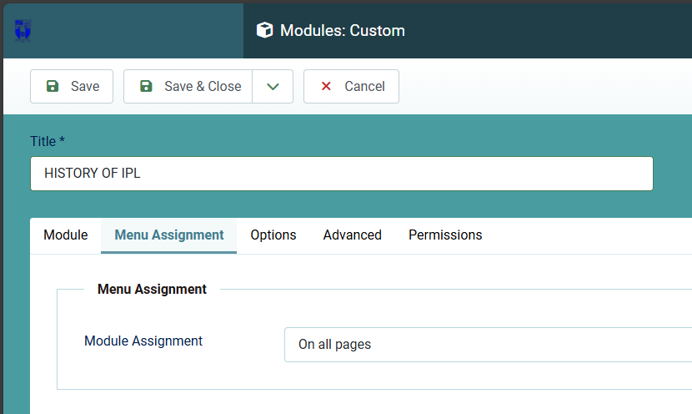

**Save and close, type localhost:8080**

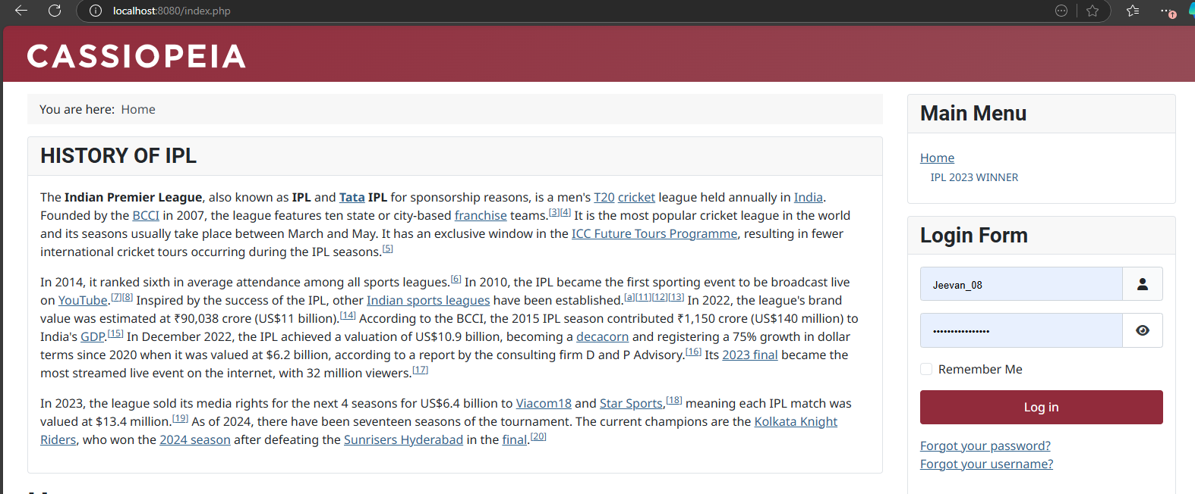

**Result:**

Thus articles, menus and modules are created in Joomla successfully.