**EX.NO:4 CREATE AND APPLY EXTENSIONS AND PLUGINS USING JOOMLA**

**DATE:**

**Aim**

To create an extension/plugin to modify the content in Joomla.

**Procedure**

**Step 1:** Create essential folders/files.

**Step 2:** Create Language Folders/Files

**Step 3:** Start apache and mysql in Xampp control panel

**Step 4:** Navigate to localhost/Joomla5/administrator to open administrator panel

**Step 5:** Discover, Install and Enable the created plugin/extension

**Step 6:** Create an Article

**Step 7:** Add Shortcode in the article to modify the article content.

**Step 8:** Add this article to the Main menu.

**Step 9:** Open localhost/Joomla5/ in a new tab.

**Step 10:** Check the article displayed with the plugin settings applied.

**Step-1: Create essential folders/files.**

Create the basic configuration file **contentplugdemo.xml** as:

<?xml version="1.0" encoding="utf-8"?>

<extension version="4.0" type="plugin" group="content" method="upgrade">

<name>plg_content_contentplugdemo</name>

<author>Jeevan</author>

<creationDate>Dec 2024</creationDate>

<copyright>Copyright (C) 2024 Jeevan</copyright>

<license>PSG</license>

<authorEmail>22dx08@psgpolytech.ac.in</authorEmail>

<version>0.01</version>

<description>PLG_CONTENT_CONTENTPLUGDEMO_XML_DESCRIPTION</description>

<files>

<filename plugin="contentplugdemo">contentplugdemo.php</filename>

<folder>language</folder>

</files>

<languages folder="language">

<language tag="en-GB">

en-GB/en-GB.plg_content_contentplugdemo.sys.ini</language>

<language tag="en-GB">

en-GB/en-GB.plg_content_contentplugdemo.ini</language>

</languages>

</extension>

Create a php file **contentplugdemo.php** to make the plugin to modify the content as:

<?php

//kill direct access

defined('_JEXEC') || die;

use Joomla\CMS\Plugin\CMSPlugin;

use Joomla\CMS\Factory;

class PlgContentContentPlugDemo extends CMSPlugin

{

public function onContentPrepare($context, &$article, &$params, $page = 0)

{

//getters

$doc = Factory::getApplication()->getDocument();

$wa = $doc->getWebAssetManager();

$pluginPath = 'plugins/content/' . $this->_name;

$view = JFactory::getApplication()->input->get('view');

//echo '<br/>the view is '.$view;

//find each card

preg_match_all('/{card.*?\/card}/s', $article->text, $matches);

//an array to store the new divs

foreach ($matches[0] as $value) {

//this searches between the card tags to find the body

//this would be in group 2 of this match.. see RegEx101.com for more info

preg_match('/(?<={card)(.*?})(.*?)(?={\/card})/s', $value, $cardMatcher);

$cardBody = $cardMatcher[2];

//Match the title attribute based on the first group in the previous match

preg_match('/(?<=title=").*?(?=")/s', $cardMatcher[1], $titleMatch);

$title = '';

//if this isn't null, the title attribute must be there

if ($titleMatch) {

$title = $titleMatch[0];

}

//generate the output

if ($title == '') {

//make a card div with no title

$output = '<div class="card bg-success mb-3 text-light"><div class="card-body">'.$cardBody.'</div></div>';

} else {

//make a card div with a span title and a card body div, remember to close both divs.

$output = '<div class="card bg-primary mb-3 text-light"><span class="card-header">'.$title . '</span><div class="card-body">'. $cardBody.'</div></div>';

}

//replace the original card $value with the new $output

$article->text = str_replace($value, $output, $article->text);

}

}

}

**Step 2: Create Language Folders/Files**

**en-GB.plg_content_contentplugdemo.ini**

PLG_CONTENT_CONTENTPLUGDEMO="Content Plugin Demo"

PLG_CONTENT_CONTENTPLUGDEMO_XML_DESCRIPTION="Adds a shortcode for creating cards in articles"

**en-GB.plg_content_contentplugdemo.sys.ini**

PLG_CONTENT_CONTENTPLUGDEMO="Content Plugin Demo"

PLG_CONTENT_CONTENTPLUGDEMO_XML_DESCRIPTION="Adds a shortcode for creating cards in articles"

Create a directory structure as:

* **xampp**
  + **htdocs**
  + **Joomla5**
  + **plugins**
    - **content**
      * **contentplugdemo**
        + contentplugdemo.php
        + contentplugdemo.xml
        + **language**

**en-GB**

en-GB.plg_content_contentplugdemo.ini

en-GB.plg_content_contentplugdemo.sys.ini

**Step 3: Start apache and mysql in Xampp control panel**

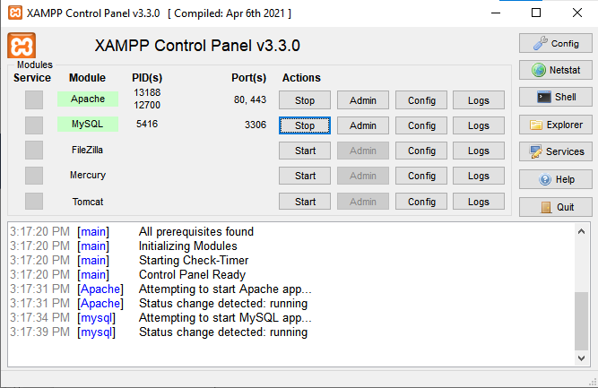

**Step 4: Navigate to localhost/joomla/administrator to open administrator panel**

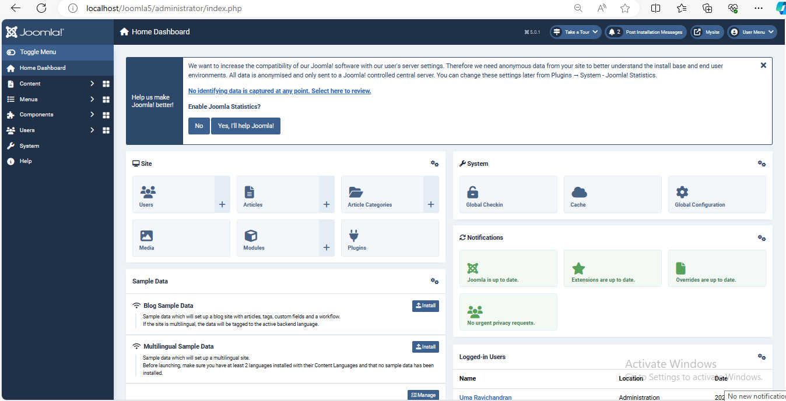

**Step 5: Discover, Install & Enable the created plugin/extension**

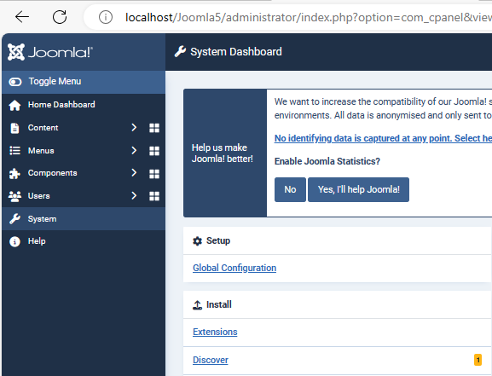

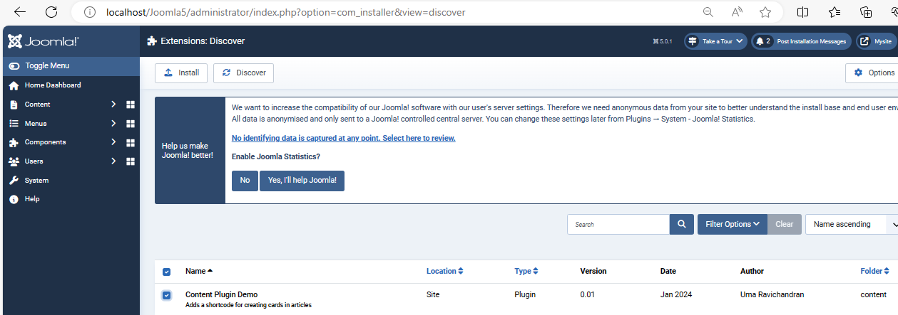

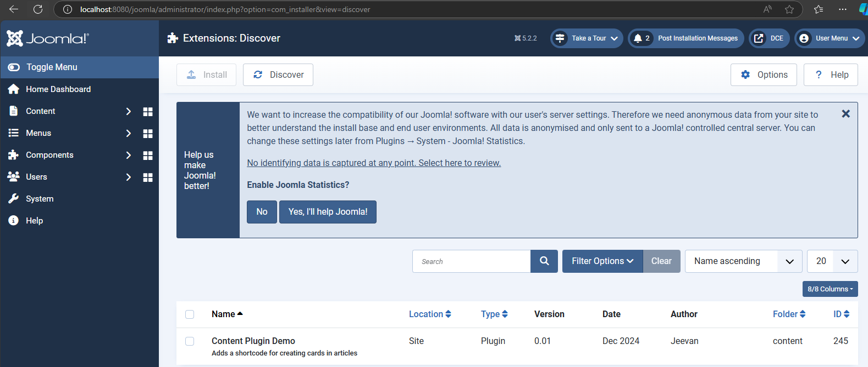

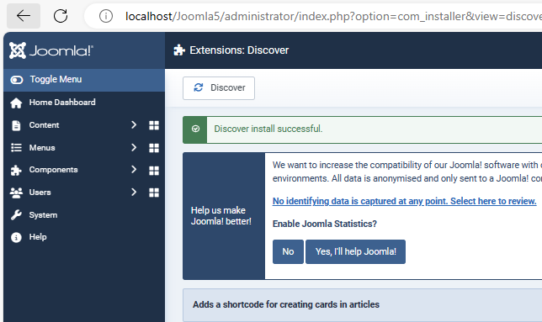

**Step 6: Create an article named: Yamaha RD 350**

**Step 7: Add the following Short code in the article to modify the article content.**

{card title="Plug in creation for Joomla Content"} Content: Article {/card}

{card}

// content

{card}

**Step 8: Add this article to the Main menu as:**

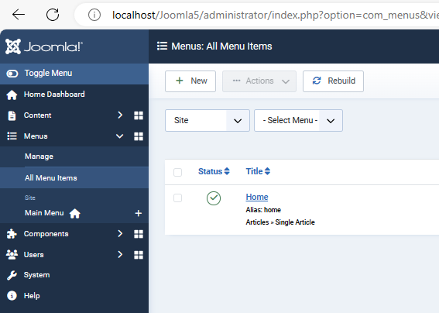

**Click Home -> Menu Item Type -> Select -> Article -> Single article**

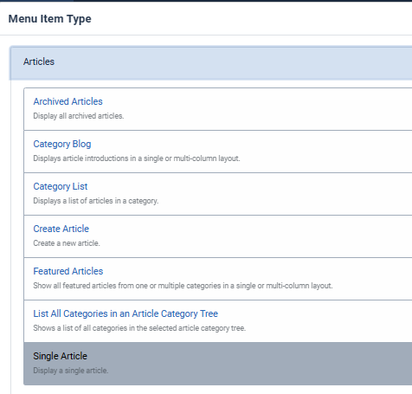

**Select article -> Select -> Yamaha RD 350**

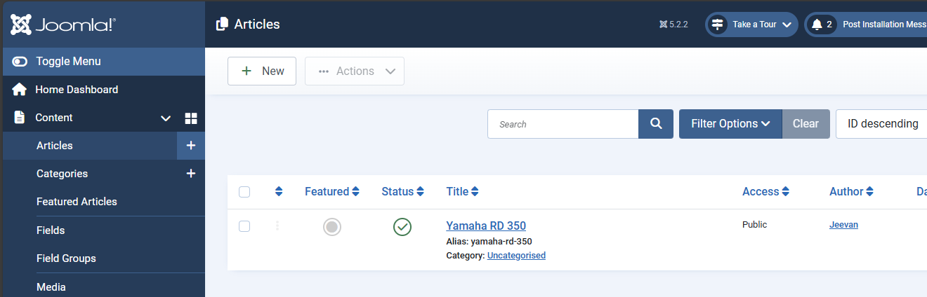

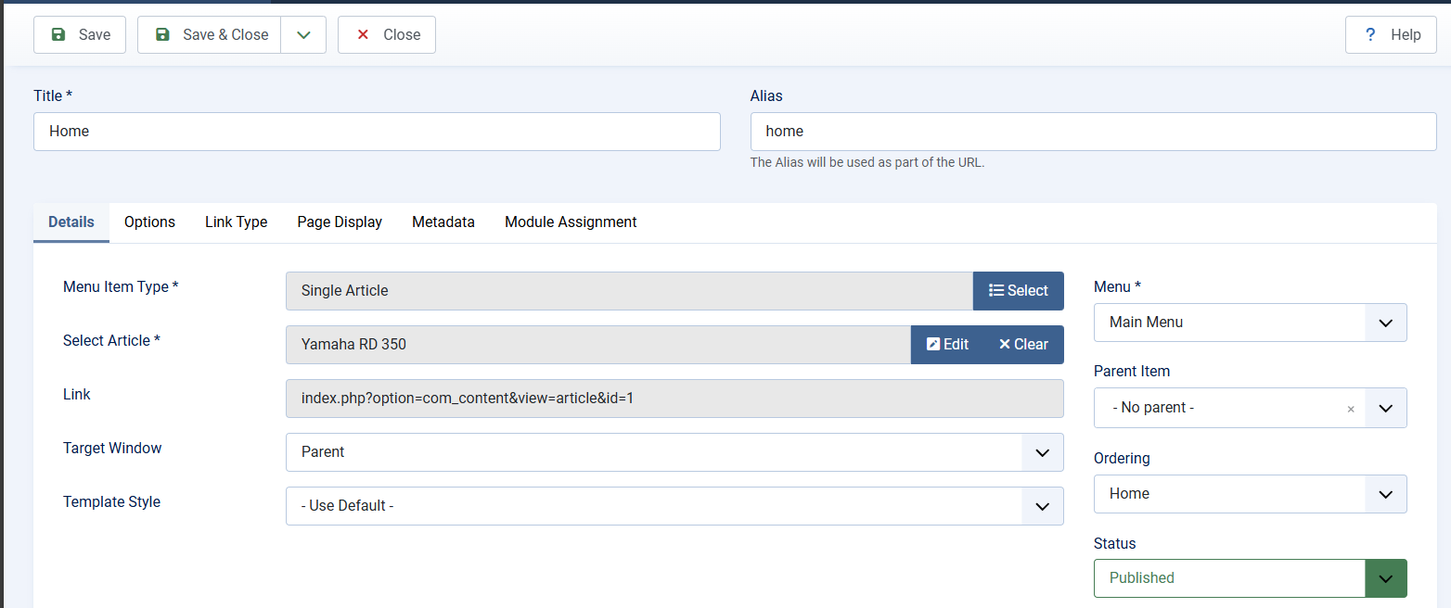

**Save & Close**

**Step 9: Enable extension “Content Plugin Demo” and localhost:8080**

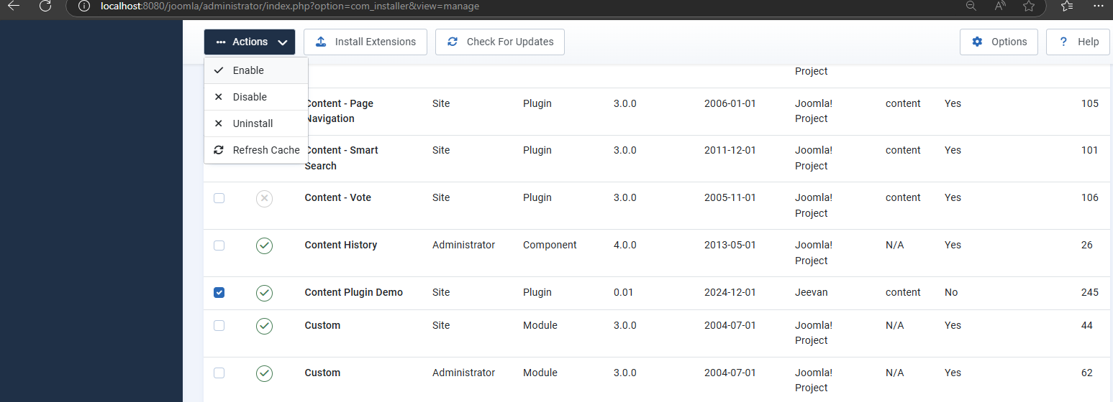

**Step 10: Open localhost/Joomla/ in a new tab.**

**Step 11: Check the article displayed with the plugin settings applied.**

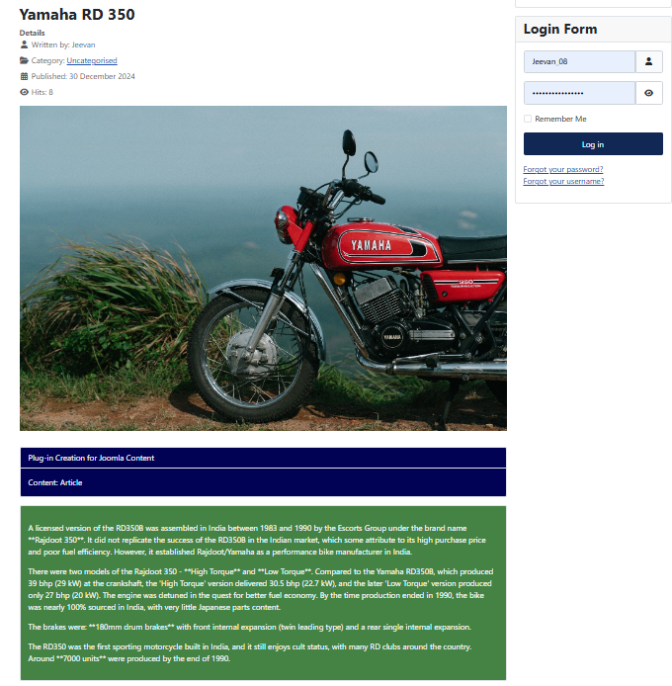

**Result:**

Thus, creating and applying extensions and plugins using joomla was executed successfully.