**EX.NO : 5 INSTALL AND CONFIGURE WORDPRESS TOOL**

**DATE : 08/01/25**

**AIM**

To install and configure the WordPress Tool.

**PROCEDURE**

**STEP 1:** Download 6.4.2 from [**https://.org/download/**](https://wordpress.org/download/) **&** extract it in c:\xampp\htdocs\.

**STEP 2:** Create a Database in phpmyadmin.

requires MySQL database. So create a new empty database named “mydb” with user/password (for example, user as "root" and password as "root" or else you can leave it empty).

Then, continue with the installation process.

**STEP 3:** Open the url:localhost\wordpress

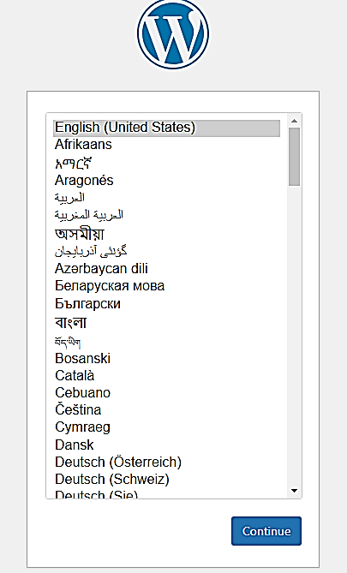

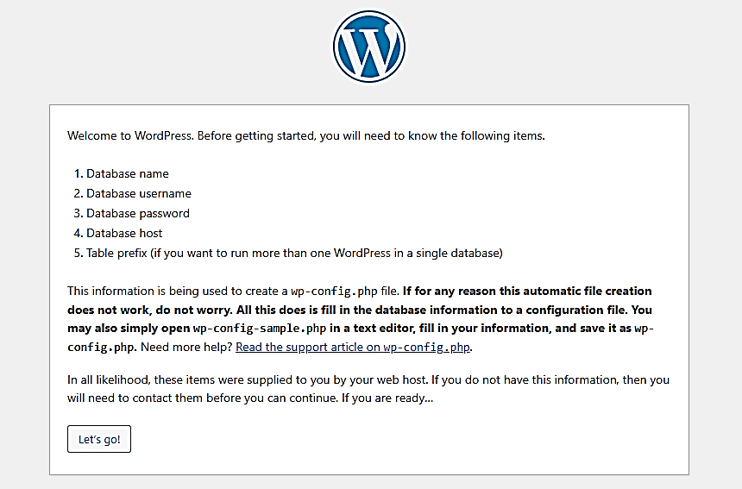

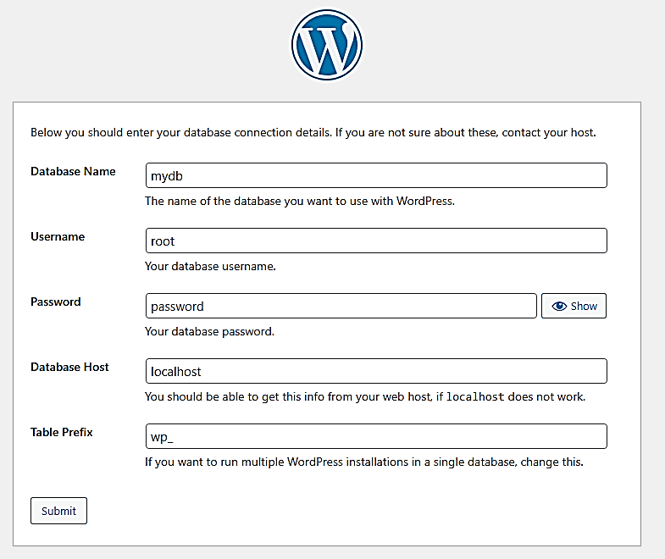

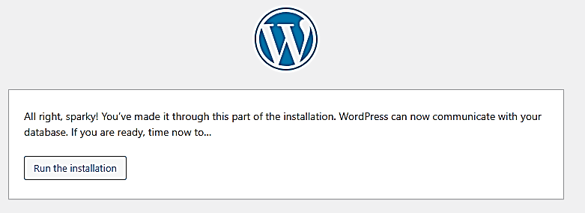

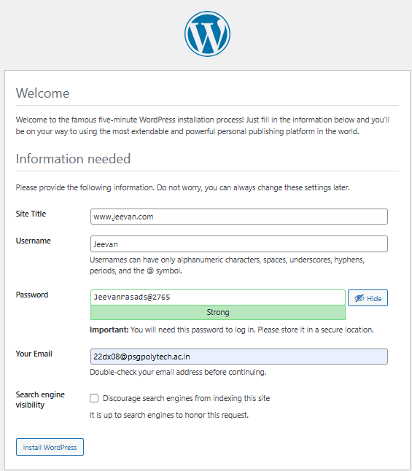

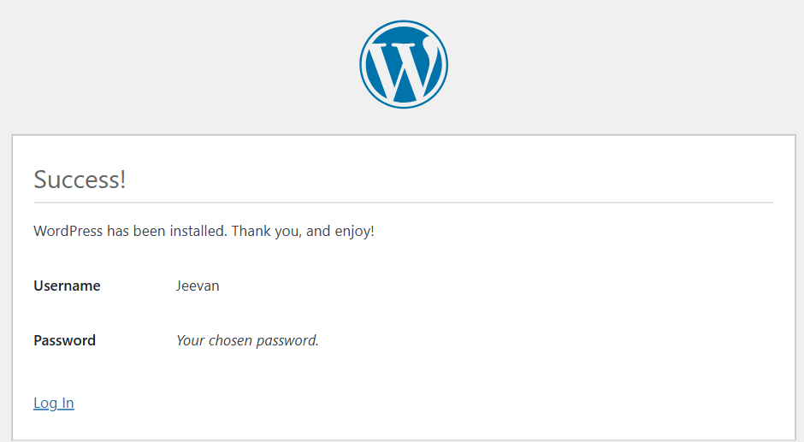

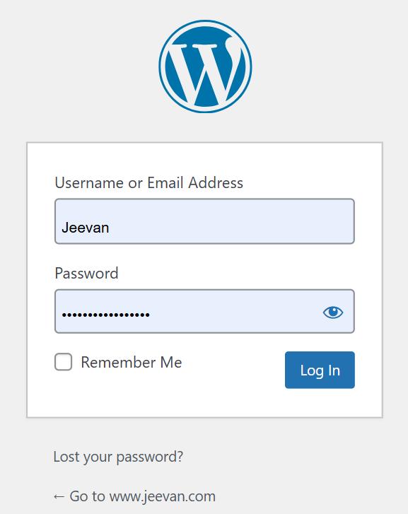

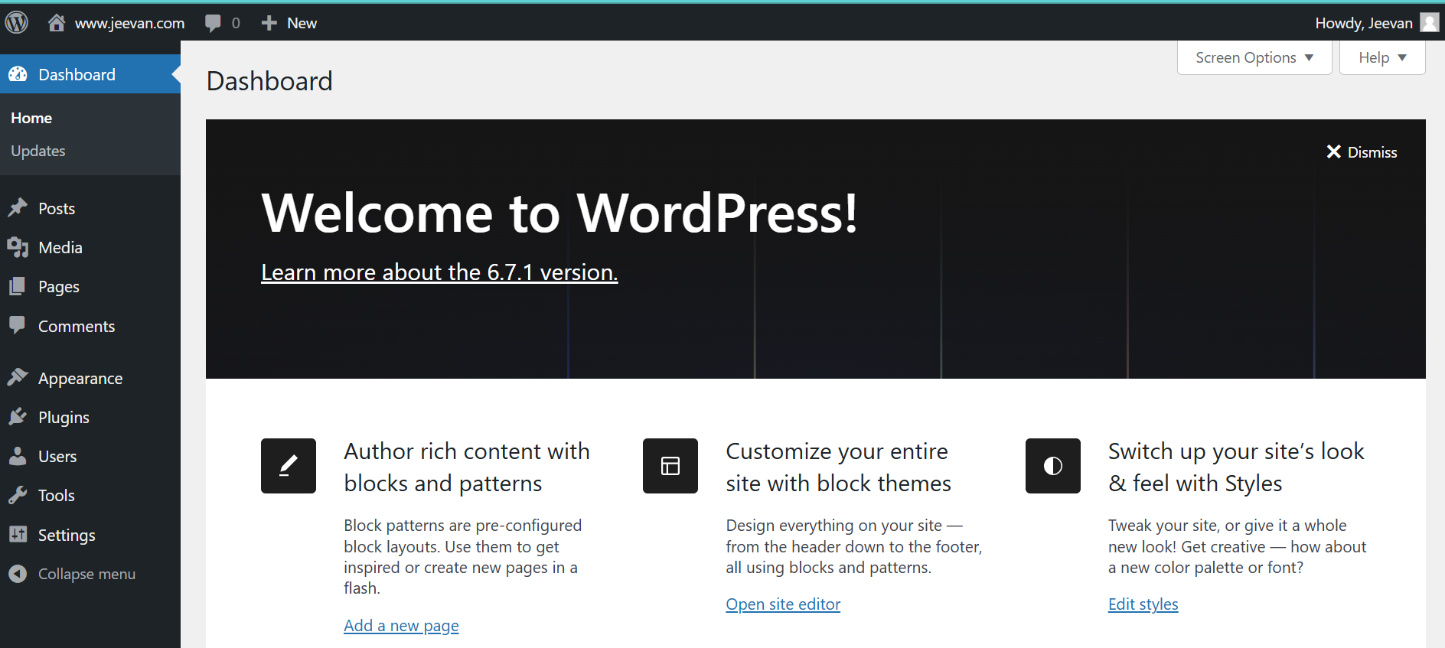

**RESULT**

Thus, the WordPress tool was installed and configured successfully.