COLLEGE R PROGRAMMING PROJECT
SUPERMARKET SALES DATA ANALYSIS
Implementation of Unit I–IV Concepts in R

Submitted by
1. [Student Name] — [Roll Number]
2. [Student Name] — [Roll Number]
3. [Student Name] — [Roll Number]
4. [Student Name] — [Roll Number]

[College / Department Name]
Guided by: [Guide / Faculty Name]
Academic Year: [Insert Academic Year]

Important note about the supplied format and rubric
The uploaded materials available for this task included SDAUR.zip and supermarket_sales.csv. A separate project report format, assessment rubric, and additional instructor instructions were not present among the uploaded files. This document therefore uses a conventional, editable college project structure and cannot be certified as an exact match to the instructor’s template. Replace/reorder headings once the official format and rubric are supplied. Names, roll numbers, institution and guide details remain placeholders.

Certificate
This is a placeholder certificate for completion by the institution. “This is to certify that the project titled Supermarket Sales Data Analysis was completed by [Student Names] under the guidance of [Guide Name] as part of the R Programming course.”
Guide Signature: ____________________ Head of Department: ____________________ Date: __________

Declaration
We declare that this project report is prepared for the R Programming course using the supplied supermarket_sales.csv dataset and the course materials included in SDAUR.zip. We have not fabricated observations or dataset columns. Any analysis limitations and execution caveats are stated in the report.

Acknowledgement
We thank our course instructor for the Unit I–IV learning materials and guidance. We also acknowledge the source files supplied with this activity. Complete this section with any institution-specific acknowledgement required by the official report format.

Abstract
This project examines 1,000 supermarket transactions across three branches and six product lines. The supplied CSV contains 17 original variables. The analysis covers dataset quality, descriptive statistics, product-line and branch revenue, customer type and payment method patterns, the relationship between quantity and invoice total, customer ratings, and month/weekday summaries. Seven problem statements are addressed using R concepts from the provided Unit I–IV material, including data frames, vectors, type conversion, descriptive statistics, dplyr data wrangling, visualization, correlation, simple regression, multiple regression, and group-comparison tests. Independent calculations from the supplied CSV show total recorded revenue of 322,966.75; Food and beverages has the highest product-line revenue (56,144.84), Branch C has the highest branch revenue (110,568.71), and quantity has a positive correlation with invoice total (r≈0.706). Mean invoice totals do not differ significantly by customer type or payment method in the tests conducted. The dataset contains no missing values or exact duplicate rows. R scripts are included, but execution of the scripts in an R runtime was not possible in the preparation environment because Rscript was unavailable; they must be run in RStudio before submission.

Contents
1. Introduction and dataset suitability
2. Objectives and methodology
3. Problem statements, results and inferences
4. Unit I–IV implementation mapping

Supplemental syllabus concepts demonstrated separately
The supplied Unit I material includes matrix creation and indexing; the data_join.pdf demonstrates joins; Missing_value.pdf demonstrates NA/empty-string checks and replacement; datatype_change (1).pdf covers conversion to factors; and wrangling using tidyr (1).pdf shows wide/long reshaping. These techniques are included in scripts/course_concept_demos.R using tiny teaching-only tables because the supermarket CSV has one main transaction table, no missing values, and no need for an artificial join. The demonstration data are never merged into the project dataset and are not used in the reported findings.
5. Conclusion and limitations
6. References
Appendix A. R project execution
Appendix B. Oral examination preparation

1. Introduction and dataset suitability
The purpose is to demonstrate beginner-level R programming and statistical analysis on a real transaction dataset. The analysis uses only the supplied records and does not synthesize additional observations.

1.1 Dataset profile
Item | Observed value
Rows / observations | 1,000
Original columns / variables | 17
Substantive categorical fields | Branch, City, Customer type, Gender, Product line, Payment (six fields)
Numerical fields | Unit price, Quantity, Tax 5%, Total, cogs, gross margin percentage, gross income, Rating (eight fields; one is constant)
Date/time fields | Date and Time are stored as text in the raw CSV and can be parsed/derived for temporal summaries
Date range | 1 January 2019 to 30 March 2019
Missing values | 0 across all 17 columns
Exact duplicate rows | 0
Unique Invoice IDs | 1,000
Suitability | Meets minimum 500 observations and 10 variables
The file has 17 variables and 1,000 observations, satisfying the stated minimum size. It has six meaningful categorical grouping fields and eight numerical fields. However, some numerical variables are accounting-derived and gross margin percentage is constant; they should not all be interpreted as independent information. Invoice ID is an identifier, not an explanatory variable.

1.2 Data quality and handling
The source CSV was preserved unchanged in data/supermarket_sales.csv. A working copy trims whitespace and converts Date to a date type and selected grouping variables to factors. No missing values or exact duplicate rows were detected, so no records were removed. The date range is limited to three months and conclusions about time should remain descriptive.

2. Objectives and methodology
- Profile the dataset and verify data quality without changing the source records.
- Compare total revenue and typical invoice amounts across product lines and branches.
- Compare transaction amounts by customer type and payment method using group summaries and suitable tests.
- Measure the association between quantity purchased and invoice total.
- Describe customer ratings and test their linear association with invoice total.
- Summarize revenue over the available months and weekdays.
- Apply the relevant Unit I–IV concepts from the supplied SDAUR material and prepare reproducible scripts and output tables.
Method: CSV import and inspection; cleaning of a working copy; frequency and grouped summaries; mean, median, standard deviation, variance, quartiles and IQR; bar charts, histograms, boxplots and scatterplots; Pearson correlation; Welch two-sample t-test; one-way ANOVA; and linear regression. Statistical tests use a conventional alpha of 0.05 and are interpreted as associations/comparisons, not causal evidence.

3. Problem statements, results and inferences

Problem Statement 1: Which product lines generate the greatest total revenue?
Objective: Rank product lines by aggregate invoice total and compare transaction count, mean invoice amount and rating. Columns: Product line, Total, Rating. Methods: group_by(), summarise(), sum(), mean(), bar chart.
Product line | Transactions | Revenue | Mean invoice total | Mean rating
Food and beverages | 174 | 56144.84 | 322.67 | 7.11
Sports and travel | 166 | 55122.83 | 332.07 | 6.92
Electronic accessories | 170 | 54337.53 | 319.63 | 6.92
Fashion accessories | 178 | 54305.89 | 305.09 | 7.03
Home and lifestyle | 160 | 53861.91 | 336.64 | 6.84
Health and beauty | 152 | 49193.74 | 323.64 | 7.00
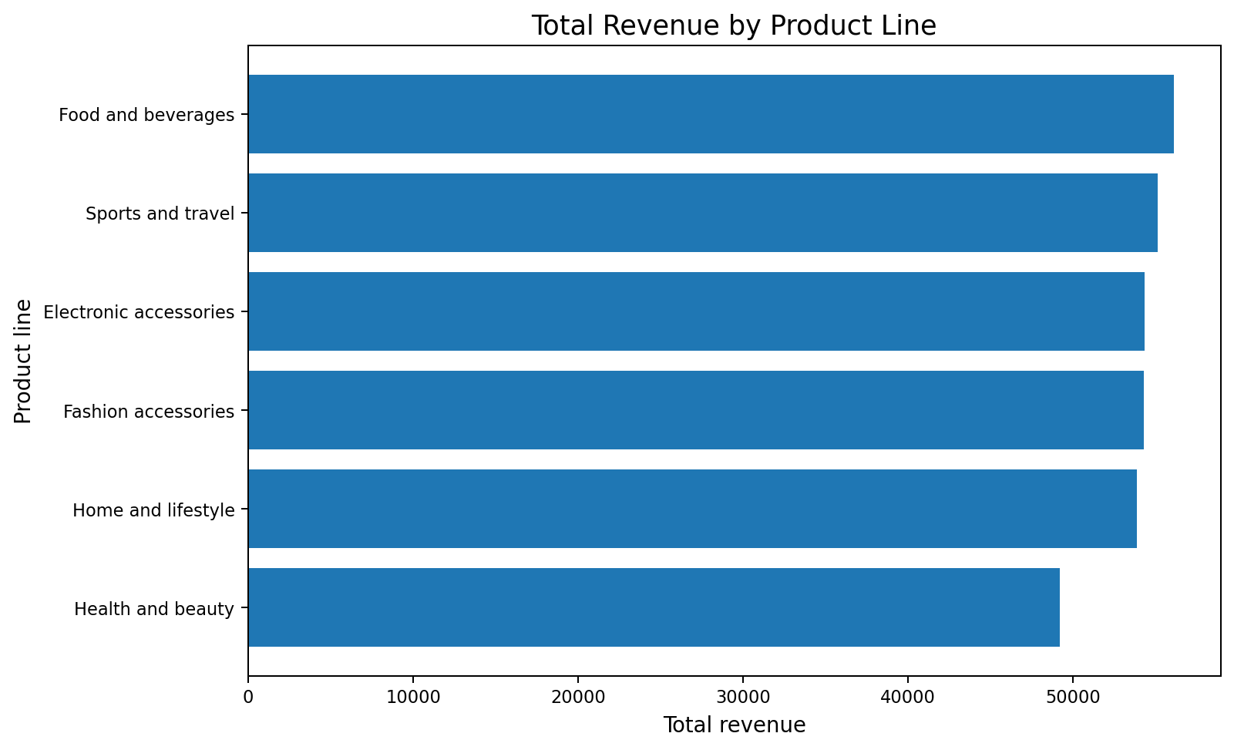
Figure 1. Total revenue by product line.
Inference: Food and beverages leads with 56,144.84, followed by Sports and travel (55,122.83). Health and beauty is lowest at 49,193.74. The range is modest relative to total revenue; revenue ranking alone does not measure profitability or customer satisfaction.
Conclusion: Food and beverages has the highest recorded revenue in this sample, while Health and beauty has the lowest. Differences should be considered alongside transaction counts and margins.

Problem Statement 2: How do the branches compare in revenue and average invoice total?
Objective: Compare branches A, B and C using aggregate revenue, transaction counts and mean invoice total. Columns: Branch, City, Total. Methods: grouped summary, bar chart and one-way ANOVA on Total by Branch.
Branch | City | Transactions | Revenue | Mean invoice total
A | Yangon | 340 | 106200.37 | 312.35
B | Mandalay | 332 | 106197.67 | 319.87
C | Naypyitaw | 328 | 110568.71 | 337.10
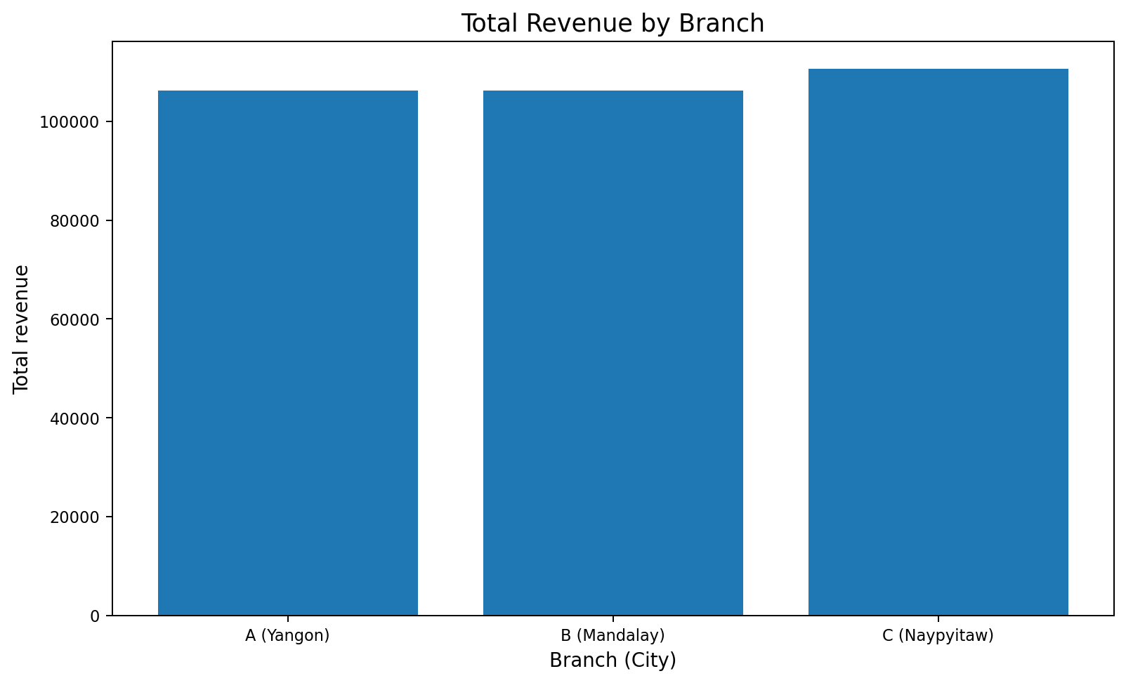
Figure 2. Total revenue by branch.
Inference: Branch C (Naypyitaw) has the highest total revenue (110,568.71), while Branch A and Branch B are nearly tied at approximately 106,200 each. Branch C also has the highest average invoice total (337.10). The one-way ANOVA does not find a statistically significant difference in mean invoice totals across branches (F≈0.885, p≈0.413).
Conclusion: Branch C has the highest aggregate revenue, but the observed differences in mean invoice totals are not statistically significant at the 5% level. Revenue totals also reflect the number and mix of transactions.

Problem Statement 3: Do Member and Normal customers have different average invoice totals?
Objective: Compare average and median invoice totals by customer type. Columns: Customer type, Total, Rating. Methods: group summaries, bar chart, Welch two-sample t-test.
Customer type | Transactions | Revenue | Mean invoice total | Mean rating
Member | 501 | 164223.44 | 327.79 | 6.94
Normal | 499 | 158743.30 | 318.12 | 7.01
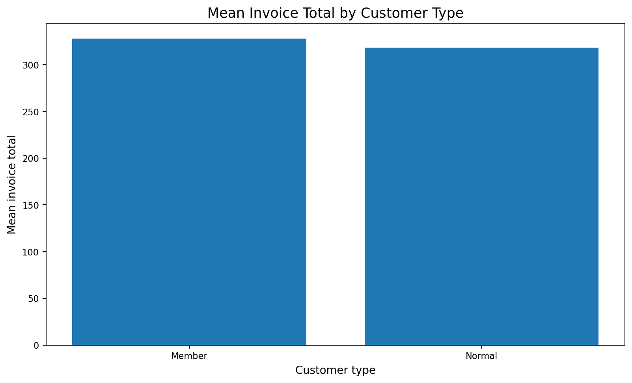
Figure 3. Mean invoice total by customer type.
Inference: Member customers average 327.79 per transaction and Normal customers average 318.12. The Welch t-test is not statistically significant (t≈0.622, p≈0.534), so this sample does not provide evidence of a mean difference at alpha=0.05.
Conclusion: Member average invoice total is numerically higher, but the difference is not statistically significant in this sample. This does not prove the groups are identical.

Problem Statement 4: Which payment methods are most used, and do mean invoice totals differ?
Objective: Compare transaction counts, revenue and average total for Cash, Credit card and Ewallet. Columns: Payment, Total. Methods: group summaries, bar chart and one-way ANOVA.
Payment method | Transactions | Revenue | Mean invoice total
Cash | 344 | 112206.57 | 326.18
Credit card | 311 | 100767.07 | 324.01
Ewallet | 345 | 109993.11 | 318.82
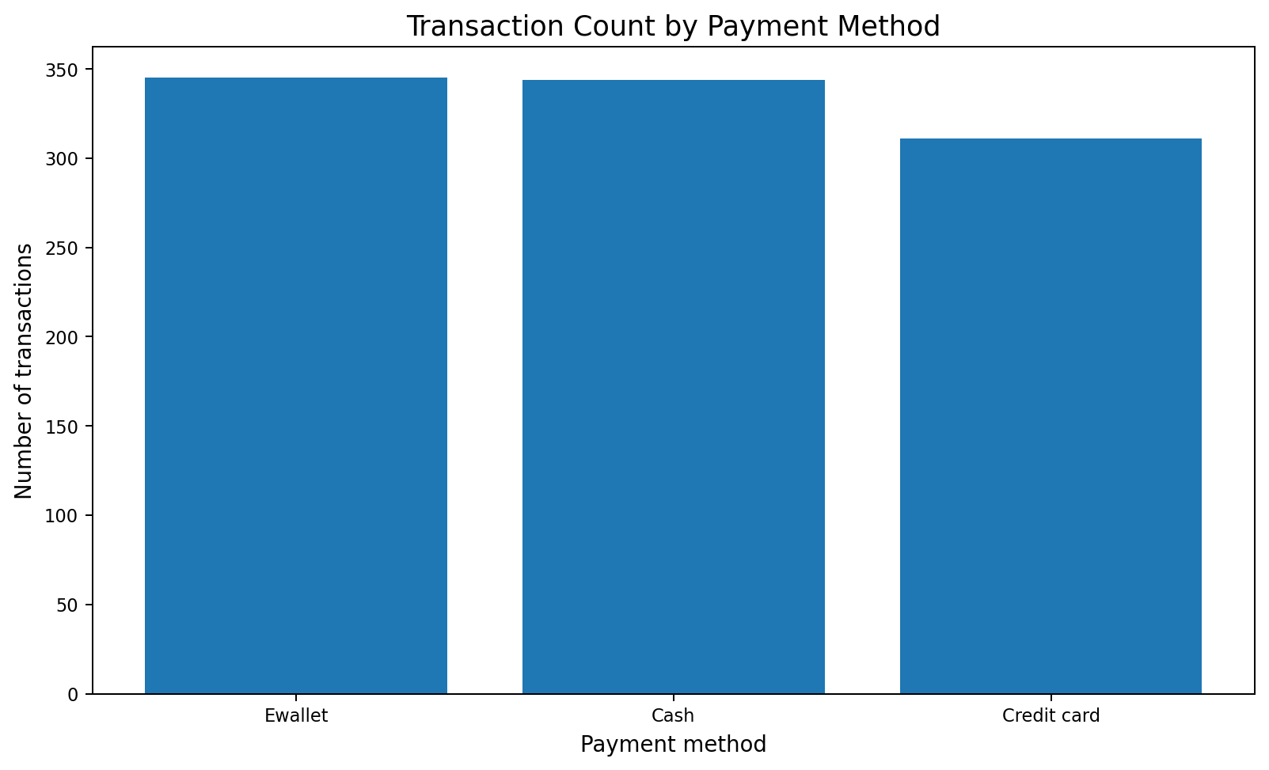
Figure 4. Transaction count by payment method.
Inference: Ewallet records 345 transactions, Cash 344 and Credit card 311. Mean invoice totals are close (Cash 326.18, Credit card 324.01, Ewallet 318.82); ANOVA is not significant (F≈0.081, p≈0.922).
Conclusion: Ewallet and Cash are almost equally frequent in the sample. There is no evidence from this ANOVA that average invoice totals differ by payment method.

Problem Statement 5: How strongly is quantity associated with invoice total?
Objective: Measure the linear association between quantity purchased and total invoice amount. Columns: Quantity, Unit price, Total. Methods: scatterplot, Pearson correlation, simple/multiple linear regression as syllabus exercises.
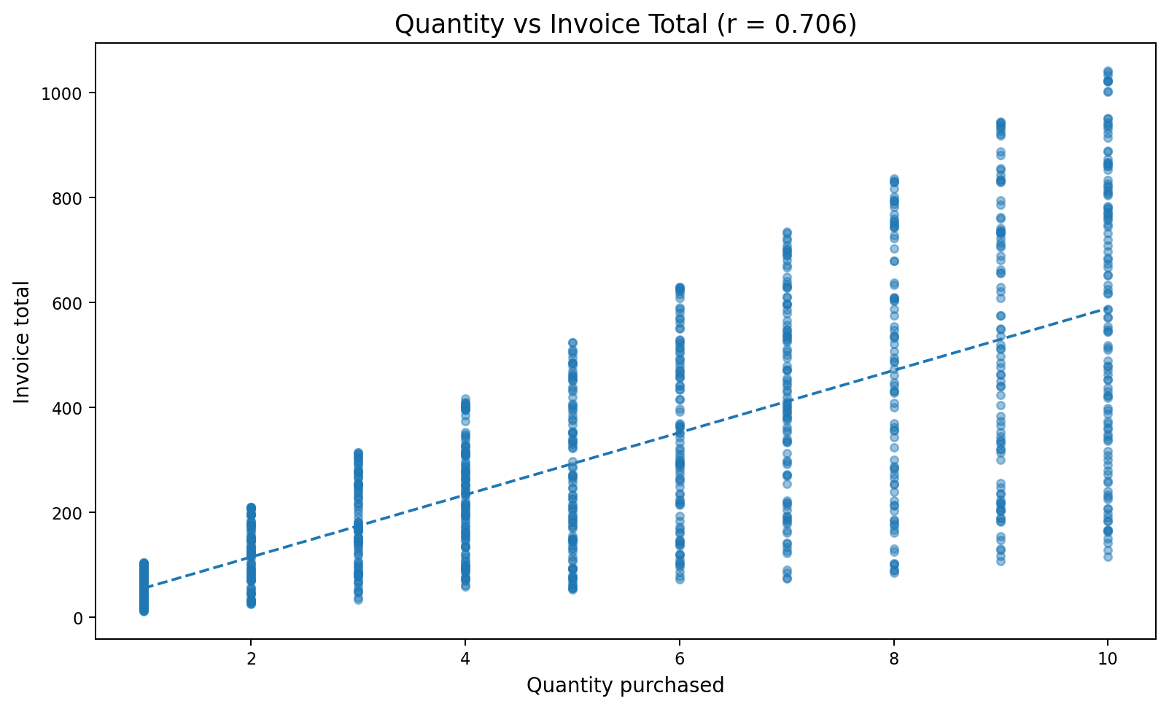
Figure 5. Quantity purchased versus invoice total.
Inference: Quantity and total have a positive Pearson correlation of about 0.706 (p≈2.1×10⁻¹⁵¹). Transactions with more items tend to have higher totals, but unit prices vary and Total is calculated from the transaction components, so this is an expected association rather than causal evidence.
Conclusion: Quantity is a useful descriptive correlate of invoice total, but unit price also matters. The regression exercise demonstrates model fitting rather than a causal business forecast.

Problem Statement 6: What does the customer-rating distribution show, and is rating related to invoice total?
Objective: Describe customer ratings and test their linear association with invoice total. Columns: Rating, Total. Methods: mean, median, standard deviation, histogram, Pearson correlation. Mean rating is 6.973; median is 7.0; SD is 1.719; range is 4.0 to 10.0.
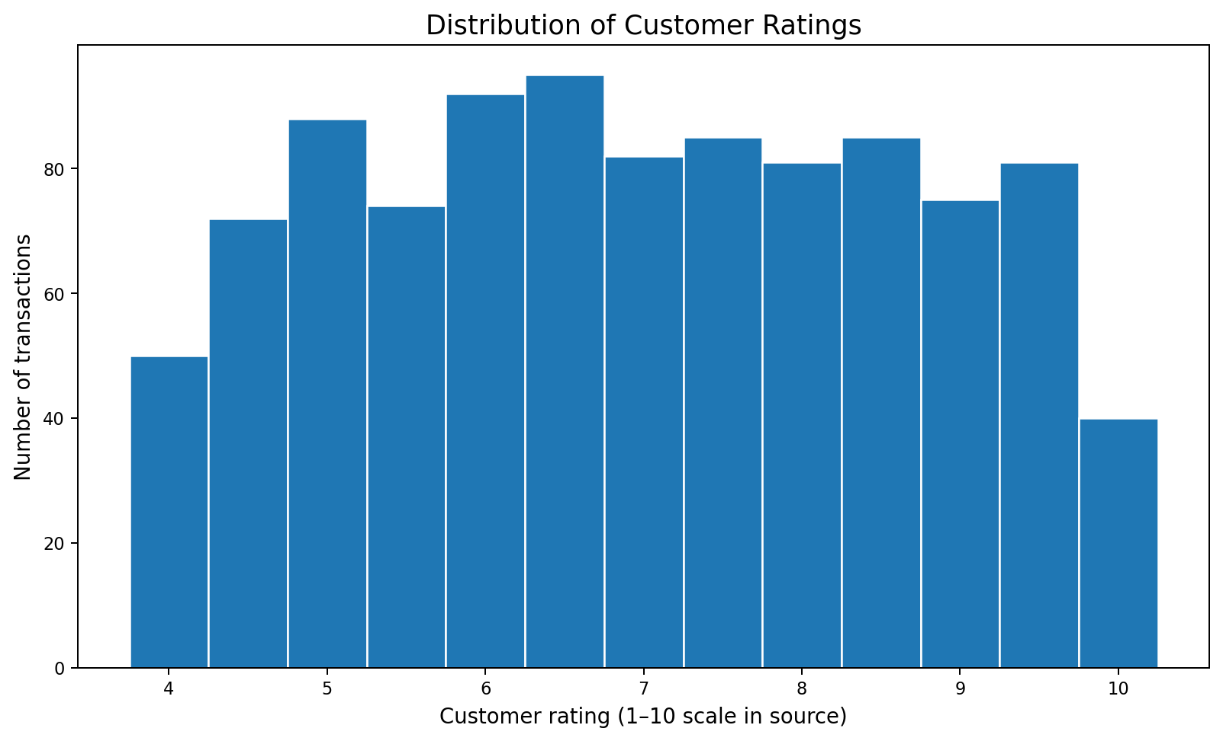
Figure 6. Distribution of customer ratings.
Inference: Ratings span 4.0 to 10.0, with a mean of 6.973 and median 7.0. The correlation with invoice total is very weak (r≈−0.036) and not statistically significant (p≈0.250). Thus higher-value transactions are not demonstrably associated with higher ratings in this sample.
Conclusion: Ratings cluster around 7, and there is no statistically significant linear association between rating and total invoice amount in the supplied data.

Problem Statement 7: How does revenue vary across months and weekdays?
Objective: Describe revenue patterns over the supplied time period. Columns: Date, Total, Time. Methods: Date conversion, derive month/day of week, group summaries, line chart and weekday table. The period covers only January–March 2019.
Month | Transactions | Revenue | Mean invoice total
2019-01 | 352 | 116291.87 | 330.37
2019-02 | 303 | 97219.37 | 320.86
2019-03 | 345 | 109455.51 | 317.26
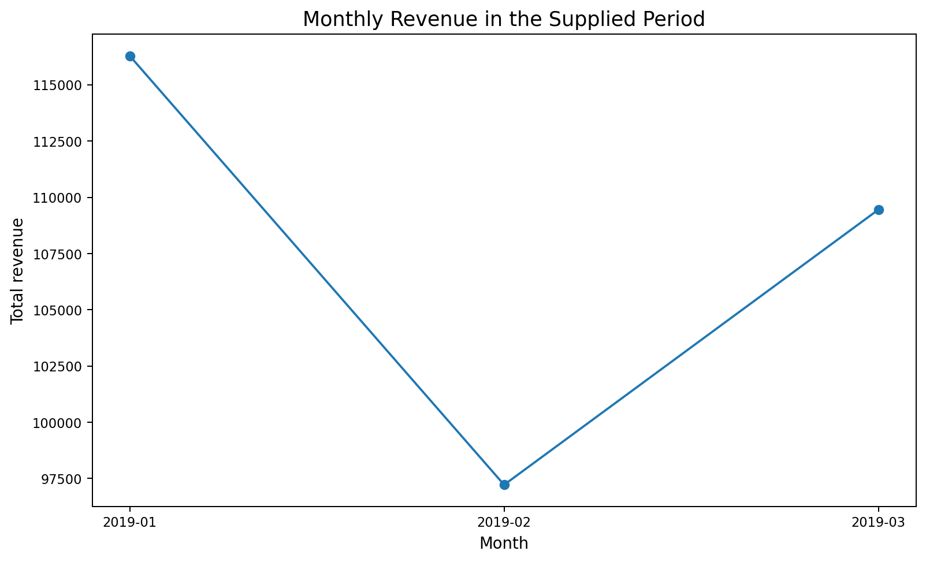
Figure 7. Monthly revenue during the supplied period.
Inference: January has the highest revenue (116,291.87; 352 transactions), February is lowest (97,219.37; 303 transactions), and March recovers to 109,455.51 (345 transactions). This describes only the three observed months and should not be called a long-term seasonal trend.
Additional weekday summary: Saturday has the highest total revenue (56,120.81) and highest mean invoice total (342.20) among weekdays in this dataset. These differences are descriptive; no causal explanation can be established from the CSV alone.

3.8 Overall descriptive statistics
Variable | Mean | Median | SD | Minimum | Maximum
Unit price | 55.672 | 55.230 | 26.495 | 10.080 | 99.960
Quantity | 5.510 | 5.000 | 2.923 | 1.000 | 10.000
Tax 5% | 15.379 | 12.088 | 11.709 | 0.508 | 49.650
Total | 322.967 | 253.848 | 245.885 | 10.678 | 1042.650
cogs | 307.587 | 241.760 | 234.177 | 10.170 | 993.000
gross income | 15.379 | 12.088 | 11.709 | 0.508 | 49.650
Rating | 6.973 | 7.000 | 1.719 | 4.000 | 10.000

4. Unit I–IV implementation mapping
The project uses the supplied course files as the priority. A machine-readable mapping is also saved at outputs/reports/unit_mapping.csv and a readable version at UNIT_MAPPING.md. Some supplied PDFs are image-only or had very little extractable text; this limitation is recorded rather than inventing unseen contents.
Unit | Verified concepts applied | Project scripts / outputs
I | Arithmetic, vectors, types, functions, matrices/indexing examples, data frames, CSV import/export, str(), summary() | scripts/unit1.R; dataset_profile.csv
II | Missing/duplicate audit, type conversion, descriptive statistics, dplyr wrangling, tidyr concept, bar/histogram/box/scatter/density plots | scripts/unit2.R; scripts/problem_statements.R; summary CSVs and PNGs
III | Scatterplots, Pearson correlation, lm(), summary(), predict(), regression line and residual checks | scripts/unit3.R; unit3 output tables/plots
IV | Numeric correlation matrix, multiple regression, coefficient tests, confidence intervals, prediction, diagnostics | scripts/unit4.R; unit4 output tables/plots

5. Conclusion and limitations
The dataset meets the size requirement with 1000 observations and 17 variables. Total recorded revenue across the supplied 1,000 invoices is 322,966.75, and mean invoice total is 322.97. Food and beverages has the largest product-line revenue, Branch C has the largest branch revenue, quantity is positively associated with invoice total, and customer ratings show almost no linear association with invoice total. The tests for mean invoice-total differences by branch, product line, payment method and customer type are not statistically significant at the 5% level in these calculations.
Interpret results cautiously. This is observational transaction data, covers three months, and does not include inventory, operating costs, promotions, customer demographics beyond the supplied categories, or causal variables. `gross margin percentage` is constant; `Tax 5%` and `gross income` are accounting-derived and highly redundant with `cogs`; Branch and City are one-to-one. These facts limit some predictive interpretations.

6. References
1. Supplied dataset: supermarket_sales.csv (provided for this project activity; the original publisher/source URL was not included with the file).
2. Supplied course materials: SDAUR.zip, containing Unit I command script, dplyr, descriptive statistics, bar/box/histogram/pie/violin/scatter plotting practicals, linear regression notes, multiple regression R script, missing-value, data join, data type change, and tidyr/wrangling materials.
3. R Core Team. R: A Language and Environment for Statistical Computing. https://www.r-project.org/ (general R reference; consult documentation for function details).

Appendix A. How to run the project in RStudio
- Install R and RStudio if not already installed.
- Extract the ZIP and open R_Unit1_to_Unit4_Project.Rproj.
- Keep data/supermarket_sales.csv in the supplied data folder; do not change the source file name.
- Open main.R and run it from the project root. The script checks/installs dplyr, ggplot2 and tidyr. Internet access may be needed to install packages.
- Review outputs/plots/ and outputs/reports/ after execution.
- Before submission, run the full script in RStudio, review warnings/errors, and add the actual R console/session information if your instructor requests it.
Execution status: the full R scripts have not been executed in the preparation environment because Rscript was not installed. Static project checks and independent numerical calculations using the supplied CSV were performed; successful execution must be confirmed in RStudio before claiming the project has run end-to-end.

Appendix B. Oral examination preparation
See oral_exam/viva_questions_and_functions.md for likely viva questions, short answers and function explanations. It includes the actual findings and the key limitations to explain honestly.

