Assignment 1

Web Application Security Lab

Jeevan S U

241059038

1. Metadata: <meta> Tags
- Purpose: <meta> tags are used to provide metadata about the HTML document, such as descriptions, keywords, author, and viewport settings.
- Commonly found metadata elements:
  - Description: A summary of the page content.
  - Keywords: Keywords relevant to the page for search engine optimization (SEO).
  - Viewport: Controls the viewport settings, particularly for mobile responsiveness (e.g., <meta name="viewport" content="width=device-width, initial-scale=1">).
  - Charset: Defines the character encoding for the webpage (e.g., <meta charset="UTF-8">).
  - Robots: Specifies whether search engines should index the page or follow the links on the page (e.g., <meta name="robots" content="index, follow">).
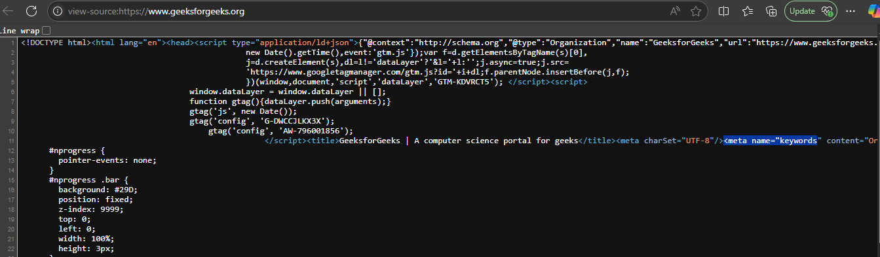

2. Headings and Semantic Elements
- Headings: Headings like <h1>, <h2>, <h3>, etc., are used to structure the content hierarchically and make it more accessible. Typically:
  - <h1>: The main title of the page, usually the most important heading.
  - <h2>, <h3>, etc.: Sub-headings that break down the content into sections and subsections.
- Semantic Elements: These are elements that give meaning to the page structure.
  - <header>: Defines the header of the page, often containing the logo, navigation bar, or introductory content.
  - <footer>: Represents the footer area, typically containing copyright information, privacy policy links, and other administrative details.
  - <section>: Used to group related content, making the page more understandable to both users and search engines.
  - <article>: Represents an independent piece of content (e.g., blog posts, tutorials, or news articles).
  - <nav>: Defines navigation links, usually containing a menu of links to other parts of the site

3. Multimedia Elements
- Multimedia Elements: Look for elements like <video>, <audio>, or <iframe>. These are used to embed media into a webpage.
  - : Embeds video content, often with options for play/pause and volume control.
  - : Embeds audio content for listening.
  - : Embeds content from another source, such as a YouTube video or an external interactive element. It may also be used for embedding other websites or services.
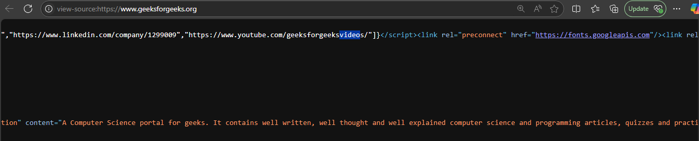

4. Security-Relevant Tags
- Content Security Policy (CSP): CSP is used to restrict which external resources (like JavaScript, CSS, images) can be loaded by the browser, helping to prevent attacks such as Cross-Site Scripting (XSS) and data injection attacks.
  - Example: <meta http-equiv="Content-Security-Policy" content="default-src 'self'; script-src 'self' https://trusted-scripts.com;">
- Sandboxed iframes: The <iframe> element can have a sandbox attribute that restricts what the embedded content can do. This can prevent malicious scripts from executing in the iframe and limit access to certain resources.
  - Example: <iframe src="https://example.com" sandbox="allow-scripts allow-same-origin">
- HTTP Headers for Security: Security headers like X-Content-Type-Options, Strict-Transport-Security, and X-Frame-Options can be set to improve security.

5. CORS (Cross-Origin Resource Sharing)
- CORS Headers: These headers control how resources (like fonts, APIs, or images) are shared across different origins (domains). A CORS policy can be set to specify which domains are allowed to access a resource.
  - Example: A CORS header in the response from the server might look like Access-Control-Allow-Origin: * (or a specific domain) to allow cross-origin requests from the specified domains.
  - Purpose: CORS helps prevent malicious websites from accessing sensitive data from another website, protecting user privacy and data integrity.

6. SRI (Subresource Integrity)
- Purpose: SRI is a security feature that enables browsers to verify that the resources they fetch (like JavaScript libraries or stylesheets) haven’t been tampered with. The browser will compare a cryptographic hash of the file with the hash specified in the integrity attribute.
- Example:
- <script src="https://example.com/script.js" integrity="sha384-xyz" crossorigin="anonymous"></script>
  - If the file has been altered (even by one byte), the browser will not load it, preventing potential attacks.

Deliverable Summary
- Metadata: The <meta> tags provide information like character encoding, description, viewport settings, and SEO-related metadata.
- Headings and Semantic Elements: Headings (<h1>, <h2>, etc.) are used to structure the content hierarchically, while semantic elements like <header>, <footer>, <section>, and <nav> organize the page into meaningful sections.
- Multimedia: Elements like <video>, <audio>, and <iframe> are used to include media or external content.
- Security:
  - CSP: Defines policies for loading external resources to prevent XSS and other attacks.
  - Sandboxed iframes: Limits actions within embedded iframes to improve security.
  - CORS: Manages cross-origin requests to control which resources can be shared between different domains.
  - SRI: Ensures the integrity of external resources by checking their hashes.
