Low-Level Design (LLD)
Version: 1.0
Date: 14-06-2026
Prepared by: Jeevan Suresh [Trenser Technologies]

1. Purpose
- This document will provide detailed design of the pressure monitoring system
- It elaborates High Level Design (HLD) into specific functions, data structure and control logic.

2. Functional Decomposition
- Setup Configuration Module
  - ReadConfiguration()
- Poll time Check Module
  - CheckPollTime()
- Random Pressure data generator module
  - ReadPressureData()
- Process Data module
  - BackGroundProcess()
  - ProcessData()
  - CheckThresholdRange()
  - CheckOperatingRange()
- Output warning module
  - PrintMessage()
- Fault Management module
  - FaultHandler()
  - SafeMode()

3. Detailed Function Descriptions

ReadConfiguration()
ERRORTYPE ReadConfig(PRESSURECONFIG *);
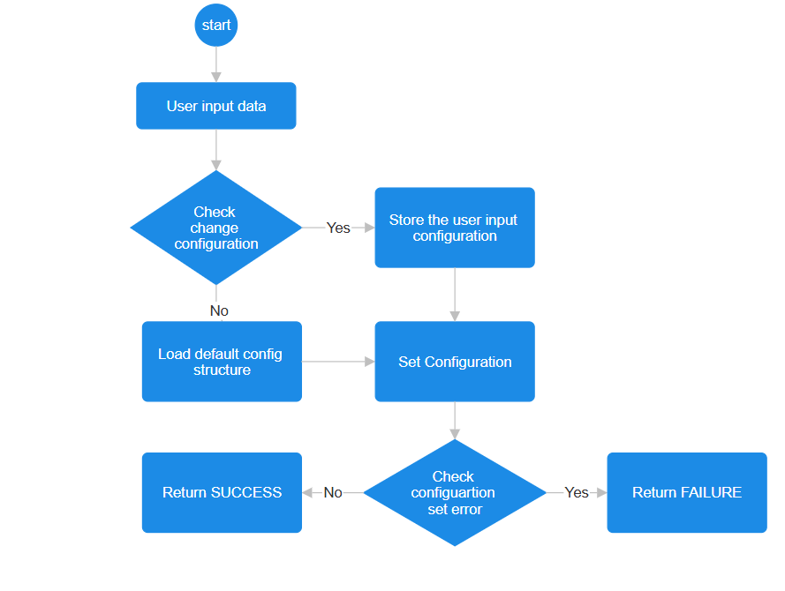CheckPollTime()
ERRORTYPE CheckPollTime(long int *);
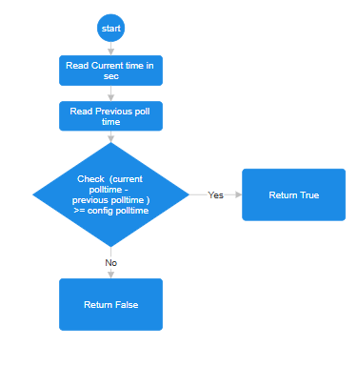
ReadPressureData()
ERRORTYPE ReadPressureData(float *);
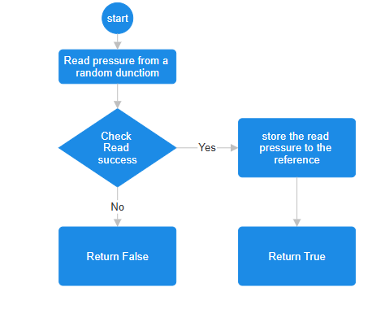

BackGroundProcess()
void BackGroundProcess (void);
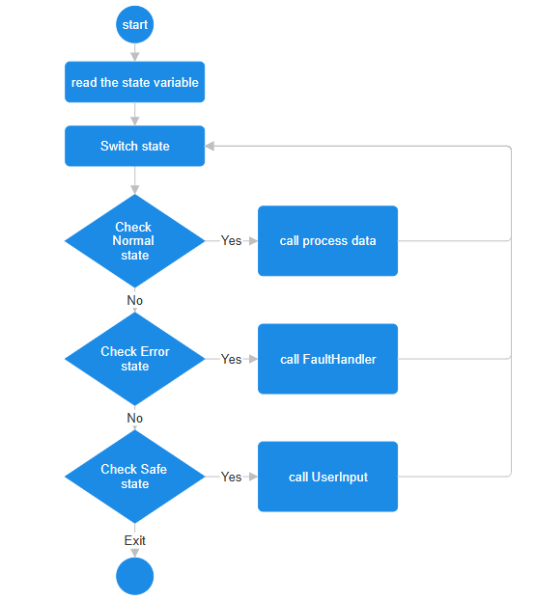

ProcessData()
ERRORTYPE ProcessData(PRESSURECONFIG*, float);
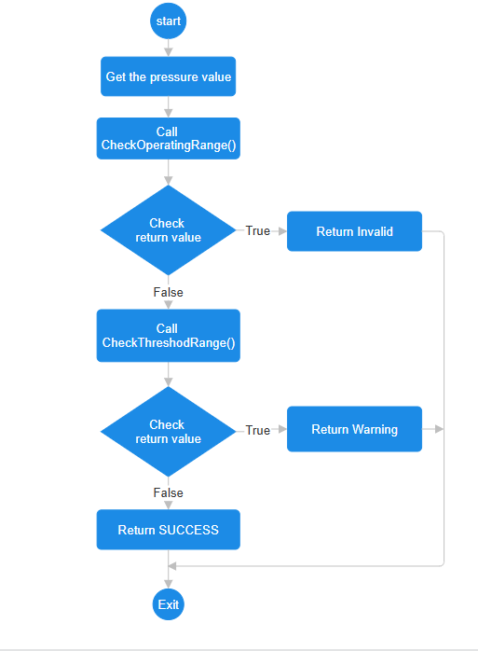

CheckOperatingRange()
ERRORTYPE CheckOperatingRange(PRESSURECONFIG*, float)
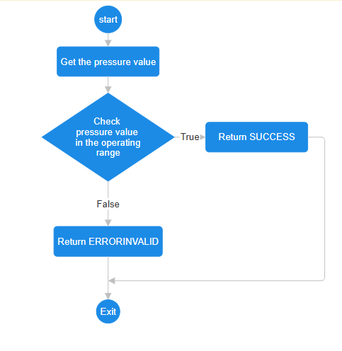
CheckThresholdRange()
ERRORTYPE CheckThresholdRange (PRESSURECONFIG*, float)
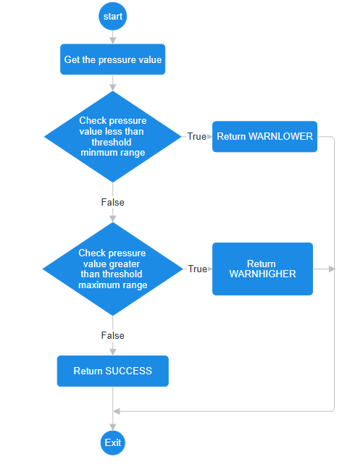

PrintMessage()
Void PrintMessage(ERRORTYPE, float)
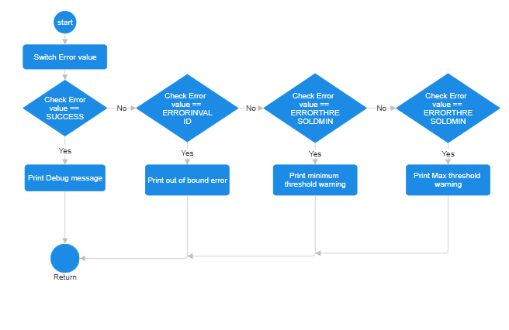
FaultHandler
Void FaultHandler(PRESSURECONFIG*)
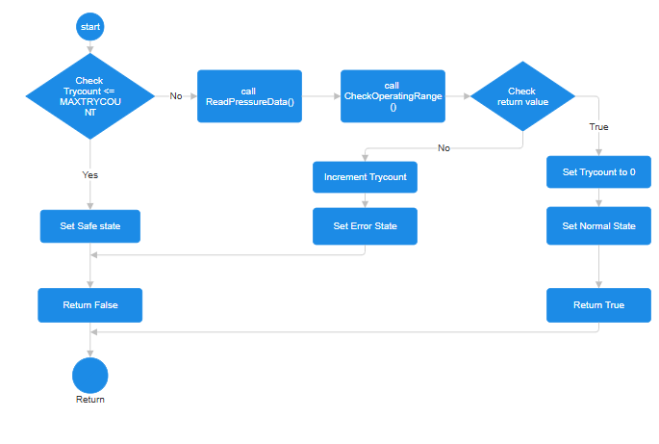
SafeMode
ERRORTYPE SafeMode(STATETYPE);
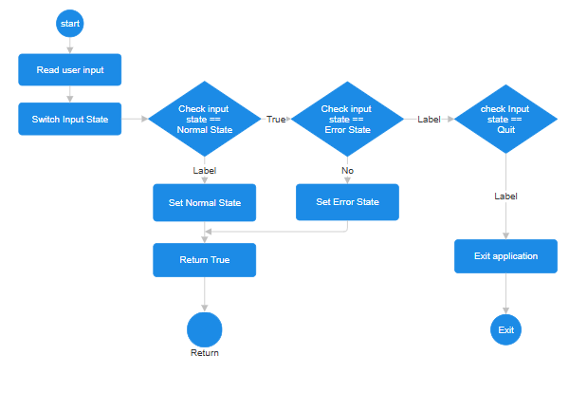

4. Data Structures
Structures
typedef struct
{
const char *CONFIGVERSION;
float fLowerThresholdRange;
float fUpperThresholdRange;
float fLowerOperatingRange;
float fUpperOperatingRange;
long int Checktime;
int iMaxTryCount;
}PRESSURECONFIG;
Enumerators
typedef enum
{
NOERROR,
ERRORINVALID,
ERRORTHRESHOLDMIN,
ERRORTHRESHOLDMAX
}ERRORTYPE;
typedef enum
{
NORMALSTATE,
ERRORSTATE,
SAFESTATE,
}STATETYPE;
Global Variable
STATETYPE RunningState;

Macros
SUCCESS 0
FAILURE -1
DEFAULT_MIN_THRESHOLD 10.8
DEFAULT_MAX_THRESHOLD 70.5
DEFAULT_MIN_OPERATING_RANGE 2.18
DEFAULT_MIN_OPERATING_RANGE 105.50
DEFAULT_CHECK_TIME 2
DEFAULT_RETRY_TIME_OUT 100

5. Error Handling
- Error Handling
  - Set error state when read value exceed operating range
  - Set safe state number of retry reaches MAX_TRY_COUNT which is 10
- boundary checks
  - check pressure value in the threshold range 10.8 psi to 70.5 psi
  - check pressure value in the operating range 2.18 psi to 105.5 psi
- exception mechanisms
  - enter safe mode after retry count reaches MAX_TRY_COUNT 10.

6. Timing and Performance
- CPU % must be less than 40%
- Poll time must be 2 seconds
- Retry timing must be 100ms

7. Test Points
Unit test
- ReadConfiguration()
- CheckPollTime()
- ReadPressureData()
- ProcessData()
- CheckThresholdRange()
- CheckOperatingRange()
- PrintMessage()
- FaultHandler()
- SafeMode()

8. Traceability
Function | Requirement ID
ReadConfiguration | FR-1
CheckPollTime | FR-2
ReadPressureData | FR-3
ProcessData | FR-4,FR-5
PrintMessage | FR-6, FR-7
FaultHandler | FR-8

