**FLOOD MONITORING AND EARLY WARNING USING INTERNET OF THINGS**

**TEAM MEMBER**

**610221106010:MAHESHWARI.V**

**610221106021:RAMYA.P**

**610221106022:RAMYA.S**

**610221106341:HABIBUR RAHMAN.S**

**610221106321:JEEVANANTHAM.J**

**Phase 5 Submission Document**

**Project Title: Flood Monitoring and Early Warning**

**Phase 5: Project Documentation & Submission**

**Topic: In this section we will document the**

**complete project and prepare it for submission.**

**FLOOD MONITORING AND EARLY WARNING**

**INTRODUCTION**

Flood Monitoring and Early Warning (FMEW) is a system designed to detect, monitor, and provide timely warnings about potential or ongoing floods to mitigate their impact on communities and infrastructure. Here's a brief overview of its definition and design considerations:

**Definition**

Flood Monitoring and Early Warning (FMEW) refers to a comprehensive system that combines various technologies, data sources, and communication channels to:

1. **Monitor Weather and Hydrological Conditions**: Continuously gather data on rainfall, river levels, soil moisture, and other relevant parameters.

2. **Predict Flood Events**: Use predictive models and historical data to forecast potential floods.

3. **Warn Affected Areas**: Disseminate timely warnings to vulnerable communities and relevant authorities.

4. **Coordinate Response:** Facilitate coordination among emergency responders and agencies.

5. **Provide Public Information**: Offer clear and understandable information to the public about the flood situation and recommended actions.

**Design Considerations**:

1. **Data Collection** : Implement a network of weather stations, river gauges, rainfall sensors, and radar systems to collect real-time data.

2. **Data Integration**: Develop a central system that integrates data from various sources for analysis and decision-making.

3. **Modeling and Prediction**: Utilize hydrological and meteorological models to predict flood events based on incoming data.

4. **Risk Assessment**: Identify vulnerable areas and populations to prioritize warnings and response efforts.

5. **Communication Infrastructure**: Establish reliable communication channels, including SMS alerts, sirens, mobile apps, and internet platforms.

6. **Warning Systems**: Develop tiered warning systems that account for the severity of the flood and its potential impact.

7. **Community Engagement**: Educate and engage communities in understanding the warning signals and evacuation procedures.

8. **Emergency Response Plan**: Have a well-defined plan for emergency response agencies to act swiftly when a flood warning is issued.

9. **Regular Testing and Maintenance**: Ensure the system undergoes regular testing and maintenance to guarantee its functionality.

10. **Scalability and Redundancy**: Design the system to scale with the growth of the population and incorporate redundancy for resilience.

Effective FMEW systems save lives and reduce the economic impact of floods by providing timely information and facilitating proactive measures. It's essential to tailor the design to the specific geographic and climatic conditions of the region it serves.

**Innovation of Flood Monitoring System**

Incorporating predictive modeling and historical flood data is a crucial approach to enhance the accuracy of early flood warnings. By leveraging past flood events and advanced modeling techniques, you can:

1. **Pattern Recognition**: Identify patterns and trends in historical flood data to understand the conditions that lead to flooding in specific regions.

2. **Predictive Models**: Develop predictive models, including machine learning algorithms, that consider factors such as rainfall, river levels, soil saturation, topography, and more to forecast potential flood risks.

3. **Real-time Data Integration**: Combine historical data with real-time information from weather stations, river gauges, and remote sensing technologies to continually update and improve the predictive model's accuracy.

4. **Early Warning Systems**: Implement early warning systems that automatically generate alerts when the predictive model detects conditions indicative of impending floods.

5. **Risk Assessment**: Evaluate the vulnerability of different areas and communities to prioritize warnings and allocate resources for evacuation and disaster response.

6. **Community Engagement**: Educate the public about flood risks and the importance of heeding early warnings to ensure their safety. By integrating predictive modeling with historical flood data, you can provide more accurate and timely warnings, potentially saving lives and minimizing the damage caused by flood events. This approach is critical for disaster preparedness and response efforts

**Loading and preprocessing a Dataset in Flood Monitoring and Early Warning**

**Loading and preprocessing a dataset in flood monitoring and early warning is**

**an essential step in developing a reliable and effective system. The quality of**

**the dataset has a direct impact on the performance of the system, so it is important to carefully curate and clean the data before using it to train a model.**

Loading the dataset

**The first step is to load the dataset into a suitable data processing environment. This can be a spreadsheet program, a statistical software package, or a programming language such as Python or R**

**Preprocessing the dataset**

**Once the dataset is loaded, it is important to preprocess it to ensure that it is in a format that is suitable for training a model. This may involve the following steps:**

**• Removing outliers: Outliers are data points that are significantly different from the rest of the data. They can be caused by errors in data collection or measurement. It is important to remove outliers from the data before using it to train a model.**

**• Converting data types: The data should be converted to a consistent data type, such as floats or integers. This will make it easier to process the data and train a model.**

**• Filling in missing values: Missing values should be filled in before using the data to train a model. There are a variety of methods for filling in missing values, such as using the mean or median of the data.**

**• Splitting the data into training and testing sets: The data should be split into training and testing sets. The training set will be used to train the model, and the testing set will be used to evaluate the performance of the model. It is important to split the data in a way that ensures that the training and testing sets are representative of the overall dataset.**

**Additional considerations**

**When preprocessing a dataset for flood monitoring and early warning, there are a few additional considerations to keep in mind:**

**\* Government agencies: Government agencies often collect data on weather conditions, river levels, and other factors that can contribute to flooding.**

**\* Weather stations: Weather stations collect data on rainfall, temperature, and other weather conditions.**

**\*Satellite imagery: Satellite imagery can be used to identify flooded areas and track the movement of floodwaters.**

**\*** **Data sources: There are a variety of data sources that can be used for flood monitoring and early warning. Some common sources include:**

**\* Feature engineering: Feature engineering is the process of creating new features from existing features in the dataset. This can be done to improve the performance of the model. For example, you could create a new feature that represents the change in rainfall over time**

**\* Data balancing: If the dataset is imbalanced, meaning that there is a significant difference in the number of positive and negative examples, it may be necessary to balance the data before training the model. This can be done by oversampling the minority class or undersampling the majority class.**

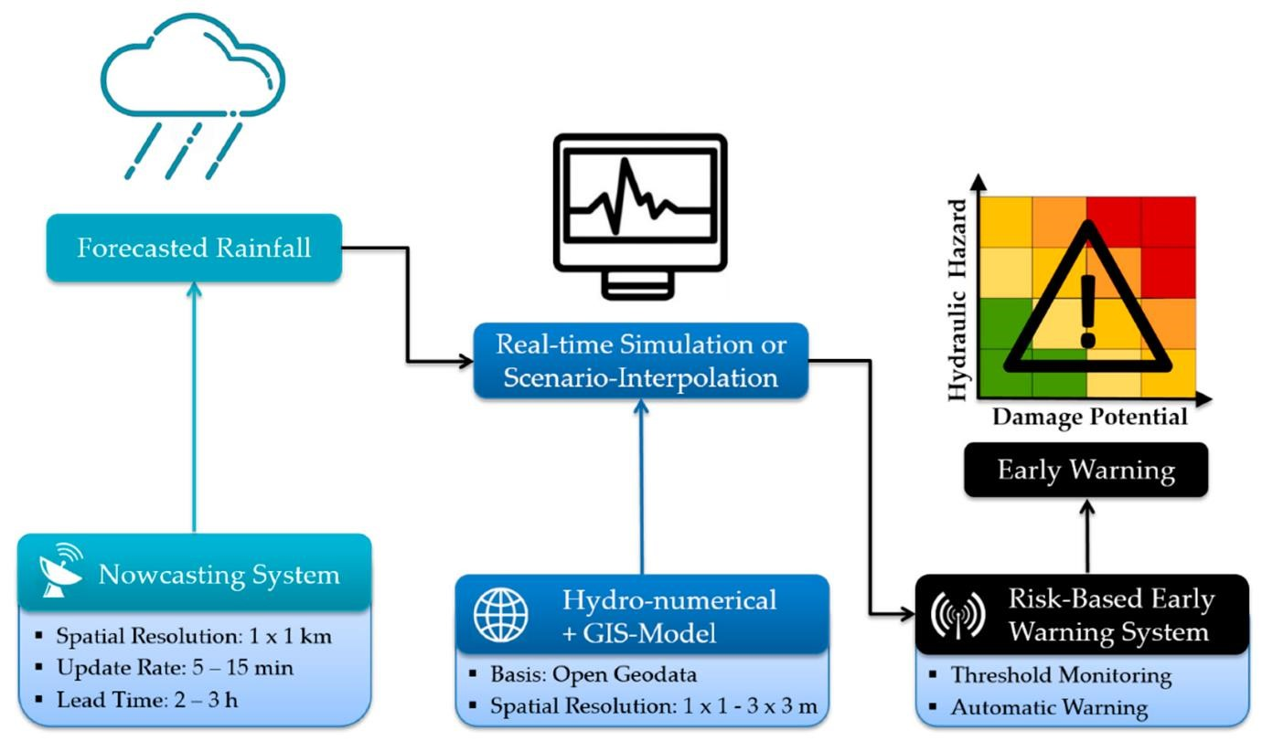

**To load and preprocess a dataset in flood monitoring and early warning with coding, you can use the following steps:**

Step 1: Import the necessary libraries. Python

import pandas as pd import numpy as np

Step 2: Load the dataset.

Python

# Load the dataset from a CSV file dataset = pd.read_csv('dataset.csv') Step 3: Clean and preprocess the data.

Python

# Remove outliers dataset = dataset[dataset['column_name'] < 1000]

# Convert data types dataset['column_name'] = dataset['column_name'].astype('float')

Step 4: Split the data into training and testing sets.

Python

# Split the data into training and testing sets from sklearn.model_selection import train_test_split

X_train, X_test, y_train, y_test = train_test_split(dataset, dataset['target_variable'], test_size=0.25, random_state=42) Step 5: Save the preprocessed data.

Python

# Save the preprocessed data to a CSV file

X_train.to_csv('X_train.csv', index=False) X_test.to_csv('X_test.csv', index=False) y_train.to_csv('y_train.csv', index=False) y_test.to_csv('y_test.csv', index=False)

# Fill in missing values dataset['column_name'].fillna(dataset['column_name'].mean(), inplace=True)

**\*This is a basic example of how to load and preprocess a dataset in flood monitoring and early warning with coding. You may need to modify the code depending on the specific needs of your dataset and the model you are using.**

**\*Here are some additional tips for loading and preprocessing a dataset in flood monitoring and early warning:**

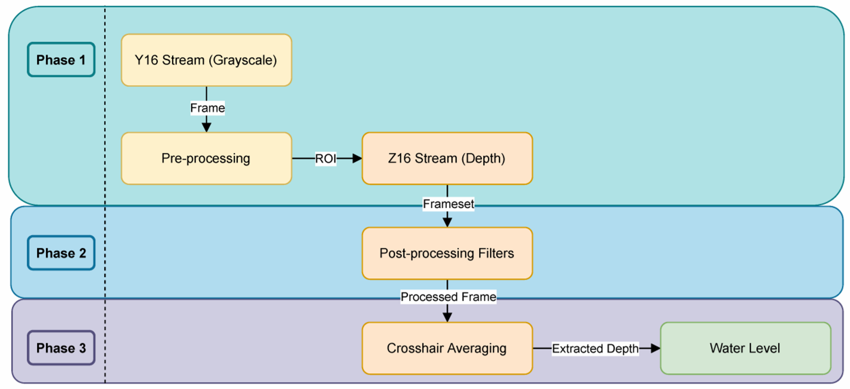

**\*Use a consistent data format for all of your data. This will make it easier to process the data and train a model.**

**\* If you are using multiple data sources, make sure that the data is merged in** **a consistent way.**

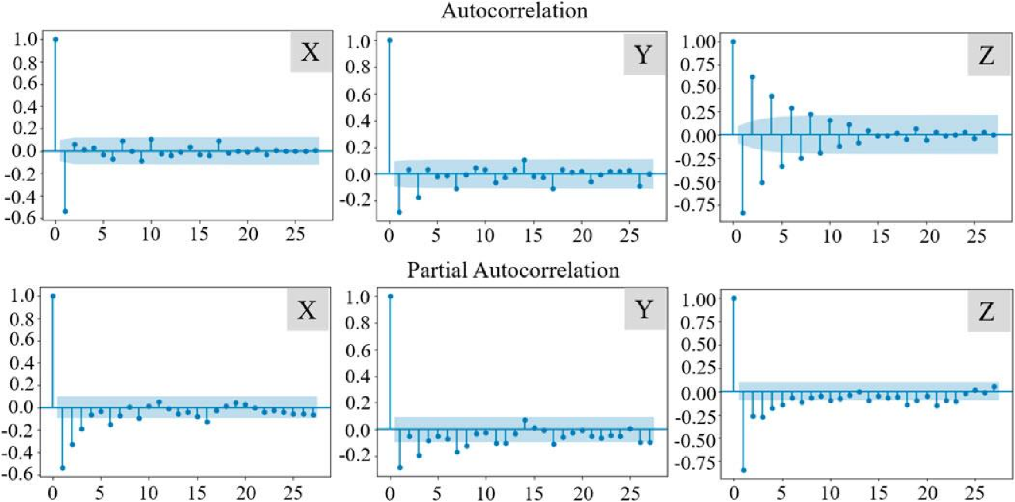

**\*Be careful not to overfit the model to the training data. This can be done by using a validation set or by using regularization techniques.**

**\* Evaluate the performance of the model on the testing set to ensure that it is generalizing well.**

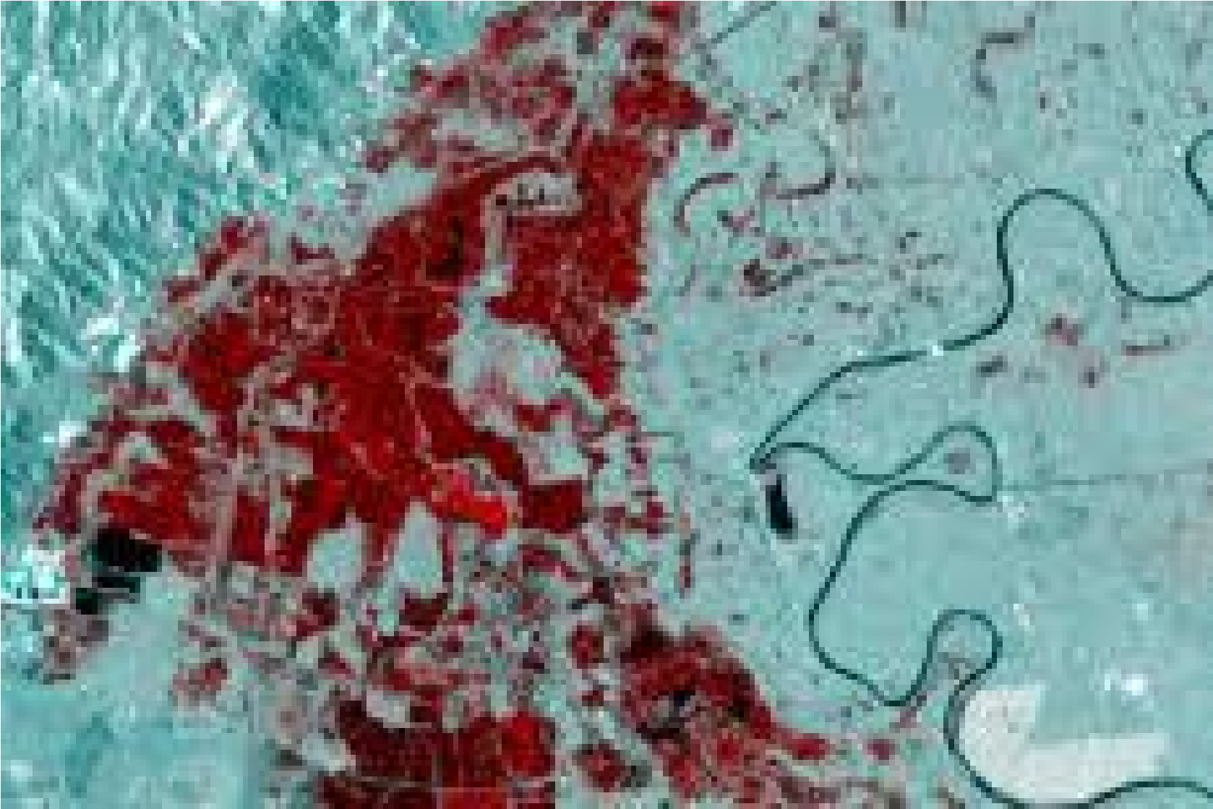

**\*Flood monitoring and early warning systems (FLEWS) are essential tools for reducing flood risk and saving lives. By providing early warning of potential flooding, FLEWS can give people time to evacuate or take other protective measures.**

**\*FLEWS have become increasingly sophisticated in recent years, thanks to advances in technology and data science. FLEWS now use a variety of data sources, including rain gauges, river gauges, satellite imagery, and weather radar, to monitor weather conditions and identify potential flood threats. This data is then used to generate accurate and timely flood warnings for people in at-risk areas**

**\*FLEWS are used all over the world, and they have helped to save countless lives. For example, in the United States, the National Weather Service's FLEWS is credited with saving thousands of lives each year.**

**\*Here is a summary of the benefits of flood monitoring and early warning systems:**

**\*Reduce loss of life and injury**

**\* Minimize property damage**

**\* Protect infrastructure and critical services**

**\*Facilitate evacuation and other emergency response measures**

**\* Improve public awareness of flood risk**

**FLEWS are an essential part of any comprehensive flood risk management strategy. By investing in FLEWS, governments and communities can help to protect their citizens and their property from the devastating effects of flooding.**

**In addition to the benefits listed above, FLEWS can also help to:**

**\*Support sustainable development**

**\*Reduce poverty and inequality**

**\*Promote social cohesion and resilience**

**FLEWS are a critical tool for building a more sustainable and resilient future in the face of climate change and other challenges.**

**Flood monitoring and early warning systems are crucial for mitigating the impact of floods on communities and infrastructure. Machine learning can play a significant role in enhancing the accuracy and timeliness of these systems. Here's how machine learning can be applied to flood monitoring and early warning:**

1. **Data Collection:**
   * **Remote Sensing: Machine learning models can analyze data from satellites and remote sensing technologies to monitor weather conditions, water levels, and land cover changes.**
2. **Data Preprocessing:**
   * **Data Cleaning: Removing noise and outliers from collected data to ensure its accuracy.**
   * **Feature Extraction: Identifying relevant features such as rainfall patterns, river discharge, and soil moisture.**
   * **Data Fusion: Integrating data from various sources to create a comprehensive view of the flood situation.**
3. **Prediction Models:**
   * **Rainfall Predictions: Machine learning models can forecast rainfall patterns and intensity, which are critical for flood prediction.**
   * **Hydrological Models: ML models can predict river discharge and water levels based on various factors like rainfall, temperature, and land topography.**
   * **Machine Learning Algorithms: Models like decision trees, random forests, support vector machines, and neural networks can be trained to make predictions based on historical data.**
4. **Early Warning System:**
   * **Trigger Thresholds: Establishing trigger thresholds for various parameters (e.g., river levels, rainfall) beyond which a flood warning is issued.**
   * **Real-time Monitoring: Continuously monitoring data from various sensors and sources in real-time.**
   * **Model Integration: Combining predictions from different models to provide a more accurate flood risk assessment.**
5. **Alerting and Communication:**
   * **Automated Alerts: Machine learning systems can trigger automated alerts when predefined thresholds are exceeded.**
   * **Communication Channels: Disseminating warnings through various channels, including mobile apps, text messages, social media, and sirens.**
6. **Risk Assessment:**
   * **Vulnerability Mapping: ML can help assess the vulnerability of specific areas, taking into account factors like population density, infrastructure, and topography.**
   * **Evacuation Planning: Predictive models can assist in planning evacuation routes and centers.**
7. **Continuous Learning:**
   * **Retraining Models: Periodically updating machine learning models with new data to improve prediction accuracy.**
   * **Adaptive Models: Developing models that can adapt to changing environmental conditions and data sources.**
8. **Feedback Mechanism:**
   * **Encouraging community feedback to improve the system and understand its limitations.**
9. **Post-Flood Analysis:**
   * **Using machine learning to analyze flood events, evaluate system performance, and identify areas for improvement.**

**It's important to note that the effectiveness of a flood monitoring and early warning system depends on the quality of data, the accuracy of the predictive models, and the speed of communication. Collaborative efforts involving meteorologists, hydrologists, data scientists, and local authorities are essential for the successful implementation of such systems. Additionally, the system should be designed to be resilient, adaptable, and capable of providing timely information to vulnerable communities.**

**Certainly! In machine learning and data science, there are several key activities involved in building and deploying a predictive model. These activities include feature engineering, model training, and model evaluation. Here's a brief overview of each of these activities:**

1. **Feature Engineering**:
   * Feature Selection: Identify and select relevant features (variables or attributes) from your dataset. This helps reduce noise and improve model performance.
   * Feature Transformation: Transform or preprocess features to make them more suitable for modeling. This can include techniques like scaling, one-hot encoding, or creating new features from existing ones.
   * Handling Missing Data: Address missing values in your dataset, which can involve imputation or removal of instances with missing data.
   * Feature Creation: Generate new features based on domain knowledge or by applying mathematical transformations to existing features.
   * Feature Scaling: Normalize or standardize features to ensure they have similar scales, which can be important for certain algorithms.
2. **Model Training**:
   * Data Splitting: Split your dataset into training, validation, and test sets. The training set is used to train the model, the validation set helps tune hyperparameters, and the test set assesses model performance.
   * Model Selection: Choose an appropriate machine learning algorithm or model architecture based on the nature of your problem (classification, regression, clustering, etc.).
   * Hyperparameter Tuning: Optimize model hyperparameters through techniques like grid search, random search, or Bayesian optimization to improve model performance.
   * Training the Model: Use the training data to train the selected model, adjusting the model's parameters to minimize a chosen loss function.
3. **Model Evaluation**:
   * Performance Metrics: Select appropriate evaluation metrics for your specific problem. Common metrics include accuracy, precision, recall, F1 score, mean squared error, or area under the ROC curve.
   * Cross-Validation: Use techniques like k-fold cross-validation to assess model performance more robustly and reduce the risk of overfitting.
   * Model Interpretability: Understand how the model is making predictions, especially in cases where interpretability is crucial, such as in healthcare or finance.
   * Model Comparison: Compare different models to select the best-performing one, considering trade-offs like complexity, accuracy, and interpretability.
4. **Model Deployment**:
   * Once you have a trained and evaluated model, you can deploy it to make predictions on new, unseen data. Deployment may involve creating APIs, integrating the model into a web application, or deploying it to a production environment.
   * Ongoing Monitoring: Continue to monitor the model's performance in the production environment and update it as needed to maintain accuracy.
5. **Feature Engineering**:
   * Feature Selection: Identify and select relevant features (variables or attributes) from your dataset. This helps reduce noise and improve model performance.
   * Feature Transformation: Transform or preprocess features to make them more suitable for modeling. This can include techniques like scaling, one-hot encoding, or creating new features from existing ones.
   * Handling Missing Data: Address missing values in your dataset, which can involve imputation or removal of instances with missing data.
   * Feature Creation: Generate new features based on domain knowledge or by applying mathematical transformations to existing features.
   * Feature Scaling: Normalize or standardize features to ensure they have similar scales, which can be important for certain algorithms.
6. **Model Training**:
   * Data Splitting: Split your dataset into training, validation, and test sets. The training set is used to train the model, the validation set helps tune hyperparameters, and the test set assesses model performance.
   * Model Selection: Choose an appropriate machine learning algorithm or model architecture based on the nature of your problem (classification, regression, clustering, etc.).
   * Hyperparameter Tuning: Optimize model hyperparameters through techniques like grid search, random search, or Bayesian optimization to improve model performance.
   * Training the Model: Use the training data to train the selected model, adjusting the model's parameters to minimize a chosen loss function.
7. **Model Evaluation**:
   * Performance Metrics: Select appropriate evaluation metrics for your specific problem. Common metrics include accuracy, precision, recall, F1 score, mean squared error, or area under the ROC curve.
   * Cross-Validation: Use techniques like k-fold cross-validation to assess model performance more robustly and reduce the risk of overfitting.
   * Model Interpretability: Understand how the model is making predictions, especially in cases where interpretability is crucial, such as in healthcare or finance.
   * Model Comparison: Compare different models to select the best-performing one, considering trade-offs like complexity, accuracy, and interpretability.
8. **Model Deployment**:
   * Once you have a trained and evaluated model, you can deploy it to make predictions on new, unseen data. Deployment may involve creating APIs, integrating the model into a web application, or deploying it to a production environment.
   * Ongoing Monitoring: Continue to monitor the model's performance in the production environment and update it as needed to maintain accuracy.

These activities are iterative and interrelated, and the success of a machine learning project often depends on the quality of work put into each of these phases. Additionally, domain knowledge and problem-specific expertise play a significant role in guiding these activities.

These activities are iterative and interrelated, and the success of a machine learning project often depends on the quality of work put into each of these phases. Additionally, domain knowledge and problem-specific expertise play a significant role in guiding these activities.

[https://wokwi.com/projects/378906304430834689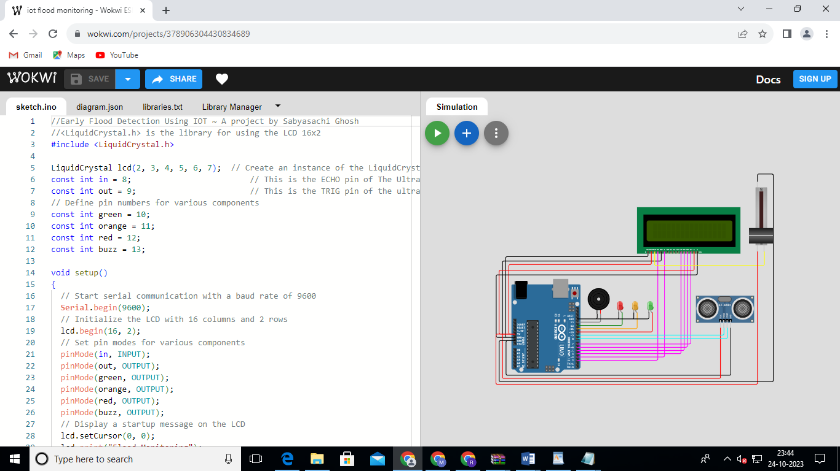](https://wokwi.com/projects/378906304430834689)

//Early Flood Detection Using IOT ~ A project by Sabyasachi Ghosh

//<LiquidCrystal.h> is the library for using the LCD 16x2

#include <LiquidCrystal.h>

LiquidCrystal lcd(2, 3, 4, 5, 6, 7);  // Create an instance of the LiquidCrystal library

const int in = 8;                         // This is the ECHO pin of The Ultrasonic sensor HC-SR04

const int out = 9;                        // This is the TRIG pin of the ultrasonic Sensor HC-SR04

// Define pin numbers for various components

const int green = 10;

const int orange = 11;

const int red = 12;

const int buzz = 13;

void setup()

{

  // Start serial communication with a baud rate of 9600

**Serial**.begin(9600);

  // Initialize the LCD with 16 columns and 2 rows

  lcd.begin(16, 2);

  // Set pin modes for various components

  pinMode(in, INPUT);

  pinMode(out, OUTPUT);

  pinMode(green, OUTPUT);

  pinMode(orange, OUTPUT);

  pinMode(red, OUTPUT);

  pinMode(buzz, OUTPUT);

  // Display a startup message on the LCD

  lcd.setCursor(0, 0);

  lcd.print("Flood Monitoring");

  lcd.setCursor(0, 1);

  lcd.print("Alerting System");

// Wait for 5 seconds and then clear the LCD

  delay(5000);

  lcd.clear();

}

void loop()

{

  // Read distance from the ultrasonic sensor (HC-SR04)

  long dur;

  long dist;

  long per;

  digitalWrite(out, LOW);

  delayMicroseconds(2);

  digitalWrite(out, HIGH);

  delayMicroseconds(10);

  digitalWrite(out, LOW);

  dur = pulseIn(in, HIGH);

  dist = (dur * 0.034) / 2;

  // Map the distance value to a percentage value

  per = map(dist, 10.5, 2, 0, 100);

  // Ensure that the percentage value is within bounds

  if (per < 0)

  {

    per = 0;

  }

  if (per > 100)

  {

    per = 100;

  }

  // Print water level data to serial

**Serial**.print("Water Level:");

**Serial**.println(String(per));

  lcd.setCursor(0, 0);

  lcd.print("Water Level:");

  lcd.print(String(per));

  lcd.print("%  ");

  // Check water level and set alert levels

  if (dist <= 3)

  {

    lcd.setCursor(0, 1);

    lcd.print("Red Alert!   ");

    digitalWrite(red, HIGH);

    digitalWrite(green, LOW);

    digitalWrite(orange, LOW);

    digitalWrite(buzz, HIGH);

    delay(2000);

    digitalWrite(buzz, LOW);

    delay(2000);

    digitalWrite(buzz, HIGH);

    delay(2000);

    digitalWrite(buzz, LOW);

    delay(2000);

  }

  else if (dist <= 10)

  {

    lcd.setCursor(0, 1);

    lcd.print("Orange Alert!  ");

    digitalWrite(orange, HIGH);

    digitalWrite(red, LOW);

    digitalWrite(green, LOW);

    digitalWrite(buzz, HIGH);

    delay(3000);

    digitalWrite(buzz, LOW);

    delay(3000);

  }

  else

  {

    lcd.setCursor(0, 1);

    lcd.print("Green Alert!  ");

    digitalWrite(green, HIGH);

    digitalWrite(orange, LOW);

    digitalWrite(red, LOW);

    digitalWrite(buzz, LOW);

  }

}

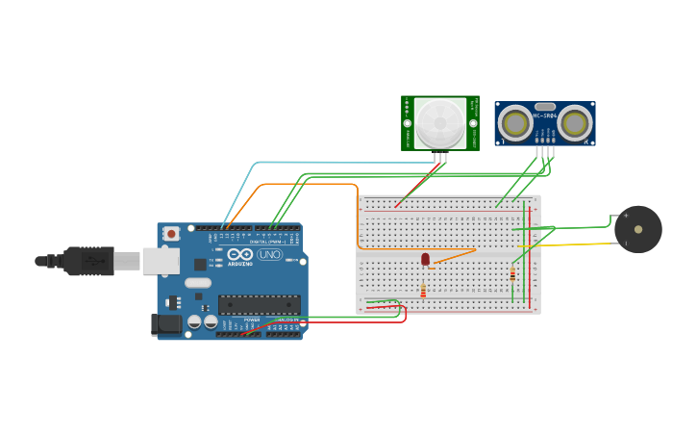

// C++ code

//

int PIR = 0;

int Distance = 0;

long readUltrasonicDistance(int triggerPin, int echoPin)

{

pinMode(triggerPin, OUTPUT); // Clear the trigger

digitalWrite(triggerPin, LOW);

delayMicroseconds(2);

// Sets the trigger pin to HIGH state for 10 microseconds

digitalWrite(triggerPin, HIGH);

delayMicroseconds(10);

digitalWrite(triggerPin, LOW);

pinMode(echoPin, INPUT);

// Reads the echo pin, and returns the sound wave travel time in microseconds

return pulseIn(echoPin, HIGH);

}

void setup()

{

pinMode(13, INPUT);

pinMode(12, OUTPUT);

pinMode(6, OUTPUT);

}

void loop()

{

delay(1); // Wait for 1 millisecond(s)

PIR = digitalRead(13);

delay(10); // Wait for 10 millisecond(s)

if (PIR == HIGH) {

digitalWrite(12, HIGH);

} else {

digitalWrite(12, LOW);

}

Distance = 0.01723 * readUltrasonicDistance(5, 4);

if (Distance <= 100) {

tone(6, 880, 125); // play tone 69 (A5 = 880 Hz)

delay(125); // Wait for 125 millisecond(s)

} else {

noTone(6);

}

}

**Tinkercad Link:**

<https://www.tinkercad.com/things/3Vs6ARbfJ5H-copy-of-flood-detector-and-early-warning/editel?sharecode=eZvaJAGSHBdy07kz6F1TpjdrCMq_gicvnCJfaPVDdLY>

**conclusion:**

In conclusion, flood monitoring and early warning systems are critical for mitigating the devastating impact of floods on communities and infrastructure. These systems play a pivotal role in providing timely information to help people and authorities make informed decisions and take necessary actions to protect lives and property. When integrated with modern technologies such as machine learning (ML) and the Internet of Things (IoT), these systems become even more effective and responsive. Here are some key takeaways:

1. **Data-Driven Decision Making**: The integration of ML and IoT allows for data-driven decision-making in flood monitoring and early warning systems. These technologies provide real-time data, predictive models, and automated alerts, enabling more accurate and timely responses.
2. **Increased Accuracy**: ML algorithms can analyze a wide range of data sources, including historical data, sensor data, and weather forecasts, to improve the accuracy of flood predictions. IoT sensors provide high-resolution real-time data for better monitoring.
3. **Faster Response**: ML and IoT enable faster response times by automating the monitoring process, setting trigger thresholds, and issuing warnings as soon as predetermined conditions are met.
4. **Adaptability**: ML models can adapt to changing environmental conditions and learn from new data, making the system more resilient and capable of responding to evolving flood dynamics.
5. **Community Engagement**: Modern flood monitoring systems, including apps and web portals, can engage the community by providing access to real-time data and flood risk information, empowering individuals to take precautionary measures.
6. **Efficient Resource Allocation**: These systems allow for more efficient allocation of resources during flood events, focusing efforts where they are most needed.
7. **Post-Flood Analysis**: ML can be used to conduct post-flood analysis to improve the system's performance and preparedness for future events.
8. **Resilience and Redundancy**: It is essential to design these systems with resilience and redundancy to ensure they remain operational in challenging conditions.
9. **Collaboration**: Successful flood monitoring and early warning systems require collaboration between meteorologists, hydrologists, data scientists, local authorities, and the public.

Overall, the combination of ML and IoT technologies offers a powerful solution to enhance the effectiveness of flood monitoring and early warning systems. These systems continue to evolve, providing more accurate predictions, faster response times, and better community engagement, ultimately contributing to the reduction of flood-related risks and impacts on society.