Experiment No. 10
Converted from the uploaded notebook file.

Development of a Real-Time IoE Stream Analytics and Anomaly Detection System using Node-RED and MQTT
This notebook demonstrates real-time Stream Analytics and Anomaly Detection for Internet of Everything (IoE) device data. Since this is a self-contained notebook environment, we will:
1. Install an MQTT broker and libraries to simulate Node-RED/MQTT topology.
2. Simulate a real-time IoE telemetry stream.
3. Build an online anomaly detection engine.
4. Visualize anomalies and system metrics in real-time.

Code Cell 2
# Install necessary libraries including an MQTT client and lightweight broker simulator
!pip install -q paho-mqtt
!apt-get install -q -y mosquitto mosquitto-clients
!service mosquitto start
Output:
Reading package lists...
Building dependency tree...
Reading state information...
The following additional packages will be installed:
libdlt2 libmosquitto1 libwebsockets19t64
Suggested packages:
apparmor
The following NEW packages will be installed:
libdlt2 libmosquitto1 libwebsockets19t64 mosquitto mosquitto-clients
0 upgraded, 5 newly installed, 0 to remove and 0 not upgraded.
Need to get 663 kB of archives.
After this operation, 1,954 kB of additional disk space will be used.
Get:1 http://archive.ubuntu.com/ubuntu noble/universe amd64 libmosquitto1 amd64 2.0.18-1build3 [54.1 kB]
Get:2 http://archive.ubuntu.com/ubuntu noble/universe amd64 libdlt2 amd64 2.18.10-10 [65.4 kB]
Get:3 http://archive.ubuntu.com/ubuntu noble/universe amd64 libwebsockets19t64 amd64 4.3.3-1.1build3 [229 kB]
Get:4 http://archive.ubuntu.com/ubuntu noble/universe amd64 mosquitto amd64 2.0.18-1build3 [242 kB]
Get:5 http://archive.ubuntu.com/ubuntu noble/universe amd64 mosquitto-clients amd64 2.0.18-1build3 [71.9 kB]
Fetched 663 kB in 1s (553 kB/s)
Selecting previously unselected package libmosquitto1:amd64.
(Reading database ... 122813 files and directories currently installed.)
Preparing to unpack .../libmosquitto1_2.0.18-1build3_amd64.deb ...
Unpacking libmosquitto1:amd64 (2.0.18-1build3) ...
Selecting previously unselected package libdlt2:amd64.
Preparing to unpack .../libdlt2_2.18.10-10_amd64.deb ...
Unpacking libdlt2:amd64 (2.18.10-10) ...
Selecting previously unselected package libwebsockets19t64:amd64.
Preparing to unpack .../libwebsockets19t64_4.3.3-1.1build3_amd64.deb ...
Unpacking libwebsockets19t64:amd64 (4.3.3-1.1build3) ...
Selecting previously unselected package mosquitto.
Preparing to unpack .../mosquitto_2.0.18-1build3_amd64.deb ...
Unpacking mosquitto (2.0.18-1build3) ...
Selecting previously unselected package mosquitto-clients.
Preparing to unpack .../mosquitto-clients_2.0.18-1build3_amd64.deb ...
Unpacking mosquitto-clients (2.0.18-1build3) ...
Setting up libmosquitto1:amd64 (2.0.18-1build3) ...
Setting up libwebsockets19t64:amd64 (4.3.3-1.1build3) ...
Setting up mosquitto-clients (2.0.18-1build3) ...
Setting up libdlt2:amd64 (2.18.10-10) ...
Setting up mosquitto (2.0.18-1build3) ...
invoke-rc.d: could not determine current runlevel
invoke-rc.d: policy-rc.d denied execution of start.
Created symlink /etc/systemd/system/multi-user.target.wants/mosquitto.service → /usr/lib/systemd/system/mosquitto.service.
Processing triggers for man-db (2.12.0-4build2) ...
Processing triggers for libc-bin (2.39-0ubuntu8.9) ...
/sbin/ldconfig.real: /usr/local/lib/libtbbbind.so.3 is not a symbolic link

/sbin/ldconfig.real: /usr/local/lib/libtbbbind_2_0.so.3 is not a symbolic link

/sbin/ldconfig.real: /usr/local/lib/libtbb.so.12 is not a symbolic link

/sbin/ldconfig.real: /usr/local/lib/libtbbbind_2_5.so.3 is not a symbolic link

/sbin/ldconfig.real: /usr/local/lib/libhwloc.so.15 is not a symbolic link

/sbin/ldconfig.real: /usr/local/lib/libur_adapter_level_zero_v2.so.0 is not a symbolic link

/sbin/ldconfig.real: /usr/local/lib/libtcm_debug.so.1 is not a symbolic link

/sbin/ldconfig.real: /usr/local/lib/libur_loader.so.0 is not a symbolic link

/sbin/ldconfig.real: /usr/local/lib/libtbbmalloc.so.2 is not a symbolic link

/sbin/ldconfig.real: /usr/local/lib/libur_adapter_level_zero.so.0 is not a symbolic link

/sbin/ldconfig.real: /usr/local/lib/libtcm.so.1 is not a symbolic link

/sbin/ldconfig.real: /usr/local/lib/libtbbmalloc_proxy.so.2 is not a symbolic link

/sbin/ldconfig.real: /usr/local/lib/libumf.so.1 is not a symbolic link

/sbin/ldconfig.real: /usr/local/lib/libur_adapter_opencl.so.0 is not a symbolic link

[74G[ OK ]

Code Cell 3
import json
import time
import random
import paho.mqtt.client as mqtt
import pandas as pd
import numpy as np
import matplotlib.pyplot as plt
from IPython.display import clear_output

# Configure global parameters
MQTT_BROKER = "localhost"
MQTT_PORT = 1883
MQTT_TOPIC = "ioe/sensors/telemetry"

print("Environment and MQTT client dependencies initialized successfully.")
Output:
Environment and MQTT client dependencies initialized successfully.

Step 1: Real-Time IoE Telemetry Simulator
We will create a publisher that streams telemetry data representing physical parameters like temperature, pressure, or vibration. It will occasionally inject spikes or drops (anomalies).

Code Cell 5
import threading

def start_telemetry_simulator(stop_event):
"""Simulates real-time IoE device sending metrics over MQTT."""
client = mqtt.Client(callback_api_version=mqtt.CallbackAPIVersion.VERSION2)
try:
client.connect(MQTT_BROKER, MQTT_PORT, 60)
except Exception as e:
print(f"Connection failed: {e}. Ensure mosquitto service is running.")
return

print("Simulator publisher successfully connected to broker.")

step = 0
while not stop_event.is_set():
# Standard telemetry: sine wave base + noise
base_val = 50.0 + 10.0 * np.sin(step * 0.1)
noise = random.normalvariate(0, 1.5)
value = base_val + noise

is_anomaly = False
# Inject anomaly every ~30 iterations
if step > 0 and step % 30 == 0:
anomaly_direction = random.choice([-1, 1])
value += anomaly_direction * random.uniform(15, 25)
is_anomaly = True

payload = {
"timestamp": time.time(),
"device_id": "ioe_sensor_01",
"metric_value": round(value, 3),
"injected_anomaly": is_anomaly
}

client.publish(MQTT_TOPIC, json.dumps(payload))
step += 1
time.sleep(0.5)

client.disconnect()
print("Simulator publisher stopped.")

Step 2: Stream Processor and Anomaly Detection Engine
We will set up a consumer client. It subscribes to the MQTT topic, processes data points in real-time using a rolling window to detect outliers, and retains history for performance monitoring.

Code Cell 7
# Stream history lists
timestamps = []
values = []
detected_anomalies = []
true_anomalies = []

# Configuration for rolling z-score detector
WINDOW_SIZE = 15
THRESHOLD = 2.5

def on_message(client, userdata, msg):
try:
data = json.loads(msg.payload.decode())
val = data["metric_value"]
ts = data["timestamp"]
true_anom = data["injected_anomaly"]

timestamps.append(ts)
values.append(val)
true_anomalies.append(true_anom)

# Anomaly detection algorithm: Rolling Z-Score
if len(values) >= WINDOW_SIZE:
window = values[-WINDOW_SIZE:]
mean = np.mean(window)
std = np.std(window)
if std == 0:
std = 1e-5
z_score = abs(val - mean) / std
is_detected = z_score > THRESHOLD
else:
is_detected = False

detected_anomalies.append(is_detected)
except Exception as e:
print(f"Error processing message: {e}")

# Configure subscriber
sub_client = mqtt.Client(callback_api_version=mqtt.CallbackAPIVersion.VERSION2)
sub_client.on_message = on_message
sub_client.connect(MQTT_BROKER, MQTT_PORT, 60)
sub_client.subscribe(MQTT_TOPIC)
print("Subscriber initialized and configured.")
Output:
Subscriber initialized and configured.

Step 3: Run the System and Visualize
We launch the background simulator thread, run the subscriber loop to gather streaming data, and generate dynamic real-time plots of performance metrics.

Code Cell 9
# Reset telemetry state
timestamps.clear()
values.clear()
detected_anomalies.clear()
true_anomalies.clear()

stop_event = threading.Event()
pub_thread = threading.Thread(target=start_telemetry_simulator, args=(stop_event,))
pub_thread.start()

# Start subscriber network loop
sub_client.loop_start()

try:
# Allow some data points to stream in
print("Gathering initial data stream... (running for 15 seconds)")
for i in range(15):
time.sleep(1)

# Live visualization loop
for _ in range(15):
clear_output(wait=True)

if len(values) > 0:
fig, (ax1, ax2) = plt.subplots(2, 1, figsize=(12, 8))

# Plot 1: Live Telemetry Stream
ax1.plot(values, label="Telemetry Stream", color="#1f77b4")

# Identify index of detected and true anomalies
det_indices = [idx for idx, val in enumerate(detected_anomalies) if val]
det_vals = [values[idx] for idx in det_indices]
true_indices = [idx for idx, val in enumerate(true_anomalies) if val]
true_vals = [values[idx] for idx in true_indices]

ax1.scatter(true_indices, true_vals, color="green", marker="o", s=100, facecolors='none', edgecolors='g', label="Injected Anomaly")
ax1.scatter(det_indices, det_vals, color="red", marker="x", s=80, label="Detected Anomaly")
ax1.set_title("Real-Time IoE Data Stream with Anomalies")
ax1.set_xlabel("Datapoint Index")
ax1.set_ylabel("Value")
ax1.legend()
ax1.grid(True)

# Plot 2: Performance Evaluation Metrics over time
tp = sum(1 for i in range(len(detected_anomalies)) if detected_anomalies[i] and true_anomalies[i])
fp = sum(1 for i in range(len(detected_anomalies)) if detected_anomalies[i] and not true_anomalies[i])
fn = sum(1 for i in range(len(detected_anomalies)) if not detected_anomalies[i] and true_anomalies[i])

precision = tp / (tp + fp) if (tp + fp) > 0 else 1.0
recall = tp / (tp + fn) if (tp + fn) > 0 else 1.0
f1 = 2 * (precision * recall) / (precision + recall) if (precision + recall) > 0 else 1.0

metrics = ["Precision", "Recall", "F1-Score"]
scores = [precision, recall, f1]

ax2.bar(metrics, scores, color=["#2ca02c", "#d62728", "#9467bd"])
ax2.set_ylim(0, 1.1)
ax2.set_ylabel("Score")
ax2.set_title("Real-Time Detector Performance Metrics")
for idx, score in enumerate(scores):
ax2.text(idx, score + 0.02, f"{score:.2f}", ha='center', weight='bold')

plt.tight_layout()
plt.show()

time.sleep(2.0)

finally:
# Clean shutdown of stream loop and simulator thread
stop_event.set()
pub_thread.join()
sub_client.loop_stop()
sub_client.disconnect()
print("Real-time pipeline shut down successfully.")
Output:
<Figure size 1200x800 with 2 Axes>
Generated visualization:
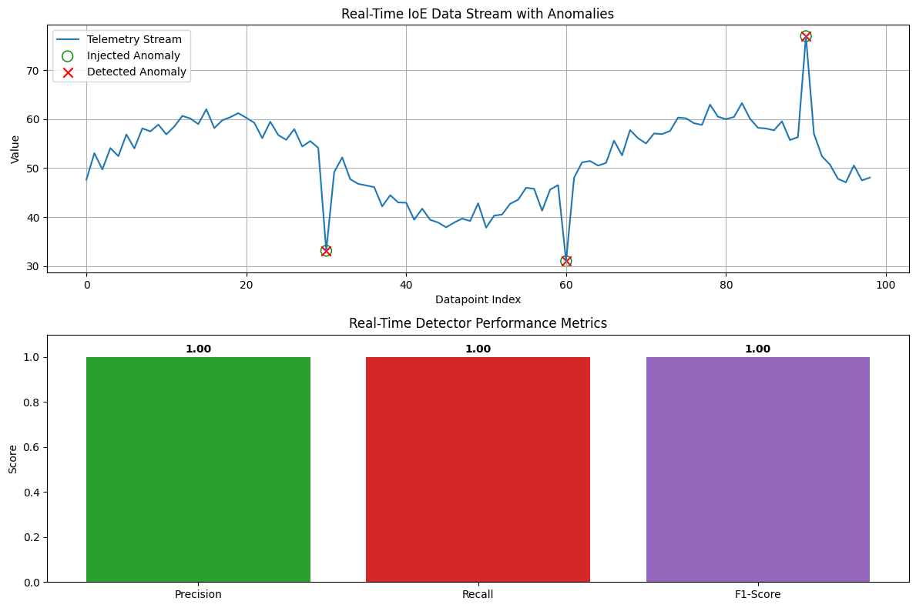
Output:
Simulator publisher stopped.
Real-time pipeline shut down successfully.

