CNN-Based Deep Learning Model for IoE Edge Applications
This notebook covers:
- Model implementation (lightweight CNN suitable for edge devices).
- Model training and validation (using CIFAR-10 as a surrogate dataset).
- Performance Evaluation (Accuracy, Confusion Matrix, and Sample Predictions).
- Edge Deployment Analysis (Inference Latency and Resource/Model Size Analysis).
import tensorflow as tf
from tensorflow.keras import layers, models
import numpy as np
import matplotlib.pyplot as plt
import time
import os
from sklearn.metrics import confusion_matrix, classification_report
import seaborn as sns
# Set random seed for reproducibility
tf.random.set_seed(42)
np.random.seed(42)
# Load and preprocess CIFAR-10 dataset
(x_train, y_train), (x_test, y_test) = tf.keras.datasets.cifar10.load_data()
# Normalize pixel values to be between 0 and 1
x_train, x_test = x_train / 255.0, x_test / 255.0
zz5
class_names = ['airplane', 'automobile', 'bird', 'cat', 'deer', 'dog', 'frog', 'horse', 'ship', 'truck']
print(f"Training data shape: {x_train.shape}")
print(f"Testing data shape: {x_test.shape}")

Output:
Downloading data from https://www.cs.toronto.edu/~kriz/cifar-10-python.tar.gz
[1m170498071/170498071[0m [32m━━━━━━━━━━━━━━━━━━━━[0m[37m[0m [1m1529s[0m 9us/step
Training data shape: (50000, 32, 32, 3)
Testing data shape: (10000, 32, 32, 3)

Lightweight CNN Architecture for Edge Deployments
# Define a lightweight CNN to mimic edge device computational constraints
def create_edge_cnn():
model = models.Sequential([
layers.Conv2D(32, (3, 3), activation='relu', input_shape=(32, 32, 3)),
layers.MaxPooling2D((2, 2)),
layers.Conv2D(64, (3, 3), activation='relu'),
layers.MaxPooling2D((2, 2)),
layers.Conv2D(64, (3, 3), activation='relu'),
layers.Flatten(),
layers.Dense(64, activation='relu'),
layers.Dense(10)
])
return model
model = create_edge_cnn()
model.compile(optimizer='adam',
loss=tf.keras.losses.SparseCategoricalCrossentropy(from_logits=True),
metrics=['accuracy'])
model.summary()

Output:
/usr/local/lib/python3.13/dist-packages/keras/src/layers/convolutional/base_conv.py:113: UserWarning: Do not pass an `input_shape`/`input_dim` argument to a layer. When using Sequential models, prefer using an `Input(shape)` object as the first layer in the model instead.
super().__init__(activity_regularizer=activity_regularizer, **kwargs)

Output:
[1mModel: "sequential"[0m

Output:
┏━━━━━━━━━━━━━━━━━━━━━━━━━━━━━━━━━┳━━━━━━━━━━━━━━━━━━━━━━━━┳━━━━━━━━━━━━━━━┓
┃[1m [0m[1mLayer (type) [0m[1m [0m┃[1m [0m[1mOutput Shape [0m[1m [0m┃[1m [0m[1m Param #[0m[1m [0m┃
┡━━━━━━━━━━━━━━━━━━━━━━━━━━━━━━━━━╇━━━━━━━━━━━━━━━━━━━━━━━━╇━━━━━━━━━━━━━━━┩
│ conv2d ([38;5;33mConv2D[0m) │ ([38;5;45mNone[0m, [38;5;34m30[0m, [38;5;34m30[0m, [38;5;34m32[0m) │ [38;5;34m896[0m │
├─────────────────────────────────┼────────────────────────┼───────────────┤
│ max_pooling2d ([38;5;33mMaxPooling2D[0m) │ ([38;5;45mNone[0m, [38;5;34m15[0m, [38;5;34m15[0m, [38;5;34m32[0m) │ [38;5;34m0[0m │
├─────────────────────────────────┼────────────────────────┼───────────────┤
│ conv2d_1 ([38;5;33mConv2D[0m) │ ([38;5;45mNone[0m, [38;5;34m13[0m, [38;5;34m13[0m, [38;5;34m64[0m) │ [38;5;34m18,496[0m │
├─────────────────────────────────┼────────────────────────┼───────────────┤
│ max_pooling2d_1 ([38;5;33mMaxPooling2D[0m) │ ([38;5;45mNone[0m, [38;5;34m6[0m, [38;5;34m6[0m, [38;5;34m64[0m) │ [38;5;34m0[0m │
├─────────────────────────────────┼────────────────────────┼───────────────┤
│ conv2d_2 ([38;5;33mConv2D[0m) │ ([38;5;45mNone[0m, [38;5;34m4[0m, [38;5;34m4[0m, [38;5;34m64[0m) │ [38;5;34m36,928[0m │
├─────────────────────────────────┼────────────────────────┼───────────────┤
│ flatten ([38;5;33mFlatten[0m) │ ([38;5;45mNone[0m, [38;5;34m1024[0m) │ [38;5;34m0[0m │
├─────────────────────────────────┼────────────────────────┼───────────────┤
│ dense ([38;5;33mDense[0m) │ ([38;5;45mNone[0m, [38;5;34m64[0m) │ [38;5;34m65,600[0m │
├─────────────────────────────────┼────────────────────────┼───────────────┤
│ dense_1 ([38;5;33mDense[0m) │ ([38;5;45mNone[0m, [38;5;34m10[0m) │ [38;5;34m650[0m │
└─────────────────────────────────┴────────────────────────┴───────────────┘

Output:
[1m Total params: [0m[38;5;34m122,570[0m (478.79 KB)

Output:
[1m Trainable params: [0m[38;5;34m122,570[0m (478.79 KB)

Output:
[1m Non-trainable params: [0m[38;5;34m0[0m (0.00 B)
# Train the model
history = model.fit(x_train, y_train, epochs=10,
validation_data=(x_test, y_test),
batch_size=64)

Output:
Epoch 1/10
[1m782/782[0m [32m━━━━━━━━━━━━━━━━━━━━[0m[37m[0m [1m79s[0m 99ms/step - accuracy: 0.4177 - loss: 1.5944 - val_accuracy: 0.5142 - val_loss: 1.3472
Epoch 2/10
[1m782/782[0m [32m━━━━━━━━━━━━━━━━━━━━[0m[37m[0m [1m70s[0m 90ms/step - accuracy: 0.5572 - loss: 1.2411 - val_accuracy: 0.5902 - val_loss: 1.1458
Epoch 3/10
[1m782/782[0m [32m━━━━━━━━━━━━━━━━━━━━[0m[37m[0m [1m74s[0m 94ms/step - accuracy: 0.6130 - loss: 1.0996 - val_accuracy: 0.6257 - val_loss: 1.0559
Epoch 4/10
[1m782/782[0m [32m━━━━━━━━━━━━━━━━━━━━[0m[37m[0m [1m72s[0m 92ms/step - accuracy: 0.6508 - loss: 1.0023 - val_accuracy: 0.6486 - val_loss: 1.0047
Epoch 5/10
[1m782/782[0m [32m━━━━━━━━━━━━━━━━━━━━[0m[37m[0m [1m80s[0m 89ms/step - accuracy: 0.6772 - loss: 0.9300 - val_accuracy: 0.6639 - val_loss: 0.9689
Epoch 6/10
[1m782/782[0m [32m━━━━━━━━━━━━━━━━━━━━[0m[37m[0m [1m82s[0m 90ms/step - accuracy: 0.6978 - loss: 0.8726 - val_accuracy: 0.6793 - val_loss: 0.9237
Epoch 7/10
[1m782/782[0m [32m━━━━━━━━━━━━━━━━━━━━[0m[37m[0m [1m83s[0m 92ms/step - accuracy: 0.7161 - loss: 0.8219 - val_accuracy: 0.6893 - val_loss: 0.9061
Epoch 8/10
[1m782/782[0m [32m━━━━━━━━━━━━━━━━━━━━[0m[37m[0m [1m70s[0m 90ms/step - accuracy: 0.7296 - loss: 0.7792 - val_accuracy: 0.6931 - val_loss: 0.8996
Epoch 9/10
[1m782/782[0m [32m━━━━━━━━━━━━━━━━━━━━[0m[37m[0m [1m70s[0m 90ms/step - accuracy: 0.7420 - loss: 0.7400 - val_accuracy: 0.6871 - val_loss: 0.9260
Epoch 10/10
[1m782/782[0m [32m━━━━━━━━━━━━━━━━━━━━[0m[37m[0m [1m70s[0m 89ms/step - accuracy: 0.7545 - loss: 0.7054 - val_accuracy: 0.6914 - val_loss: 0.9252

Model Evaluation
# Plot validation curves
plt.figure(figsize=(12, 4))
plt.subplot(1, 2, 1)
plt.plot(history.history['accuracy'], label='Accuracy')
plt.plot(history.history['val_accuracy'], label = 'Val Accuracy')
plt.xlabel('Epoch')
plt.ylabel('Accuracy')
plt.legend(loc='lower right')
plt.title('Accuracy Curves')
plt.subplot(1, 2, 2)
plt.plot(history.history['loss'], label='Loss')
plt.plot(history.history['val_loss'], label = 'Val Loss')
plt.xlabel('Epoch')
plt.ylabel('Loss')
plt.legend(loc='upper right')
plt.title('Loss Curves')
plt.show()

Output:
<Figure size 1200x400 with 2 Axes>
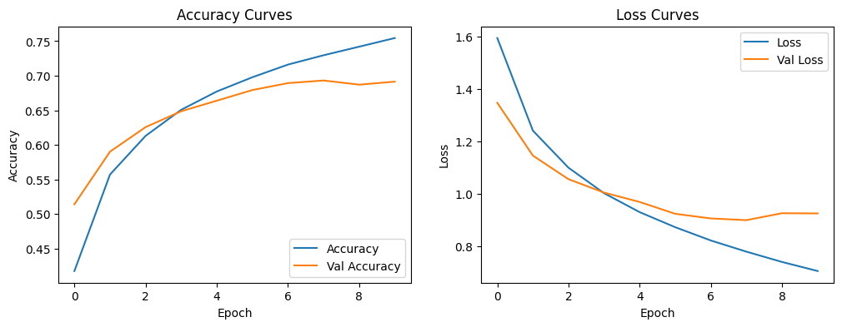
# Confusion Matrix
y_pred_logits = model.predict(x_test)
y_pred = np.argmax(y_pred_logits, axis=1)
cm = confusion_matrix(y_test, y_pred)
plt.figure(figsize=(10, 8))
sns.heatmap(cm, annot=True, fmt='d', xticklabels=class_names, yticklabels=class_names, cmap='Blues')
plt.xlabel('Predicted')
plt.ylabel('True')
plt.title('Confusion Matrix')
plt.show()

Output:
[1m313/313[0m [32m━━━━━━━━━━━━━━━━━━━━[0m[37m[0m [1m5s[0m 16ms/step

Output:
<Figure size 1000x800 with 2 Axes>
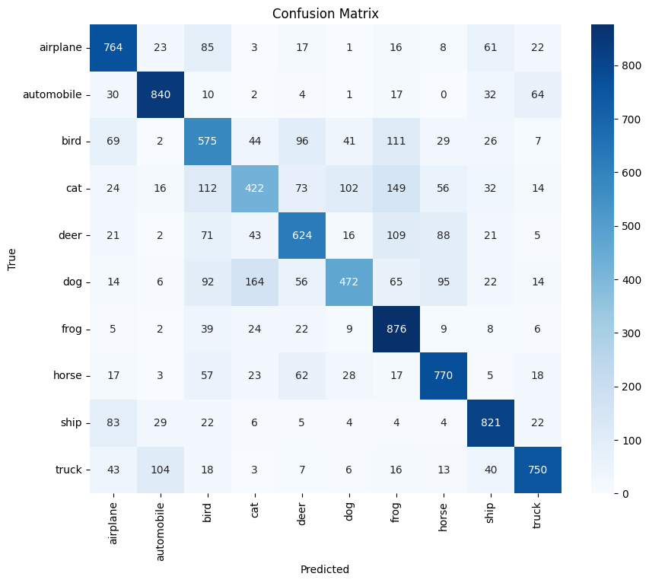
# Display Sample Predictions
plt.figure(figsize=(10, 10))
for i in range(9):
plt.subplot(3, 3, i+1)
plt.imshow(x_test[i])
true_label = class_names[y_test[i][0]]
pred_label = class_names[y_pred[i]]
color = 'green' if true_label == pred_label else 'red'
plt.title(f"True: {true_label}\nPred: {pred_label}", color=color)
plt.axis('off')
plt.tight_layout()
plt.show()

Output:
<Figure size 1000x1000 with 9 Axes>
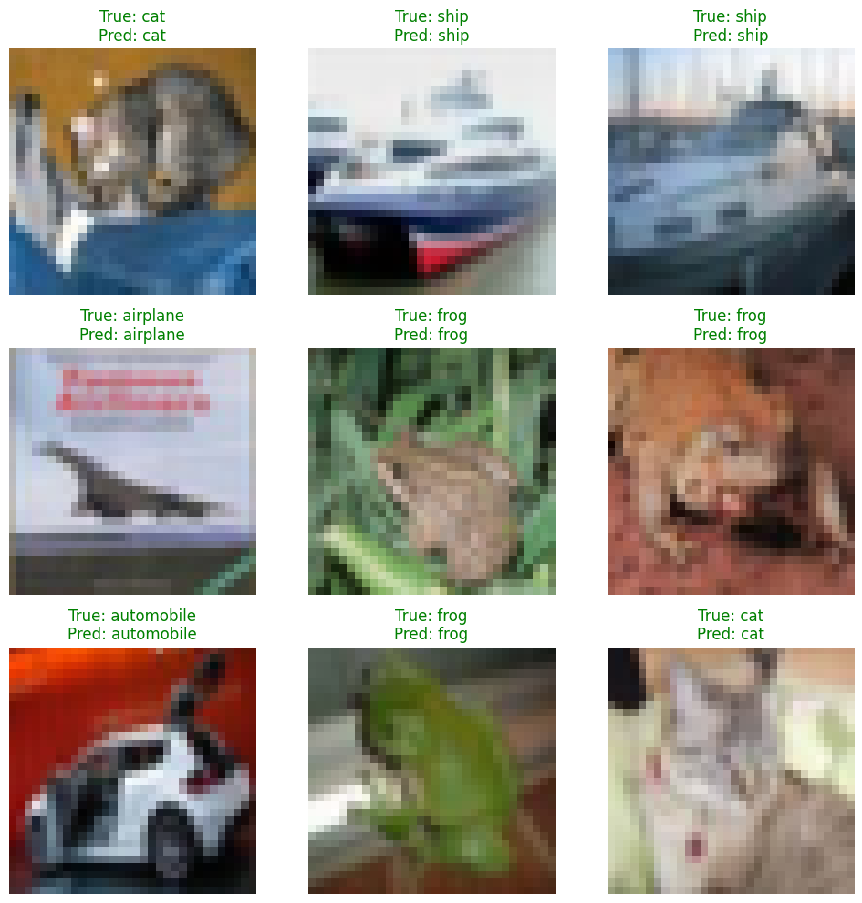

Inference Latency & Resource Analysis (Edge Profiling)
# Measure inference latency
num_samples = 100
start_time = time.time()
for i in range(num_samples):
_ = model.predict(x_test[i:i+1], verbose=0)
end_time = time.time()
avg_latency = (end_time - start_time) / num_samples * 1000
print(f"Average single-sample inference latency: {avg_latency:.2f} ms")

Output:
Average single-sample inference latency: 98.89 ms
# Save the model to evaluate size on disk
model.save('edge_cnn_model.h5')
model_size_mb = os.path.getsize('edge_cnn_model.h5') / (1024 * 1024)
print(f"Model Size on Disk: {model_size_mb:.2f} MB")

Output:
WARNING:absl:You are saving your model as an HDF5 file via `model.save()` or `keras.saving.save_model(model)`. This file format is considered legacy. We recommend using instead the native Keras format, e.g. `model.save('my_model.keras')` or `keras.saving.save_model(model, 'my_model.keras')`.

Output:
Model Size on Disk: 1.45 MB

