IoE Framework & 5G/6G Communication Benchmarking
Experiment 6 — Notebook Documentation

IoE Framework & 5G/6G Communication Benchmarking
This notebook contains the implementation of:
- People-Process-Data-Things (P-P-D-T) simulation engine.
- Edge/Fog-to-Cloud pipeline processing comparisons.
- Comparative benchmarking visualizations of 5G vs 6G network parameters (Throughput, Latency, Reliability, and Energy Efficiency).

Code
import numpy as np
import pandas as pd
import matplotlib.pyplot as plt
import seaborn as sns
import time
import random
# Set random seed for reproducibility
np.random.seed(42)
random.seed(42)
# Configure visual aesthetics
sns.set_theme(style="whitegrid")
plt.rcParams["figure.figsize"] = (12, 5)
plt.rcParams["axes.labelsize"] = 12
plt.rcParams["axes.titlesize"] = 14

1. P-P-D-T Data Flow Simulation
We model the structured interaction of the four core pillars of the Internet of Everything (IoE):
- People: Wearable vital data (Heart rate, Activity indexes).
- Things: Environmental IoT Telemetry (Temperature, Humidity, Vibration).
- Data: Payload size, timestamps, structured stream data packets.
- Process: Triggering logic based on anomalies (e.g., local warning flags).

Code
def generate_ppdt_stream(num_samples=1000):
timestamps = pd.date_range(start="2026-01-01", periods=num_samples, freq="s")
# Things (Sensors)
temp = np.random.normal(loc=24.0, scale=1.5, size=num_samples)
vibration = np.random.normal(loc=0.05, scale=0.01, size=num_samples)
# People (Wearables)
heart_rate = np.random.normal(loc=72, scale=8, size=num_samples).astype(int)
activity_index = np.random.choice([0, 1, 2], size=num_samples, p=[0.6, 0.3, 0.1]) # Rest, Walk, Run
# Assemble Base Data
df = pd.DataFrame({
"timestamp": timestamps,
"thing_temp_celsius": temp,
"thing_vibration_g": vibration,
"people_heart_rate": heart_rate,
"people_activity": activity_index,
"data_packet_size_kb": np.random.choice([2, 4, 8, 16], size=num_samples, p=[0.5, 0.3, 0.15, 0.05])
})
# Process Engine (Defining trigger logic for anomalies)
# e.g., High heart rate combined with running or abnormal system vibration
df["process_alert_triggered"] = (
((df["people_heart_rate"] > 95) & (df["people_activity"] == 0)) |
(df["thing_vibration_g"] > 0.075)
).astype(int)
return df
ppdt_df = generate_ppdt_stream(num_samples=500)
display(ppdt_df.head(10))
 | timestamp | thing_temp_celsius | thing_vibration_g | people_heart_rate | people_activity | data_packet_size_kb | process_alert_triggered
0 | 2026-01-01 00:00:00 | 24.745071 | 0.059262 | 83 | 0 | 2 | 0
1 | 2026-01-01 00:00:01 | 23.792604 | 0.069094 | 79 | 1 | 2 | 0
2 | 2026-01-01 00:00:02 | 24.971533 | 0.036014 | 72 | 0 | 4 | 0
3 | 2026-01-01 00:00:03 | 26.284545 | 0.055630 | 66 | 0 | 2 | 0
4 | 2026-01-01 00:00:04 | 23.648770 | 0.043494 | 77 | 0 | 4 | 0
5 | 2026-01-01 00:00:05 | 23.648795 | 0.045129 | 75 | 0 | 4 | 0
6 | 2026-01-01 00:00:06 | 26.368819 | 0.044076 | 79 | 1 | 4 | 0
7 | 2026-01-01 00:00:07 | 25.151152 | 0.041360 | 77 | 1 | 8 | 0
8 | 2026-01-01 00:00:08 | 23.295788 | 0.050485 | 80 | 1 | 2 | 0
9 | 2026-01-01 00:00:09 | 24.813840 | 0.041690 | 67 | 0 | 2 | 0

2. Edge/Fog-to-Cloud Pipeline Performance Evaluation
Comparing processing latency when processing events locally at Edge/Fog node vs. routing raw data all the way back to the Centralized Cloud.

Code
def evaluate_pipeline_performance(df):
# Simulated propagation & processing parameters (in milliseconds)
# Edge: Low transport delay, moderate local compute constraint
edge_network_delay = np.random.normal(loc=5, scale=1, size=len(df)) # 5ms average
edge_compute_delay = np.random.normal(loc=2, scale=0.3, size=len(df)) # 2ms local decision
# Cloud: High transport delay, fast/scalable compute
cloud_network_delay = np.random.normal(loc=45, scale=8, size=len(df)) # 45ms average WAN
cloud_compute_delay = np.random.normal(loc=0.5, scale=0.1, size=len(df)) # 0.5ms ultra-fast cloud nodes
df_perf = df.copy()
df_perf["edge_total_latency_ms"] = edge_network_delay + edge_compute_delay
df_perf["cloud_total_latency_ms"] = cloud_network_delay + cloud_compute_delay
return df_perf
ppdt_perf_df = evaluate_pipeline_performance(ppdt_df)
# Visualize latency profile distributions
plt.figure(figsize=(10, 5))
sns.histplot(ppdt_perf_df["edge_total_latency_ms"], color="teal", label="Edge/Fog Processing", kde=True, bins=30)
sns.histplot(ppdt_perf_df["cloud_total_latency_ms"], color="coral", label="Direct-to-Cloud Processing", kde=True, bins=30)
plt.title("Latency Distribution Comparison: Edge/Fog vs Cloud Pipeline")
plt.xlabel("End-to-End Latency (ms)")
plt.ylabel("Packet Count")
plt.legend()
plt.tight_layout()
plt.show()
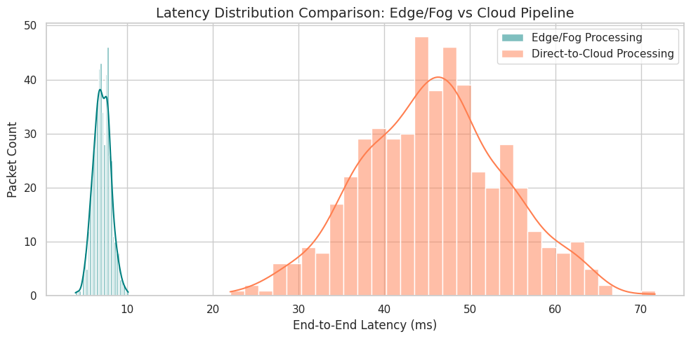

3. Benchmarking 5G vs 6G Communication for IoE Applications
We model and visualize simulated telemetry comparing 5G and 6G standards across key performance indicators (KPIs).

Code
# Define typical synthetic performance stats for 5G and 6G technologies
metrics = ["Throughput (Gbps)", "Latency (ms)", "Reliability (% packets received)", "Energy Efficiency (J/Mb)"]
# Average target figures from literature specifications
# 5G: ~20 Gbps peak, ~1-5ms air interface latency, 99.999% reliability, standard energy budget
# 6G: ~1000 Gbps peak, ~0.1ms air interface latency, 99.99999% reliability, 10x energy efficiency optimization
performance_data = {
"Metric": ["Throughput (Gbps)", "Throughput (Gbps)",
"Latency (ms)", "Latency (ms)",
"Reliability (%)", "Reliability (%)",
"Energy Consumption (nJ/bit)", "Energy Consumption (nJ/bit)"],
"Standard": ["5G", "6G", "5G", "6G", "5G", "6G", "5G", "6G"],
"Value": [20.0, 1000.0, 1.0, 0.1, 99.999, 99.99999, 1.2, 0.08]
}
benchmark_df = pd.DataFrame(performance_data)
display(benchmark_df)
 | Metric | Standard | Value
0 | Throughput (Gbps) | 5G | 20.00000
1 | Throughput (Gbps) | 6G | 1000.00000
2 | Latency (ms) | 5G | 1.00000
3 | Latency (ms) | 6G | 0.10000
4 | Reliability (%) | 5G | 99.99900
5 | Reliability (%) | 6G | 99.99999
6 | Energy Consumption (nJ/bit) | 5G | 1.20000
7 | Energy Consumption (nJ/bit) | 6G | 0.08000

Code
fig, axes = plt.subplots(2, 2, figsize=(14, 10))
# 1. Throughput Comparison
sns.barplot(ax=axes[0, 0], x="Standard", y="Value", data=benchmark_df[benchmark_df["Metric"] == "Throughput (Gbps)"], palette="Blues_d")
axes[0, 0].set_title("Peak Data Rate (Throughput)")
axes[0, 0].set_ylabel("Gbps (Log scale)")
axes[0, 0].set_yscale("log")
# 2. Latency Comparison
sns.barplot(ax=axes[0, 1], x="Standard", y="Value", data=benchmark_df[benchmark_df["Metric"] == "Latency (ms)"], palette="Oranges_r")
axes[0, 1].set_title("Over-the-Air Interface Latency")
axes[0, 1].set_ylabel("Milliseconds (Lower is Better)")
# 3. Reliability Comparison
sns.barplot(ax=axes[1, 0], x="Standard", y="Value", data=benchmark_df[benchmark_df["Metric"] == "Reliability (%)"], palette="Greens_d")
axes[1, 0].set_title("Transmission Reliability")
axes[1, 0].set_ylabel("Reliability (%)")
axes[1, 0].set_ylim(99.9, 100.0001)
# 4. Energy Efficiency
sns.barplot(ax=axes[1, 1], x="Standard", y="Value", data=benchmark_df[benchmark_df["Metric"] == "Energy Consumption (nJ/bit)"], palette="Purples_r")
axes[1, 1].set_title("Energy Consumption Per Bit")
axes[1, 1].set_ylabel("nanoJoules/bit (Lower is Better)")
plt.suptitle("5G vs 6G Communication Comparison Metrics for IoE Frameworks", fontsize=16, weight='bold')
plt.tight_layout()
plt.show()
/tmp/ipykernel_1737/1307282718.py:4: FutureWarning:
Passing `palette` without assigning `hue` is deprecated and will be removed in v0.14.0. Assign the `x` variable to `hue` and set `legend=False` for the same effect.
sns.barplot(ax=axes[0, 0], x="Standard", y="Value", data=benchmark_df[benchmark_df["Metric"] == "Throughput (Gbps)"], palette="Blues_d")
/tmp/ipykernel_1737/1307282718.py:10: FutureWarning:
Passing `palette` without assigning `hue` is deprecated and will be removed in v0.14.0. Assign the `x` variable to `hue` and set `legend=False` for the same effect.
sns.barplot(ax=axes[0, 1], x="Standard", y="Value", data=benchmark_df[benchmark_df["Metric"] == "Latency (ms)"], palette="Oranges_r")
/tmp/ipykernel_1737/1307282718.py:15: FutureWarning:
Passing `palette` without assigning `hue` is deprecated and will be removed in v0.14.0. Assign the `x` variable to `hue` and set `legend=False` for the same effect.
sns.barplot(ax=axes[1, 0], x="Standard", y="Value", data=benchmark_df[benchmark_df["Metric"] == "Reliability (%)"], palette="Greens_d")
/tmp/ipykernel_1737/1307282718.py:21: FutureWarning:
Passing `palette` without assigning `hue` is deprecated and will be removed in v0.14.0. Assign the `x` variable to `hue` and set `legend=False` for the same effect.
sns.barplot(ax=axes[1, 1], x="Standard", y="Value", data=benchmark_df[benchmark_df["Metric"] == "Energy Consumption (nJ/bit)"], palette="Purples_r")
