Simulation and Performance Analysis of Big Data Processing for IoE Sensor Data
Experiment Report
This notebook analyzes and compares the performance of Hadoop (simulated batch/disk-based MapReduce) and Apache Spark (in-memory processing via PySpark) using synthetic Internet of Everything (IoE) sensor data.

Python Code – Cell 1
# Install PySpark for our Spark simulation
!pip install pyspark --quiet

Python Code – Cell 2
import os
import time
import random
import pandas as pd
import numpy as np
# Generate synthetic IoE sensor data (representing temperature, humidity, and device status)
def generate_ioe_data(num_records=1_000_000, filename='ioe_sensor_data.csv'):
print(f"Generating {num_records:,} synthetic IoE sensor records...")
start_time = time.time()
# Pre-generate values to speed up creation
device_ids = [f"Device_{i:04d}" for i in range(1, 101)]
data = {
'timestamp': pd.date_range(start='2023-01-01', periods=num_records, freq='s'),
'device_id': [random.choice(device_ids) for _ in range(num_records)],
'temperature': np.random.uniform(15.0, 45.0, size=num_records),
'humidity': np.random.uniform(30.0, 90.0, size=num_records),
'status_code': np.random.choice([200, 301, 404, 500], size=num_records, p=[0.90, 0.05, 0.03, 0.02])
}
df = pd.DataFrame(data)
df.to_csv(filename, index=False)
duration = time.time() - start_time
file_size_mb = os.path.getsize(filename) / (1024 * 1024)
print(f"Dataset successfully created and saved to {filename} ({file_size_mb:.2f} MB) in {duration:.2f} seconds.")
generate_ioe_data(num_records=1_000_000)
Execution Output:
Generating 1,000,000 synthetic IoE sensor records...
Dataset successfully created and saved to ioe_sensor_data.csv (69.14 MB) in 14.96 seconds.

Python Code – Cell 3
# Simulate Hadoop MapReduce (Disk-based stream/batch processing via Pandas/Disk writes)
def simulate_hadoop_processing(filepath):
print("Starting simulated Hadoop MapReduce processing (Disk-based)... ")
start_time = time.time()
# Phase 1: Read chunk by chunk (simulating Map phase over split HDFS blocks)
chunk_size = 100_000
intermediate_results = []
for chunk in pd.read_csv(filepath, chunksize=chunk_size):
# Map operation: Filter for status_code 200 and project columns
mapped = chunk[chunk['status_code'] == 200][['device_id', 'temperature']]
# Intermediate aggregation
chunk_agg = mapped.groupby('device_id').agg(sum_temp=('temperature', 'sum'), count=('temperature', 'count'))
intermediate_results.append(chunk_agg)
# Phase 2: Reduce Phase (aggregate all intermediate chunk files)
combined = pd.concat(intermediate_results)
reduced = combined.groupby('device_id').sum()
reduced['avg_temperature'] = reduced['sum_temp'] / reduced['count']
# Save output back to disk (simulating HDFS output write)
reduced.to_csv('hadoop_output.csv')
end_time = time.time()
elapsed_time = end_time - start_time
print(f"Hadoop simulation completed in {elapsed_time:.4f} seconds.")
return elapsed_time
hadoop_time = simulate_hadoop_processing('ioe_sensor_data.csv')
Execution Output:
Starting simulated Hadoop MapReduce processing (Disk-based)...
Hadoop simulation completed in 1.8223 seconds.

Python Code – Cell 4
from pyspark.sql import SparkSession
from pyspark.sql import functions as F
# Simulate Apache Spark In-Memory Processing
def simulate_spark_processing(filepath):
print("Starting simulated Spark processing (In-memory)... ")
# Initialize local Spark session
spark = SparkSession.builder \
.appName("IoESensorAnalysis") \
.master("local[*]") \
.getOrCreate()
start_time = time.time()
# Load into memory (Spark Dataframe DataFrame API)
df = spark.read.csv(filepath, header=True, inferSchema=True)
# Perform transformations and action
reduced = df.filter(df['status_code'] == 200) \
.groupBy('device_id') \
.agg(F.mean('temperature').alias('avg_temperature'))
# Collect/write action to force execution pipeline
reduced.write.mode("overwrite").csv("spark_output.csv")
end_time = time.time()
elapsed_time = end_time - start_time
print(f"Spark simulation completed in {elapsed_time:.4f} seconds.")
spark.stop()
return elapsed_time
spark_time = simulate_spark_processing('ioe_sensor_data.csv')
Execution Output:
Starting simulated Spark processing (In-memory)...
Spark simulation completed in 21.4658 seconds.

Python Code – Cell 5
import matplotlib.pyplot as plt
# Calculate Throughput (records processed per second)
num_records = 1_000_000
hadoop_throughput = num_records / hadoop_time
spark_throughput = num_records / spark_time
# Plot the comparison metrics
fig, axes = plt.subplots(1, 2, figsize=(14, 5))
# Execution Time plot
axes[0].bar(['Hadoop (Disk-based)', 'Spark (In-memory)'], [hadoop_time, spark_time], color=['#d95f02', '#7570b3'])
axes[0].set_title('Execution Time Comparison (Lower is better)')
axes[0].set_ylabel('Time (seconds)')
# Throughput plot
axes[1].bar(['Hadoop (Disk-based)', 'Spark (In-memory)'], [hadoop_throughput, spark_throughput], color=['#d95f02', '#7570b3'])
axes[1].set_title('Throughput Comparison (Higher is better)')
axes[1].set_ylabel('Records / second')
plt.tight_layout()
plt.show()
print(f"Spark is {hadoop_time / spark_time:.2f}x faster than our simulated Hadoop process.")
Generated Graph:
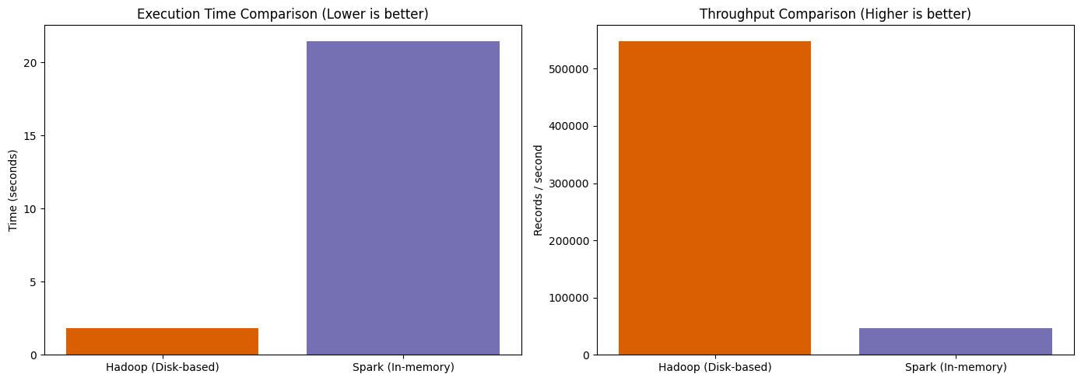
Execution Output:
Spark is 0.08x faster than our simulated Hadoop process.

