FLY INTERNATIONAL TRAVEL MANAGEMENT SYSTEM

A PROJECT REPORT

Submitted by

JEEVA V (8115U24AM028)
SARAN M (8115U24AM047)
THIRUKKUMARAN S (8115U24AM059)
VISHNU PRASATH R (8115U24AM063)

in partial fulfilment for the award of the course

AMC1361-MOBILE APPLICATION DEVELOPMENT IN
DEPARTMENT OF COMPUTER SCIENCE AND ENGINEERING
(ARTIFICIAL INTELLIGENCE AND MACHINE LEARNING)


K. RAMAKRISHNAN COLLEGE OF ENGINEERING
(AUTONOMOUS) SAMAYAPURAM, TRICHY


ANNA UNIVERSITY CHENNAI 600 025

NOVEMBER 2026

FLY INTERNATIONAL TRAVEL MANAGEMENT SYSTEM

PROJECT FINAL DOCUMENT

Submitted by

JEEVA V (8115U24AM028)
SARAN M (8115U24AM047)
THIRUKKUMARAN S (8115U24AM059)
VISHNU PRASATH R (8115U24AM063)

in partial fulfilment for the award of the course

AGC1341 – MOBILE APPLICATION DEVELOPMENT IN
DEPARTMENT OF
COMPUTER SCIENCE AND ENGINEERING (ARTIFICIAL INTELLIGENCE AND MACHINE LEARNING)

Under the Guidance of

Mrs. C. Rani
Department of CSE( Artificial Intelligence and Machine Learning)
K. RAMAKRISHNAN COLLEGE OF ENGINEERING


K. RAMAKRISHNAN COLLEGE OF ENGINEERING
(AUTONOMOUS)
ANNA UNIVERSITY, CHENNAI



K. RAMAKRISHNAN COLLEGE OF ENGINEERING (AUTONOMOUS)
ANNA UNIVERSITY, CHENNAI

BONAFIDE CERTIFICATE

Certified that this project report titled “FLY INTERNATIONAL TRAVEL MANAGEMENT SYSTEM” is the bonafide work of JEEVA V (8115U24AM028), SARAN M (8115U24AM047), THIRUKKUMARAN S (8115U24AM059), VISHNU PRASATH R (8115U24AM063) who carried out the work under my supervision.

SIGNATURE SIGNATURE

Dr. B. KIRAN BALA M.E.,M.B.A.,Ph.D.,
Mrs. C.RANI M.E.,

HEAD OF THE DEPARTMENT SUPERVISOR ASSOCIATE PROFESSOR, ASSISTANT PROFESSOR,
Department of Computer Science Department of Artificial Intelligence Engineering(Artificial Intelligence and Data Science,
Machine Learnig) K. Ramakrishnan College of
K. Ramakrishnan College of Engineering, (Autonomous)
Engineering, (Autonomous) Samayapuram, Trichy.
Samayapuram, Trichy.

SIGNATURE OF INTERNAL EXAMINER SIGNATURE OF EXTERNAL EXAMINER

NAME: NAME:
DATE: DATE:

K. RAMAKRISHNAN COLLEGE OF ENGINEERING (AUTONOMOUS)
ANNA UNIVERSITY, CHENNAI

DECLARATION BY THE CANDIDATES

We declare that to the best of our knowledge the work reported here in has been composed solely by ourself and that it has not been in whole or in part in any previous application for a degree.

Submitted for the project Viva-Voce held at K. Ramakrishnan College of Engineering on

SIGNATURE OF THE CANDIDATES

ACKNOWLEDGEMENT

We thank the almighty GOD, without whom it would not have been possible for us to complete my project.

We wish to address our profound gratitude to Dr.K.RAMAKRISHNAN, Chairman, K. Ramakrishnan College of Engineering(Autonomous), who encouraged and gave us all help throughout the course.

We extend my hearty gratitude and thanks to our honorable and grateful Executive Director Dr.S.KUPPUSAMY, B.Sc., MBA., Ph.D., K. Ramakrishnan College of Engineering(Autonomous).

We are glad to thank our Principal Dr.D.SRINIVASAN, M.E., Ph.D.,FIE., MIIW., MISTE., MISAE., C.Engg, for giving us permission to carry out this project.
We wish to convey our sincere thanks to Dr.B.KIRAN BALA, M.E., M.B.A., Ph.D., Head of the Department, Artificial Intelligence and Machine Learning for giving us constant encouragement and advice throughout the course.

We are grateful to Mrs. C.RANI,.M.E., Assistant Professor, Artificial Intelligence and Data Science, K. Ramakrishnan College of Engineering (Autonomous), for her guidance and valuable suggestions during the course of study.

Finally, we sincerely acknowledged in no less terms all our staff members, our parents and, friends for their co-operation and help at various stages of this project work.
JEEVA V (8115U24AM028)
SARAN M (8115U24AM047)
THIRUKKUMARAN S (8115U24AM059)
VISHNU PRASATH R (8115U24AM063)

K. RAMAKRISHNAN COLLEGE OF ENGINEERING


(AUTONOMOUS) ANNA UNIVERSITY, CHENNAI
DEPARTMENT OF CSE (ARTIFICIAL INTELLIGENCE AND MACHINE LEARNING)
VISION
To become a renowned hub for AIML technologies to producing highly talented globally recognizable technocrats to meet industrial needs and societal expectation.
MISSION
Mission of the Department
M1 To impart advanced education in AI and Machine Learning, built upon a foundation
In Computer Science and Engineering.
M2 To foster Experiential learning equips students with engineering skills to tackle real-world problems.
M3 To promote collaborative innovation in AI, machine learning, and related research and development with industries.
M4 To provide an enjoyable environment for pursuing excellence while upholding strong personal and professional values and ethics.

PROGRAM EDUCATIONAL OBJECTIVES (PEO’s)
PEO1 Excel in technical abilities to build intelligent systems in the fields of AI & ML in order to find new opportunities.
PEO2 Embrace new technology to solve real-world problems, whether alone or as a team, while prioritizing ethics and societal benefits.
PEO3 Accept lifelong learning to expand future opportunities in research and product development.

PROGRAM SPECIFIC OUTCOMES (PSO’s)
PSO1 Expertise in tailoring ML algorithms and models to excel in designated applications and fields.

PSO2 Ability to conduct research, contributing to machine learning advancements and innovations that tackle emerging societal challenges.

PROGRAM OUTCOMES (POs)
Engineering students will be able to:

PO1 Engineering knowledge: Apply the knowledge of mathematics, science, engineering fundamentals, and an engineering specialization to the solution of complex engineering problems. PO2 Problem analysis: Identify, formulate, review research literature, and analyze complex engineering problems reaching substantiated conclusions using first principles of mathematics, natural sciences, and engineering sciences.
PO3 Design/development of solutions: Design solutions for complex engineering problems and design system components or processes that meet the specified needs with appropriate consideration for the public health and safety, and the cultural, societal, and environmental considerations.
PO4 Conduct investigations of complex problems: Use research-based knowledge and research methods including design of experiments, analysis and interpretation of data, and synthesis of the information to provide valid conclusions.
PO5 Modern tool usage: Create, select, and apply appropriate techniques, resources, and modern engineering and IT tools including prediction and modelling to complex engineering activities with an understanding of the limitations.
PO6 The Engineer and Society: Apply reasoning informed by the contextual knowledge to assess societal, health, safety, legal and cultural issues and the consequent responsibilities relevant to the professional engineering practice.
PO7 Ethics: Apply ethical principles and commit to professional ethics and responsibilities and norms of the engineering practice.
PO8 Individual and team work: Function effectively as an individual, and as a member or leader in diverse teams, and in multidisciplinary settings
PO9 Communication: Communicate effectively on complex engineering activities with the engineering community and with society at large, such as, being able to comprehend and write effective reports and design documentation, make effective presentations, and give and receive clear instructions.
PO10 Project management and finance: Demonstrate knowledge and understanding of the engineering and management principles and apply these to one’s own work, as a member and leader in a team, to manage projects and in multidisciplinary environments.
PO11 Life-long learning: Recognize the need for and have the preparation and ability to engage in independent and life-long learning in the broadest context of technological change.

ABSTRACT

Fly International Travel Management System is a mobile application developed to bridge the gap between international travelers, airlines, and travel service providers by providing a simple, reliable, and accessible platform for managing overseas journeys. Planning an international trip requires searching for suitable flights, comparing fares, keeping passport and visa details ready, and tracking bookings, which becomes difficult when these tasks are handled through separate websites, travel agents, and manual records. Traditional methods of booking tickets through agents, phone calls, and scattered online portals often result in delays, duplicated effort, and difficulties in obtaining accurate information. To overcome these challenges, Fly International Travel Management System provides a centralized digital platform that simplifies the process of searching, booking, and managing international flights. One of the major features of Fly International Travel Management System is its flight booking management system, which enables users to search flights and create bookings by specifying the destination, travel class, departure date, number of seats, airline, and contact information. These bookings can be reviewed and tracked by the traveler, allowing changes in booking status to be monitored from a single place. The application also provides a structured way to manage traveler information, passport details, and visa status, reducing dependency on manual records and unorganized communication methods. Furthermore, Fly International Travel Management System aims to create awareness about travel documentation requirements and encourage travelers to prepare their passports, visas, and itineraries well before departure. By maintaining an organized database of registered travelers and their bookings, the system supports faster communication and better coordination before and during a journey.

viii

ABSTRACT WITH POs AND PSOs MAPPING

ABSTRACT | POs MAPPED | PSOs MAPPED
Fly International Travel Management System is a mobile application designed to simplify international travel planning by integrating essential travel services into a single platform. It enables users to register traveler profiles, search international flights, manage passport and visa details, book tickets, and track booking status. The application aims to improve coordination, document readiness, and convenience during trip planning. By providing centralized access to travel information and booking management features, Fly International Travel Management System reduces the complexity of organizing overseas journeys. The proposed system offers a user-friendly approach to international travel management and can be enhanced with intelligent fare recommendations, online payment integration, and real-time flight tracking. | PO1-3 PO2-3 PO3-3 PO4-3 PO5-3 PO6-3 PO7-3 PO8-3 PO9-3 PO10-3 PO11-3 PO12-3 | PSO1 – 3  PSO2 – 3

Note: 1- Low, 2-Medium, 3- High

TABLE OF CONTENTS

CH E
APTER |  | TITLE | PAG
No. |  |  | No.
 |  | ABSTRACT | viii
 |  | LIST OF ABBREVIATIONS | xii
 |  | LIST OF FIGURES | xiii
1 |  | INTRODUCTION | 1
 | 1.1 | Objective | 1
 | 1.2 | Overview of the System | 1
 | 1.3 | Purpose and Importance | 2
 | 1.4 | Challenges in International Travel Management | 3
 | 1.5 | Project Summarization | 3
2 |  | LITERATURE SURVEY | 4
 | 2.1 | Traditional Travel Booking Methods | 4
 | 2.2 | Digital Travel Booking Platforms | 6
 | 2.3 | Role of Airline and Immigration Systems | 6
 | 2.4 | Related Works and Existing Systems | 7
3 |  | PROJECT METHODOLOGY | 8
 | 3.1 | Proposed Workflow of the System | 8
 | 3.2 | System Architectural Diagram | 9
 | 3.3 | Hardware and Software Requirements | 10
4 |  | RELEVANCE OF THE PROJECT | 11
 | 4.1 | Why the Model Was Chosen | 11
 | 4.2 | Comparison with Existing Models | 11
 | 4.3 | Advantages and Limitations | 12

5 |  | MODULE DESCRIPTION | 13
 | 5.1 | Authentication and Profile Module | 13
 | 5.2 | Home and Flight Search Module | 13
 | 5.3 | Flight Booking Management Module | 14
 | 5.4 | Passport, Visa and Notification Module | 14
 | 5.5 | Booking History and Status Module | 15
6 |  | RESULTS AND DISCUSSION | 16
 | 6.1 | Generated Output and System Performance | 16
 | 6.2 | User Interaction and UI Review | 16
7 |  | CONCLUSION & FUTURE SCOPE | 17
 | 7.1 | Conclusion and Summary of Outcomes | 17
 | 7.2 | Future Enhancements & Long-Term Scope | 17
 |  | APPENDICES | 18
 |  | APPENDIX A – SOURCE CODE | 18
 |  | APPENDIX B – SCREENSHOTS | 29
 |  | REFERENCES | 33

LIST OF ABBREVIATIONS

S. NO. | ACRONYM | ABBREVIATION
1 | AI | Artificial Intelligence
2 | API | Application Programming Interface
3 | APK | Android Package Kit
4 | DB | Database
5 | DBMS | Database Management System
6 | FCM | Firebase Cloud Messaging
7 | HTTP | Hypertext Transfer Protocol
8 | SDK | Software Development Kit
9 | UI | User Interface
10 | UX | User Experience

xii

LIST OF FIGURES

FIGURE NO | TITLE | PAGE NO.
3.2.1 | System Architecture | 8
B.1.1 | Login Page | 29
B.1.2 | Register page | 30
B.1.3 | Traveler profile | 31
B.1.4 | Flight Search and Booking Status Page | 32

xiii

  - Objective

CHAPTER 1 INTRODUCTION
The main objective of Fly International Travel Management System is to develop a mobile application that helps users search, book, and manage international flights through a simple and accessible platform. The application organizes traveler registration, passport and visa information, destination-based flight search, travel class selection, and booking details. Instead of depending only on travel agents, phone calls, or several unconnected websites, users can use a centralized interface to plan their journeys and manage travel-related information.
A further objective is to improve coordination between travelers, airlines, and authorized travel coordinators. The system allows travelers to maintain their profiles and passport details, while users can submit bookings containing details such as destination, travel class, number of seats, airline, and contact information. Notifications and booking-status updates can help users respond promptly where these features are implemented. The application should protect personal information and encourage users to confirm visa and entry requirements with the airline and embassy.

Overview of the System
Fly International Travel Management System is a mobile application that supports common activities involved in planning and managing international travel. Users can register as travelers, provide their passport and contact details, update visa status, search for international flights, and submit flight bookings. A dashboard can present relevant bookings and traveler information, helping users access important functions from one place.

Search results and booking details should be reviewed by users before any ticket is confirmed. The application is intended to support planning and coordination; it does not grant visa approval or replace guidance from airlines, embassies, and immigration authorities.
The application can use a layered structure that separates the user interface, application logic, and data storage. Mobile screens support registration, flight search, bookings, and profile management. Application services validate user input and coordinate data operations, while a database stores traveler profiles, passport details, booking records, and status updates. Cloud services and notifications may be integrated when configured and tested.

Purpose and Importance
The purpose of Fly International Travel Management System is to reduce the difficulty of planning and booking international journeys. Travelers may need to contact multiple agents or visit different websites to compare flights, prepare documents, and track tickets, making it difficult to keep every detail organized. A centralized platform can organize traveler details and bookings in a consistent format, making the planning and coordination process easier to manage.
The importance of the project lies in improving access to travel-related information and encouraging well-prepared international travel. Flight search filters, passport and visa tracking, and booking status updates can help users coordinate more effectively. The system must handle personal data responsibly, display clear consent and privacy information, and remind users that visa approval and entry decisions must be confirmed by the airline, embassy, and immigration authorities.
Additionally, Fly International Travel Management System helps build a strong connection between travelers, airlines, and travel service providers by promoting a transparent and user-friendly booking system. It encourages individuals to keep their passport and visa information updated so that they can book and travel more efficiently.

Challenges in International Travel Management
International travelers may face difficulties finding flights to the required destination, comparing fares across travel classes, keeping passport and visa details up to date, and tracking booking information accurately. Information shared through informal channels can become outdated, duplicated, or difficult to track. In urgent situations, delays may occur when booking details are incomplete or confirmations are scattered across different emails and messages.
International travel also requires careful handling of passport validity, visa status, and booking status. Travel plans may change, and a traveler may not meet the entry requirements of a destination at a particular time. A structured application can help organize bookings and documents, but users must verify details with the airline and the destination country’s authorities and should not treat search results as a guarantee of seat availability or entry.

Project Summarization

Fly International Travel Management System is a mobile application intended to make international flight search and travel coordination more organized. The system brings together traveler registration, profile management, passport and visa tracking, flight search, booking submission, and booking-status tracking. By keeping these functions within one interface, it aims to reduce fragmented communication and help travelers manage their journeys more efficiently. The project provides a practical example of mobile application development, database management, user-interface design, and notification-based communication. Its data model can organize traveler profiles and flight bookings, while validation and access controls help protect information. Future improvements may include airline partnerships, real-time fare comparison, multilingual support, and enhanced privacy controls. All operational claims should be supported by testing of the implemented application.

CHAPTER 2 LITERATURE SURVEY
The literature survey examines traditional international travel booking methods, digital travel platforms, airline reservation applications, and systems for managing travel documents and bookings. It identifies common limitations in manual coordination and explains how mobile platforms can help organize traveler information and communication. The survey provides a basis for designing Fly International Travel Management System as a focused system for flight search and booking management.

Traditional Travel Booking Methods

1.TITLE:World Tourism Organization (UNWTO),“International Tourism Highlights.”

YEAR:2023

This reference presents global trends in international tourism, including the growth of cross-border travel and the importance of reliable travel services. It highlights the need for accessible travel information, efficient booking, and better coordination between travelers and service providers. In the Fly International Travel Management System project, these concepts are applied by providing a centralized platform where travelers can register, search international flights, and manage their bookings.

2. TITLE: International Air Transport Association (IATA), “Timatic Travel

Document Verification Service.”

YEAR:2023

This reference provides information about verifying passport, visa, and health document requirements for passengers travelling between countries. It emphasizes the importance of checking entry requirements before departure and helping airlines and travelers avoid denied boarding. These ideas are implemented in Fly International Travel Management System through traveler registration, passport and visa status tracking, and features that remind users to prepare their travel documents. In the Fly International Travel Management System project, these concepts are applied by providing a centralized platform where travelers can register, update their document details, and manage their international bookings.

3.TITLE: Ministry of External Affairs, Government of India, “Passport Seva:

Online Passport Services.”

YEAR:2010

This reference focuses on the procedures involved in applying for and managing passports for international travel. It explains the importance of accurate personal details, validity periods, and proper documentation before a journey. In the proposed application, these procedures help establish the importance of collecting accurate traveler information and informing users that passport and visa approval must be verified by the relevant government authorities.

4.TITLE: Ministry of Civil Aviation, Government of India,

“DigiYatra: Digital Processing of Air Travellers.”

YEAR:2022

The DigiYatra initiative provides a digital approach to processing air travellers and improving the airport experience. It demonstrates how digital technology can simplify the management of traveler identity and journey information. Fly International Travel Management System adopts a similar centralized approach by organizing traveler profiles, passport details, destination information, and flight bookings to make searching and booking easier.

5.TITLE: Google, “Firebase Authentication Documentation.”

YEAR:2024

Google Firebase Authentication provides information about implementing secure user registration and login functionality in mobile applications. It supports authentication methods that help protect user accounts and manage access to application services. This concept is useful in Fly International Travel Management System for developing secure login and registration modules, allowing travelers to access the application through authenticated accounts. Room Database documentation provides methods for inserting, updating, deleting, and retrieving records efficiently. In Fly International Travel Management System, this concept is useful for organizing traveler details, flight booking information, and other application records.

Digital Travel Booking Platforms
Modern digital travel platforms use searchable flight listings, mobile interfaces, databases, location services, and notifications to help people find and book journeys. Structured traveler profiles can make passport and visa information easier to manage, while booking records can help travelers review the details of a trip. Such systems are most useful when records are maintained accurately and users understand how their personal information is shared.
Digital tools can still be fragmented: an online portal may list many flights but not track visa readiness, while a document checklist may not connect to actual bookings. Fly International Travel Management System aims to organize flight search, traveler documents, and booking management within one mobile application. Its usefulness depends on accurate records, user consent, reliable communication, and appropriate verification.

Role of Airline and Immigration Systems
Airline reservation systems and immigration information systems demonstrate the importance of accurate records, clear status updates, and timely communication. Their workflows may include seat inventory, passenger identity checks, ticketing records, and coordination with airport staff. These systems operate under aviation and border-control procedures and should be treated as authoritative for ticketing decisions and entry permission.
Fly International Travel Management System focuses on helping travelers search flights and manage bookings rather than replacing an airline reservation system. It can help users search flight records and share booking details, but it cannot independently confirm seat availability, visa approval, or the validity of a travel document. Clear notices and links to airline and embassy contacts are important parts of responsible use. Airline systems and immigration authorities demonstrate the importance of accurate records, clear status updates, and timely communication. Such systems are most useful when records are maintained accurately and users understand how their personal information is shared.

Related Works and Existing Systems
Related systems include airline reservation software, online travel agencies, corporate travel management tools, and mobile applications that notify travelers about booking updates. These systems illustrate the value of maintaining traveler information, organizing bookings, and communicating updates. Their capabilities and verification procedures vary, so users should rely on the relevant airline and embassy for final decisions.
A common challenge is that flight search, document preparation, and booking tracking may take place in separate systems. Fly International Travel Management System aims to bring traveler registration, flight search, passport and visa tracking, and booking management together in a single mobile interface. It is designed as a planning aid and should be used alongside established airline and government services.

CHAPTER 3 PROJECT METHODOLOGY
The project methodology describes the approach used to design and develop Fly International Travel Management System. It includes identifying user requirements, designing the application architecture, developing traveler and booking modules, organizing records in a database, and testing the main workflows. The system is intended to support flight search and booking coordination through a clear and accessible mobile interface.

Proposed Workflow of the System
The workflow begins when a user opens Fly International Travel Management System and registers or signs in, if authentication is enabled. A traveler can create a profile with passport number, nationality, and visa status and keep the details updated. The traveler can then search flights by destination and travel class and submit a flight booking with the passenger name, airline, departure date, number of seats, and contact details. The application validates the input, stores the booking, and presents relevant flight records or notifications according to the implemented search and communication features.
Users should review the displayed information and contact the airline or travel provider to confirm current fares, baggage rules, and entry requirements. Booking status can be updated as confirmations are received, and completed or cancelled bookings should be clearly marked to reduce confusion. The system must not claim that a traveler is eligible to enter a country based only on a profile, and any location or notification features depend on correct configuration and user permissions. The application validates the input, stores the booking, and presents relevant flight records or notifications according to the implemented search and communication features. A traveler can create a profile with passport and visa details and update them. A user can submit a flight booking with the destination, travel class, departure date, and contact details.

System Architectural Diagram
The system architecture of Fly International Travel Management System can be organized into presentation, application-logic, data, and notification layers. The presentation layer contains screens for registration, flight search, profile management, and flight bookings. The application layer validates user input and coordinates search and status updates. The data layer stores traveler profiles and booking records, while configured cloud or notification services may support communication between the application and its users.
External services, where used, can support push notifications, maps, or secure cloud storage. Database access rules should ensure that users can only view or modify information permitted by the application’s privacy model. Traveler passport details and booking information should be protected, and the system should avoid exposing sensitive data publicly. Synchronization and notification behavior depend on network availability and correct service configuration.

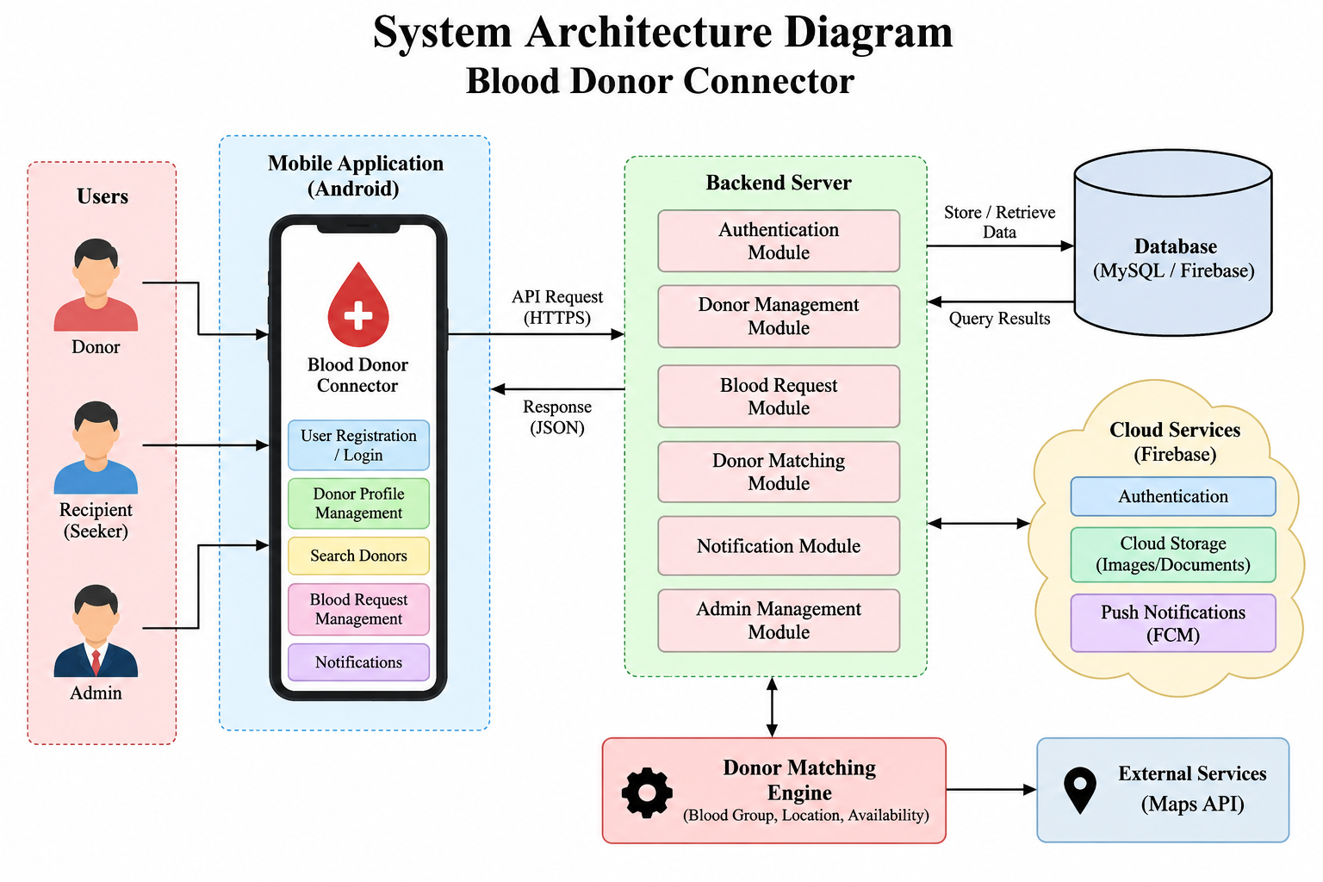
Fig 3.2.1(Architecture Diagram)

Hardware and Software Requirements
The hardware requirements for developing and testing Fly International Travel Management System include a computer or laptop capable of running the selected development environment and tools, sufficient memory and storage for the project, and an Android smartphone or emulator for checking screen layouts and workflows. An internet connection is needed for features that depend on cloud storage, remote databases, maps, flight data services, and notifications.
The software requirements depend on the implementation and may include Android Studio, Kotlin, the Android SDK, a database such as Firebase or a relational database, and libraries for navigation and network communication. Any cloud project, API access, or notification service must be configured and tested. Credentials and personal traveler information should be stored and handled securely.

CHAPTER 4 RELEVANCE OF THE PROJECT

Why the Model Was Chosen
Fly International Travel Management System was chosen because planning an international journey involves several connected activities that are often handled through separate channels. A traveler may need to search for flights, check passport and visa readiness, make a booking, and track its status. A centralized mobile interface can make these tasks easier to organize while helping users access the information needed for their trip.
The project also provides an opportunity to demonstrate mobile application development, data validation, database design, and user-focused interface development. Traveler profiles and flight bookings form the core data entities, while search and status updates support the main workflow. Privacy, consent, and accurate communication are essential because the application handles sensitive passport details and contact information.

Comparison with Existing Models
Existing travel services may focus on ticket sales, airline operations, visa processing, or corporate travel management. Travel agents and messaging groups can arrange journeys quickly, but they may not provide structured search or status tracking. Airline reservation and immigration systems manage ticketing inventory and entry procedures, which are outside the scope of a simple travel-management application.
Fly International Travel Management System focuses on helping travelers search and manage international flights through a mobile interface. It can organize profiles, passport and visa status, flight search, and booking details, while established airlines and government authorities remain responsible for ticketing rules, visa decisions, and confirming actual seat availability. The application can provide a structured travel record that is easier to review than scattered emails and messages.

Advantages and Limitations
Fly International Travel Management System offers potential benefits by bringing traveler profiles and flight bookings into one organized interface. Search filters can help users identify suitable flights by destination and travel class, while document tracking and booking status can improve coordination. Structured booking details can reduce missing information and make communication clearer.
The application also has limitations. Listed flights may be unavailable or fares may change, and records may become outdated. Network failures can affect remote search and notifications. Personal information requires careful protection, and no application can guarantee a confirmed seat or visa approval. Airline ticketing and entry eligibility must always be confirmed by the airline and the relevant government authorities.

CHAPTER 5 MODULE DESCRIPTION

Authentication and Profile Module
The Authentication and Profile Module provides the initial point of access to Fly International Travel Management System where sign-in is enabled. Travelers can create or update a profile containing relevant information such as name, passport number, nationality, and visa status. Input validation should help prevent incomplete or invalid records, and users should understand which details are visible to others.
Authentication and access controls are important because passport details and flight bookings may contain sensitive information. The application should restrict access according to its privacy design, obtain consent before sharing information, and allow users to update or remove outdated details where supported. Authentication alone does not guarantee secure access; database rules and backend checks are also required.

Home and Flight Search Module
The Home and Flight Search Module presents the main functions of the application and allows users to search for international flights. Search options may include destination and travel class, depending on the implemented features. The results should present only the information needed to choose a flight and should clearly indicate that fares and availability must be confirmed with the airline.
Flight information may be incomplete or outdated, and search results do not guarantee seat availability or entry eligibility. The application should handle empty searches, no matching flights, permission denial, and network errors clearly. Location access should be requested only when needed and with an explanation of its purpose. The interface should display flight and booking details clearly and avoid exposing unnecessary personal data.

Flight Booking Management Module
The Flight Booking Management Module allows travelers or authorized coordinators to submit and review flight bookings. A booking may include the passenger name, destination, travel class, airline, departure date, number of seats, and contact details. Validation helps ensure that important fields are present and understandable. The module can provide a central place to review the status of a booking and update it when changes occur.
Booking management requires consistent status handling and appropriate access control. Users should be able to identify whether a booking is pending, confirmed, or cancelled, where these states are supported. Changes should be recorded accurately, and obsolete bookings should not continue to appear as active. The application should encourage users to confirm all arrangements with the airline or travel provider.

Passport, Visa and Notification Module
The Passport, Visa and Notification Module is intended to help travelers track passport validity and visa status based on profile details such as passport number, nationality, and visa status, and to notify relevant users when notification services are configured. Document tracking is a preliminary reminder aid only; it does not determine visa approval or entry eligibility. Notifications should include sufficient context without unnecessarily exposing sensitive details.
A traveler or coordinator can review document status and booking reminders using the available communication method. Clear status information can help reduce duplicate bookings and keep trip preparation understandable. Users should verify document requirements and follow the procedures of the airline and destination country.
The module depends on accurate traveler profiles, current document details, network access, and correct notification configuration. A message being sent does not mean it has been read or acted upon. The system should provide clear error handling and protect passport details from unauthorized access.

Booking History and Status Module
The Booking History and Status Module helps users review registered traveler information and monitor flight bookings. Traveler records may include passport and visa details, while booking records can show whether a booking is pending, confirmed, or cancelled. Search and filtering can make records easier to navigate when the dataset grows. The reliability of the booking history depends on users keeping their details up to date and on the booking status being updated promptly. Users should confirm important changes directly with the airline, and the application should protect stored records from unauthorized access.

CHAPTER 6 RESULTS AND DISCUSSION

Generated Output and System Performance
Fly International Travel Management System produces outputs based on the information entered by users and the flight and traveler records available in the system. These may include flight search results, traveler profiles, booking summaries, and booking-status updates. Functional testing should check registration, validation, search filters, booking submission, status changes, and handling of missing or invalid information.
System performance should be evaluated using repeatable tests rather than assumed from the design. Relevant measures include response time for flight searches, successful saving and retrieval of records, reliability of notifications where enabled, and clear recovery from network or validation errors. Results should be recorded from the actual implemented application.

User Interaction and UI Review
User interaction is important because people may use Fly International Travel Management System while planning under time pressure or while travelling. The interface should make flight search, booking creation, and passport details easy to understand, with readable labels and clear feedback after each action. The application should avoid misleading fare or urgency indicators and should clearly state that airline confirmation is required before travel. Accessibility features such as readable text, sufficient contrast, and clear navigation can help users with different needs complete tasks comfortably.
A user-interface review should examine whether common tasks can be completed without unnecessary steps and whether error messages explain how to recover. Flight search should be evaluated for relevance and clarity, while booking forms should be checked for completeness and ease of use.

CHAPTER 7 CONCLUSION & FUTURE SCOPE

Conclusion and Summary of Outcomes
Fly International Travel Management System is a mobile application designed to organize international flight search and booking management. It brings together traveler registration, profile management, passport and visa tracking, flight search, booking submission, and status tracking within one interface where implemented. The application aims to help users plan journeys and communicate booking details more systematically.
The project's main contribution is its focus on bringing traveler information and booking coordination into a structured mobile workflow. Search and booking records can make information easier to review, while clear status updates can help reduce duplicate or outdated bookings. The system is a planning aid and does not replace airlines, immigration procedures, visa processing, or professional travel advice.

Future Enhancements & Long-Term Scope
Future development can improve the reliability and usefulness of Fly International Travel Management System by adding online payment integration, stronger privacy controls, real-time flight tracking, multilingual support, and improved offline handling. A feedback process could help users correct outdated profiles, while testing can improve accessibility and the reliability of booking-status updates.
Further improvements may include verified integration with airline reservation systems and visa services, secure traveler consent management, automated reminders for passport expiry and departure dates, and analytics on booking trends. Any integration involving passport or identity information should follow applicable privacy and security requirements. Search and fare suggestions must remain a preliminary planning feature rather than a final ticketing decision.

APPENDICES APPENDIX A SOURCE CODE

A.1 Traveler and Booking Management
Description: This module allows users to register as travelers, store passport, visa and contact information, record passport validity, and manage traveler records. Room Database provides local storage for traveler information.
Listing A.1: Traveler Data Model
package com.flyinternational.data.model

import androidx.room.Entity
import androidx.room.PrimaryKey

@Entity(tableName = "travelers")
data class Traveler(
@PrimaryKey(autoGenerate = true)
val id: Int = 0,

val userId: String,
val fullName: String,
val passportNumber: String,
val visaStatus: String,
val phoneNumber: String,
val nationality: String,
val passportExpiryDate: String = "",
val isPassportValid: Boolean = true
)

Listing A.2: Flight Booking Data Model

package com.flyinternational.data.model

import androidx.room.Entity
import androidx.room.PrimaryKey

@Entity(tableName = "flight_bookings")
data class FlightBooking(
@PrimaryKey(autoGenerate = true)
val id: Int = 0,

val travelerId: String,
val passengerName: String,
val travelClass: String,
val numberOfSeats: Int,
val airlineName: String,
val destination: String,
val departureDate: String,
val contactNumber: String,
val status: String = "Pending"
)
Listing A.3: Traveler Data Access Object
package com.flyinternational.data.local

import androidx.room.Dao
import androidx.room.Delete
import androidx.room.Insert
import androidx.room.OnConflictStrategy
import androidx.room.Query
import com.flyinternational.data.model.Traveler
import kotlinx.coroutines.flow.Flow

@Dao
interface TravelerDao {

@Insert(onConflict = OnConflictStrategy.REPLACE)
suspend fun insertTraveler(traveler: Traveler): Long

@Query("SELECT * FROM travelers ORDER BY fullName")
fun getAllTravelers(): Flow<List<Traveler>>

@Query(
"""
SELECT * FROM travelers
WHERE visaStatus = :visaStatus
AND nationality = :nationality
AND isPassportValid = 1
ORDER BY fullName
"""
)
fun searchTravelers(
visaStatus: String,
nationality: String
): Flow<List<Traveler>>

@Query("SELECT * FROM travelers WHERE id = :travelerId")
suspend fun getTravelerById(travelerId: Int): Traveler?

@Query("SELECT * FROM travelers WHERE userId = :userId LIMIT 1")
suspend fun getTravelerByUserId(userId: String): Traveler?

@Delete
suspend fun deleteTraveler(traveler: Traveler)
}

Listing A.4: Flight Booking Data Access Object
package com.flyinternational.data.local

import androidx.room.Dao
import androidx.room.Delete
import androidx.room.Insert
import androidx.room.OnConflictStrategy
import androidx.room.Query
import com.flyinternational.data.model.FlightBooking
import kotlinx.coroutines.flow.Flow

@Dao
interface FlightBookingDao {

@Insert(onConflict = OnConflictStrategy.REPLACE)
suspend fun insertBooking(
booking: FlightBooking
): Long

@Query(
"""
SELECT * FROM flight_bookings
ORDER BY departureDate
"""
)
fun getAllBookings(): Flow<List<FlightBooking>>

@Query(
"""
SELECT * FROM flight_bookings
WHERE travelClass = :travelClass
AND destination = :destination
AND status = 'Pending'
ORDER BY departureDate
"""
)
fun searchBookings(
travelClass: String,
destination: String
): Flow<List<FlightBooking>>

@Query(
"""
SELECT * FROM flight_bookings
WHERE travelerId = :userId
ORDER BY departureDate
"""
)
fun getBookingsByUser(
userId: String
): Flow<List<FlightBooking>>

@Delete
suspend fun deleteBooking(
booking: FlightBooking
)
}

Listing A.5: Traveler Registration Screen Using Jetpack Compose
package com.flyinternational.ui.traveler

import androidx.compose.foundation.layout.*
import androidx.compose.foundation.rememberScrollState
import androidx.compose.foundation.verticalScroll
import androidx.compose.material3.*
import androidx.compose.runtime.*
import androidx.compose.ui.Modifier
import androidx.compose.ui.unit.dp
import com.flyinternational.data.model.Traveler

@Composable
fun TravelerRegistrationScreen(
userId: String,
onRegisterTraveler: (Traveler) -> Unit
) {
var name by remember { mutableStateOf("") }
var passportNumber by remember { mutableStateOf("") }
var visaStatus by remember { mutableStateOf("Not Applied") }
var phone by remember { mutableStateOf("") }
var nationality by remember { mutableStateOf("") }
var passportValid by remember { mutableStateOf(true) }

val visaOptions = listOf(
"Not Applied", "Applied",
"Approved", "Rejected"
)

Column(
modifier = Modifier
.fillMaxSize()
.verticalScroll(rememberScrollState())
.padding(16.dp),
verticalArrangement = Arrangement.spacedBy(12.dp)
) {
Text(
text = "Traveler Registration",
style = MaterialTheme.typography.headlineMedium
)

OutlinedTextField(
value = name,
onValueChange = { name = it },
label = { Text("Full Name") },
modifier = Modifier.fillMaxWidth()
)

OutlinedTextField(
value = passportNumber,
onValueChange = { passportNumber = it.uppercase() },
label = { Text("Passport Number") },
modifier = Modifier.fillMaxWidth()
)

Text("Select Visa Status")

visaOptions.forEach { option ->
Row(
verticalAlignment =
androidx.compose.ui.Alignment.CenterVertically
) {
RadioButton(
selected = visaStatus == option,
onClick = { visaStatus = option }
)
Text(option)
}
}

OutlinedTextField(
value = phone,
onValueChange = { phone = it },
label = { Text("Contact Number") },
modifier = Modifier.fillMaxWidth()
)

OutlinedTextField(
value = nationality,
onValueChange = { nationality = it },
label = { Text("Nationality") },
modifier = Modifier.fillMaxWidth()
)

Row(
verticalAlignment =
androidx.compose.ui.Alignment.CenterVertically
) {
Checkbox(
checked = passportValid,
onCheckedChange = { passportValid = it }
)
Text("Passport Valid for 6+ Months")
}

Button(
onClick = {
val passportPattern = Regex("[A-Z][0-9]{7}")

if (
name.isNotBlank() &&
passportNumber.matches(passportPattern) &&
passportValid &&
phone.matches(Regex("[0-9]{10}")) &&
nationality.isNotBlank()
) {
onRegisterTraveler(
Traveler(
userId = userId,
fullName = name.trim(),
passportNumber = passportNumber,
visaStatus = visaStatus,
phoneNumber = phone,
nationality = nationality.trim(),
isPassportValid = passportValid
)
)
}
},
modifier = Modifier.fillMaxWidth()
) {
Text("Register as Traveler")
}
}
}
  - Flight Booking and Flight Search
Description: This module enables users to search international flights by travel class and destination and to submit flight bookings for registered travelers. It supports communication between travelers and the airline booking services.
Listing A.6: Flight Search Request and Response Models
package com.flyinternational.data.model data class FlightSearchRequest(
val destination: String, val travelClass: String, val numberOfSeats: Int,
val departureDate: String
)
data class FlightSearchResponse( val title: String,
val flights: List<FlightOption>, val estimatedFare: Double,
val tips: List<String>
)
data class FlightOption( val flightNumber: String,
val airlineName: String, val fare: Double
)

data class FlightBookingDto( val passengerName: String,
val travelClass: String, val destination: String,
val numberOfSeats: Int, val departureDate: String
)

Listing A.7: Retrofit Service for Flight Booking
package com.flyinternational.data.remote

import com.flyinternational.data.model.FlightSearchRequest
import com.flyinternational.data.model.FlightSearchResponse
import com.flyinternational.data.model.FlightBookingDto
import com.flyinternational.data.model.FlightBooking
import retrofit2.http.Body
import retrofit2.http.GET
import retrofit2.http.POST
import retrofit2.http.Query

interface FlightApiService {

@GET("api/flights/search")
suspend fun searchFlights(
@Query("travelClass") travelClass: String,
@Query("destination") destination: String
): FlightSearchResponse

@POST("api/bookings")
suspend fun createFlightBooking(
@Body request: FlightBookingDto
): FlightBooking
}
Listing A.8: Flight Booking Screen
package com.flyinternational.ui.booking

import androidx.compose.foundation.layout.*
import androidx.compose.foundation.rememberScrollState
import androidx.compose.foundation.verticalScroll
import androidx.compose.material3.*
import androidx.compose.runtime.*
import androidx.compose.ui.Modifier
import androidx.compose.ui.unit.dp
import com.flyinternational.data.model.FlightBooking

@Composable
fun FlightBookingScreen(
travelerId: String,
onSubmitBooking: (FlightBooking) -> Unit
) {
var passengerName by remember { mutableStateOf("") }
var travelClass by remember { mutableStateOf("Economy") }
var seats by remember { mutableStateOf("1") }
var airline by remember { mutableStateOf("") }
var destination by remember { mutableStateOf("") }
var date by remember { mutableStateOf("") }
var phone by remember { mutableStateOf("") }
var message by remember { mutableStateOf<String?>(null) }

val classes = listOf(
"Economy", "Premium Economy",
"Business", "First Class"
)

Column(
modifier = Modifier
.fillMaxSize()
.verticalScroll(rememberScrollState())
.padding(16.dp),
verticalArrangement = Arrangement.spacedBy(12.dp)
) {
Text(
"Book Flight Ticket",
style = MaterialTheme.typography.headlineMedium
)

OutlinedTextField(
value = passengerName,
onValueChange = { passengerName = it },
label = { Text("Passenger Name") },
modifier = Modifier.fillMaxWidth()
)

Text("Travel Class")

classes.forEach { option ->
Row {
RadioButton(
selected = travelClass == option,
onClick = { travelClass = option }
)
Text(
option,
modifier = Modifier.padding(top = 12.dp)
)
}
}

OutlinedTextField(
value = seats,
onValueChange = { seats = it.filter(Char::isDigit) },
label = { Text("Number of Seats") },
modifier = Modifier.fillMaxWidth()
)

OutlinedTextField(
value = airline,
onValueChange = { airline = it },
label = { Text("Airline Name") },
modifier = Modifier.fillMaxWidth()
)

OutlinedTextField(
value = destination,
onValueChange = { destination = it },
label = { Text("Destination Country") },
modifier = Modifier.fillMaxWidth()
)

OutlinedTextField(
value = date,
onValueChange = { date = it },
label = { Text("Departure Date (YYYY-MM-DD)") },
modifier = Modifier.fillMaxWidth()
)

OutlinedTextField(
value = phone,
onValueChange = { phone = it },
label = { Text("Contact Number") },
modifier = Modifier.fillMaxWidth()
)

Button(
onClick = {
val seatCount = seats.toIntOrNull()

if (
passengerName.isNotBlank() &&
seatCount != null &&
seatCount > 0 &&
airline.isNotBlank() &&
destination.isNotBlank() &&
date.matches(
Regex("\\d{4}-\\d{2}-\\d{2}")
) &&
phone.matches(Regex("[0-9]{10}"))
) {
onSubmitBooking(
FlightBooking(
travelerId = travelerId,
passengerName = passengerName.trim(),
travelClass = travelClass,
numberOfSeats = seatCount,
airlineName = airline.trim(),
destination = destination.trim(),
departureDate = date,
contactNumber = phone
)
)
message = "Flight booking submitted."
} else {
message = "Please enter valid booking details."
}
},
modifier = Modifier.fillMaxWidth()
) {
Text("Submit Flight Booking")
}

message?.let {
Text(it, color = MaterialTheme.colorScheme.primary)
}
}
}
  - Firebase Authentication
Description Firebase Authentication provides email-and-password registration and login. The authenticated user's Firebase UID can identify the traveler associated with a profile and their flight bookings.

Listing A.9: Firebase Authentication Repository
package com.flyinternational.data.auth

import com.google.firebase.auth.FirebaseAuth
import kotlinx.coroutines.tasks.await

class AuthRepository(
private val auth: FirebaseAuth =
FirebaseAuth.getInstance()
) {

val currentUser
get() = auth.currentUser

suspend fun register(
email: String,
password: String
): Result<String> {
return try {
require(email.isNotBlank()) {
"Email is required."
}

require(password.length >= 6) {
"Password must be at least 6 characters."
}

val result = auth
.createUserWithEmailAndPassword(
email.trim(),
password
)
.await()

val uid = result.user?.uid
?: error("Unable to create user account.")

Result.success(uid)
} catch (e: Exception) {
Result.failure(e)
}
}

suspend fun login(
email: String,
password: String
): Result<String> {
return try {
require(email.isNotBlank()) {
"Email is required."
}

require(password.isNotBlank()) {
"Password is required."
}

val result = auth
.signInWithEmailAndPassword(
email.trim(),
password
)
.await()

val uid = result.user?.uid
?: error("Unable to retrieve user ID.")

Result.success(uid)
} catch (e: Exception) {
Result.failure(e)
}
}

APPENDIX B SCREENSHOTS
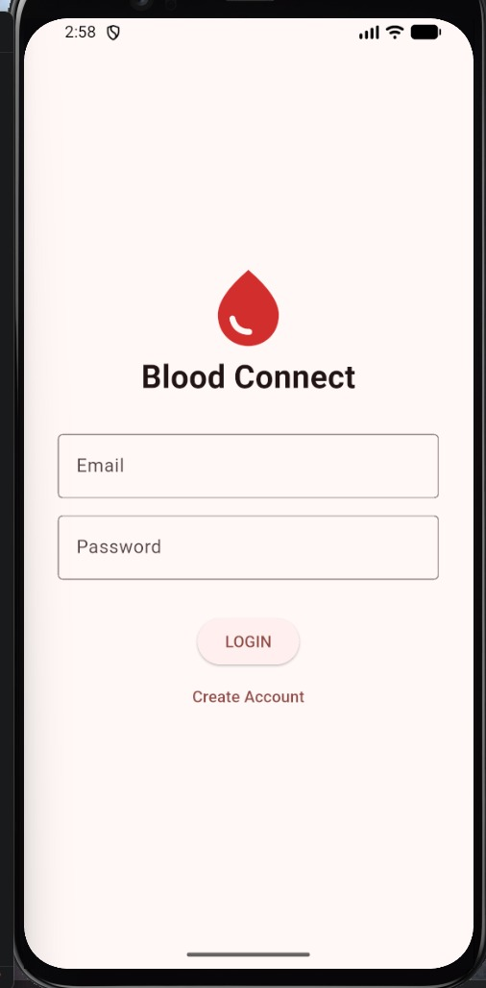

Fig B.1.1 Login Page

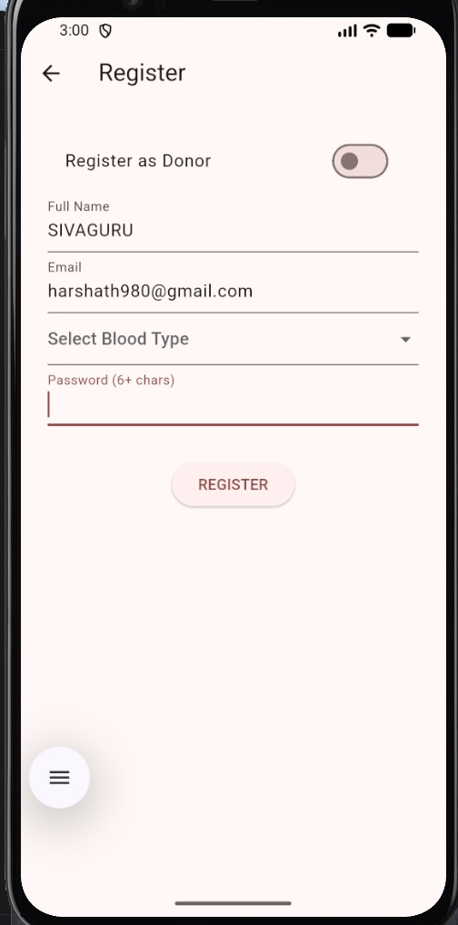

Fig B.1.2 Register page

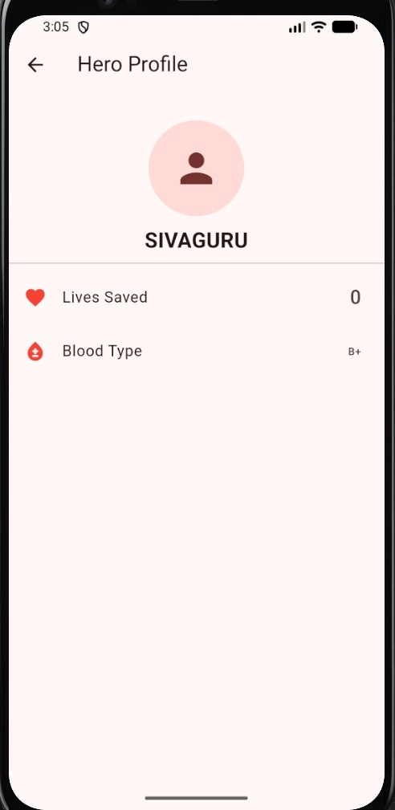

Fig B.1.3 Profile Page
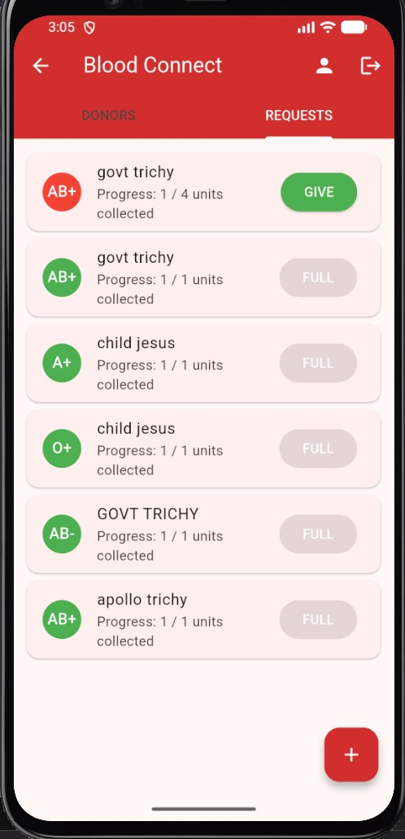

Fig B.1.4 Flight Search and Booking Status Page

REFERENCES

[1] Android Developers, “Jetpack Compose,” Android Developers Documentation, for developing modern Android user interfaces for traveler registration and flight booking management.

[2] Android Developers, “Save Data in a Local Database Using Room,” Android Developers Documentation, for storing traveler details and flight bookings locally.

[3] Google, “Firebase Authentication Documentation,” Google Firebase, for implementing secure user registration and login in mobile applications.

[4] World Tourism Organization (UNWTO), “International Tourism Highlights,” UNWTO, Madrid, Spain, 2023.

[5] International Air Transport Association (IATA),

“Timatic Travel Document Verification Service,” IATA, Montreal, Canada.

[6] Ministry of External Affairs, Government of India, “Passport Seva: Online Passport Services,” Government of India.

[7] Square, Inc., “Retrofit: A Type-Safe HTTP Client for Android and Java,” Retrofit Documentation, for communication between the Fly International Travel Management System mobile application and its backend services.

[8] International Civil Aviation Organization (ICAO), “Annex 9 to the Convention on International Civil Aviation: Facilitation,” ICAO, Montreal, Canada.

[9] Ministry of Civil Aviation, Government of India, “DigiYatra: Digital Processing of Air Travellers,” Government of India.

[10] International Air Transport Association (IATA), “Passenger Services Conference Resolutions Manual,” IATA, Montreal, Canada.

