1. What is DVCS?
DVCS (Distributed Version Control System) is a version control system where every developer has a complete copy of the repository, including its history, on their local computer. Git is an example of a DVCS.
2.Advantages of DVCS?
- Works offline – Developers can commit, view history, create branches, and compare changes without an internet connection.
- Faster operations – Most Git operations happen locally, so they don't depend on network speed.
- Complete repository locally – Each developer has a copy of the repository and its history.
- Better reliability – If the remote server is temporarily unavailable, developers can continue working locally.
- Easy branching and merging – Developers can create branches for features or fixes and merge them later.
- Supports collaboration – Multiple developers can work independently and share their changes through a remote repository.
- Safer history – Multiple local copies of repository data provide additional redundancy.
3. Working Directory → Staging Area → Local Repo → Remote Repo

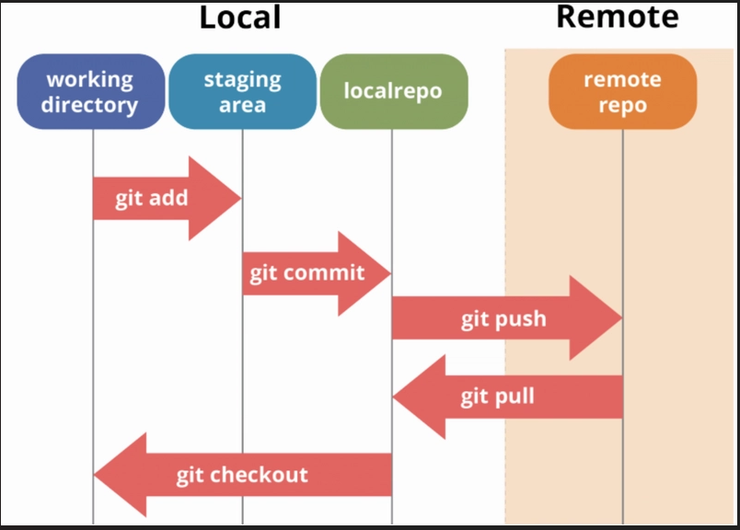
Working Directory – Where you create and modify files.
Staging Area – Where you select changes that should be included in the next commit.
Local Repository – Stores your commits on your computer.
Remote Repository – Stores the repository on a remote server for collaboration.
4.git add
git add moves changes from the Working Directory to the Staging Area.
Command : git add <file-name>

5.git commit
git commit saves the staged changes as a new commit in the Local Repository.
Command : git commit -m "commit message"
6.git restore
git restore is used to discard or restore changes in files.
Suppose you modify:
index.html
To discard the unstaged changes: git restore index.html
The file is restored to the version from the index (normally the staged version, or HEAD if it isn't staged).
To remove a file from the Staging Area while keeping its changes in the Working Directory: git restore --staged index.html
7.git rm –cached
git rm --cached removes a file from Git's tracking/staging area but keeps the actual file on your computer. This is often used when you accidentally start tracking a file that should be ignored.
git rm --cached <file-name>

8.git log
git log displays the commit history of the repository.
git log

9.git log –oneline
git log --oneline displays the commit history in a short, one-line format. It is easier to read than the normal git log, especially when the repository has many commits.
git log --oneline

