**Assignment-based Subjective Questions**

**Question 1**. From your analysis of the categorical variables from the dataset, what could you infer about their effect on the dependent variable? (Do not edit)

**Total Marks**: 3 marks (Do not edit)

**Answer:** <Your answer for Question 1 goes below this line> (Do not edit)

There are a couple of categorical variables namely season, mnth, yr, weekday, working day and weathersit. These categorical variables have a major effect on the dependent variable ‘cnt’. The below figure shows the correlation among the same.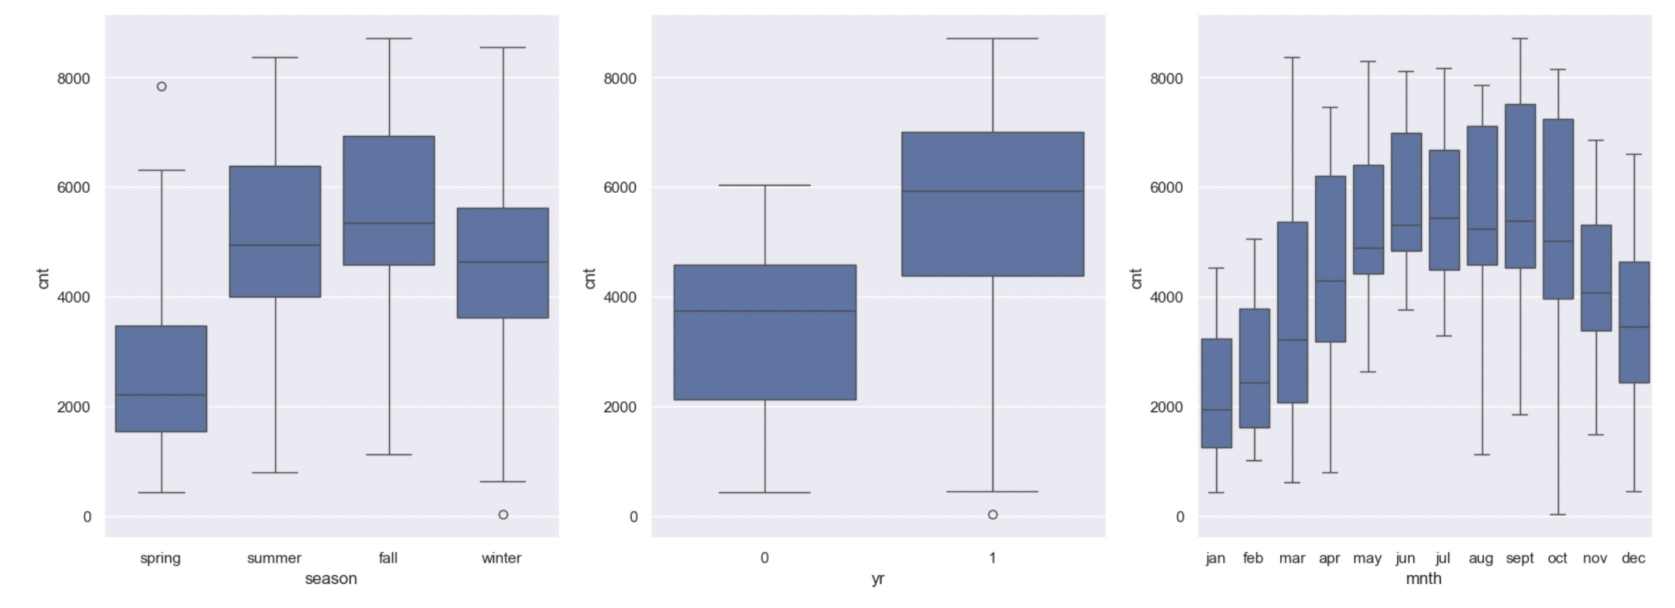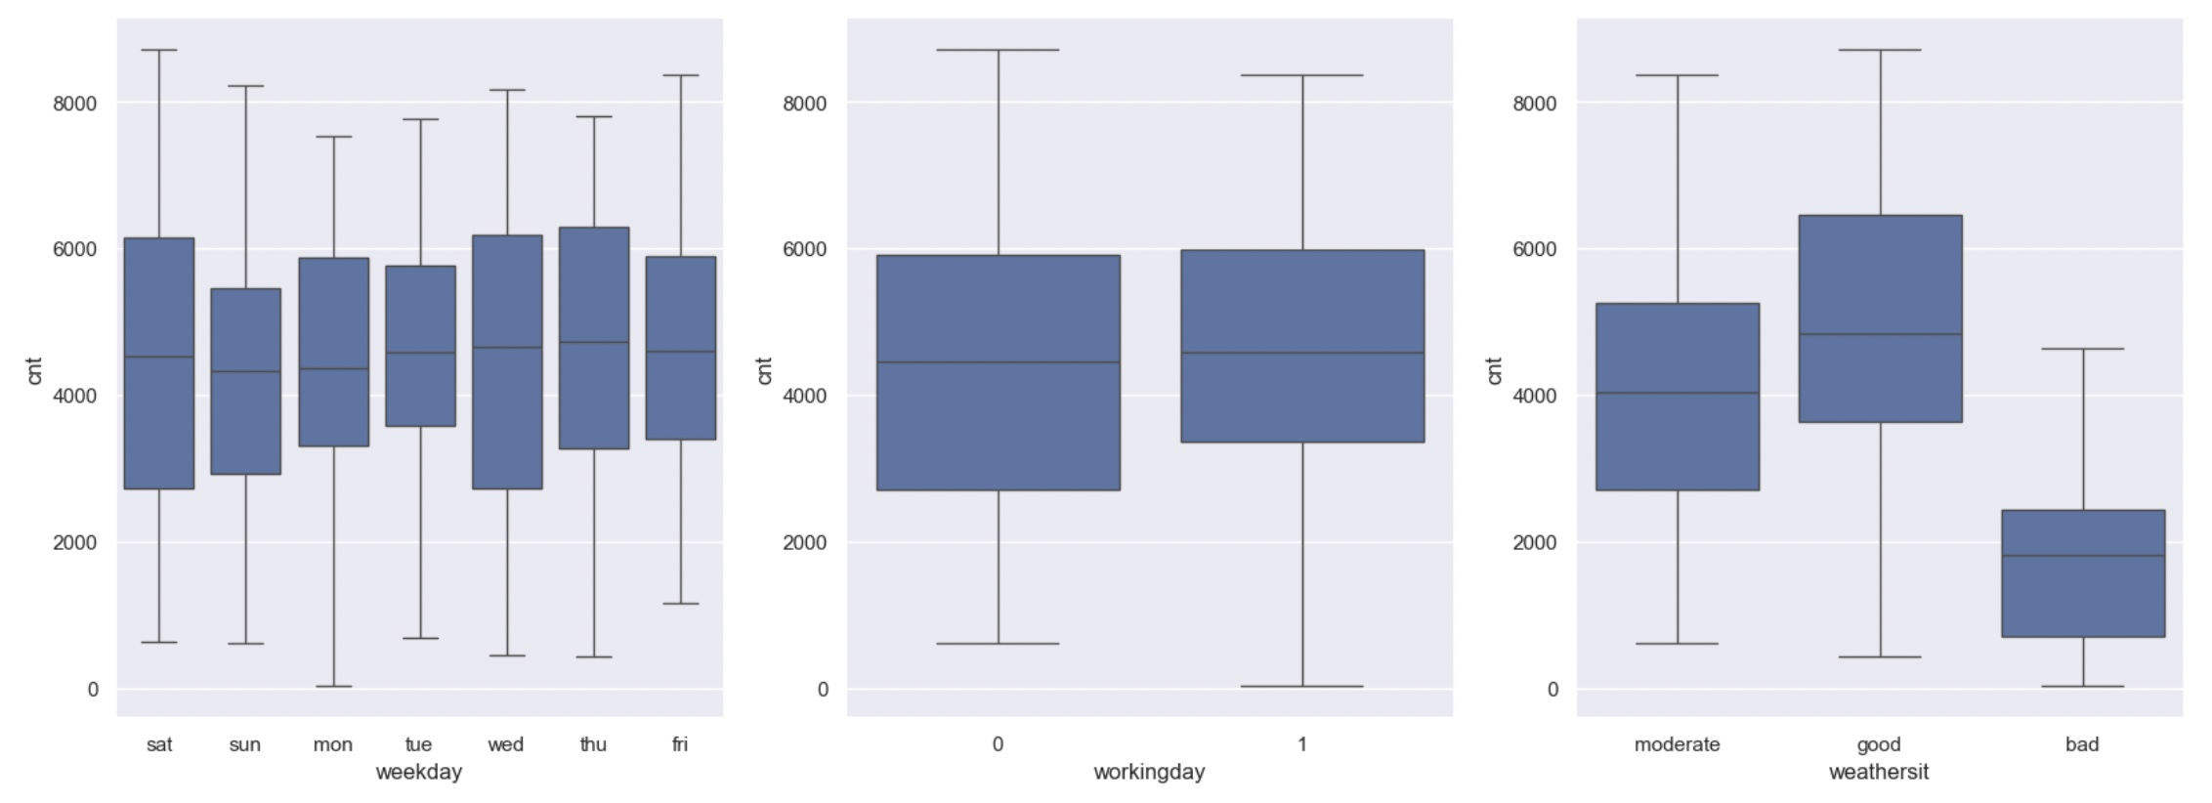

**Question 2.** Why is it important to use **drop_first=True** during dummy variable creation? (Do not edit)

**Total Marks:** 2 marks (Do not edit)

**Answer:** <Your answer for Question 2 goes below this line> (Do not edit)

The intention behind the dummy variable is that for a categorical variable with ‘n’ levels, you create ‘n-1’ new columns each indicating whether that level exists or not using a zero or one. Hence drop_first=True is used so that the resultant can match up n-1 levels. Hence it reduces the correlation among the dummy variables. Eg: If there are 3 levels, the drop_first will drop the first column.

**Question 3.** Looking at the pair-plot among the numerical variables, which one has the highest correlation with the target variable? (Do not edit)

**Total Marks:** 1 mark (Do not edit)

**Answer:** <Your answer for Question 3 goes below this line> (Do not edit)

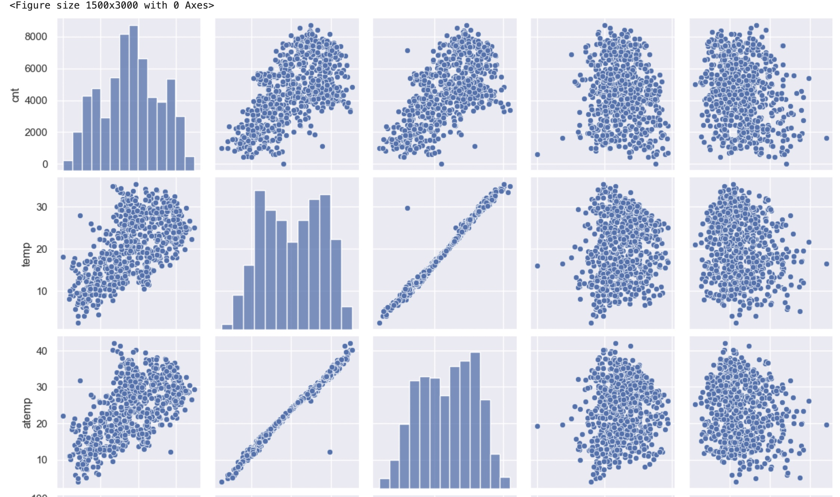

The ‘temp’ and ‘atemp’ variables have highest correlation when compared to the rest with target variable as ‘cnt’.

**Question 4.** How did you validate the assumptions of Linear Regression after building the model on the training set? (Do not edit)

**Total Marks:** 3 marks (Do not edit)

**Answer:** <Your answer for Question 4 goes below this line> (Do not edit)

Linear Regression models are validated based on Linearity,No auto-correlation,Normality of error, Homoscedasticity, Multicollinearity.

**Question 5.** Based on the final model, which are the top 3 features contributing significantly towards explaining the demand of the shared bikes? (Do not edit)

**Total Marks:** 2 marks (Do not edit)

**Answer:** <Your answer for Question 5 goes below this line> (Do not edit)

Top 3 features that has significant impact towards explaining the demand of the shared bikes are temperature,year and season

**General Subjective Questions**

**Question 6.** Explain the linear regression algorithm in detail. (Do not edit)

**Total Marks:** 4 marks (Do not edit)

**Answer:** Please write your answer below this line. (Do not edit)

Linear regression is a form of predictive modeling technique which tells us the relationship between the dependent (target variable) and independent variables (predictors). Since linear regression shows the linear relationship, which means it finds how the value of the dependent variable is changing according to the value of the independent variable. If there is a single input variable (x), such linear regression is called simple linear regression. And if there is more than one input variable, such linear regression is called multiple linear regression. The linear regression model gives a sloped straight line describing the relationship within the variables. A regression line can be a Positive Linear Relationship or a Negative Linear Relationship. The goal of the linear regression algorithm is to get the best values for a0 and a1 to find the best fit line and the best fit line should have the least error. In Linear Regression, RFE or Mean Squared Error (MSE) or cost function is used, which helps to figure out the best possible values for a0 and a1, which provides the best fit line for the data points.

**Question 7.** Explain the Anscombe’s quartet in detail. (Do not edit)

**Total Marks:** 3 marks (Do not edit)

**Answer:** Please write your answer below this line. (Do not edit)

Anscombe’s Quartet can be defined as a group of four data sets which are nearly identical in simple descriptive statistics, but there are some peculiarities in the dataset that fools the regression model if built. They have very different distributions and appear differently when plotted on scatter plots. It was constructed to illustrate the importance of plotting the graphs before analyzing and model building, and the effect of other observations on statistical properties.There are these four data set plots which have nearly same statistical observations, which provides same statistical information that involves variance, and mean of all x,y points in all four datasets.

* 1 st data set fits linear regression model as it seems to be linear relationship between X and y
* 2 nd data set does not show a linear relationship between X and Y , which means it does not fit the linear regression model.
* 3 rd data set shows some outliers present in the dataset which can’t be handled by a linear regression model.
* 4 th data set has a high leverage point means it produces a high correlation coeff. Its conclusion is that regression algorithms can be fooled so, it's important to data visualization before build machine learning model.

**Question 8.** What is Pearson’s R? (Do not edit)

**Total Marks:** 3 marks (Do not edit)

**Answer:** Please write your answer below this line. (Do not edit)

n Statistics, the Pearson's Correlation Coefficient is also referred to as Pearson's r, the Pearson product-moment correlation coefficient (PPMCC), or bivariate correlation. It is a statistic that measures the linear correlation between two variables.

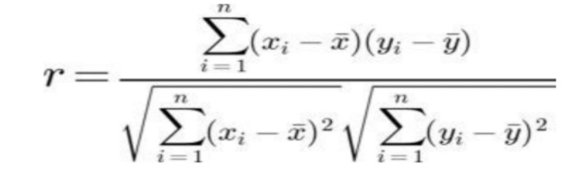

**Question 9.** What is scaling? Why is scaling performed? What is the difference between normalized scaling and standardized scaling? (Do not edit)

**Total Marks:** 3 marks (Do not edit)

**Answer:** Please write your answer below this line. (Do not edit)

Scaling means you're transforming your data so that it fits within a specific scale. It is one type of data pre-processing step where we will fit data in specific scale and speed up the calculations in an algorithm. Collected data contains features varying in magnitudes, units and range. If scaling is not performed than algorithm tends to weigh high values magnitudes and ignore other parameters which will result in incorrect modeling. Difference between Normalizing Scaling and Standardize Scaling:

1. In normalized scaling minimum and maximum value of features being used whereas in Standardize scaling mean and standard deviation is used for scaling.
2. Normalized scaling is used when features are of different scales whereas standardized scaling is used to ensure zero mean and unit standard deviation.
3. Normalized scaling scales values between (0,1) or (-1,1) whereas standardized scaling is not having or is not bounded in a certain range.
4. Normalized scaling is affected by outliers whereas standardized scaling is not having any effect by outliers.
5. Normalized scaling is used when we don’t know about the distribution whereas standardized scaling is used when distribution is normal.
6. Normalized scaling is called as scaling normalization whereas standardized scaling is called as Z Score Normalization.

**Question 10.** You might have observed that sometimes the value of VIF is infinite. Why does this happen? (Do not edit)

**Total Marks:** 3 marks (Do not edit)

**Answer:** Please write your answer below this line. (Do not edit)

VIF(VarianceInflationFactor) basically helps explain the relationship of one independent variable with all the other independent variables. The formulation of VIF is given below: A VIF value of greater than 10 is definitely high, a VIF of greater than 5 should also not be ignored and inspected appropriately. A very high VIF value shows a perfect correlation between two independent variables. In the case of perfect correlation, we get R2 =1, which lead to 1/(1-R2) infinity. To solve this problem we need to drop one of the variables from the dataset which is causing this perfect multicollinearity.

**Question 11.** What is a Q-Q plot? Explain the use and importance of a Q-Q plot in linear regression.

(Do not edit)

**Total Marks:** 3 marks (Do not edit)

**Answer:** Please write your answer below this line. (Do not edit)

**Q-Q Plot**: A tool to compare the quantiles of your data with those of a theoretical distribution (like normal).

**Use in Linear Regression**: It helps to verify the assumption of **normality of residuals**, which is critical for the validity of the regression model's statistical tests.

**Interpretation**: If the residuals are normally distributed, the Q-Q plot should show points following a straight line. Any deviations suggest violations of the normality assumption, which might necessitate model adjustments.