**WEEK – 7 : HANDS-ON EXERCISE**

**React**

**Exercise 1: Cricket Player Management Using ES6 Features in React**

**Scenario:**

Build a React app using ES6 features to display and filter cricket players.

**Step 1: Create the React Application**

npx create-react-app cricketapp

**Step 2: Navigate into the Application Directory**

cd cricketapp

**Step 3: Open Project in Visual Studio Code**

code .

**Step 4: Create a component ListOfPlayers.js**

**CODE:**

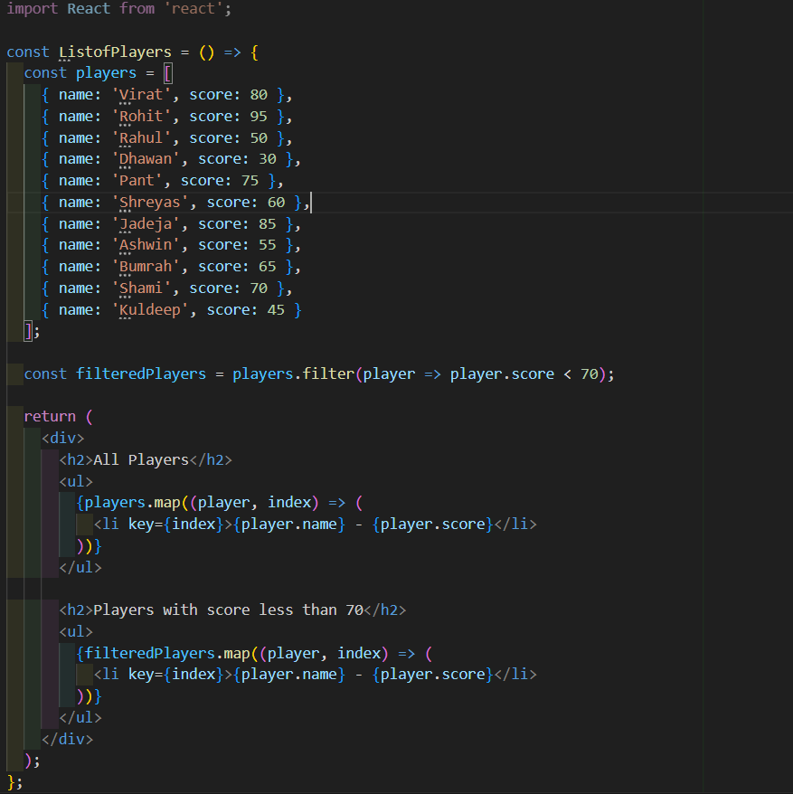



**Step 5: Create a component IndianPlayers.js**

**CODE:**

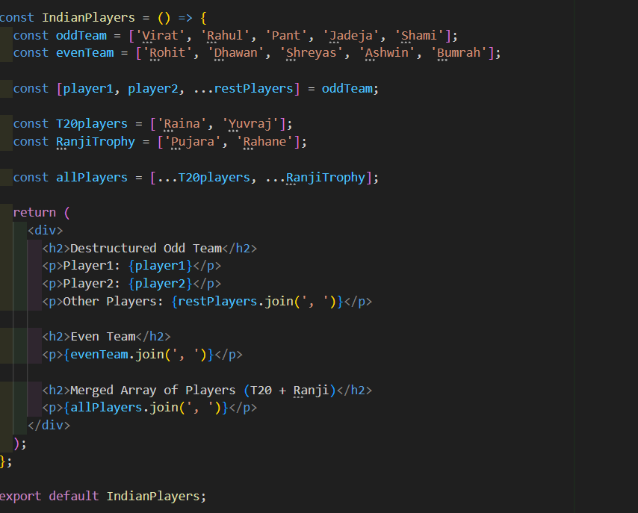

**Step 6 : App.js**

**CODE:**

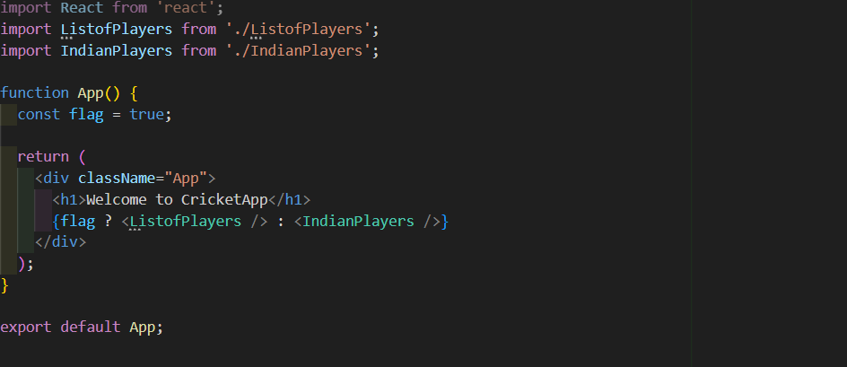

**Step 7: Run the application**

npm start

**OUTPUT:**

When Flag=true

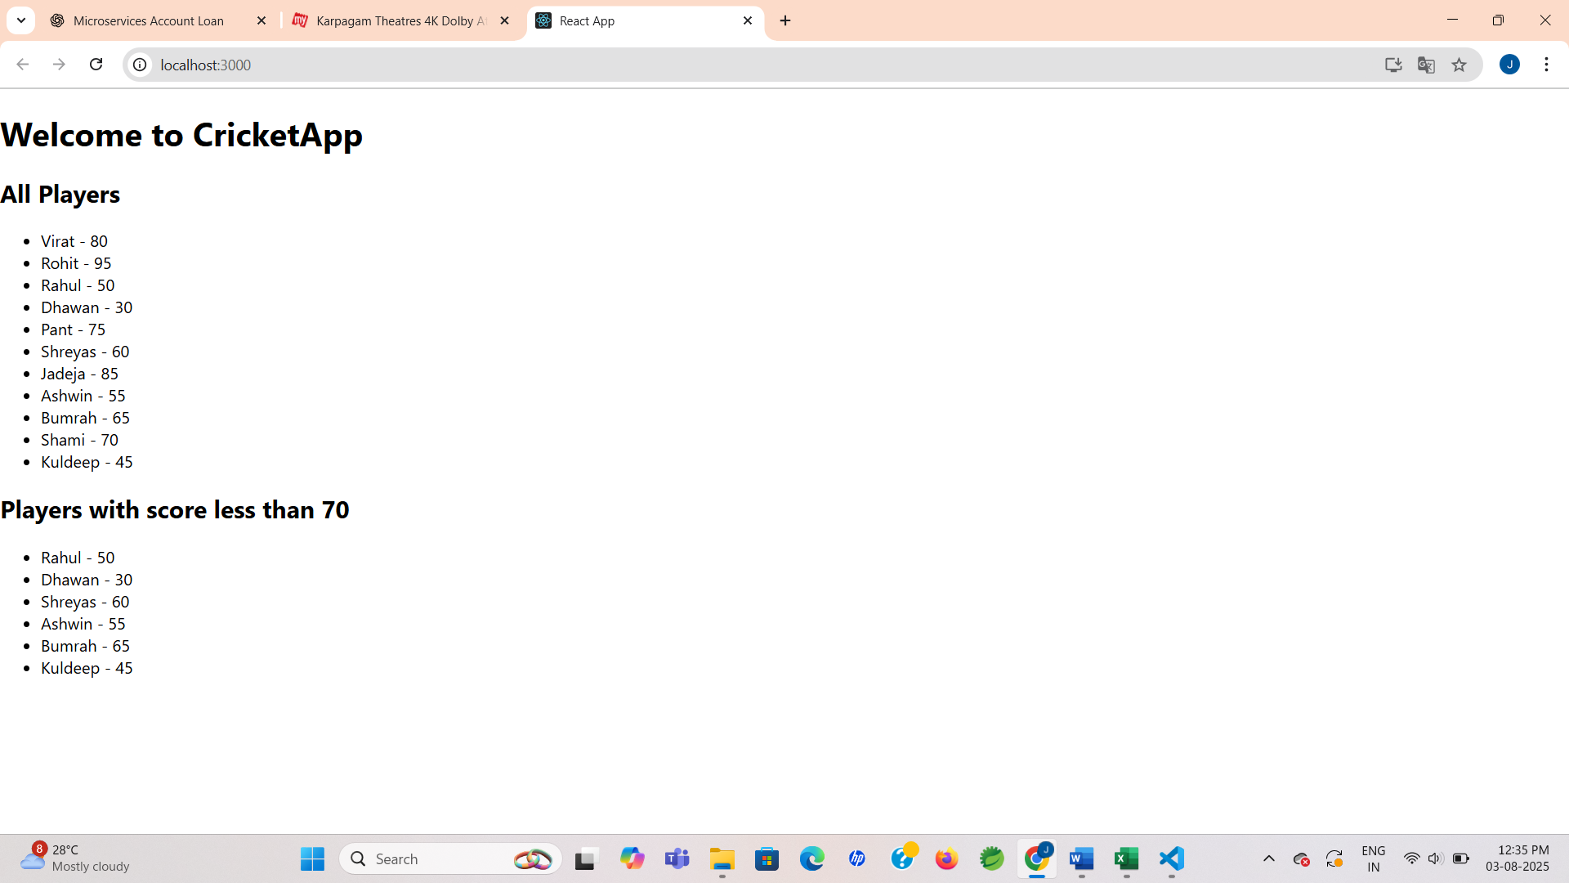

When Flag=false

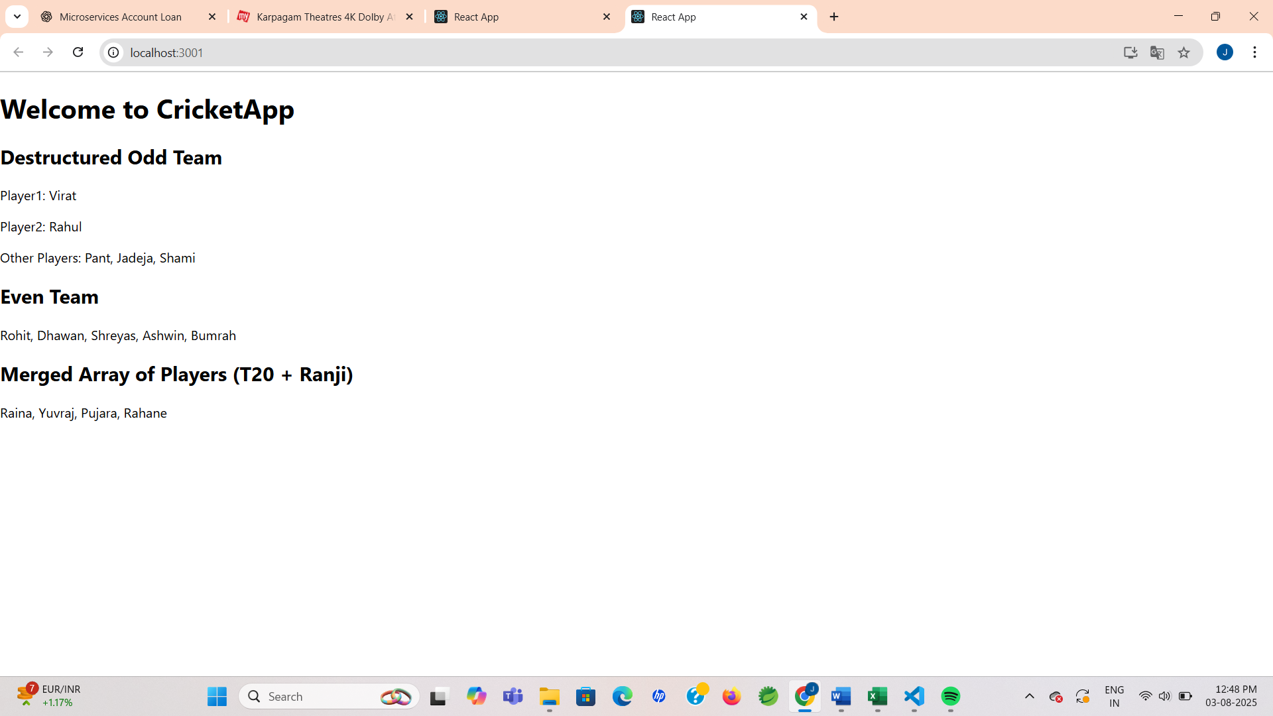

**Exercise 2: Office Space Rental App using JSX in React**

**Scenario:**

Create a React app called "OfficeSpaceRentalApp" that shows a list of office spaces with their name, rent, and address using JSX. Highlight rent in green if it's above ₹60,000, or red if it's ₹60,000 or below.

**Step 1: Create a React App**

npx create-react-app OfficeSpaceRentalApp

cd OfficeSpaceRentalApp

**Step 2: App.js**

**CODE:**

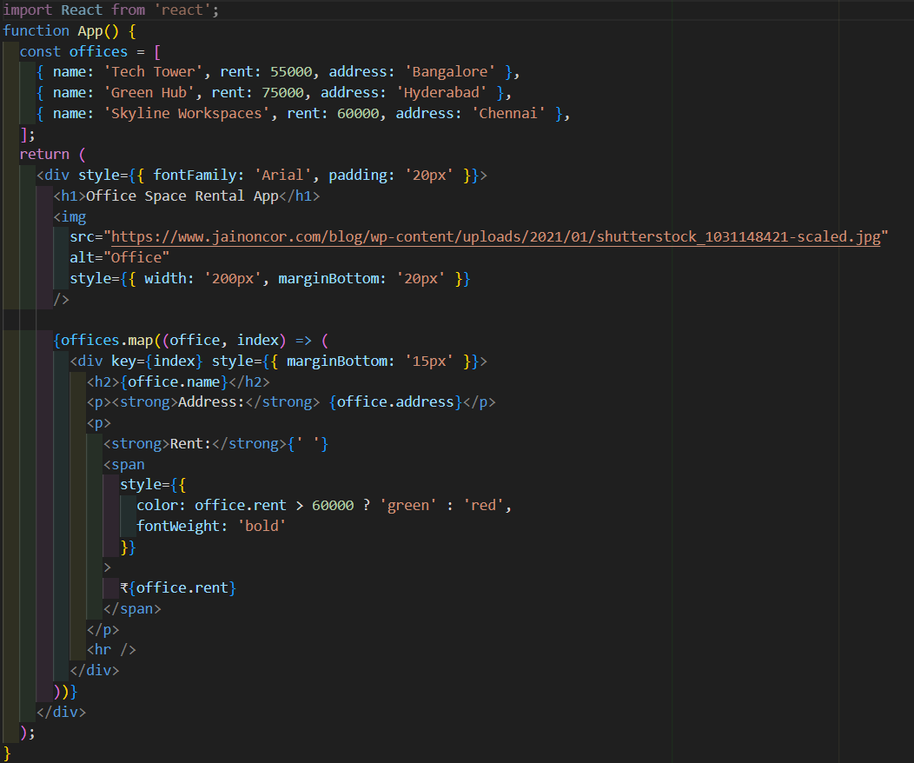



**Step 3: Run the Application**

**OUTPUT:**

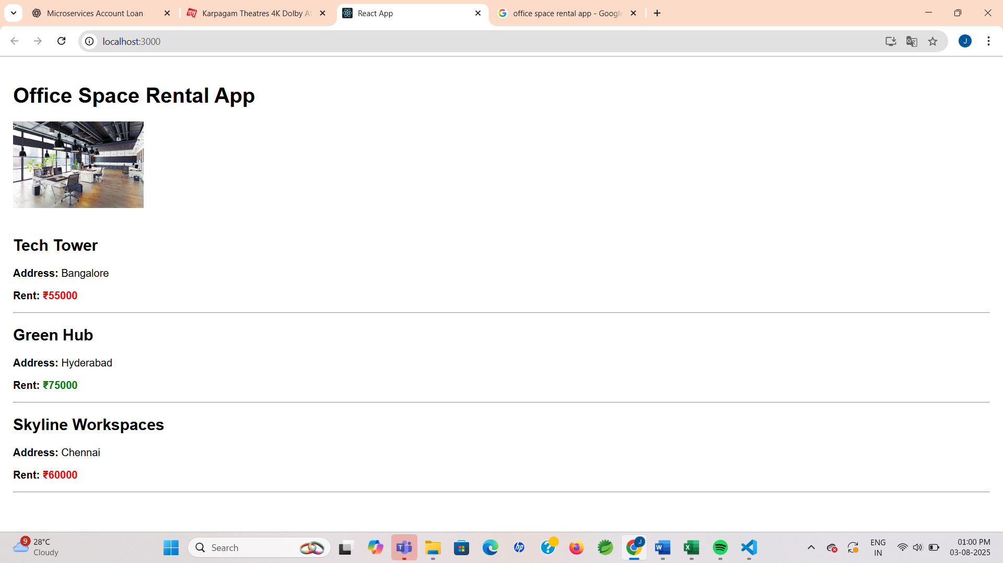

**Exercise 3 : Event Handling in React**

**Scenario:**

This React app demonstrates simple state and event handling. It features a counter, alert messages, synthetic event handling, and includes a currency converter component.

**Step 1 : Create React App**

npx create-react-app currencyconverterapp

* After it finishes, navigate into the app:

cd currencyconverterapp

**Step 2: Create currencyconverter.js**

**CODE:**

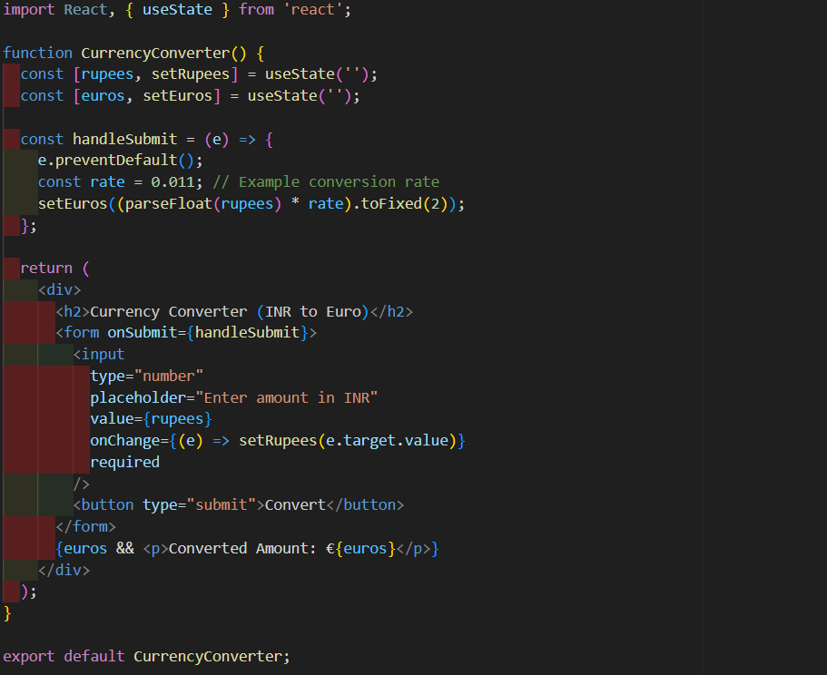

**Step 3: App.js**

**CODE:**

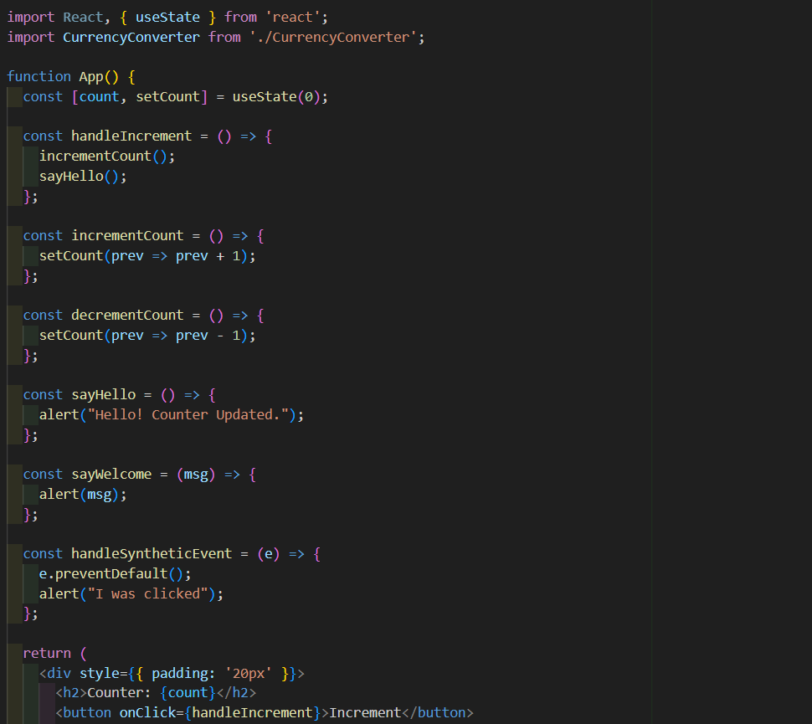

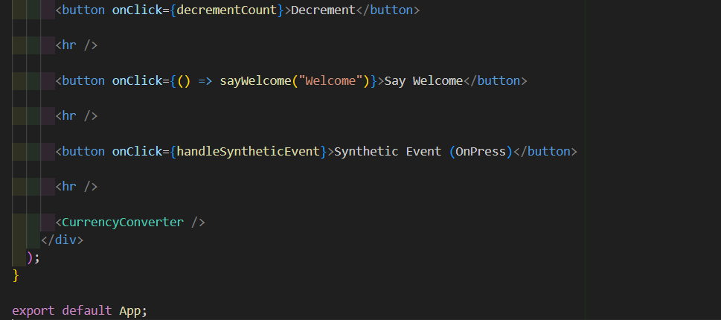

**Step 4: Run the application**

**OUTPUT:**

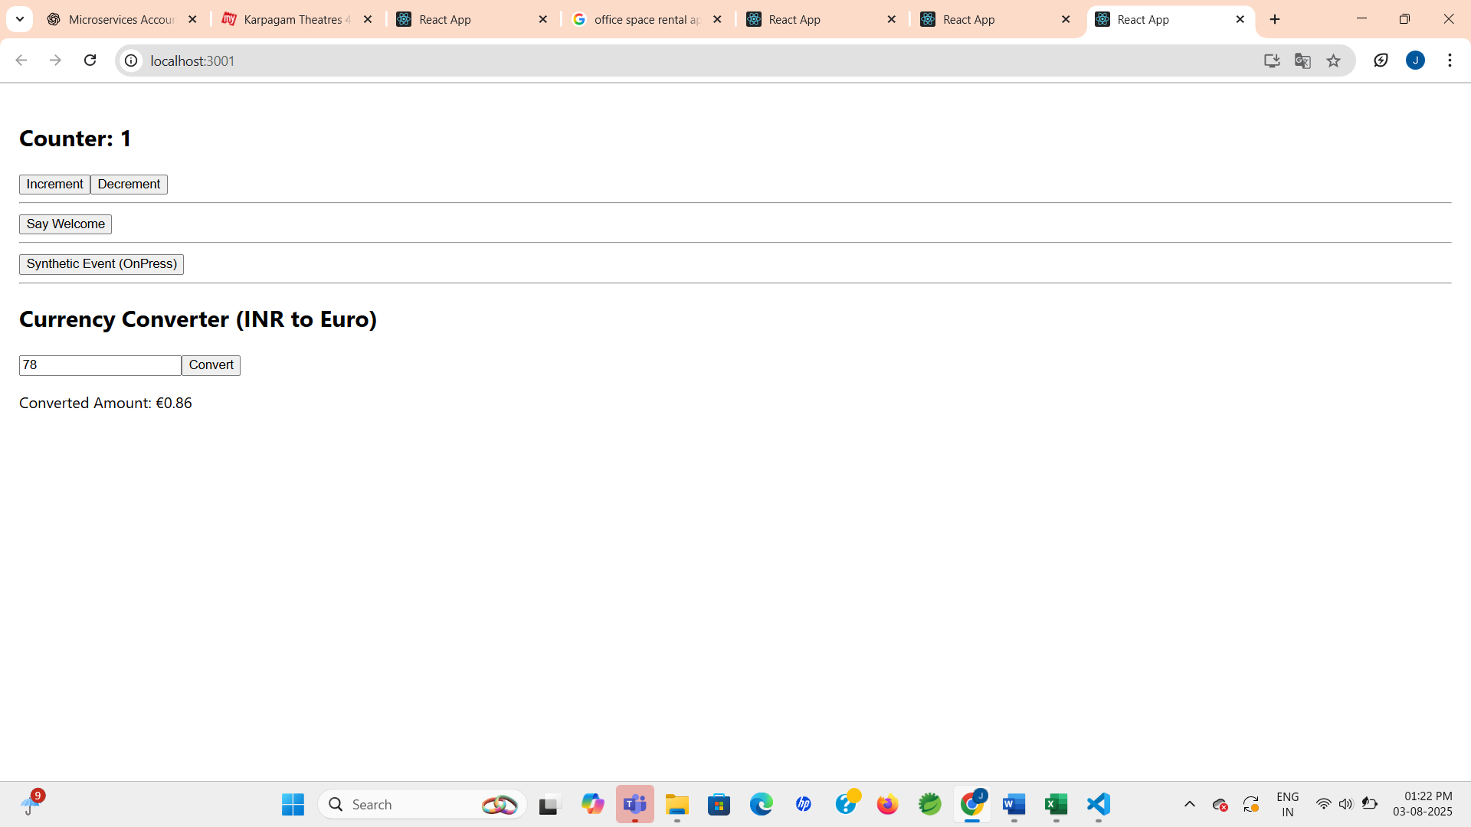

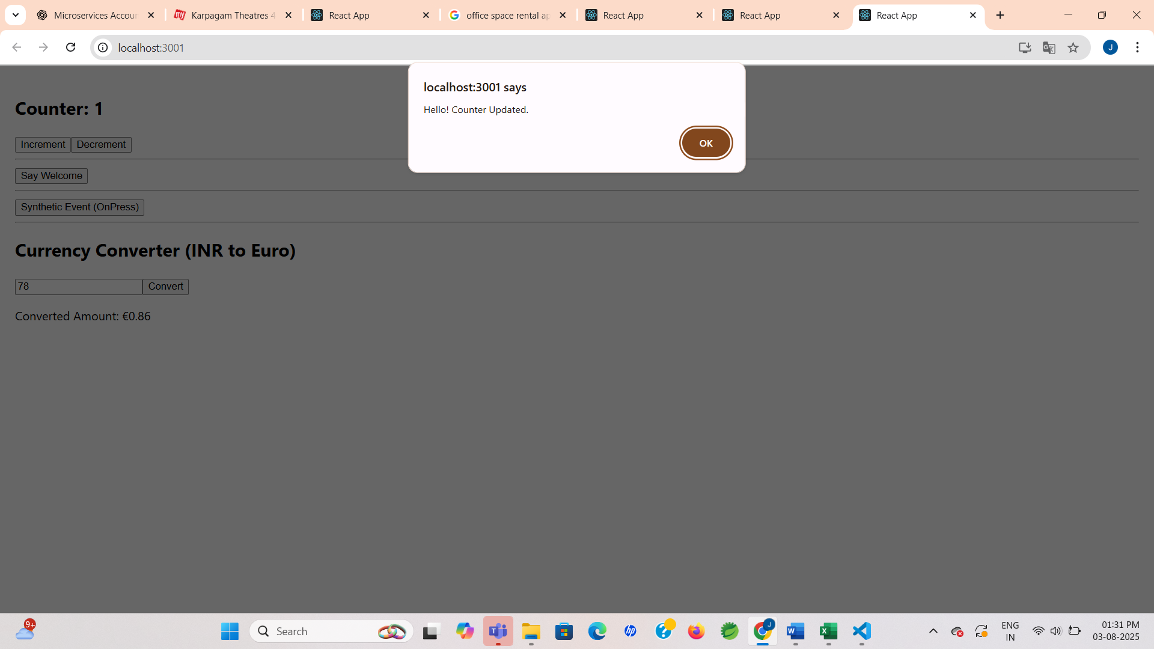

**Exercise 4: Conditional Rendering in React – Flight Ticket Booking App**

**Scenario:**

A guest visits the site and sees flight details. After logging in, they can book tickets. Logging out returns them to the guest view.

**Step 1: Create React App**

npx create-react-app bookingapp

cd bookingapp

code .

**Step 2: Create Guest.js**

**CODE:**

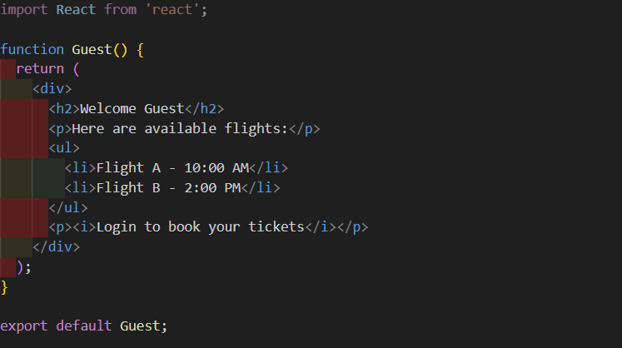

**Step 3: Create User.js**

**CODE:**

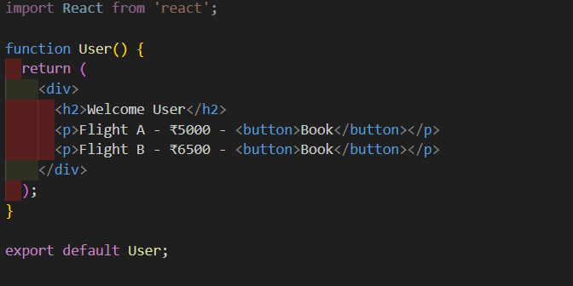

**Step 4: App.js**

**CODE:**

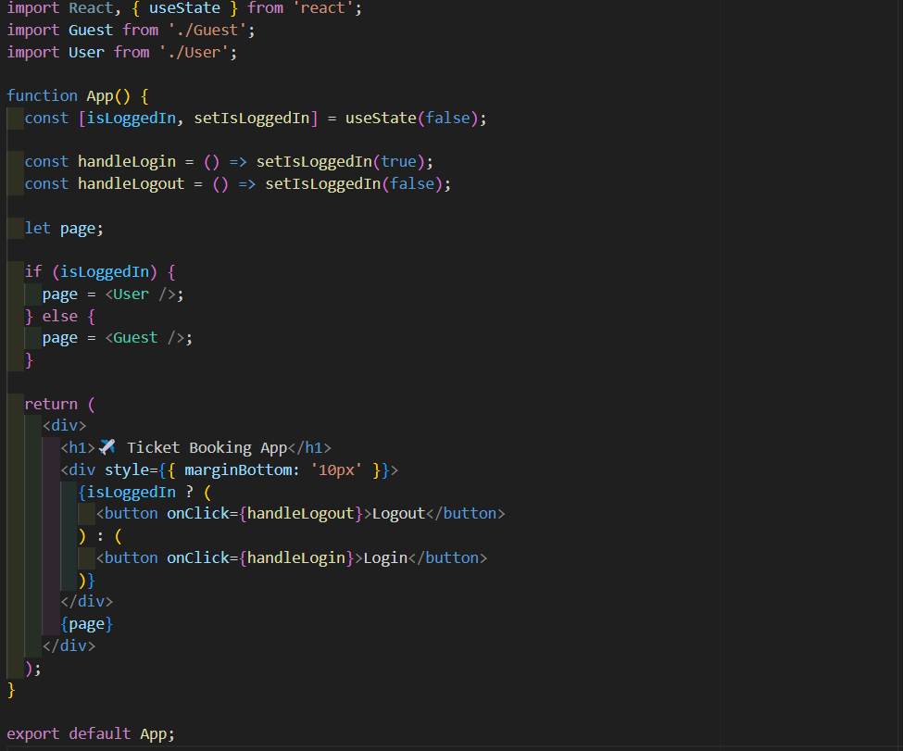

**Step 5: Run the Application**

**OUTPUT:**

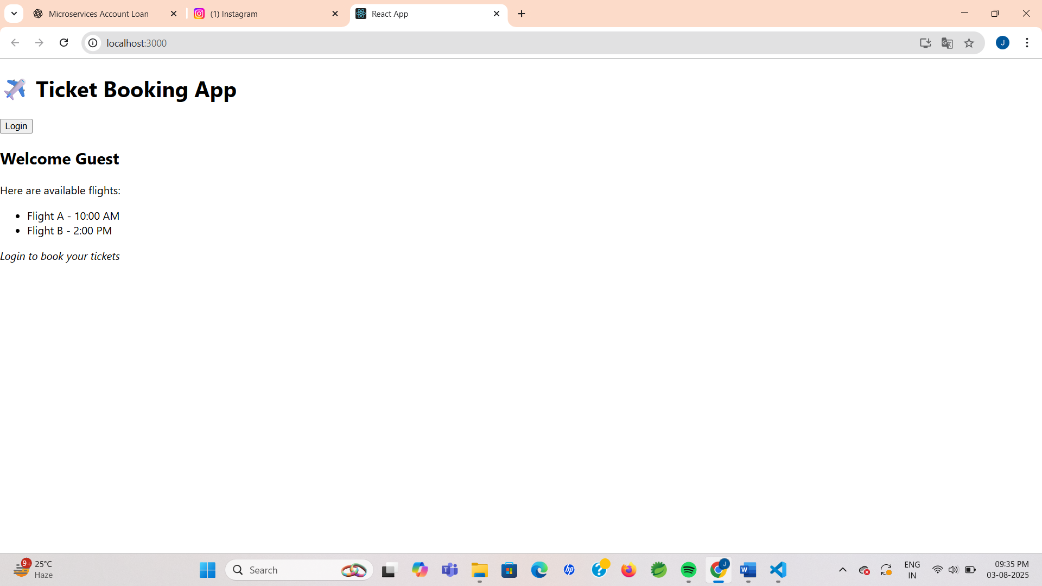

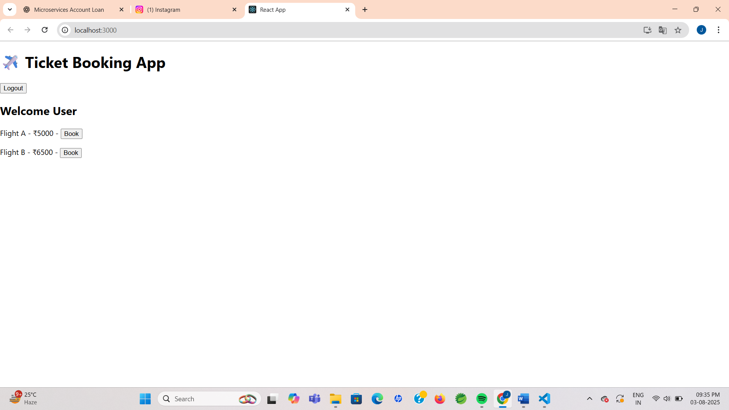

**Exercise 5 : Conditional Rendering Practice with BloggerApp**

**Scenario:**

A user opens the BloggerApp and clicks buttons to view either Book, Blog, or Course details. Based on the button clicked, only that specific section is shown using different conditional rendering techniques.

**Step 1 : Create React App**

npx create-react-app bloggerapp

cd bloggerapp

code .

**Step 2 : Create App.js**

**CODE:**

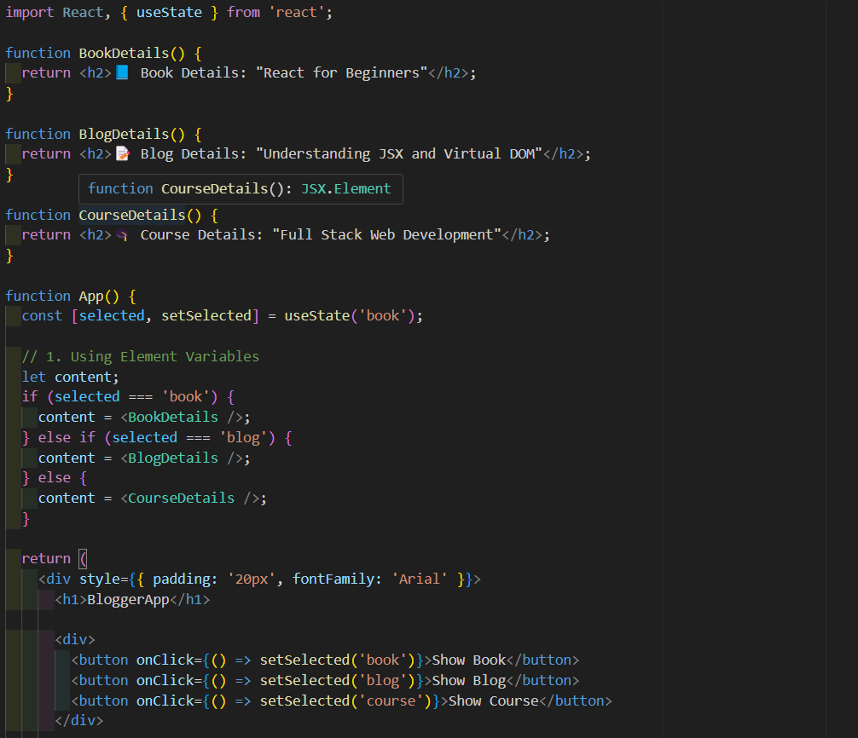

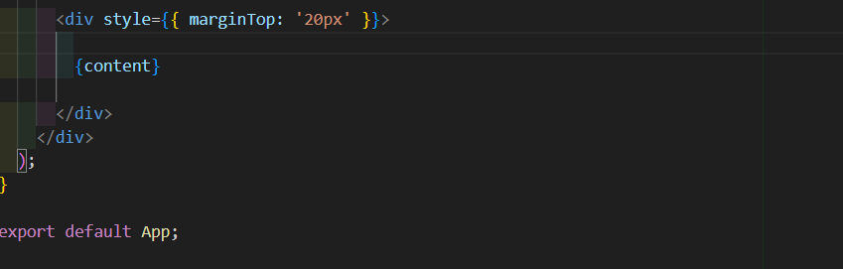

**Step 3 : Run the application**

**OUTPUT:**

