FST-8 (28-04-2026)
PART-B: CHEMISTRY

46. [Ni(NH₃)₆]Cl₂,[Ni(CO)₄],[Pt(en)₃]Cl₄, [Co(ox)₃]^{–3},[Pt(en)₂Cl₂]Cl₂,
[Cr(en)(ox)(gly)],[ZnCl₄]^{–2},[PdCl₄]^{–2}
Count number of complexes which shows optical isomerism.
(1) 4 (2) 3
(3) 2 (4) 5

47. NaCl(A)(B)(C)
Determine total number of atoms in per unit formula of (A), (B) & (C).
(1) 22 (2) 23
(3) 15 (4) 16

48.
(a) C ⇒ CH≡CH ; D ⇒
(b) B ⇒ ; E ⇒
(c) A ⇒ CH₂ = CH₂; C ⇒ CH ≡ CH

Which of the following is/are correct:
(1) only a, b
(2) only b
(3) only a, c
(4) a, b, c
49.
The number(s) of correct statement is/are :
(a) is soluble in aqueous NaOH
(b) Dichlorocarbene is electrophile involved in to conversion.
(c) is cumene hydroperoxide
(d) is called as salicylic acid
(1) 2 (2) 1
(3) 4 (4) 3

50. A compound has the empirical formula
C₂H₃O₂. Its vapour density is 59. Its molecular formula will be.
(1) C₂H₃O₂ (2) C₄H₆O₄
(3) C₆H₉O₆ (4) C₈H₁₂O₈

51. For a hypothetical reaction of the kind
More AB₃ could be produced at equilibrium by
(1) using a catalyst
(2) removing some of B₂
(3) increasing the temperature
(4) Increasing the pressure

52. The correct order of acidic strength of the following is:-
(1) SO₂ > P₂O₃ > SiO₂ > Al₂O₃
(2) P₂O₃ > SO₂ > SiO₂ > Al₂O₃
(3) P₂O₃ > Al₂O₃ > SO₂ > SiO₂
(4) Al₂O₃ > SiO₂ > P₂O₃ > SO₂
53. Match the Column: (For molecular geometry)

Column-I |  | Column-II
(a) | SF₄ | (P) | Tetrahedral
(b) | BrF₃ | (Q) | Pyramidal
(c) | BrO₃– | (R) | See-saw
(d) | NH₄⁺ | (S) | T-shape (Bent T)
(1) a-P; b-Q; c-R; d-S
(2) a-S; b-R; c-P; d-Q
(3) a-R; b-S; c-Q; d-P
(4) a-Q; b-S; c-R; d-P

54. Which of the following statement is/are correct
(a) CH₃–CH₂–NH–CH₃ and
CH₃–CH₂–CH₂–NH–H (Metamerism)
(b) CH₃–CH=CH–CH₃ and
(Position isomerism)
(c)
(Chain isomerism)
(d)
(Unsaturated hydrocarbon)
(1) a, c, d (2) c, d
(3) only c (4) a, b, c

55. The number of correct match is/are:

Column-I |  | Column-II
(a) | Tropone | Aromatic
(b) | [6] Annulene | Aromatic
(c) | [8] Annulene | Nonaromatic
(d) | [10] Annulene | Nonaromatic
(e) | [14] Annulene | Aromatic

(1) 5 (2) 2
(3) 4 (4) 3
56.
 | Column–I | Column–II
A | Orientation of orbitals | P | Azimuthal Quantum  Number
B | Zero Probability density of e– | Q | Magnetic Quantum  Number
C | Shape of  subshell | R | Principal Quantum  Number
D | Energy of the shell | S | Node
(1) A → Q , B → S, C → R, D → P
(2) A → S , B → Q, C → P, D → R
(3) A → Q , B → S, C → P, D → R
(4) A → R , B → P, C → Q, D → S

57. In the electrochemical cell :
the EMF of cell is E₁. When the concentration of Ni⁺² and Cu⁺² are changed to 0.01M then the emf changes to E₂. From the following which one is the correct relationship between E₁ and E₂.
(1) E₁ > E₂ (2) E₁ < E₂
(3) E₁ = E₂ (4) E₁ = 0 ≠ E₂

58. Statement-I: In the periodicity of the graph IE (ionization energy) v/s Z
(atomic number) (only Z = 1 to Z = 60), the maxima of the curve corresponds to noble gases and minima of the curve corresponds to Alkali metals.
Statement-II: Generally, across a period, the increase in nuclear charge outweighs the shielding effect. Consequently the outer electrons are held more tightly.
(1) Statement I is correct but Statement II is incorrect.
(2) Both statements are correct
(3) Statement I is incorrect but Statement II is correct
(4) Both Statements are incorrect
59. Which of the following complex is incorrect against to indicated properties?
(1) [Ni(NH₃)₆]²⁺ < [Ni(en)₃]²⁺;chelation effect
(2) [Fe(CN)₆]^{3–} < [Fe(SCN)₆]^{3–} ; stability
(3) [FeF₆]^{3–} < [Fe(H₂O)₆]³⁺ ; crystal field splitting energy
(4) [Co(CO)₄] < [Ni(CO)₄] ; valence shells electrons of central metal ion.

60. Match List-I with List-II.

List I  Mixture of  Compounds |  | List II  Reagent used to  distinguish
A. | Diethyl amine  + Ethyl amine | I. | Bromine water
B. | Acetaldehyde  + Acetone | II. | CHCl₃ +KOH, Δ
C. | Ethanol  + Phenol | III. | Neutral FeCl₃
D. | Benzoic acid  + Cinnamic acid | IV. | Ammoniacal silver  nitrate

Choose the correct answer from the options given below:
(1) A-IV, B-II, C-I, D-III
(2) A-IV, B-II, C-III, D-I
(3) A-II, B-IV, C-I, D-III
(4) A-II, B-IV, C-III, D-I
61. Amongst the following, the total number of compounds soluble in aqueous NaOH at room temperature is:
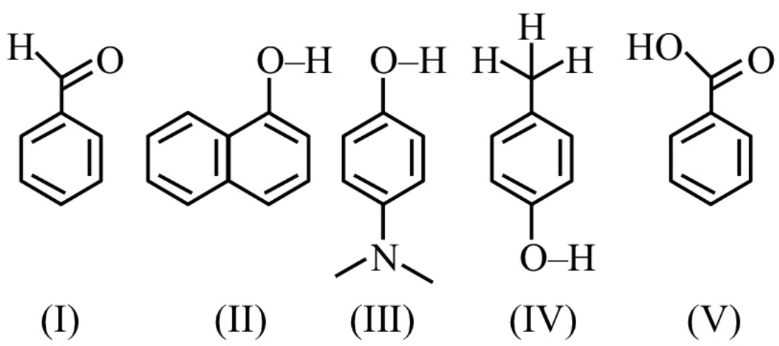
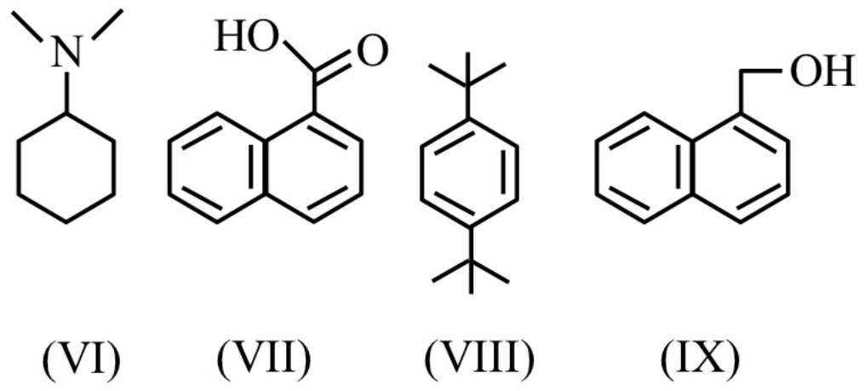
(1) 5 (2) 4
(3) 6 (4) 3

62. The conjugate base of the weak acid in the reaction is
(1) HBr (2) H₂O
(3) Br– (4) H₃O⁺

63. The standard electrode potential for the following reaction is –0.57 V. What is potential at pH = 10
(1) –0.17V (2) –0.21V
(3) –0.39V (4) +1.95V

64. Which of the following species is planar and polar?
(1) SO₃ (2) POCl₃
(3) (4)
65. Given below are two statements:
Statement-I: The second ionization enthalpy of B, Al and Ga is in the order of B > Al > Ga.
Statement-II: The correct order in terms of first ionization enthalpy is Si < Ge < Pb < Sn. In the light of the above statements, choose the correct answer from the options given below:
(1) Both Statement-I and Statement-II are true.
(2) Both Statement-I and Statement-II are false.
(3) Statement-I is true but Statement-II is false.
(4) Statement-I is false but Statement-II is true.

66. Identify the correct statements
A. Glucose exist in two anomeric forms.
B. Anomers of glucose differ in
configuration at C-1 in cyclic hemiacetal structure.
C. Melting point of α-anomer of glucose is greater than β-anomer.
D. Specific rotation of α-anomer is +19° while for β-anomer is +112°
E. α and β-anomers of glucose are prepared by crystallization of saturated glucose solution at 303 K and 371 K respectively.
Choose the correct answer from the options given below:
(1) A and B only
(2) B and C only
(3) A, B and D only
(4) A, B and E only
67. Identify compounds A and E in the following reaction sequence.

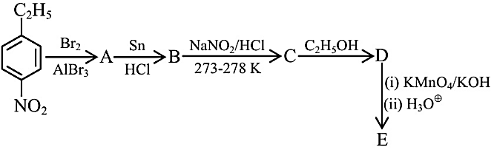
(1) 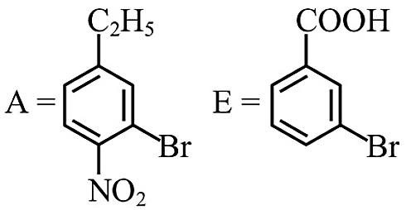
(2) 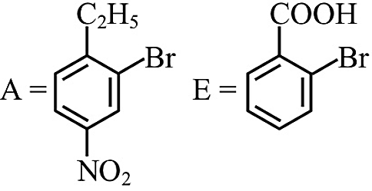
(3) 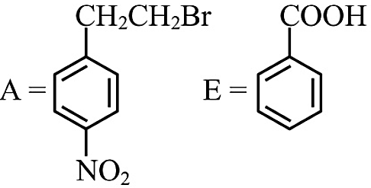
(4) 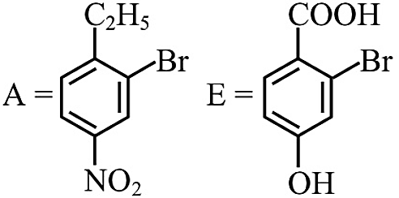

68. Half life of a radioactive element is 20 min. Remaining amount of element is 2 gram after 1 hours. Find initial amount of radioactive element-
(1) 16g (2) 32g
(3) 8g (4) 64g

69. For a chemical reaction at 27°C, the activation energy is 1200 R. The ratio of the rate constants at 327°C and 27° C will be-
(1) 2 (2) 40
(3) e (4) e²
70. Given below are two statements :-
Statement-I : Among Zn, Mn, Sc and Cu, the energy required to remove the third valence electron is highest for Zn and lowest for Sc.
Statement-II: The correct order of the following complexes in terms of CFSE is [Co(H₂O)₆]²⁺ < [Co(H₂O)₆]³⁺ < [Co(en)₃]³⁺ In the light of the above statements, choose the correct answer from the options given below :
(1) Both Statement-I and Statement-II are true.
(2) Both Statement-I and Statement-II are false.
(3) Statement-I is true but Statement-II is false.
(4) Statement-I is false but Statement-II is true.

71. In the formation of CH₄ if pure 2s and 2p orbitals participate, which of the following statements is false ?
(1) Three C-H bonds will be at right angle
(2) One C-H bond will be weaker than other three C-H bonds
(3) The shape of molecule will be tetrahedral
(4) The angle of C-H bond formed by S-S overlapping will be uncertain with respect to other three bonds

72. Complete the following reaction sequence and give the name of major product 'P'.
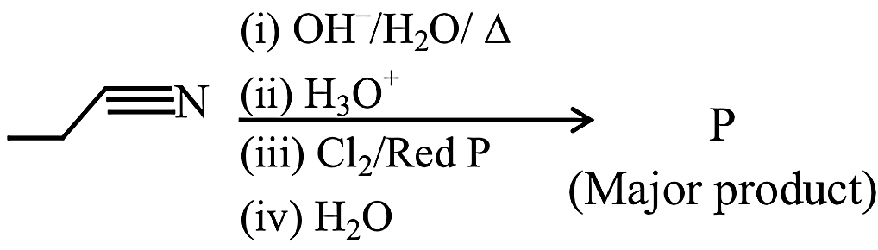
(1) 2-Chloropropanoic acid
(2) 3-Chloropropanoic acid
(3) 1-Chloropropane
(4) 2-Chloropropane
73. Match List I with List II.

List I  Element  Detected |  | List II  Reagent used/Product  formed
A. | Nitrogen |  | I. | Na₂[Fe(CN)₅NO]
B. | Sulphur |  | II. | AgNO₃
C. | Phosphorus |  | III. | Fe₄[Fe(CN)₆]₃
D. | Halogen |  | IV. | (NH₄)₂MoO₄

Choose the correct answer from the options given below:
(1) A-III, B-I, C-IV, D-II
(2) A-II, B-IV, C-I, D-III
(3) A-II, B-I, C-IV, D-III
(4) A-IV, B-II, C-I, D-III

74 The equivalent mass of oxidising agent in the following reaction is:
SO₂+ 2H₂S→ 3S + 2H₂O
(1) 32 (2) 64
(3) 16 (4) 8

75. When 100 g of a non volatile solute is dissolved in 100 g of benzene, it results in rise in boiling point by 1°C. Molecular mass of solute is
(K_{b} for benzene = 2.53 Km^{–1})
(1) 253 (2) 25.3
(3) 233 (4) 2530
76. Which of the following pair is mixed
oxides of 3d-elements.
(1) Ti₂O₃, Fe₂O₃
(2) Mn₃O₄, V₂O₄
(3) Mn₃O₄, Fe₃O₄
(4) Fe₃O₄, Cr₂O₃

77. Correct stability order of monohalide of Boron family:
(1) BX > AlX > GaX > lnX > TlX
(2) BX < AlX < GaX < lnX <TlX
(3) BX > AlX < GaX < InX <TlX
(4) AlX > GaX > BX > lnX < TlX

78. Consider the following organic reaction sequence. Choose the final product (X) from the following (consider the major product in all intermediate reactions)
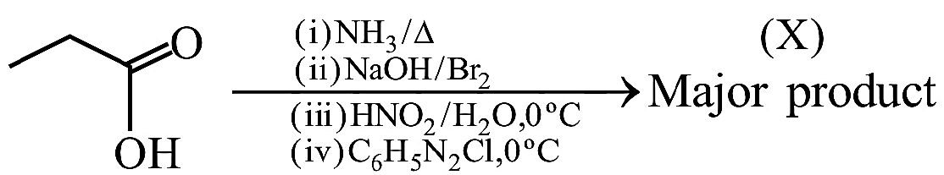

(1) Benzene
(2) Phenol
(3) Propanol
(4) Chlorobenzene
79. Match the example given in Column I with the name of the reaction in Column II

Column I  (Example) |  | Column II  (Reaction)
(i) |  | (a) | Friedel Crafts  acylation
(ii) |  | (b) | Hell-Volhard-Zelinsky Reaction  (HVZ reaction)
(iii) |  | (c) | Aldol  condensation  reaction
(iv) | R–CH₂–COOH | (d) | Cannizzaro  reaction
(v) | 2CH₃CHO  CH₃–CH=CHCHO | (e) | Rosenmund  reduction

(1) i-e, ii-d, iii-a, iv-b, v-c
(2) i-e, ii-c, iii-a, iv-b, v-d
(3) i-c, ii-d, iii-e, iv-a, v-b
(4) i-b, ii-a, iii-e, iv-b, v-c

80. How much electricity in terms of faraday is required to produce 40g Al form molten Al₂O₃
(1) 3F (2)
(3) (4)
81 The enthalpy of reaction
2H₂(g) + O₂(g) → 2H₂O(l) ΔH =–572 kJ mol^{–1}
What will be standard enthalpy of formation of H₂O(l)?
(1) +572 kJ mol^{–1}
(2) +286 kJ mol^{–1}
(3) –286 kJ mol^{–1}
(4) +2860 kJ mol^{–1}

82.
List-I  (Acid) |  | List-II  (Basicity) |  | List-III  (P-H bond)
(A) | H₃PO₂ | (p) | 3 | (i) | 2
(B) | H₃PO₃ | (q) | 1 | (ii) | 1
(C) | H₃PO₄ | (r) | 2 | (iii) | 0
(D) | H₄P₂O₇ | (s) | 4 | (iv) | 3
(1) A-q (i); B-r (i); C-p, (iii); D-s (iii)
(2) A-q (i); B-r (ii); C-p, (iii); D-s (iii)
(3) A-q (i); B-q (ii); C-r, (iii); D-s (iv)
(4) A-s (ii); B-q (iii); C-p, (iv); D-r, (i)

83.
pOH values of x and y are respectively:
(1) 9 and 2 (2) 7 and 7
(3) 2 and 9 (4) 6 and 6

84. (A) will be
(1)
(2)
(3)
(4) None of the above.
85. 'x' is the product which is obtained by the hydrolysis of prop-1-yne in the presence of mercuric sulphate under dilute acidic medium at 333 K. 'y' is the product which is obtained by the reaction of ethane nitrile with methyl magnesium bromide in dry ether followed by hydrolysis. IUPAC name of product obtained from 'x' and 'y' in the presence of barium hydroxide followed by heating is:
(1) 2-Methylpent-4-en-3-one
(2) 4-Methylpent-3-en-2-one
(3) 4-Methylpent-1-ene
(4) 2-Methylpent-3-one

86. Which of the following is a lyophobic colloid?
(1) Gelatin (2) Sulphur
(3) Starch (4) Gum

87. Statement 1 : Phase transition involves change in internal energy only and not in entropy.
Statement 2 : Phase transition occurs at constant pressure.
(1) Statement 1 is true but statement 2 is false
(2) Statement 1 is false but statement 2 is true.
(3) Both the statements are true.
(4) Both the statements are false.

88. Mark the correct statement :
(1) I group basic redicals precipitate as chlorides
(2) IV group basic radicals precipitate as sulphides
(3) V group basic radicals precipitate as carbonates
(4) All the above statements are correct
89. Match the LIST-I with LIST-II
LIST-I  Name reaction |  | LIST-II  Product obtainable
(A) | Swarts reaction | (I) | Ethyl benzene
(B) | Sandmeyer reaction | (II) | Ethyl iodide
(C) | Wurtz-Fittig reaction | (III) | Cyanobenzene
(D) | Finkelstein reaction | (IV) | Ethyl fluoride

Choose the correct answer from the options given below:
(1) A-II, B-III, C-I, D-IV
(2) A-IV, B-I, C-III, D-II
(3) A-IV, B-III, C-I, D-II
(4) A-II, B-I, C-III, D-IV

90. The value of Henry's constant K_{H} is ____.
(1) Greater for gases with higher solubility.
(2) Greater for gases with lower solubility.
(3) Constant for all gases.
(4) Not related to the solubility of gases.

