Subject | Physics
Question English | A small block of mass M moves on a frictionless surface of an inclined plane, as shown in figure. The angle of the incline suddenly changes from 60° to 30° at point B. The block is initially at rest at A. Assume that collisions between the block and the incline are totally inelastic \[g = 10m/{s^2}\].  The speed of the block at point B immediately after it strikes the second incline is
Question_hindi
Question image | 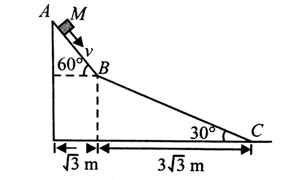
Question Type | single_choice
Option1 English | \[\sqrt {60} \,m/s\]
Option1 hindi
Option2 English | \[\sqrt {45} \,m/s\]
Option 2 Hindi
Option3 English | \[\sqrt {30} \,m/s\]
Option 3 Hindi
Option4 English | \[\sqrt {75} \,m/s\]
Option4 Hindi
Solution English
Solution Hindi
Correct Marks | 3
Incorrect Marks | 1
Correct Answer | A
Assertion English
Assertion Hindi
Solution English
Solution Hindi

