1. **package** com.javacore;

**import** java.util.*;

**public** **class** Prog01 {

**public** **static** **void** main(String[] args) {

Scanner sc = **new** Scanner(System.***in***);

System.***out***.println("enter string:");

String str = sc.nextLine();

**char**[] ch = str.toCharArray();

**int** n = ch.length;

**boolean** found = **false**;

**for** (**int** i = 0; i < n; i++) {

**char** cur = ch[i];

**int** count = 1;

**for** (**int** j = i + 1; j < n; j++) {

**if** (ch[j] == cur) {

found = **true**;

count++;

ch[j] = '#';

}

}

**if** (found) {

System.***out***.println(cur + ": " + count);

}

}

**if** (!found) {

System.***out***.println("no duplicates");

}

}

}

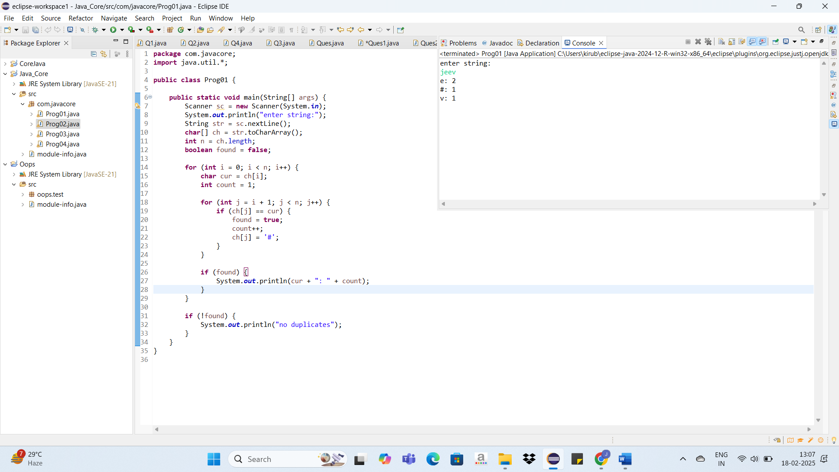

2. **package** com.javacore;

**import** java.util.*;

**public** **class** Prog02 {

**public** **static** **void** main(String[] args) {

Scanner sc = **new** Scanner(System.***in***);

String word = sc.nextLine();

StringBuilder sb = **new** StringBuilder();

**if**(sb.charAt(0)=='"') {

sb.append("@");

}

**if** (word.length() >= 2) {

sb.append(word.substring(0, 2));

} **else** {

sb.append(word);

**while** (sb.length() < 2) {

sb.append("@");

}

}

System.***out***.println(sb);

}

}

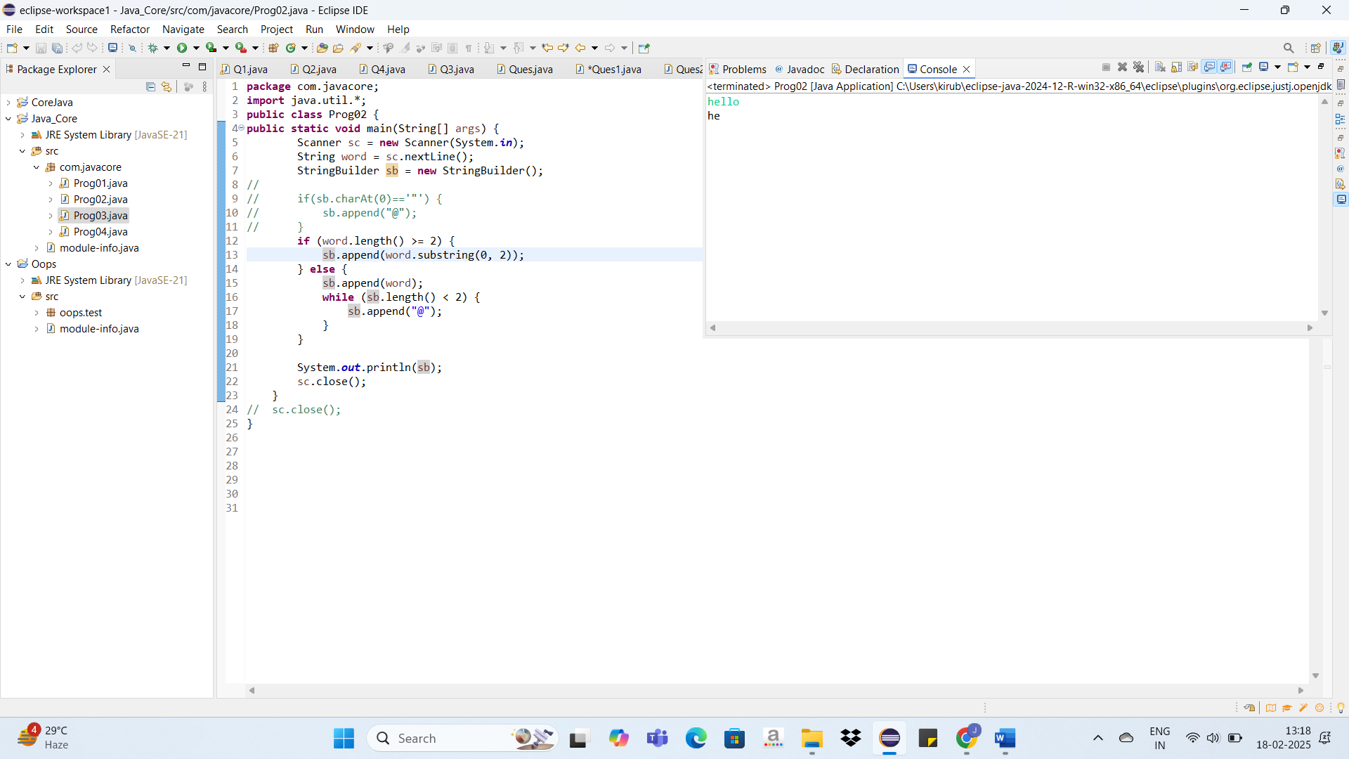

3. **package** com.javacore;

**import** java.util.*;

**class** AgeValidationException **extends** Exception {

AgeValidationException(String m) {

**super**(m);

}

}

**class** ExceptionDemo {

**static** **void** validateAge(**int** age) **throws** AgeValidationException {

**if** (age < 1) {

**throw** **new** AgeValidationException("Age is too low");

} **else** **if** (age > 100) {

**throw** **new** AgeValidationException("Age is too high");

} **else** {

System.***out***.println("Age is between 1 and 100");

}

}

}

**public** **class** Prog03 {

**public** **static** **void** main(String[] args) {

Scanner sc = **new** Scanner(System.***in***);

System.***out***.println("enter the age:");

**int** n = sc.nextInt();

**try** {

ExceptionDemo.*validateAge*(n);

} **catch** (AgeValidationException e) {

System.***out***.println("Exception has occurred: " + e);

}

System.***out***.println("Rest of the code");

}

}

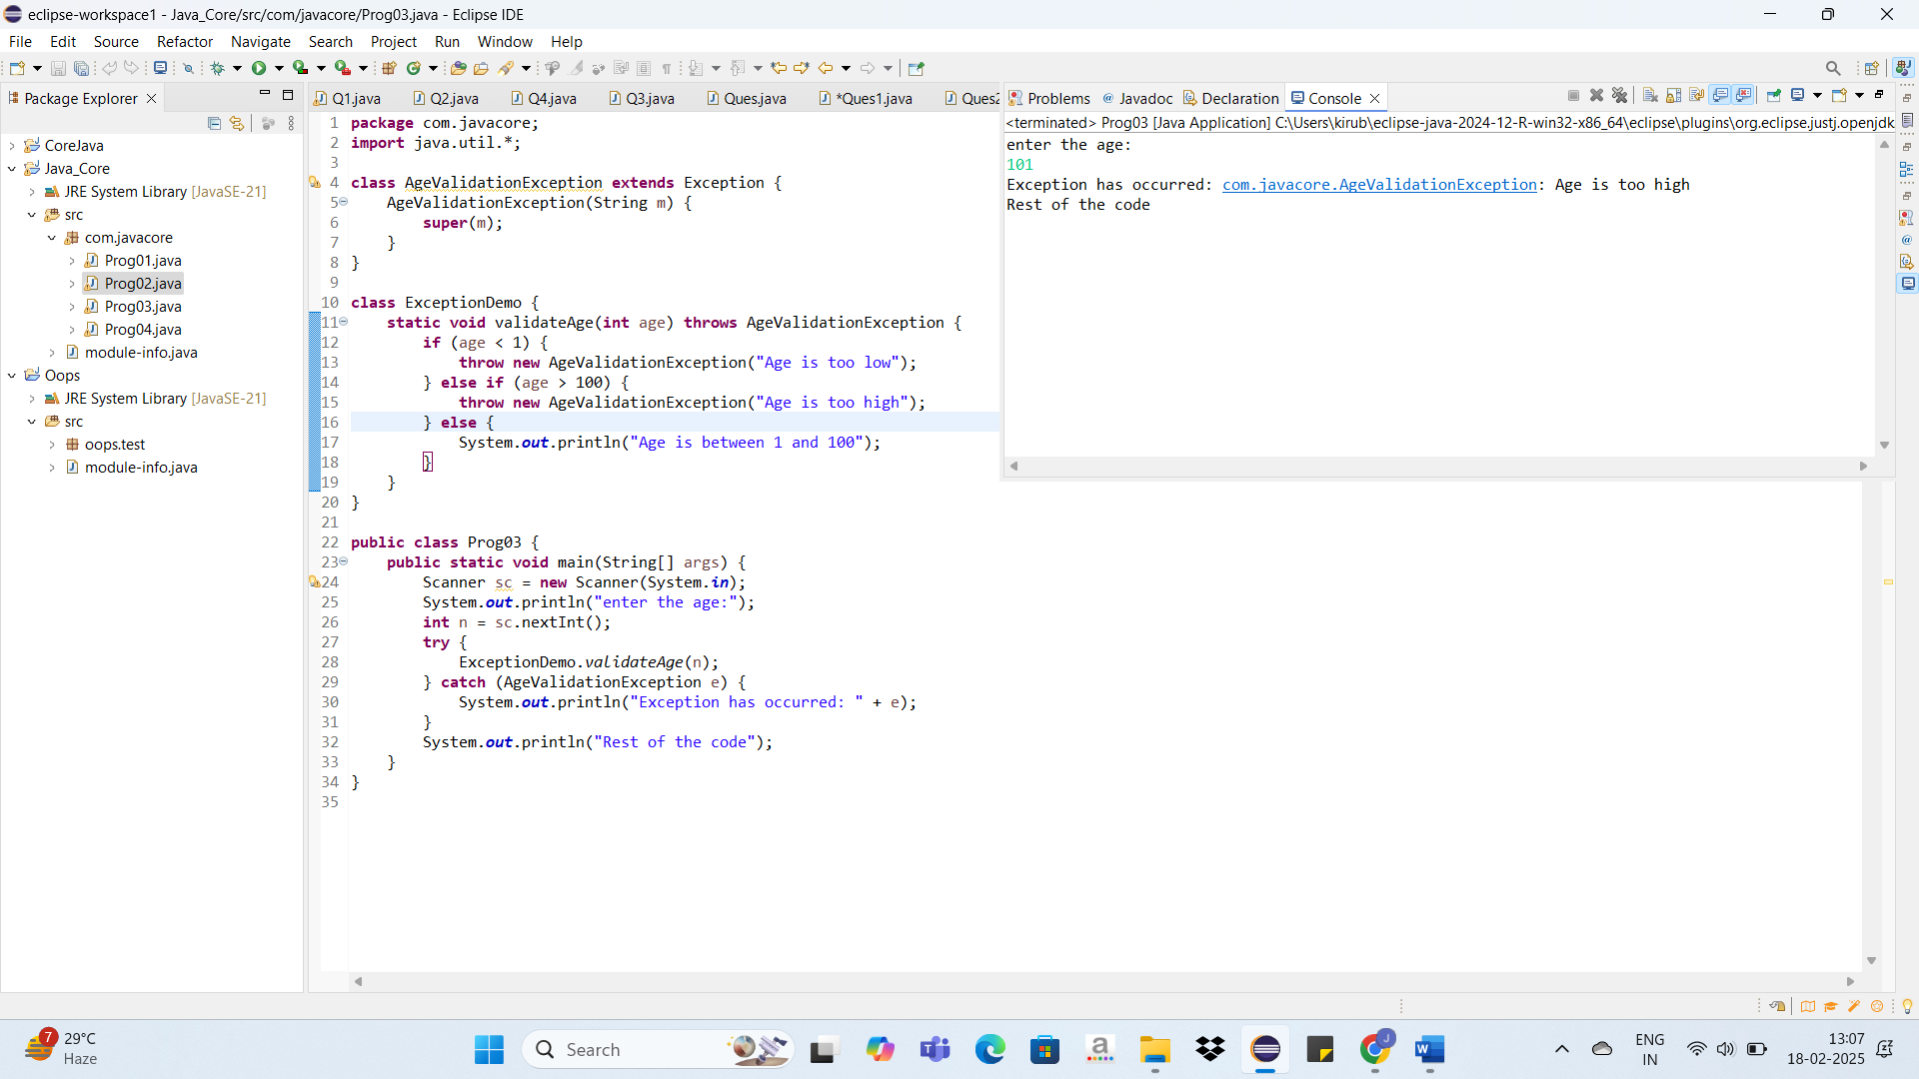

4.

**package** com.javacore;

**import** java.util.*;

**class** Product {

**private** **int** productId;

**private** String productName;

**private** String productCategory;

**private** **double** productPrice;

**private** **double** productDiscount;

**private** **int** productQuantity;

**public** Product(**int** productId, String productName, String productCategory, **double** productPrice,

**double** productDiscount, **int** productQuantity) {

**this**.productId = productId;

**this**.productName = productName;

**this**.productCategory = productCategory;

**this**.productPrice = productPrice;

**this**.productDiscount = productDiscount;

**this**.productQuantity = productQuantity;

}

**public** **int** getProductId() {

**return** productId;

}

**public** **void** setProductId(**int** productId) {

**this**.productId = productId;

}

**public** **double** getProductPrice() {

**return** productPrice;

}

**public** **void** setProductPrice(**double** productPrice) {

**this**.productPrice = productPrice;

}

**public** String getProductName() {

**return** productName;

}

**public** **void** setProductName(String productName) {

**this**.productName = productName;

}

**public** String toString() {

**return** "ProductId: " + productId + ", Name: " + productName + ", Price: " + productPrice + ", Category: " + productCategory;

}

**static** **class** ProductIdComparator **implements** Comparator<Product> {

**public** **int** compare(Product p1, Product p2) {

**return** Integer.*compare*(p1.getProductId(), p2.getProductId());

}

}

**static** **class** ProductPriceComparator **implements** Comparator<Product> {

**public** **int** compare(Product p1, Product p2) {

**return** Double.*compare*(p1.getProductPrice(), p2.getProductPrice());

}

}

}

**public** **class** Prog04 {

**public** **static** **void** main(String[] args) {

Scanner sc = **new** Scanner(System.***in***);

List<Product> p = **new** ArrayList<>();

p.add(**new** Product(101, "iphone10", "Mobile", 20000.0, 0.2, 2));

p.add(**new** Product(102, "Dell", "Laptop", 20000.0, 0.3, 4));

p.add(**new** Product(103, "iphone13", "Mobile", 10000.0, 0.5, 1));

p.add(**new** Product(104, "Lenovo", "Laptop", 70000.0, 0.8, 3));

p.add(**new** Product(105, "iphone12", "Mobile", 50000.0, 0.5, 6));

System.***out***.println("1-sort by id");

System.***out***.println("2-list mobiles with price more than 40000");

System.***out***.println("3-Exit");

**int** choice = sc.nextInt();

**switch**(choice) {

**case** 1:

Collections.*sort*(p, **new** Product.ProductIdComparator());

System.***out***.println("Sorted by Product ID:");

**for** (Product pro : p) {

System.***out***.println(pro);

}

**break**;

**case** 2:

System.***out***.println("Mobiles with price greater than 40000:");

**for** (Product pro : p) {

**if** (pro.getProductPrice() > 40000) {

System.***out***.println(pro);

}

}

**break**;

**case** 3:

System.***out***.println("Thank You");

**break**;

**default**:

System.***out***.println("Invalid choice");

}

}

}

